Lesson 26
Objective: Compare fractions greater than 1 by reasoning using benchmark fractions.

Suggested Lesson Structure
 Fluency Practice (10 minutes)
 Application Problem (5 minutes)
 Concept Development (35 minutes)
 Student Debrief (10 minutes)
Total Time (60 minutes)
Fluency Practice (10 minutes)
- Change Fractions to Mixed Numbers 4.NF.4 (4 minutes)
- Change Mixed Numbers to Fractions 4.NF.4 (6 minutes)
Change Fractions to Mixed Numbers (4 minutes)
Materials: (S) Personal white board
Note: This fluency activity reviews Lesson 24.
T: (Write $\frac{\text{4}}{\text{3}}$.) Say the fraction.
S: 4 thirds.
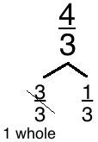
T: (Draw a number bond with $\frac{\text{4}}{\text{3}}$ as the whole.) How many thirds are in 1?
1
S: 3 thirds.
T: (Write $\frac{\text{3}}{\text{3}}$ as a part. Write $\frac{}{\text{3}}$ as the other part.) Write the remaining part, filling in the unknown numerator.
S: (Write $\frac{\text{1}}{\text{3}}$ as the unknown part.)
T: (Cross out $\frac{\text{3}}{\text{3}}$ and write 1 beneath it. Write $\frac{\text{4}}{\text{3}}$ =____.) Write $\frac{\text{4}}{\text{3}}$ as a mixed number.
S: (Write $\frac{\text{4}}{\text{3}}$ = $\text{1}\frac{\text{1}}{\text{3}}$.)
Continue with the following possible sequence: $\frac{\text{9}}{\text{4}}$, $\frac{\text{14}}{\text{5}}$, and $\frac{\text{11}}{\text{3}}$.

Change Mixed Numbers to Fractions (6 minutes)
Materials: (S) Personal white board
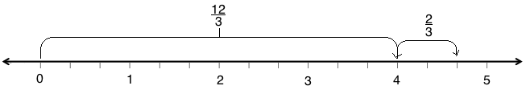
Note: This fluency activity reviews Lesson 25.

T: (Write $\text{4}\frac{\text{2}}{\text{3}}$.) $\text{4}\frac{\text{2}}{\text{3}}$ is between which two whole numbers?
S: 4 and 5.
T: Draw a number line, and label 0, 1, 2, 3, 4, and 5.
S: (Draw a number line. Label 0, 1, 2, 3, 4, and 5.)
T: Decompose each whole number into thirds.
T: How many thirds are in 1?
S: 3 thirds.
T: 2?
S: 6 thirds.
T: 4?
S: 12 thirds.
T: Label 12 thirds on your number line.
S: (Draw an arrow from 0 to 4. Above the arrow, write $\frac{\text{12}}{\text{3}}$.)
T: (Write $\text{4}\frac{\text{2}}{\text{3}}$ = $\frac{}{\text{3}}$ + $\frac{\text{2}}{\text{3}}$.) Fill in the unknown numerator in the number sentence.
S: (Write $\text{4}\frac{\text{2}}{\text{3}}$ = $\frac{\text{12}}{\text{3}}$ + $\frac{\text{2}}{\text{3}}$.)
T: (Write $\text{4}\frac{\text{2}}{\text{3}}$ = $\frac{\text{12}}{\text{3}}$ + $\frac{\text{2}}{\text{3}}$ = $\frac{}{\text{3}}$.) Label the slide from 4 to $\text{4}\frac{\text{2}}{\text{3}}$ on your number line. Then, complete the number sentence.
S: (Draw and label an arrow from 4 to $\frac{\text{2}}{\text{3}}$ more than 4. Write $\text{4}\frac{\text{2}}{\text{3}}$ = $\frac{\text{12}}{\text{3}}$ + $\frac{\text{2}}{\text{3}}$ = $\frac{\text{14}}{\text{3}}$.)

NOTES ON
MULTIPLE MEANS
OF REPRESENTATION:
English language learners may need explicit instruction in reading and speaking mixed numbers. Teach students to read the whole number, say and, and then read the fraction.

Continue with the following possible sequence: $\text{2}\frac{\text{3}}{\text{4}}$ and $\text{2}\frac{\text{3}}{\text{5}}$.
Application Problem (5 minutes)
Barbara needed $\text{3}\frac{\text{1}}{\text{4}}$ cups of flour for her recipe. If she measured $\frac{\text{1}}{\text{4}}$ cup at a time, how many times did she have to fill the measuring cup?
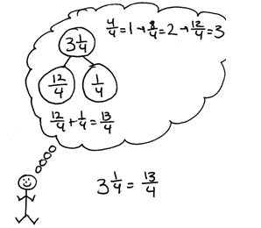
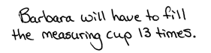

Note: This Application Problem builds on the learning from Lesson 25. Students will convert $\text{3}\frac{\text{1}}{\text{4}}$ to $\frac{\text{13}}{\text{4}}$ to determine that Barbara would have to fill the measuring cup 13 times. In Lesson 26, students will compare fractions greater than 1. This Application Problem extends to the Concept Development of today’s lesson as students compare $\frac{\text{13}}{\text{4}}$, $\frac{\text{9}}{\text{2}}$, and $\text{3}\frac{\text{6}}{\text{8}}$. It also hints at division by a unit fraction, a Grade 5 standard.
Concept Development (35 minutes)
Materials: (S) Personal white board
Problem 1: Compare mixed numbers and fractions on a number line using benchmark fractions.
T: Barbara needed $\frac{\text{13}}{\text{4}}$ cups of flour, her friend Jeanette needed $\frac{\text{9}}{\text{2}}$ cups, and her friend Robert needed $\text{3}\frac{\text{6}}{\text{8}}$ cups. Let’s compare the amounts using a number line.

NOTES ON
MULTIPLE MEANS
OF REPRESENTATION:
Some learners may benefit from scaffolded questioning to convert $\frac{\text{9}}{\text{2}}$ to a mixed number. Ask, “How many halves make 1?” Then, say, “Count by 2 halves. 2 halves, 4 halves, 6 halves, 8 halves. Stop. We only have $\frac{\text{9}}{\text{2}}$. Decompose $\frac{\text{9}}{\text{2}}$ using a bond with $\frac{\text{8}}{\text{2}}$and the remaining fraction.”

T: Draw a number line with the endpoints of 3 and 5. In the Application Problem, we found that $\frac{\text{13}}{\text{4}}$ equals $\text{3}\frac{\text{1}}{\text{4}}$. Find 3 on the number line. Imagine the fourths. Mark $\frac{\text{1}}{\text{4}}$ past 3. That shows where 3 + $\frac{\text{1}}{\text{4}}$ is located. Label $\frac{\text{13}}{\text{4}}$.
T: Plot $\frac{\text{9}}{\text{2}}$ on the number line. Work with a partner. How many ones are in $\frac{\text{9}}{\text{2}}\text{?}$ How many remaining halves?
S: There are four groups of 2 halves in 9. There are 4 ones and $\frac{\text{1}}{\text{2}}$ more. We can find 4 on the number line, and then mark $\frac{\text{1}}{\text{2}}$ past the 4.
T: Label $\frac{\text{9}}{\text{2}}\text{.}$ Is 9 halves greater than or less than 13 fourths?
S: Greater than, of course. There are 4 ones in $\frac{\text{9}}{\text{2}}\text{.}$ There are only 3 ones in $\frac{\text{13}}{\text{4}}\text{.}$
T: Plot and label $\text{3}\frac{\text{6}}{\text{8}}\text{.}$ Explain to a partner how this is done.
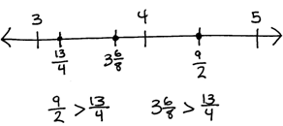

S: We can find the ones, 3, and then picture in our minds where $\frac{\text{6}}{\text{8}}$ more would be. $\frac{\text{6}}{\text{8}}$ is $\frac{\text{2}}{\text{8}}$ greater than $\frac{\text{1}}{\text{2}}$ since $\frac{\text{4}}{\text{8}} \text{=} \frac{\text{1}}{\text{2}}$. $\text{3}\frac{\text{6}}{\text{8}}$ is between$\text{ 3}\frac{\text{1}}{\text{2}}$ and 4. $\frac{\text{6}}{\text{8}} \text{=} \frac{\text{3}}{\text{4}}$. $\text{3}\frac{\text{6}}{\text{8}} \text{=} \text{3}\frac{\text{3}}{\text{4}}\text{.}$
T: Compare $\text{3}\frac{\text{6}}{\text{8}}$ and $\frac{\text{13}}{\text{4}}\text{.}$
S: $\text{3}\frac{\text{6}}{\text{8}}$ is greater than $\text{3}\frac{\text{1}}{\text{2}}\text{.}$ $\frac{\text{13}}{\text{4}}$ is less than $\text{3}\frac{\text{1}}{\text{2}}\text{.}$ $\text{3}\frac{\text{6}}{\text{8}}$ is greater than $\frac{\text{13}}{\text{4}}\text{.}$
Repeat with $\frac{\text{58}}{\text{8}}\text{, 7}\frac{\text{5}}{\text{8}}\text{, and} \frac{\text{30}}{\text{4}}\text{.}$
Problem 2: Compare two mixed numbers or two fractions greater than 1.
T: (Display $\frac{\text{29}}{\text{7}}$ and $\frac{\text{31}}{\text{8}}$.) Can we compare these fractions easily?
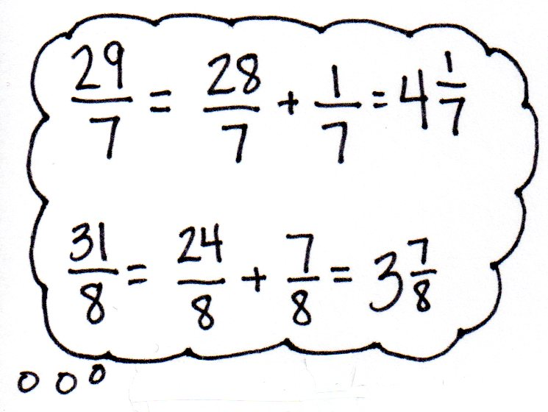
S: No, the denominators are different. They are not mixed numbers. Mixed numbers would be easier to compare.
T: To compare them, let’s rewrite $\frac{\text{29}}{\text{7}}$ and $\frac{\text{31}}{\text{8}}$ as mixed numbers.
S: 4 copies of 7 sevenths is $\frac{\text{28}}{\text{7}}$, so 29 sevenths must be $\text{4}\frac{\text{1}}{\text{7}}$.
$\frac{\text{28}}{\text{7}}\text{+}\frac{\text{1}}{\text{7}}\text{=} \text{4}\frac{\text{1}}{\text{7}}\text{.}$
S: 3 copies of 8 eighths is $\frac{\text{24}}{\text{8}}\text{,}$ so 31 eighths must be $\text{3}\frac{\text{7}}{\text{8}}$.
$\frac{\text{24}}{\text{8}}\text{+}\frac{\text{7}}{\text{8}}\text{=} \text{3}\frac{\text{7}}{\text{8}}$.
T: Compare $\text{4}\frac{\text{1}}{\text{7}}$ and $\text{3}\frac{\text{7}}{\text{8}}$ using the words a little bit more and a little bit less.
S: $\text{4}\frac{\text{1}}{\text{7}}$is a little bit more than 4. $\text{3}\frac{\text{7}}{\text{8}}$is a little bit less than 4.
T: Write a comparison statement for $\frac{\text{29}}{\text{7}}$ and $\frac{\text{31}}{\text{8}}$.
S: $\frac{\text{29}}{\text{7}}$ > $\frac{\text{31}}{\text{8}}$.
T: Write $\text{5}\frac{\text{7}}{\text{8}}\text{and 5}\frac{\text{9}}{\text{10}}$. Name the whole numbers these are between.
S: 5 and 6.
MP.7
T: They both have 5 ones. Since the ones are the same, we look to the fractional units to compare. Compare $\frac{\text{7}}{\text{8}}$ and $\frac{\text{9}}{\text{10}}\text{.}$
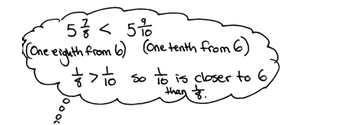
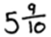
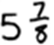
S: $\frac{\text{7}}{\text{8}}$ is 1 eighth away from 6. $\frac{\text{9}}{\text{10}}$ is 1 tenth away from 6.
$\frac{\text{1}}{\text{10}}$ is less than $\frac{\text{1}}{\text{8}}\text{,}$which means that $\text{5}\frac{\text{9}}{\text{10}}$ will be closer to 6 than $\text{5}\frac{\text{7}}{\text{8}}\text{.}$ $\text{5}\frac{\text{7}}{\text{8} }\text{<} \text{5}\frac{\text{9}}{\text{10}}\text{.}$
MP.7
T: Compare $\frac{\text{43}}{\text{8}}$and $\frac{\text{35}}{\text{6}}\text{.}$
S: $\frac{\text{43}}{\text{8}}\text{=} \text{5}\frac{\text{3}}{\text{8}}\text{.}$ $\frac{\text{35}}{\text{6}}\text{=} \text{5}\frac{\text{5}}{\text{6}}\text{.}$ Now, we can compare $\frac{\text{3}}{\text{8}}\text{and}\frac{\text{5}}{\text{6}}$ because both mixed numbers have the same number of ones. $\frac{\text{3}}{\text{8}}$< $\frac{\text{1}}{\text{2}}$ and $\frac{\text{5}}{\text{6}}$ > $\frac{\text{1}}{\text{2}}$. So, $\text{5}\frac{\text{3}}{\text{8}}\text{<} \text{5}\frac{\text{5}}{\text{6}}$, and that means $\frac{\text{43}}{\text{8}}\text{<}\frac{\text{35}}{\text{6}}$.
Problem Set (10 minutes)
Students should do their personal best to complete the Problem Set within the allotted 10 minutes. For some classes, it may be appropriate to modify the assignment by specifying which problems they work on first. Some problems do not specify a method for solving. Students should solve these problems using the RDW approach used for Application Problems.
Student Debrief (10 minutes)
Lesson Objective: Compare fractions greater than 1 by reasoning using benchmark fractions.
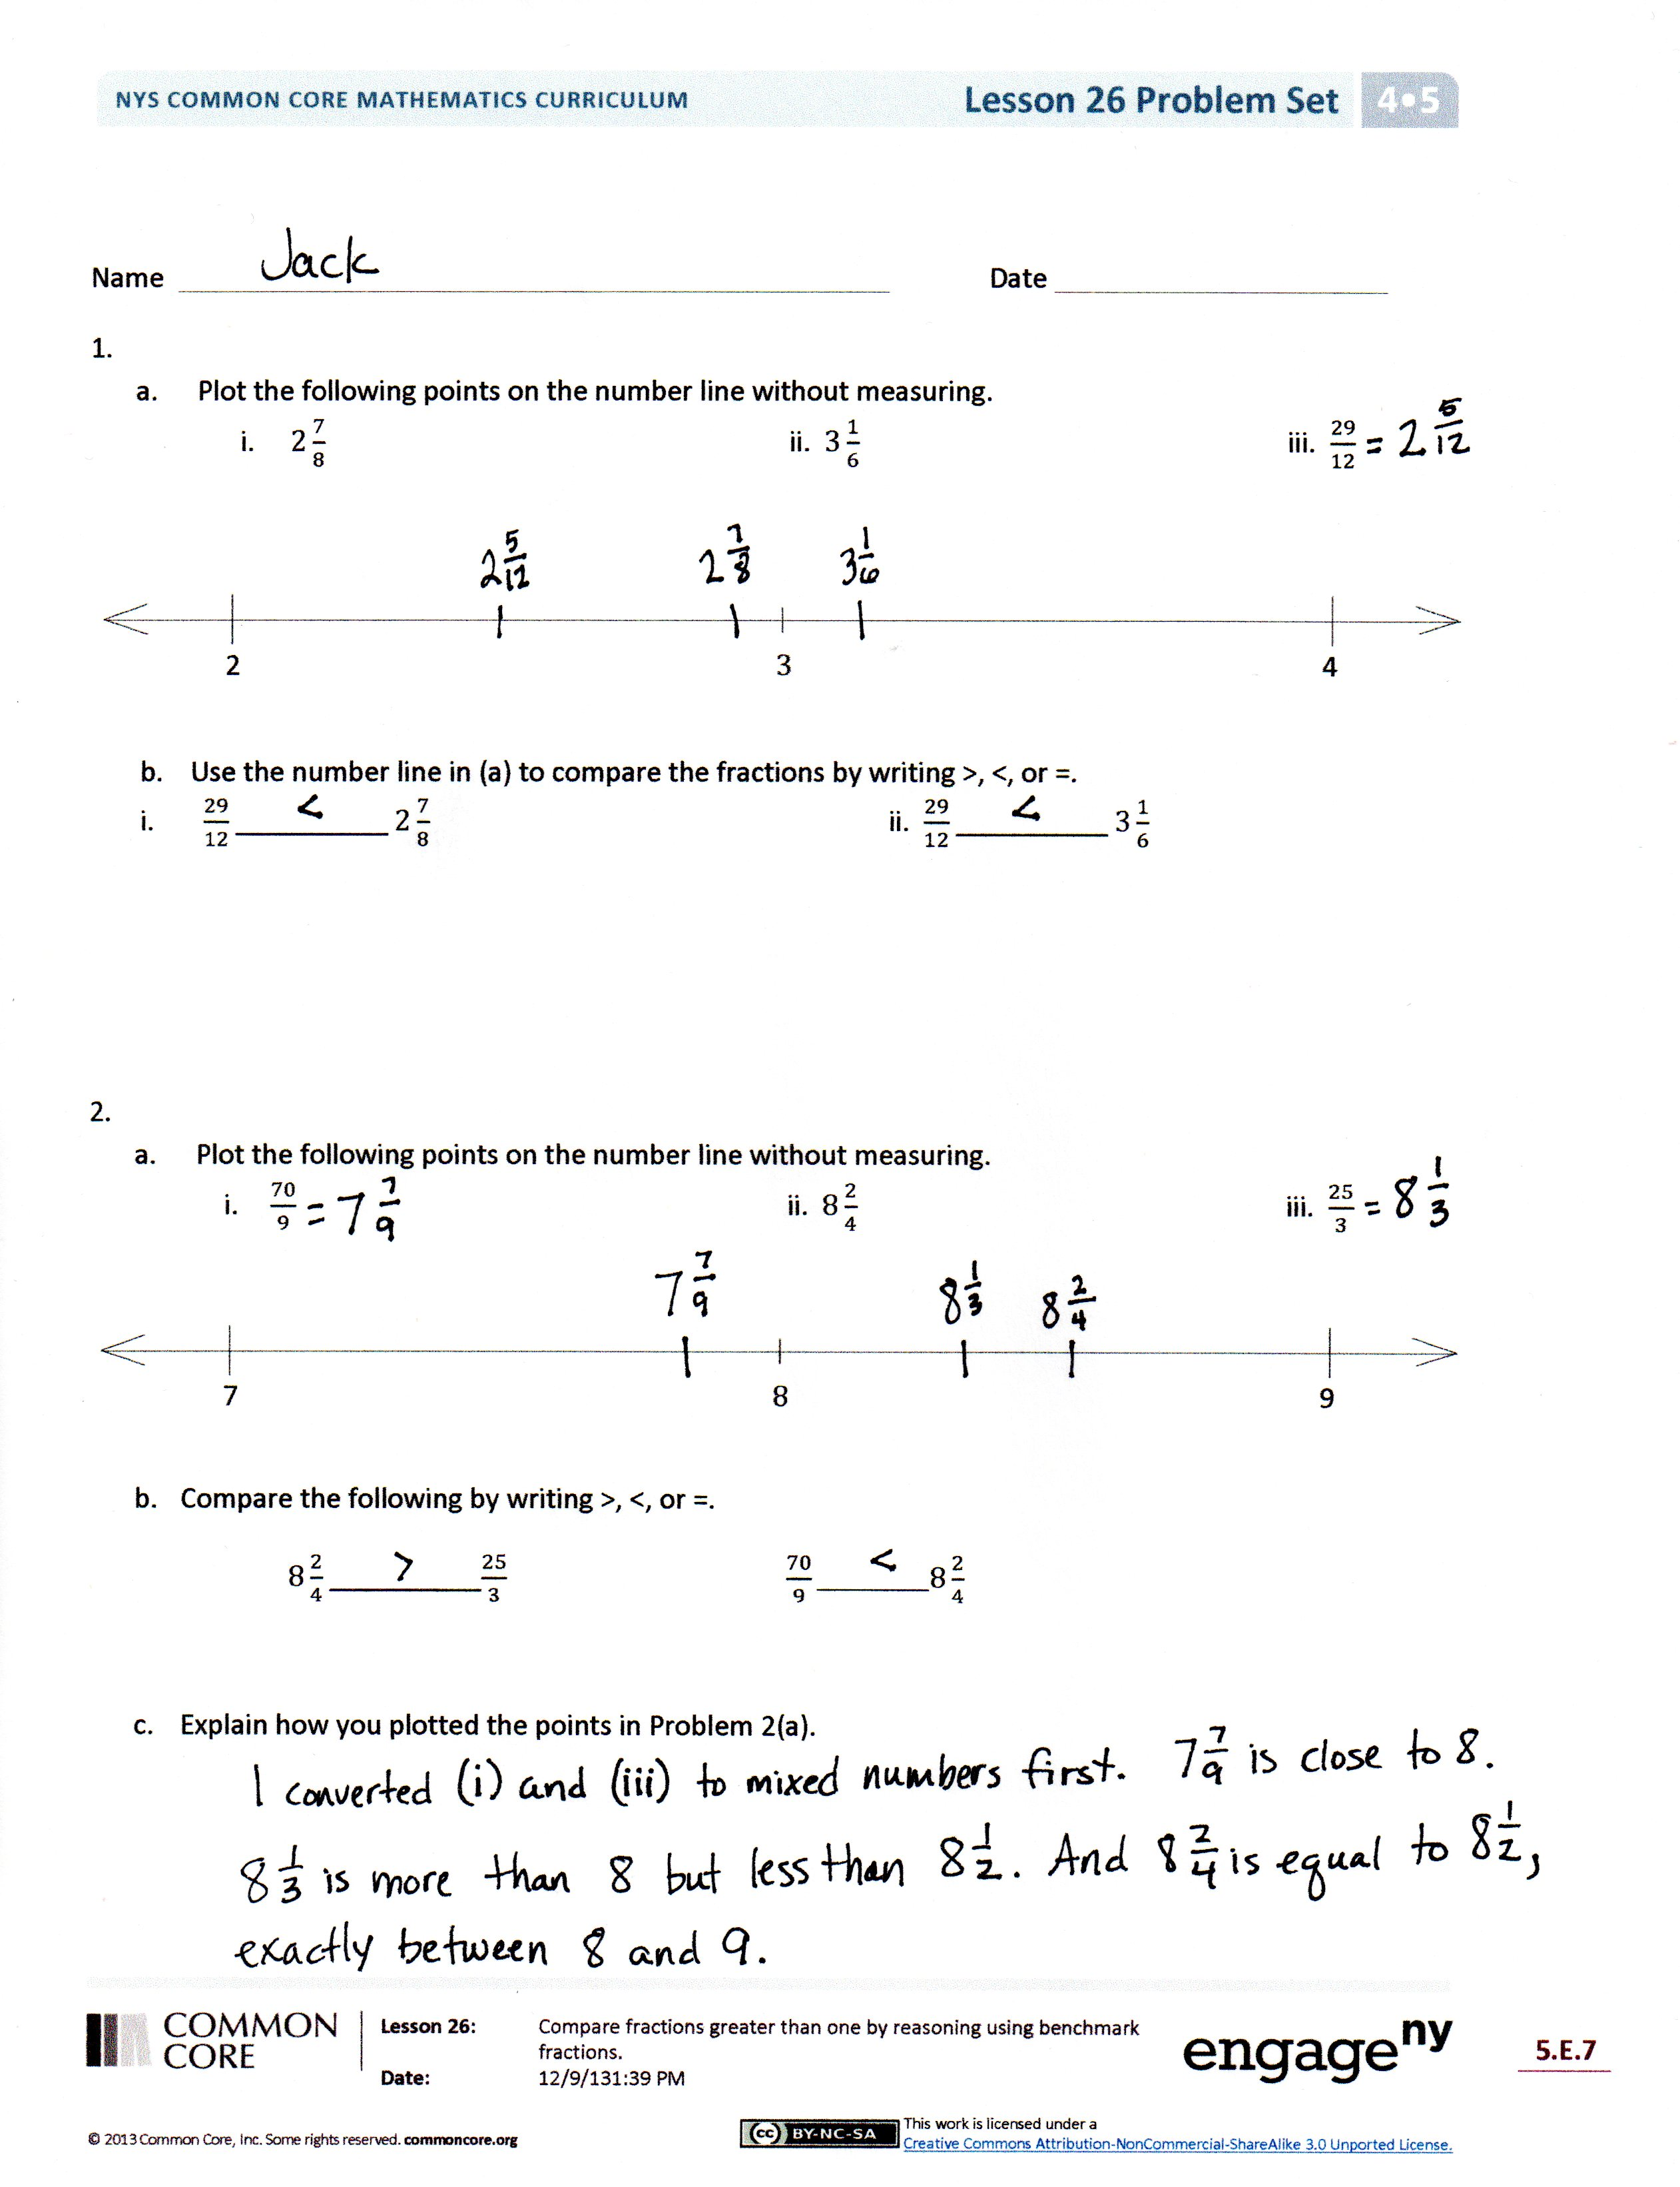
The Student Debrief is intended to invite reflection and active processing of the total lesson experience.
Invite students to review their solutions for the Problem Set. They should check work by comparing answers with a partner before going over answers as a class. Look for misconceptions or misunderstandings that can be addressed in the Debrief. Guide students in a conversation to debrief the Problem Set and process the lesson.
Any combination of the questions below may be used to lead the discussion.
- When comparing the mixed numbers and fractions on the Problem Set, which strategies did you use? Were some strategies easier than others? Was it helpful to think about benchmark fractions?
- Why is it often easier to compare mixed numbers than to compare fractions greater than 1?
- How does this lesson relate to earlier lessons? How did earlier lessons help you to understand this lesson?
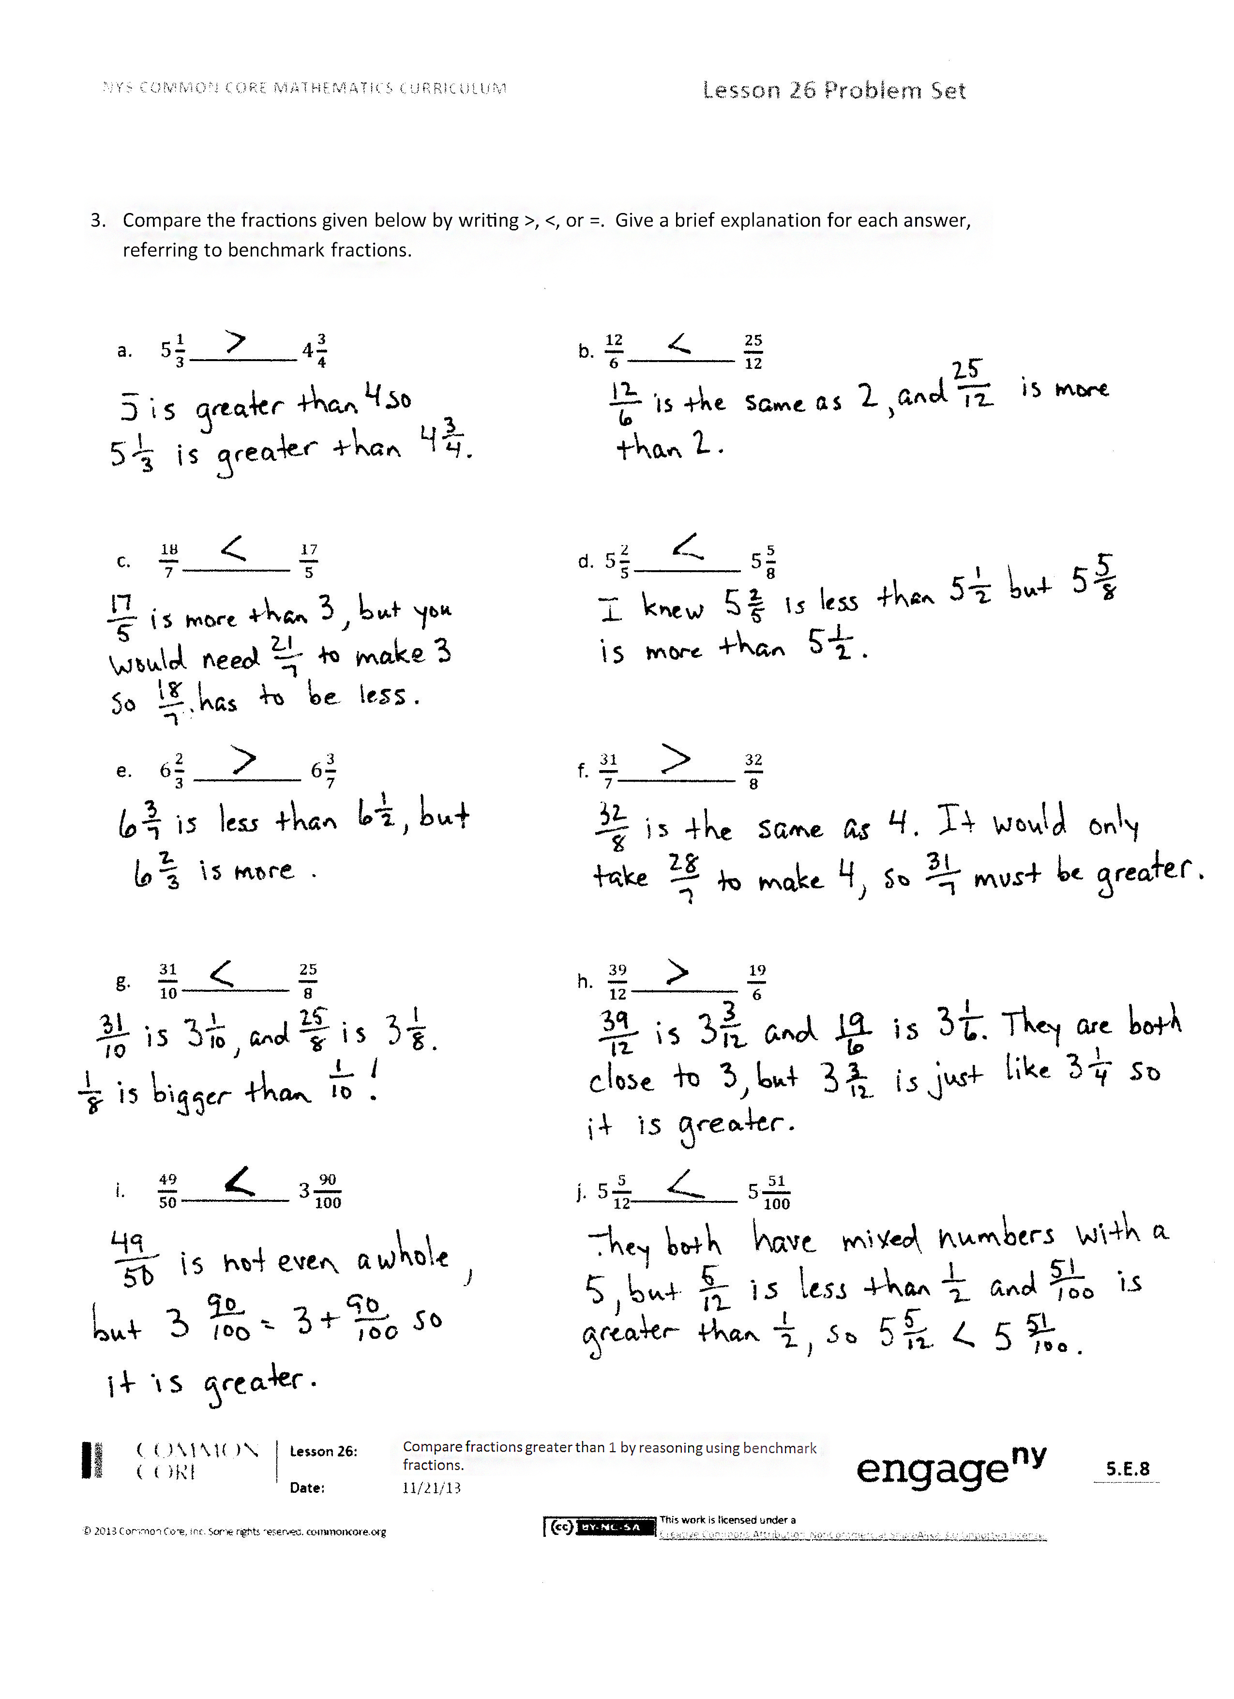
- In what way is Problem 3(a) easier than 3(b)?
- At first glance, Problem 3(j) looks really difficult. What makes it easier to solve?
- How did the Application Problem connect to today’s lesson?
Exit Ticket (3 minutes)
After the Student Debrief, instruct students to complete the Exit Ticket. A review of their work will help with assessing students’ understanding of the concepts that were presented in today’s lesson and planning more effectively for future lessons. The questions may be read aloud to the students.
Name Date

  - Plot the following points on the number line without measuring.
- $2\frac{7}{8}$ ii. $3\frac{1}{6}$ iii. $\frac{29}{12}$
2 $3$ 4

- Use the number line in Problem 1(a) to compare the fractions by writing >, ˂, or =.
- $\frac{29}{12}$__________ $2\frac{7}{8}$ ii. $\frac{29}{12}$__________ $3\frac{1}{6}$

  - Plot the following points on the number line without measuring.
    - $\frac{70}{9}$ ii. $8\frac{2}{4}$ iii. $\frac{25}{3}$
7 $8$ 9

- Compare the following by writing >, ˂, or =.
i. $8\frac{2}{4}$ __________$\frac{25}{3}$ ii. $\frac{70}{9}__________8\frac{2}{4}$

- Explain how you plotted the points in Problem 2(a).

- Compare the fractions given below by writing >, ˂, or =. Give a brief explanation for each answer, referring to benchmark fractions.
  - $5\frac{1}{3}$__________ $4\frac{3}{4}$ b. $\frac{12}{6}$__________ $\frac{25}{12}$

c. $\frac{18}{7}$__________ $\frac{17}{5}$ d. $5\frac{2}{5}$__________ $5\frac{5}{8}$

- $6\frac{2}{3}$__________ $6\frac{3}{7}$ f. $\frac{31}{7}$___________ $\frac{32}{8}$

- $\frac{31}{10}$__________ $\frac{25}{8}$ h. $\frac{39}{12}$__________ $\frac{19}{6}$

- $\frac{49}{50}$__________ $3\frac{90}{100}$ j. $5\frac{5}{12}$__________ $5\frac{51}{100}$

Name Date
Compare the fractions given below by writing >, ˂, or =.
Give a brief explanation for each answer, referring to benchmark fractions.

        - $3\frac{2}{3}$__________ $3\frac{4}{6}$

        - $\frac{12}{3}$__________ $\frac{27}{7}$

3. $\frac{10}{6}$__________ $\frac{5}{4}$

4. $3\frac{2}{5}$__________ $3\frac{3}{10}$

Name Date

- Plot the following points on the number line without measuring.
    - $2\frac{1}{6}$ ii. $3\frac{3}{4}$ iii. $\frac{33}{9}$
2 $3$ 4

- Use the number line in Problem 1(a) to compare the fractions by writing >, ˂, or =.
    - $\frac{33}{9}$__________ $2\frac{1}{6}$ ii. $\frac{33}{9}$__________ $3\frac{3}{4}$

  - Plot the following points on the number line without measuring.
    - $\frac{65}{8}$ ii. $8\frac{5}{6}$ iii. $\frac{29}{4}$
7 $8$ 9

- Compare the following by writing >, ˂, or =.
i. $8\frac{5}{6}$ __________$\frac{65}{8}$ ii. $\frac{29}{4}__________\frac{65}{8}$

- Explain how you plotted the points in Problem 2(a).

            - Compare the fractions given below by writing >, ˂, or =. Give a brief explanation for each answer, referring to benchmark fractions.
  - $5\frac{1}{3}$__________ $5\frac{3}{4}$ b. $\frac{12}{4}$__________ $\frac{25}{8}$

- $\frac{18}{6}$__________ $\frac{17}{4}$ d. $5\frac{3}{5}$__________ $5\frac{5}{10}$

- $6\frac{3}{4}$__________ $6\frac{3}{5}$ f. $\frac{33}{6}$__________ $\frac{34}{7}$

- $\frac{23}{10}$__________ $\frac{20}{8}$ h. $\frac{27}{12}$__________ $\frac{15}{6}$

- $2\frac{49}{50}$__________ $2\frac{99}{100}$ j. $6\frac{5}{9}$ __________ $6\frac{49}{100}$

