Lesson 25
Objective: Decompose and compose fractions greater than 1 to express them in various forms.

Suggested Lesson Structure
 Fluency Practice (12 minutes)
 Application Problem (6 minutes)
 Concept Development (32 minutes)
 Student Debrief (10 minutes)
Total Time (60 minutes)
Fluency Practice (12 minutes)
- How Many Ones? 4.NF.1 (3 minutes)
- Add and Subtract Fractions 4.NF.3 (4 minutes)
- Change Fractions to Mixed Numbers 4.NF.4 (5 minutes)
How Many Ones? (3 minutes)
Materials: (S) Personal white board
Note: This fluency activity prepares students for Lesson 25.
T: I’ll say a fraction; you will say the number of ones it is equal to. 2 halves.
S: 1 one.
T: 4 halves.
S: 2 ones.
T: 6 halves.
S: 3 ones.
T: (Write $\frac{\text{10}}{\text{2}}$ = .) On your personal white boards, write the answer.
S: (Write $\frac{\text{10}}{\text{2}}$ = 5.)
Continue with the following possible sequence: $\frac{\text{10}}{\text{10}}$, $\frac{\text{20}}{\text{10}}$, $\frac{\text{30}}{\text{10}}$, $\frac{\text{60}}{\text{10}}$, $\frac{\text{3}}{\text{3}}$, $\frac{\text{6}}{\text{3}}$, $\frac{\text{9}}{\text{3}}$, $\frac{\text{15}}{\text{3}}$, $\frac{\text{4}}{\text{4}}$, $\frac{\text{8}}{\text{4}}$, $\frac{\text{16}}{\text{4}}$, $\frac{\text{12}}{\text{12}}$, $\frac{\text{24}}{\text{12}}$, $\frac{\text{36}}{\text{12}}$, and $\frac{\text{120}}{\text{12}}$.

Add and Subtract Fractions (4 minutes)
Materials: (S) Personal white board
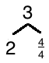
Note: This fluency activity reviews Lesson 22.
T: (Draw a number bond with a whole of 3. Write 2 as the known part and $\frac{}{\text{4}}$ as the unknown part.) How many fourths are in 1?
S: 4 fourths.
T: (Write $\frac{\text{4}}{\text{4}}$ as the unknown part. Beneath it, write 3 – $\frac{\text{1}}{\text{4}}$ = 2 + $\frac{}{\text{4}}$.) Write the number sentence.
3 – $\frac{1}{4}$ = $\text{2} \text{+}\frac{\text{3}}{\text{4}}$
2 $\frac{3}{4}$ + $\frac{}{4}$ = $3$
S: (Write 3 – $\frac{\text{1}}{\text{4}}$ = 2 + $\frac{\text{3}}{\text{4}}$ = $\text{2}\frac{\text{3}}{\text{4}}$.)
Continue with the following possible sequence: 5 – $\frac{\text{5}}{\text{6}}$, 7 – $\frac{\text{2}}{\text{5}}$ , and 5 – $\frac{\text{3}}{\text{8}}$.
T: How much does 3 fourths need in order to equal 1?
S: 1 fourth.
2 $\frac{3}{4}$ + = $3$
T: (Write 2$\frac{\text{3}}{\text{4}}$ + __ = 3.) Write the number sentence, filling in the unknown number.
S: (Write 2$\frac{\text{3}}{\text{4}}$ + $\frac{\text{1}}{\text{4}}$ = 3.)
Continue with the following possible sequence: $\text{4}\frac{\text{1}}{\text{6}}$ + __ = 5, $\text{6}\frac{\text{3}}{\text{5}}$ + __ = 7, and $\text{4}\frac{\text{5}}{\text{8}}$ + __ = 5.
Change Fractions to Mixed Numbers (5 minutes)
Materials: (S) Personal white board
Note: This fluency activity reviews Lesson 24.
T: Draw a number line with endpoints 0 and 3.
T: (Write $\frac{\text{9}}{\text{4}}$.) Say the fraction.
S: 9 fourths.
T: Decompose each whole number into fourths by marking each fourth with a dot. Label $\frac{\text{9}}{\text{4}}$.
T: How many fourths are in 1?
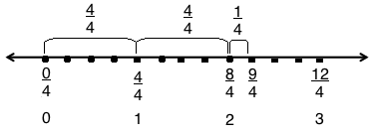
S: 4 fourths.
T: 2?
S: 8 fourths.
T: 3?
S: 12 fourths.
T: Label each whole number both as a fraction and whole number.
T: How many groups of 4 fourths are in 9 fourths?
S: Two groups.
T: (Write $\frac{\text{9}}{\text{4}}$ = 2 × $\frac{\text{4}}{\text{4}}$ + $\frac{\text{1}}{\text{4}}$ = 2 + $\frac{}{\text{4}}$.) Fill in the unknown numerator and write $\frac{\text{9}}{\text{4}}$ as a mixed number.
S: (Write $\frac{\text{9}}{\text{4}}$ = $\frac{\text{8}}{\text{4}}$ + $\frac{\text{1}}{\text{4}}$ = 2 + $\frac{\text{1}}{\text{4}}$ = $\text{2}\frac{\text{1}}{\text{4}}$.)
T: (Write $\frac{\text{9}}{\text{4}}$ = $\frac{\text{ × 4}}{\text{4}}$ + $\frac{\text{1}}{\text{4}}$ = 2 + $\frac{\text{1}}{\text{4}}$ = $\text{2}\frac{\text{1}}{\text{4}}$.) Fill in the numerator’s unknown factor to make the number sentence true.
S: Write$\frac{\text{9}}{\text{4}}$ = $\frac{\text{ 2 × 4}}{\text{4}}$ + $\frac{\text{1}}{\text{4}}$ = 2 + $\frac{\text{1}}{\text{4}}$ = $\text{2}\frac{\text{1}}{\text{4}}$.)
Continue the process for the following possible sequence: $\frac{\text{16}}{\text{5}}$ and $\frac{\text{15}}{\text{4}}$.
Application Problem (6 minutes)
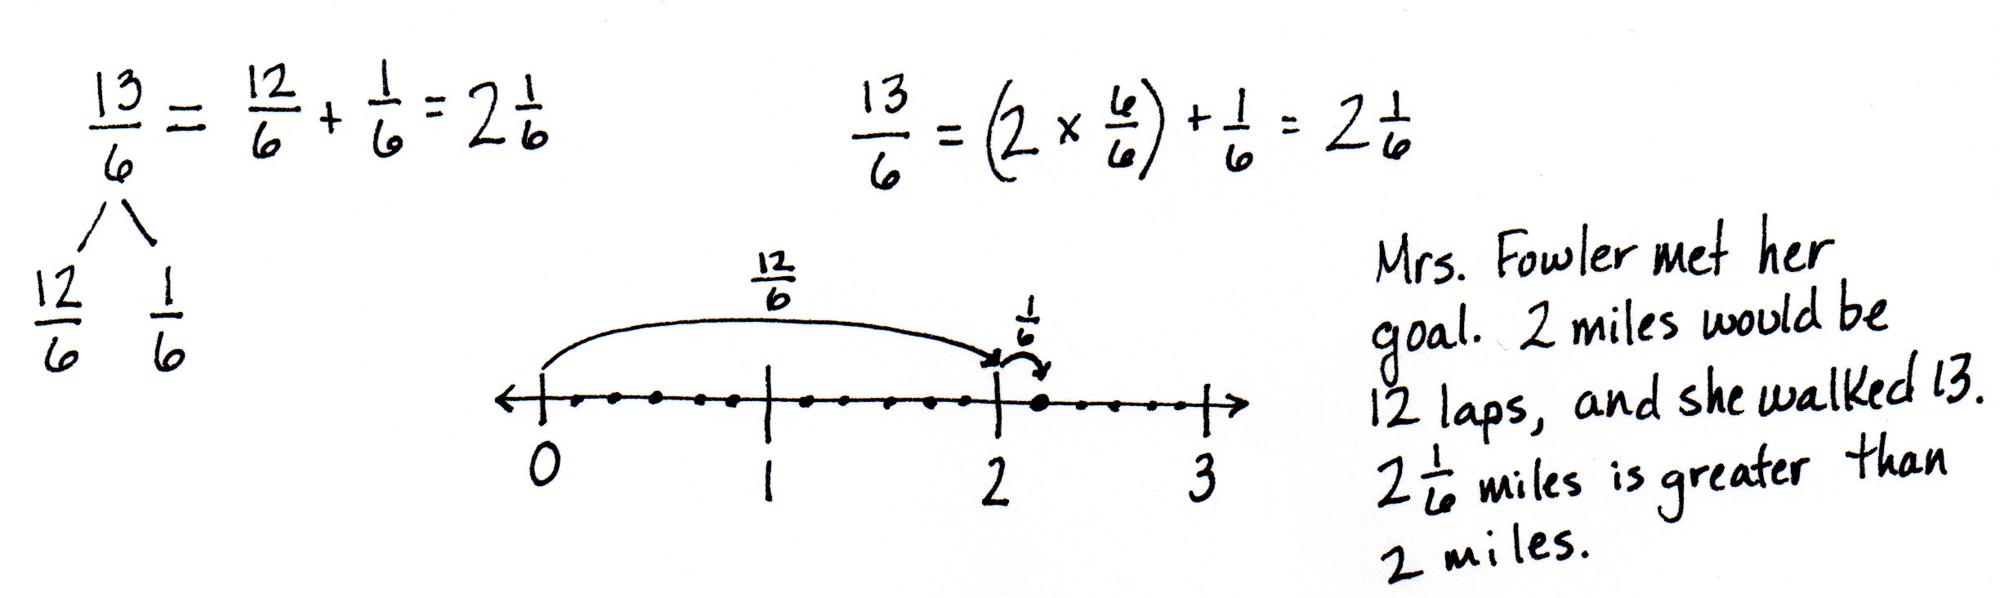
Mrs. Fowler knew that the perimeter of the soccer field was $\frac{\text{1}}{\text{6}}$ mile. Her goal was to walk two miles while watching her daughter’s game. If she walked around the field 13 times, did she meet her goal? Explain your thinking.

Note: This Application Problem builds on Lesson 24 where students learned to convert a fraction to a mixed number. Knowing how to make this conversion leads to today’s lesson in which students will use what they know about mixed numbers to convert to a fraction greater than 1.
Concept Development (32 minutes)
Materials: (S) Personal white board
Problem 1: Model with a number line to convert a mixed number into a fraction greater than 1.
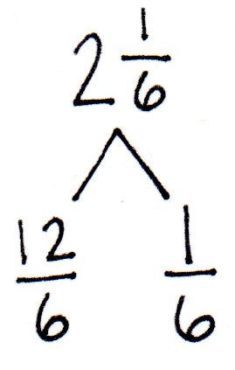
T: (Display $\text{2}\frac{\text{1}}{\text{6}}.$) Use a number bond to decompose $\text{2}\frac{\text{1}}{\text{6}}$ into ones and sixths. How many sixths are in 2 ones?
MP.2
S: 12 sixths.
T: $\frac{\text{12}}{\text{6}}$ + $\frac{\text{1}}{\text{6}}$ equals…?
S: $\frac{\text{13}}{\text{6}}$.
T: To check our work, let’s draw a number line with 0 and 3 as endpoints. Use dots to decompose each whole number into sixths. Locate $\text{2}\frac{\text{1}}{\text{6}}.$
T: Point to zero. Slide your finger to 1. How many sixths are there from 0 to 1?
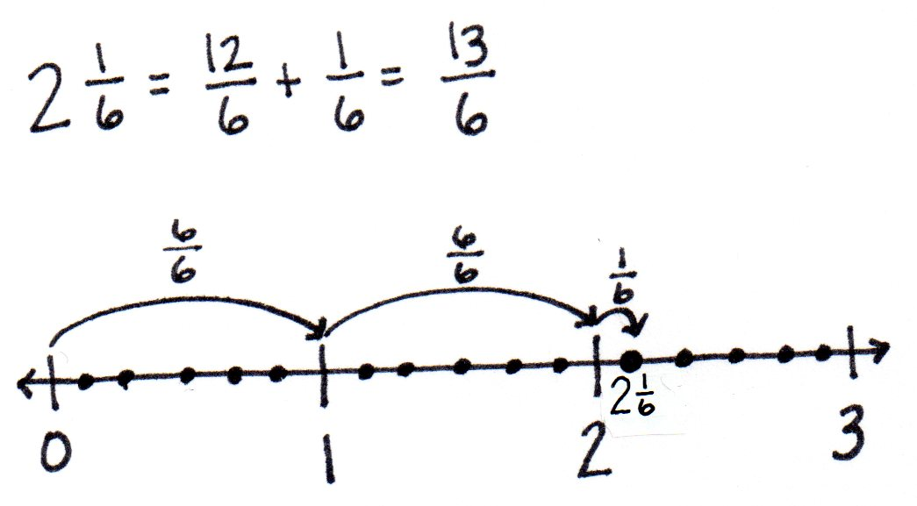
S: 6 sixths. (Record $\frac{\text{6}}{\text{6}}$ above the arrow from 0 to 1.)
T: Slide your finger from 1 to 2. How many sixths are there from 1 to 2?
S: 6 sixths. (Record $\frac{\text{6}}{\text{6}}$ above the arrow from 1 to 2.)
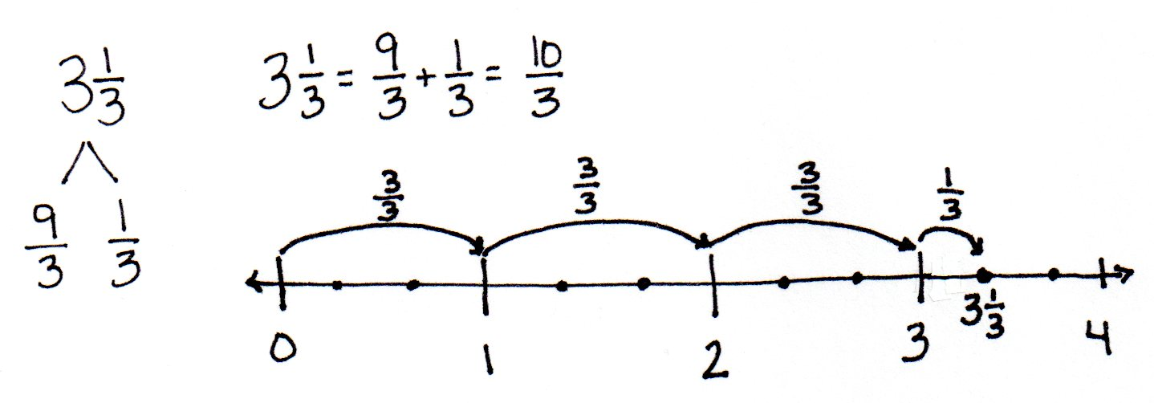
T: Slide your finger to $\text{2}\frac{\text{1}}{\text{6}}$. Say an addition sentence representing our movements. (Slide your finger as students say the sentence.)
MP.2
S: $\frac{\text{6}}{\text{6}}$ + $\frac{\text{6}}{\text{6}}$ + $\frac{\text{1}}{\text{6}}$ = $\frac{\text{13}}{\text{6}}$.
T: $\text{2}\frac{\text{1}}{\text{6}}$ is equal to…?
S: $\frac{\text{13}}{\text{6}}.$
T: Notice, in the Application Problem, you converted a fraction greater than 1, $\frac{\text{13}}{\text{6}}$, to a mixed number, $2\frac{1}{6}.$ Now, you’ve converted a mixed number to a fraction greater than 1.

NOTES ON
MULTIPLE MEANS
OF ACTION AND EXPRESSION:
When explaining multiples of $\frac{\text{4}}{\text{4}}$ to English language learners, check for understanding. Explain in students’ first language, if needed, and couple your language with visual aids, such as the following:
1 = $\frac{\text{4}}{\text{4}}$
2 = 2 × $\frac{\text{4}}{\text{4}}$
3 = 3 × $\frac{\text{4}}{\text{4}}$

T: With your partner, convert $\text{3}\frac{\text{1}}{\text{3}}$ to a fraction greater than 1. Draw a number line to model your work.
Problem 2: Use multiplication to convert a mixed number to a fraction.
T: (Display $\text{4}\frac{\text{1}}{\text{4}}\text{.}$) Draw a number bond for $\text{4}\frac{\text{1}}{\text{4}}$, separating the ones and the fourths as two parts.
T: 1 one equals 4 fourths, so 2 ones equals 2 × (4 fourths). What is 4 ones equal to? Write your answer in unit form.
S: 4 ones = 4 × (4 fourths).
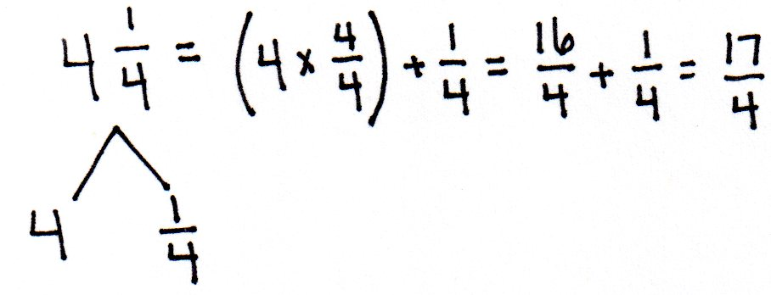
T: Write that expression numerically, and add the remaining 1 fourth. What is the total number of fourths?
S: $\text{4}\frac{\text{1}}{\text{4}}$ = 4 + $\frac{\text{1}}{\text{4}}$ = $\left(4×\frac{4}{4}\right)$+ $\frac{\text{1}}{\text{4}}$ = $\frac{\text{16}}{\text{4}}$ + $\frac{\text{1}}{\text{4}}$ = $\frac{\text{17}}{\text{4}}$.
T: With your partner, convert $\text{2}\frac{\text{2}}{\text{3}}$ into a fraction greater than 1 using multiplication.
S: $\text{2}\frac{\text{2}}{\text{3}}$ = $\left(2×\frac{3}{3}\right)$+ $\frac{\text{2}}{\text{3}}$ = $\frac{\text{6}}{\text{3}}$ + $\frac{\text{2}}{\text{3}}$ = $\frac{\text{8}}{\text{3}}$.
T: Compare your number sentence with mine. $\text{2}\frac{\text{2}}{\text{3}}$ = $\left(\frac{2 × 3}{3}\right)$+ $\frac{\text{2}}{\text{3}}$ = $\frac{\text{6}}{\text{3}}$ + $\frac{\text{2}}{\text{3}}$ = $\frac{\text{8}}{\text{3}}$.
S: Instead of showing $\left(2×\frac{3}{3}\right)$, it’s written as $\left(\frac{2 × 3}{3}\right)$. Both mean the same. They both equal $\frac{\text{6}}{\text{3}}$, and both are read as “two times 3 thirds.”
Repeat the process with $\text{5}\frac{\text{3}}{\text{4}}$.
Problem 3: Use mental math to convert a mixed number into a fraction greater than 1.
T: Write $\text{3}\frac{4}{5}.$ Create a picture in your head. How many ones and how many fifths?
S: 3 ones and 4 fifths.
T: How many fifths are there in 3 ones?
S: 1 = $\frac{\text{5}}{\text{5}}$ , 2 = $\frac{\text{10}}{\text{5}}$ , and 3 = $\frac{\text{15}}{\text{5}}\text{.}$ $\frac{\text{5}}{\text{5}}\text{,}\frac{\text{10}}{\text{5}}\text{,}\frac{\text{15}}{\text{5}}$.
T: Plus $\frac{\text{4}}{\text{5}}$ is…?
S: $\frac{\text{19}}{\text{5}}$.
Repeat the process with $\text{4}\frac{\text{2}}{\text{3}}.$
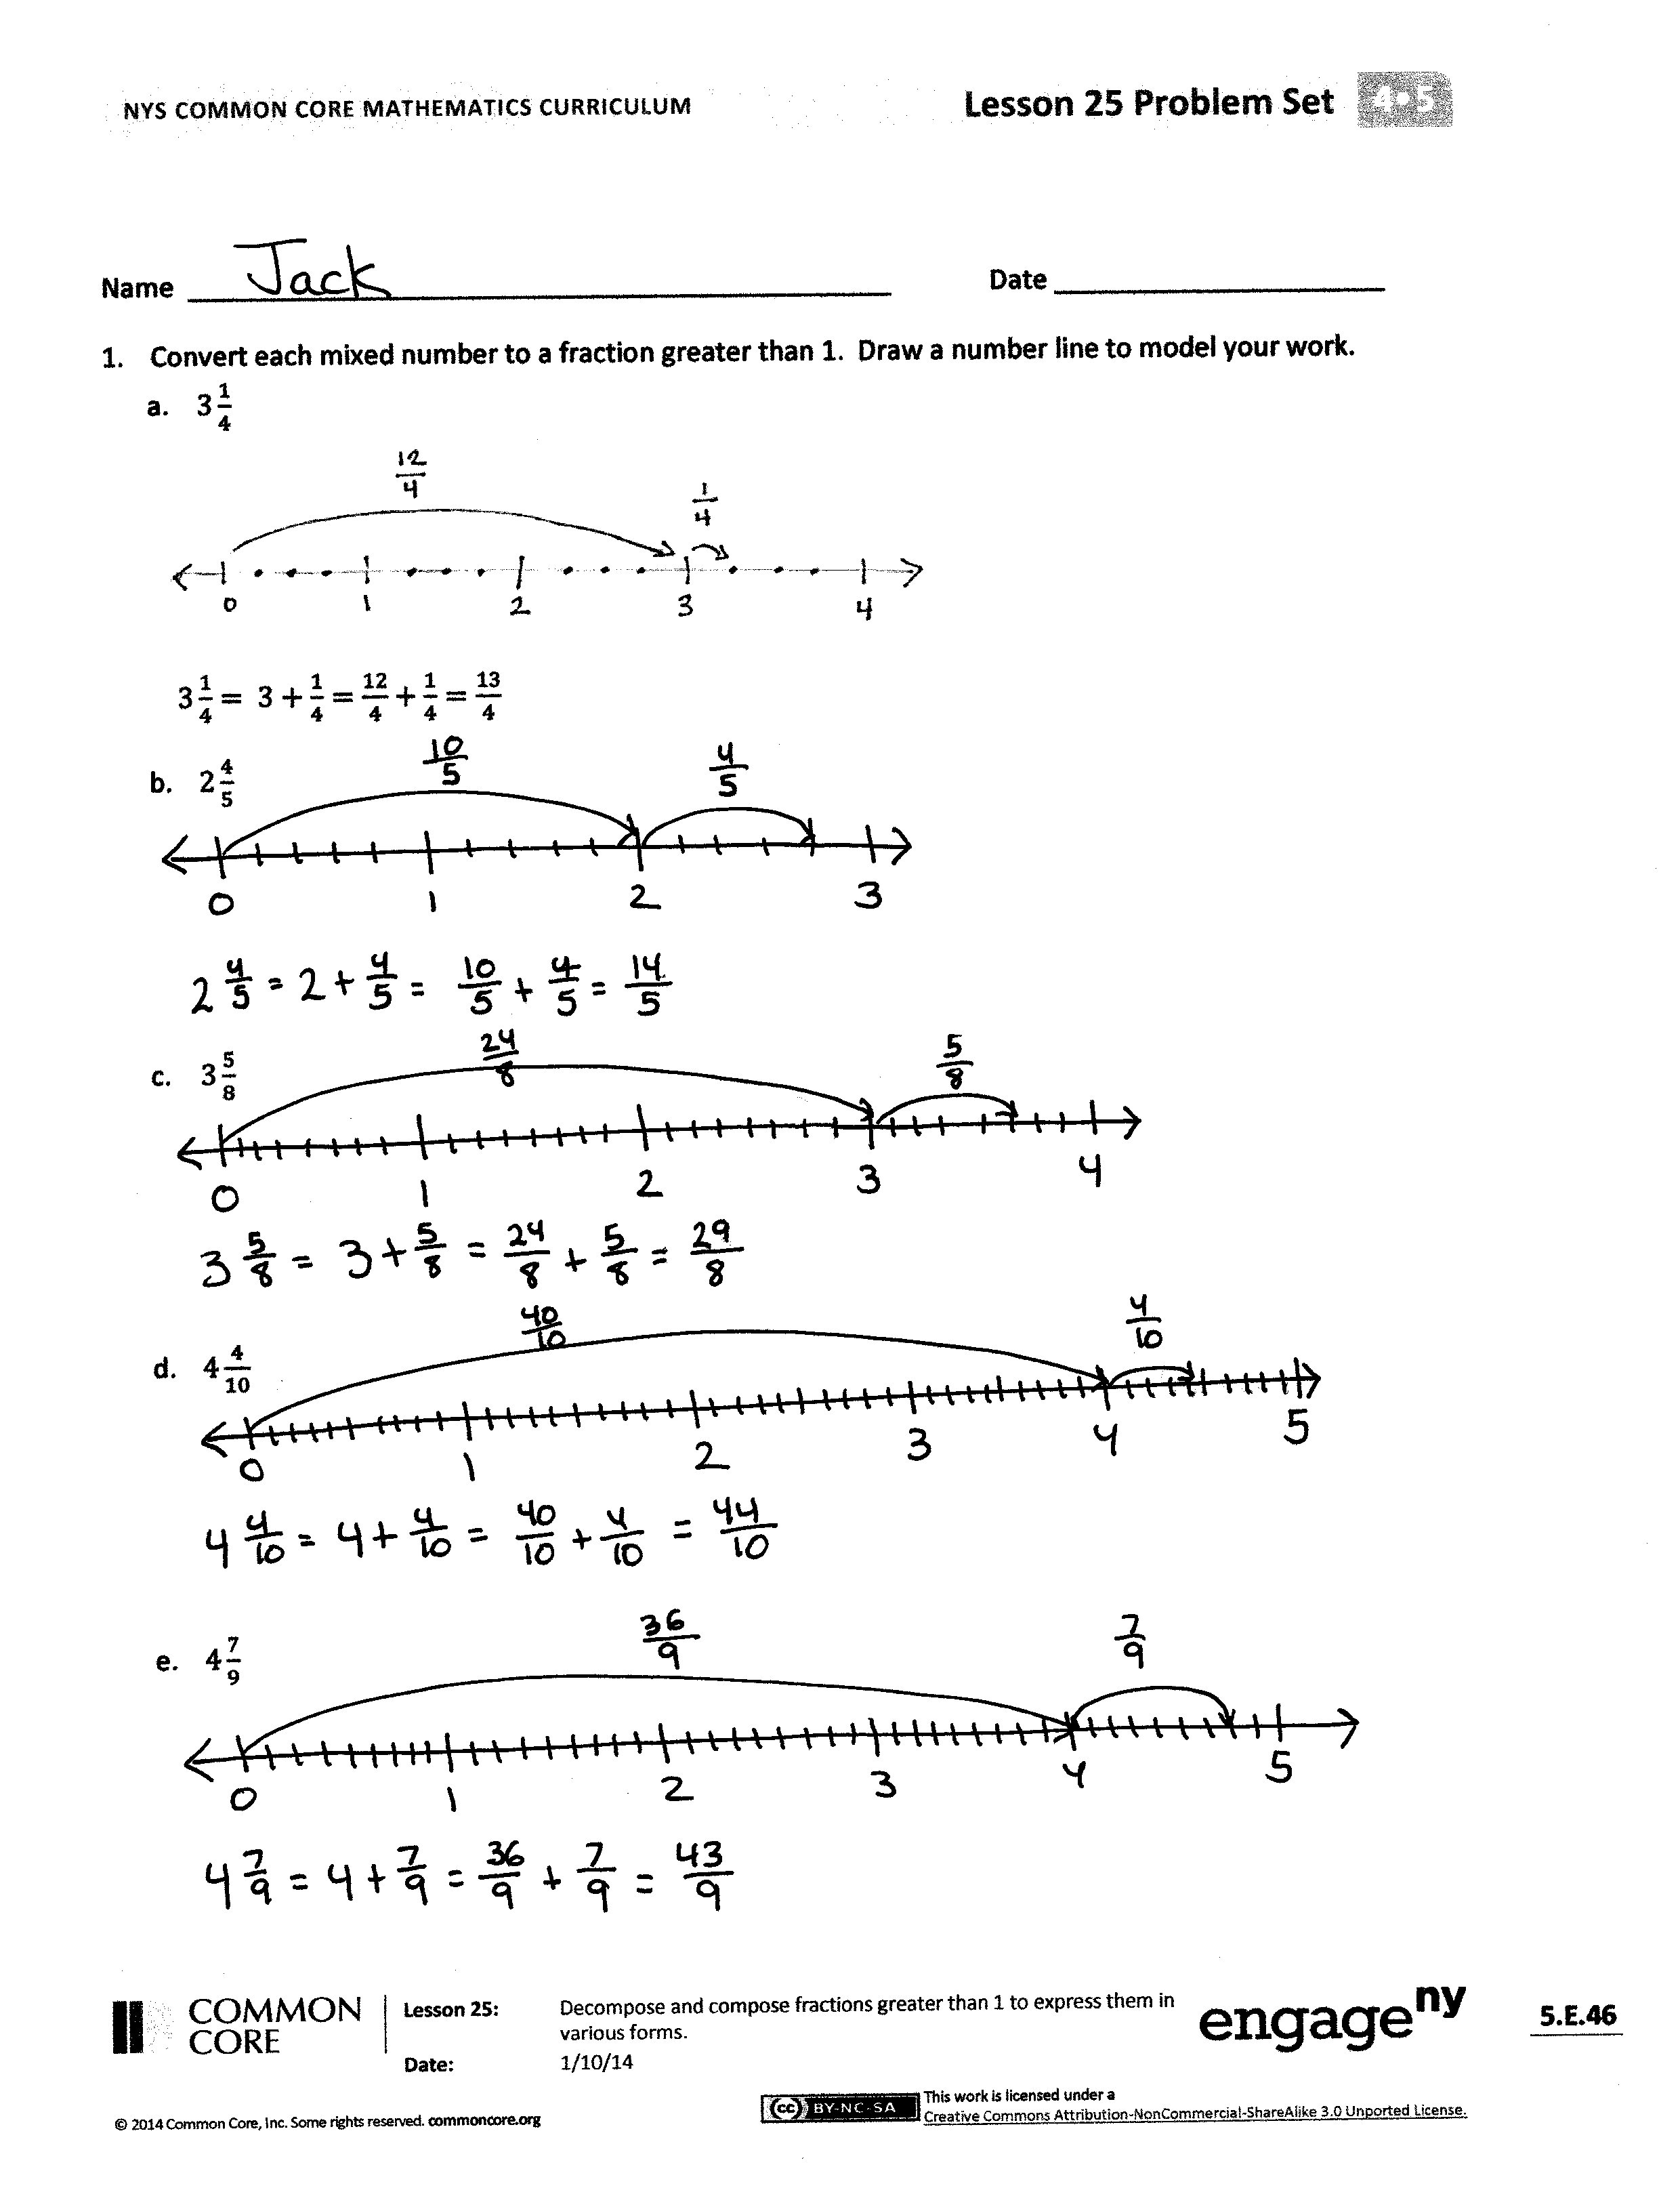
Problem Set (10 minutes)
Students should do their personal best to complete the Problem Set within the allotted 10 minutes. For some classes, it may be appropriate to modify the assignment by specifying which problems they work on first. Some problems do not specify a method for solving. Students should solve these problems using the RDW approach used for Application Problems.
Student Debrief (10 minutes)
Lesson Objective: Decompose and compose fractions greater than 1 to express them in various forms.
The Student Debrief is intended to invite reflection and active processing of the total lesson experience.
Invite students to review their solutions for the Problem Set. They should check work by comparing answers with a partner before going over answers as a class. Look for misconceptions or misunderstandings that can be addressed in the Debrief. Guide students in a conversation to debrief the Problem Set and process the lesson.
Any combination of the questions below may be used to lead the discussion.
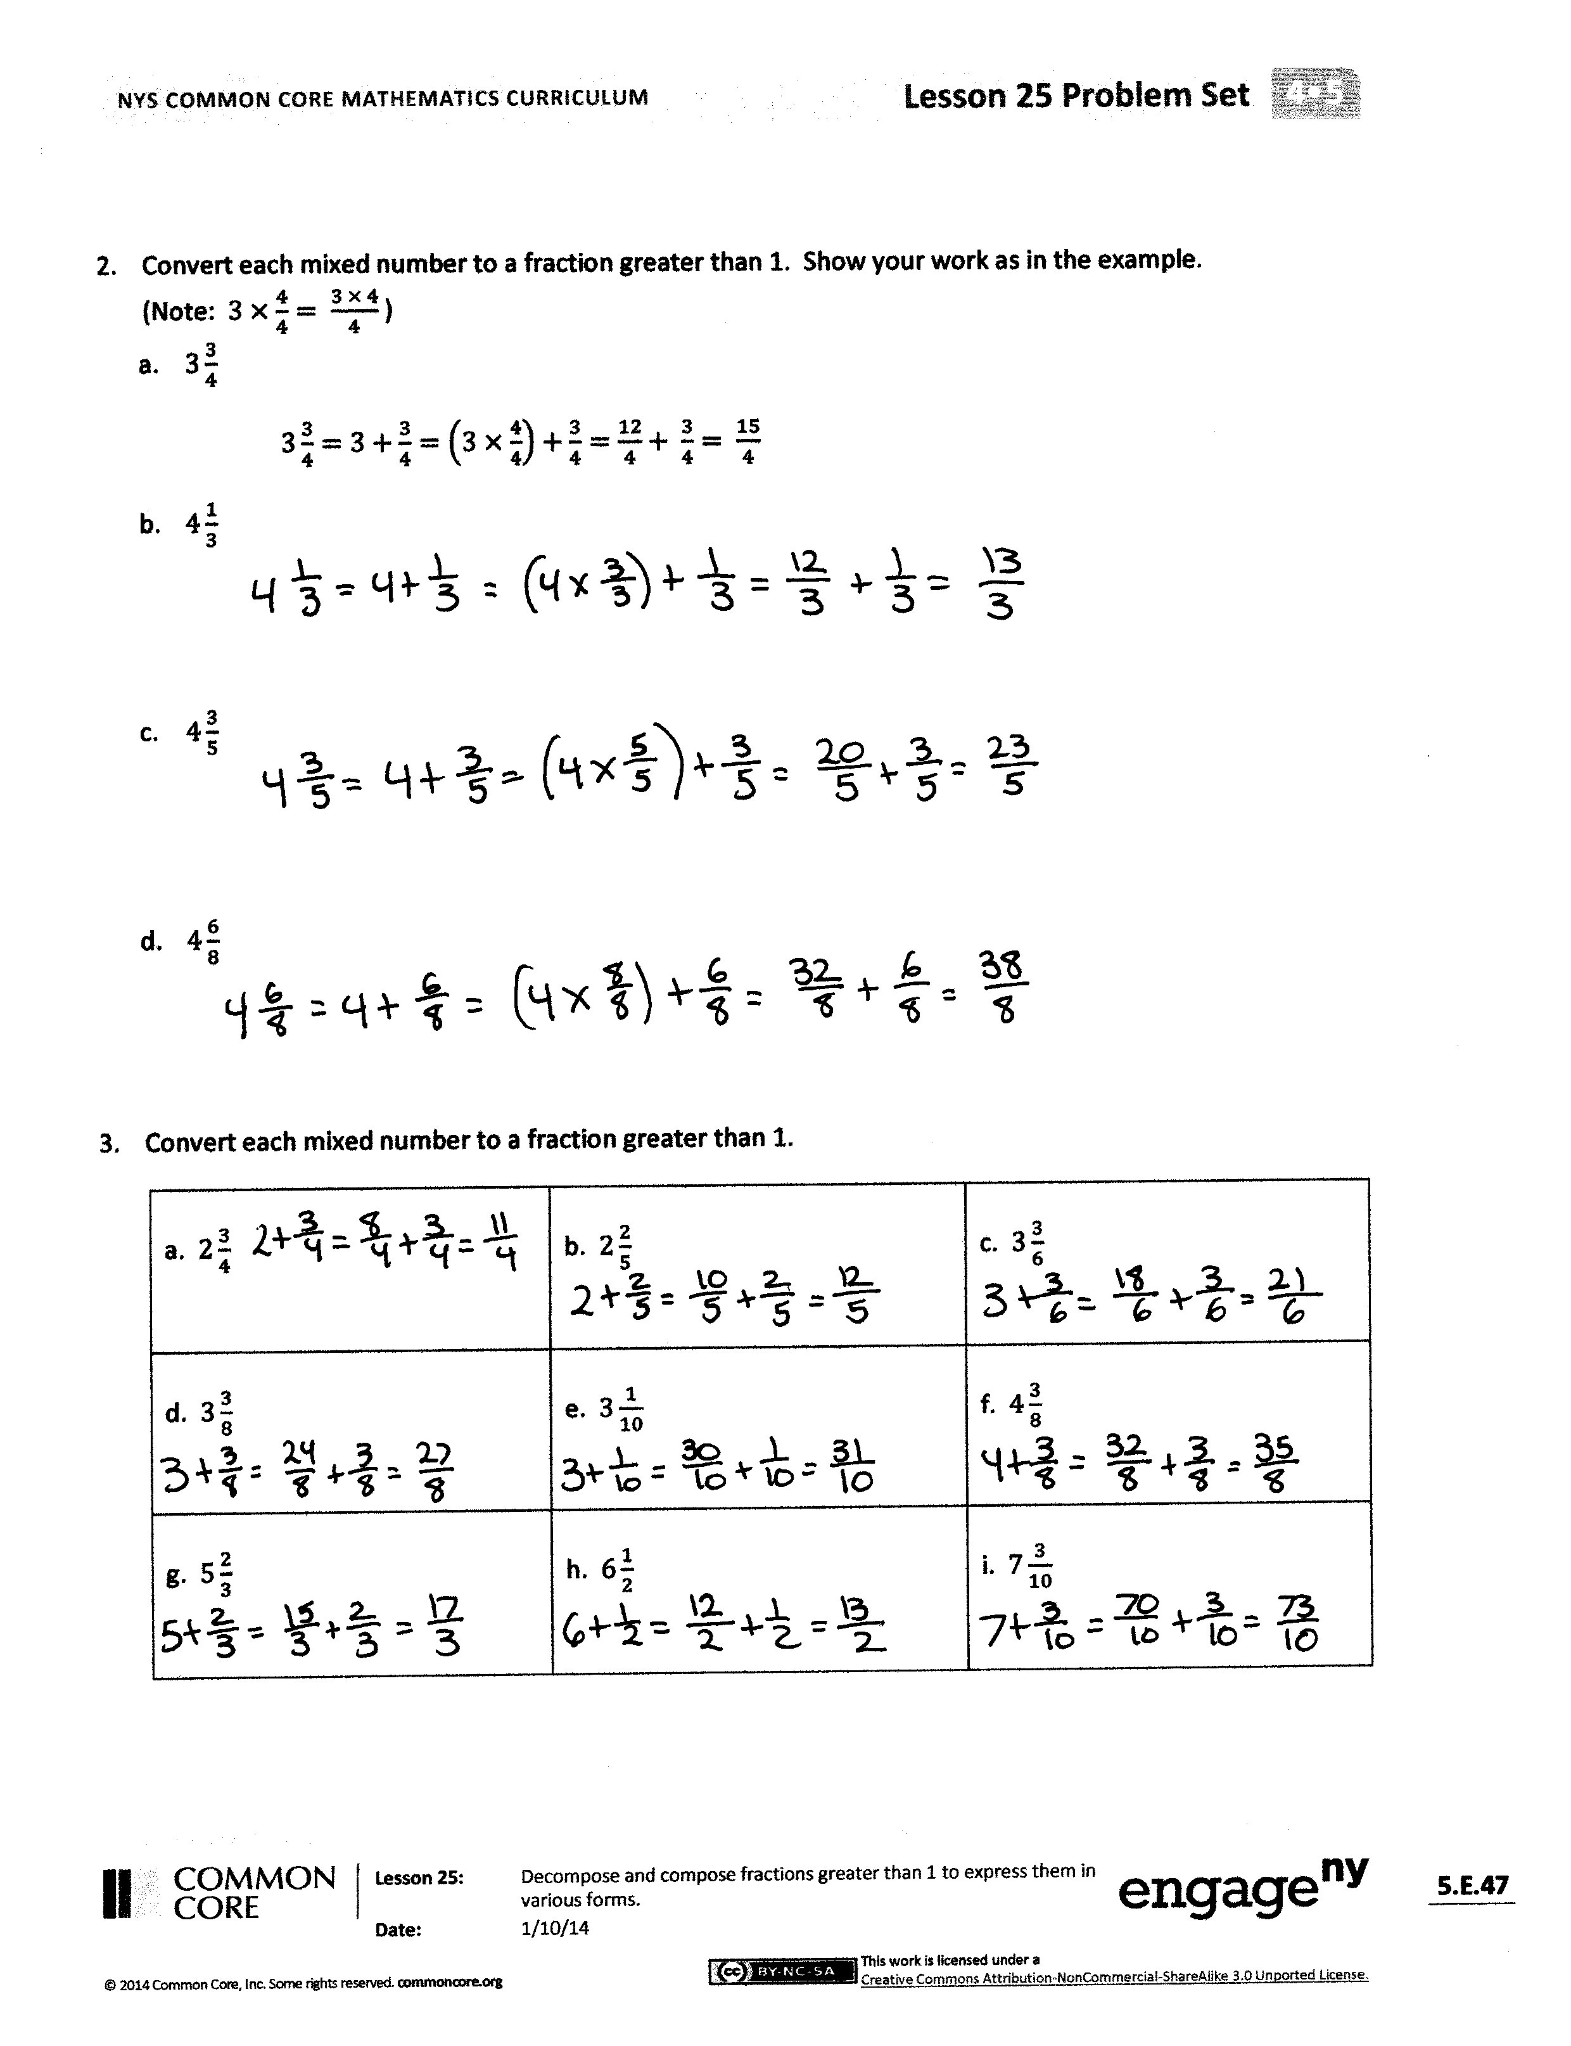
- Explain to your partner how you solved Problems 1(b), 2(b), and 3(b). Did you use the same strategies to solve or different strategies?
- How was the work from previous lessons helpful in converting from a mixed number to a fraction greater than 1?
- How does the number line help to show the conversion from a mixed number to a fraction greater than 1?
- How did the Application Problem connect to today’s lesson?
Exit Ticket (3 minutes)
After the Student Debrief, instruct students to complete the Exit Ticket. A review of their work will help with assessing students’ understanding of the concepts that were presented in today’s lesson and planning more effectively for future lessons. The questions may be read aloud to the students.

Name Date
- Convert each mixed number to a fraction greater than 1. Draw a number line to model your work.
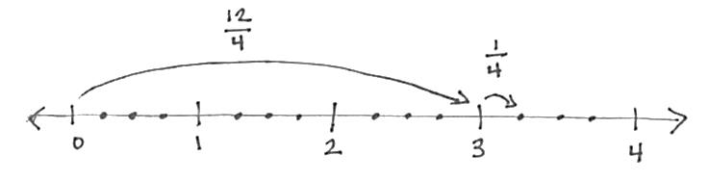
  - $3\frac{1}{4}$

$3\frac{1}{4}= 3+\frac{1}{4}=\frac{12}{4}+\frac{1}{4}=\frac{13}{4}$

  - $2\frac{4}{5}$

  - $3\frac{5}{8}$

  - $4\frac{4}{10}$

  - $4\frac{7}{9}$

- Convert each mixed number to a fraction greater than 1. Show your work as in the example.
(Note: $3×\frac{4}{4}= \frac{3 × 4}{4}$ )
  - $3\frac{3}{4}$
$3\frac{3}{4}=3+\frac{3}{4}=\left(3×\frac{4}{4}\right)+\frac{3}{4}=\frac{12}{4}+ \frac{3}{4}= \frac{15}{4}$

  - $4\frac{1}{3}$

  - $4\frac{3}{5}$

  - $4\frac{6}{8}$

- Convert each mixed number to a fraction greater than 1.
a. $2\frac{3}{4}$ | b. $2\frac{2}{5}$ | c. $3\frac{3}{6}$
d. $3\frac{3}{8}$ | e. $3\frac{1}{10}$ | f. $4\frac{3}{8}$
g. $5\frac{2}{3}$ | h. $6\frac{1}{2}$ | i. $7\frac{3}{10}$

Name Date
Convert each mixed number to a fraction greater than 1.
- $3\frac{1}{5}$

- $2\frac{3}{5}$

- $4\frac{2}{9}$

Name Date
- Convert each mixed number to a fraction greater than 1. Draw a number line to model your work.
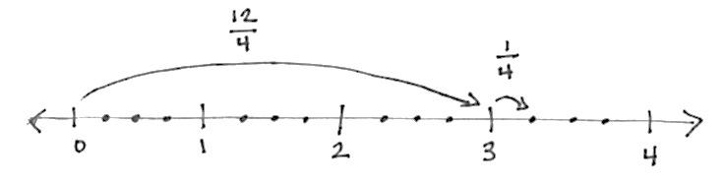
  - $3\frac{1}{4}$

$3\frac{1}{4}= 3+\frac{1}{4}=\frac{12}{4}+\frac{1}{4}=\frac{13}{4}$

  - $4\frac{2}{5}$

  - $5\frac{3}{8}$

  - $3\frac{7}{10}$

  - $6\frac{2}{9}$

- Convert each mixed number to a fraction greater than 1. Show your work as in the example.
(Note: $3×\frac{4}{4}= \frac{3 × 4}{4}$ )
  - $3\frac{3}{4}$
$3\frac{3}{4}=3+\frac{3}{4}=\left(3×\frac{4}{4}\right)+\frac{3}{4}=\frac{12}{4}+ \frac{3}{4}= \frac{15}{4}$

  - $5\frac{2}{3}$

  - $4\frac{1}{5}$

  - $3\frac{7}{8}$

- Convert each mixed number to a fraction greater than 1.
a. $2\frac{1}{3}$ | b. $2\frac{3}{4}$ | c. $3\frac{2}{5}$
d. $3\frac{1}{6}$ | e. $4\frac{5}{12}$ | f. $4\frac{2}{5}$
g. $4\frac{1}{10}$ | h. $5\frac{1}{5}$ | i. $5\frac{5}{6}$
j. $6\frac{1}{4}$ | k. $7\frac{1}{2}$ | l. $7\frac{11}{12}$

