Lesson 24
Objective: Decompose and compose fractions greater than 1 to express them in various forms.

Suggested Lesson Structure
 Fluency Practice (12 minutes)
 Application Problem (6 minutes)
 Concept Development (32 minutes)
 Student Debrief (10 minutes)
Total Time (60 minutes)
Fluency Practice (12 minutes)
- Add and Subtract 4.NBT.4 (3 minutes)
- Count by Equivalent Fractions 4.NF.1 (3 minutes)
- Add and Subtract Fractions 4.NF.3 (3 minutes)
- Multiply Fractions on a Number Line 4.NF.4 (3 minutes)
Add and Subtract (3 minutes)
Materials: (S) Personal white board
Note: This fluency activity reviews adding and subtracting using the standard algorithm.
T: (Write 547 thousands 936 ones.) On your personal white boards, write this number in standard form.
S: (Write 547,936.)
T: (Write 270 thousands 654 ones.) Add this number to 547,936 using the standard algorithm.
S: (Write 547,936 + 270,654 = 818,590 using the standard algorithm.)
Continue the process for 547,239 + 381,798.
T: (Write 500 thousands.) On your boards, write this number in standard form.
S: (Write 500,000.)
T: (Write 213 thousands 724 ones.) Subtract this number from 500,000 using the standard algorithm.
S: (Write 500,000 – 213,724 = 286,276 using the standard algorithm.)
Continue the process for 635,704 – 395,615.

Count by Equivalent Fractions (3 minutes)
Note: This activity reviews Lesson 23.
T: Count by ones to 10, starting at 0.
S: 0, 1, 2, 3, 4, 5, 6, 7, 8, 9, 10.
T: Count by halves to 10 halves, starting at 0 halves. (Write as students count.)
$\frac{\text{0}}{\text{2}}$ $\frac{\text{1}}{\text{2}}$ $\frac{\text{2}}{\text{2}}$ $\frac{\text{3}}{\text{2}}$ $\frac{\text{4}}{\text{2}}$ $\frac{\text{5}}{\text{2}}$ $\frac{\text{6}}{\text{2}}$ $\frac{7}{2}$ $\frac{8}{2}$ $\frac{\text{9}}{\text{2}}$ $\frac{\text{10}}{\text{2}}$
0 $\frac{\text{1}}{\text{2}}$ 1 $\frac{\text{3}}{\text{2}}$ 2 $\frac{\text{5}}{\text{2}}$ 3 $\frac{\text{7}}{\text{2}}$ 4 $\frac{\text{9}}{\text{2}}$ 5
0 $\frac{\text{1}}{\text{2}}$ 1 $\text{1}\frac{\text{1}}{\text{2}}$ 2 $\text{2}\frac{\text{1}}{\text{2}}$ 3 $\text{3}\frac{\text{1}}{\text{2}}$ 4 $\text{4}\frac{\text{1}}{\text{2}}$ 5

S: $\frac{\text{0}}{\text{2}}$ , $\frac{1}{2}$ , $\frac{\text{2}}{\text{2}}$ , $\frac{3}{2}$ , $\frac{\text{4}}{\text{2}}$ , $\frac{\text{5}}{\text{2}}$ , $\frac{\text{6}}{\text{2}}$ , $\frac{\text{7}}{\text{2}}$ , $\frac{\text{8}}{\text{2}}$ , $\frac{\text{9}}{\text{2}}$ , $\frac{\text{10}}{\text{2}}$.
T: 1 is the same as how many halves?
S: 2 halves.
T: (Beneath $\frac{\text{2}}{\text{2}}$, write 1.) 2 is the same as how many halves?
S: 4 halves.
T: (Beneath $\frac{\text{4}}{\text{2}}$, write 2.)
Continue the process for 3, 4, and 5.
T: Count by halves again. This time, when you come to the whole numbers, say them. (Write as students count.)
S: $\text{0,}\frac{\text{1}}{\text{2}}\text{,} \text{1,} \frac{\text{3}}{\text{2}}\text{,} \text{2,}\frac{\text{5}}{\text{2}}\text{,} \text{3,} \frac{\text{7}}{\text{2}}\text{, 4,}\frac{\text{9}}{\text{2}}\text{, 5}$.
T: Count by halves once more. This time, convert to whole numbers and mixed numbers. (Write as students count.)
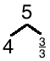
S: 0$\text{, }\frac{\text{1}}{\text{2}}\text{,}$ 1, $\text{1}\frac{\text{1}}{\text{2}}\text{,}$ 2, $\text{2}\frac{\text{1}}{\text{2}}\text{, }$3, $\text{3}\frac{\text{1}}{\text{2}}\text{, }$4, $\text{4}\frac{\text{1}}{\text{2}}\text{, }$5.
Add and Subtract Fractions (3 minutes)
Materials: (S) Personal white board
Note: This fluency activity reviews Lesson 22.
5 – $\frac{\text{2}}{\text{3}}\text{=} \text{4}\frac{\text{1}}{\text{3}}$
$\text{4}\frac{\text{1}}{\text{3}}\text{+ ___}$ = 5
T: (Draw a number bond with a whole of 5. Write 4 as the known part and $\frac{}{\text{3}}$ as the unknown part.) How many thirds are in 1?
S: 3 thirds.
T: (Write $\frac{\text{3}}{\text{3}}$ as the unknown part. Beneath it, write 5 – $\frac{\text{2}}{\text{3}}$ = 4 + $\frac{}{\text{3}}$.) Write the number sentence.
S: (Write 5 – $\frac{\text{2}}{\text{3}}$ = 4 + $\frac{\text{1}}{\text{3}}$ = $\text{4}\frac{\text{1}}{\text{3}}$.)
Continue with the following possible sequence: 4 – $\frac{\text{3}}{\text{5}}$ and 5 – $\frac{\text{3}}{\text{4}}$.
T: How much more does 1 third need to equal 1?
S: 2 thirds.
T: (Write $\text{4}\frac{\text{1}}{\text{3}}$ + __ = 5.) Write the number sentence, filling in the unknown part.
S: (Write $\text{4}\frac{\text{1}}{\text{3}}$ + $\frac{\text{2}}{\text{3}}$= 5.)
Continue with the following possible sequence: $\text{3}\frac{\text{2}}{\text{5}}$ + __ = 4 and $\text{4}\frac{\text{1}}{\text{4}}$ + __ = 5.
Multiply Fractions on a Number Line (3 minutes)
Materials: (S) Personal white board
Note: This fluency activity reviews Lesson 23.
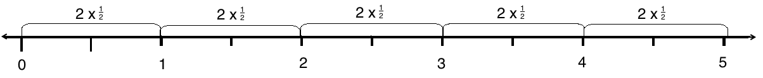
T: Draw a number line on your personal white boards.
S: (Draw a number line.)
T: (Write 10 × $\frac{\text{1}}{\text{2}}$.) How many halves will you record on your number line?
S: 10 halves.
T: Starting at 0, draw tick marks on your number line to represent 10 halves.
S: (Draw 11 tick marks equally spaced on the number line.)
T: (Write __ × $\frac{\text{1}}{\text{2}}$ = 1.) How many halves are in 1?
S: 2 halves.
T: (Write 2 × $\frac{\text{1}}{\text{2}}$ = 1.) Label as many ones as possible, and record each with multiplication.
S: (Label 5 ones, and record each slide on the number line as 2 × $\frac{\text{1}}{\text{2}}$.)
T: How many times did you write 2 × $\frac{\text{1}}{\text{2}}$?
S: 5 times.
T: (Write 10 × $\frac{\text{1}}{\text{2}}$ = 5 × $\frac{}{\text{2}}$ = __.) Fill in the unknown numerator and unknown whole number.
S: (Write 10 × $\frac{\text{1}}{\text{2}}$ = 5 × $\frac{\text{2}}{\text{2}}$ = 5.)
Continue with the following possible sequence: 12 × $\frac{\text{1}}{\text{3}}$.
Application Problem (6 minutes)
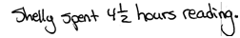
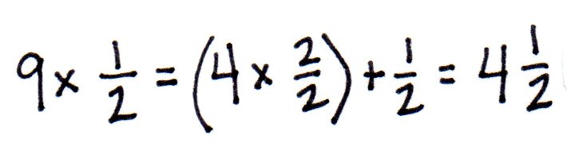
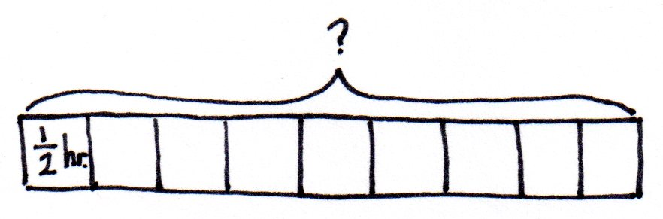
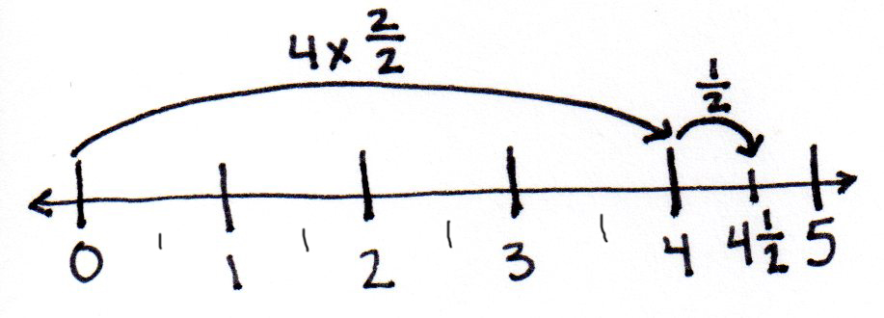
Shelly read her book for $\frac{\text{1}}{\text{2}}$ hour each afternoon for 9 days. How many hours did Shelly spend reading in all 9 days?

Note: This Application Problem relates back to Lesson 23 where students multiplied unit fractions to build fractions greater than 1. Ask students who are struggling to explain their number sentence to draw a number line.
Concept Development (32 minutes)

NOTES ON
MULTIPLE MEANS
OF REPRESENTATION:
Some learners may need explicit instructions for counting by 3 thirds and later by 5 fifths. It might be helpful to scaffold the count by directing students to first count by threes. Then, have them count by 3 thirds. If needed, do the same for counting by 5 fifths.

Materials: (S) Personal white board
Problem 1: Rename fractions as mixed numbers using decomposition.
T: (Display $\frac{\text{7}}{\text{3}}$.) How many thirds make 1?
S: 3 thirds.
T: Count by 3 thirds.
S: 3 thirds, 6 thirds, 9 thirds.
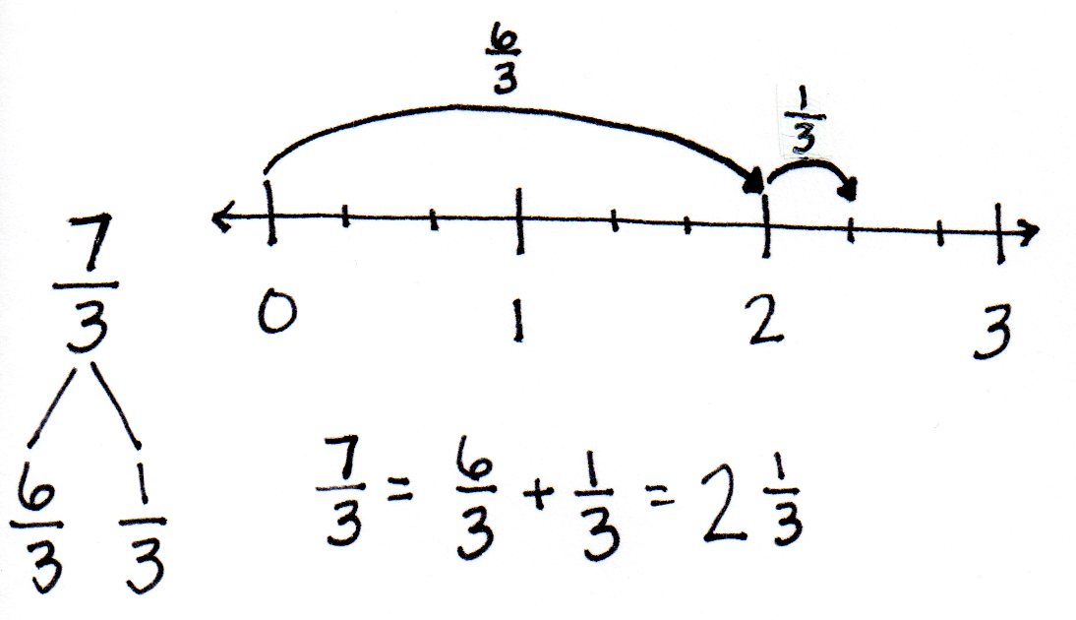
T: Stop. We only have 7 thirds. Decompose $\frac{\text{7}}{\text{3}}$ using a bond to show $\frac{\text{6}}{\text{3}}$ and the remaining fraction.
S: (Draw bond.)
T: Use the bond to write an addition sentence for $\frac{\text{7}}{\text{3}}$.
S: $\frac{\text{7}}{\text{3}}$ = $\frac{\text{6}}{\text{3}}$ +$\frac{\text{1}}{\text{3}}$.
T: Rename using whole numbers.
S: $\frac{\text{6}}{\text{3}}$ + $\frac{\text{1}}{\text{3}}$ = 2 + $\frac{\text{1}}{\text{3}}$.
T: (Write $\frac{\text{7}}{\text{3}}$ = $\text{2}\frac{\text{1}}{\text{3}}$.) Let’s use a number line to model that. Draw a number line with endpoints 0 and 3. Decompose each whole number into thirds and plot $\frac{\text{7}}{\text{3}}$. Start at zero. Slide $\frac{\text{6}}{\text{3}}$. Slide $\frac{\text{1}}{\text{3}}$. $\frac{7}{3}$ is equal to…?
S: $\text{2}\frac{\text{1}}{\text{3}}.$
Repeat the process with $\frac{\text{13}}{\text{5}}$.
Problem 2: Convert a fraction into a mixed number using multiplication.
T: (Display $\frac{\text{7}}{\text{3}}.$) How many groups of 3 thirds are in 7 thirds?
S: 2.
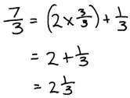
T: We write two groups of 3 thirds as 2 × $\frac{\text{3}}{\text{3}}$. (Record as shown to the right.) How many thirds remain?
S: $\frac{\text{1}}{\text{3}}\text{.}$
T: What is 2 + $\frac{\text{1}}{\text{3}}\text{?}$
S: $\text{2}\frac{\text{1}}{\text{3}}\text{.}$
T: True or false: $\text{2}\frac{\text{1}}{\text{3}}$ = $\frac{\text{7}}{\text{3}}?$
S: True.
T: (Display $\frac{\text{10}}{\text{4}}\text{.}$) How many groups of $\frac{\text{4}}{\text{4}}$ are in $\frac{\text{10}}{\text{4}}$?

NOTES ON
MULTIPLE MEANS
OF ACTION AND EXPRESSION:
Guide students to identify and strengthen personally efficient strategies for converting a fraction to a mixed number. After practice with number bonds and multiplication, facilitate student reflection and self-assessment. Students might ask themselves, “Which method is easier for me? Which is fastest?”

S: 2.
T: Record a number sentence to show $\frac{\text{10}}{\text{4}}$ as a mixed number.
S: $\frac{\text{10}}{\text{4}}$ = $\left(2 ×\frac{4}{4}\right)$+ $\frac{\text{2}}{\text{4}}$ = $\text{2}\frac{\text{2}}{\text{4}}$.
T: Watch as I write that expression a new way:
$\frac{\text{10}}{\text{4}}$ = $\frac{\text{2 × 4}}{\text{4}}$ + $\frac{\text{2}}{\text{4}}$. Discuss this expression with your partner.
S: The 2 is in the numerator! But, if I multiply 2 times 4, I get 8. So, $\frac{\text{8}}{\text{4}}$ is the same as $\frac{\text{2 × 4}}{\text{4}}$. 2 × $\frac{\text{4}}{\text{4}}$ = $\frac{\text{2 × 4}}{\text{4}}$.
T: With your partner, write the following fractions as mixed numbers using multiplication: $\frac{\text{12}}{\text{5}}$, $\frac{\text{20}}{\text{6}}$, $\frac{\text{35}}{\text{10}}$, and $\frac{\text{26}}{\text{12}}$.
Problem Set (10 minutes)
Students should do their personal best to complete the Problem Set within the allotted 10 minutes. For some classes, it may be appropriate to modify the assignment by specifying which problems they work on first. Some problems do not specify a method for solving. Students should solve these problems using the RDW approach used for Application Problems.
Student Debrief (10 minutes)
Lesson Objective: Decompose and compose fractions greater than 1 to express them in various forms.
The Student Debrief is intended to invite reflection and active processing of the total lesson experience.
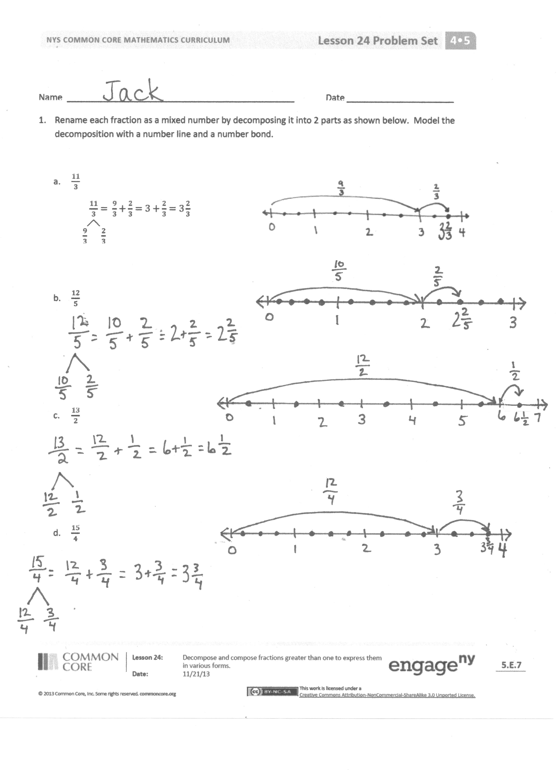
Invite students to review their solutions for the Problem Set. They should check work by comparing answers with a partner before going over answers as a class. Look for misconceptions or misunderstandings that can be addressed in the Debrief. Guide students in a conversation to debrief the Problem Set and process the lesson.
Any combination of the questions below may be used to lead the discussion.
- How can drawing a number line help you when converting a fraction to a mixed number?
- How can decomposing a fraction into two parts help you rename each fraction?
- In Problem 1, how did you decide what your two parts should be? Use a specific example to explain.
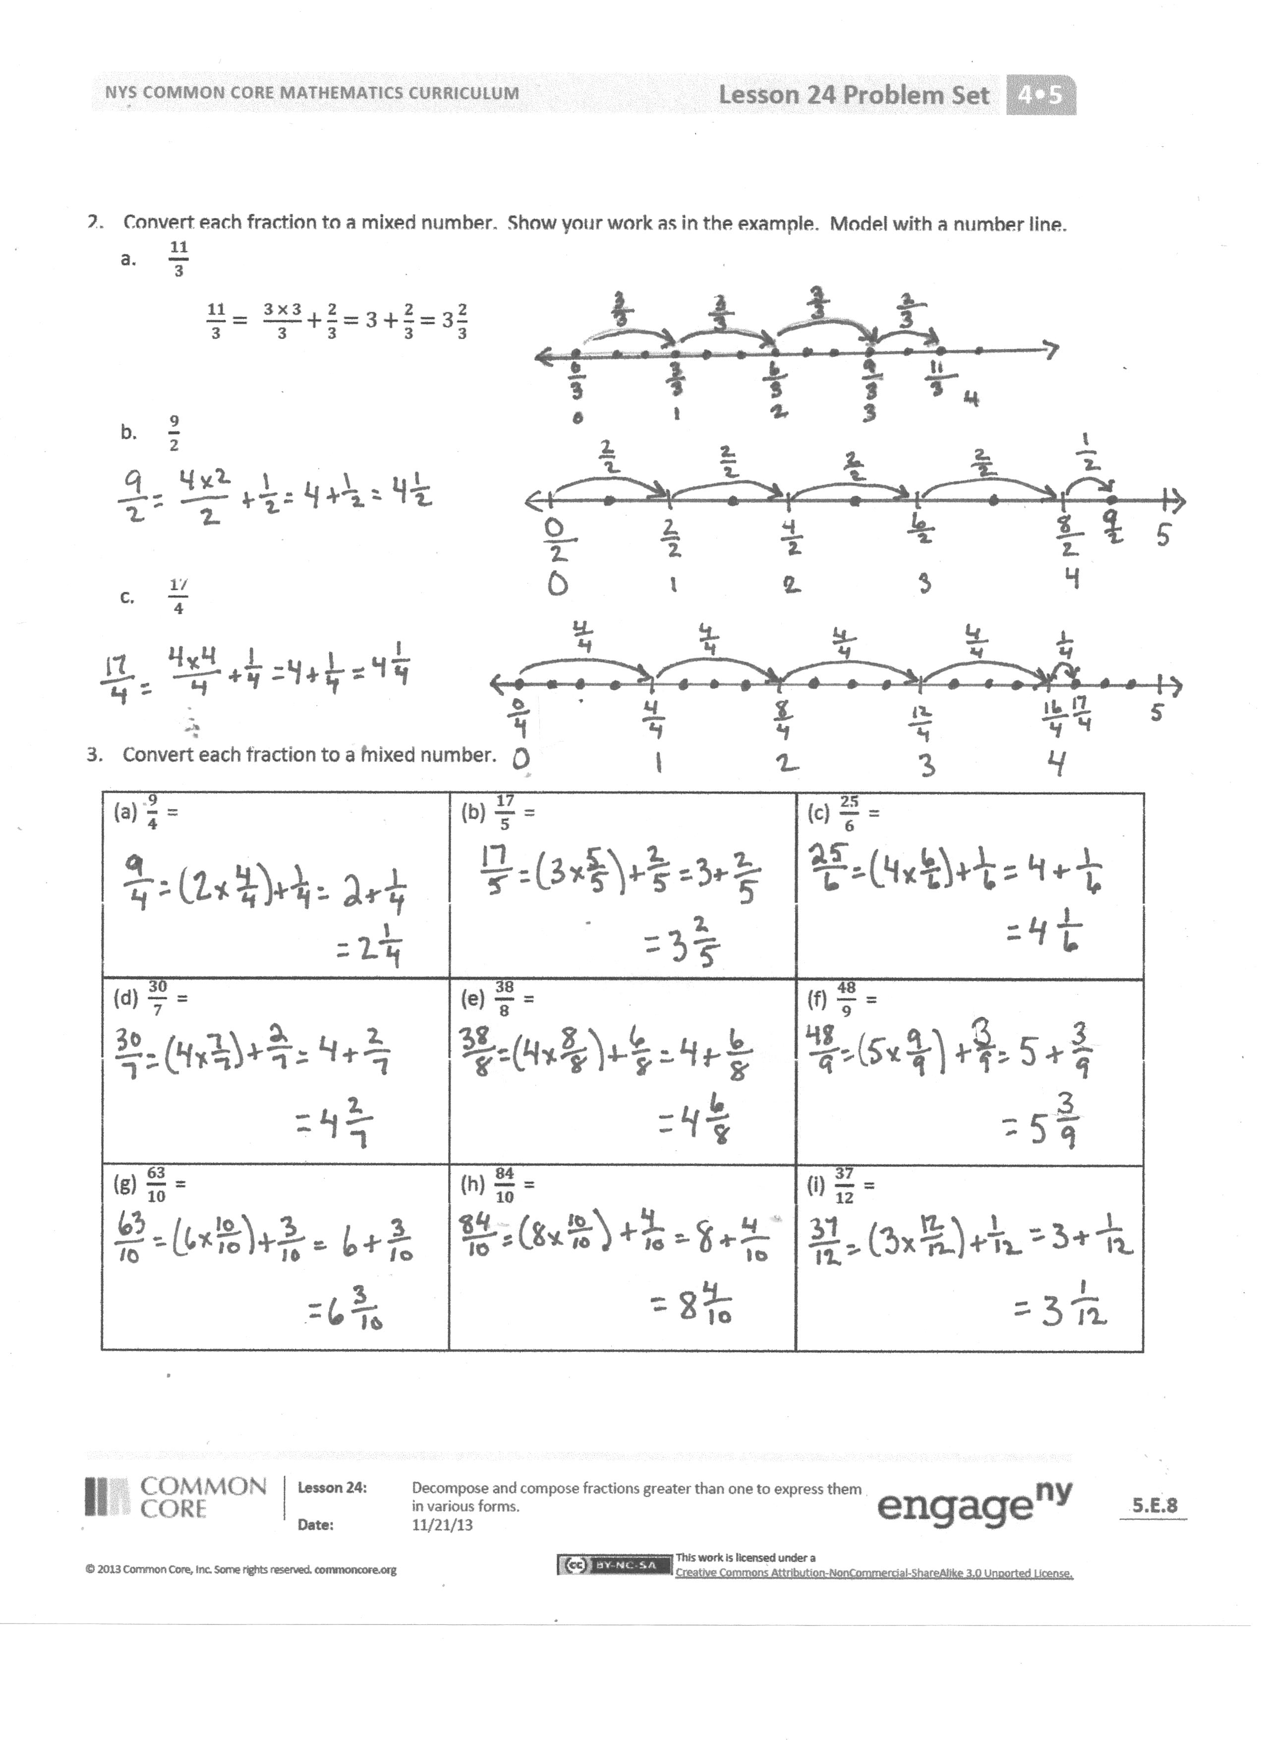
- Compare the strategies you used in Problem 1 with the strategies you used in Problem 2. In the example in Problem 1(a) and Problem 2(a), how is using a number bond of $\frac{\text{9}}{\text{3}}$ and $\frac{\text{2}}{\text{3}}$ related to $\frac{\text{3 × 3}}{\text{3}}$ + $\frac{\text{2}}{\text{3}}$?
- In Problem 3, which fractions were the easiest for you to convert? Which were the most challenging? Why?
- How did the Application Problem connect to today’s lesson?
Exit Ticket (3 minutes)
After the Student Debrief, instruct students to complete the Exit Ticket. A review of their work will help with assessing students’ understanding of the concepts that were presented in today’s lesson and planning more effectively for future lessons. The questions may be read aloud to the students.
Name Date
- Rename each fraction as a mixed number by decomposing it into two parts as shown below. Model the decomposition with a number line and a number bond.
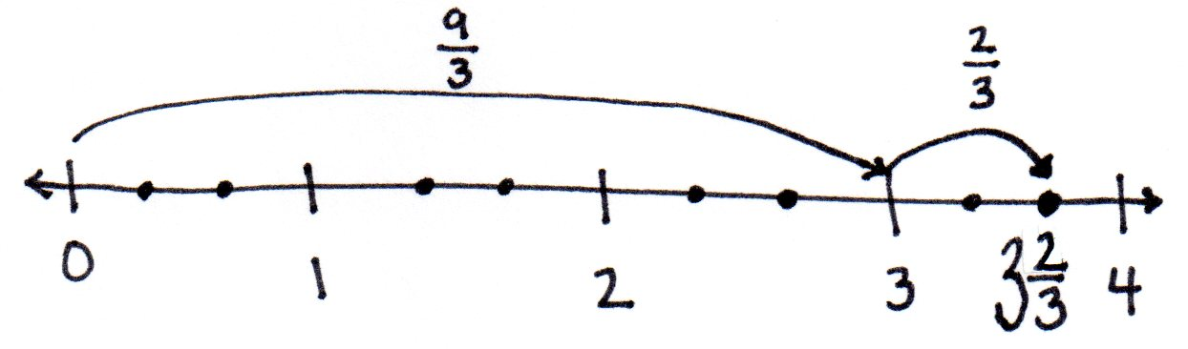
  - $\frac{11}{3}$
$\frac{11}{3}= \frac{9}{3}+\frac{2}{3}=3+\frac{2}{3}=3\frac{2}{3}$
$\frac{9}{3} \frac{2}{3}$

  - $\frac{12}{5}$

  - $\frac{13}{2}$

  - $\frac{15}{4}$

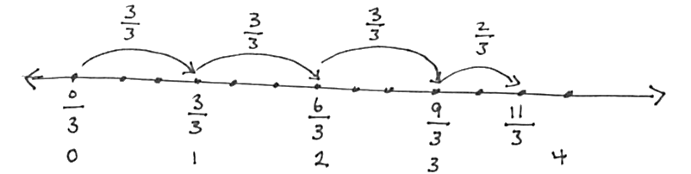
- Convert each fraction to a mixed number. Show your work as in the example. Model with a number line.
  - $\frac{11}{3}$
$\frac{11}{3}= \frac{3 × 3}{3}+\frac{2}{3}=3+\frac{2}{3}=3\frac{2}{3}$

  - $\frac{9}{2}$

  - $\frac{17}{4}$

- Convert each fraction to a mixed number.
a. $\frac{9}{4}$ = | b. $\frac{17}{5}$ = | c. $\frac{25}{6}$ =
d. $\frac{30}{7}$ = | e. $\frac{38}{8}$ = | f. $\frac{48}{9}$ =
g. $\frac{63}{10}$ = | h. $\frac{84}{10}$ = | i. $\frac{37}{12}$ =

Name Date
- Rename the fraction as a mixed number by decomposing it into two parts. Model the decomposition with a number line and a number bond.
$$\frac{17}{5}$$

- Convert the fraction to a mixed number. Model with a number line.
$\frac{19}{3}$

- Convert the fraction to a mixed number.
$\frac{11}{4}$

Name Date
- Rename each fraction as a mixed number by decomposing it into two parts as shown below. Model the decomposition with a number line and a number bond.
  - $\frac{11}{3}$
$\frac{11}{3}= \frac{9}{3}+\frac{2}{3}=3+\frac{2}{3}=3\frac{2}{3}$
$\frac{9}{3} \frac{2}{3}$
  - $\frac{13}{4}$

  - $\frac{16}{5}$

  - $\frac{15}{2}$

  - $\frac{17}{3}$

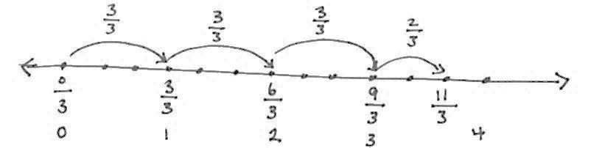
- Convert each fraction to a mixed number. Show your work as in the example. Model with a number line.
  - $\frac{11}{3}$
$\frac{11}{3}= \frac{3 × 3}{3}+\frac{2}{3}=3+\frac{2}{3}=3\frac{2}{3}$

  - $\frac{13}{2}$

  - $\frac{18}{4}$

- Convert each fraction to a mixed number.
a. $\frac{14}{3}$ = | b. $\frac{17}{4}$ = | c. $\frac{27}{5}$ =
d. $\frac{28}{6}$ = | e. $\frac{23}{7}$ = | f. $\frac{37}{8}$ =
g. $\frac{51}{9}$ = | h. $\frac{74}{10}$ = | i. $\frac{45}{12}$ =

