Lesson 23
Objective: Add and multiply unit fractions to build fractions greater than 1 using visual models.

Suggested Lesson Structure
 Fluency Practice (16 minutes)
 Application Problem (5 minutes)
 Concept Development (29 minutes)
 Student Debrief (10 minutes)
Total Time (60 minutes)
Fluency Practice (16 minutes)
- Add and Subtract 4.NBT.4 (4 minutes)
- Count by Equivalent Fractions 4.NF.1 (4 minutes)
- Add and Subtract Fractions 4.NF.3 (4 minutes)
- Add to and Subtract From Ones 4.NF.3 (4 minutes)
Add and Subtract (4 minutes)
Materials: (S) Personal white board
Note: This fluency activity reviews adding and subtracting using the standard algorithm.
T: (Write 457 thousands 393 ones.) On your personal white board, write this number in standard form.
S: (Write 457,393.)
T: (Write 385 thousands 142 ones.) Add this number to 457,393 using the standard algorithm.
S: (Write 457,393 + 385,142 = 842,535 using the standard algorithm.)
Continue the process for 465,758 + 492,458.
T: (Write 300 thousands.) On your board, write this number in standard form.
S: (Write 300,000.)
T: (Write 137 thousands 623 ones.) Subtract this number from 300,000 using the standard algorithm.
S: (Write 300,000 – 137,623 = 162,377 using the standard algorithm.)
Continue the process for 534,803 – 235,257.

Count by Equivalent Fractions (4 minutes)
Note: This activity builds fluency with equivalent fractions. The progression builds in complexity. Work the students up to the highest level of complexity in which they can confidently participate.
T: Count by twos to 12, starting at 0.
$\frac{\text{0}}{\text{6}}$ $\frac{\text{2}}{\text{6}}$ $\frac{\text{4}}{\text{6}}$ $\frac{\text{6}}{\text{6}}$ $\frac{\text{8}}{\text{6}}$ $\frac{\text{10}}{\text{6}}$ $\frac{\text{12}}{\text{6}}$
$\text{0}$ $\frac{\text{2}}{\text{6}}$ $\frac{\text{4}}{\text{6}}$ 1 $\frac{\text{8}}{\text{6}}$ $\frac{\text{10}}{\text{6}}$ 2
$\text{0}$ $\frac{\text{2}}{\text{6}}$ $\frac{\text{4}}{\text{6}}$ 1 $\text{1}\frac{\text{2}}{\text{6}}$ $\text{1}\frac{\text{4}}{\text{6}}$ 2

S: 0, 2, 4, 6, 8, 10, 12.
T: Count by 2 sixths to 12 sixths, starting at 0 sixths. (Write as students count.)
S: $\frac{\text{0}}{\text{6}}$, $\frac{\text{2}}{\text{6}}$, $\frac{\text{4}}{\text{6}}$, $\frac{6}{6}$, $\frac{\text{8}}{\text{6}}$, $\frac{\text{10}}{\text{6}}$, $\frac{\text{12}}{\text{6}}$.
T: 1 is the same as how many sixths?
S: 6 sixths.
T: (Beneath $\frac{\text{6}}{\text{6}}$, write 1.) 2 is the same as how many sixths?
S: 12 sixths.
T: (Beneath $\frac{\text{12}}{\text{6}}$, write 2.) Count by 2 sixths again. This time, when you come to 1 or 2, say the whole number. (Write as students count.)
S: 0, $\frac{\text{2}}{\text{6}}$, $\frac{\text{4}}{\text{6}}$, 1, $\frac{\text{8}}{\text{6}}$, $\frac{10}{6}$, 2.
T: (Point at $\frac{\text{8}}{\text{6}}$.) Say 8 sixths as a mixed number.
S: $\text{1}\frac{\text{2}}{\text{6}}$.
Continue the process for $\frac{\text{10}}{\text{6}}$.
T: Count by 2 sixths again. This time, convert to whole numbers and mixed numbers. (Write as students count.)
S: $\text{0}$, $\frac{\text{2}}{\text{6}}$, $\frac{\text{4}}{\text{6}}$, 1, $\text{1}\frac{\text{2}}{\text{6}}$, $\text{1}\frac{\text{4}}{\text{6}}$, 2.
T: Let’s count by 2 sixths again. After you say 1, alternate between saying the mixed number and the fraction. Try not to look at the board.
S: $0$, $\frac{\text{2}}{\text{6}}$, $\frac{\text{4}}{\text{6}}$, 1, $\text{1}\frac{\text{2}}{\text{6}}$, $\frac{\text{10}}{\text{6}}$, 2.
T: 2 is the same as how many sixths?
S: $\frac{\text{12}}{\text{6}}$.
T: Let’s count backward by 2 sixths starting at $\frac{\text{12}}{\text{6}}$. Alternate between fractions and mixed numbers down to 1, and then continue to count down by 2 sixths to $\frac{\text{0}}{\text{6}}\text{.}$ Try not to look at the board.
S: $\frac{\text{12}}{\text{6}}$, $\text{1}\frac{\text{4}}{\text{6}}$, $\frac{\text{8}}{\text{6}}$, 1, $\frac{\text{4}}{\text{6}}$, $\frac{\text{2}}{\text{6}}$, $\frac{\text{0}}{\text{6}}$.
Add and Subtract Fractions (4 minutes)
Materials: (S) Personal white board
Note: This fluency activity reviews Lesson 22.
T: (Draw a number bond with a whole of 2. Write 1 as the known part and $\frac{}{\text{5}}$ as the unknown part.) How many fifths are in 1?
2
$$\frac{5}{5}$$
1
S: 5 fifths.
T: (Write $\frac{5}{5}$ as the unknown part. Beneath it, write 2 – $\frac{\text{2}}{\text{5}}$ = 1 + $\frac{}{5}$.) Write the number sentence.
S: (Write 2 – $\frac{\text{2}}{\text{5}}$ = 1 + $\frac{\text{3}}{\text{5}}$ =$\text{ 1}\frac{\text{3}}{\text{5}}$.)
Continue the process for 2 – $\frac{\text{1}}{\text{3}}$, 2 – $\frac{\text{3}}{\text{4}}$, and 2 – $\frac{\text{5}}{\text{6}}\text{.}$
2 – $\frac{\text{2}}{\text{5}}$ = $\text{1}\text{ + }\frac{\text{3}}{\text{5}}=1\frac{3}{5}$
$1\frac{\text{3}}{\text{5}}$ + $\frac{}{\text{5}}$ = 2
T: How much does 3 fifths need to be 1?
S: 2 fifths.
T: (Write $\text{2}\frac{3}{5}$ + ___ = 3.) Write the number sentence, filling in the unknown number.
S: (Write $\text{2}\frac{3}{5}$ + $\frac{2}{5}$ = 3.)
Continue with the following possible sequence: $\text{1}\frac{\text{2}}{\text{3}}$ + __ = 2, $\text{1}\frac{\text{1}}{\text{4}}$ + __ = 2, and $\text{1}\frac{\text{1}}{\text{6}}$ + __ = 2.
Add to and Subtract from Ones (4 minutes)
Materials: (S) Personal white board
Note: This fluency activity reviews Lesson 22.
T: (Write 1 + $\frac{\text{1}}{\text{4}}$.) Write the complete number sentence.
S: (Write 1 + $\frac{\text{1}}{\text{4}}$ = $\text{1}\frac{\text{1}}{\text{4}}$.)
Continue the process for 2 + $\frac{\text{3}}{\text{5}}$ and 3 + $\frac{\text{3}}{\text{10}}$.
T: (Write 2 – $\frac{\text{1}}{\text{3}}$.) Draw a number line to match the subtraction problem. Then, beneath it, write the complete number sentence.
S: (Draw a number line as shown to the right. Write 2 – $\frac{\text{1}}{\text{3}}$ = $\text{1}\frac{\text{2}}{\text{3}}$.)
Continue with the following possible sequence: 3 – $\frac{\text{3}}{\text{4}}$ and 3 – $\frac{\text{7}}{\text{10}}$.
Application Problem (5 minutes)
Mrs. Wilcox cut quilt squares, and then divided them evenly into 8 piles. She decided to sew together 1 pile each night. After 5 nights, what fraction of the quilt squares was sewn together? Draw a tape diagram or a number line to model your thinking, and then write a number sentence to express your answer.
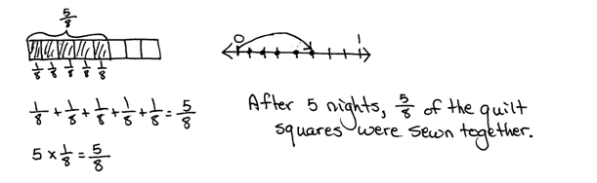
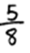

NOTES ON
MULTIPLE MEANS
OF REPRESENTATION:
When directing students to draw the number line for 6 × 2 , it may be helpful to clarify the directive for English language learners and others by phrasing instructions as, “Draw a number line and label six groups of 2,” or, “Model these number sentences on a number line.” Students working below grade level and English language learners may also benefit from modeling the first group of two.

Note: This Application Problem builds on Lesson 3’s objective of learning to decompose non-unit fractions and representing them as a whole number times a unit fraction using tape diagrams. Understanding the representation of a non-unit fraction in this way will help students as they learn the content of today’s lesson in which they will add and multiply unit fractions to compose fractions greater than 1.
Concept Development (29 minutes)
Materials: (S) Personal white board
Problem 1: Multiply a whole number times a unit fraction.
T: Write 6 × 2 as an addition sentence showing six groups of 2.
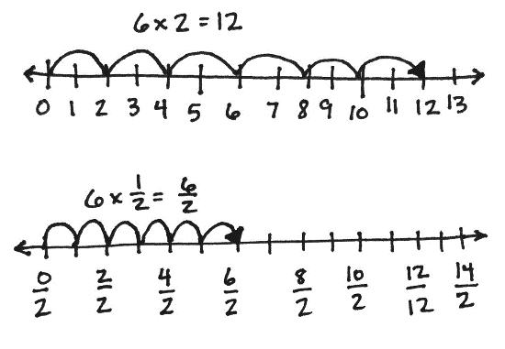
S: (Write 2 + 2 + 2 + 2 + 2 + 2 = 12.)
T: Draw a number line to show 6 twos.
S: (Draw number line as shown to the right.)
T: Write 6 × $\frac{\text{1}}{\text{2}}$ as an addition sentence showing six groups of $\frac{\text{1}}{\text{2}}$.
MP.7
S: (Write $\frac{\text{1}}{\text{2}}$ + $\frac{\text{1}}{\text{2}}$ + $\frac{\text{1}}{\text{2}}$ + $\frac{\text{1}}{\text{2}}$ + $\frac{\text{1}}{\text{2}}$ + $\frac{\text{1}}{\text{2}}$ = $\frac{\text{6}}{\text{2}}\text{.}$)
T: Draw a number line to show 6 halves.
S: (Draw number line as shown to the right.)
T: Work with your partner to draw parentheses, grouping halves to make ones.
S: We know $\frac{\text{1}}{\text{2}}$ + $\frac{\text{1}}{\text{2}}$ = 1, so maybe we can make three groups of that. Yeah, let’s draw parentheses around three separate groups of 2 halves.
MP.7
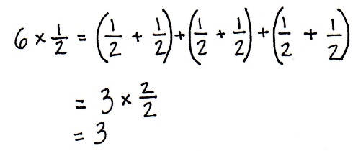
T: (Place parentheses.) 3 × $\frac{\text{2}}{\text{2}}$ (point to the number sentence)
is equal to…?
S: 3.
T: True or false? 6 × $\frac{\text{1}}{\text{2}}$ = 3 × $\frac{\text{2}}{\text{2}}\text{.}$ Discuss with your partner.
Problem 2: Multiply a whole number times a unit fraction using the associative property.
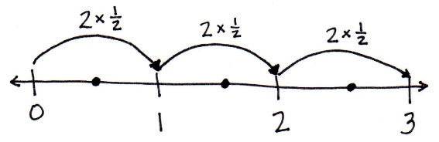
T: Let’s solve 6 × $\frac{\text{1}}{\text{2}}$ using unit form. 6 × $\frac{\text{1}}{\text{2}}$ is 6 halves.
T: (Display number line as pictured.) Do you see three groups of 2 halves?
S: Yes.
T: (Display: 6 halves = (3 × 2) halves = 3 × (2 halves) = 3 × $\left(\frac{\text{2}}{\text{2}}\right)$ = 3 × 1 = 3.)
T: Discuss this with your partner.
S: It tells us 6 halves equals 3 or 6 × $\frac{\text{1}}{\text{2}}$ = 3. 3 × (2 halves) and 3 × $\left(\frac{2}{2}\right)$ shows the 3 ones really clearly. 2 halves make 1 and 3 × 1 = 3.
T: But, why did it start with (3 × 2) halves? Why not (2 × 3) halves? Or, (1 × 6) halves?
S: Because we want to make ones. 2 halves make 1.
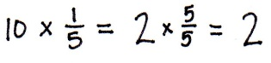
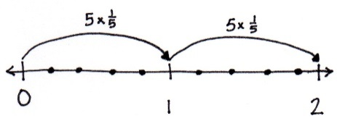
T: How many groups of 2 halves are in 6 halves?
S: 3.
T: So, 6 halves equals 3.
T: (Display 10 × $\frac{\text{1}}{\text{5}}$.) Solve for 10 fifths using unit form.
S: We want to make groups of 5 fifths to make ones.
10 fifths is the same as (2 × 5) fifths.
2 × (5 fifths) = 2 × $\left(\frac{5}{5}\right)$ = 2 × 1 = 2.
T: Support your answer with a number line.
S: I can make 10 slides of a fifth. My arrows show 2 slides of $\frac{\text{5}}{\text{5}}$. That is equal to 2.
10 ×$\frac{\text{1}}{\text{5}}$ = 2 × $\frac{\text{5}}{\text{5}}$ = 2. Repeat with 8 × $\frac{\text{1}}{\text{4}}$.
Problem 3: Express the product of a whole number times a unit fraction as a mixed number.
T: (Display: 9 copies of $\frac{\text{1}}{\text{4}}$.) 9 fourths. How many fourths make 1?
S: 4 fourths.
T: To makes ones, how many 4 fourths are in 9 fourths?
S: 2.
T: Two groups of 4 fourths makes 8 fourths. There is 1 fourth remaining.
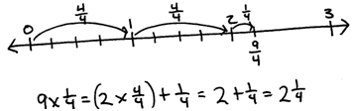
Display: 9 × $\frac{\text{1}}{\text{4}}$ = (2 × $\frac{4}{4}$) + $\frac{\text{1}}{\text{4}}$ = 2 + $\frac{\text{1}}{\text{4}}$ = $\text{2}\frac{\text{1}}{\text{4}}$.
T: Draw a number line with endpoints 0 and 3. Label the ones and partition fourths. With your partner show (2 × $\frac{\text{4}}{\text{4}}$) + $\frac{\text{1}}{\text{4}}$. (Allow students time to draw two slides of $\frac{\text{4}}{\text{4}}$, and then a slide of $\frac{\text{1}}{\text{4}}$ as pictured to the right.)
T: With your partner, solve for 8 copies of 1 third.
S: There are two groups of 3 thirds in 8 thirds. That leaves 2 thirds remaining. 8 × $\frac{\text{1}}{\text{3}}$ = (2 × $\frac{\text{3}}{\text{3}}$) + $\frac{\text{2}}{\text{3}}$ = $\text{2}\frac{\text{2}}{\text{3}}$.
Repeat with 7 × $\frac{\text{1}}{\text{2}}$, 13 × $\frac{1}{5}$, and 17 × $\frac{\text{1}}{\text{6}}$.
Problem Set (10 minutes)
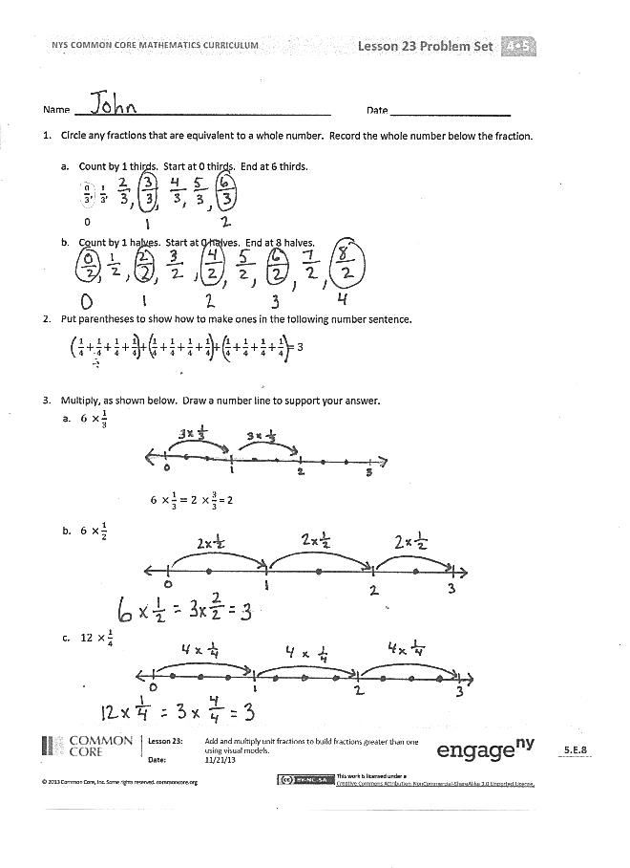
Students should do their personal best to complete the Problem Set within the allotted 10 minutes. For some classes, it may be appropriate to modify the assignment by specifying which problems they work on first. Some problems do not specify a method for solving. Students should solve these problems using the RDW approach used for Application Problems.
Student Debrief (10 minutes)
Lesson Objective: Add and multiply unit fractions to build fractions greater than 1 using visual models.
The Student Debrief is intended to invite reflection and active processing of the total lesson experience.
Invite students to review their solutions for the Problem Set. They should check work by comparing answers with a partner before going over answers as a class. Look for misconceptions or misunderstandings that can be addressed in the Debrief. Guide students in a conversation to debrief the Problem Set and process the lesson.
Any combination of the questions below may be used to lead the discussion.
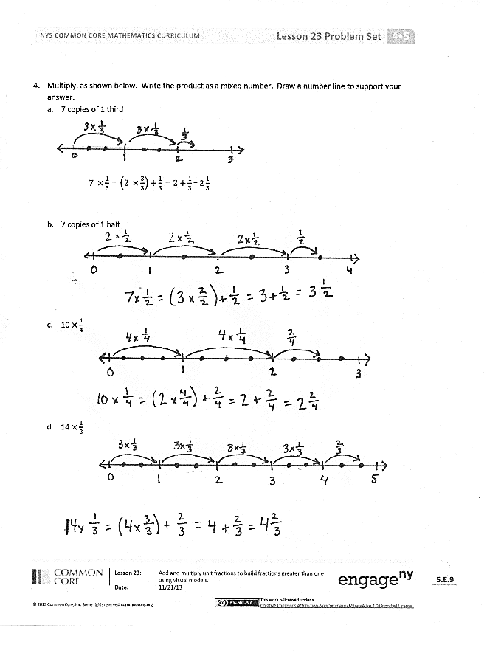
- How is your work in Problem 1(a) related to your work in Problem 3(a)? How is adding like-unit fractions related to multiplying unit fractions? Is this true for Problems 1(b) and 3(b)?
- Using Problem 3(a), explain how 6 × $\frac{\text{1}}{\text{3}}$ is the same as 2 × $\frac{\text{3}}{\text{3}}\text{.}$
- Explain why Problems 3(b) and 3(c) equal the same whole number.
- Which is greater, 6 × $\frac{\text{1}}{\text{3}}$ or 6 × $\frac{\text{1}}{\text{2}}$ ?
- How are parentheses helpful as you solve Problem 2?
- Look at Problem 2 and Problem 3. Is there a way to tell when the product will be a whole number before multiplying? Explain your thinking.
- How did the Application Problem connect to today’s lesson?
Exit Ticket (3 minutes)
After the Student Debrief, instruct students to complete the Exit Ticket. A review of their work will help with assessing students’ understanding of the concepts that were presented in today’s lesson and planning more effectively for future lessons. The questions may be read aloud to the students.

Name Date
- Circle any fractions that are equivalent to a whole number. Record the whole number below the fraction.
- Count by 1 thirds. Start at 0 thirds. End at 6 thirds.
$\frac{0}{3}, \frac{1}{3},$
0

- Count by 1 halves. Start at 0 halves. End at 8 halves.

- Use parentheses to show how to make ones in the following number sentence.
$\frac{1}{4}+\frac{1}{4}+\frac{1}{4}+\frac{1}{4}+ \frac{1}{4}+\frac{1}{4}+\frac{1}{4}+\frac{1}{4}+ \frac{1}{4}+\frac{1}{4}+\frac{1}{4}+\frac{1}{4}=3$

- Multiply, as shown below. Draw a number line to support your answer.
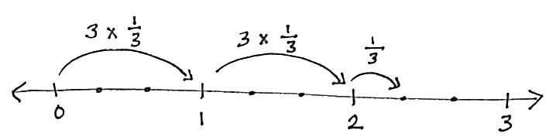
- $6×\frac{1}{3}$

$6×\frac{1}{3}=2×\frac{3}{3}$ = 2
- $6×\frac{1}{2}$

- $12×\frac{1}{4}$

- Multiply, as shown below. Write the product as a mixed number. Draw a number line to support your answer.
- 7 copies of 1 third
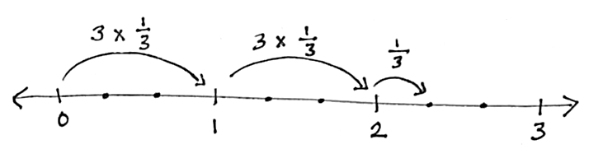

$7×\frac{1}{3}=\left(2×\frac{3}{3}\right)+\frac{1}{3}=2+\frac{1}{3}$ = 2 $\frac{1}{3}$

- 7 copies of 1 half

- 10 $×\frac{1}{4}$

- 14 $×\frac{1}{3}$

Name Date
Multiply and write the product as a mixed number. Draw a number line to support your answer.
- 8 $×\frac{1}{2}$

- 7 copies of 1 fourth

- 13 × $\frac{1}{3}$
Name Date
- Circle any fractions that are equivalent to a whole number. Record the whole number below the fraction.
- Count by 1 fourths. Start at 0 fourths. Stop at 6 fourths.
$$\frac{0}{4}, \frac{1}{4},$$
0

- Count by 1 sixths. Start at 0 sixths. Stop at 14 sixths.

- Use parentheses to show how to make ones in the following number sentence.
$$\frac{1}{3}+\frac{1}{3}+\frac{1}{3}+\frac{1}{3}+\frac{1}{3}+\frac{1}{3}+\frac{1}{3}+\frac{1}{3}+\frac{1}{3}+\frac{1}{3}+\frac{1}{3}+\frac{1}{3}=4$$

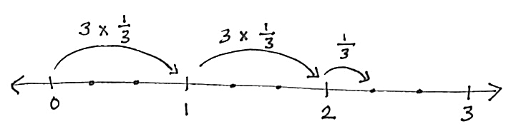
- Multiply, as shown below. Draw a number line to support your answer.

- 6 × $\frac{1}{3}$

6 × $\frac{1}{3}=$ 2 × $\frac{3}{3}$ = 2

- 10 × $\frac{1}{2}$

- 8 × $\frac{1}{4}$

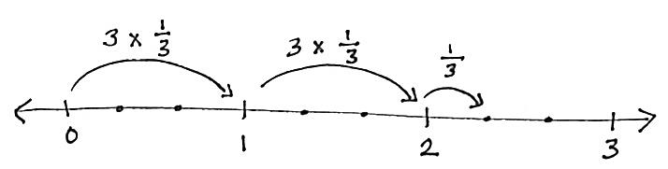
- Multiply, as shown below. Write the product as a mixed number. Draw a number line to support your answer.
- 7 copies of 1 third

7 × $\frac{1}{3}=\left(2×\frac{3}{3}\right)$ + $\frac{1}{3}$ = 2 + $\frac{1}{3}$ = 2 $\frac{1}{3}$

- 7 copies of 1 fourth

- 11 groups of 1 fifth

- 7 × $\frac{1}{2}$

- 9 × $\frac{1}{5}$

