Lesson 22
Objective: Add a fraction less than 1 to, or subtract a fraction less than
1 from, a whole number using decomposition and visual models.

Suggested Lesson Structure
 Fluency Practice (12 minutes)
 Application Problem (5 minutes)
 Concept Development (33 minutes)
 Student Debrief (10 minutes)
Total Time (60 minutes)
Fluency Practice (12 minutes)
- Sprint: Add Fractions 4.NF.3 (8 minutes)
- Count by Equivalent Fractions 4.NF.1 (4 minutes)
Sprint: Add Fractions (8 minutes)
Materials: (S) Add Fractions Sprint
Note: This fluency activity reviews Lesson 16. This Sprint is designed for students to add fractions and express their answers as fractions greater than one or as mixed numbers. Consider allowing the students to not rename fractions and mixed numbers for larger units so that they do not have to perform additional processes while they are focusing on adding fractions.
Count by Equivalent Fractions (4 minutes)
Note: This activity builds fluency with equivalent fractions. The progression builds in complexity. Work the students up to the highest level of complexity in which they can confidently participate.
T: Count by twos to 20 starting at 0. (Write as students count.)
S: 0, 2, 4, 6, 8, 10, 12, 14, 16, 18, 20.
T: Count by 2 tenths to 20 tenths starting at 0 tenths.
$\frac{\text{0}}{\text{10}}$ $\frac{\text{2}}{\text{10}}$ $\frac{\text{4}}{\text{10}}$ $\frac{\text{6}}{\text{10}}$ $\frac{8}{10}$ $\frac{\text{10}}{\text{10}}$ $\frac{\text{12}}{\text{10}}$ $\frac{\text{14}}{\text{10}}$ $\frac{\text{16}}{\text{10}}$ $\frac{\text{18}}{\text{10}}$ $\frac{\text{20}}{\text{10}}$
0 $\frac{\text{2}}{\text{10}}$ $\frac{\text{4}}{\text{10}}$ $\frac{\text{6}}{\text{10}}$ $\frac{\text{8}}{\text{10}}$ 1 $\frac{\text{12}}{\text{10}}$ $\frac{\text{14}}{\text{10}}$ $\frac{\text{16}}{\text{10}}$ $\frac{\text{18}}{\text{10}}$ 2
0 $\frac{\text{2}}{\text{10}}$ $\frac{\text{4}}{\text{10}}$ $\frac{\text{6}}{\text{10}}$ $\frac{\text{8}}{\text{10}}$ 1 $\text{1}\frac{\text{2}}{\text{10}}$ $\text{1}\frac{\text{4}}{\text{10}}$ $\text{1}\frac{\text{6}}{\text{10}}$ $\text{1}\frac{\text{8}}{\text{10}}$ 2

S: $\frac{\text{0}}{\text{10}}$, $\frac{\text{2}}{\text{10}}$, $\frac{\text{4}}{\text{10}}$, $\frac{\text{6}}{\text{10}}$, $\frac{\text{8}}{\text{10}}$, $\frac{\text{10}}{\text{10}}$, $\frac{\text{12}}{\text{10}}$, $\frac{\text{14}}{\text{10}}$, $\frac{\text{16}}{\text{10}}$, $\frac{\text{18}}{\text{10}}$, $\frac{\text{20}}{\text{10}}$.
T: 1 is the same as how many tenths?
S: 10 tenths.
T: (Beneath $\frac{\text{10}}{\text{10}}$, write 1.) 2 is the same as how many tenths?
S: 20 tenths.
T: (Beneath $\frac{\text{20}}{\text{10}}$, write 2.) Count by 2 tenths again. This time, when you come to the whole number, say the whole number. (Write as students count.)
S: 0, $\frac{\text{2}}{\text{10}}$, $\frac{\text{4}}{\text{10}}$, $\frac{\text{6}}{\text{10}}$, $\frac{\text{8}}{\text{10}}$, 1, $\frac{\text{12}}{\text{10}}$, $\frac{\text{14}}{\text{10}}$, $\frac{\text{16}}{\text{10}}$, $\frac{\text{18}}{\text{10}}$, 2.

NOTES ON
MULTIPLE MEANS
OF ENGAGEMENT:
Some learners may benefit from counting again and again until they gain fluency. Another way to differentiate the Counting by Equivalent Fractions fluency activity for students working above or below grade level is to grant them more autonomy. Students may enjoy this as a partner activity in which they take turns leading and counting. Students can make individualized choices about when to convert larger units, counting forward and backward, as well as speed.

T: (Point to $\frac{\text{12}}{\text{10}}$.) Say 12 tenths as a mixed number.
S: $\text{1}\frac{\text{2}}{\text{10}}$.
Continue the process for $\frac{\text{14}}{\text{10}}$, $\frac{\text{16}}{\text{10}}$, and $\frac{\text{18}}{\text{10}}$.
T: Count by 2 tenths again. This time, convert to whole numbers and mixed numbers. (Write as students count.)
S: 0, $\frac{\text{2}}{\text{10}}$, $\frac{\text{4}}{\text{10}}$, $\frac{\text{6}}{\text{10}}$, $\frac{\text{8}}{\text{10}}$, 1, $\text{1}\frac{\text{2}}{\text{10}}$, $\text{1}\frac{\text{4}}{\text{10}}$, $\text{1}\frac{\text{6}}{\text{10}}$, $\text{1}\frac{\text{8}}{\text{10}}$, 2.
T: Let’s count by 2 tenths again. After you say 1, alternate between saying the mixed number and the fraction. Try not to look at the board.
S: 0, $\frac{\text{2}}{\text{10}}$, $\frac{\text{4}}{\text{10}}$, $\frac{\text{6}}{\text{10}}$, $\frac{\text{8}}{\text{10}}$, 1, $\text{1}\frac{\text{2}}{\text{10}}$, $\frac{\text{14}}{\text{10}}$, $\text{1}\frac{\text{6}}{\text{10}}$, $\frac{\text{18}}{\text{10}}$, 2.
T: 2 is the same as how many tenths?
S: $\frac{\text{20}}{\text{10}}$.
T: Let’s count backwards starting at $\frac{\text{20}}{\text{10}}$, alternating between fractions greater than one and mixed numbers. Try not to look at the board.
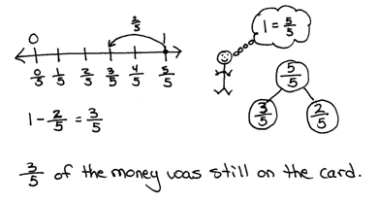
S: $\frac{\text{20}}{\text{10}}$, $\text{1}\frac{\text{8}}{\text{10}}$, $\frac{\text{16}}{\text{10}}$, $\text{1}\frac{\text{4}}{\text{10}}$, $\frac{\text{12}}{\text{10}}$, 1, $\frac{\text{8}}{\text{10}}$, $\frac{\text{6}}{\text{10}}$, $\frac{\text{4}}{\text{10}}$, $\frac{\text{2}}{\text{10}}$, 0.
Application Problem (5 minutes)
Winnie went shopping and spent $\frac{\text{2}}{\text{5}}$ of the money that was on a gift card. What fraction of the money was left on the card? Draw a number line and a number bond to help show your thinking.
Note: This Application Problem reviews Lesson 17’s objective of subtracting a fraction from 1. In this lesson, students subtract from a larger whole number using tape diagrams, number bonds, and a number line to aid in understanding.
Concept Development (33 minutes)
Materials: (S) Personal white board
Problem 1: Add a fraction less than 1 to a whole number using a tape diagram.
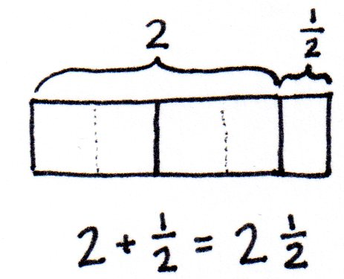
T: Answer in mixed units: 2 meters + 5 centimeters is…?
S: 2 meters 5 centimeters.
T: 2 hours + 5 minutes is…?
S: 2 hours 5 minutes.
T: 2 ones + 5 eighths is…?
S: 2 ones and 5 eighths.
MP.7
T: (Display 2 + $\frac{\text{1}}{\text{2}}\text{.}$) Draw a tape diagram to show 2 ones. To know how large to draw $\frac{\text{1}}{\text{2}}$, let’s partition each whole number into 2 halves.
T: (Demonstrate partitioning the 2 ones with dotted lines.)
T: Partition the ones and extend your model to add $\frac{\text{1}}{\text{2}}\text{.}$ Say a number sentence that adds the whole number to the fraction.
S: 2 + $\frac{\text{1}}{\text{2}}$= $\text{2}\frac{\text{1}}{\text{2}}$.
T: In this case, 2 ones plus 1 half gave us a sum that is a mixed number. We have seen mixed numbers often when working with measurement and place value, like when we added hundreds and tens, which are two different units.
Repeat the process with 3 + $\frac{\text{2}}{\text{3}}$ = $\text{3}\frac{\text{2}}{\text{3}}$.
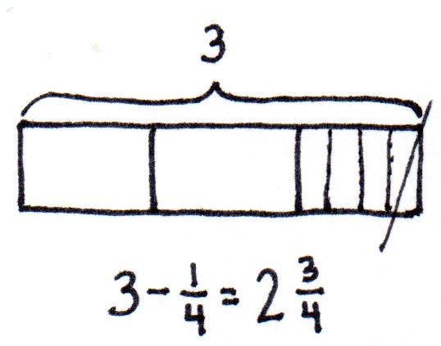
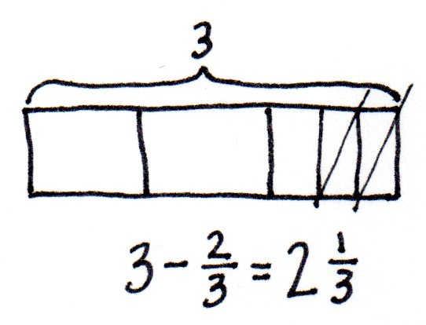
Problem 2: Subtract a fraction less than 1 from a whole number using a tape diagram.
T: (Display 3 – $\frac{\text{1}}{\text{4}}$.) Draw a tape diagram to represent 3, partitioned as 3 ones. Watch as I subtract $\frac{\text{1}}{\text{4}}$. (Partition a one into 4 parts. Cross off $\frac{\text{1}}{\text{4}}$. Trace along the tape diagram with your finger to count the remaining parts.)
T: What is remaining?
S: 2 and 3 fourths. 2 ones and 3 fourths.
T: Say the complete subtraction sentence.
S: 3 – $\frac{\text{1}}{\text{4}}$ = $\text{2}\frac{\text{3}}{\text{4}}$.
T: Subtract 3 – $\frac{\text{2}}{\text{3}}$. Draw a tape diagram with your partner. Discuss your drawing with your partner.
S: I drew a tape diagram 3 units long. I partitioned the last unit into thirds, and then I crossed off 2 thirds.
T: Say the entire number sentence.
S: 3 – $\frac{\text{2}}{\text{3}}$ = $\text{2}\frac{\text{1}}{\text{3}}$.
T: Discuss what you see happening to the number of ones when you subtract the fraction.
S: It gets smaller. There are fewer ones. If we started with 3, the answer was 2 and some parts. Right, so if we had a big number such as 391 – $\frac{\text{2}}{\text{3}}$, we know the whole number would be 1 less, 390, and some parts.

NOTES ON
MULTIPLE MEANS
OF REPRESENTATION:
Clarify for English language learners multiple meanings for the term whole. Whole can mean the total or sum as modeled in a number bond. Use whole number when referring to a unit in the ones, tens, hundreds, etc.

T: What relationship do you see between the fraction being subtracted and the fraction in the answer?
S: They are the same unit. They are part of one of the whole numbers. They add together to make 1. That’s why the whole number is 1 less in the answer. Right. In the last problem, we took away $\frac{\text{2}}{\text{3}}$ and the fraction in the answer was $\frac{\text{1}}{\text{3}}$. Those add to make 1.
Problem 3: Given three related numbers, form fact family facts.
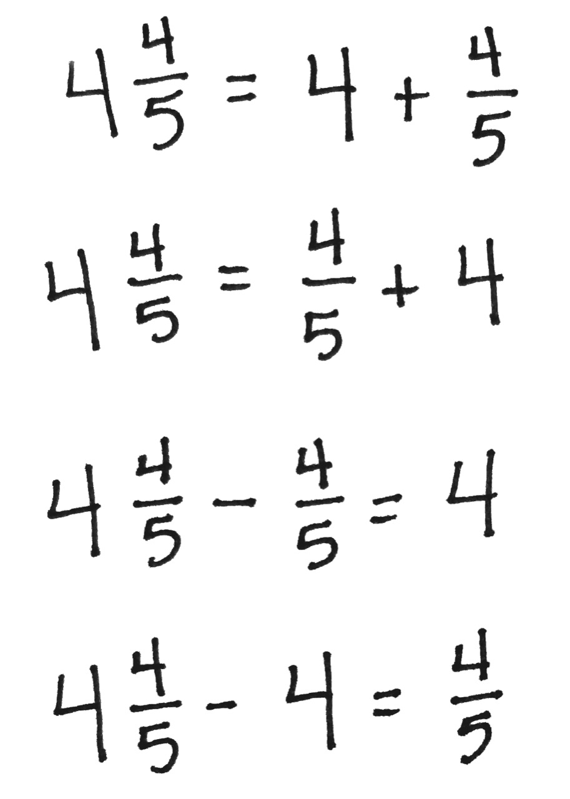
T: Write 4, $\text{4}\frac{\text{4}}{\text{5}}$, and $\frac{\text{4}}{\text{5}}$. These numbers are related. Draw a number bond to show the whole and the parts. Write two addition facts and two subtraction facts that use 4, $\text{4}\frac{\text{4}}{\text{5}}$, and $\frac{\text{4}}{\text{5}}$. Make a choice as to whether to write your sums and differences to the right or to the left of the equal sign.
S: 4 + $\frac{\text{4}}{\text{5}}$ = $\text{4}\frac{\text{4}}{\text{5}}$. $\frac{\text{4}}{\text{5}}$ + 4 = $\text{4}\frac{\text{4}}{\text{5}}$. $\text{4}\frac{\text{4}}{\text{5}}$ – $\frac{4}{5}$ = 4. $\text{4}\frac{\text{4}}{\text{5}}$ – 4 = $\frac{\text{4}}{\text{5}}$.
T: We can add and subtract ones and fractions just like we have always done. One number represents the whole, and the other two numbers represent the parts. For each of the following sets of related numbers, write two addition facts and two subtraction facts.
$\frac{\text{3}}{\text{4}}$, $\text{6}\frac{\text{3}}{\text{4}}\text{,}$6 5, $\text{4}\frac{\text{1}}{\text{3}}\text{,} \frac{\text{2}}{\text{3}}$ $\frac{\text{2}}{\text{5}}$, $\text{4}\frac{\text{3}}{\text{5}}$, 5
Problem 4: Subtract a fraction less than 1 from a whole number using decomposition.
T: Write the expression 5 – $\frac{\text{1}}{\text{4}}$. Discuss a strategy for solving this problem with your partner.
S: We can rename 1 one as 4 fourths, so we have $\text{4}\frac{\text{4}}{\text{4}}$ – $\frac{\text{1}}{\text{4}}$. We can make a mixed number so the total is 4 and a fraction. It’s like unbundling a ten to subtract some ones.
T: Draw a number bond for 5 decomposed into two parts, 4 and 4 fourths or 4 and 1. (Allow students time to draw the bond.)

T: Construct a number line to represent 5 – $\frac{\text{1}}{\text{4}}$with 4 and 5 as endpoints. We are subtracting from $\frac{\text{4}}{\text{4}}$, so our answer will be more than 4 and less than 5. Draw an arrow to represent 5 – $\frac{\text{1}}{\text{4}}\text{.}$ Write the number sentence under your number line.
S: (Write 5 – $\frac{\text{1}}{\text{4}}$ = $\text{4}\frac{\text{3}}{\text{4}}\text{.}$)
T: Subtract 7 – $\frac{\text{3}}{\text{5}}$. Solve with your partner, drawing a number bond and number line. (Allow students time to solve.)
T: Let’s show your thinking using a number sentence. 7 decomposed is…?
S: 6 and $\frac{\text{5}}{\text{5}}$.
T: (Record the bond under the number sentence.) How many ones remain?
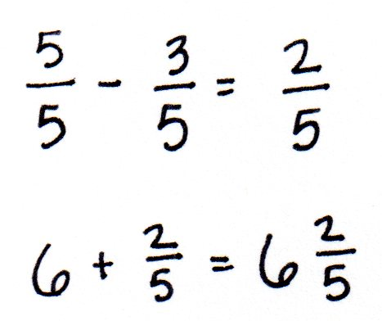
S: 6.
T: (Record 6 in the number sentence.) $\frac{\text{5}}{\text{5}}$ – $\frac{\text{3}}{\text{5}}$ is…?
S: $\frac{\text{2}}{\text{5}}$.
T: So, $\frac{\text{2}}{\text{5}}$ remains. Add that to 6. The difference is…?
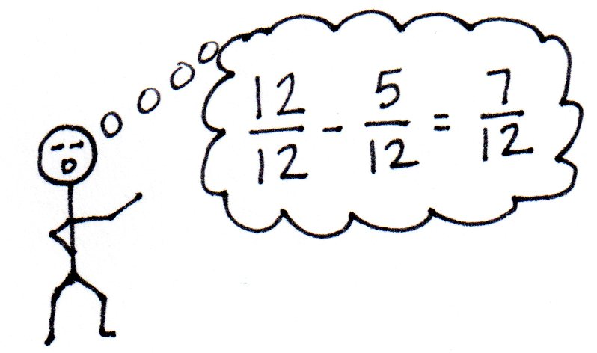
S: $\text{6}\frac{\text{2}}{\text{5}}$.
T: Subtract 9 – $\frac{\text{5}}{\text{12}}$. Twelfths are a lot to partition on a number line. Solve this using just a number sentence and a number bond to decompose the total.
S: 9 – $\frac{\text{5}}{\text{12}}$= $\text{8}\frac{\text{7}}{\text{12}}$.
Problem Set (10 minutes)
Students should do their personal best to complete the Problem Set within the allotted 10 minutes. For some classes, it may be appropriate to modify the assignment by specifying which problems they work on first. Some problems do not specify a method for solving. Students should solve these problems using the RDW approach used for Application Problems.
Student Debrief (10 minutes)
Lesson Objective: Add a fraction less than 1 to, or subtract a fraction less than 1 from, a whole number using decomposition and visual models.
The Student Debrief is intended to invite reflection and active processing of the total lesson experience.
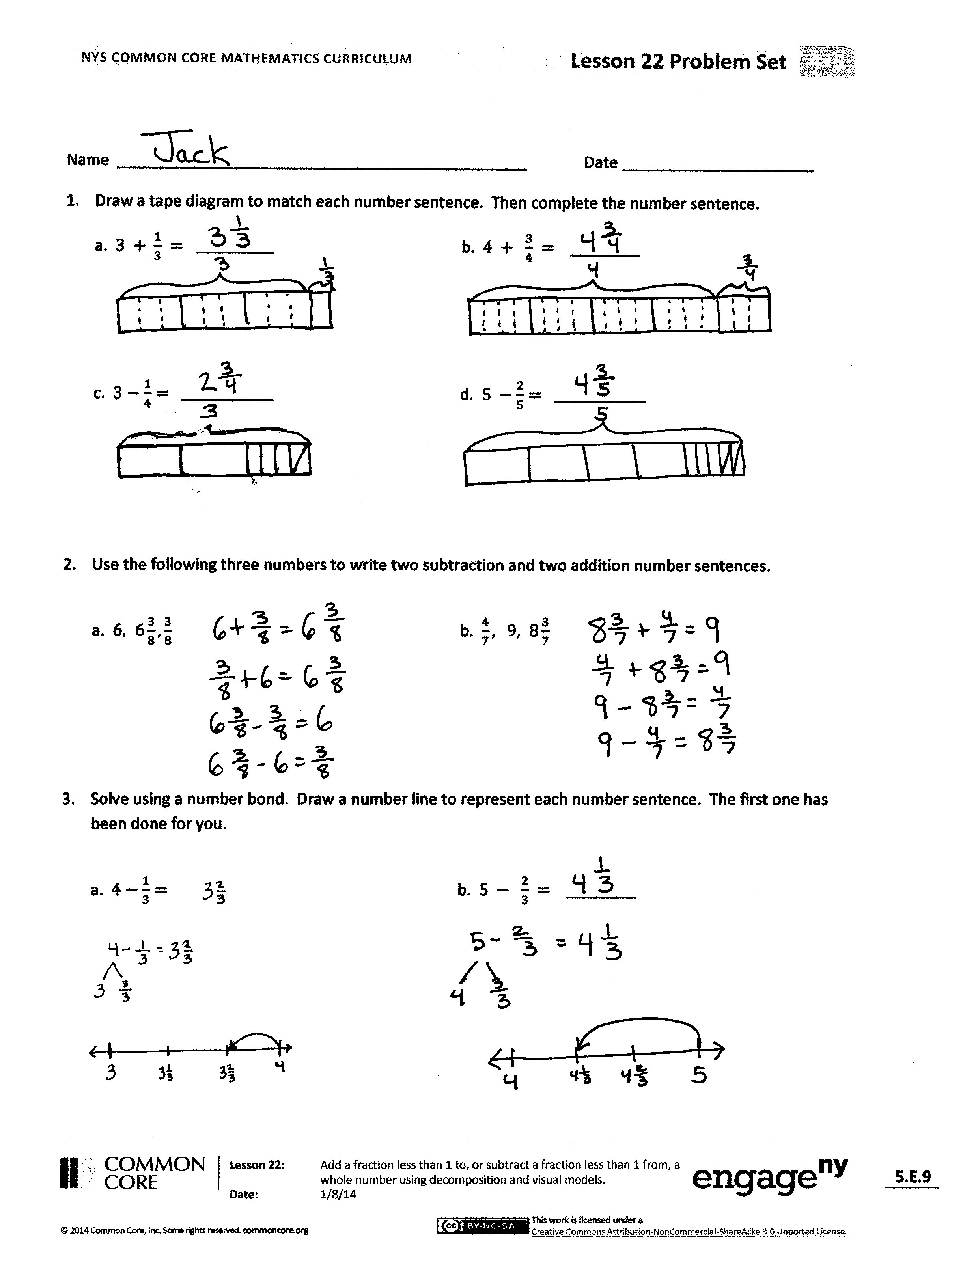
Invite students to review their solutions for the Problem Set. They should check work by comparing answers with a partner before going over answers as a class. Look for misconceptions or misunderstandings that can be addressed in the Debrief. Guide students in a conversation to debrief the Problem Set and process the lesson.
Any combination of the questions below may be used to lead the discussion.
- Why is it necessary to decompose the total into ones and a fraction before subtracting? How does that relate to a subtraction problem such as 74 – 28?
- How did knowing how to subtract a fraction from 1 prepare you for this lesson?
- Describe how the whole number is decomposed to subtract a fraction. Use Problem 3(b) to discuss.
- How were number lines and number bonds helpful in representing how to find the difference?
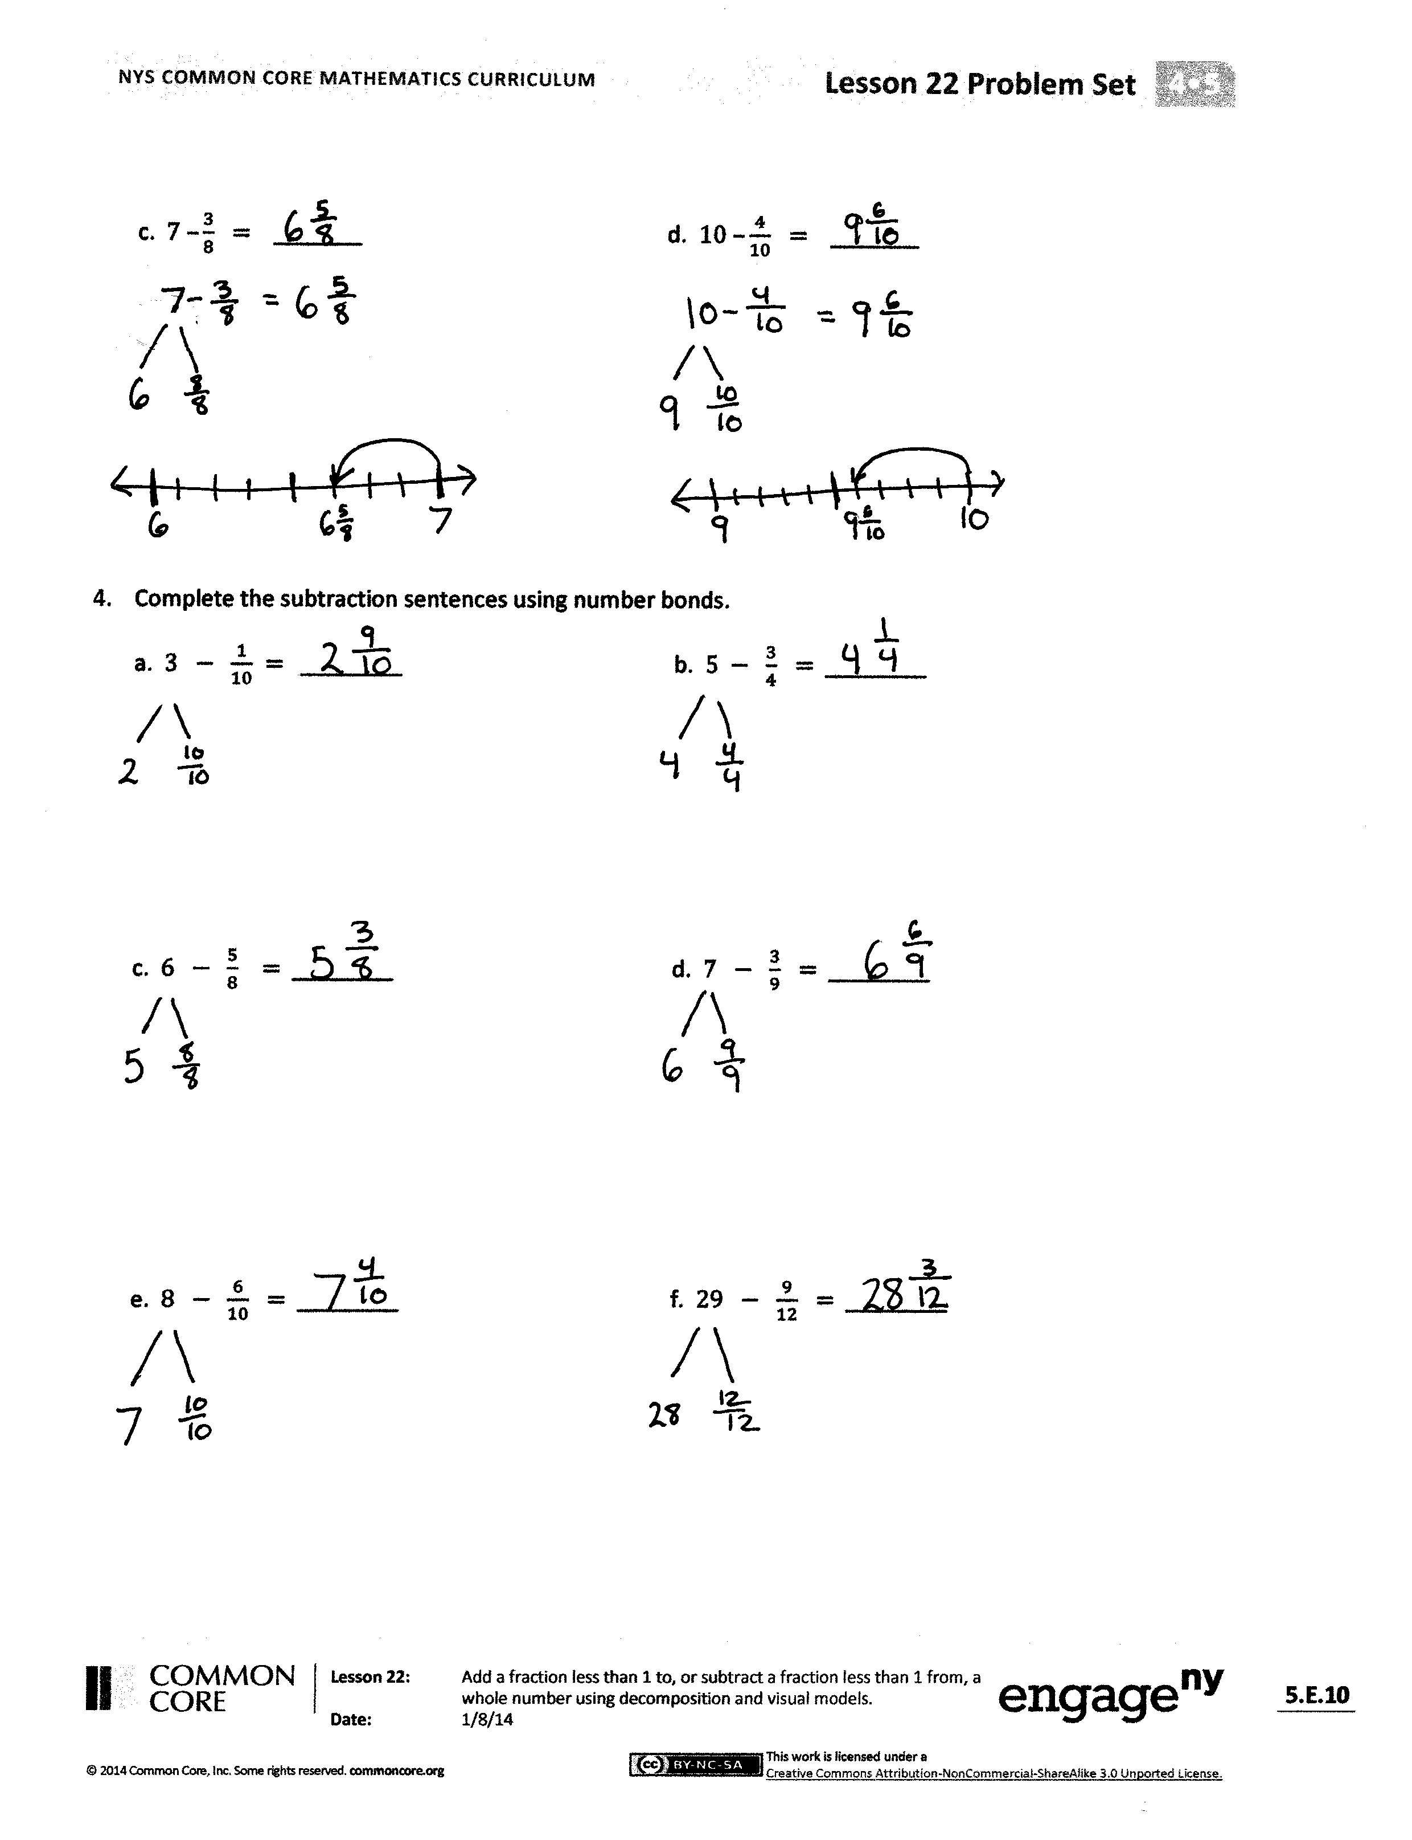
- How did the Application Problem connect to today’s lesson?
Exit Ticket (3 minutes)
After the Student Debrief, instruct students to complete the Exit Ticket. A review of their work will help with assessing students’ understanding of the concepts that were presented in today’s lesson and planning more effectively for future lessons. The questions may be read aloud to the students.
A
Number Correct: _______
Add Fractions
 | 1 + 1 = |  |  |  | $\frac{ 2 }{5} + \frac{ 2 }{5} + \frac{ 2 }{5} =$ | 1 $\frac{}{5}$
 | $\frac{ 1 }{5} + \frac{ 1 }{5} =$ |  |  |  | 3 + 3 + 3 =
 | 2 + 1 = |  |  |  | $\frac{ 3 }{8} + \frac{ 3 }{8} + \frac{ 3 }{8} =$ | eighths
 | $\frac{ 2 }{5} + \frac{ 1 }{5} =$ |  |  |  | $\frac{ 3 }{8} + \frac{ 3 }{8} + \frac{ 3 }{8} =$ | 1 $\frac{}{8}$
 | 2 + 2 = |  |  |  | $\frac{ 5 }{8} + \frac{ 5 }{8} + \frac{ 5 }{8} =$ | 1 $\frac{}{8}$
 | $\frac{ 2 }{5} + \frac{ 2 }{5} =$ |  |  |  | 1 + 1 + 1 =
 | 3 + 2 = |  |  |  | $\frac{ 1 }{2} + \frac{ 1 }{2} + \frac{ 1 }{2} =$ | halves
 | $\frac{ 3 }{5} + \frac{ 2 }{5} =$ | fifths |  |  | $\frac{ 1 }{2} + \frac{ 1 }{2} + \frac{ 1 }{2} =$ | 1 $\frac{}{2}$
 | $\frac{ 5 }{5} =$ |  |  |  | 4 + 4 + 4 =
 | $\frac{ 3 }{5} + \frac{ 2 }{5} =$ |  |  |  | $\frac{ 4 }{10} + \frac{ 4 }{10} + \frac{ 4 }{10} =$ | tenths
 | 3 + 2 = |  |  |  | $\frac{ 4 }{10} + \frac{ 4 }{10} + \frac{ 4 }{10} =$ | 1 $\frac{}{10}$
 | $\frac{ 3 }{8} + \frac{ 2 }{8} =$ |  |  |  | $\frac{ 6 }{10} + \frac{ 6 }{10} + \frac{ 6 }{10} =$ | 1 $\frac{}{10}$
 | 3 + 2 + 2 = |  |  |  | 2 + 2 + 2 =
 | $\frac{ 3 }{8} + \frac{ 2 }{8} + \frac{ 2 }{8} =$ |  |  |  | $\frac{ 2 }{6} + \frac{ 2 }{6} + \frac{ 2 }{6} =$ | sixths
 | $\frac{ 3 }{8} + \frac{ 3 }{8} + \frac{ 2 }{8} =$ | eighths |  |  | $\frac{ 2 }{6} + \frac{ 2 }{6} + \frac{ 2 }{6} =$
 | $\frac{ 8 }{8} =$ |  |  |  | $\frac{ 3 }{6} + \frac{ 3 }{6} + \frac{ 3 }{6} =$ | 1 $\frac{}{6}$
 | $\frac{ 3 }{8} + \frac{ 3 }{8}+ \frac{ 2 }{8} =$ |  |  |  | $\frac{ 5 }{12} + \frac{ 2 }{12} + \frac{ 4 }{12} =$
 | 2 + 1 + 1 = |  |  |  | $\frac{ 4 }{12} + \frac{ 4 }{12} + \frac{ 4 }{12} =$
 | $\frac{ 2 }{3} + \frac{ 1 }{3} + \frac{ 1 }{3} =$ | thirds |  |  | $\frac{ 5 }{12} + \frac{ 5 }{12} + \frac{ 7 }{12} =$ | 1 $\frac{}{12}$
 | $\frac{ 2 }{3} + \frac{ 1 }{3} + \frac{ 1 }{3} =$ | 1 $\frac{}{3}$ |  |  | $\frac{ 7 }{12} + \frac{ 9 }{12} + \frac{ 7 }{12} =$ | 1 $\frac{}{12}$
 | 2 + 2 + 2 = |  |  |  | $\frac{ 7 }{15} + \frac{ 8 }{15} + \frac{ 7 }{15} =$ | 1 $\frac{}{15}$
 | $\frac{ 2 }{5} + \frac{ 2 }{5} + \frac{ 2 }{5} =$ | fifths |  |  | $\frac{ 12 }{15} + \frac{ 8 }{15} + \frac{ 9 }{15} =$ | 1 $\frac{}{15}$
B
[KEY]

Number Correct: _______
Improvement: _______
Add Fractions
 | 1 + 1 = |  |  |  | $\frac{3}{8} + \frac{3}{8} + \frac{3}{8} =$ | 1 $\frac{}{8}$
 | $\frac{1}{6} + \frac{1}{6} =$ |  |  |  | 1 + 1 + 1 =
 | 3 + 1 = |  |  |  | $\frac{1}{2} + \frac{1}{2} + \frac{1}{2} =$ | halves
 | $\frac{3}{6} + \frac{1 }{6} =$ |  |  |  | $\frac{1}{2} + \frac{1}{2} + \frac{1}{2} =$ | 1 $\frac{}{2}$
 | 3 + 2 = |  |  |  | 2 + 2 + 2 =
 | $\frac{3}{6} + \frac{2}{6} =$ |  |  |  | $\frac{2}{5} + \frac{2}{5} + \frac{2}{5} =$ | fifths
 | 4 + 2 = |  |  |  | $\frac{2}{5} + \frac{2}{5} + \frac{2}{5} =$ | 1 $\frac{}{5}$
 | $\frac{4}{6} + \frac{2}{6} =$ | sixths |  |  | $\frac{3}{5} + \frac{3}{5} + \frac{3}{5} =$ | 1 $\frac{}{5}$
 | $\frac{6}{6} =$ |  |  |  | 6 + 6 + 6 =
 | $\frac{4}{6} + \frac{2}{6} =$ |  |  |  | $\frac{6}{10} + \frac{6}{10} + \frac{6}{10} =$ | tenths
 | 5 + 2 = |  |  |  | $\frac{6}{10} + \frac{6}{10} + \frac{6}{10} =$ | 1 $\frac{}{10}$
 | $\frac{5}{8} + \frac{2}{8} =$ |  |  |  | $\frac{5}{10} + \frac{5}{10} + \frac{5}{10} =$ | 1 $\frac{}{10}$
 | 5 + 1 + 1 = |  |  |  | 2 + 2 + 2 =
 | $\frac{5}{8} + \frac{1}{8} + \frac{1}{8} =$ |  |  |  | $\frac{2}{6} + \frac{2}{6} + \frac{2}{6} =$ | sixths
 | $\frac{5}{8} + \frac{2}{8} + \frac{1}{8} =$ | eighths |  |  | $\frac{2}{6} + \frac{2}{6} + \frac{2}{6} =$
 | $\frac{8}{8} =$ |  |  |  | $\frac{3}{6} + \frac{3}{6} + \frac{3}{6} =$ | 1 $\frac{}{6}$
 | $\frac{3}{8} + \frac{3}{8}+ \frac{2}{8} =$ |  |  |  | $\frac{5}{12} + \frac{3}{12} + \frac{3}{12} =$
 | 1+ 1 + 2 = |  |  |  | $\frac{5}{12} + \frac{5}{12} + \frac{2}{12} =$
 | $\frac{1}{3} + \frac{1}{3} + \frac{2}{3} =$ | thirds |  |  | $\frac{6}{12} + \frac{5}{12} + \frac{6}{12} =$ | 1 $\frac{}{12}$
 | $\frac{1}{3} + \frac{1}{3} + \frac{2}{3} =$ | 1 $\frac{}{3}$ |  |  | $\frac{8}{12} + \frac{10}{12} + \frac{5}{12} =$ | 1 $\frac{}{12}$
 | 3 + 3 + 3 = |  |  |  | $\frac{7}{15} + \frac{7}{15} + \frac{8}{15} =$ | 1 $\frac{}{15}$
 | $\frac{3}{8} + \frac{3}{8} + \frac{3}{8} =$ | eighths |  |  | $\frac{13}{15} + \frac{9}{15} + \frac{7}{15} =$ | 1 $\frac{}{15}$

Name Date
- Draw a tape diagram to match each number sentence. Then, complete the number sentence.
a. $3 + \frac{1}{3} = ____________$ | b. $4 + \frac{3}{4} =$ ________
c. $3-\frac{1}{4}= ______________$ | d. $5-\frac{2}{5}= ______________$

- Use the following three numbers to write two subtraction and two addition number sentences.
a. $6, 6\frac{3}{8}, \frac{3}{8}$ | b. $\frac{4}{7}, 9, 8\frac{3}{7}$
- Solve using a number bond. Draw a number line to represent each number sentence. The first one has been done for you.
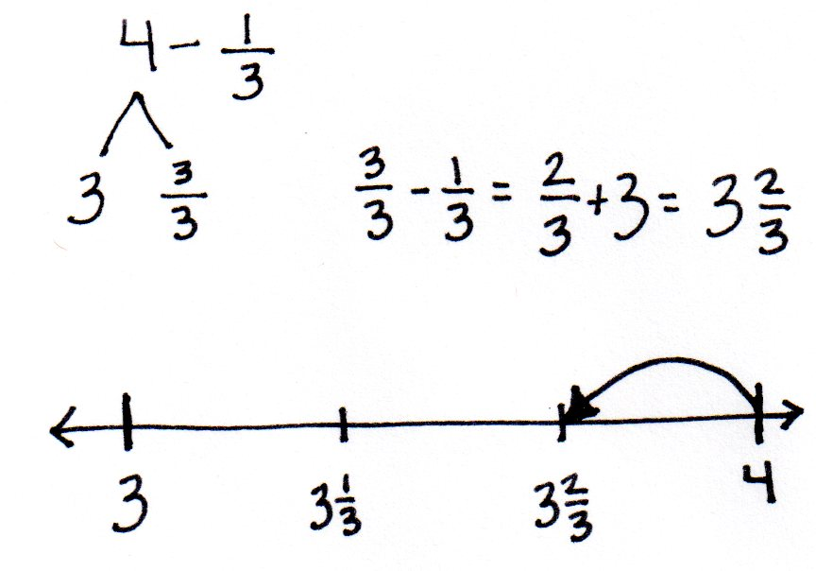  a. $4-\frac{1}{3}=$ | b. $5- \frac{2}{3} =$________
c. $7 - \frac{3}{8} =$ _______ | d. $10 - \frac{4}{10} =$ _______

- Complete the subtraction sentences using number bonds.
a. $3-\frac{1}{10} =$________ b. $5 - \frac{3}{4} =$ ________

c. $6-\frac{5}{8} =$ ________ d. $7-\frac{3}{9} =$________

e. $8-\frac{6}{10} =$________ f. $29-\frac{9}{12} =$________

Name Date
Complete the subtraction sentences using number bonds. Draw a model if needed.
- $6-\frac{1}{5} =$________

- 8$-\frac{5}{6} =$________

- $7-\frac{5}{8} =$ ________

Name Date
- Draw a tape diagram to match each number sentence. Then, complete the number sentence.
a. $2 + \frac{1}{4} = ____________$ | b. $3 + \frac{2}{3} =$ ________
c. $2-\frac{1}{5}= ______________$ | d. $3-\frac{3}{4}= ______________$

- Use the following three numbers to write two subtraction and two addition number sentences.
a. $4, 4\frac{5}{8}, \frac{5}{8}$ | b. $\frac{2}{7}, 5\frac{5}{7}, 6$

- Solve using a number bond. Draw a number line to represent each number sentence. The first one has been done for you.
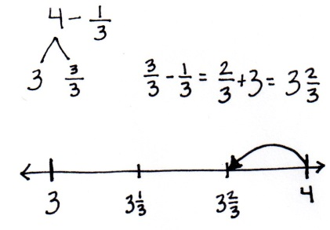  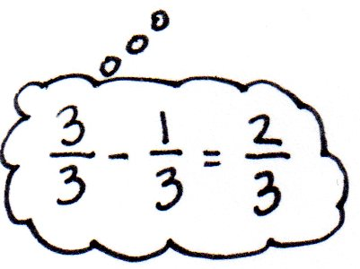  a. $4-\frac{1}{3}=$ | b. 8$- \frac{5}{6} =$________
c. $7 –\frac{4}{5} =$ _______ | d. $3 –\frac{3}{10} =$ _______
- Complete the subtraction sentences using number bonds.
a. $6-\frac{1}{4} =$________ b. $7-\frac{2}{10} =$ ________

c. $5-\frac{5}{6} =$ ________ d. $6-\frac{6}{8} =$________

e. $3-\frac{7}{8} =$________ f. $26-\frac{7}{10} =$________

