Lesson 21
Objective: Use visual models to add two fractions with related units using the denominators 2, 3, 4, 5, 6, 8, 10, and 12.

Suggested Lesson Structure

A NOTE ON
STANDARDS ALIGNMENT:
In Lesson 21, students will add fractions with related denominators where one denominator is a factor of the other. Students are able to generate equivalent fractions (4.NF.1) from their work in Topic B. It is a natural progression for students to be exposed to finding sums of fractions with unlike but related denominators where one denominator is a factor of the other. In Grade 5, students will find sums and differences of fractions with unlike and unrelated denominators (5.NF.1). Lessons 20 and 21 prepare students to work with decimals in Module 6 where students will add two fractions with like denominators of 100 (4.NBT.5).

 Fluency Practice (12 minutes)
 Application Problem (5 minutes)
 Concept Development (33 minutes)
 Student Debrief (10 minutes)
Total Time (60 minutes)
Fluency Practice (12 minutes)
- Sprint: Subtract Fractions 4.NF.3 (9 minutes)
- Add Fractions 4.NF.3 (3 minutes)
Sprint: Subtract Fractions (9 minutes)
Materials: (S) Subtract Fractions Sprint
Note: This fluency activity reviews Lesson 17. In the Sprint’s final quadrant, starting at Problem 31, there are a few problems which can be simplified (31, 32, 36, 37, 40, 41, and 43). Because both answers are correct, simply read both answers.
Add Fractions (3 minutes)
Materials: (S) Personal white board
Note: This fluency activity reviews Lesson 18.
T: (Write $\frac{\text{5}}{\text{10}}$ + $\frac{\text{3}}{\text{10}}$ + $\frac{\text{1}}{\text{10}}$ = $\frac{}{\text{10}}.$) On your personal white boards, write the complete number sentence.
S: (Write $\frac{\text{5}}{\text{10}}$ + $\frac{\text{3}}{\text{10}}$ + $\frac{\text{1}}{\text{10}}$ = $\frac{\text{9}}{\text{10}}.$)
T: (Write $\frac{\text{5}}{\text{8}}$ + $\frac{\text{2}}{\text{8}}$ + $\frac{\text{1}}{\text{8}}$ = $\frac{}{\text{8}}.$) Write the complete number sentence.
S: (Write $\frac{\text{5}}{\text{8}}$ + $\frac{\text{2}}{\text{8}}$ + $\frac{\text{1}}{\text{8}}$ = $\frac{\text{8}}{\text{8}}.$)
T: (Write $\frac{\text{5}}{\text{8}}$ + $\frac{\text{2}}{\text{8}}$ + $\frac{\text{1}}{\text{8}}$ = $\frac{\text{8}}{\text{8}}.$) Rename 8 eighths as a whole number.
S: (Write $\frac{\text{5}}{\text{8}}$ + $\frac{\text{2}}{\text{8}}$ + $\frac{\text{1}}{\text{8}}$ = $\frac{\text{8}}{\text{8}}$ = 1.)
Continue the process with $\frac{\text{2}}{\text{6}}$ + $\frac{\text{3}}{\text{6}}$ + $\frac{\text{1}}{\text{6}}$.
T: (Write $\frac{\text{2}}{\text{3}}$ + $\frac{\text{1}}{\text{3}}$ + $\frac{\text{2}}{\text{3}}$ = $\frac{}{\text{3}}.$) Complete the equation.
S: (Write $\frac{\text{2}}{\text{3}}$ + $\frac{\text{1}}{\text{3}}$ + $\frac{\text{2}}{\text{3}}$ = $\frac{\text{5}}{\text{3}}.$)
T: How many thirds are in 1?
S: 3 thirds.
T: Write $\frac{\text{5}}{\text{3}}$ as a mixed number.
S: (Write $\frac{\text{2}}{\text{3}}$ + $\frac{\text{1}}{\text{3}}$ + $\frac{\text{2}}{\text{3}}$ = $\frac{\text{5}}{\text{3}}$ = $\text{1}\frac{\text{2}}{\text{3}}$.)
Continue the process with $\frac{\text{5}}{\text{8}}$ + $\frac{\text{5}}{\text{8}}$ + $\frac{\text{5}}{\text{8}}$.
Application Problem (5 minutes)
Two-fifths liter of chemical A was added to $\frac{\text{7}}{\text{10}}$ liter of chemical B to make chemical C. How many liters of chemical C are there?

Note: This Application Problem builds on the work of Lesson 20 where students learned to add two fractions with related units. This Application Problem bridges to today’s lesson where students will again add two fractions with related units, but this time, they will use number bonds to write the sums as mixed numbers.
Concept Development (33 minutes)
Materials: (S) Personal white board
Problem 1: Add two fractions with related units modeled with a tape diagram. Use a number bond to rename the sum as a mixed number.
T: Solve $\frac{\text{3}}{\text{8}}$ + $\frac{\text{3}}{\text{4}}.$ Work with your partner to draw tape diagrams to represent each fraction. Decompose the larger unit into smaller units as we did in Lesson 20. Solve and write a complete number sentence to show your answer. Explain the process that you used.
S: (Write $\frac{\text{3}}{\text{8}}$ + $\frac{\text{6}}{\text{8}}$ = $\frac{\text{9}}{\text{8}}$.) We drew tape diagrams to show eighths and fourths and then shaded in $\frac{\text{3}}{\text{8}}$ of one and $\frac{\text{3}}{\text{4}}$ of the other. We decomposed the larger unit of fourths into eighths and found that $\frac{\text{3}}{\text{4}}$ = $\frac{\text{6}}{\text{8}}$.
T: Is $\frac{\text{9}}{\text{8}}$ greater than 1 or less than 1?
S: It’s greater than 1. Since $\frac{\text{8}}{\text{8}}$ is equal to 1, $\frac{\text{9}}{\text{8}}$ is greater than 1.
T: Draw a number bond to show $\frac{\text{9}}{\text{8}}$as a whole and $\frac{\text{8}}{\text{8}}$ as a part.
S: (Draw a number bond as shown to the right.)
T: In your complete number sentence, show the mixed number equal to $\frac{9}{8}$.
S: (Write $\frac{\text{3}}{\text{8}}$ + $\frac{\text{6}}{\text{8}}$ = $\frac{\text{9}}{\text{8}}$ = $\text{1}\frac{\text{1}}{\text{8}}$.)
Repeat with $\frac{\text{2}}{\text{5}}$ + $\frac{\text{7}}{\text{10}}$ from the Application Problem, drawing the number bond to name the mixed number.
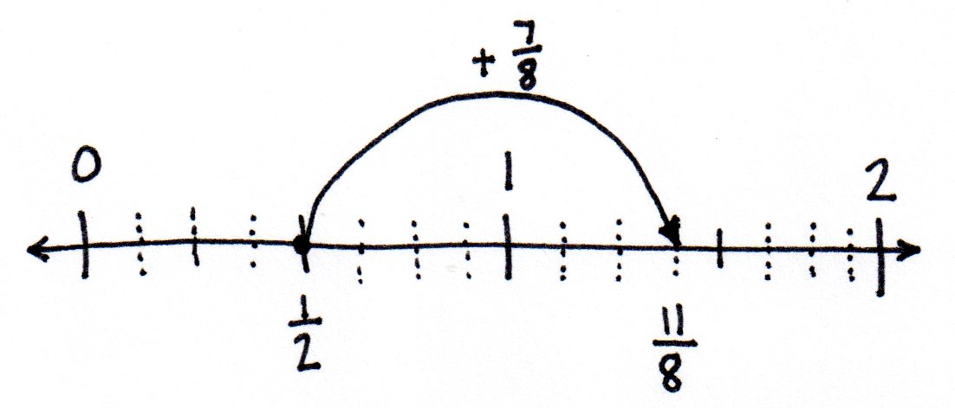
Problem 2: Add two fractions with related units using a number line and number bonds. Use a number bond to rename the sum as a mixed number.
T: Write $\frac{\text{1}}{\text{2}}$ + $\frac{\text{7}}{\text{8}}.$
T: Will the sum be greater or less than 1?
S: Greater.
T: Draw a number line, labeling the whole numbers and the larger units. Decompose the larger units to show the smaller units. Show the addition with arrows, and then, write a number sentence. (Allow students time to work.)

NOTES ON
MULTIPLE MEANS
OF REPRESENTATION:
Ease the task of speaking in English to review the process of adding $\frac{\text{1}}{\text{2}}\text{+}\frac{\text{7}}{\text{8}}$ for English language learners by providing sentence frames. However, if students are otherwise unable to fully express themselves, allow discussion in their first language, or if writing is easier, have students journal.
T: With your partner, review the process you used.
S: We estimated that the sum would be greater than 1, since we were adding a half to a fraction greater than
1 half. We drew a number line from 0 to 2 and then labeled the whole numbers. Halves are the larger unit, so we marked and labeled 1 half. Then, we marked the intervals for the eighths. We drew an arrow to show $\frac{\text{1}}{\text{2}}$ + $\frac{\text{7}}{\text{8}}$. $\frac{\text{4}}{\text{8}}$ + $\frac{\text{7}}{\text{8}}$ = $\frac{\text{11}}{\text{8}}.$ $\frac{\text{1}}{\text{2}}$ + $\frac{\text{7}}{\text{8}}$ = $\frac{\text{11}}{\text{8}}.$
T: Draw a number bond to rename $\frac{\text{11}}{\text{8}}$as a mixed number. Write the mixed number in the complete number sentence.
S: (Draw a number bond as shown to the right. Write $\frac{\text{11}}{\text{8}}$ = $\frac{\text{8}}{\text{8}}$ + $\frac{\text{3}}{\text{8}}$ = $\text{1}\frac{\text{3}}{\text{8}}$.)
Repeat with $\frac{\text{5}}{\text{6}}$ + $\frac{\text{2}}{\text{3}}$.
Problem 3: Add two fractions with related units without using a model. Express the answer as a mixed number.
T: Write $\frac{\text{3}}{\text{4}}$ + $\frac{\text{6}}{\text{8}}.$ With a partner, determine the sum of $\frac{\text{3}}{\text{4}}$ and $\frac{\text{6}}{\text{8}}$ by converting to equivalent fractions. Explain the process that you used.
S: (Write $\frac{\text{3}}{\text{4}}$ = $\frac{\text{3} \text{×} \text{2}}{\text{4} \text{×} \text{2}}$ = $\frac{\text{6}}{\text{8}}$ and $\frac{\text{6}}{\text{8}}$ + $\frac{\text{6}}{\text{8}}$ = $\frac{\text{12}}{\text{8}}.$ Explain the process.)
T: Express $\frac{\text{12}}{\text{8}}$ as a mixed number using a number bond.
S: (Draw a number bond as shown to the right.
Write $\frac{\text{12}}{\text{8}}$ = $\frac{\text{8}}{\text{8}}$ + $\frac{\text{4}}{\text{8}}$ = $\text{1}\frac{\text{4}}{\text{8}}.$)
Problem Set (10 minutes)
Students should do their personal best to complete the Problem Set within the allotted 10 minutes. For some classes, it may be appropriate to modify the assignment by specifying which problems they work on first. Some problems do not specify a method for solving. Students should solve these problems using the RDW approach used for Application Problems.
Student Debrief (10 minutes)
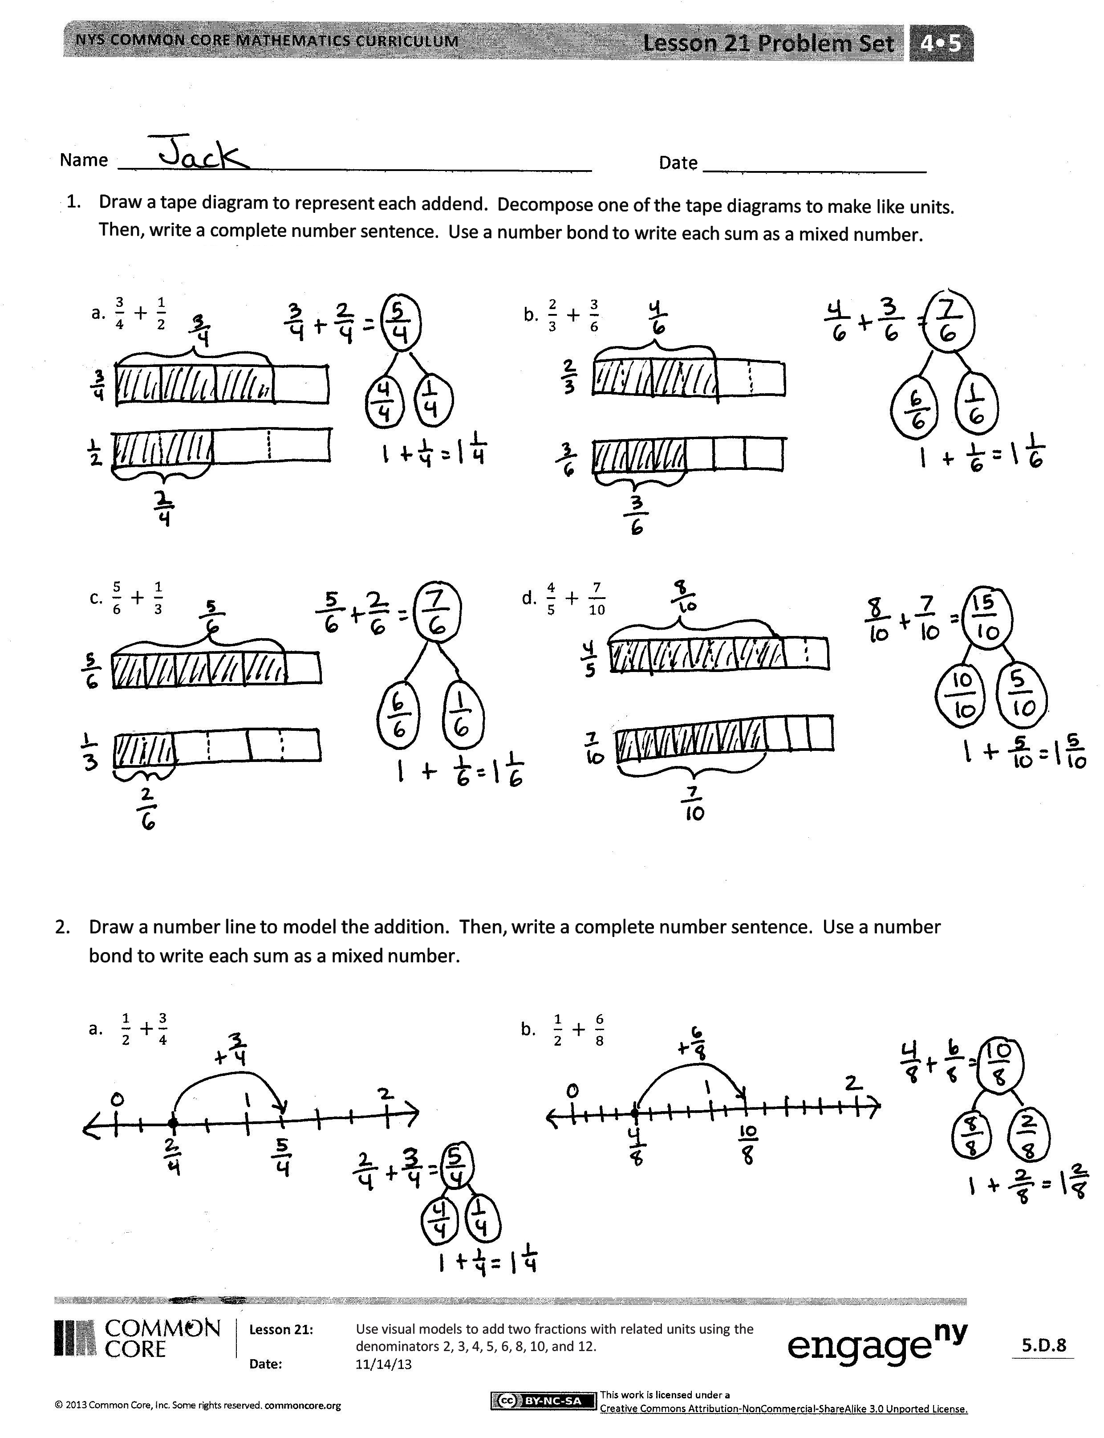
Lesson Objective: Use visual models to add two fractions with related units using the denominators 2, 3, 4, 5, 6, 8, 10, and 12.
The Student Debrief is intended to invite reflection and active processing of the total lesson experience.
Invite students to review their solutions for the Problem Set. They should check work by comparing answers with a partner before going over answers as a class. Look for misconceptions or misunderstandings that can be addressed in the Debrief. Guide students in a conversation to debrief the Problem Set and process the lesson.
Any combination of the questions below may be used to lead the discussion.
- What was the complexity of the Problem Set for today’s lesson (Lesson 21) as compared to yesterday’s Problem Set (Lesson 20)?
- How do number bonds help to show fractions as mixed numbers?
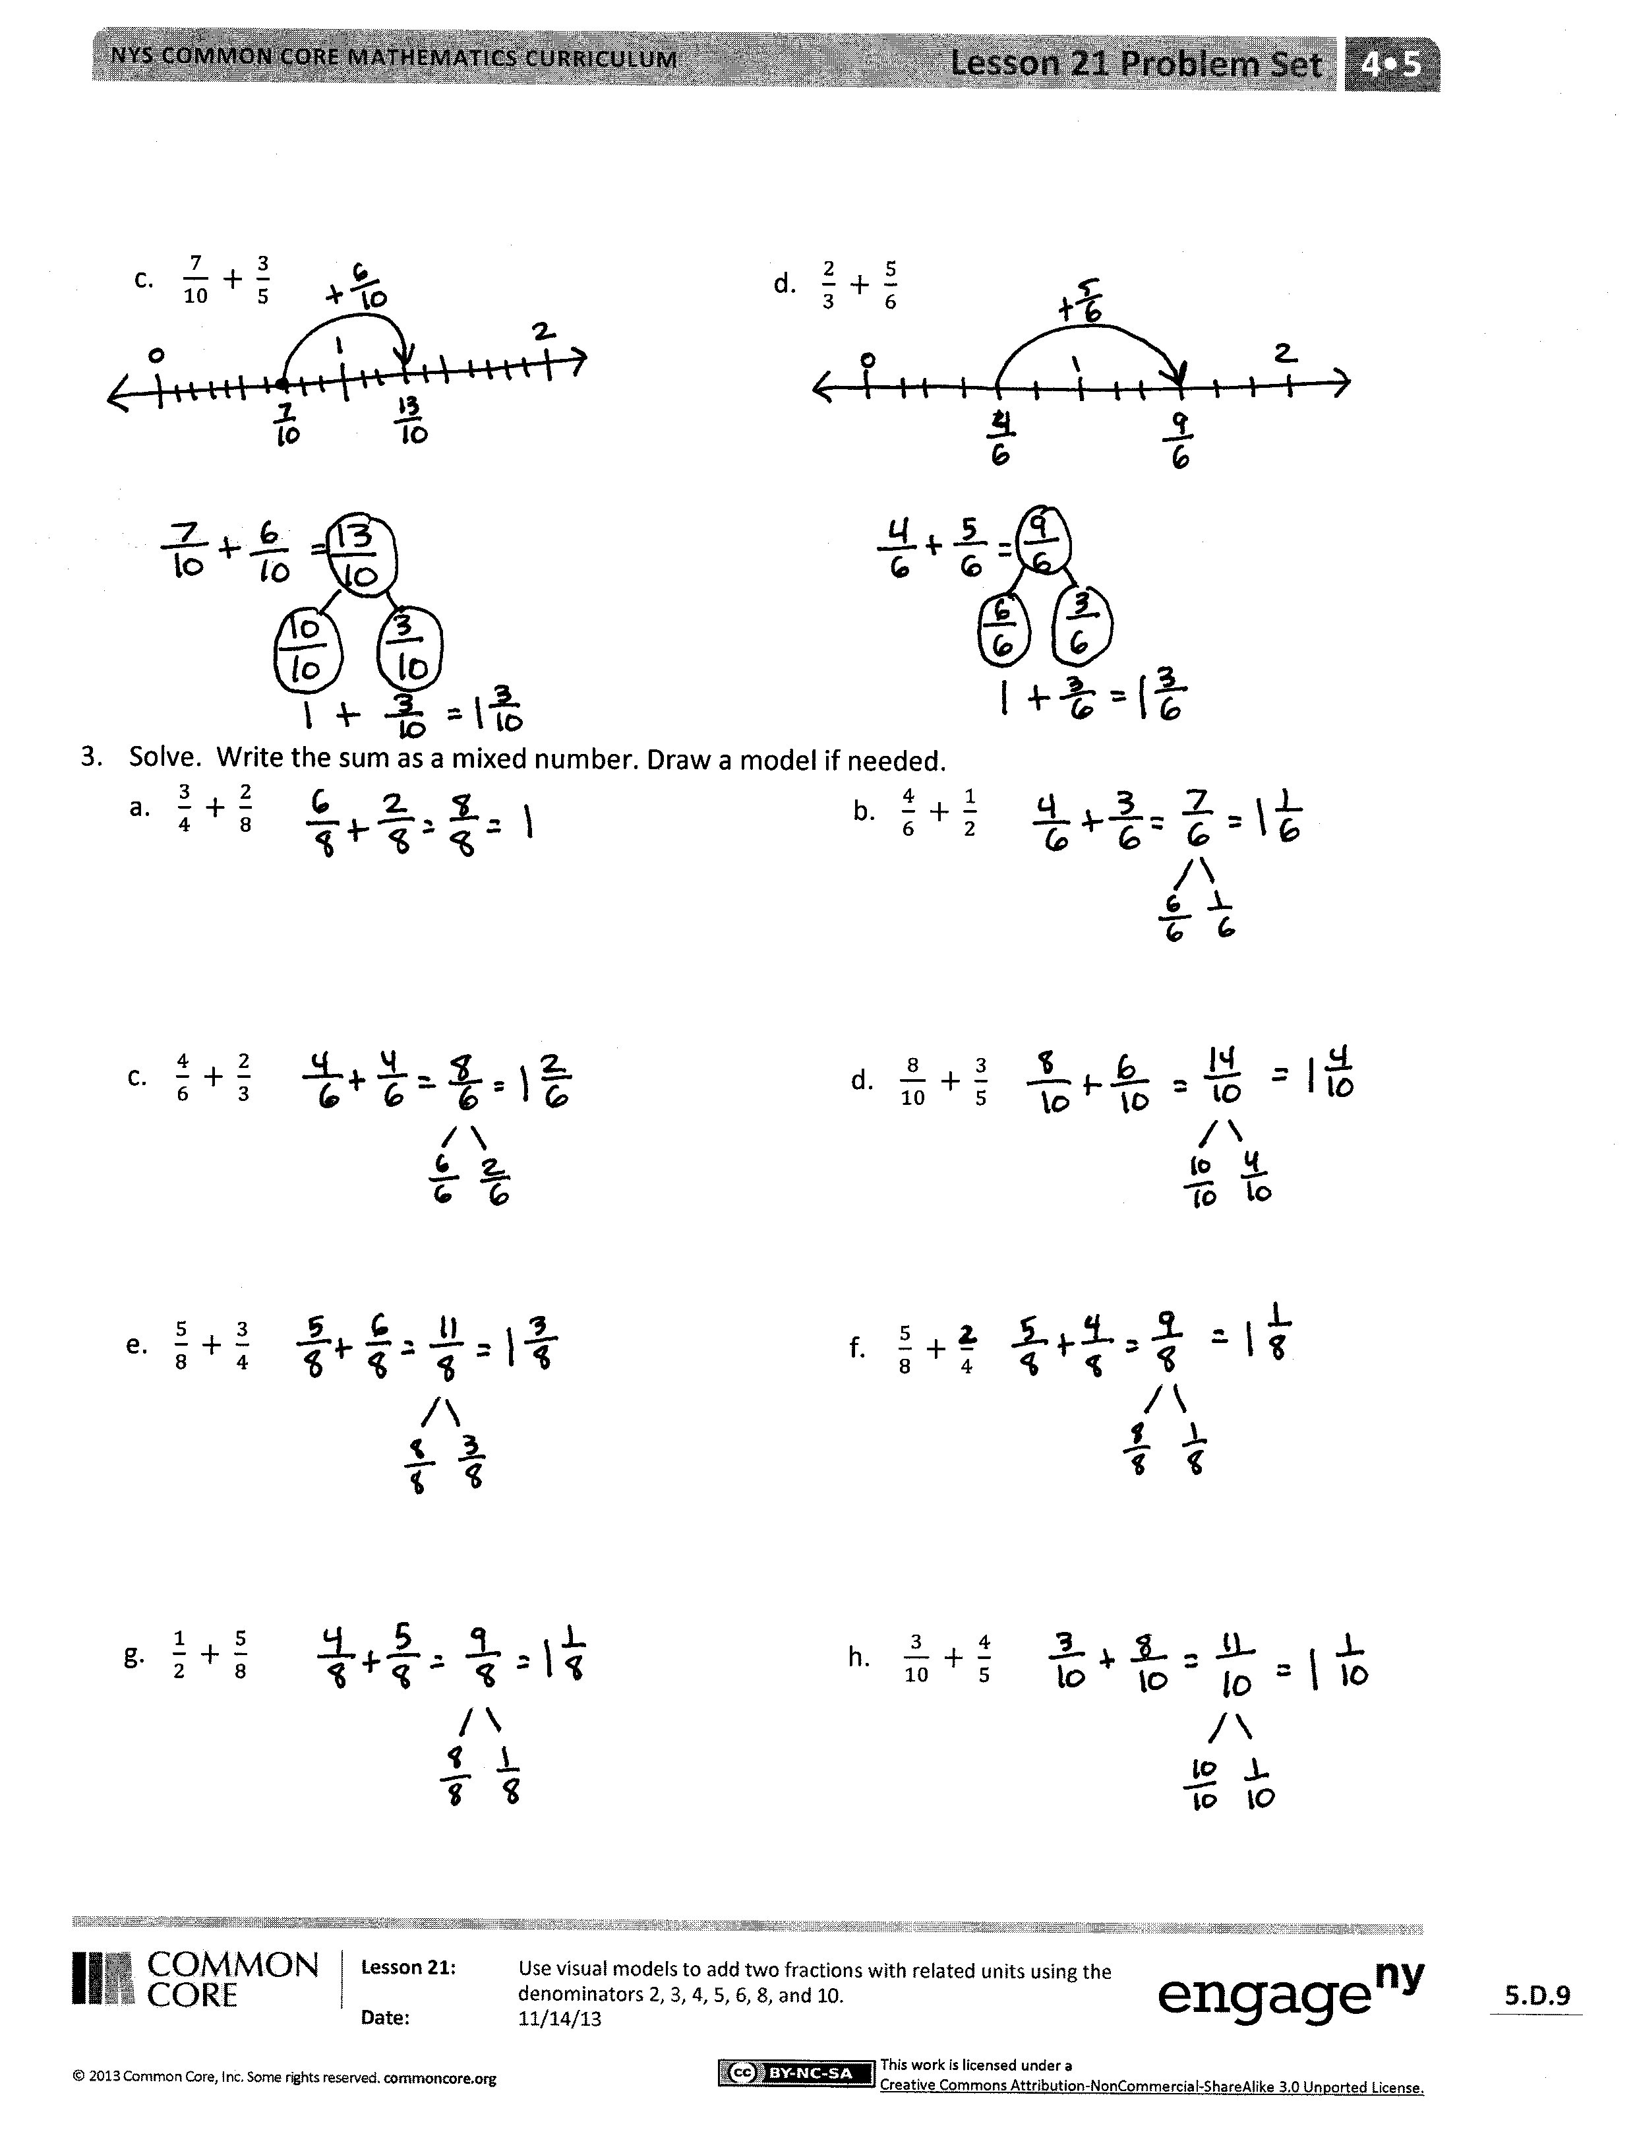
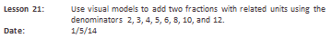
- What benefit can you see in expressing a fraction as a mixed number or a mixed number as a fraction?
- Compare Problems 1(a) and 2(a). Which strategy worked better for you? Explain.
- How did the Application Problem connect to today’s lesson?
Exit Ticket (3 minutes)
After the Student Debrief, instruct students to complete the Exit Ticket. A review of their work will help with assessing students’ understanding of the concepts that were presented in today’s lesson and planning more effectively for future lessons. The questions may be read aloud to the students.
A
Number Correct: _______
Subtract Fractions
 | 2 – 1 = |  |  |  | $\frac{ 4 }{3} – \frac{ 2 }{3} =$
 | $\frac{ 2 }{2} – \frac{ 1 }{2} =$ |  |  |  | $1\frac{1}{3} – \frac{ 2 }{3} =$
 | $1 – \frac{ 1 }{2} =$ |  |  |  | $1\frac{2}{3} – \frac{ 1 }{3} =$
 | 3 – 1 = |  |  |  | 7 – 4 =
 | $\frac{ 3 }{3} – \frac{ 1 }{3} =$ |  |  |  | $\frac{ 7 }{5} – \frac{ 4 }{5} =$
 | $1 – \frac{ 1 }{3} =$ |  |  |  | $1\frac{2}{5} – \frac{ 4 }{5} =$
 | 8 – 1 = |  |  |  | $1\frac{4}{5} – \frac{ 2 }{5} =$
 | $\frac{ 8 }{8} – \frac{ 1 }{8} =$ |  |  |  | 5 – 3 =
 | $1 – \frac{ 1 }{8} =$ |  |  |  | $\frac{ 5 }{4} – \frac{ 3 }{4} =$
 | 5 – 1 = |  |  |  | $1\frac{1}{4} – \frac{ 3 }{4} =$
 | $\frac{ 5 }{5} – \frac{ 1 }{5} =$ |  |  |  | $1\frac{3}{4} – \frac{ 1 }{4} =$
 | $1 – \frac{ 1 }{5} =$ |  |  |  | $1 – \frac{ 3 }{8} =$
 | $1 – \frac{ 2 }{5} =$ |  |  |  | $1 – \frac{ 7 }{8} =$
 | $1 – \frac{ 4 }{5} =$ |  |  |  | $1\frac{7}{8} – \frac{ 3 }{8} =$
 | $1 – \frac{ 3 }{5} =$ |  |  |  | $1\frac{3}{8} – \frac{ 7 }{8} =$
 | $1 – \frac{ 1 }{4} =$ |  |  |  | $1 – \frac{ 1 }{6} =$
 | $1 – \frac{ 3 }{4} =$ |  |  |  | $1 – \frac{ 5 }{6} =$
 | $1 – \frac{ 1 }{10} =$ |  |  |  | $1\frac{5}{6} – \frac{ 1 }{6} =$
 | $1 – \frac{ 9 }{10} =$ |  |  |  | $1\frac{1}{6} – \frac{ 5 }{6} =$
 | $1 – \frac{ 3 }{10} =$ |  |  |  | $1 – \frac{ 5 }{12} =$
 | $1 – \frac{ 7 }{10} =$ |  |  |  | $1\frac{1}{12} – \frac{ 7 }{12} =$
 | 4 – 2 = |  |  |  | $1\frac{4}{15} – \frac{ 13 }{15} =$
B
[KEY]

Number Correct: _______
Improvement: _______
Subtract Fractions
 | 3 – 1 = |  |  |  | $\frac{5}{4} – \frac{3}{4} =$
 | $\frac{3}{3} – \frac{1}{3} =$ |  |  |  | $1\frac{1}{4} – \frac{3}{4} =$
 | $1 – \frac{1}{3} =$ |  |  |  | $1\frac{3}{4} – \frac{1}{4} =$
 | 2 – 1 = |  |  |  | 8 – 4 =
 | $\frac{2}{2} – \frac{1}{2} =$ |  |  |  | $\frac{8}{5} – \frac{4}{5} =$
 | $1 – \frac{1}{2} =$ |  |  |  | $1\frac{3}{5} – \frac{4}{5} =$
 | 6 – 1 = |  |  |  | $1\frac{4}{5} – \frac{3}{5} =$
 | $\frac{6}{6} – \frac{1}{6} =$ |  |  |  | 7 – 5 =
 | $1 – \frac{1}{6} =$ |  |  |  | $\frac{7}{6} – \frac{5}{6} =$
 | 10 – 1 = |  |  |  | $1\frac{1}{6} – \frac{5}{6} =$
 | $\frac{10}{10} – \frac{1}{10} =$ |  |  |  | $1\frac{5}{6} – \frac{1}{6} =$
 | $1 – \frac{1}{10} =$ |  |  |  | $1 – \frac{5}{8} =$
 | $1 – \frac{2}{10} =$ |  |  |  | $1 – \frac{7}{8} =$
 | $1 – \frac{4}{10} =$ |  |  |  | $1\frac{7}{8} – \frac{5}{8} =$
 | $1 – \frac{3}{10} =$ |  |  |  | $1\frac{5}{8} – \frac{7}{8} =$
 | $1 – \frac{1}{5} =$ |  |  |  | $1 – \frac{1}{4} =$
 | $1 – \frac{4}{5} =$ |  |  |  | $1 – \frac{3}{4} =$
 | $1 – \frac{1}{8} =$ |  |  |  | $1\frac{3}{4} – \frac{1}{4} =$
 | $1 – \frac{7}{8} =$ |  |  |  | $1\frac{1}{4} – \frac{3}{4} =$
 | $1 – \frac{3}{8} =$ |  |  |  | $1 – \frac{7}{12} =$
 | $1 – \frac{5}{8} =$ |  |  |  | $1\frac{1}{12} – \frac{5}{12} =$
 | 5 – 3 = |  |  |  | $1\frac{7}{15} – \frac{11}{15} =$

Name Date
- Draw a tape diagram to represent each addend. Decompose one of the tape diagrams to make like units. Then, write a complete number sentence. Use a number bond to write each sum as a mixed number.
a. $\frac{3}{4} + \frac{1}{2}$ | b. $\frac{2}{3} + \frac{3}{6}$
c. $\frac{5}{6} + \frac{1}{3}$ | d. $\frac{4}{5} + \frac{7}{10}$

- Draw a number line to model the addition. Then, write a complete number sentence. Use a number bond to write each sum as a mixed number.
- $\frac{1}{2} +\frac{3}{4}$ | - $\frac{1}{2} + \frac{6}{8}$
- $\frac{7}{10} + \frac{3}{5}$ | - $\frac{2}{3} + \frac{5}{6}$

- Solve. Write the sum as a mixed number. Draw a model if needed.

- $\frac{3}{4} + \frac{2}{8}$
- $\frac{4}{6} + \frac{1}{2}$

- $\frac{4}{6} + \frac{2}{3}$
- $\frac{8}{10} + \frac{3}{5}$

- $\frac{5}{8} + \frac{3}{4}$
- $\frac{5}{8} + \frac{2}{4}$

- $\frac{1}{2} + \frac{5}{8}$
- $\frac{3}{10} + \frac{4}{5}$

Name Date
Solve. Write a complete number sentence. Use a number bond to write each sum as a mixed number.
Use a model if needed.
- $\frac{1}{4} + \frac{7}{8}$

- $\frac{2}{3} + \frac{7}{12}$
Name Date
- Draw a tape diagram to represent each addend. Decompose one of the tape diagrams to make like units. Then, write a complete number sentence. Use a number bond to write each sum as a mixed number.
a. $\frac{7}{8} + \frac{1}{4}$ | b. $\frac{4}{8} + \frac{2}{4}$
c. $\frac{4}{6} + \frac{1}{2}$ | d. $\frac{3}{5} + \frac{8}{10}$

- Draw a number line to model the addition. Then, write a complete number sentence. Use a number bond to write each sum as a mixed number.
- $\frac{1}{2} +\frac{5}{8}$ | - $\frac{3}{4} + \frac{3}{8}$
- $\frac{4}{10} + \frac{4}{5}$ | - $\frac{1}{3} + \frac{5}{6}$

- Solve. Write the sum as a mixed number. Draw a model if needed.

- $\frac{1}{2} + \frac{6}{8}$ b. $\frac{7}{8} + \frac{3}{4}$

- $\frac{5}{6} + \frac{1}{3}$ $\text{d.} \frac{9}{10} + \frac{2}{5}$

- $\frac{4}{12} + \frac{3}{4}$ $\text{f}. \frac{1}{2} + \frac{5}{6}$

- $\frac{3}{12} + \frac{5}{6}$ h. $\frac{\text{7}}{\text{10}} + \frac{\text{4}}{\text{5}}$

