Lesson 19
Objective: Solve word problems involving addition and subtraction of fractions.

Suggested Lesson Structure
 Fluency Practice (12 minutes)
 Application Problem (6 minutes)
 Concept Development (32 minutes)
 Student Debrief (10 minutes)
Total Time (60 minutes)
Fluency Practice (12 minutes)
- Count by Equivalent Fractions 4.NF.1 (6 minutes)
- Add and Subtract Fractions 4.NF.3 (6 minutes)
Count by Equivalent Fractions (6 minutes)
Note: This activity builds fluency with equivalent fractions. The progression builds in complexity. Work the students up to the highest level of complexity in which they can confidently participate.
T: Starting at 0, count by twos to 12.
S: 0, 2, 4, 6, 8, 10, 12.
$\frac{\text{0}}{\text{12}}$ $\frac{\text{2}}{\text{12}}$ $\frac{\text{4}}{\text{12} }$ $\frac{\text{6}}{\text{12}}$ $\frac{\text{8}}{\text{12 }}$ $\frac{\text{10}}{\text{12}}$ $\frac{\text{12}}{\text{12}}$
$0$ $\frac{\text{2}}{\text{12}}$ $\frac{\text{4}}{\text{12} }$ $\frac{\text{6}}{\text{12}}$ $\frac{\text{8}}{\text{12 }}$ $\frac{\text{10}}{\text{12}}$ 1
$0$ $\frac{\text{2}}{\text{12}}$ $\frac{\text{4}}{\text{12} }$ $\frac{\text{1}}{\text{2}}$ $\frac{\text{8}}{\text{12 }}$ $\frac{\text{10}}{\text{12}}$ 1
$0$ $\frac{\text{1}}{\text{6}}$ $\frac{\text{2}}{\text{6}}$ $\frac{\text{1}}{\text{2}}$ $\frac{\text{4}}{\text{6}}$ $\frac{\text{5}}{\text{6}}$ 1
$0$ $\frac{\text{1}}{\text{6}}$ $\frac{\text{1}}{\text{3}}$ $\frac{\text{1}}{\text{2}}$ $\frac{\text{2}}{\text{3}}$ $\frac{\text{5}}{\text{6}}$ 1

T: Count by 2 twelfths from 0 twelfths to 12 twelfths. (Write as students count.)
S: $\frac{\text{0}}{\text{12}}$, $\frac{\text{2}}{\text{12}}$, $\frac{\text{4}}{\text{12} }$, $\frac{\text{6}}{\text{12}}$, $\frac{\text{8}}{\text{12 }}$, $\frac{\text{10}}{\text{12}}$, $\frac{\text{12}}{\text{12}}$.
T: (Point to$\frac{\text{12}}{\text{12}}$.) 12 twelfths is the same as 1 of what unit?
S: 1 one.
T: (Beneath $\frac{\text{12}}{\text{12}}$, write 1.) Count by 2 twelfths again from 0 to 1. Try not to look at the board.
S: $0$, $\frac{\text{2}}{\text{12}}$, $\frac{\text{4}}{\text{12} }$, $\frac{\text{6}}{\text{12}}$, $\frac{\text{8}}{\text{12 }}$, $\frac{\text{10}}{\text{12}}$, 1.
T: (Point to $\frac{\text{6}}{\text{12}}$.) 6 twelfths is the same as what unit fraction?
S: 1 half.
T: (Beneath $\frac{\text{6}}{\text{12}}$, write $\frac{\text{1}}{\text{2}}$.) Count by 2 twelfths again. This time, convert $\frac{\text{6}}{\text{12}}$ to $\frac{\text{1}}{\text{2}}$ and $\frac{\text{12}}{\text{12}}$ to 1. Try not to look at the board.
S: $0,$ $\frac{\text{2}}{\text{12}}$, $\frac{\text{4}}{\text{12}}$, $\frac{\text{1}}{\text{2}}$, $\frac{\text{8}}{\text{12}}$, $\frac{\text{10}}{\text{12} }$, 1.
T: (Point to $\frac{\text{2}}{\text{12}}$.) What’s $\frac{\text{2}}{\text{12}}$ renamed to a larger unit?
S: 1 sixth.
T: (Beneath $\frac{\text{2}}{\text{12}}$, write $\frac{\text{1}}{\text{6}}$. Point to $\frac{\text{4}}{\text{12}}$.) What’s $\frac{\text{4}}{\text{12}}$ renamed as sixths?
S: 2 sixths.
Continue, renaming $\frac{\text{8}}{\text{12}}$ and $\frac{\text{10}}{\text{12} }$ as sixths.
S: 0, $\frac{\text{1}}{\text{6}}$, $\frac{\text{2}}{\text{6}}$, $\frac{\text{1}}{\text{2}}$, $\frac{\text{4}}{\text{6}}$, $\frac{\text{5}}{\text{6}}$, 1.
Continue, renaming $\frac{\text{2}}{\text{6}}$ and $\frac{\text{4}}{\text{6}}$ as thirds.
S: $0$, $\frac{\text{1}}{\text{6}}$, $\frac{\text{1}}{\text{3}}$, $\frac{\text{1}}{\text{2}}$, $\frac{\text{2}}{\text{3}}$, $\frac{\text{5}}{\text{6}}$, 1.
Direct students to count back and forth by 2 twelves from 0 to 1, occasionally changing directions.
Add and Subtract Fractions (6 minutes)
Materials: (S) Personal white board
Note: This fluency activity reviews Lesson 18.
T: (Write $\frac{\text{3}}{\text{6}}$ + $\frac{\text{1}}{\text{6}}$ + $\frac{\text{1}}{\text{6}}.$) Write the complete number sentence on your personal white boards.
S: (Write$\frac{\text{3}}{\text{6}}$ + $\frac{\text{1}}{\text{6}}$ + $\frac{\text{1}}{\text{6}}$ = $\frac{\text{5}}{\text{6}}.\text{)}$
T: (Write $\frac{\text{7}}{\text{8}}$ – $\frac{\text{2}}{\text{8}}$ = __.) Write the complete number sentence on your personal white boards.
S: (Write $\frac{\text{7}}{\text{8}}$ – $\frac{\text{2}}{\text{8}}$ = $\frac{\text{5}}{\text{8}}$.)
Continue with the following possible sequence: $\frac{\text{5}}{\text{10}}$ + $\frac{\text{2}}{\text{10}}$ + $\frac{\text{2}}{\text{10}} ,$ $\frac{\text{2}}{\text{5}}$ + $\frac{\text{2}}{\text{5}}$ + $\frac{\text{2}}{\text{5}}$, $\frac{\text{5}}{\text{6}}$ – $\frac{\text{1}}{\text{6}}$ – $\frac{\text{3}}{\text{6}}$, 1 – $\frac{\text{1}}{\text{5}}$, 1 – $\frac{\text{3}}{\text{5}}$, 1 – $\frac{\text{3}}{\text{8}}$, 1 – $\frac{\text{7}}{\text{10}}$,
$\text{1}\frac{\text{9}}{\text{10}}$ – $\frac{\text{3}}{\text{10}}$ – $\frac{\text{5}}{\text{10}}$, and$\text{1}\frac{\text{7}}{\text{12}}$ – $\frac{\text{5}}{\text{12}}$ – $\frac{\text{11}}{\text{12}}$.

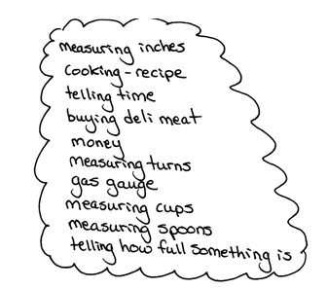
Application Problem (6 minutes)
Fractions are all around us! Make a list of times that you have used fractions, heard fractions, or seen fractions. Be ready to share your ideas.
Note: This Application Problem encourages students to think of real life examples of fractions. Additionally, this Application Problem contextualizes previously learned skills in the module and prepares students for today’s problem-solving lesson involving fractions. Have students spend a few minutes brainstorming together in small groups and then share ideas with the whole group.
Concept Development (32 minutes)
Materials: (S) Problem Set
Suggested Delivery of Instruction for Solving Lesson 19’s Word Problems
1. Model the problem.
Have two pairs of students, who can successfully model the problem, work at the board while the others work independently or in pairs at their seats. Review the following questions before beginning the first problem.
- Can you draw something?
- What can you draw?
- What conclusions can you make from your drawing?
As students work, circulate. Reiterate the questions above. After two minutes, have the two pairs of students share only their labeled diagrams. For about one minute, have the demonstrating students receive and respond to feedback and questions from their peers.
2. Calculate to solve and write a statement.
Give everyone two minutes to finish work on that question, sharing their work and thinking with a peer.
All should then write their equations and statements of the answer.
3. Assess the solution for reasonableness.
Give students one to two minutes to assess and explain the reasonableness of their solution.
Note: Problems 1–4 of the Problem Set will be used during the Concept Development portion of the lesson.
Problem 1: Use the RDW process to solve a word problem involving the addition of fractions.
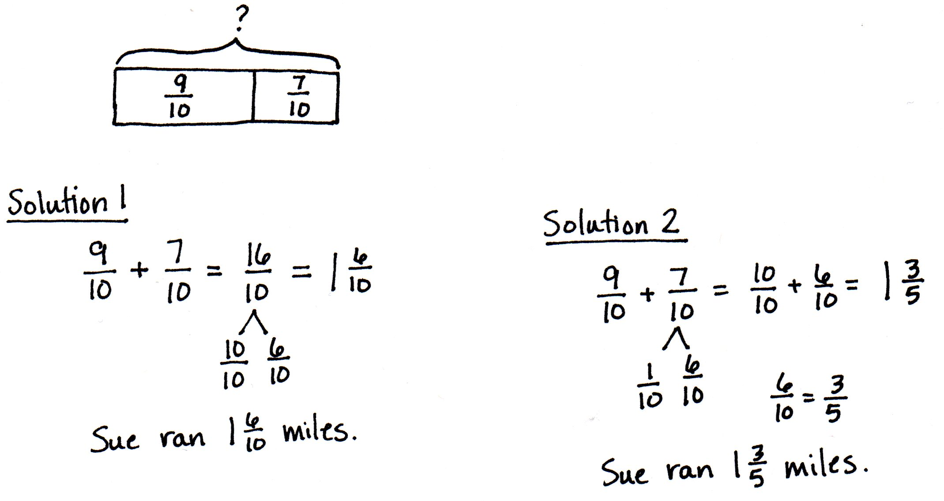
Sue ran $\frac{\text{9}}{\text{10}}$ mile on Monday and $\frac{\text{7}}{\text{10}}$ mile on Tuesday. How many miles did Sue run in the 2 days?

NOTES ON
MULTIPLE MEANS
OF ENGAGEMENT:
Differentiate the difficulty of Problem 1 by adjusting the numbers. Students working above grade level may enjoy the challenge of adding three addends, for example $\frac{\text{37}}{\text{100}}$ + $\frac{\text{18}}{\text{100}}$ + $\frac{\text{65}}{\text{100}}$. Grade 4 expectations in this domain are limited to fractions with like denominators 2, 3, 4, 5, 6, 8, 10, 12, and 100.

Students may initially represent the problem by drawing number bonds or number lines as they did in the previous lessons to model addition. Assist students in finding the parts and wholes. In Problem 1, the 2 parts, $\frac{\text{9}}{\text{10}}$ and $\frac{\text{7}}{\text{10}}$, make the whole, $\text{1}\frac{\text{3}}{\text{5}}$. Encourage students to represent this relationship as a tape diagram to model, as done with whole number addition. In contrast to their previous solutions, students are not drawing the fractional units to count. Instead, they are seeing the relationship the two fractions have with each other and calculating based on what they know about whole number and fraction addition. Possible strategies and solutions to this problem may include, but are not limited to, those shown above.
Problem 2: Use the RDW process to solve a word problem involving the addition and subtraction of fractions.
Mr. Salazar cut his son’s birthday cake into 8 equal pieces. Mr. Salazar, Mrs. Salazar, and the birthday boy each ate 1 piece of cake. What fraction of the cake was left?

Although each person had 1 piece of cake, the students must consider the 1 piece as a fractional unit of the whole. The whole is represented as 1, and students may choose to take from or add to the whole. Again, encourage students to think about the parts and the whole when drawing a picture to represent the problem. A tape diagram is a good way to connect the part–whole relationship, with which they are familiar in whole number addition and subtraction, to fraction computation. The parts can be taken or added one at a time, or students may group them as $\frac{\text{3}}{\text{8}}$ before computing.
Problem 3: Use the RDW process to solve a word problem subtracting a fraction from 1.
Maria spent $\frac{\text{4}}{\text{7}}$ of her money on a book and saved the rest. What fraction of her money did Maria save?
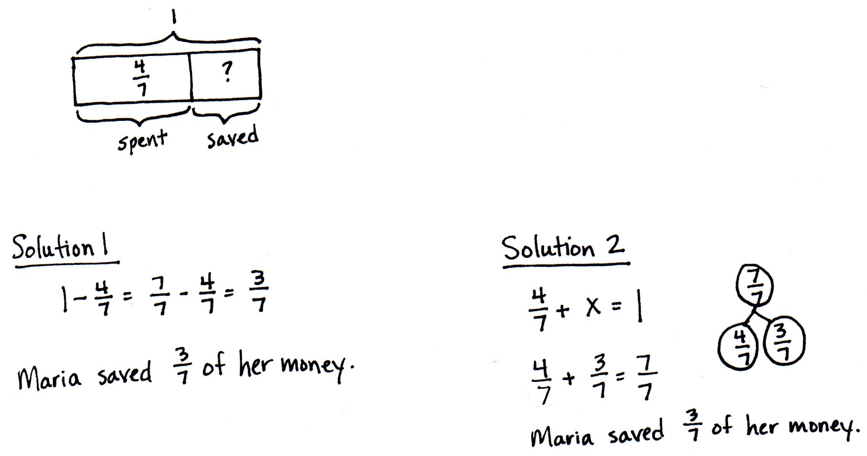

In this problem, students subtract a fraction from 1. Some may write 1 as $\frac{\text{7}}{\text{7}}$ and then subtract $\frac{\text{4}}{\text{7}}$. Alternatively, students may choose to add up to $\frac{\text{7}}{\text{7}}$.
Problem 4: Use the RDW process to solve a word problem involving the subtraction of fractions.
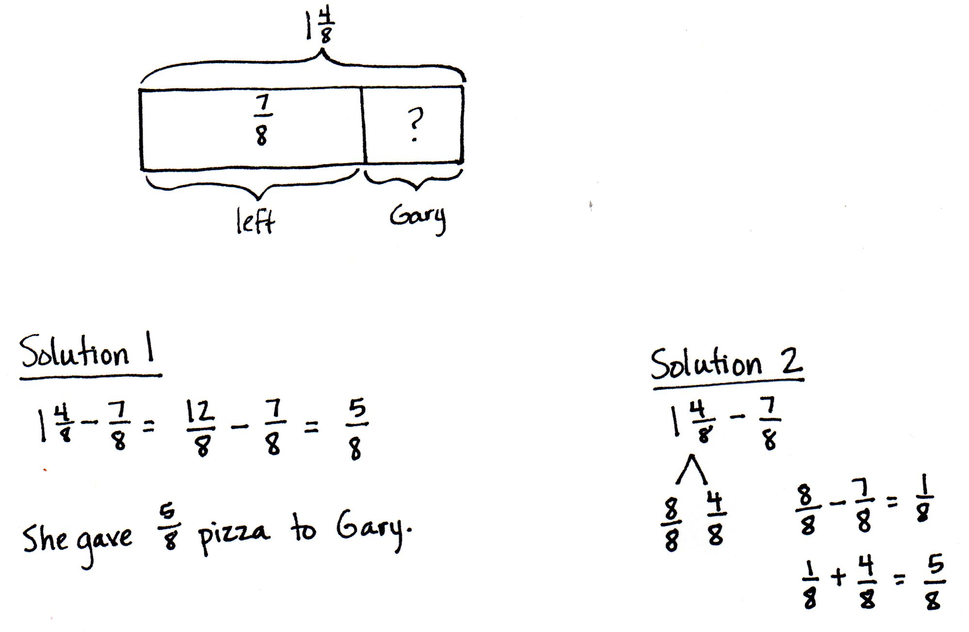
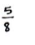
Mrs. Jones had $\text{1}\frac{\text{4}}{\text{8}}$ pizzas left after a party. After giving some to Gary, she had $\frac{\text{7}}{\text{8}}$ pizza left. What fraction of a pizza did she give Gary?

Students can use an adding up method but will likely choose one of the subtracting methods. One way is to rewrite the mixed number as $\frac{\text{12}}{\text{8}}$ and subtract. The other method subtracts from 1 and adds back the fractional part as practiced in Lesson 17.

NOTES ON
MULTIPLE MEANS
OF ACTION AND EXPRESSION:
To prepare students working below grade level and others to meaningfully participate in today’s work and the closing Debrief, quickly review strategies from which students may choose:
- Take apart and redistribute (using a number bond).
- Counting up to subtract.
- Thinking part–whole (using a tape diagram).
Problem Set (10 minutes)
Students should do their personal best to complete the remaining two problems of the Problem Set within the allotted 10 minutes.
Student Debrief (10 minutes)
Lesson Objective: Solve word problems involving addition and subtraction of fractions.
The Student Debrief is intended to invite reflection and active processing of the total lesson experience.
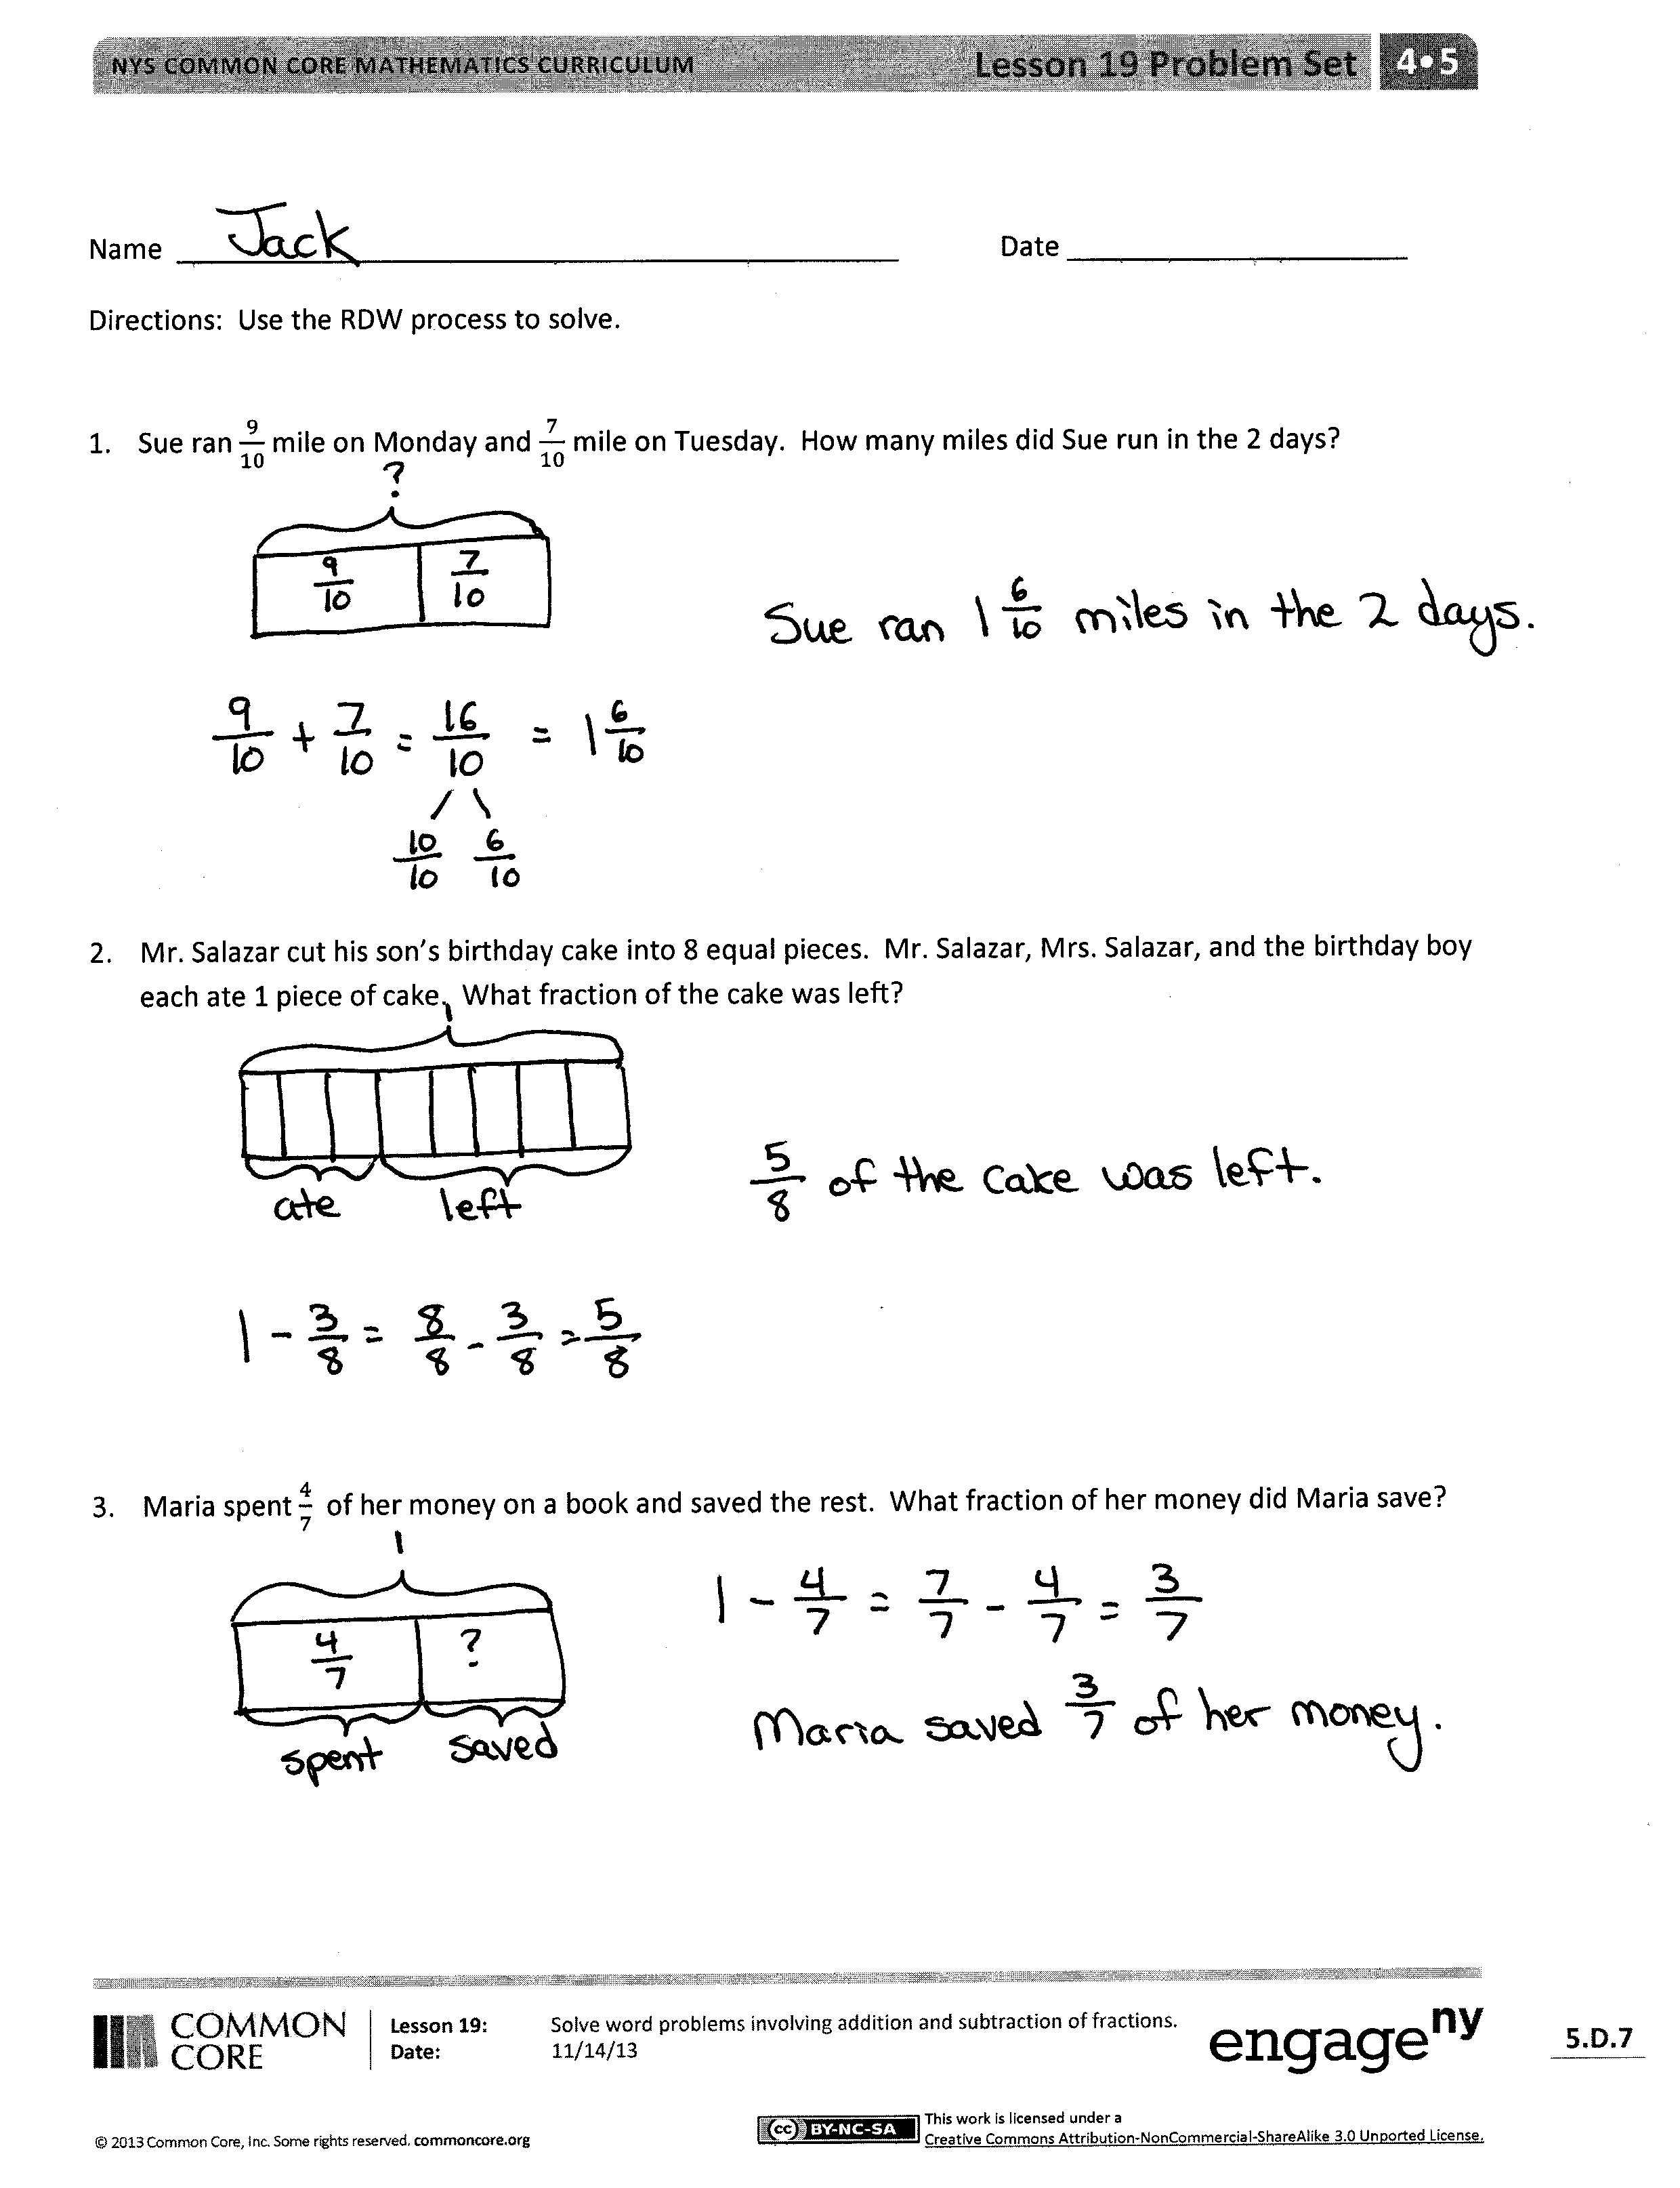
Invite students to review their solutions for the Problem Set. They should check work by comparing answers with a partner before going over answers as a class. Look for misconceptions or misunderstandings that can be addressed in the Debrief. Guide students in a conversation to debrief the Problem Set and process the lesson.
Any combination of the questions below may be used to lead the discussion.
- What strategies did you use to solve the problems in the Problem Set? Did you use the same strategy each time?
- Which problem(s) were the most difficult? How were they difficult? What strategies did you use to persevere?
- Which problem(s) were the least difficult? Why?
- Was it easier to solve Problems 5 and 6 on your own after having completed Problems 1–4 together as a group? Why or why not? Did you use the same strategies that you used in solving Problems 1–4?
- How was Problem 4 different from the other problems?
- What was challenging about Problem 5? About Problem 6?
- How did the Application Problem connect to today’s lesson?
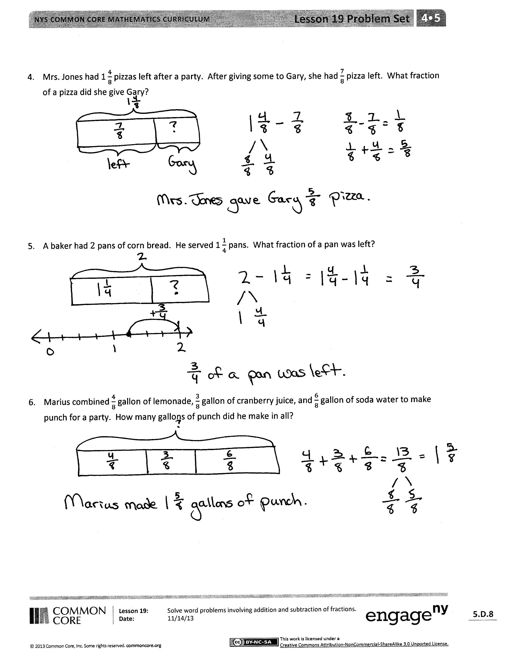
Exit Ticket (3 minutes)
After the Student Debrief, instruct students to complete the Exit Ticket. A review of their work will help with assessing students’ understanding of the concepts that were presented in today’s lesson and planning more effectively for future lessons. The questions may be read aloud to the students.

Name Date
Use the RDW process to solve.
- Sue ran $\frac{\text{9}}{\text{10}}$mile on Monday and $\frac{\text{7}}{\text{10}}$ mile on Tuesday. How many miles did Sue run in the 2 days?

- Mr. Salazar cut his son’s birthday cake into 8 equal pieces. Mr. Salazar, Mrs. Salazar, and the birthday boy each ate 1 piece of cake. What fraction of the cake was left?

- Maria spent $\frac{\text{4}}{\text{7}}$ of her money on a book and saved the rest. What fraction of her money did Maria save?

- Mrs. Jones had $\text{1}\frac{\text{4}}{\text{8}}$pizzas left after a party. After giving some to Gary, she had $\frac{\text{7}}{\text{8}}$ pizza left. What fraction of a pizza did she give Gary?

- A baker had 2 pans of corn bread. He served $\text{1}\frac{\text{1}}{\text{4}}$ pans. What fraction of a pan was left?

- Marius combined $\frac{\text{4}}{\text{8}}$ gallon of lemonade, $\frac{\text{3}}{\text{8}}$ gallon of cranberry juice, and $\frac{\text{6}}{\text{8}}$ gallon of soda water to make punch for a party. How many gallons of punch did he make in all?

Name Date
Use the RDW process to solve.
- Mrs. Smith took her bird to the vet. Tweety weighed $\text{1}\frac{\text{3}}{\text{10}}$ pounds. The vet said that Tweety weighed $\frac{\text{4}}{\text{10}}$ pound more last year. How much did Tweety weigh last year?

- Hudson picked $\text{1}\frac{\text{1}}{\text{4}}$ baskets of apples. Suzy picked 2 baskets of apples. How many more baskets of apples did Suzy pick than Hudson?

Name Date
Use the RDW process to solve.
- Isla walked $\frac{\text{3}}{\text{4}}$mile each way to and from school on Wednesday. How many miles did Isla walk that day?

- Zach spent $\frac{\text{2}}{\text{3}}$ hour reading on Friday and $\text{1}\frac{\text{1}}{\text{3}}$hours reading on Saturday. How much more time did he read on Saturday than on Friday?

- Mrs. Cashmore bought a large melon. She cut a piece that weighed $\text{1}\frac{\text{1}}{\text{8}}$ pounds and gave it to her neighbor. The remaining piece of melon weighed $\frac{\text{6}}{\text{8}}$ pound. How much did the whole melon weigh?

- Ally’s little sister wanted to help her make some oatmeal cookies. First, she put $\frac{\text{5}}{\text{8}}$ cup of oatmeal in the bowl. Next, she added another $\frac{\text{5}}{\text{8}}$cup of oatmeal. Finally, she added another $\frac{\text{5}}{\text{8}}$ cup of oatmeal. How much oatmeal did she put in the bowl?

- Marcia baked 2 pans of brownies. Her family ate $\text{1}\frac{\text{5}}{\text{6}}$ pans. What fraction of a pan of brownies was left?

- Joanie wrote a letter that was $\text{1}\frac{\text{1}}{\text{4}}$ pages long. Katie wrote a letter that was $\frac{\text{3}}{\text{4}}$ page shorter than Joanie’s letter. How long was Katie’s letter?

