Lesson 18

Objective: Add and subtract more than two fractions.

Suggested Lesson Structure

 Fluency Practice (12 minutes)

 Concept Development (38 minutes)

 Student Debrief (10 minutes)

**Total Time (60 minutes)**

Fluency Practice (12 minutes)

* Count by Equivalent Fractions **4.NF.1** (6 minutes)
* Subtract Fractions **4.NF.2** (6 minutes)

Count by Equivalent Fractions (6 minutes)

Note: This activity builds fluency with equivalent fractions. The progression builds in complexity. Work the students up to the highest level of complexity in which they can confidently participate.

T: Starting at 0, count by ones to 10. (Write as students count.)

S: 0, 1, 2, 3, 4, 5, 6, 7, 8, 9, 10.

T: Count by 1 tenths to 10 tenths starting at 0 tenths.

S: , , , , , , , , , ,.

T: (Point to .) 10 tenths is the same as 1 of what unit?

0 1 2 3 4 5 6 7 8 9 10

1

1

1

S: 1 one.

T: (Beneath , write 1.) Count by 1 tenths from 0 to 1 again. This time, when you come to , say 1. Try not to look at the board.

S: 0, , , , , , , , , , 1.

|  |  |
| --- | --- |
|  | NOTES ON  MULTIPLE MEANS  OF ENGAGEMENT: |
| One way to differentiate the Counting by Equivalent Fractionsfluency activity for students working above grade level is to grant them more autonomy. Students may enjoy this as a partner activity in which students take turns leading and counting. Students can make individualized choices about when to convert larger units, counting forward and backward, and speed. | |

T: (Point to .) 5 tenths is the same as 1 of what unit?

S: 1 half.

T: (Beneath , write .) Count by 1 tenths again. This time, convert to and 1. Try not to look at the board.

S: 0, , , , , , , , , , 1.

T: (Point to .) What larger unit is equivalent to?

S: .

Repeat the process, replacing even numbers of tenths with fifths.

T: (Beneath , write .) Count by 1 tenths again. This time, count in the largest unit for each.

S: 0, , , , , , , , , , 1.

Direct students to count by tenths back and forth from 0 to 1, occasionally changing directions.

Subtract Fractions (6 minutes)

Materials: (S) Personal white board

Note: This fluency activity reviews Lesson 17.

T: (Write 1 – = .) How many thirds are in 1?

S: 3 thirds.

T: Write the subtraction sentence. Beneath it, rewrite the subtraction sentence, renaming the whole number in thirds. (Allow students time to work.)

T: Say the subtraction sentence with 1 renamed as thirds.

S: – = .

Continue with the following possible sequence: 1 – , 1 – , and 1 – .

T: (Write – = .) Write the subtraction sentence on your personal white boards.

S: (Write – = .)

T: Can we take from ?

S: No.

T: (Break apart , writing as one of the parts.) Take from , and solve using an addition sentence.

S: (Break apart into and . Take from Write + = to show the part of the whole number that remains plus the fractional part of the mixed number.)

Continue with the following possible sequence: – , – , and – .

Concept Development (38 minutes)

Materials: (S) Adding and subtracting fractions (Practice Sheet)

Note: Arrange students in groups of three to solve and critique each other’s work.

Exploration:

* Problems are sequenced from simple to complex and comprise addition and subtraction problems.

|  |  |
| --- | --- |
|  | NOTES ON  MULTIPLE MEANS  OF REPRESENTATION: |
| Exploration stations are sequenced from simple (Problem A) to complex (Problem F). To best guide student understanding, consider giving students working below grade level additional time to solve Problems A, B, and C, and then advance in order. | |

* All begin solving Problem A in the first rectangle.
* Students switch papers clockwise in their groups. Students analyze the solution in the first rectangle and critique it by discussing the solution with the writer. Then, students consider a different method to solve and record it in the second rectangle for Problem A.
* Students switch papers clockwise again for the second round of critiquing and third round of solving.

**MP.3**

* Switching papers for the last time of the round, the original owner of the paper analyzes the three different methods used to solve the problem. A brief discussion may ensue as more than three methods could have been used within the group.
* The process continues as students solve Problems B through F.
* Some groups may not finish all problems during the time allotted, but the varied problems will allow students to analyze and solve a wide variety of problems to prepare them for the Problem Set.
* Use the last five minutes of the Concept Development, prior to handing out the Problem Set, to review the many different solutions. The teacher may select one solution from three problems or three solutions from one problem to debrief. Identify common methods for solving addition and subtraction problems when there are more than two fractions.

Below are possible solutions for each problem. Students are encouraged to solve using computation through decomposition or other strategies.

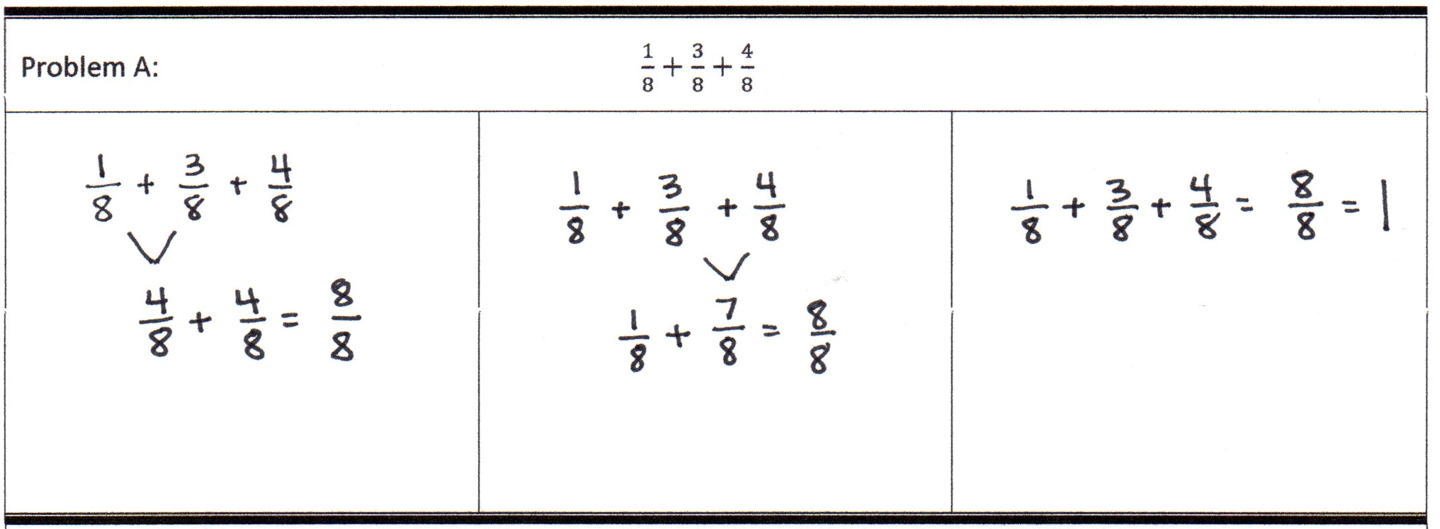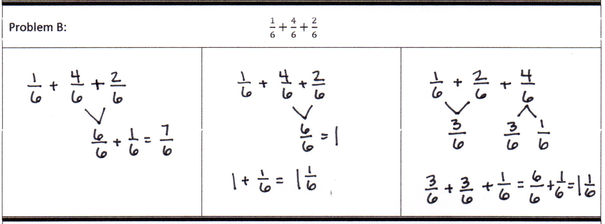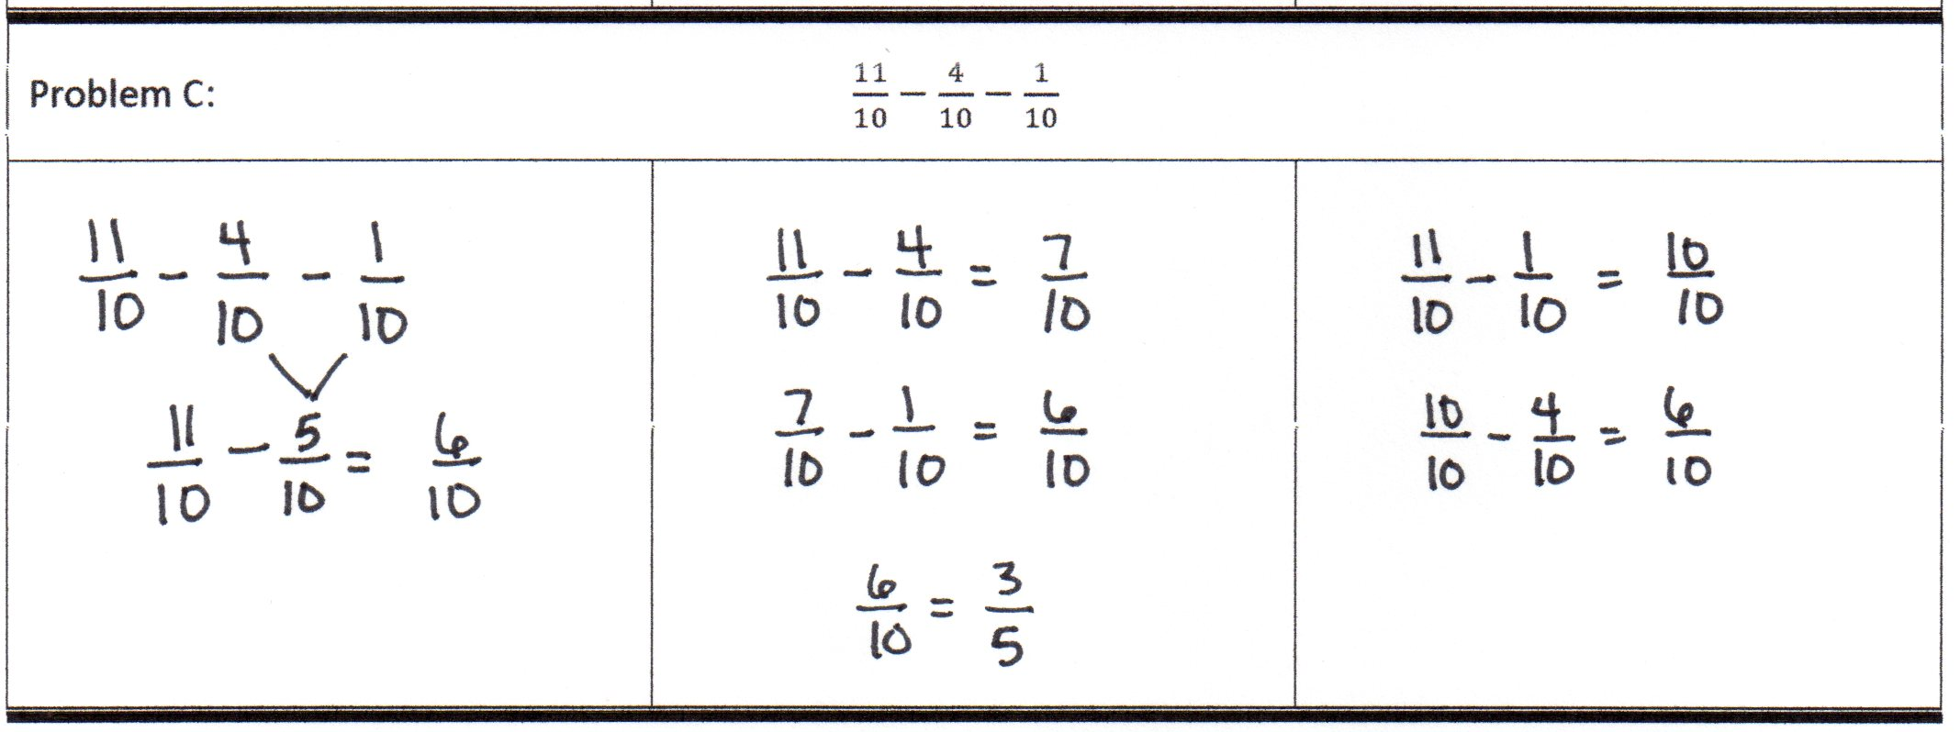

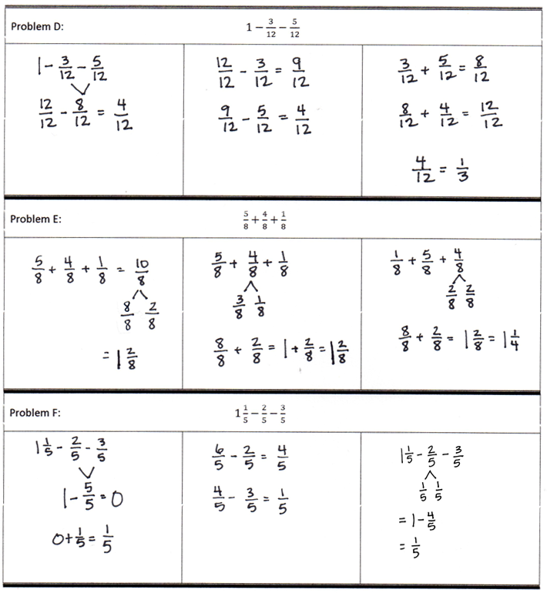

Problem Set (10 minutes)

Students should do their personal best to complete the Problem Set within the allotted 10 minutes. For some classes, it may be appropriate to modify the assignment by specifying which problems they work on first. Some problems do not specify a method for solving. Students should solve these problems using the RDW approach used for Application Problems.

Student Debrief (10 minutes)

**Lesson Objective:** Add and subtract more than two fractions.

The Student Debrief is intended to invite reflection and active processing of the total lesson experience.

Invite students to review their solutions for the Problem Set. They should check work by comparing answers with a partner before going over answers as a class. Look for misconceptions or misunderstandings that can be addressed in the Debrief. Guide students in a conversation to debrief the Problem Set and process the lesson.

Any combination of the questions below may be used to lead the discussion.

* 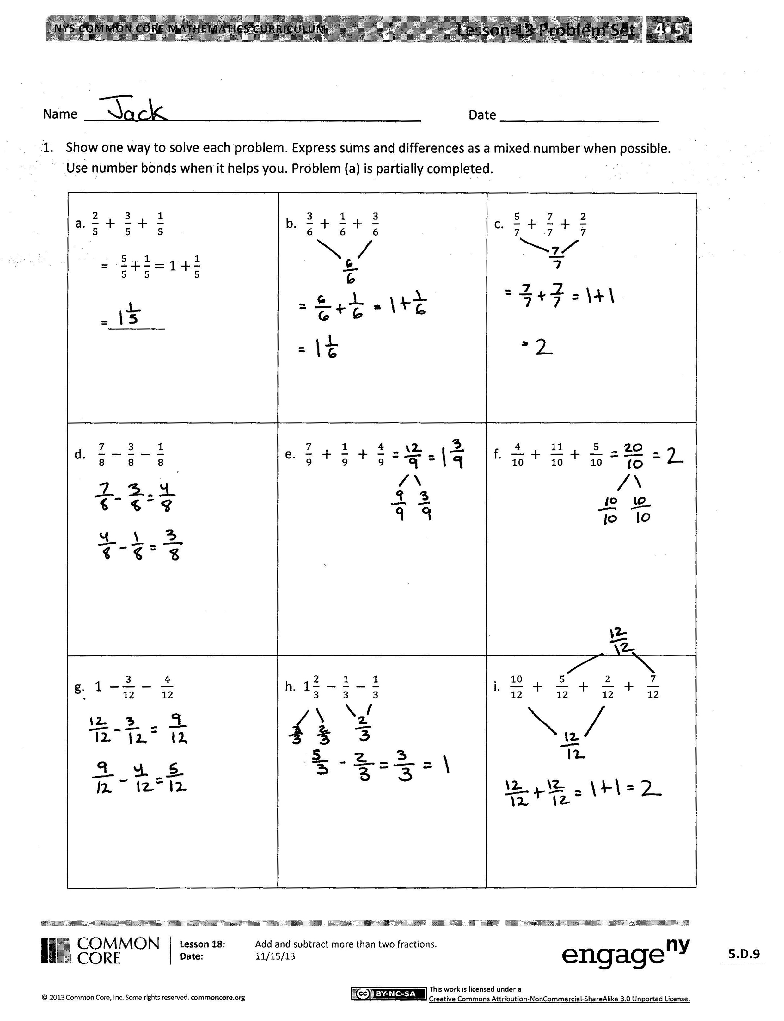In Problem 1(h), the total is a mixed number. Was it necessary to change the mixed number to a fraction in this case? Explain.
* Discuss your solution strategy for Problem 1(i). Grouping fractions to make 1 is a strategy that can help in solving problems mentally. Solving for + and + can lead to the solution more rapidly.
* For Problem 2, did you agree with Monica or Stewart? Explain why you chose that strategy. Do you see a different method?
* Consider how you solved Problem 1(c) and the other solution for it in Problem 3. Would this solution be accurate? (Display = = 2.) Explain why this representation for addition of fractions is correct.
* Observe your solution to Problem 1(d). Is my solution correct? Why? Explain. (Display  
   = .)
* 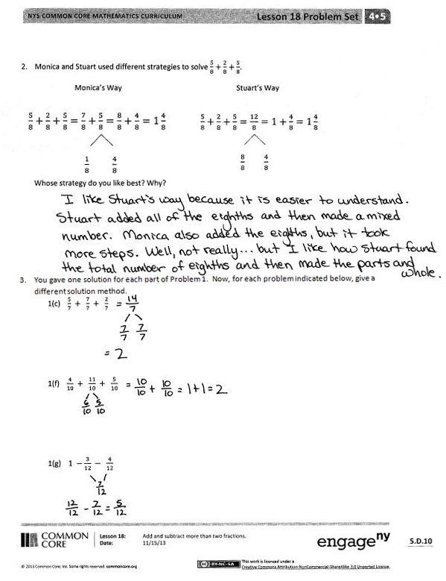Explain in words how we add or subtract more than two fractions with like units.
* When is it necessary to decompose the total in a subtraction problem into fractions? Give an example.

Exit Ticket (3 minutes)

After the Student Debrief, instruct students to complete the Exit Ticket. A review of their work will help with assessing students’ understanding of the concepts that were presented in today’s lesson and planning more effectively for future lessons. The questions may be read aloud to the students.

Name [1] Date

|  |  |  |
| --- | --- | --- |
| Problem A: | | |
|  |  |  |
| Problem B: | | |
|  |  |  |
| Problem C: | | |
|  |  |  |
| Problem D:[2] | | |
|  |  |  |
| Problem E: | | |
|  |  |  |
| Problem F: | | |
|  |  |  |

Name Date

1. Show one way to solve each problem. Express sums and differences as a mixed number when possible. Use number bonds when it helps you. Part (a) is partially completed.

|  |  |  |
| --- | --- | --- |
| a.  =    =________ | b. | c. |
| d. | e. | f. |
| g. | h. | i. |

1. Monica and Stuart used different strategies to solve .

 **Monica’s Way**  **Stuart’s Way**

Whose strategy do you like best? Why?

1. You gave one solution for each part of Problem 1. Now, for each problem indicated below, give a different solution method.

1(c)

1(f)

1(g)

Name Date

Solve the following problems. Use number bonds to help you.



Name Date

1. Show one way to solve each problem. Express sums and differences as a mixed number when possible. Use number bonds when it helps you. Part (a) is partially completed.

|  |  |  |
| --- | --- | --- |
| a.  =  = ________ | b. | c. |
| d. 1 | e. | f. |
| g. | h. | i. |

1. Bonnie used two different strategies to solve .

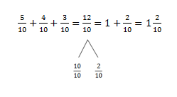  **Bonnie’s First Strategy** **Bonnie’s Second Strategy**

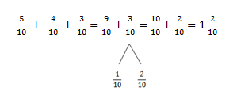

Which strategy do you like best? Why?

1. You gave one solution for each part of Problem 1. Now, for each problem indicated below, give a different solution method.

1(b)

1(e)

1(h)

1. adding and subtracting fractions
2. adding and subtracting fractions