Lesson 17
Objective: Use visual models to add and subtract two fractions with the same units, including subtracting from one whole.

Suggested Lesson Structure
 Fluency Practice (12 minutes)
 Application Problem (5 minutes)
 Concept Development (33 minutes)
 Student Debrief (10 minutes)
Total Time (60 minutes)
Fluency Practice (12 minutes)
- Count by Equivalent Fractions 4.NF.1 (4 minutes)
- Take Out the Whole Number 4.NF.3 (4 minutes)
- Draw Tape Diagrams 4.NF.3 (4 minutes)
Count by Equivalent Fractions (4 minutes)
Note: This activity builds fluency with equivalent fractions. The progression builds in complexity. Work the students up to the highest level of complexity in which they can confidently participate.
T: Starting at 0, count by ones to 6.
S: 0, 1, 2, 3, 4, 5, 6.
T: Count by sixths from 0 sixths to 6 sixths. (Write as students count.)
S: $\frac{\text{0}}{\text{6}}\text{,}\frac{\text{1}}{\text{6}}\text{,}\frac{\text{2}}{\text{6}}\text{,}\frac{\text{3}}{\text{6}}\text{,}\frac{\text{4}}{\text{6}}\text{,}\frac{\text{5}}{\text{6}}\text{,}\frac{\text{6}}{\text{6}}$.
$$\frac{\text{0}}{\text{6}} \frac{\text{1}}{\text{6}} \frac{\text{2}}{\text{6}} \frac{\text{3}}{\text{6}} \frac{\text{4}}{\text{6}} \frac{\text{5}}{\text{6}} \frac{\text{6}}{\text{6}}$$
$$\text{0 }\frac{\text{1}}{\text{6}} \frac{\text{2}}{\text{6}} \frac{\text{3}}{\text{6}} \frac{\text{4}}{\text{6}} \frac{\text{5}}{\text{6}}\text{ 1 }$$
$$\text{0 }\frac{\text{1}}{\text{6}} \frac{\text{2}}{\text{6}} \frac{\text{1}}{\text{2}} \frac{\text{4}}{\text{6}} \frac{\text{5}}{\text{6}}\text{ 1 }$$
$$\text{0 }\frac{\text{1}}{\text{6}} \frac{\text{1}}{\text{3}} \frac{\text{1}}{\text{2}} \frac{\text{2}}{\text{3}} \frac{\text{5}}{\text{6}}\text{ 1 }$$
T: (Point to $\frac{6}{6}$.) 6 sixths is the same as 1 of what unit?
S: 1 one.
T: (Beneath$\frac{\text{6}}{\text{6}}$, write 1.) Count by 1 sixths again from 0 to 1. This time, when you come to
$\frac{6}{6}$, say 1. Try not to look at the board. (Write as students count.)
S: $\text{0}\text{, }\frac{\text{1}}{\text{6}}\text{,}\frac{\text{2}}{\text{6}}\text{,}\frac{\text{3}}{\text{6}}\text{,}\frac{\text{4}}{\text{6}}\text{,}\frac{\text{5}}{\text{6}}\text{,} \text{1}$.
T: (Point to$\frac{\text{3}}{\text{6}}$.) 3 sixths is the same as 1 of what unit?
S: 1 half.

NOTES ON
MULTIPLE MEANS
OF ENGAGEMENT:
If students appear challenged beyond their comfort level, scaffold converting smaller units to larger units in the Count by Equivalent Fractions fluency activity. Before students count by sixths up to 1, have them count by sixths up to 1 half, converting one fraction at a time.

T: (Beneath $\frac{\text{3}}{\text{6}}$, write$\frac{\text{1}}{\text{2}}$.) Count by 1 sixths again. This time, include 1 half and 1. Try not to look at the board.
S: $\text{0}\text{, }\frac{\text{1}}{\text{6}}\text{,}\frac{\text{2}}{\text{6}}\text{,}\frac{\text{1}}{\text{2}}\text{,}\frac{\text{4}}{\text{6}}\text{,}\frac{\text{5}}{\text{6}}\text{,} \text{1}$.
T: What other fractions can we convert to larger units?
S: $\frac{\text{2}}{\text{6}}$ and $\frac{\text{4}}{\text{6}}$.
T: (Point to $\frac{\text{2}}{\text{6}}$.) 2 sixths is the same as what unit fraction?
S: $\frac{\text{1}}{\text{3}}$.
T: (Beneath $\frac{\text{2}}{\text{6}}$, write $\frac{\text{1}}{\text{3}}$. Point to $\frac{\text{4}}{\text{6}}$.) $\frac{\text{4}}{\text{6}}$ is the same as how many thirds?
S: $\frac{\text{2}}{\text{3}}$.
T: (Beneath $\frac{\text{4}}{\text{6}}$, write $\frac{\text{2}}{\text{3}}$.) Count by 1 sixths again. This time, include $\frac{\text{1}}{\text{3}}$ and $\frac{\text{2}}{\text{3}}$. Try not to look at the board.
S: $\text{0}\text{, }\frac{\text{1}}{\text{6}}\text{,}\frac{\text{1}}{\text{3}}\text{,}\frac{\text{1}}{\text{2}}\text{,}\frac{\text{2}}{\text{3}}\text{,}\frac{\text{5}}{\text{6}}\text{,} \text{1}$.
Direct students to count by sixths forward and backward from $0$ to 1, occasionally changing directions.
Take Out the Whole Number (4 minutes)
Materials: (S) Personal white board
Note: This fluency activity prepares students for today’s lesson.
T: How many halves are in 1?
S: 2 halves.
T: How many thirds are in 1?
S: 3 thirds.
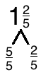
T: How many fifths are in 1?
S: 5 fifths.
T: (Write $\text{1}\frac{\text{2}}{\text{5}}$. Beneath it, write a number bond. Write $\frac{\text{2}}{\text{5}}$ as one of the parts.
Write $\frac{}{\text{5}}$ for the other part.) On your personal white boards, write the completed number bond.
S: (Write completed number bond.)
Continue with the following possible sequence of mixed numbers: $\text{1}\frac{\text{3}}{\text{4}}, \text{1}\frac{\text{2}}{\text{3}}$, $\text{1}\frac{\text{3}}{\text{10}}$, and $\text{1}\frac{\text{5}}{\text{8}}$.

Draw Tape Diagrams (4 minutes)
Materials: (S) Personal white board
Note: This fluency activity reviews Lesson 16.
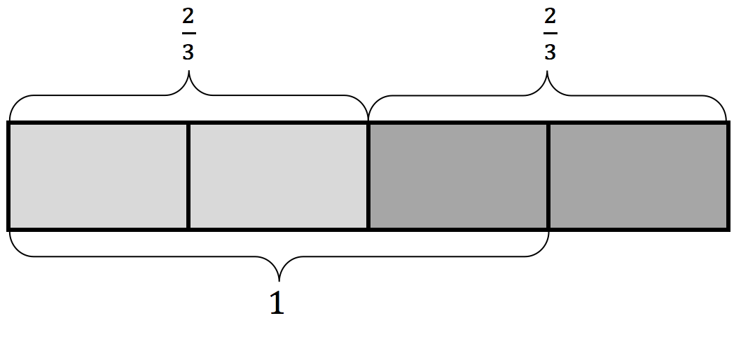
T: (Write $\frac{\text{2}}{\text{3}}$ + $\frac{\text{2}}{\text{3}}$ = .) Complete the addition sentence.
S: $\frac{\text{2}}{\text{3}}$ + $\frac{\text{2}}{\text{3}}$ = $\frac{\text{4}}{\text{3}}.$
T: (Write $\frac{\text{2}}{\text{3}}$ + $\frac{\text{2}}{\text{3}}$ = $\frac{\text{4}}{\text{3}}.$) Draw a tape diagram to show $\frac{\text{2}}{\text{3}}$ + $\frac{\text{2}}{\text{3}}$ = $\frac{4}{3}.$
S: (Draw tape diagram showing $\frac{\text{2}}{\text{3}}$ + $\frac{\text{2}}{\text{3}}$ = $\frac{\text{4}}{\text{3}}.$)
T: How many thirds are in 1?
S: 3 thirds.
T: (Write $\frac{\text{2}}{\text{3}}$ + $\frac{\text{2}}{\text{3}}$ = $\frac{\text{4}}{\text{3}}$ = $\text{1}\frac{}{\text{3}}.$) On your personal white boards, fill in the unknown numerator.
S: (Write $\frac{\text{2}}{\text{3}}$ + $\frac{\text{2}}{\text{3}}$ = $\frac{\text{4}}{\text{3}}$ = $\text{1}\frac{\text{1}}{\text{3}}$.)
Continue with the following possible sequence: $\frac{\text{3}}{\text{4}}$ + $\frac{\text{2}}{\text{4}}$ and $\frac{\text{4}}{\text{5}}$ + $\frac{\text{3}}{\text{5}}$.
Application Problem (5 minutes)
Use a number bond to show the relationship between $\frac{\text{2}}{\text{6}},\frac{\text{3}}{\text{6}}$, and $\frac{\text{5}}{\text{6}}$. Then, use the fractions to write two addition and two subtraction sentences.
Note: This Application Problem reviews work from earlier grades using related facts. The number sentences could also be written with the sum or difference on the left. The process of creating number bonds to show the relationship between addition and subtraction helps to bridge to the beginning of today’s lesson where students identify related fraction facts when 1 one is the whole.

NOTES ON
MULTIPLE MEANS
OF REPRESENTATION:
Students working below grade level may benefit from drawing a tape diagram or another pictorial model of $\frac{\text{5}}{\text{6}}\text{,}\frac{\text{2}}{\text{6}}\text{,}$ and $\frac{\text{3}}{\text{6}}$ in order to meaningfully derive two addition and two subtraction sentences from the number bond.

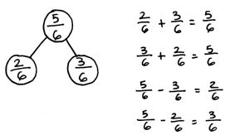
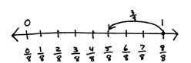
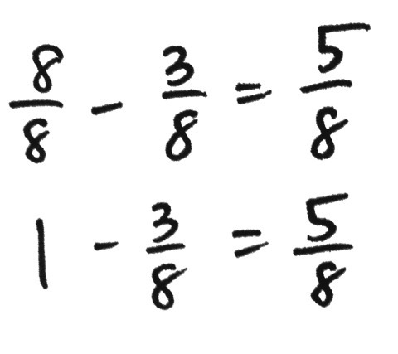
Concept Development (33 minutes)
Materials: (S) Personal white board
Problem 1: Subtract a fraction from 1.
T: Let’s find the value of 1 – $\frac{\text{3}}{\text{8}}$. Are the units the same?
S: No, there are ones and eighths.
T: Rename 1 one as eighths.
S: 8 eighths.

NOTES ON
MULTIPLE MEANS
OF REPRESENTATION:
Student modeling of subtraction and addition on the number line may vary slightly depending on how students solve. For example, students working below grade level may model counting down with an arrow representing a series of hops. Encourage part–whole thinking and modeling by means of modeling with the number bond before the number line, if beneficial.

T: 8 eighths minus 3 eighths is…?
S: 5 eighths.
T: Model the subtraction using a number line. To simplify our number lines, use hash marks to show the eighths. Label 0, 1, and the numbers used to solve.
T: Record your work from the number line as a number sentence.
S: (Write $\frac{\text{8}}{\text{8}}\text{–}\frac{\text{3}}{\text{8}}\text{=}\frac{\text{5}}{\text{8}}$ or $\text{1–}\frac{\text{3}}{\text{8}}\text{=}\frac{\text{5}}{\text{8}}$.)
T: (Display $\text{1–}\frac{\text{2}}{\text{5}}$.) Discuss with your partner how to solve.
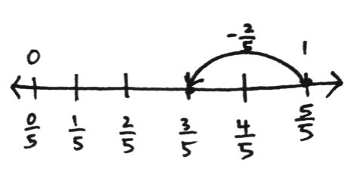
S: We have to make like units. 1 one is equal to 5 fifths. 5 fifths minus 2 fifths equals 3 fifths. $\frac{\text{5}}{\text{5}}\text{–}\frac{\text{2}}{\text{5}}\text{=}\frac{\text{3}}{\text{5}}$. $\text{1–}\frac{\text{2}}{\text{5}}\text{=}\frac{\text{3}}{\text{5}}$.
T: Work with a partner to show $\text{1–}\frac{\text{2}}{\text{5}}$ is the same as $\frac{\text{5}}{\text{5}}\text{–}\frac{\text{2}}{\text{5}}$ using a number line.
T: (Display $\text{1–}\frac{\text{2}}{\text{3}}\text{=} x$.) Draw a number bond to show $\frac{\text{2}}{\text{3}}$, $x$, and 1.
T: Write two subtraction and two addition sentences using $\frac{\text{2}}{\text{3}}$, $x$, and 1.
S: $\frac{\text{2}}{\text{3}}\text{+}$ $x$ = 1. $x$ + $\frac{\text{2}}{\text{3}}\text{=} \text{1}$. 1– $\frac{\text{2}}{\text{3}}\text{=} x$. 1– $x$ = $\frac{\text{2}}{\text{3}}$.
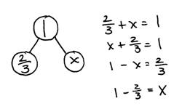
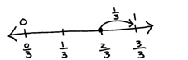
T: Draw a number line with endpoints 0 and 1. Partition and label thirds.
T: $\frac{\text{2}}{\text{3}}$ + $x$ = 1. Draw a point at $\frac{\text{2}}{\text{3}}$. How many more thirds does it take to make 1?
S: 1 third.
T: We can think of subtraction as an unknown addend problem and count up.
Repeat with 1 – $\frac{\text{7}}{\text{12}}$.
Problem 2: Subtract a fraction from a number between 1 and 2.
T: Let’s solve $\text{1}\frac{\text{1}}{\text{5}}\text{–}\frac{\text{2}}{\text{5}}$. First, draw a number bond to decompose $\text{1}\frac{\text{1}}{\text{5}}$ into a whole number and fractional parts. Show the whole number as fifths.
S: (Show $\text{1}\frac{\text{1}}{\text{5}}$ decomposed as $\frac{\text{5}}{\text{5}}$ and $\frac{\text{1}}{\text{5}}$.)
T: I’m going to draw two tape diagrams to show the whole of $\text{1}\frac{\text{1}}{\text{5}}$ with $\frac{2}{5}$ subtracted in different ways. (Draw two tape diagrams side by side. Cross off 2 fifths, as shown below, and write the related number sentences. See illustration below.) Compare the methods with your partner.

S: The solution on the left added 5 fifths and 1 fifth to get 6 fifths and then subtracted 2 fifths. The second solution subtracted 2 fifths from 5 fifths and added that to 1 fifth. That’s how we learned how to subtract in Grades 1 and 2. When I subtract 8 from 13, I take it from the ten and add back 3.
T: Did both methods give the same answer?
S: Yes.
T: We can subtract from the total number of fifths, or we can subtract from 1, or take from 1, and add back the extra fifth.
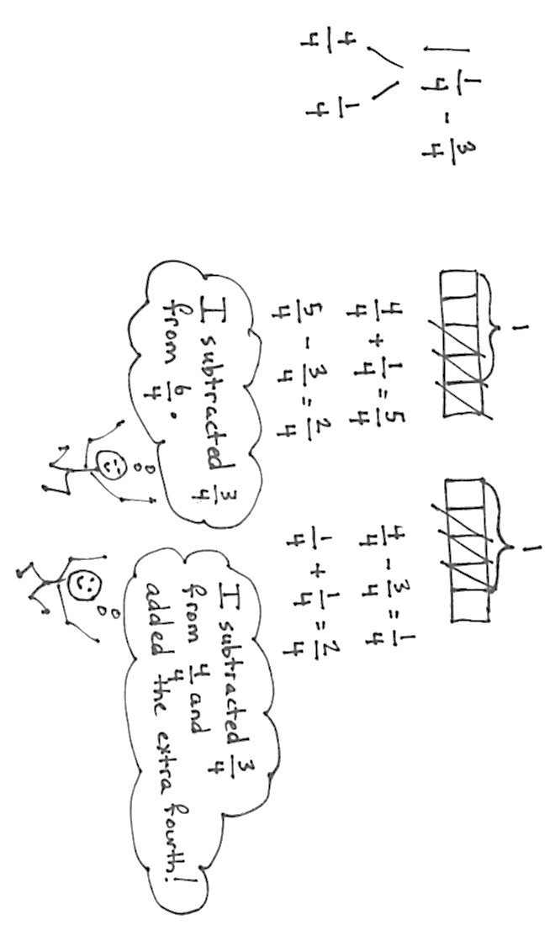
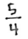
T: Practice both methods using $\text{1}\frac{\text{1}}{\text{4}}\text{–}\frac{\text{3}}{\text{4}}.$ Start by showing our number bond. Partner A, subtract from the total. Partner B, take from 1. Draw a tape diagram if it helps you.
T: Try $\text{1}\frac{\text{3}}{\text{8}}-\frac{\text{5}}{\text{8}}$, switching strategies with your partner.
S: (Solve.)
T: By the way, 13 – 8 can also be solved by thinking 8 + ____ = 13 and counting up. What number sentence shows counting up as a strategy for solving $\text{1}\frac{\text{1}}{\text{5}} \text{–} \frac{\text{2}}{\text{5}}\text{?}$ Talk to your partner.
S: $\frac{\text{2}}{\text{5}}\text{+ ____=}\frac{\text{6}}{\text{5}}$. $\frac{\text{2}}{\text{5}}\text{+ ____=} \text{1}\frac{\text{1}}{\text{5}}$. It’s an unknown addend. An unknown part.
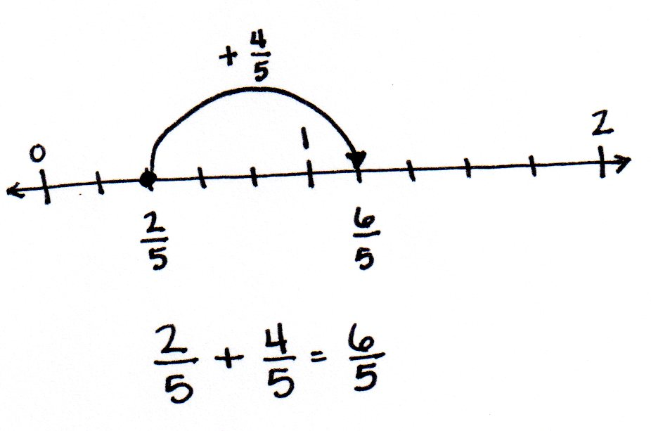
T: Let’s show it on the number line. (Draw the image to the right.)
T: I could also jump up to the whole number and add on.
T: The number line is a nice way to show counting up where the tape diagram was better for showing taking from the total and taking from 1. I chose to use the models that I thought would help you best understand. With your partner, take a moment to think about what subtracting from the total and subtracting from the whole number would look like on the number line.
Problem Set (10 minutes)
Students should do their personal best to complete the Problem Set within the allotted 10 minutes. For some classes, it may be appropriate to modify the assignment by specifying which problems they work on first. Some problems do not specify a method for solving. Students should solve these problems using the RDW approach used for Application Problems.
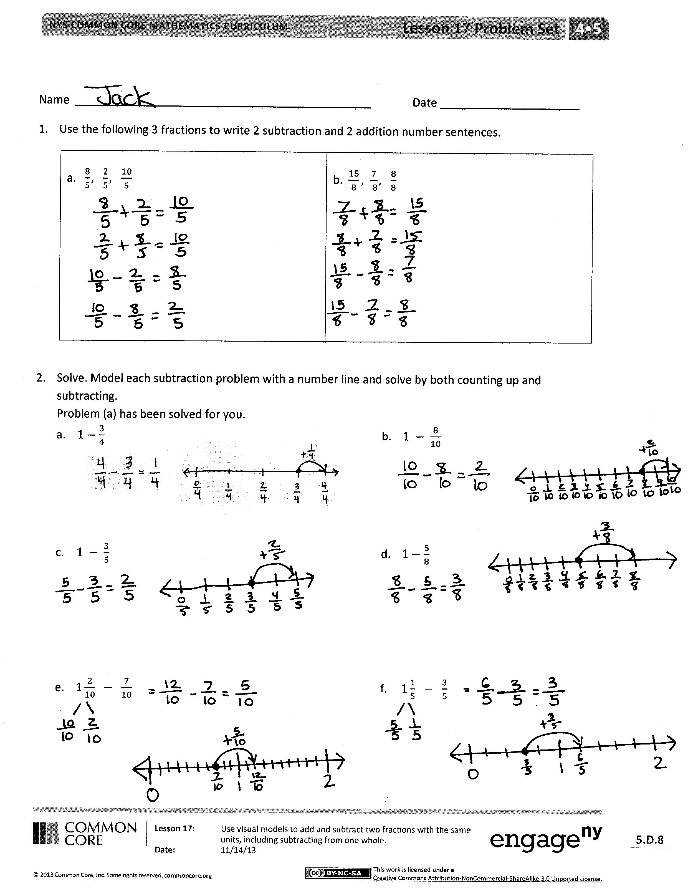
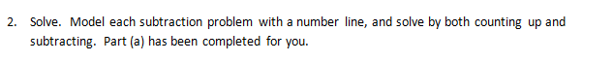
Student Debrief (10 minutes)
Lesson Objective: Use visual models to add and subtract two fractions with the same units, including subtracting from one whole.
The Student Debrief is intended to invite reflection and active processing of the total lesson experience.
Invite students to review their solutions for the Problem Set. They should check work by comparing answers with a partner before going over answers as a class. Look for misconceptions or misunderstandings that can be addressed in the Debrief. Guide students in a conversation to debrief the Problem Set and process the lesson.
Any combination of the questions below may be used to lead the discussion.
- For Problems 1(a) and (b), how did you determine the two addition and subtraction number sentences?
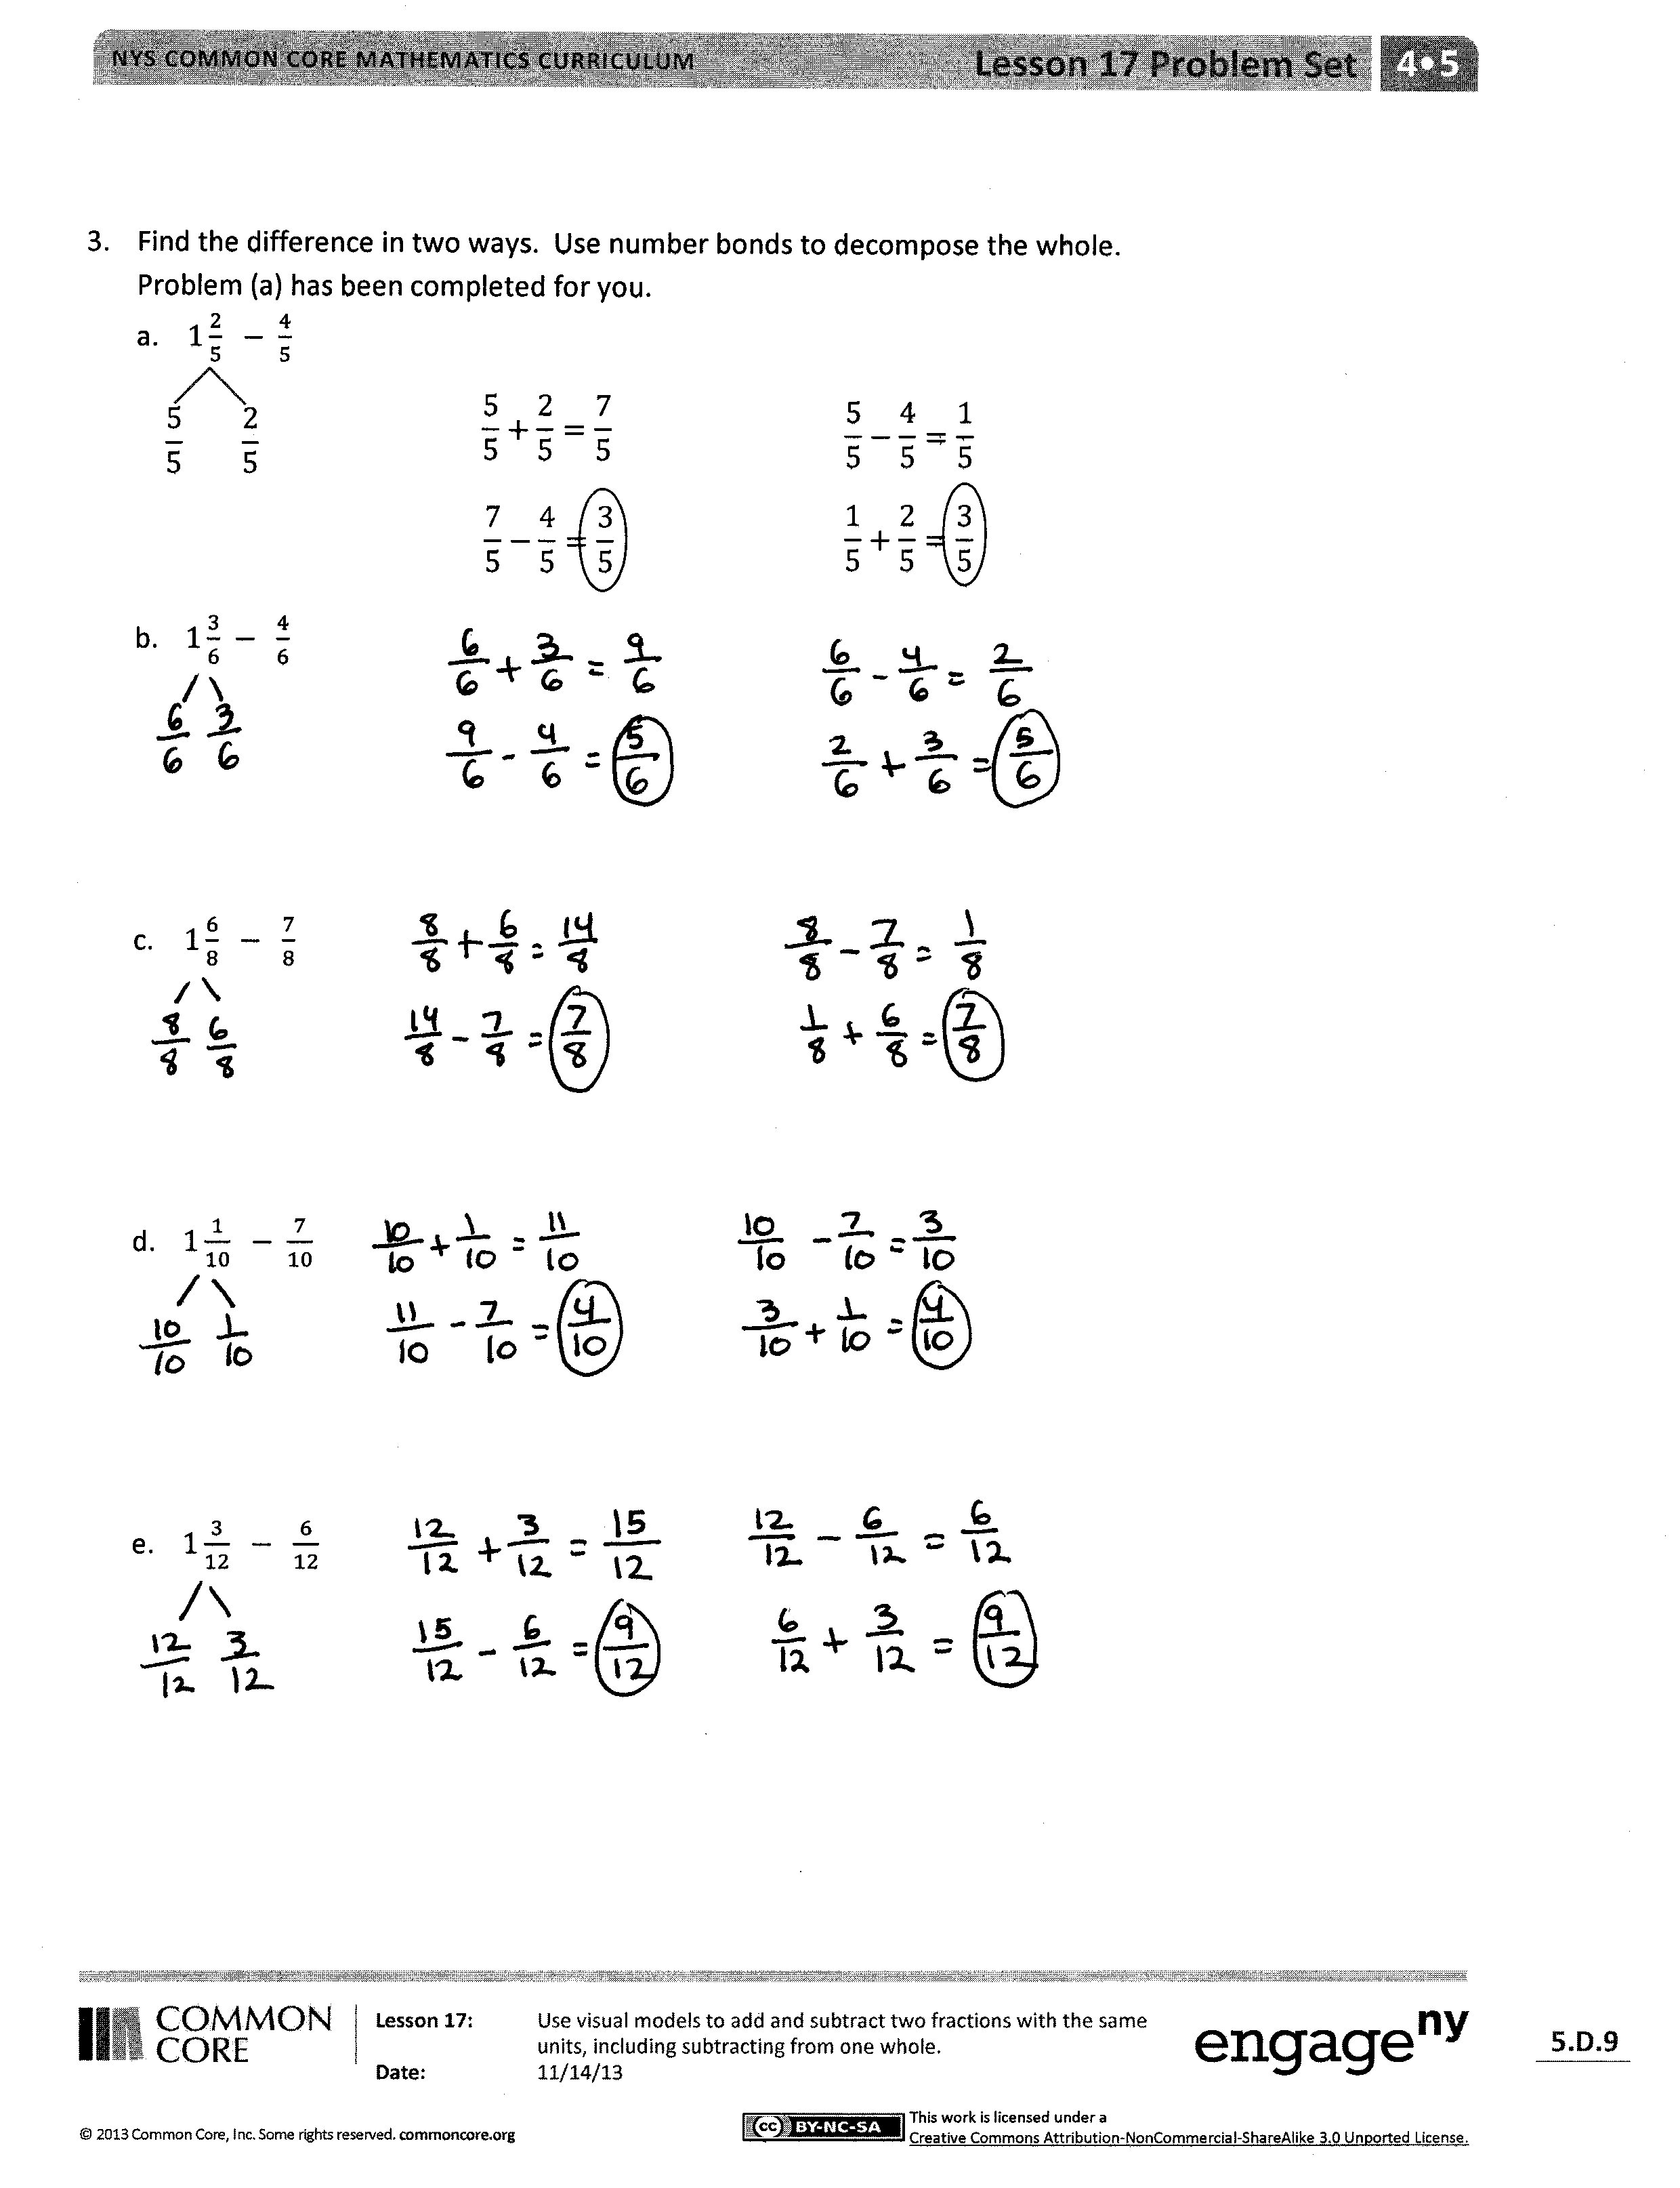
- Which strategy did you prefer for Problem 2(a–f)?
- What support does the number line offer you when solving problems such as these?
- Is the counting up strategy useful when solving subtraction problems? Explain.
- What extra step is there in solving when the fraction is written as a whole or mixed number instead of as a fraction?
- How is subtract from 1, or take from 1, similar to the take from 10 strategy?
- What role do fact families play in fractions? How are fraction fact families similar to whole number fact families?
- How did the Application Problem connect to today’s lesson?
Exit Ticket (3 minutes)
After the Student Debrief, instruct students to complete the Exit Ticket. A review of their work will help with assessing students’ understanding of the concepts that were presented in today’s lesson and planning more effectively for future lessons. The questions may be read aloud to the students.

Name Date
- Use the following three fractions to write two subtraction and two addition number sentences.
a. $\frac{8}{5}, \frac{2}{5}, \frac{10}{5}$ | b. $\frac{15}{8}, \frac{7}{ 8}, \frac{8}{8}$

- Solve. Model each subtraction problem with a number line, and solve by both counting up and subtracting. Part (a) has been completed for you.

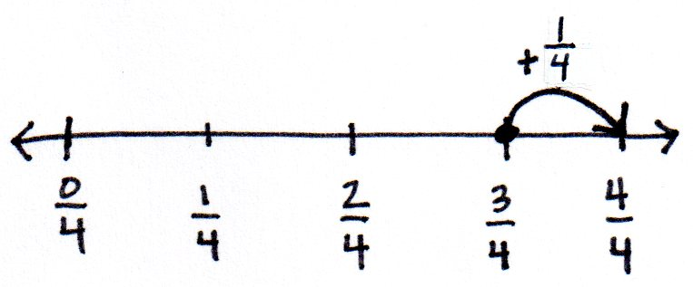
- $1-\frac{3}{4}$
- $1 - \frac{8}{10}$

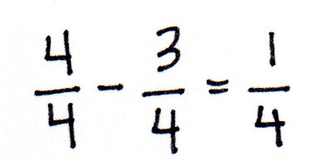

- $1 - \frac{3}{5}$
- $1-\frac{5}{8}$

- $1\frac{2}{10} - \frac{7}{10}$
- $1\frac{1}{5} - \frac{3}{5}$

- Find the difference in two ways. Use number bonds to decompose the total. Part (a) has been completed for you.
- $1\frac{2}{5} - \frac{4}{5}$
$$\frac{7}{5}-\frac{4}{5}=\frac{3}{5}$$
$$\frac{5}{5}+\frac{2}{5}=\frac{7}{5}$$
$$\frac{5}{5}-\frac{4}{5}=\frac{1}{5}$$
$$\frac{1}{5}+\frac{2}{5}=\frac{3}{5}$$

$$\frac{5}{5} \frac{2}{5}$$

- $1\frac{3}{6} - \frac{4}{6}$

- $1\frac{6}{8} - \frac{7}{8}$

- $1\frac{1}{10} - \frac{7}{10}$

- $1\frac{3}{12} - \frac{6}{12}$

Name Date
      - Solve. Model the problem with a number line, and solve by both counting up and subtracting.
$1- \frac{2}{5}$

      - Find the difference in two ways. Use a number bond to show the decomposition.
$1\frac{2}{7} - \frac{5}{7}$

Name Date
- Use the following three fractions to write two subtraction and two addition number sentences.
a. $\frac{5}{6}, \frac{4}{6}, \frac{9}{6}$ | b. $\frac{5}{9}, \frac{13}{ 9}, \frac{8}{9}$

- Solve. Model each subtraction problem with a number line, and solve by both counting up and subtracting.
- $1 - \frac{5}{8}$ b. $1 - \frac{2}{5}$

- $1\frac{3}{6} - \frac{5}{6}$ d. $1 - \frac{1}{4}$

- $1\frac{1}{3} - \frac{2}{3}$ f. $1\frac{1}{5} - \frac{2}{5}$

- Find the difference in two ways. Use number bonds to decompose the total. Part (a) has been completed for you.
- $1\frac{2}{5} - \frac{4}{5}$
$$\frac{7}{5}-\frac{4}{5}=\frac{3}{5}$$
$$\frac{5}{5}+\frac{2}{5}=\frac{7}{5}$$
$$\frac{5}{5}-\frac{4}{5}=\frac{1}{5}$$
$$\frac{1}{5}+\frac{2}{5}=\frac{3}{5}$$

$$\frac{5}{5} \frac{2}{5}$$

- $1\frac{3}{8} - \frac{7}{8}$

- $1\frac{1}{4} - \frac{3}{4}$

- $1\frac{2}{7} - \frac{5}{7}$

- $1\frac{3}{10} - \frac{7}{10}$

