Lesson 11
Objective: Observe conservation of weight on the balance scale.

Suggested Lesson Structure
 Fluency Practice (13 minutes)
 Application Problem (5 minutes)
 Concept Development (25 minutes)
 Student Debrief (7 minutes)
Total Time (50 minutes)
Fluency Practice (13 minutes)
- Heavier or Lighter K.MD.1 (4 minutes)
- Double 5-Groups K.CC.2 (4 minutes)
- Hidden Numbers K.OA.3 (5 minutes)
Heavier or Lighter (4 minutes)
Materials: (T) Balance scale and assorted objects
Note: This activity prepares students for today’s lesson by reviewing vocabulary, isolating the attribute of weight, and incorporating a kinesthetic component to enhance conceptual understanding.
T: Look at my objects. (Show a cotton ball and an orange, for example.) I’m going to put them on the scale. Watch carefully to see how the scale moves. Raise your hand when you know which one is heavier. (Wait for all hands to go up, and then give the signal.) Ready?
S: The orange!
T: Yes! Now, pretend you’re the scale! Show me the side that is heavier.
S: (Pretend to hold the orange in one hand and then quickly lower the hand to indicate weight.)
T: Now, raise your hand when you know which is lighter. (Wait for all hands to go up, and then give the signal.) Ready?
S: The cotton ball!
T: Yes! Now, pretend you’re the scale! Show me the side that is lighter.
S: (Pretend to hold the cotton ball in one hand and gradually lift it as if being pulled up by a balloon.)
Continue with a variety of objects, especially those that will produce unexpected results. Compare a large feather to a small rock so that students can see that size does not always correlate to weight.

Double 5-Groups (4 minutes)
Materials: (T) Large 5-group cards (Lesson 5 Fluency Template 1)
Note: Introducing Say Ten counting now lays the foundation for later work with decomposing teen numbers.
Conduct activity as outlined in Lesson 10, but now continue to ten 5.
Hidden Numbers (5 minutes)
Materials: (S) Hidden numbers mat (Lesson 3 Fluency Template) inserted into personal white board
Note: Finding embedded numbers anticipates the work of Module 4 by developing part–whole thinking.
Conduct activity as described in Lesson 3, but this time guide students to find hidden numbers within a group of 9.
Application Problem (5 minutes)
Materials: (S) Small bag of about 10 Lego-type building blocks, balance scale for small group, 20 pennies
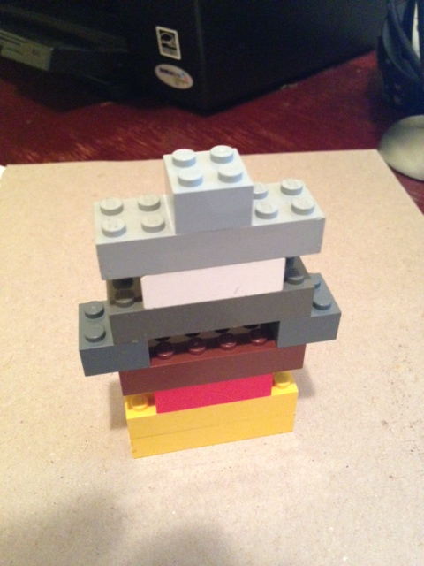
Use your blocks to make the heaviest building that you can. How many pennies are as heavy as your building? Turn to your friend. Talk about your different buildings and how much they weigh.
Note: This question will allow students to puzzle over and discuss whether or not the configuration of their building affects its weight, serving as an anticipatory set for today’s lesson.
Concept Development (25 minutes)
NOTES ON
MULTIPLE MEANS
OF REPRESENTATION:
Introduce the term heaviest to English language learners before the lesson so that they can understand your directions and gain the full benefit of the Application Problem. Show visuals of heavy, heavier, and heaviest on your word wall and refer to them as you give directions. Have them practice saying, “Object A is heavier than Object B,” “Object B is lighter than object C,” etc., in preparation for the lesson.
Materials: (T) Balance scale, ball of clay (S) Balance scale, ball of clay (per small group or pair)
T: I have a ball of clay for each pair of students. When you get your clay, Partner A will make it into two balls that are about the same size.
S: (Pass out clay to Partner A.)
T: Now, here is a balance scale. Partner B, put the two new balls on each side of the scale.
S: (Partner B puts them on the scale.)
T: Talk to your partner. Are the balls the same weight? Use the math words heavier than and lighter than, please.
S: No. This one is heavier than the other because it went down. This ball is lighter because the scale is going up on this side.
T: (Show a balance that has a ball of clay on each side, one heavier than the other.) Look at my scale. (Point to the ball that is heavier.)
S: (Point.)
T: The one that is lighter?
S: (Point.)
T: I want to make the balls the same weight, so I will take a bit of clay from the heavier one and move it to the lighter one. I’ll keep moving little pieces until they balance. I’m making sure to keep my clay in the middle, not on the edge.
T: Now, you try. Take turns moving pieces from the heavier ball to the lighter ball until they balance, until they weigh the same amount.
S: (Manipulate the clay until they are equal.)
T: Are your clay balls the same weight now?
S: Yes.
T: Remove one ball, all of you. Without removing any clay, Partner A, make your ball nice and round. Partner B, make your ball into a pancake. You have 30 seconds.
T: Put your clay back on the scale. Do they still weigh the same amount?
S: Yes!
MP.3
T: Partner B, I want you to take your pancake off and quickly make all of it into two balls. (Pause.)
T: Talk to your partner. What do you think will happen when you put the two smaller balls back on the scale?
S: They are going to weigh more because they are more now. I think it’s going to be the same because we didn’t take any off. I think it’s going to weigh less because they are smaller.
T: Okay. Put the balls back on the scale.
S: They are still the same!
T: How are they the same? Are they the same number? The same size?
S: No. The same weight!
NOTES ON
MULTIPLE MEANS
OF ENGAGEMENT:
Ask students working above grade level what would happen if you placed both clay balls on one side and placed the building blocks on the other side. Would the two sides of the balance scale be equal? Ask them to explain why they balanced (or did not balance) the scale.
T: Let’s try another experiment. Partner A, take your ball and quickly make it into three smaller balls.
T: Talk to your partner. What will happen this time when Partner A puts his or her part back on the scale.
S: It’s going to balance. No. This time there is more, so it’s going to weigh more. No. I think it’s the same even though there are more pieces. It balanced before, so it will this time, too. It would only change if we took off clay and didn’t put it back.
T: Put the three balls back on the scale.
T: Are the two sides of the balance showing the same number of balls?
S: No. One side has two balls, and the other has three balls.
T: Are they the same size?
S: No. These ones are smaller.
T: Are they the same weight?
S: Yes, they are!
Continue the process, moving it along as quickly as possible so that students stay focused on the weighing rather than the manipulation of the clay. You might have Partner A put his two balls together to make one ball and see if it balances Partner B’s three smaller balls. Then have Partner B put his three balls back together into one bigger ball so they end up back where they started with two balls that balance on the scale.
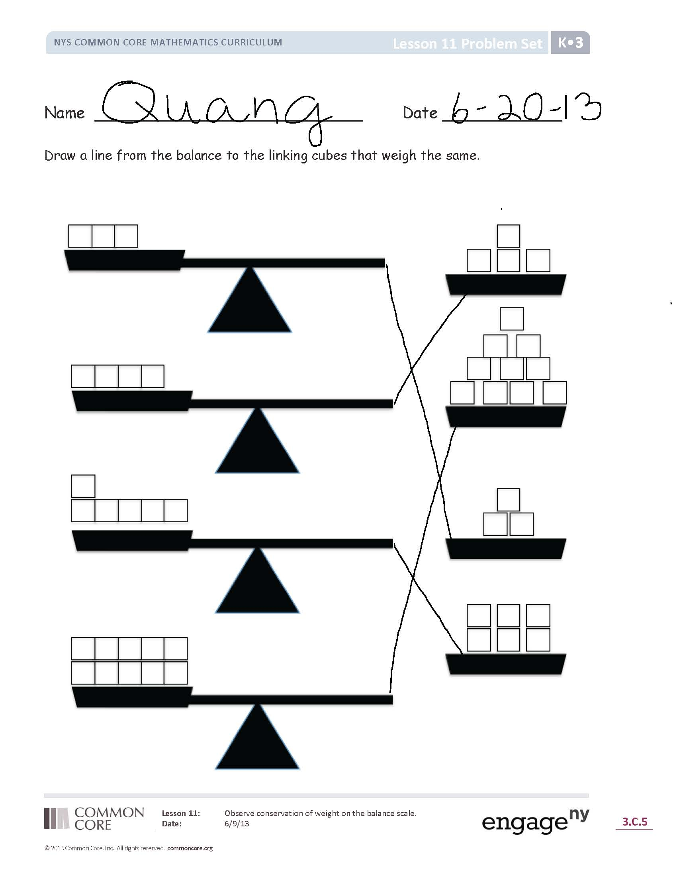
Problem Set (10 minutes)
Students should do their personal best to complete the Problem Set within the allotted time.
Student Debrief (7 minutes)
Lesson Objective: Observe conservation of weight on the balance scale.
The Student Debrief is intended to invite reflection and active processing of the total lesson experience.
Invite students to review their solutions for the Problem Set. They should check work by comparing answers with a partner before going over answers as a class. Look for misconceptions or misunderstandings that can be addressed in the Student Debrief. Guide students in a conversation to debrief the Problem Set and process the lesson.
You may choose to use any combination of the questions below to lead the discussion.
- What happened when you took the clay ball apart, made it into two balls, and weighed them together on the balance?
- What do you think would happen if you took that same clay ball apart and made it into 10 little balls and put them all on the balance? A hundred little balls?
- Can one thing have the same weight as 10 things? (If you have materials to demonstrate this, all the better. One option is base ten Dienes blocks. In a high-quality set, the thousands cube has the same weight as ten of the hundreds flats.)

Name Date
Draw a line from the balance to the linking cubes that weigh the same.
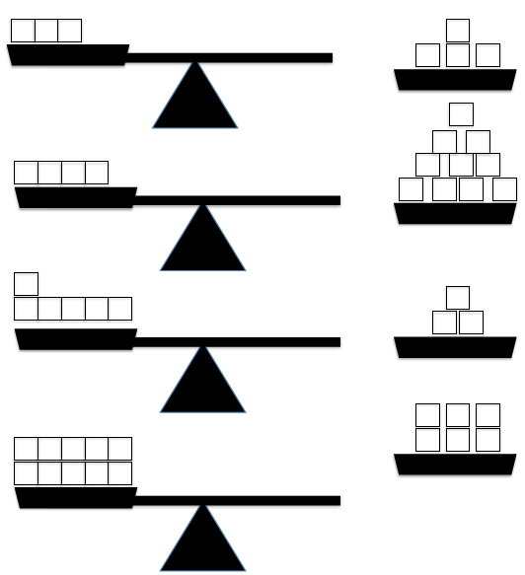

Name Date
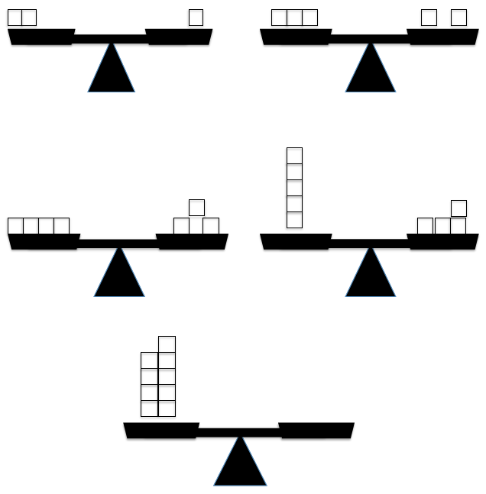
Draw linking cubes so each side weighs the same.

