Lesson 16
Objective: Use visual models to add and subtract two fractions with the same units.

Suggested Lesson Structure
 Fluency Practice (12 minutes)
 Application Problem (5 minutes)
 Concept Development (33 minutes)
 Student Debrief (10 minutes)
Total Time (60 minutes)
Fluency Practice (12 minutes)
- Count by Equivalent Fractions 4.NF.1 (6 minutes)
- Compare Fractions 4.NF.2 (6 minutes)
Count by Equivalent Fractions (6 minutes)
Note: This activity builds fluency with equivalent fractions. The progression builds in complexity. Work the students up to the highest level of complexity in which they can confidently participate.
T: Starting at 0, count by ones to 8.
$$\frac{\text{0}}{\text{8}} \frac{\text{1}}{\text{8}} \frac{\text{2}}{\text{8}} \frac{\text{3}}{\text{8}} \frac{\text{4}}{\text{8}} \frac{\text{5}}{\text{8}} \frac{\text{6}}{\text{8}} \frac{\text{7}}{\text{8}} \frac{\text{8}}{\text{8}}$$
$$\text{0} \frac{\text{1}}{\text{8}} \frac{\text{2}}{\text{8}} \frac{\text{3}}{\text{8}} \frac{\text{4}}{\text{8}} \frac{\text{5}}{\text{8}} \frac{\text{6}}{\text{8}} \frac{\text{7}}{\text{8}} \text{ 1 }$$
$$\text{0} \frac{\text{1}}{\text{8}} \frac{\text{2}}{\text{8}} \frac{\text{3}}{\text{8}} \frac{\text{1}}{\text{2}} \frac{\text{5}}{\text{8}} \frac{\text{6}}{\text{8}} \frac{\text{7}}{\text{8}} \text{ 1 }$$
$$\text{0} \frac{\text{1}}{\text{8}} \frac{\text{1}}{\text{4}} \frac{\text{3}}{\text{8}} \frac{\text{1}}{\text{2}} \frac{\text{5}}{\text{8}} \frac{\text{3}}{\text{4}} \frac{\text{7}}{\text{8}} \text{ 1 }$$

S: 0, 1, 2, 3, 4, 5, 6, 7, 8.
T: Starting at 0 eighths, count by 1 eighths to 8 eighths. (Write as students count.)
S: $\frac{\text{0}}{\text{8}}\text{,} \frac{\text{1}}{\text{8}}\text{,}\frac{\text{2}}{\text{8}}\text{,}\frac{\text{3}}{\text{8}}\text{,}\frac{\text{4}}{\text{8}}\text{,}\frac{\text{5}}{\text{8}}\text{,}\frac{\text{6}}{\text{8}}\text{,}\frac{\text{7}}{\text{8}}\text{,}\frac{\text{8}}{\text{8}}$.
T: (Point to $\frac{\text{8}}{\text{8}}$.) 8 eighths is the same as 1 of what unit?
S: 1 one.
T: (Beneath$\frac{\text{8}}{\text{8}}$ , write 1.) Count by 1 eighths from zero to 1. This time, when you come to 1, say 1. Try not to look at the board.
S: $\text{0}\text{,}\frac{\text{1}}{\text{8}}\text{,}\frac{\text{2}}{\text{8}}\text{,}\frac{\text{3}}{\text{8}}\text{,}\frac{\text{4}}{\text{8}}\text{,}\frac{\text{5}}{\text{8}}\text{,}\frac{\text{6}}{\text{8}}\text{,}\frac{\text{7}}{\text{8}}\text{, 1}.$
T: (Point to $\frac{\text{4}}{\text{8}}$.) 4 eighths is the same as 1 of what unit?
S: 1 half.
T: (Beneath $\frac{\text{4}}{\text{8}}$, write $\frac{\text{1}}{\text{2}}$.) Count by 1 eighths again. This time, convert to $\frac{\text{1}}{\text{2}}$ and 1. Try not to look at the board.
S: 0$\text{,}\frac{\text{1}}{\text{8}}\text{,}\frac{\text{2}}{\text{8}}\text{,}\frac{\text{3}}{\text{8}}\text{,}\frac{\text{1}}{\text{2}}\text{,}\frac{\text{5}}{\text{8}}\text{,}\frac{\text{6}}{\text{8}}\text{,}\frac{\text{7}}{\text{8}}\text{, 1}.$
T: What other fractions can we rename to make smaller-sized units?
S: $\frac{\text{2}}{\text{8}}$ and $\frac{\text{6}}{\text{8}}$.
T: (Point to $\frac{\text{2}}{\text{8}}$.) What’s 2 eighths renamed?
S: $\frac{\text{1}}{\text{4}}$.
T: (Beneath $\frac{\text{2}}{\text{8}}$, write $\frac{\text{1}}{\text{4}}$. Point to $\frac{\text{6}}{\text{8}}$.) What’s $\frac{\text{6}}{\text{8}}$ renamed?
S: $\frac{\text{3}}{\text{4}}$.
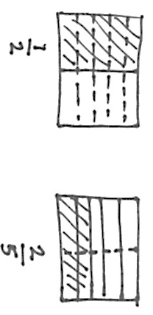
T: (Beneath $\frac{\text{6}}{\text{8}}$, write $\frac{\text{3}}{\text{4}}$.) Count by 1 eighths again. This time, convert to $\frac{\text{1}}{\text{4}}$ and $\frac{\text{3}}{\text{4}}$. Try not to look at the board.
S: 0$\text{,}\frac{\text{1}}{\text{8}}\text{,}\frac{\text{1}}{\text{4}}\text{,}\frac{\text{3}}{\text{8}}\text{,}\frac{\text{1}}{\text{2}}\text{,}\frac{\text{5}}{\text{8}}\text{,}\frac{\text{3}}{\text{4}}\text{,}\frac{\text{7}}{\text{8}}\text{, 1}.$
Direct students to count by eighths back and forth from 0 to 1, occasionally changing directions.
Compare Fractions (6 minutes)
Materials: (S) Personal white board
Note: This fluency activity reviews Lesson 15.
T: On your personal white boards, draw two area models. (Allow students time to draw.)
T: (Write $\frac{\text{1}}{\text{2}}.$) Partition and shade your first diagram into an area model that shows $\frac{\text{1}}{\text{2}}.$ Then, write $\frac{\text{1}}{\text{2}}$ beneath it.
S: (Partition the first area model into 2 equal units. Shade one unit. Write $\frac{\text{1}}{\text{2}}$ beneath it.)
T: (Write $\frac{\text{1}}{\text{2}}$ ___ $\frac{\text{2}}{\text{5}}$.) Partition and shade your second area model to show $\frac{\text{2}}{\text{5}}.$ Then, write $\frac{\text{2}}{\text{5}}$ beneath it.
S: (Partition the second area model into 5 equal units. Shade 2 units. Write $\frac{\text{2}}{\text{5}}$ beneath the shaded area.)
T: Partition the area models so that both fractions have common denominators.
S: (Draw dotted lines through the area models.)
T: Write a greater than, less than, or equal sign to compare the fractions.
S: (Write $\frac{\text{1}}{\text{2}}$ > $\frac{\text{2}}{\text{5}}$.)
Continue with the following possible sequence: Compare $\frac{\text{1}}{\text{5}}$ and $\frac{\text{3}}{\text{10}}$ , $\frac{\text{1}}{\text{4}}$ and $\frac{\text{5}}{\text{8}}$ , and $\frac{\text{1}}{\text{3}}$ and $\frac{\text{3}}{\text{4}}$.
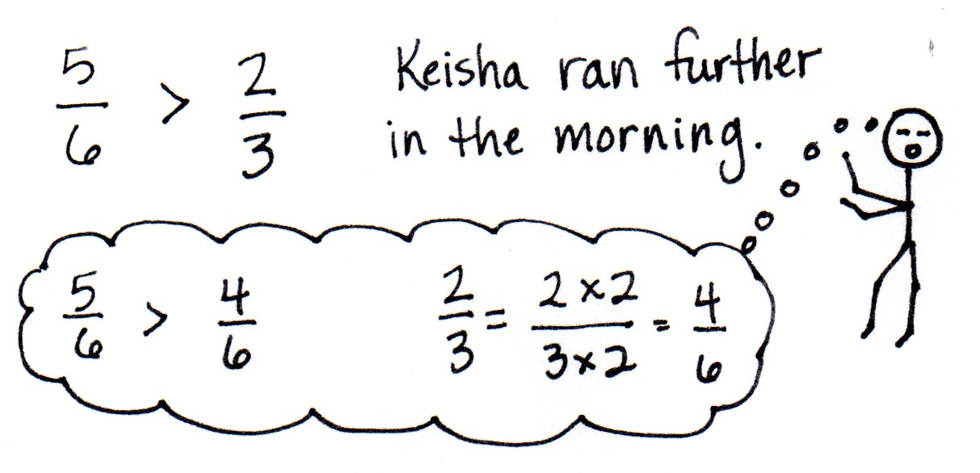
Application Problem (5 minutes)
Keisha ran $\frac{\text{5}}{\text{6}}$ mile in the morning and $\frac{\text{2}}{\text{3}}$ mile in the afternoon. Did Keisha run farther in the morning or in the afternoon? Solve independently. Share your solution with your partner. Did your partner solve the problem in the same way or a different way? Explain.
Note: This Application Problem builds on the Concept Developments of Lessons 14 and 15 where students learned to compare fractions with unrelated denominators by finding common units.
Concept Development (33 minutes)
Materials: (S) Personal white board, blank number lines (Template)
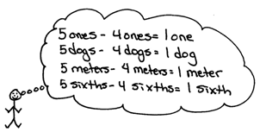
Problem 1: Solve for the difference using unit language and a number line.
T: (Project 5 – 4.) Solve. Say the number sentence using units of ones.
S: 5 ones – 4 ones = 1 one.
T: Say the number sentence if the unit is dogs.
S: 5 dogs – 4 dogs = 1 dog.

NOTES ON
MULTIPLE MEANS
OF REPRESENTATION:
Be sure to articulate the ending digraph /th/ to distinguish six from sixth for English language learners. Coupling spoken expressions with words or models may also improve student comprehension. For example, write out 5 sixths – 4 sixths = 1 sixth.

T: Say the number sentence if the unit is meters.
S: 5 meters – 4 meters = 1 meter.
T: Say the number sentence if the unit is sixths.
S: 5 sixths – 4 sixths = 1 sixth.
T: Let’s show that 5 sixths – 4 sixths = 1 sixth.
T: (Project a number line with endpoints 0 and 1, partitioned into sixths.) Make tick marks on the first number line on your Template to make a number line with endpoints 0 and 1 above the number line. Partition the number line into sixths. (See illustration on next page.)
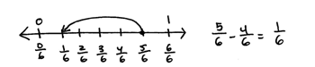
T: Draw a point at 5 sixths. Put the tip of your pencil on the point. Count backward to subtract 4 sixths.
T: Move your pencil and count back with me as we subtract.
S: 4 sixths, 3 sixths, 2 sixths, 1 sixth!
T: Draw one arrow above the number line to model $\frac{\text{5}}{\text{6}}$ – $\frac{\text{4}}{\text{6}}$. (Demonstrate.) Tell me the subtraction sentence.
S: $\frac{\text{5}}{\text{6}}\text{–}\frac{\text{4}}{\text{6}}\text{=}\frac{\text{1}}{\text{6}}$.
Repeat with $\frac{\text{7}}{\text{8}}$ – $\frac{\text{3}}{\text{8}}$.

NOTES ON
MULTIPLE MEANS
OF ENGAGEMENT:
Students working above grade level and others may present alternative subtraction strategies, such as counting up rather than counting down to solve $\frac{\text{7}}{\text{6}}\text{–}\frac{\text{5}}{\text{6}}$. Though not introduced in this lesson, the appropriate use of these strategies is desirable and will be introduced later in the module.

T: Solve for 7 sixths – 2 sixths. Work with a partner. Use the language of units and subtraction.
S: 7 sixths – 2 sixths = 5 sixths. I know 7 ones minus 2 ones is 5 ones. I can subtract sixths like I subtract ones. $\frac{\text{7}}{\text{6}}\text{–}\frac{\text{2}}{\text{6}}\text{=}\frac{\text{5}}{\text{6}}.$
T: Discuss with your partner how to draw a number line to represent this problem.
S: We partition it like the first problem and draw the arrow to subtract. But, $\frac{\text{7}}{\text{6}}$ is more than 1 whole. 6 sixths is equal to 1. We have 7 sixths. Let’s make the number line with endpoints 0 and 2.
T: Label the endpoints 0 and 2. Partition the number line into sixths. Subtract.
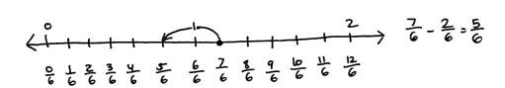
S: On the number line, we started at 7 sixths and then went back 2 sixths. The answer is 5 sixths. $\frac{\text{7}}{\text{6}}\text{–}\frac{\text{2}}{\text{6}}\text{=}\frac{\text{5}}{\text{6}}$.
Repeat with $\frac{7}{4}-\frac{5}{4}$.
Problem 2: Decompose to record a difference greater than 1 as a mixed number.
T: (Display 10 sixths – 2 sixths.) Solve in unit form, and write a number sentence using fractions.
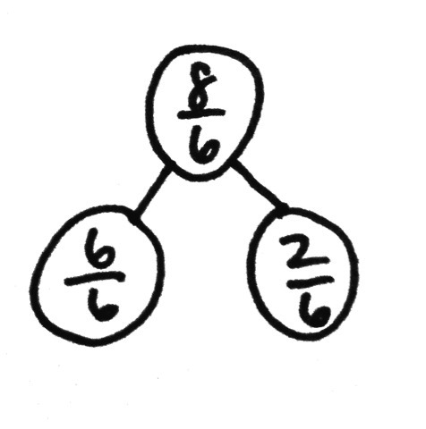
S: (Write 10 sixths – 2 sixths = 8 sixths and $\frac{\text{10}}{\text{6}}\text{–}\frac{\text{2}}{\text{6}}\text{=}\frac{\text{8}}{\text{6}}$.)
T: Use a number bond to decompose $\frac{\text{8}}{\text{6}}$ into the whole and fractional parts.
S: (Draw a number bond as pictured to the right.)
T: $\frac{\text{6}}{\text{6}}$ is the same as…?
S: 1 whole.
T: We can rename $\frac{\text{8}}{\text{6}}$ as a mixed number, $\text{1}\frac{\text{2}}{\text{6}}$, using a whole number and fractional parts.
Repeat with 9 fifths – 3 fifths.
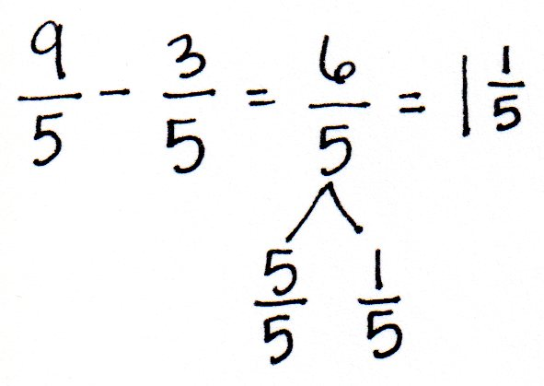

Problem 3: Solve for the sum using unit language and a number line.
T: Look back at the first example. (Point to the number line representing 5 sixths – 4 sixths.) Put your finger on 1 sixth. To 1 sixth, let’s add the 4 sixths that we took away.
T: Count as we add. 1 sixth, 2 sixths, 3 sixths, 4 sixths. Where are we now?
S: 5 sixths.
T: What is 1 sixth plus 4 sixths?
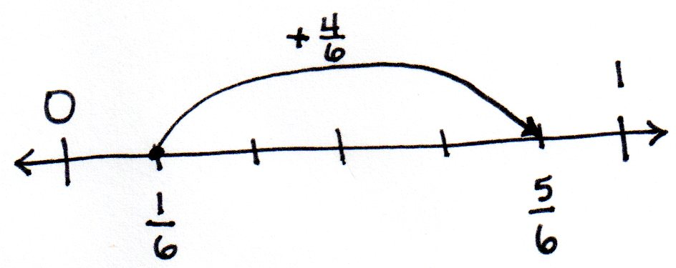
S: 5 sixths.
T: Let’s show that on the number line. (Model with students as shown to the right.)
T: 1 one plus 4 ones is…?
S: 5 ones.
T: 1 apple plus 4 apples is…?
S: 5 apples.
T: 1 sixth plus 4 sixths equals…?
S: 5 sixths.
Repeat with $\frac{\text{2}}{\text{8}}\text{+}\frac{\text{3}}{\text{8}}\text{=}\frac{\text{5}}{\text{8}}.$
Problem 4: Decompose to record a sum greater than 1 as a mixed number.
T: (Display 5 fourths + 2 fourths.) Solve in unit form, and write a number sentence using fractions.
S: (Write 5 fourths + 2 fourths = 7 fourths and $\frac{\text{5}}{\text{4}}\text{+}\frac{\text{2}}{\text{4}}\text{=}\frac{\text{7}}{\text{4}}$.)
T: Use a number bond to decompose $\frac{\text{7}}{\text{4}}$ into the whole and some parts.
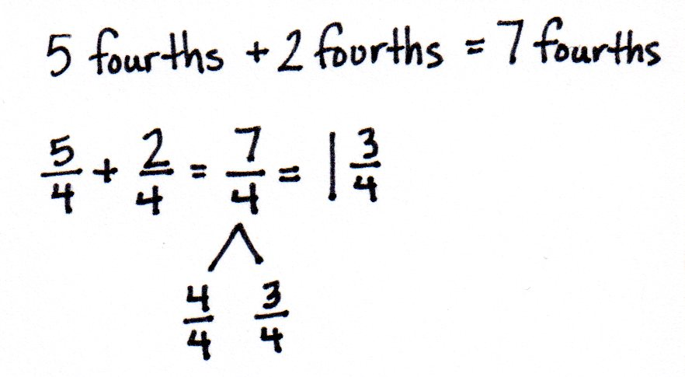
S: (Draw a number bond as pictured to the right.)
T: $\frac{\text{4}}{\text{4}}$ is the same as…?
S: 1 whole.
T: We can rename $\frac{\text{7}}{\text{4}}$ as a mixed number, $\text{1}\frac{\text{3}}{\text{4}}$.
Repeat with 6 sixths + 4 sixths.
Problem Set (10 minutes)
Students should do their personal best to complete the Problem Set within the allotted 10 minutes. For some classes, it may be appropriate to modify the assignment by specifying which problems they work on first. Some problems do not specify a method for solving. Students should solve these problems using the RDW approach used for Application Problems.

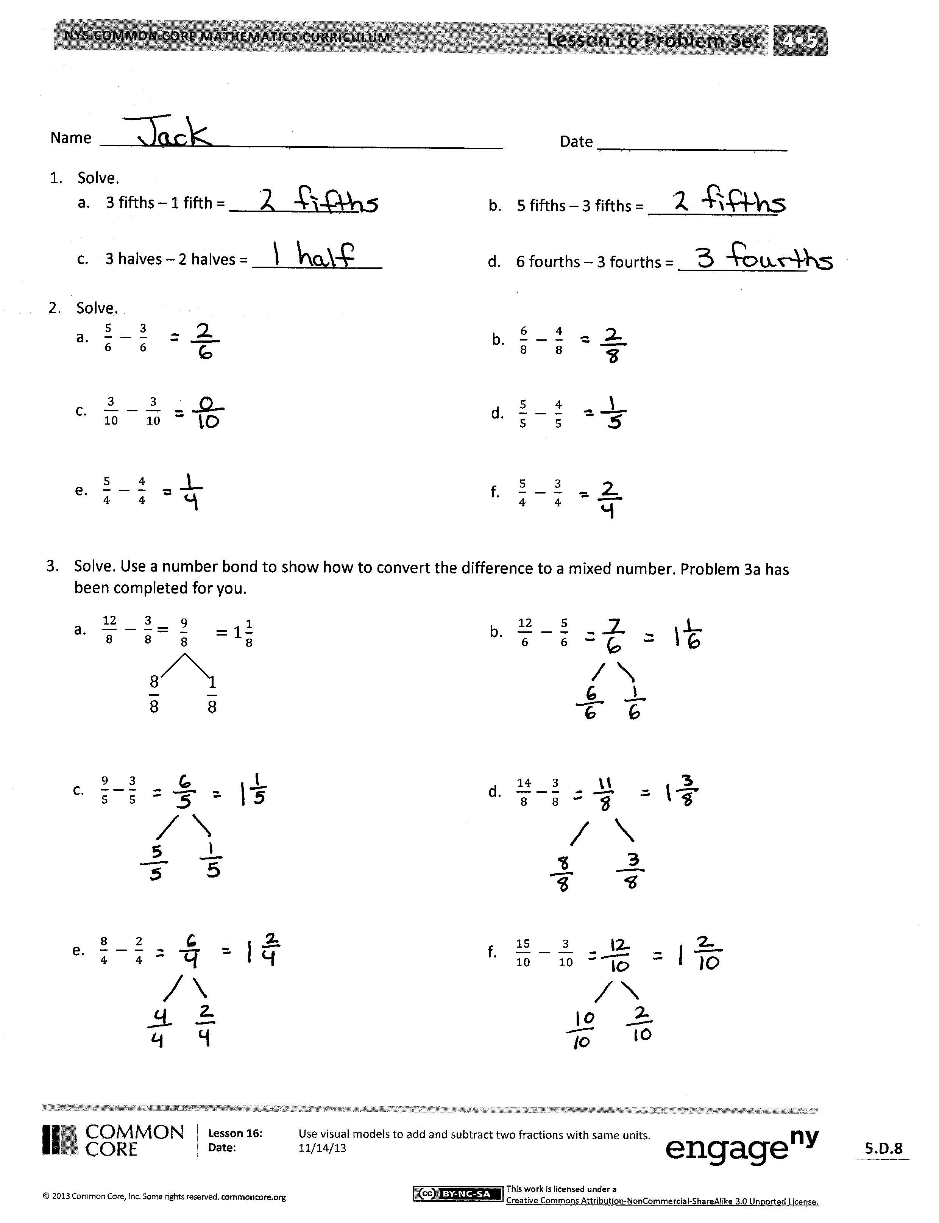
Student Debrief (10 minutes)
Lesson Objective: Use visual models to add and subtract two fractions with the same units.
The Student Debrief is intended to invite reflection and active processing of the total lesson experience.
Invite students to review their solutions for the Problem Set. They should check work by comparing answers with a partner before going over answers as a class. Look for misconceptions or misunderstandings that can be addressed in the Debrief. Guide students in a conversation to debrief the Problem Set and process the lesson.
Any combination of the questions below may be used to lead the discussion.
- How do Problems 1(a–d), 4(a), and 4(b) help you understand how to subtract or add fractions?
- In Problems 3 and 6 on the Problem Set, how do the number bonds help to decompose the fraction into a mixed number?
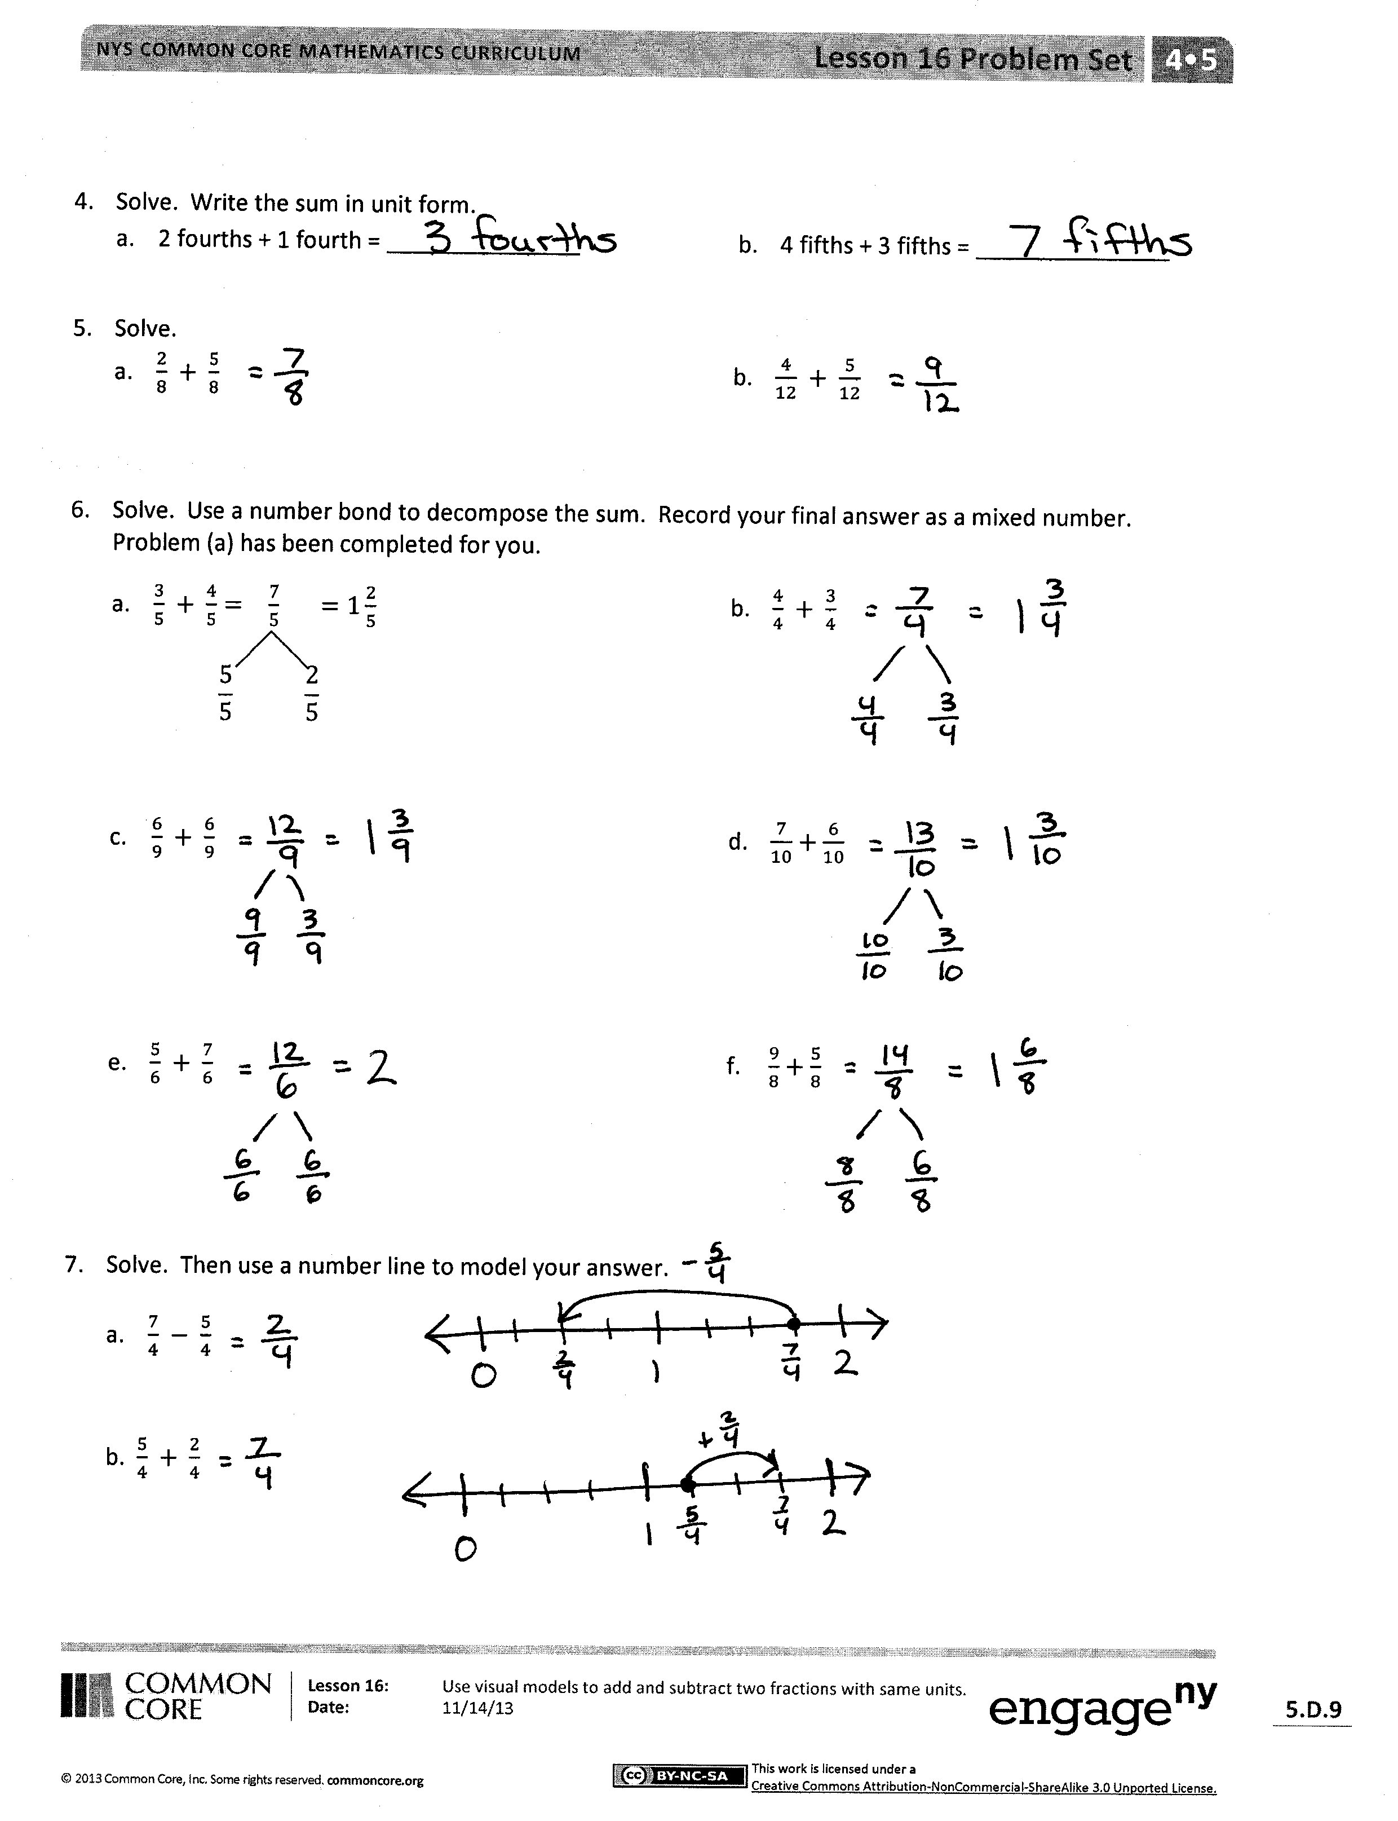
- Why would we want to name a fraction greater than 1 using a mixed number?
- How is the number line helpful in showing how we can subtract and add fractions with like units?
- How are number bonds helpful in showing how we can rename fractions greater than 1 as 1 whole and a fraction?
- How would you describe to a friend how to subtract and add fractions with like units?
Exit Ticket (3 minutes)
After the Student Debrief, instruct students to complete the Exit Ticket. A review of their work will help with assessing students’ understanding of the concepts that were presented in today’s lesson and planning more effectively for future lessons. The questions may be read aloud to the students.

Name Date
- Solve.
- 3 fifths – 1 fifth = _______________ | - 5 fifths – 3 fifths = _______________
- 3 halves – 2 halves = _______________ | - 6 fourths – 3 fourths = _______________

- Solve.

- $\frac{5}{6} - \frac{3}{6}$
- $\frac{6}{8} - \frac{4}{8}$

- $\frac{3}{10} - \frac{3}{10}$
- $\frac{5}{5} - \frac{4}{5}$

- $\frac{5}{4} - \frac{4}{4}$
- $\frac{5}{4} - \frac{3}{4}$

- Solve. Use a number bond to show how to convert the difference to a mixed number. Problem (a) has been completed for you.
$\frac{\text{9}}{\text{8}} =1\frac{1}{8}$

$$\frac{8}{8} \frac{1}{8}$$

- $\frac{12}{8} - \frac{3}{8}=$
- $\frac{12}{6} - \frac{5}{6}$

- $\frac{9}{5}-\frac{3}{5}$
- $\frac{14}{8}-\frac{3}{8}$

- $\frac{8}{4} - \frac{2}{4}$

- $\frac{15}{10} - \frac{3}{10}$

- Solve. Write the sum in unit form.
- 2 fourths + 1 fourth = _______________ | - 4 fifths + 3 fifths = _______________

- Solve.

- $\frac{2}{8} + \frac{5}{8}$

- $\frac{4}{12} + \frac{5}{12}$

- Solve. Use a number bond to decompose the sum. Record your final answer as a mixed number.
Problem (a) has been completed for you.
$\frac{\text{7}}{\text{5}} =1\frac{2}{5}$

$$\frac{5}{5} \frac{2}{5}$$

- $\frac{3}{5} + \frac{4}{5}=$

- $\frac{4}{4} + \frac{3}{4}$

- $\frac{6}{9} + \frac{6}{9}$

- $\frac{7}{10}+\frac{6}{10}$

- $\frac{5}{6} + \frac{7}{6}$
- $\frac{9}{8}+\frac{5}{8}$

- Solve. Use a number line to model your answer.

- $\frac{7}{4} - \frac{5}{4}$

- $\frac{5}{4} + \frac{2}{4}$
Name Date
- Solve. Use a number bond to decompose the difference. Record your final answer as a mixed number.
$\frac{16}{9} - \frac{5}{9}$

- Solve. Use a number bond to decompose the sum. Record your final answer as a mixed number.

$\frac{5}{12}+ \frac{10}{12}$

Name Date
  - Solve.
- 3 sixths – 2 sixths = _______________ | - 5 tenths – 3 tenths = _______________
- 3 fourths – 2 fourths = _______________ | - 5 thirds – 2 thirds = _______________

  - Solve.

- $\frac{3}{5} - \frac{2}{5}$
- $\frac{7}{9} - \frac{3}{9}$

- $\frac{7}{12} - \frac{3}{12}$
- $\frac{6}{6} - \frac{4}{6}$

- $\frac{5}{3} - \frac{2}{3}$
- $\frac{7}{4} - \frac{5}{4}$

  - Solve. Use a number bond to decompose the difference. Record your final answer as a mixed number. Problem (a) has been completed for you.
$\frac{\text{9}}{\text{6}} =1\frac{3}{6}$

$$\frac{6}{6} \frac{3}{6}$$

- $\frac{12}{6} - \frac{3}{6}=$
- $\frac{17}{8} - \frac{6}{8}$

- $\frac{9}{5}-\frac{3}{5}$

- $\frac{11}{4}-\frac{6}{4}$

- $\frac{10}{7} - \frac{2}{7}$

- $\frac{21}{10} - \frac{9}{10}$

  - Solve. Write the sum in unit form.
- 4 fifths + 2 fifths = _______________ | - 5 eighths + 2 eighths = _______________
  - Solve.
- $\frac{3}{11} + \frac{6}{11}$ b. $\frac{3}{10} + \frac{6}{10}$

  - Solve. Use a number bond to decompose the sum. Record your final answer as a mixed number$.$
- $\frac{3}{4} + \frac{3}{4}$ b. $\frac{8}{12} + \frac{6}{12}$

- $\frac{5}{8} + \frac{7}{8}$ d. $\frac{8}{10}+\frac{5}{10}$

- $\frac{3}{5} + \frac{6}{5}$ f. $\frac{4}{3}+\frac{2}{3}$

  - Solve. Use a number line to model your answer.

- $\frac{11}{9} - \frac{5}{9}$

- $\frac{13}{12} + \frac{4}{12}$

Name Date

blank number lines

