Lesson 14
Objective: Find common units or number of units to compare two fractions.

Suggested Lesson Structure
 Fluency Practice (12 minutes)
 Application Problem (5 minutes)
 Concept Development (33 minutes)
 Student Debrief (10 minutes)
Total Time (60 minutes)
Fluency Practice (12 minutes)
- Add and Subtract 4.NBT.4 (4 minutes)
- Compare Fractions 4.NF.2 (4 minutes)
- Construct a Number Line with Fractions 4.NF.2 (4 minutes)
Add and Subtract (4 minutes)
Materials: (S) Personal white board
Note: This fluency activity reviews adding and subtracting using the standard algorithm.
T: (Write 458 thousands 397 ones.) On your personal white board, write this number in standard form.
S: (Write 458,397.)
T: (Write 281 thousands 563 ones.) Add this number to 458,397 using the standard algorithm.
S: (Write 458,397 + 281,563 = 739,960 using the standard algorithm.)
Continue the process with 456,919 + 292,689.
T: (Write 900 thousands.) On your board, write this number in standard form.
S: (Write 900,000.)
T: (Write 523 thousands 536 ones.) Subtract this number from 900,000 using the standard algorithm.
S: (Write 900,000 – 523,536 = 376,464 using the standard algorithm.)
Continue the process with 512,807 – 255,258.

Compare Fractions (4 minutes)
Materials: (S) Personal white board
Note: This fluency activity reviews Lesson 12.
T: (Project a blank number line, partitioned into 2 equal parts.) Draw a number line on your personal white board, and then partition it into 2 equal parts.
S: (Draw and partition a number line.)
T: (Write 0 below the left endpoint. Write 1 below the right endpoint.) Fill in the endpoints, and write the fraction that belongs at the halfway point.
S: (Label 0, $\frac{1}{2}$, and 1.)
T: (Write $\frac{\text{7}}{\text{8}}$.) Plot 7 eighths on your number line.
S: (Plot $\frac{7}{8}$.)
T: (Write $\frac{\text{7}}{\text{8}}$ __ $\frac{\text{1}}{\text{2}}$.) On your boards, fill in the blank with a greater than or less than symbol.
S: (Write $\frac{7}{8}>\frac{1}{2}$.)
T: (Write $\frac{\text{1}}{\text{2}}$ __ $\frac{\text{3}}{\text{4}}$.) On your boards, fill in the blank with a greater than or less than symbol. Use your number line if you need to.
S: (Write $\frac{\text{1}}{\text{2}}$ < $\frac{\text{3}}{\text{4}}$.)
Continue with the following possible sequence: Compare $\frac{\text{3}}{\text{4}}$ and $\frac{\text{7}}{\text{8}}$, $\frac{\text{5}}{\text{6}}$ and $\frac{\text{1}}{\text{2}}$, and $\frac{\text{5}}{\text{6}}$ and $\frac{\text{2}}{\text{3}}$.
Construct a Number Line with Fractions (4 minutes)
Materials: (S) Personal white board
Note: This fluency activity reviews Lesson 13.
T: (Project a blank number line, partitioned into 3 equal parts.) Draw a number line on your personal white board, and then partition it into 3 equal parts.
S: (Draw a number line partitioned into 3 equal parts.)
T: (Write 1 below the left endpoint. Write 2 below the right endpoint.) Fill in the endpoints, and write the fraction that belongs at the halfway point.
S: (Write 1 below the left endpoint, 2 below the right endpoint, and $\text{1}\frac{\text{1}}{\text{2}}$ below the halfway point.)
T: (Write $\frac{\text{6}}{\text{5}}$.) Plot 6 fifths on your number line.
T: (Write $\frac{\text{6}}{\text{5}}$ __ $\text{1}\frac{\text{1}}{\text{2}}\text{.}$) On your boards, fill in the blank with a greater than or less than symbol.
S: (Write $\frac{\text{6}}{\text{5}}$ < $\text{1}\frac{\text{1}}{\text{2}}$.)
Continue with the following possible sequence: Compare $\frac{\text{17}}{\text{10}}$ and $\text{1}\frac{\text{1}}{\text{2}}$, $\frac{\text{17}}{\text{10}}$ and $\frac{\text{6}}{\text{5}}$, and $\frac{\text{19}}{\text{12}}$ and $\frac{\text{7}}{\text{4}}$.
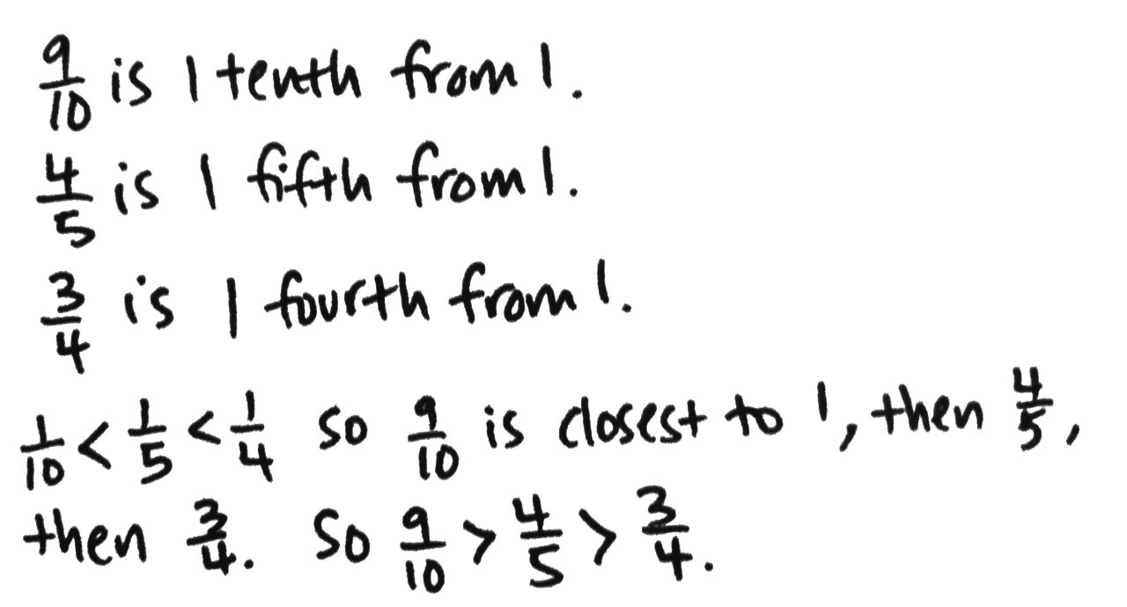
Application Problem (5 minutes)
Compare $\frac{\text{4}}{\text{5}}$, $\frac{\text{3}}{\text{4}}$, and$\frac{\text{9}}{\text{10}}$ using <, >, or =. Explain your reasoning using a benchmark.
Note: This Application Problem reviews all of Topic C and bridges to today’s lesson, in which students will compare fractions with unrelated denominators using area models.
Concept Development (33 minutes)
Materials: (S) Personal white board
Problem 1: Reason about fraction size using unit language.
T: Which is greater—1 apple or 3 apples?
S: 3 apples!

NOTES ON
MULTIPLE MEANS
OF ACTION AND EXPRESSION:
To accurately compare two fractions using a tape diagram, both tape diagrams must be the same length and aligned precisely. Providing a template of two blank parallel tape diagrams of equal length may be helpful in assisting students.

T: (Write 3 apples > 1 apple.)
T: Which is greater—1 fourth or 3 fourths?
S: 3 fourths!
T: (Write 3 fourths > 1 fourth.)
T: What do you notice about these two statements?
3 apples > 1 apple
3 fourths > 1 fourth
S: The units are the same in each. One is apples, and the other is fourths. We can compare the number of fourths like we compare the number of apples. It is easy to compare when the units are the same!
MP.7
T: Which is greater—1 fourth or 1 fifth?
S: 1 fourth.
T: (Write 1 fourth > 1 fifth.)
T: How do you know?
S: I can draw two tape diagrams to compare. I can partition a whole into fourths on one tape diagram and into fifths on the other. There are more fifths than fourths, so each fourth is going to be bigger than a fifth. $\frac{\text{1}}{\text{5}}$ is less than$\frac{\text{1}}{\text{4}}$ because fifths are smaller than fourths.
T: (Write $\frac{\text{1}}{\text{4}}$ >$\frac{\text{1}}{\text{5}}$.)
T: Which is greater—2 fourths or 2 sixths?
S: 2 fourths is greater than 2 sixths.
T: (Write $\frac{\text{2}}{\text{4}}$ >$\frac{\text{2}}{\text{6}}$.)
T: What do you notice about these statements?
$\frac{\text{1}}{\text{4}}$ >$\frac{\text{1}}{\text{5}}$ $\frac{\text{2}}{\text{4}}$ >$\frac{\text{2}}{\text{6}}$
S: Fourths are greater than fifths and sixths. In each comparison, the numerators are the same.
T: Which would be greater—2 inches or 2 feet?
S: 2 feet! I know feet are greater than inches.
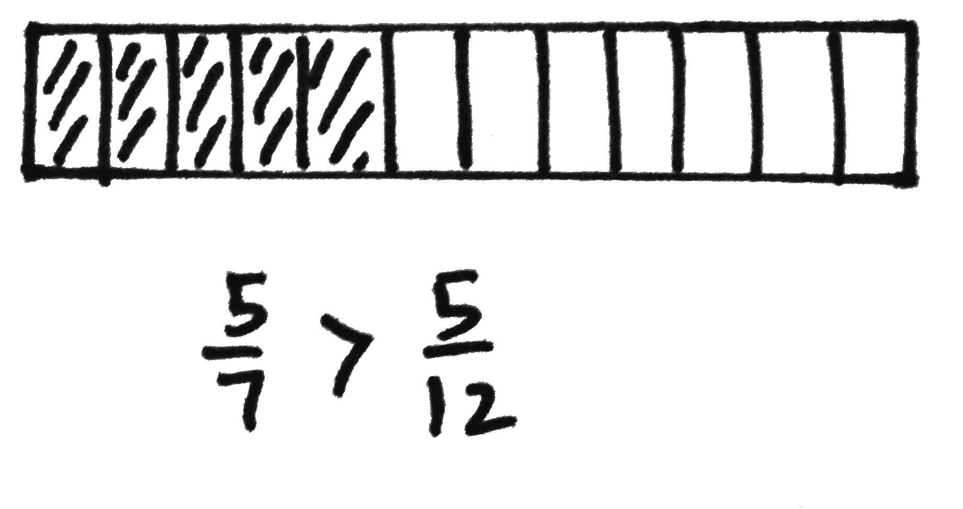
T: In the same way, 2 fourths is greater than 2 sixths because fourths are greater than sixths.
MP.7
T: When the numerator is the same, we look at the denominator to reason about which fraction is greater. The greater the denominator, the smaller the fractional unit.
Explain why $\frac{\text{5}}{\text{7}}$ is greater than $\frac{\text{5}}{\text{12}}$ of the same whole.
S: Sevenths are greater fractional units than twelfths. 5 sevenths are greater than 5 twelfths because 1 seventh is greater than
1 twelfth. The sum of 5 larger units is going to be greater than the sum of 5 smaller units.
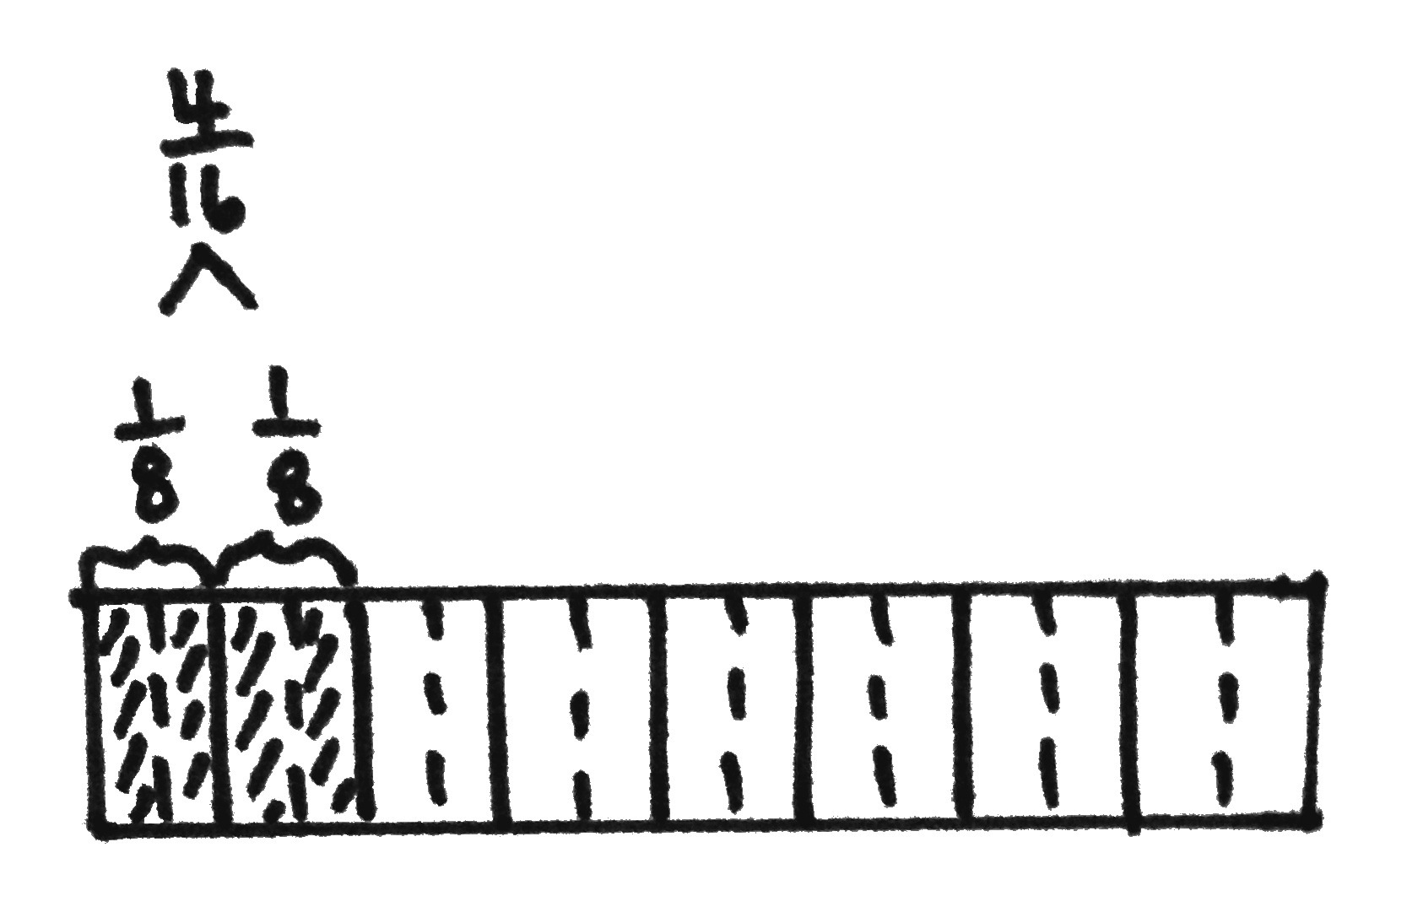
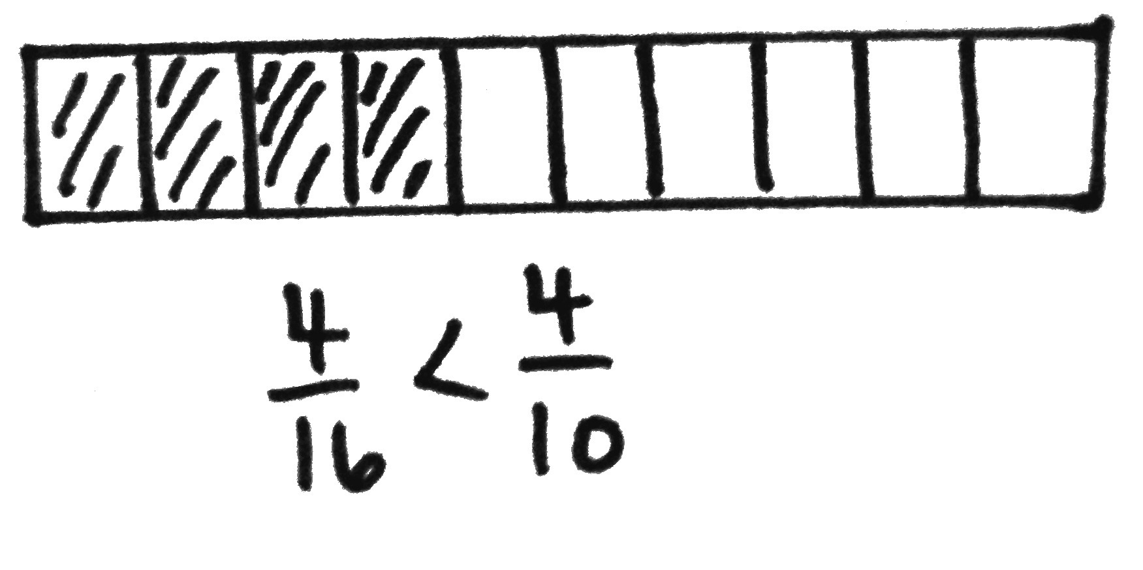
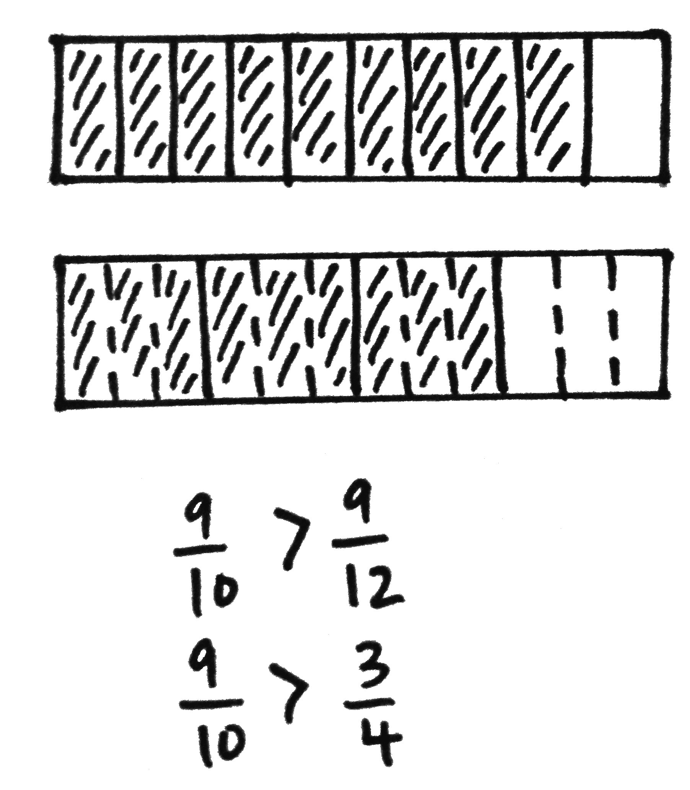
Problem 2: Compare fractions with related numerators.
T: (Display $\frac{\text{2}}{\text{8}}$ and $\frac{\text{4}}{\text{10}}$.) Draw a tape diagram to show each.
T: Partition the eighths in half. What fraction is now shown?
S: $\frac{\text{4}}{\text{16}}$. The numerators are the same! The number of shaded units is the same.
T: Compare $\frac{\text{4}}{\text{16}}$ and$\frac{\text{4}}{\text{10}}$.
S: $\frac{\text{4}}{\text{16}}$ is less than $\frac{\text{4}}{\text{10}}$ since sixteenths are smaller units than tenths. I can compare the size of the units because the numerators are the same.
T: Compare $\frac{\text{2}}{\text{8}}$ and$\frac{\text{4}}{\text{10}}$.
S: $\frac{\text{2}}{\text{8}}$ is less than$\frac{\text{4}}{\text{10}}$.
T: (Display $\frac{\text{9}}{\text{10}}$ and $\frac{\text{3}}{\text{4}}$.) Discuss a strategy for comparing these two fractions with your partner.
S: Let’s make a common numerator of 9. $\frac{\text{3}}{\text{4}}\text{=}\frac{\text{3} \text{×} \text{3}}{\text{4} \text{×} \text{3}}\text{=}\frac{\text{9}}{\text{12}}$. $\frac{\text{9}}{\text{10}}$ is greater than$\frac{\text{9}}{\text{12}}$. $\frac{\text{9}}{\text{10}}$ is greater than$\frac{\text{3}}{\text{4}}$. $\frac{\text{9}}{\text{10}}\text{+}\frac{\text{1}}{\text{10}}\text{=} \text{1}$, and $\frac{\text{3}}{\text{4}}\text{+}\frac{\text{1}}{\text{4}}\text{=} \text{1.}$ 1 tenth is less than 1 fourth, so 9 tenths is greater.
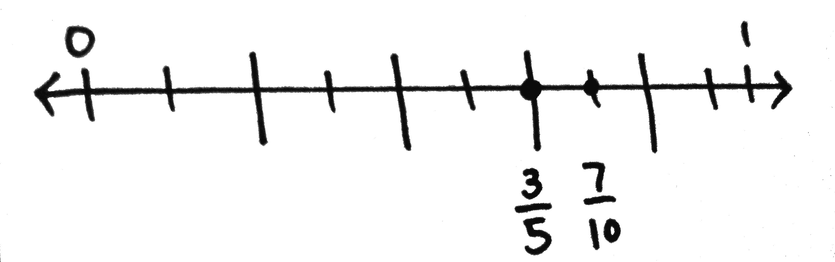
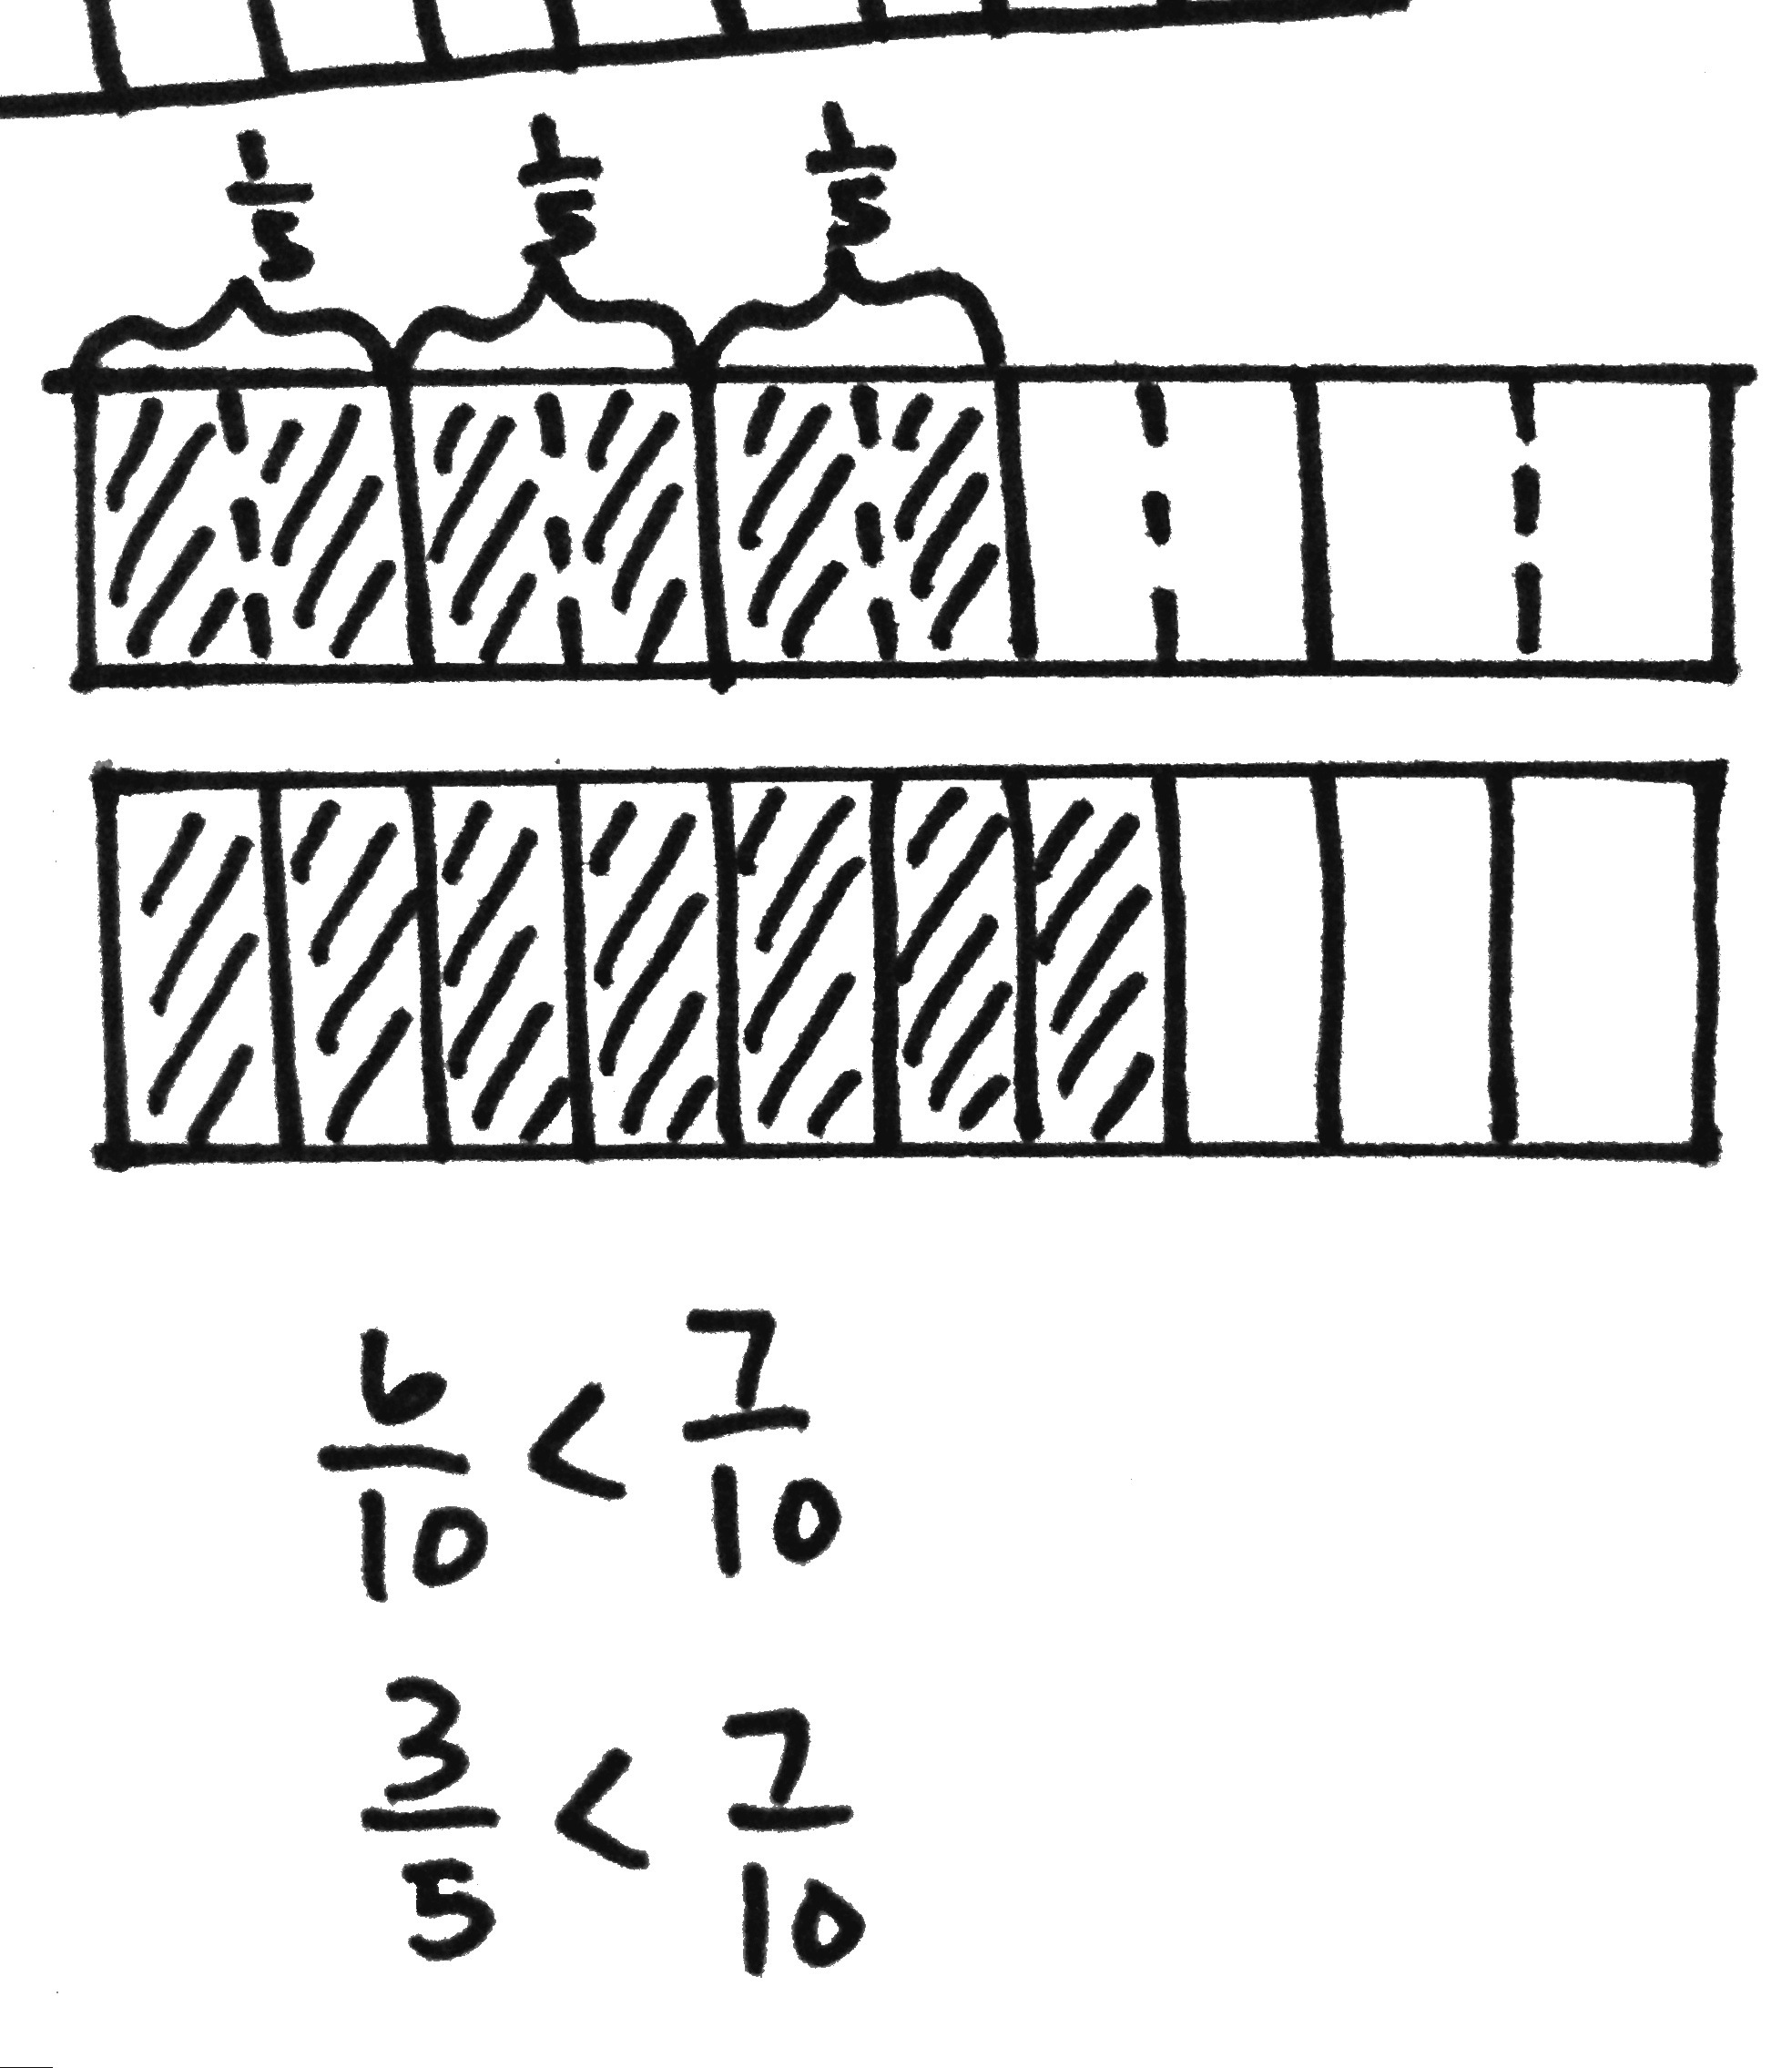
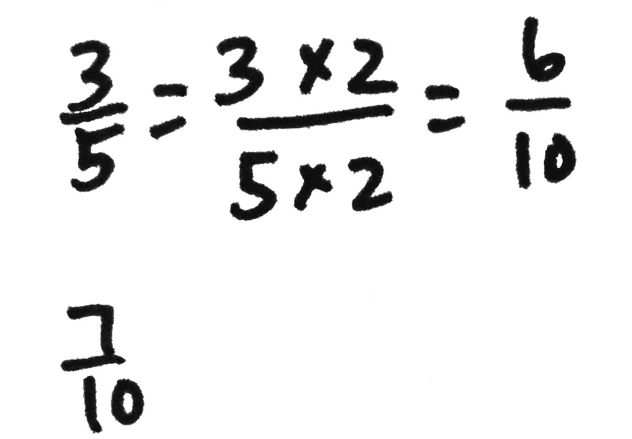
Problem 3: Compare fractions having related denominators where one denominator is a factor of the other.
T: (Display $\frac{\text{7}}{\text{10}}$ and $\frac{\text{3}}{\text{5}}$.) Model each fraction using a tape diagram. Can we make a common numerator?
S: No. We can’t multiply 3 by a number to get 7. We could make them both numerators of 21.
T: Finding a common numerator does not work easily here. Consider the denominators. Can we make like units, or common denominators?
S: Yes. We can partition each fifth in half to make tenths. $\frac{\text{3}}{\text{5}}\text{=}\frac{\text{3} \text{×} \text{2}}{\text{5} \text{×} \text{2}}\text{=}\frac{\text{6}}{\text{10}}$.
T: Compare $\frac{\text{6}}{\text{10}}$ and$\frac{\text{7}}{\text{10}}$.
S: $\frac{\text{6}}{\text{10}}$ is less than$\frac{\text{7}}{\text{10}}$. That means that $\frac{\text{3}}{\text{5}}$ is less than$\frac{\text{7}}{\text{10}}$.
T: Draw a number line to show 3 fifths. Decompose the line into tenths to show
7 tenths. $\frac{\text{3}}{\text{5}}$ is equal to how many tenths?
S: $\frac{\text{6}}{\text{10}}$.
T: Compare $\frac{\text{6}}{\text{10}}$ and$\frac{\text{7}}{\text{10}}$.
S: $\frac{\text{6}}{\text{10}}$ is less than$\frac{\text{7}}{\text{10}}$ , so $\frac{\text{3}}{\text{5}}\text{<}\frac{\text{7}}{\text{10}}$.
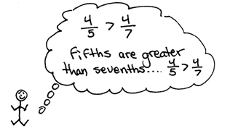
Problem 4: Compare fractions using different methods of reasoning.
T: Think about the strategies that we have learned. What strategy would you use to compare $\frac{\text{4}}{\text{5}}$ and $\frac{\text{4}}{\text{7}}$? Discuss with your partner. Defend your reasoning.
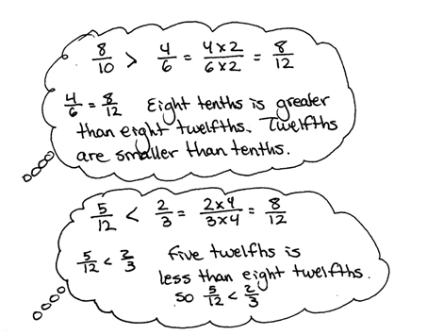
S: The numerators are the same. $\frac{\text{4}}{\text{5}}$ is greater than$\frac{\text{4}}{\text{7}}$.
There are 4 fifths and 4 sevenths. Since fifths are greater than sevenths, $\frac{\text{4}}{\text{5}}$ is greater than $\frac{\text{4}}{\text{7}}$. 4 fifths is a lot more than 1 half. 4 sevenths is a little more than 1 half.
T: Compare $\frac{\text{8}}{\text{10}}$ and$\frac{\text{4}}{\text{6}}$.
S: It looks like we can make numerators that are the same, because 8 is a multiple of 4. $\frac{\text{4}}{\text{6}}$ is the same as$\frac{\text{8}}{\text{12}}$ . $\frac{\text{8}}{\text{12}}$ is less than$\frac{\text{8}}{\text{10}}$. So, $\frac{\text{4}}{\text{6}}$ is less than $\frac{\text{8}}{\text{10}}$. $\frac{\text{8}}{\text{10}}\text{+}\frac{\text{2}}{\text{10}}\text{=} \text{1}\text{,}$ and $\frac{\text{4}}{\text{6}}\text{+}\frac{\text{2}}{\text{6}}\text{=} \text{1}$.
I know that 2 tenths is less than 2 sixths, so 8 tenths is greater.
T: Compare $\frac{\text{5}}{\text{12}}$ and$\frac{\text{2}}{\text{3}}$.
S: The units are different! Twelfths are not thirds, but we can decompose thirds to make twelfths! We can make like denominators. $\frac{\text{2}}{\text{3}}$is the same as$\frac{\text{8}}{\text{12}}$. $\frac{\text{8}}{\text{12}}$is more than$\frac{\text{5}}{\text{12}}$. $\frac{\text{2}}{\text{3}}\text{>}\frac{\text{5}}{\text{12}}$ . I wouldn’t try to make the same number of units because 5 is not a multiple of 2, but it might be possible.
5 twelfths is less than a half, and 2 thirds is more than a half.
T: How might we use what we know to compare 1$\frac{\text{2}}{\text{5}}$ and 1$\frac{\text{6}}{\text{8}}\text{?}$ Share your thoughts with your partner.
S: I see that the whole numbers are the same, so we can just compare the fractions. Let’s compare $\frac{\text{2}}{\text{5}}$and $\frac{\text{6}}{\text{8}}$. The numerators are related. 6 is a multiple of 2, so we can make fractions that have equal numerators. $\frac{\text{2}}{\text{5}}$ is the same as $\frac{\text{6}}{\text{15}} ,$ which is smaller than$\frac{\text{6}}{\begin{aligned} \\ \text{8}\end{aligned}}$. So, 1$\frac{\text{2}}{\text{5}}$ is less than $1\frac{\text{6}}{\text{8}}$. 2 fifths is less than half. 6 eighths is greater than half, so 1 $\frac{\text{6}}{\text{8}}$ is greater.
Problem Set (10 minutes)
Students should do their personal best to complete the Problem Set within the allotted 10 minutes. For some classes, it may be appropriate to modify the assignment by specifying which problems they work on first. Some problems do not specify a method for solving. Students should solve these problems using the RDW approach used for Application Problems.

NOTES ON
MULTIPLE MEANS
OF ACTION AND EXPRESSION:
Support English language learners as they explain their reasoning for Problems 5(a), 5(d), and 5(f) on the Problem Set. Provide a word bank with corresponding pictures.
Possible words for the word bank are listed below:
fourth seventh third fifteenth
whole ninth one closer
greater than less than almost
tape diagram

Student Debrief (10 minutes)
Lesson Objective: Find common units or number of units to compare two fractions.
The Student Debrief is intended to invite reflection and active processing of the total lesson experience.
Invite students to review their solutions for the Problem Set. They should check work by comparing answers with a partner before going over answers as a class. Look for misconceptions or misunderstandings that can be addressed in the Debrief. Guide students in a conversation to debrief the Problem Set and process the lesson.
Any combination of the questions below may be used to lead the discussion.
- Why were the fractions in Problem 1 easier to compare than in Problem 2?
- Problems 5(a), 5(d), and 5(f) can be compared using different types of reasoning. Explain the reasoning you used for each.
- How can you determine whether you can make common numerators or common denominators when comparing fractions?
- How are tape diagrams and number lines helpful in comparing fractions?
- What new (or significant) math vocabulary did we use today to communicate precisely?
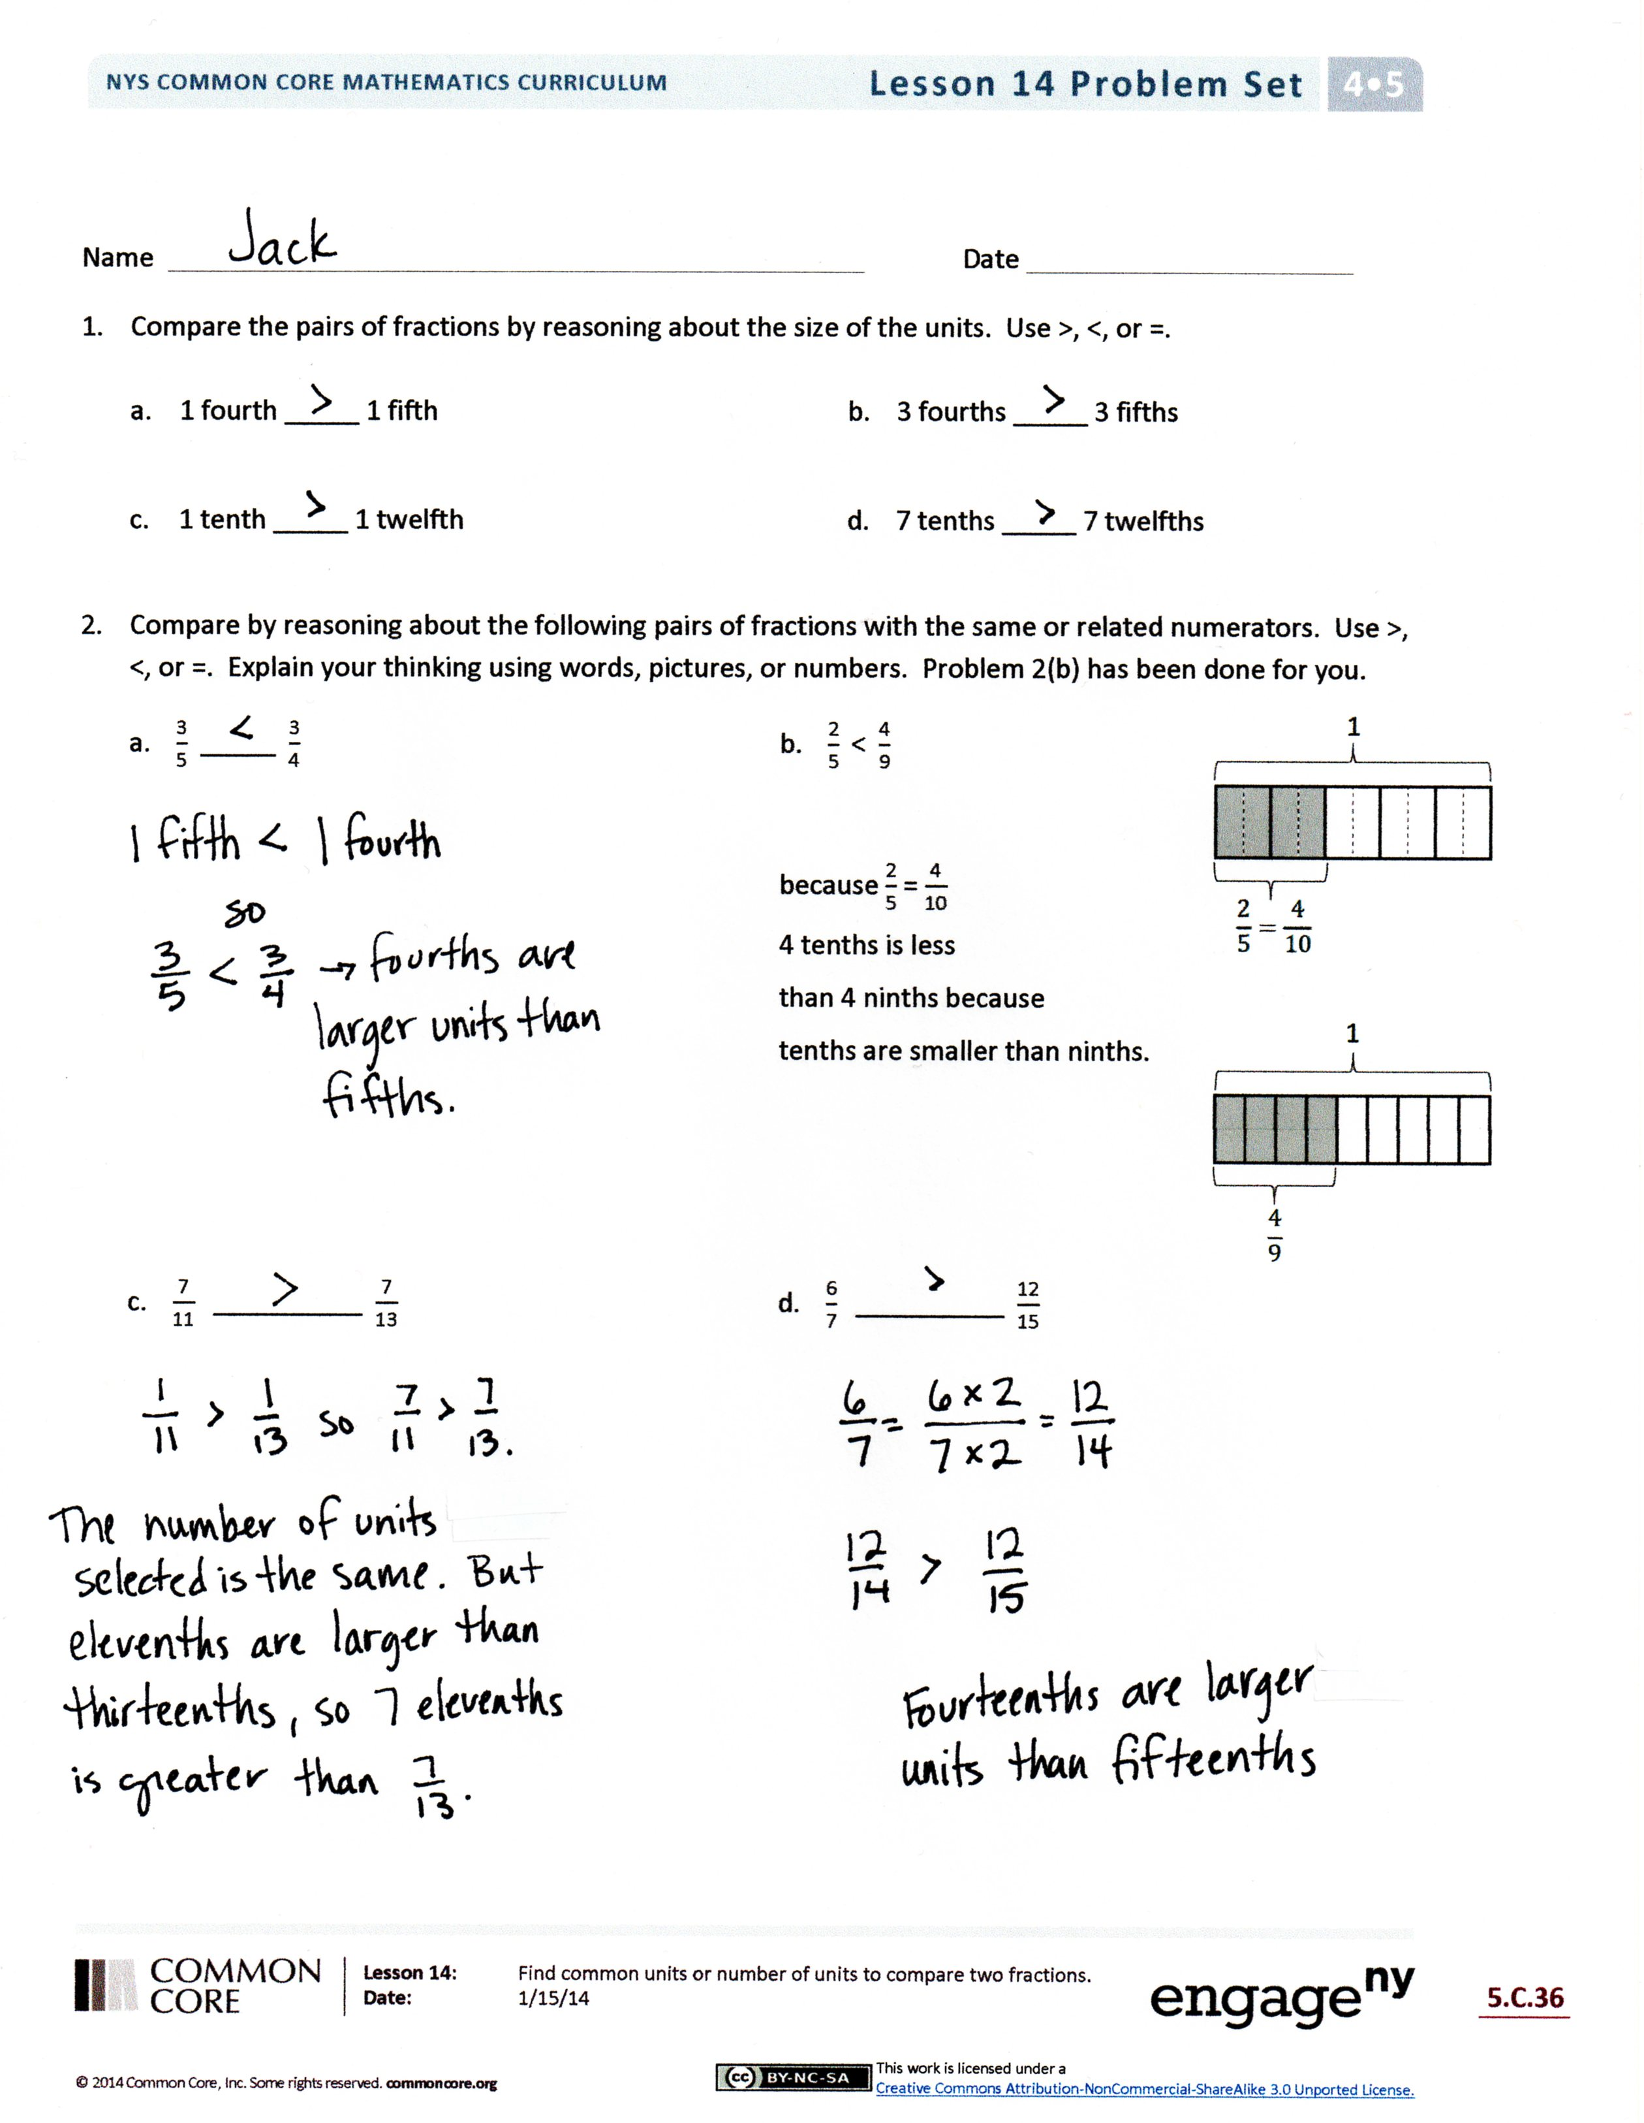
- How did the Application Problem connect to today’s lesson?
Exit Ticket (3 minutes)
After the Student Debrief, instruct students to complete the Exit Ticket. A review of their work will help with assessing students’ understanding of the concepts that were presented in today’s lesson and planning more effectively for future lessons. The questions may be read aloud to the students.

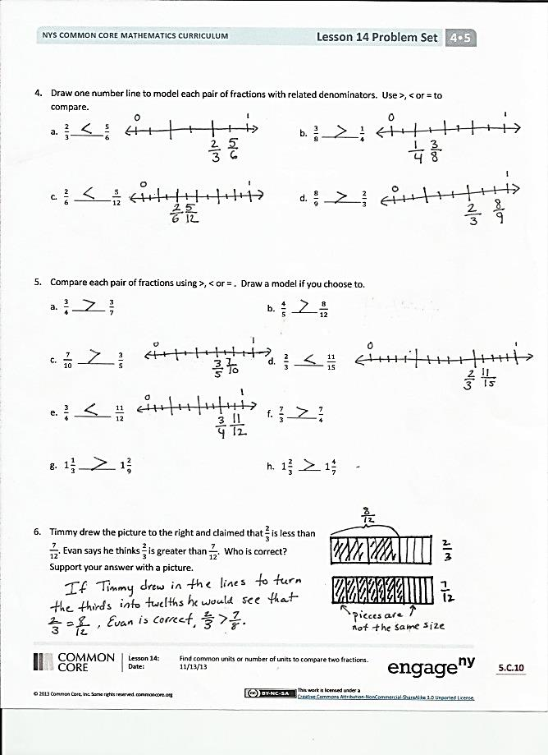
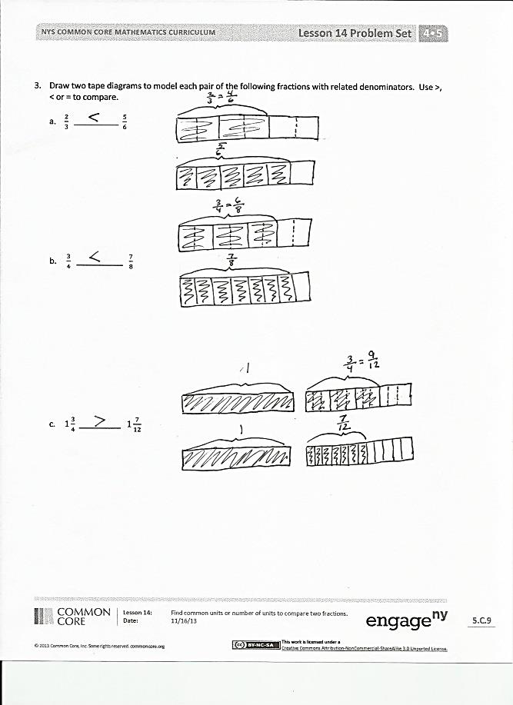

Name Date
- Compare the pairs of fractions by reasoning about the size of the units. Use >, <, or =.

- 1 fourth _____ 1 fifth
- 3 fourths _____ 3 fifths

- 1 tenth _____ 1 twelfth
- 7 tenths _____ 7 twelfths

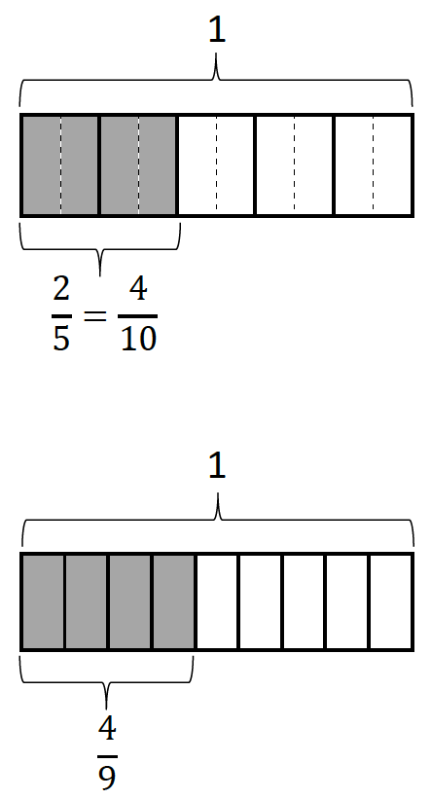
- Compare by reasoning about the following pairs of fractions with the same or related numerators.
Use >, <, or =. Explain your thinking using words, pictures, or numbers. Problem 2(b) has been done for you.
a. $\frac{\text{3}}{\text{5}}$ _____ $\frac{\text{3}}{\text{4}}$ | b. $\frac{\text{2}}{\text{5}}\text{ <}$ $\frac{\text{4}}{\text{9}}$  because $\frac{\text{2}}{\text{5}}$ = $\frac{\text{4}}{\text{10}}$  4 tenths is less  than 4 ninths because  tenths are smaller than ninths.
c. $\frac{\text{7}}{\text{11}}\text{ _________}$ $\frac{\text{7}}{\text{13}}$ | d. $\frac{\text{6}}{\text{7}}\text{ _________}$ $\frac{\text{12}}{\text{15}}$

- Draw two tape diagrams to model each pair of the following fractions with related denominators.
Use >, <, or = to compare.
- $\frac{\text{2}}{\text{3}}\text{ ____________}$ $\frac{\text{5}}{\text{6}}$

- $\frac{\text{3}}{\text{4}}$ _________ $\frac{\text{7}}{\text{8}}$

- $\text{1}\frac{\text{3}}{\text{4}}$ ________ $\text{1}\frac{\text{7}}{\text{12}}$
- Draw one number line to model each pair of fractions with related denominators. Use >, <, or = to compare.
a. $\frac{\text{2}}{\text{3}}\text{________}\frac{\text{5}}{\text{6}}$ | b. $\frac{\text{3}}{\text{8}}\text{ _________}\frac{\text{1}}{\text{4}}$
c. $\frac{\text{2}}{\text{6}}\text{ _________}\frac{\text{5}}{\text{12}}$ | d. $\frac{\text{8}}{\text{9}}\text{ _________}\frac{\text{2}}{\text{3}}$

- Compare each pair of fractions using >, <, or =. Draw a model if you choose to.
a. $\frac{\text{3}}{\text{4}}\text{ _________}$ $\frac{\text{3}}{\text{7}}$ | b. $\frac{\text{4}}{\text{5}}\text{ _______}$ $\frac{\text{8}}{\text{12}}$
c. $\frac{\text{7}}{\text{10}}\text{ __________}$ $\frac{\text{3}}{\text{5}}$ | - $\frac{\text{2}}{\text{3}}\text{ ________} \frac{\text{11}}{\text{15}}$
e. $\frac{\text{3}}{\text{4}}\text{ __________}$ $\frac{\text{11}}{\text{12}}$ | f. $\frac{\text{7}}{\text{3}}\text{ ________}$ $\frac{\text{7}}{\text{4}}$
g. $\text{1}\frac{\text{1}}{\text{3}}\text{ __________}$ $\text{1}\frac{\text{2}}{\text{9}}$ | h. $\text{1}\frac{\text{2}}{\text{3}}\text{ ______}$ $\text{1}\frac{\text{4}}{\text{7}}$

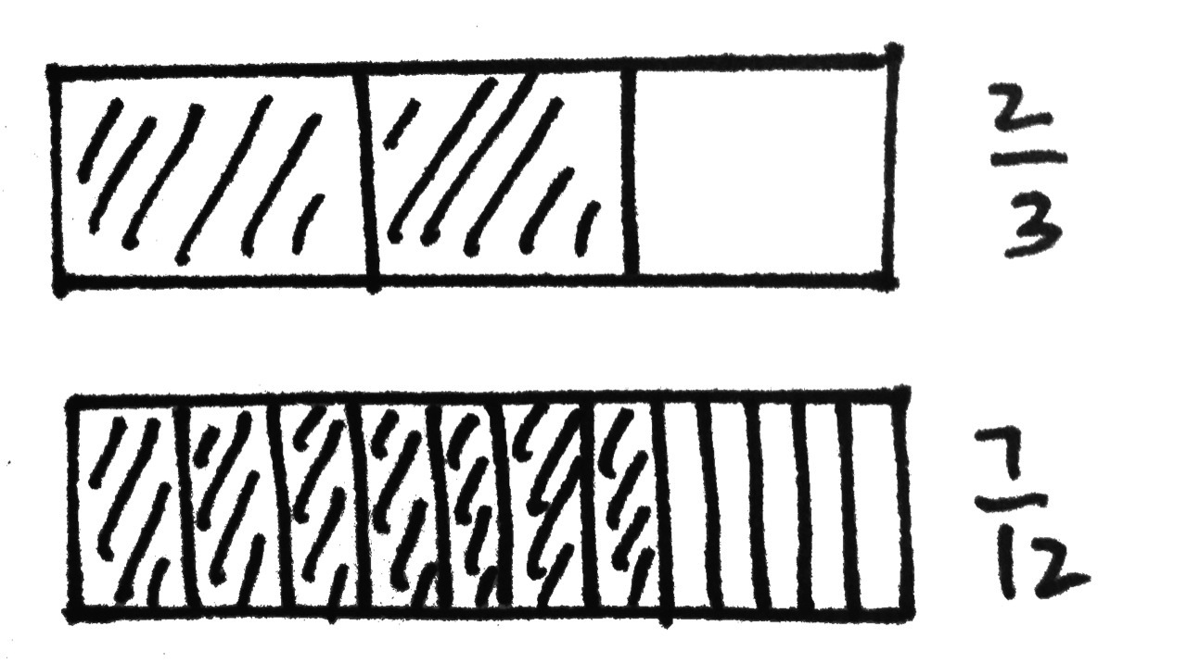
- Timmy drew the picture to the right and claimed that $\frac{\text{2}}{\text{3}}$ is less than $\frac{\text{7}}{\text{12}}$. Evan says he thinks $\frac{\text{2}}{\text{3}}$ is greater than$\frac{\text{7}}{\text{12}}$. Who is correct? Support your answer with a picture.

Name Date
- Draw tape diagrams to compare the following fractions:

$\frac{\text{2}}{\text{5}}$ ________ $\frac{\text{3}}{\text{10}}$

- Use a number line to compare the following fractions:

$\frac{\text{4}}{\text{3}}$ ________ $\frac{\text{7}}{\text{6}}$

Name Date
- Compare the pairs of fractions by reasoning about the size of the units. Use >, <, or =.
- 1 third _____ 1 sixth b. 2 halves _____ 2 thirds

- 2 fourths _____ 2 sixths d. 5 eighths _____ 5 tenths

- Compare by reasoning about the following pairs of fractions with the same or related numerators.
Use >, <, or =. Explain your thinking using words, pictures, or numbers. Problem 2(b) has been done for you.
a. $\frac{\text{3}}{\text{6}}$ $__________$ $\frac{\text{3}}{\text{7}}$ | b. $\frac{\text{2}}{\text{5}}\text{ <}$ $\frac{\text{4}}{\text{9}}$  because $\frac{\text{2}}{\text{5}}$ = $\frac{\text{4}}{\text{10}}$  4 tenths is less  than 4 ninths because  tenths are smaller than ninths.
c. $\frac{\text{3}}{\text{11}}\text{ _________}$ $\frac{\text{3}}{\text{13}}$ | d. $\frac{\text{5}}{\text{7}}\text{ _________}$ $\frac{\text{10}}{\text{13}}$
- Draw two tape diagrams to model each pair of the following fractions with related denominators.
Use >, <, or = to compare.

- $\frac{\text{3}}{\text{4}}\text{ _________}$ $\frac{\text{7}}{\text{12}}$
b. $\frac{\text{2}}{\text{4}}\text{ ___________}$ $\frac{\text{1}}{\text{8}}$

c. $\text{1}\frac{\text{4}}{\text{10}}$ ________ $\text{1}\frac{\text{3}}{\text{5}}$

- Draw one number line to model each pair of fractions with related denominators. Use >, <, or = to compare.
a. $\frac{\text{3}}{\text{4}}\text{ _________}$ $\frac{\text{5}}{\text{8}}$ | b. $\frac{\text{11}}{\text{12}}\text{ _________}$ $\frac{\text{3}}{\text{4}}$
c. $\frac{\text{4}}{\text{5}}\text{ _________}$ $\frac{\text{7}}{\text{10}}$ | d. $\frac{\text{8}}{\text{9}}\text{ _________}$ $\frac{\text{2}}{\text{3}}$
- Compare each pair of fractions using >, <, or =. Draw a model if you choose to.
a. $\frac{\text{1}}{\text{7}}\text{ ________}$ $\frac{\text{2}}{\text{7}}$ | b. $\frac{\text{5}}{\text{7}}\text{ _______}$ $\frac{\text{11}}{\text{14}}$
c. $\frac{\text{7}}{\text{10}}\text{ _________}$ $\frac{\text{3}}{\text{5}}$ | d. $\frac{\text{2}}{\text{3}}\text{ ________} \frac{\text{9}}{\text{15}}$
e. $\frac{\text{3}}{\text{4}}\text{ _________}$ $\frac{\text{9}}{\text{12}}$ | f. $\frac{\text{5}}{\text{3}}\text{ ________}$ $\frac{\text{5}}{\text{2}}$
g. $\frac{\text{4}}{\text{3}}\text{ _________}$ $\text{1}\frac{\text{2}}{\text{9}}$ | h. $\text{1}\frac{\text{1}}{\text{3}}\text{ ______}$ $\frac{\text{9}}{\text{7}}$
- Simon claims $\frac{\text{4}}{\text{9}}$ is greater than $\frac{\text{1}}{\text{3}}$. Ted thinks $\frac{\text{4}}{\text{9}}$ is less than $\frac{\text{1}}{\text{3}}$. Who is correct? Support your answer with a picture.

