Lesson 13
Objective: Reason using benchmarks to compare two fractions on the number line.

Suggested Lesson Structure
 Fluency Practice (12 minutes)
 Application Problem (5 minutes)
 Concept Development (33 minutes)
 Student Debrief (10 minutes)
Total Time (60 minutes)
Fluency Practice (12 minutes)
- Divide 3 Different Ways 4.NBT.6 (4 minutes)
- Count by Equivalent Fractions 3.NF.3 (4 minutes)
- Plot Fractions on a Number Line 4.NF.3 (4 minutes)
Divide 3 Different Ways (4 minutes)
Materials: (S) Personal white board
Note: This fluency activity reviews concepts covered in Module 3. Alternately, have students choose to solve the division problem using one of the three methods.
T: (Write 435 ÷ 3.) Solve this problem by drawing place value disks.
S: (Solve.)
T: Solve 435 ÷ 3 using the area model.
S: (Solve.)
T: Solve 435 ÷ 3 using the standard algorithm.
S: (Solve.)
Continue with 184 ÷ 4.
Count by Equivalent Fractions (4 minutes)
Note: This fluency activity reinforces Module 5 fraction concepts and prepares students for today’s lesson.
T: Count by fours to 40.
S: 0, 4, 8, 12, 16, 20, 24, 28, 32, 36, 40.
T: Count by 4 fifths from 0 fifths to 40 fifths. (Write as students count.)
S: $\frac{\text{0}}{\text{5}}\text{,}\frac{\text{4}}{\text{5}}$, $\frac{\text{8}}{\text{5}}$, $\frac{\text{12}}{\text{5}}$, $\frac{\text{16}}{\text{5}}$, $\frac{\text{20}}{\text{5}}$, $\frac{\text{24}}{\text{5}}$, $\frac{\text{28}}{\text{5}}$, $\frac{\text{32}}{\text{5}}$, $\frac{\text{36}}{\text{5}}$, $\frac{\text{40}}{\text{5}}$.
$\frac{\text{0}}{\text{5}}$ $\frac{\text{4}}{\text{5}}$ $\frac{\text{8}}{\text{5}}$ $\frac{\text{12}}{\text{5}}$ $\frac{\text{16}}{\text{5}}$ $\frac{\text{20}}{\text{5}}$ $\frac{\text{24}}{\text{5}}$ $\frac{\text{28}}{\text{5}}$ $\frac{\text{32}}{\text{5}}$ $\frac{\text{36}}{\text{5}}$ $\frac{\text{40}}{\text{5}}$
$\text{0}$ $\frac{\text{4}}{\text{5}}$ $\frac{\text{8}}{\text{5}}$ $\frac{\text{12}}{\text{5}}$ $\frac{\text{16}}{\text{5}}$ 4 $\frac{\text{24}}{\text{5}}$ $\frac{\text{28}}{\text{5}}$ $\frac{\text{32}}{\text{5}}$ $\frac{\text{36}}{\text{5}}$ 8
T: 1 one is the same as how many fifths?
S: 5 fifths.
T: 2 ones is the same as how many fifths?
S: 10 fifths.
T: 3 ones is the same as how many fifths?
S: 15 fifths.
Continue asking through 8 ones.
T: (Beneath $\frac{\text{40}}{\text{5}}$, write 8.) Count by 4 fifths again. This time, say the whole numbers when you arrive at them.
S: 0$\text{,}\frac{\text{4}}{\text{5}}$, $\frac{\text{8}}{\text{5}}$, $\frac{\text{12}}{\text{5}}$, $\frac{\text{16}}{\text{5}}$, 4, $\frac{\text{24}}{\text{5}}$, $\frac{\text{28}}{\text{5}}$, $\frac{\text{32}}{\text{5}}$, $\frac{\text{36}}{\text{5}}$, 8.
Plot Fractions on a Number Line (4 minutes)
Materials: (S) Personal white board
Note: This fluency activity reviews Lesson 12.

T: (Project a blank number line, partitioned into 2 equal parts.) Draw a number line on your personal white board, and then partition it into 2 equal parts.
S: (Draw a number line partitioned into 2 equal parts.)
T: (Write 0 below the left endpoint. Write 1 below the right endpoint.) Fill in the endpoints, and write the fraction that belongs at the halfway point.
S: (Write 0 below the left endpoint, 1 below the right endpoint, and $\frac{\text{1}}{\text{2}}$ below the halfway point.)
T: (Write $\frac{\text{1}}{\text{5}}$.) Label 1 fifth on your number line.
S: (Write $\frac{\text{1}}{\text{5}}$ between 0 and $\frac{\text{1}}{\text{2}}$ on the number line.)
T: (Write $\frac{\text{1}}{\text{5}}$ __ $\frac{\text{1}}{\text{2}}\text{.}$) On your boards, fill in the blank with a greater than or less than symbol.
S: (Write $\frac{\text{1}}{\text{5}}$ < $\frac{\text{1}}{\text{2}}$.)
Continue with the following possible sequence: Compare $\frac{\text{1}}{\text{2}}$ and $\frac{\text{7}}{\text{10}}$, $\frac{\text{1}}{\text{5}}$ and $\frac{\text{7}}{\text{10}}$, $\frac{\text{1}}{\text{2}}$ and $\frac{\text{4}}{\text{5}}$, and $\frac{\text{4}}{\text{5}}$ and $\frac{\text{7}}{\text{10}}$.
Application Problem (5 minutes)
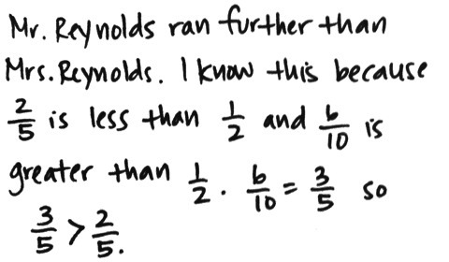
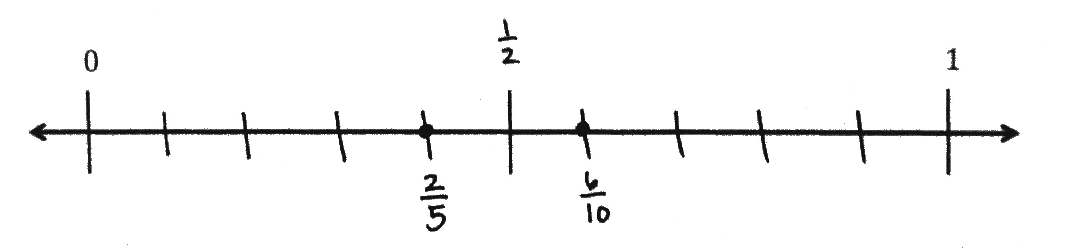
Mr. and Mrs. Reynolds went for a run. Mr. Reynolds ran for $\frac{\text{6}}{\text{10}}$ mile. Mrs. Reynolds ran for $\frac{\text{2}}{\text{5}}$ mile. Who ran farther? Explain how you know. Use the benchmarks 0, $\frac{\text{1}}{\text{2}}$ , and 1 to explain your answer.

Note: This Application Problem builds on Lesson 12, in which students learned to use benchmarks to compare two fractions. This Application Problem bridges to today’s lesson, in which students will once again compare fractions using benchmarks.
Concept Development (33 minutes)

NOTES ON
MULTIPLE MEANS
OF ENGAGEMENT:
Some students may benefit from a review of how to change an improper fraction to a mixed number by drawing a number bond. Before the lesson, instruct students to draw a number bond for an improper fraction in which one addend has a value of 1 whole.

Materials: (S) Personal white board, blank number lines with midpoint (Template)
Problem 1: Reason to compare fractions between 1 and 2.
T: Compare $\frac{\text{7}}{\text{8}}$ and $\frac{\text{6}}{\text{4}}$ with your partner.
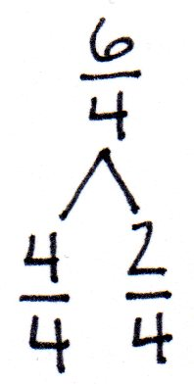
S: $\frac{\text{7}}{\text{8}}$ is less than 1. $\frac{\text{6}}{\text{4}}$ is greater than 1 because 1 is equal to $\frac{\text{4}}{\text{4}}$.
T: Draw a number bond for $\frac{\text{6}}{\text{4}}$ partitioning the whole and parts.
S: (Draw.)
T: We can use the bond to help us locate $\frac{\text{6}}{\text{4}}$ on the number line. Label a number line with endpoints 0 to 2, and locate $\frac{\text{4}}{\text{4}}$.
S: (Put pencils on $\frac{\text{4}}{\text{4}}$.)
T: $\frac{\text{6}}{\text{4}}$ is $\frac{\text{2}}{\text{4}}$ more. Imagine partitioning the line into fourths between 1 and 2. Where would you plot $\frac{\text{6}}{\text{4}}\text{?}$
S: $\frac{\text{6}}{\text{4}}$ is halfway between 1 and 2. That’s because $\frac{\text{6}}{\text{4}}\text{=} \text{1}\frac{\text{1}}{\text{2}}$. 6 fourths is 2 more fourths than 1.
2 fourths is the same as a half.
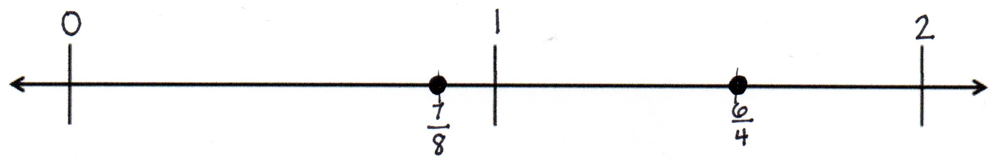
T: Plot $\frac{\text{6}}{\text{4}}$ and $\frac{\text{7}}{\text{8}}$. Write a statement to compare the two fractions.
S: $\frac{\text{7}}{\text{8}} \text{<} \frac{\text{6}}{\text{4}}$. $\frac{\text{6}}{\text{4}} \text{>} \frac{\text{7}}{\text{8}}$.
T: Next, compare $\frac{\text{5}}{\text{3}}$ and $\frac{\text{9}}{\text{5}}$. Discuss their relationship to 1.
S: Both are greater than 1, because $\frac{\text{3}}{\text{3}}$ and $\frac{\text{5}}{\text{5}}$ equal 1. Neither is very close to 1, because $\frac{\text{4}}{\text{3}}$ and $\frac{\text{6}}{\text{5}}$ would be the fractions just a little bigger than 1.
T: Write a number bond to show $\frac{\text{5}}{\text{3}}$ and $\frac{\text{9}}{\text{5}}$ as a whole and some parts.
S: (Draw bonds.)
T: Use the number bond to write each fraction as 1 and some more fractional units.
S: $\frac{\text{5}}{\text{3}}$ = $\text{1}\frac{\text{2}}{\text{3}}.$ $\frac{\text{9}}{\text{5}}$ = $\text{1}\frac{\text{4}}{\text{5}}$.

NOTES ON
MULTIPLE MEANS
OF ENGAGEMENT:
Define the term comparison symbol for English language learners. Students may well be proficient at using greater than and less than symbols but may not recognize the term.

T: Label 0, 1, and 2 on another number line. We are plotting two points. One point is $\frac{\text{2}}{\text{3}}$ greater than 1. The other is $\frac{\text{4}}{\text{5}}$ greater than 1. Discuss with your partner how to plot these two points. Consider their placement in relation to 2.
S: $\frac{\text{2}}{\text{3}}$ is 1 third less than 1. $\frac{\text{4}}{\text{5}}$ is 1 fifth less than 1. Thirds are greater than fifths, so $\frac{\text{2}}{\text{3}}$ is farther from 1 than $\frac{\text{4}}{\text{5}}$. $\text{1}\frac{\text{2}}{\text{3}}$ is farther from 2 than $\text{1}\frac{\text{4}}{\text{5}}$. The number bond lets me see that both fractions have 1 and some parts. The whole is the same, so I can compare just the parts and plot them between 1 and 2.
T: Plot the points. Compare $\frac{\text{5}}{\text{3}}$ and $\frac{\text{9}}{\text{5}}$. Write your statement using a comparison symbol.
S: (Write $\frac{\text{5}}{\text{3}}\text{< }\frac{\text{9}}{\text{5}}$ 1 $\frac{\text{2}}{\text{3}}$ <$\text{ 1}\frac{\text{4}}{\text{5}}$.)

Continue the process with $\frac{\text{7}}{\text{4}}$ and $\frac{\text{ 9}}{\text{ 5}}\text{. }$
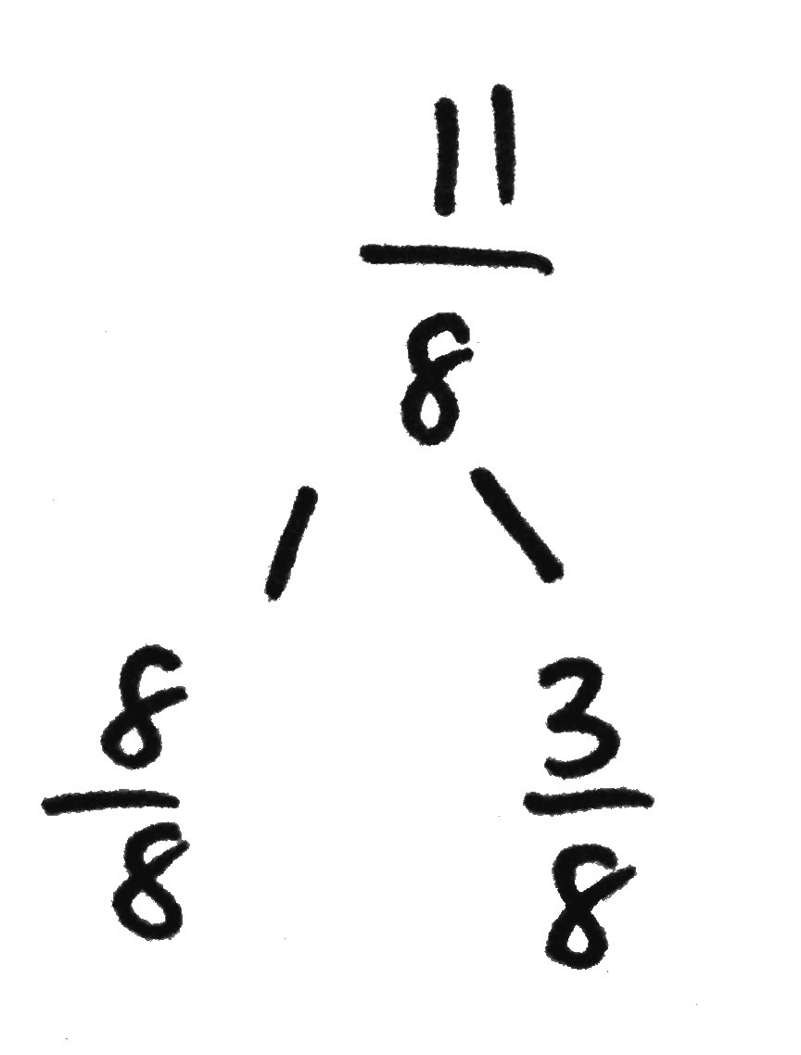
Problem 2: Reason about the size of fractions as compared to $\text{1}\frac{\text{1}}{\text{2}}$.
T: Is $\frac{\text{11}}{\text{8}}$ less than $\text{1}$ or greater than $\text{1}$? Create a number bond to guide you in your thinking.
S: $\frac{\text{11}}{\text{8}}$is greater than 1 because$\frac{\text{11}}{\text{8}}\text{=}\frac{\text{8}}{\text{8}}\text{+}\frac{\text{3}}{\text{8}}$. $\frac{\text{8}}{\text{8}}$ is equal to 1, so $\frac{\text{11}}{\text{8}}$ must be greater than 1.
T: Is $\frac{\text{11}}{\text{8}}$ less than$\text{1}\frac{\text{1}}{\text{2}}$ or greater than $\text{1}\frac{\text{1}}{\text{2}}$?
S: $1\frac{\text{1}}{\text{2}}\text{=}\frac{\text{8}}{\text{8}}\text{+}\frac{\text{4}}{\text{8}}$, and $\frac{\text{3}}{\text{8}}$ is less than $\frac{\text{4}}{\text{8}}$, so $\frac{\text{11}}{\text{8}}$ is less than $\text{1}\frac{\text{1}}{\text{2}}$. $1\frac{\text{1}}{\text{2}}$ is the same as $\frac{\text{12}}{\text{8}}$. $\frac{11}{8}$ is less than $\frac{\text{12}}{\text{8}}\text{, s}$o $\frac{\text{11}}{\text{8}}$ is less than $1\frac{\text{1}}{\text{2}}$.
T: Discuss with your partner if $\frac{5}{4}$ is greater than or less than 1.
S: (Discuss.)
T: Plot $\frac{\text{11}}{\text{8}}$ and $\frac{\text{5}}{\text{4}}$ on another number line. You reasoned that both are between 1 and 2. Let’s determine their placement using the benchmark $\text{1}\frac{\text{1}}{\text{2}}$. Label the number line with 1, $\text{1}\frac{\text{1}}{\text{2}}$, and 2. Talk it over with your partner before plotting.
S: $\frac{\text{5}}{\text{4}}$ is the same as $\text{1}\frac{\text{1}}{\text{4}}$. That’s halfway between 1 and $\text{1}\frac{\text{1}}{\text{2}}$. There are 2 fourths in a half, so $\frac{\text{5}}{\text{4}}$ is one unit away from $\text{1}\frac{\text{1}}{\text{2}}\text{,}$ and $\frac{\text{11}}{\text{8}}$ is one unit away from $\text{1}\frac{\text{1}}{\text{2}}$. Eighths are smaller than fourths, so $\frac{\text{11}}{\text{8}}$ is closer to $\text{1}\frac{\text{1}}{\text{2}}$.
T: Compare $\frac{\text{11}}{\text{8}}$ and $\frac{\text{5}}{\text{4}}$. Write your statement using a comparison symbol.
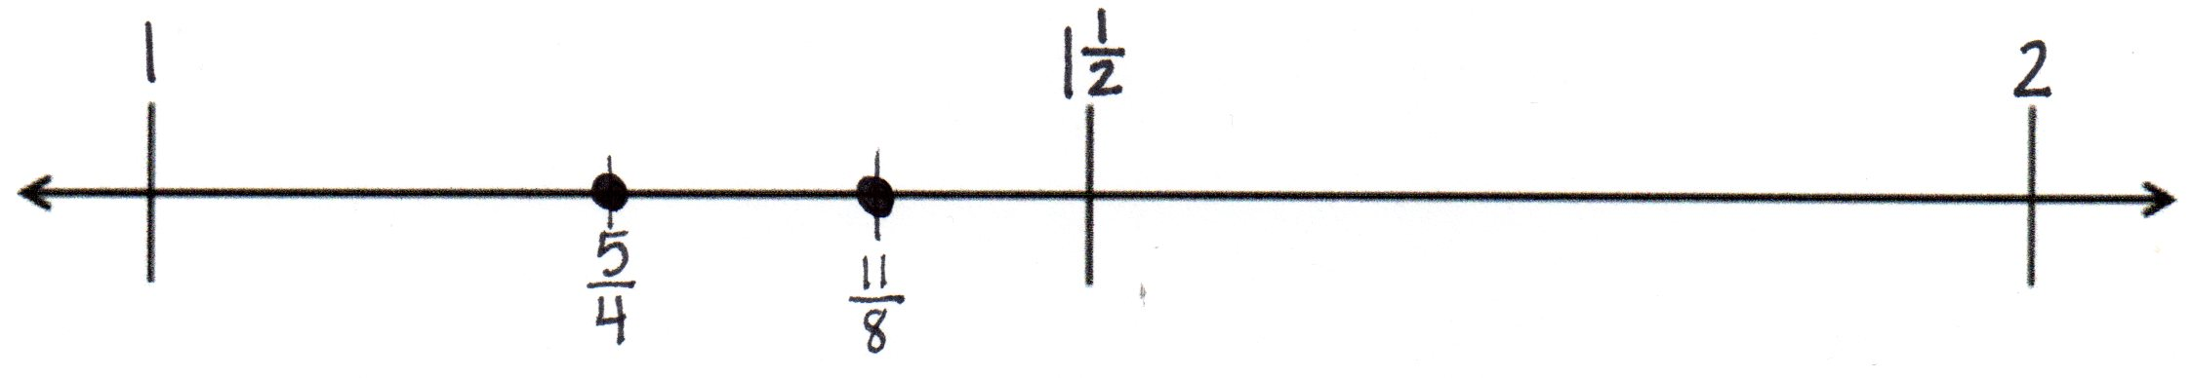
S: (Write $\frac{\text{11}}{\text{8}}\text{>}\frac{\text{5}}{\text{4}}$ or $1\frac{\text{3}}{\text{8}} \text{>} \text{1}\frac{\text{1}}{\text{4}}$ .)

T: Compare $\frac{11}{8}$ and$\frac{10}{6}$. Discuss with a partner using benchmarks to help explain.
S: Both fractions are greater than a whole but less than 2. $\frac{\text{12}}{\text{8}}\text{=} \text{1}\frac{\text{1}}{\text{2}}$. So, $\frac{\text{11}}{\text{8}}$ is one unit less than $\text{1}\frac{\text{1}}{\text{2}}$.
$\frac{\text{9}}{\text{6}}\text{=} \text{1}\frac{\text{1}}{\text{2}}$, so $\frac{\text{10}}{\text{6}}$ is one unit more than $\text{1}\frac{\text{1}}{\text{2}}$. I drew number bonds. Both numbers have a whole, so
I just compared the parts. I thought of $\frac{\text{3}}{\text{8}}$ and $\frac{\text{4}}{\text{6}}$ compared to $\frac{\text{1}}{\text{2}}$. I know $\frac{\text{4}}{\text{6}}$ is more than $\frac{\text{1}}{\text{2}}$ , so I know $\text{1}\frac{\text{4}}{\text{6}} \text{>} \text{1}\frac{\text{3}}{\text{8}}$. $\frac{\text{11}}{\text{8}}\text{<}\frac{\text{10}}{\text{6}}$.
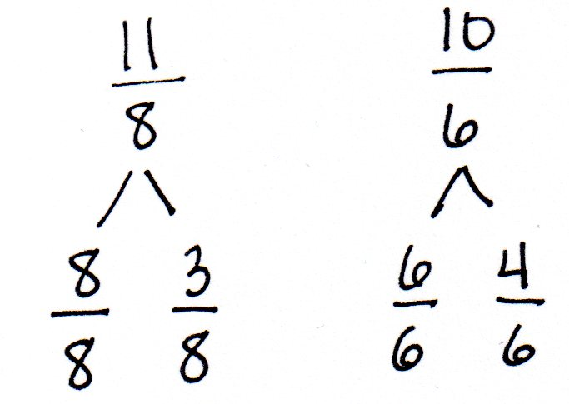
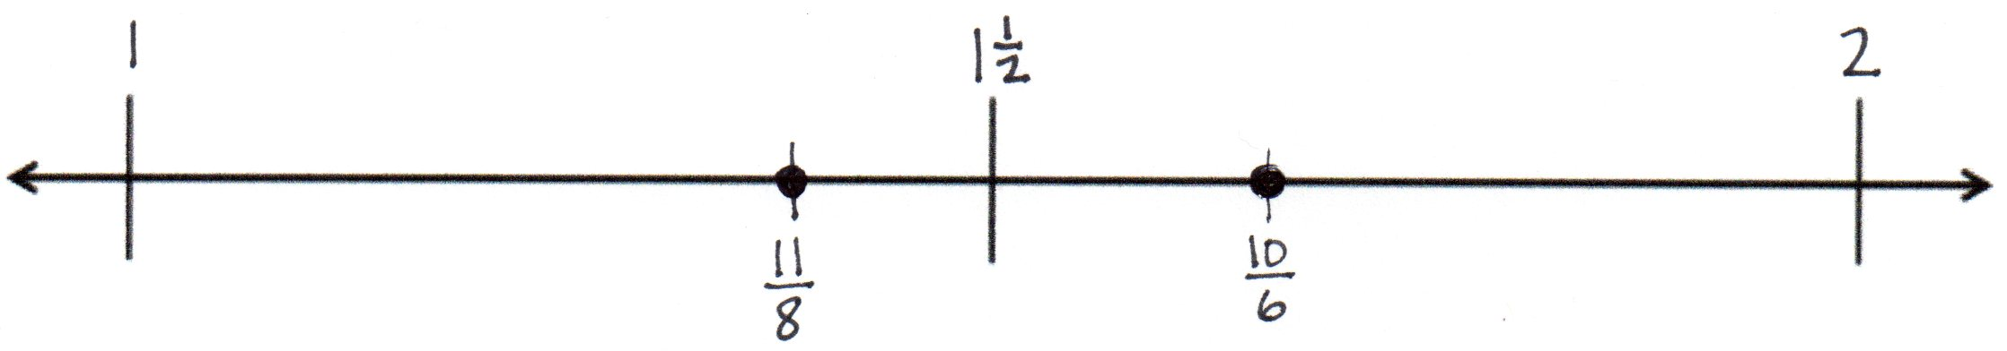

Problem 3: Reason using benchmarks to compare two fractions.
T: Which is greater: $\frac{\text{14}}{\text{10}}$ or$\frac{\text{7}}{\text{5}}\text{?}$ Discuss with a partner. Use the benchmarks to help explain.
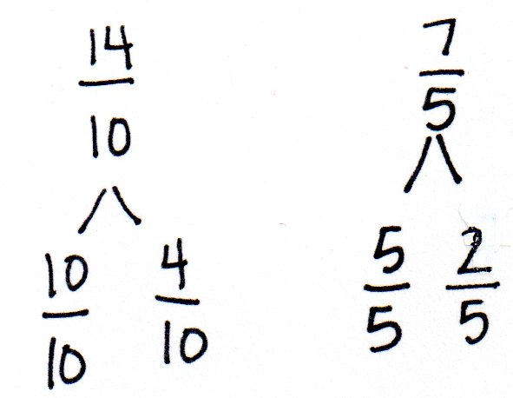
S: I used number bonds. Since both have 1 whole, I compared the parts: $\frac{\text{4}}{\text{10}}$ and$\frac{\text{2}}{\text{5}}$ are both less than 1 half. $\frac{\text{4}}{\text{10}}$ is one unit away from 1 half. But there are no fifths equal to 1 half. $\frac{\text{4}}{\text{10}}$ is 4 units from zero. $\frac{\text{2}}{\text{5}}$ is 2 units from zero. Fifths are half of tenths. I think they are equal! I can make an equivalent fraction to compare. $\frac{\text{7}}{\text{5}}\text{=}\frac{\text{7} \text{×} \text{2}}{\text{5} \text{×} \text{2}}\text{=}\frac{\text{14}}{\text{10}}$. $\frac{\text{14}}{\text{10}}$ is equal to $\frac{\text{7}}{\text{5}}$. $\frac{\text{14}}{\text{10}}\text{=}\frac{\text{7}}{\text{5}}$.
T: Compare $\frac{\text{6}}{\text{4}}$ and$\frac{\text{11}}{\text{10}}$.
S: $\frac{\text{11}}{\text{10}}$ is $\frac{\text{1}}{\text{10}}$ past 1. $\frac{\text{6}}{\text{4}}\text{=} \text{1}\frac{\text{1}}{\text{2}}$. $\frac{\text{6}}{\text{4}}$ >$\frac{\text{11}}{\text{10}}$.
T: Compare $\frac{\text{10}}{\text{8}}$ and $\frac{\text{8}}{\text{4}}$.
S: $\text{1}\frac{\text{2}}{\text{8}}$ is halfway between 1 and $\text{1}\frac{\text{1}}{\text{2}}$. $\frac{\text{8}}{\text{4}}$ = 2. $\frac{\text{10}}{\text{8}}$ <$\frac{\text{ 8}}{\text{ 4}}$.
Problem Set (10 minutes)
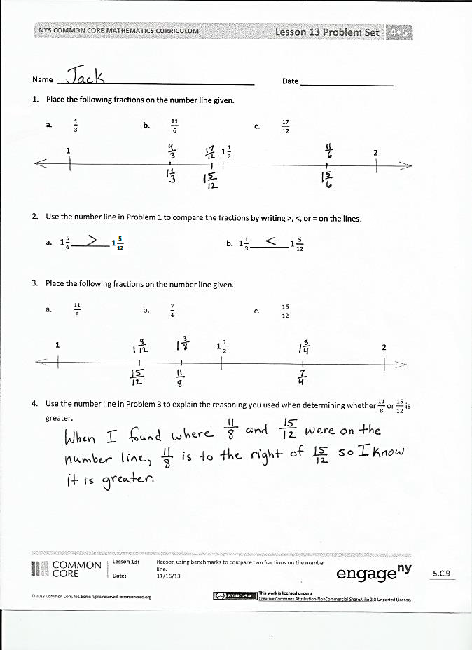
Students should do their personal best to complete the Problem Set within the allotted 10 minutes. For some classes, it may be appropriate to modify the assignment by specifying which problems they work on first. Some problems do not specify a method for solving. Students should solve these problems using the RDW approach used for Application Problems.
Student Debrief (10 minutes)
Lesson Objective: Reason using benchmarks to compare two fractions on the number line.
The Student Debrief is intended to invite reflection and active processing of the total lesson experience.
Invite students to review their solutions for the Problem Set. They should check work by comparing answers with a partner before going over answers as a class. Look for misconceptions or misunderstandings that can be addressed in the Debrief. Guide students in a conversation to debrief the Problem Set and process the lesson.

Any combination of the questions below may be used to lead the discussion.
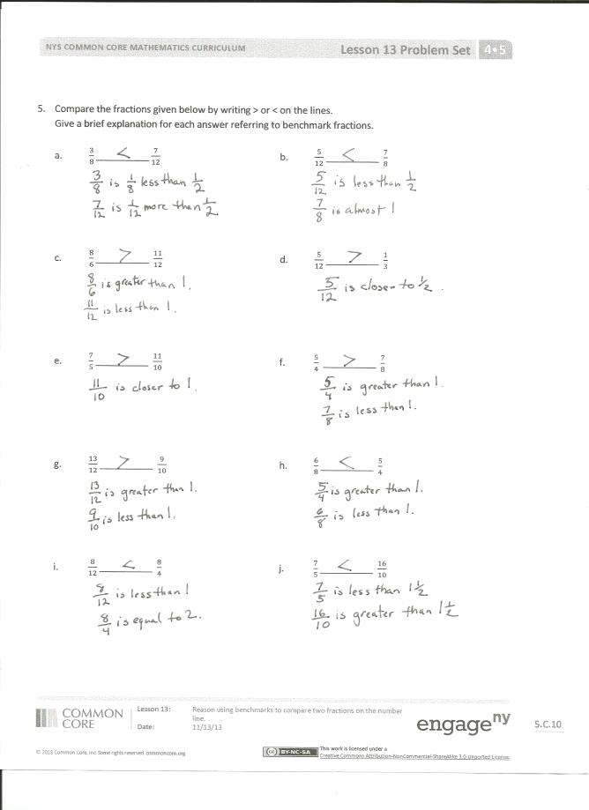
- When were number bonds helpful in solving some of the problems on the Problem Set? Explain.
- Explain your thinking in comparing the fractions when you solved Problem 5(a–j). Were benchmarks always helpful?
- How did you solve Problem 5(h)?
- What other benchmarks could you use when comparing fractions? Why are benchmarks helpful?
- How did the Application Problem connect to today’s lesson?
Exit Ticket (3 minutes)
After the Student Debrief, instruct students to complete the Exit Ticket. A review of their work will help with assessing students’ understanding of the concepts that were presented in today’s lesson and planning more effectively for future lessons. The questions may be read aloud to the students.

Name Date
- Place the following fractions on the number line given.
- $\frac{\text{4}}{\text{3}}$ b. $\frac{\text{11}}{\text{6}}$ c. $\frac{\text{17}}{\text{12}}$
1 $\text{1}\frac{\text{1}}{\text{2}}$ 2

- Use the number line in Problem 1 to compare the fractions by writing >, ˂, or = on the lines.

  - $\text{1}\frac{\text{5}}{\text{6}}$ ________ $\text{1}\frac{\text{5}}{\text{12}}$ b. $\text{ 1}\frac{\text{1}}{\text{3}}$ ________ $\text{1}\frac{\text{5}}{\text{12}}$

- Place the following fractions on the number line given.
- $\frac{\text{11}}{\text{8}}$ b. $\frac{\text{7}}{\text{4}}$ c. $\frac{\text{15}}{\text{12}}$
1 1 $\frac{\text{1}}{\text{2}}$ 2

- Use the number line in Problem 3 to explain the reasoning you used when determining whether $\frac{\text{11}}{\text{8}}$ or $\frac{\text{15}}{\text{12}}$ is greater.

- Compare the fractions given below by writing > or ˂ on the lines.
Give a brief explanation for each answer referring to benchmarks.

  - $\frac{\text{3}}{\text{8}}$_________ $\frac{\text{7}}{\text{12}}$ b. $\frac{\text{5}}{\text{12}}$_________ $\frac{\text{7}}{\text{8}}$

- $\frac{\text{8}}{\text{6}}$_________ $\frac{\text{11}}{\text{12}}$ d. $\frac{\text{5}}{\text{12}}$_________ $\frac{\text{1}}{\text{3}}$

- $\frac{\text{7}}{\text{5}}$_________ $\frac{\text{11}}{\text{10}}$ f. $\frac{\text{5}}{\text{4}}$_________ $\frac{\text{7}}{\text{8}}$

- $\frac{\text{13}}{\text{12}}$_________ $\frac{\text{9}}{\text{10}}$ h. $\frac{\text{6}}{\text{8}}$_________ $\frac{\text{5}}{\text{4}}$

- $\frac{\text{8}}{\text{12}}$__________ $\frac{\text{8}}{\text{4}}$ j. $\frac{\text{7}}{\text{5}}$__________ $\frac{\text{16}}{\text{10}}$

Name Date
- Place the following fractions on the number line given.
- $\frac{\text{5}}{\text{4}}$ b. $\frac{\text{10}}{\text{7}}$ c. $\frac{\text{16}}{\text{9}}$
1 $1\frac{\text{1}}{\text{2}}$ 2

- Compare the fractions using >, ˂, or =.

- $\frac{\text{5}}{\text{4}}$ ________ $\frac{\text{10}}{\text{7}}$
- $\frac{\text{5}}{\text{4}}$ ________ $\frac{\text{16}}{\text{9}}$
- $\frac{\text{16}}{\text{9}}$ ________ $\frac{\text{10}}{\text{7}}$

Name Date
- Place the following fractions on the number line given.
- $\frac{\text{3}}{\text{2}}$ b. $\frac{\text{9}}{\text{5}}$ c. $\frac{\text{14}}{\text{10}}$
1 $\text{1}\frac{\text{1}}{\text{2}}$ 2

- Use the number line in Problem 1 to compare the fractions by writing >, ˂, or = on the lines:
  - $\text{1}\frac{\text{1}}{\text{6}}$ ________ $\text{1}\frac{\text{4}}{\text{12}}$ b. $\text{ 1}\frac{\text{1}}{\text{2}}$ ________ $\text{1}\frac{\text{4}}{\text{5}}$

- Place the following fractions on the number line given.
- $\frac{\text{12}}{\text{9}}$ b. $\frac{\text{6}}{\text{5}}$ c. $\frac{\text{18}}{\text{15}}$
1 $\text{1}\frac{\text{1}}{\text{2}}$ 2

- Use the number line in Problem 3 to explain the reasoning you used when determining whether $\frac{\text{12}}{\text{9}}$ or $\frac{\text{18}}{\text{15}}$ was greater.

- Compare the fractions given below by writing > or ˂ on the lines.
Give a brief explanation for each answer referring to benchmarks.
  - $\frac{\text{2}}{\text{5}}$_________ $\frac{\text{6}}{\text{8}}$ b. $\frac{\text{6}}{\text{10}}$_________ $\frac{\text{5}}{\text{6}}$

- $\frac{\text{6}}{\text{4}}$_________ $\frac{\text{7}}{\text{8}}$ d. $\frac{\text{1}}{\text{4}}$_________ $\frac{\text{8}}{\text{12}}$

- $\frac{\text{14}}{\text{12}}$_________ $\frac{\text{11}}{\text{6}}$ f. $\frac{\text{8}}{\text{9}}$_________ $\frac{\text{3}}{\text{2}}$

- $\frac{\text{7}}{\text{8}}$_________ $\frac{\text{11}}{\text{10}}$ h. $\frac{\text{3}}{\text{4}}$_________ $\frac{\text{4}}{\text{3}}$

- $\frac{\text{3}}{\text{8}}$_________ $\frac{\text{3}}{\text{2}}$ j. $\frac{\text{9}}{\text{6}}$_________ $\frac{\text{16}}{\text{12}}$

Name Date
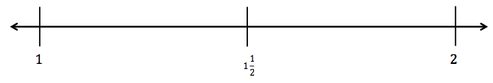

blank number lines with midpoint

