Lesson 12
Objective: Reason using benchmarks to compare two fractions on the number line.

Suggested Lesson Structure
 Fluency Practice (12 minutes)
 Application Problem (8 minutes)
 Concept Development (30 minutes)
 Student Debrief (10 minutes)
Total Time (60 minutes)
Fluency Practice (12 minutes)
- Add and Subtract 4.NBT.4 (4 minutes)
- Find Equivalent Fractions 4.NF.1 (4 minutes)
- Construct a Number Line with Fractions 4.NF.3 (4 minutes)
Add and Subtract (4 minutes)
Materials: (S) Personal white board
Note: This fluency activity reviews adding and subtracting using the standard algorithm.
T: (Write 547 thousands 686 ones.) On your personal white boards, write this number in standard form.
S: (Write 547,686.)
T: (Write 294 thousands 453 ones.) Add this number to 547,686 using the standard algorithm.
S: (Write 547,686 + 294,453 = 842,139 using the standard algorithm.)
Continue the process with 645,838 + 284,567.
T: (Write 800 thousands.) On your boards, write this number in standard form.
S: (Write 800,000.)
T: (Write 648 thousands 745 ones.) Subtract this number from 800,000 using the standard algorithm.
S: (Write 800,000 – 648,745 = 151,255 using the standard algorithm.)
Continue the process with 754,912 – 154,189.

Find Equivalent Fractions (4 minutes)
Materials: (S) Personal white board
Note: This fluency activity reviews Lesson 9.
T: (Write $\frac{\text{6}}{\text{8}}$ = $\frac{}{}\frac{÷}{÷}$ = $\frac{}{\text{4}}$. Point to $\frac{\text{6}}{\text{8}}$.) Say the fraction.
S: 6 eighths.
T: On your personal white boards, complete the number sentence to find the equivalent fraction.
S: (Write $\frac{\text{6}}{\text{8}}$ = $\frac{\text{6 ÷ 2}}{\text{8 ÷ 2}}$ = $\frac{\text{3}}{\text{4}}.$)
Continue with the following possible sequence: $\frac{\text{4}}{\text{6}}$ = $\frac{\text{2}}{\text{3}}$, $\frac{\text{4}}{\text{10}}$ = $\frac{\text{2}}{\text{5}}$, $\frac{\text{8}}{\text{10}}$ = $\frac{\text{4}}{\text{5}}$, $\frac{\text{8}}{\text{12}}$ = $\frac{\text{2}}{\text{3}}$, and $\frac{\text{9}}{\text{12}}$ = $\frac{\text{3}}{\text{4}}$.
Construct a Number Line with Fractions (4 minutes)
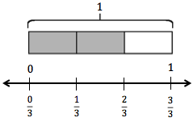
Materials: (S) Personal white board
Note: This fluency activity reviews Lesson 11.
T: (Write $\frac{\text{2}}{\text{3}}.$) Say the fraction.
S: 2 thirds.
T: On your personal white boards, draw a tape diagram. Label the whole diagram 1, and then shade in units to show $\frac{\text{2}}{\text{3}}$.
S: (Draw a tape diagram partitioned into 3 equal units. Write 1 at the top. Shade 2 units.)
T: Beneath your tape diagram, draw a number line. Then, label each fraction on the number line.
S: (Beneath the tape diagram, draw a number line. Partition and label the number line into 3 equal intervals.)
Continue with the following possible sequence:$\frac{\text{2}}{\text{5}}$, $\frac{\text{3}}{\text{4}}$, $\frac{\text{3}}{\text{6}}$, and $\frac{\text{6}}{\text{9}}$.

NOTES ON
MULTIPLE MEANS
OF ACTION AND EXPRESSION:
If students find various fractional units on one number line frustrating, give them the option of plotting $\frac{\text{1}}{\text{4}}\text{,}\frac{\text{4}}{\text{5}}\text{,}\frac{\text{5}}{\text{8}}$ on two number lines placed parallel for comparison.

Application Problem (8 minutes)
Materials: (S) Number line (Template)
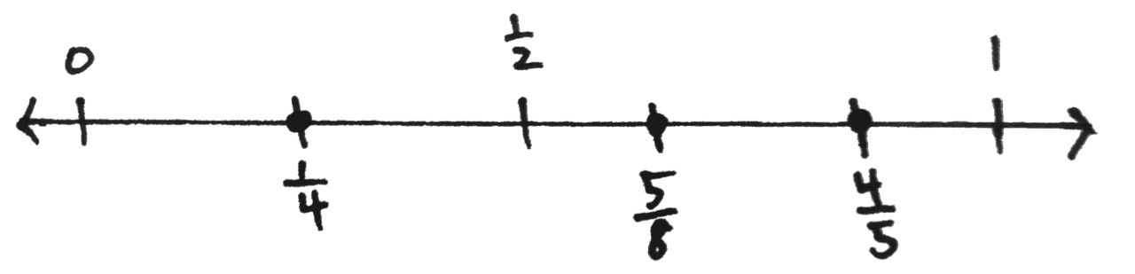
Plot$\frac{\text{1}}{\text{4}}$, $\frac{\text{4}}{\text{5}}$, and $\frac{\text{5}}{\text{8}}$ on a number line, and compare the three points.

Note: This Application Problem reviews equivalent fractions and bridges to today’s lesson, in which students will use reasoning and benchmarks to compare fractions.
Concept Development (30 minutes)

NOTES ON
MULTIPLE MEANS
OF REPRESENTATION:
Clarify for English language learners math language such as greater than and less than. Explain that greater has multiple meanings. Here, it means larger or bigger. Offer explanations in students’ first language, if possible. If students are more comfortable, allow them to use bigger, larger, smaller, etc.
Materials: (S) Personal white board, number line (Template)
Problem 1: Reason about the size of a fraction compared to $\frac{\text{1}}{\text{2}}$.
T: How many sixths equal 1 whole? Say the unit.
S: 6 sixths.
T: How many sixths equal 1 half?
S: 3 sixths. $\frac{\text{3}}{\text{6}}$ = $\frac{\text{1}}{\text{2}}$. We already know that!
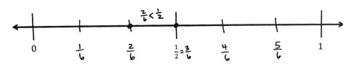
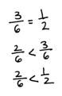
T: Is $\frac{\text{2}}{\text{6}}$ greater than or less than $\frac{\text{3}}{\text{6}}\text{?}$
S: Less than.
T: Is $\frac{\text{2}}{\text{6}}$ less than $\frac{\text{1}}{\text{2}}$ or greater than $\frac{\text{1}}{\text{2}}\text{?}$
S: Less than.
T: Using the number line Template, label 1 half. Partition the number line to show sixths. Label only the half and 2 sixths.
T: Write a number sentence comparing 2 sixths and 1 half.
S: Students write $\frac{\text{2}}{\text{6}} \text{<} \frac{\text{1}}{\text{2}}.$
Repeat the process with $\frac{\text{5}}{\text{8}}.$
T: (Write $\frac{\text{2}}{\text{3}}$.) Talk to your partner. Is $\frac{\text{2}}{\text{3}}$ greater than $\frac{\text{1}}{\text{2}}$ or less than $\frac{\text{1}}{\text{2}}$?
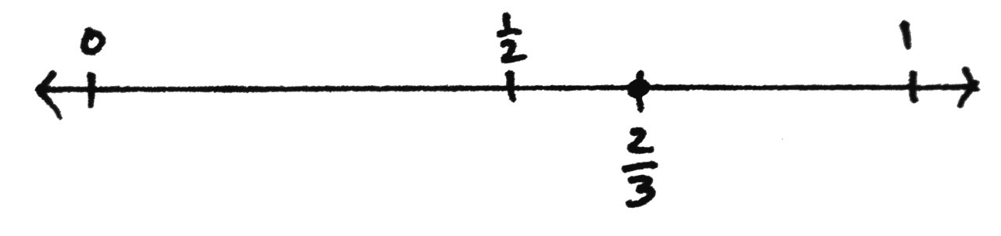
S: There are no thirds that are equal to $\frac{\text{1}}{\text{2}}.$ $\frac{\text{1}}{\text{2}}$ is between $\frac{\text{1}}{\text{3}}$ and $\frac{\text{2}}{\text{3}} ,$ so $\frac{\text{2}}{\text{3}}$ must be greater. I can draw a model to prove that. $\frac{\text{2}}{\text{3}}$ is almost 1. 1 third is less than 1 half, and 2 thirds is greater than 1 half. We can see on our other number line that $\frac{\text{3}}{\text{6}}$ is right between $\frac{1}{3}$ and $\frac{2}{3}$, and $\frac{2}{3}$ is equal to $\frac{4}{6}$. So, $\frac{2}{3}$ is greater than $\frac{1}{2}$.

T: (Write $\frac{\text{2}}{\text{5}}$.) Talk to your partner. Is $\frac{\text{2}}{\text{5}}$greater than $\frac{\text{1}}{\text{2}}$ or less than $\frac{\text{1}}{\text{2}}$?
S: Five is an odd number, so it doesn’t divide evenly by 2. Halfway between 0 fifths and 5 fifths should be somewhere between 2 fifths and 3 fifths. So, 2 fifths must be less than 1 half. $\frac{\text{1}}{\text{2}}$ is halfway between $\frac{\text{2}}{\text{5}}$ and $\frac{\text{3}}{\text{5}}$ , so $\frac{\text{2}}{\text{5}}$ is less than $\frac{\text{1}}{\text{2}}$.
T: Model $\frac{\text{2}}{\text{5}}$ on a number line. Then, compare $\frac{\text{2}}{\text{5}}$and $\frac{\text{1}}{\text{2}}$.
S: I can partition the fifths in half on the number line. That makes tenths. $\frac{\text{2}}{\text{5}}\text{=}\frac{\text{2} \text{×} \text{2}}{\text{5} \text{×} \text{2}}\text{=}\frac{\text{4}}{\text{10}}.$ I know $\frac{\text{5}}{\text{10}}$ is the same as $\frac{\text{1}}{\text{2}}.$

T: Write your conclusion on your board.
S: (Write$\frac{\text{2}}{\text{5}} \text{<} \frac{\text{1}}{\text{2}}$.)
Problem 2: Plot points on a number line by thinking about fractions in relation to 0, $\frac{\text{1}}{\text{2}}$, or 1. Compare the fractions.
T: (Write $\frac{\text{5}}{\text{12}}$.) What do we know about $\frac{\text{5}}{\text{12}}$ in relation to 0, $\frac{1}{2}$, and 1?
S: $\frac{\text{5}}{\text{12}}$ is greater than 0. It’s less than 1. $\frac{\text{5}}{\text{12}}$ is about halfway between 0 and 1. $\frac{\text{5}}{\text{12}}$ is less than $\frac{\text{1}}{\text{2}}$.
I know because $\frac{\text{6}}{\text{12}}$ is equal to $\frac{\text{1}}{\text{2}}$, and $\frac{\text{5}}{\text{12}}$ is less than $\frac{\text{6}}{\text{12}}$.
T: Plot and label $\frac{\text{5}}{\text{12}}$ on a number line. Is $\frac{\text{5}}{\text{12}}$ closer to 0 or $\frac{\text{1}}{\text{2}}$?
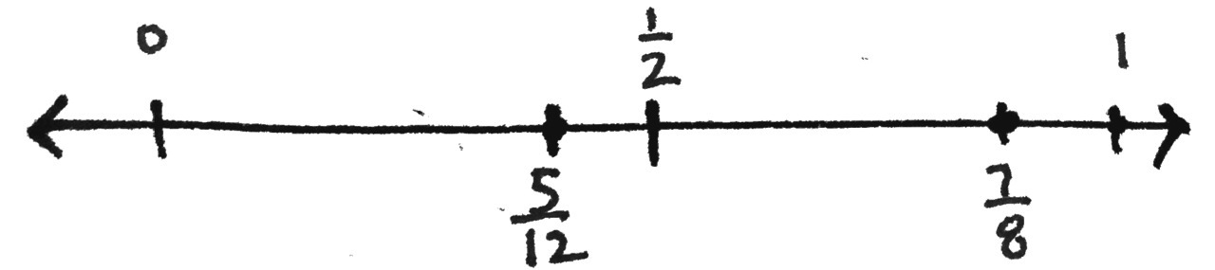
S: It looks closer to $\frac{\text{1}}{\text{2}}$.
T: How close? Count the twelfths.
S: $\frac{\text{5}}{\text{12}}$ is just $\frac{\text{1}}{\text{12}}$ away from $\frac{\text{6}}{\text{12}}$. It’s $\frac{\text{5}}{\text{12}}$ away from 0, so it’s closer to $\frac{\text{1}}{\text{2}}.$
T: (Write$\frac{\text{7}}{\text{8}}$.) What do we know about $\frac{\text{7}}{\text{8}}$ in relation to 0, $\frac{\text{1}}{\text{2}}$, and 1?
S: It’s greater than 0. It’s less than 1. It’s greater than $\frac{\text{1}}{\text{2}}$. $\frac{\text{4}}{\text{8}}$ is equal to $\frac{\text{1}}{\text{2}}$ , so $\frac{\text{7}}{\text{8}}$ is definitely more.
T: Discuss with your partner. Is $\frac{\text{7}}{\text{8}}$ closer to $\frac{\text{1}}{\text{2}}$ or to 1?
S: It is closer to 1, just 1 eighth away from 1. $\frac{\text{7}}{\text{8}}$ is 3 eighths greater than $\frac{\text{1}}{\text{2}}$ and only $\frac{\text{1}}{\text{8}}$ less than 1.
T: Plot and label $\frac{\text{7}}{\text{8}}$ on the same number line as you labeled $\frac{\text{5}}{\text{12}}$. Write a number sentence comparing
$\frac{\text{7}}{\text{8}}$ and $\frac{\text{5}}{\text{12}}$.
S: (Write $\frac{\text{7}}{\text{8}}$ > $\frac{\text{5}}{\text{12}}$. $\frac{\text{5}}{\text{12}}$ < $\frac{\text{7}}{\text{8}}$.)
T: (Write $\frac{\text{2}}{\text{6}}$.) Here is a challenge! Plot $\frac{\text{2}}{\text{6}}$ on the same number line. Discuss with your partner the relationship $\frac{\text{2}}{\text{6}}$ has to the other points on the number line. Consider the size of each unit.
S: $\frac{\text{2}}{\text{6}}$ is really close to $\frac{\text{5}}{\text{12}}$. I know $\frac{\text{2}}{\text{6}}$ is less than $\frac{\text{7}}{\text{8}}$ and less than $\frac{\text{1}}{\text{2}}$. $\frac{\text{2}}{\text{6}}$ is 1 sixth away from 1 half, and $\frac{\text{5}}{\text{12}}$ is 1 twelfth away from 1 half. So, if sixths are larger units than twelfths, then $\frac{\text{2}}{\text{6}}$ is farther away from $\frac{\text{1}}{\text{2}}$ than $\frac{\text{5}}{\text{12}}$ is. I know that 2 sixths is equal to 4 twelfths, so 5 twelfths is greater.
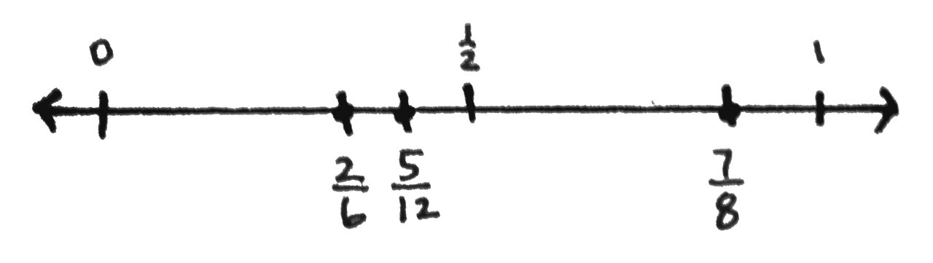
T: Excellent thinking. We can compare the distance of a point from $\frac{\text{1}}{\text{2}}$ based on the size of the fractional units. We can use these important locations on the number line as benchmarks to help us compare fractions.
Problem 3: Use the benchmarks 0, $\frac{\text{1}}{\text{2}}$, and 1 to compare two fractions without using a number line.
T: Talk to your partner. Compare $\frac{\text{5}}{\text{8}}$ and$\frac{\text{4}}{\text{5}}$. Consider the relationship $\frac{\text{5}}{\text{8}}$ has to 0, $\frac{\text{1}}{\text{2}}$, and 1.
S: $\frac{\text{5}}{\text{8}}$ is greater than $\frac{\text{1}}{\text{2}}$ since $\frac{\text{1}}{\text{2}}$ =$\frac{\text{4}}{\text{8}}$. It’s close to $\frac{\text{1}}{\text{2}}$ since it’s only a little more than$\frac{\text{4}}{\text{8}}$. $\frac{\text{5}}{\text{8}}$ is $\frac{\text{1}}{\text{8}}$ more than $\frac{\text{1}}{\text{2}}$ but $\frac{\text{3}}{\text{8}}$ from 1.
T: What about $\frac{\text{4}}{\text{5}}\text{?}$
S: $\frac{\text{4}}{\text{5}}$ is greater than $\frac{\text{1}}{\text{2}}$. It’s close to 1. It’s only $\frac{\text{1}}{\text{5}}$ away. If you have 4 fifths of something, you have most of it.
T: What can we conclude about $\frac{\text{5}}{\text{8}}$ and$\frac{\text{4}}{\text{5}}\text{?}$ Think about the size of the units.
S: Eighths are smaller than fifths, so $\frac{\text{5}}{\text{8}}$ is closer to $\frac{\text{1}}{\text{2}}$ than $\frac{\text{4}}{\text{5}}$ is. $\frac{\text{5}}{\text{8}}$ is less than$\frac{\text{4}}{\text{5}}$. 5 eighths is a little more than half, but 4 fifths is a little less than 1.
T: Compare $\frac{\text{2}}{\text{5}}$ and $\frac{\text{6}}{\text{10}}$. Again, consider the relationship $\frac{\text{2}}{\text{5}}$ has to 0, $\frac{\text{1}}{\text{2}}$, and 1.
S: I know that $\frac{\text{1}}{\text{2}}$is between $\frac{\text{2}}{\text{5}}$and $\frac{\text{3}}{\text{5}}$, so $\frac{\text{2}}{\text{5}}$ is a little less than $\frac{\text{1}}{\text{2}}$. I know that $\frac{\text{5}}{\text{10}}$ is the same as $\frac{\text{1}}{\text{2}}$, so$\frac{\text{6}}{\text{10}}$ is greater than $\frac{\text{1}}{\text{2}}$. $\frac{\text{2}}{\text{5}}$is less than $\frac{\text{6}}{\text{10}}$.
T: Talk to your partner, and compare $\frac{\text{33}}{\text{100}}$ and$\frac{\text{2}}{\text{3}}$.
S: $\frac{\text{50}}{\text{100}}$ is equal to half, so $\frac{\text{33}}{\text{100}}$ is less than $\frac{\text{1}}{\text{2}}$. $\frac{\text{2}}{\text{3}}$ is greater than $\frac{\text{1}}{\text{2}}$. $\frac{\text{33}}{\text{100}}$ is less than$\frac{\text{2}}{\text{3}}$.
Problem Set (10 minutes)
Students should do their personal best to complete the Problem Set within the allotted 10 minutes. For some classes, it may be appropriate to modify the assignment by specifying which problems they work on first. Some problems do not specify a method for solving. Students should solve these problems using the RDW approach used for Application Problems.
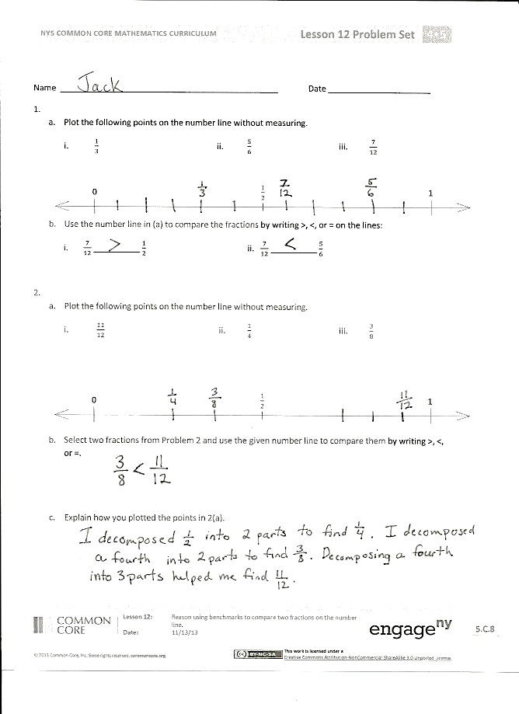
Student Debrief (10 minutes)
Lesson Objective: Reason using benchmarks to compare two fractions on the number line.
The Student Debrief is intended to invite reflection and active processing of the total lesson experience.
Invite students to review their solutions for the Problem Set. They should check work by comparing answers with a partner before going over answers as a class. Look for misconceptions or misunderstandings that can be addressed in the Debrief. Guide students in a conversation to debrief the Problem Set and process the lesson.
Any combinations of the questions below may be used to lead the discussion.
- How was the number line helpful as we compared the fractions in Problem 1(b)?
- For Problem 3(a–j), explain how you used the benchmarks 0,$\frac{\text{1}}{\text{2}}$, and 1 to compare the fractions. When both fractions were greater than $\frac{\text{1}}{\text{2}}$ , how did you know which one was greater?
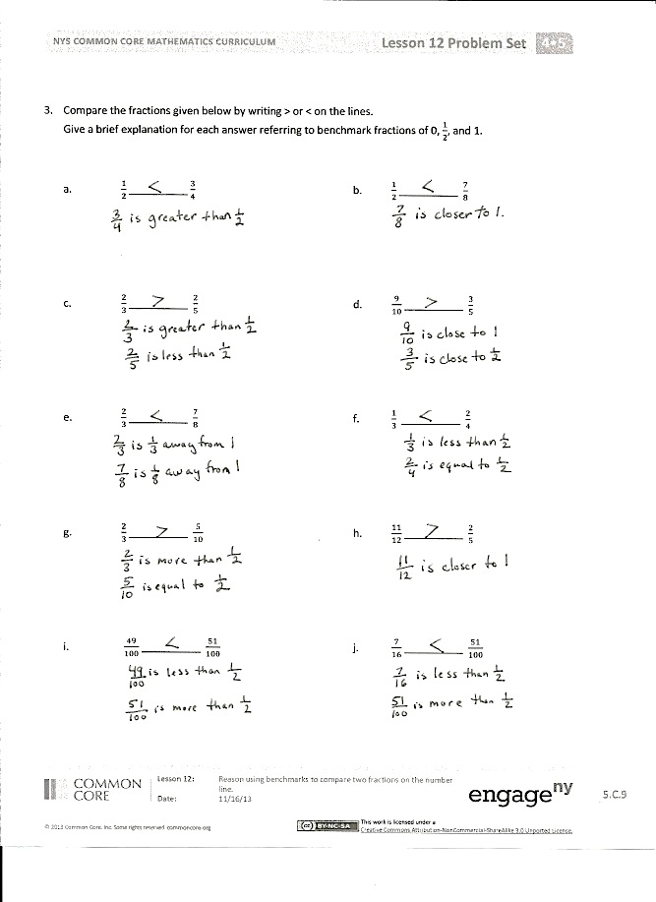
- Will the strategy of using the benchmarks 0, $\frac{\text{1}}{\text{2}}$, and 1 always help us to compare two fractions? Explain.
- How did the Application Problem connect to today’s lesson?
Exit Ticket (3 minutes)
After the Student Debrief, instruct students to complete the Exit Ticket. A review of their work will help with assessing students’ understanding of the concepts that were presented in today’s lesson and planning more effectively for future lessons. The questions may be read aloud to the students.

Name Date

  - Plot the following points on the number line without measuring.
i. $\frac{1}{3}$ ii. $\frac{5}{6}$ iii. $\frac{7}{12}$
0 $\frac{1}{2}$ 1

  - Use the number line in Part (a) to compare the fractions by writing >, ˂, or = on the lines.

- $\frac{7}{12}$________ $\frac{1}{2}$ ii. $\frac{7}{12}$________ $\frac{5}{6}$

  - Plot the following points on the number line without measuring.
i. $\frac{11}{12}$ ii. $\frac{1}{4}$ iii. $\frac{3}{8}$
0 $\frac{1}{2}$ 1

  - Select two fractions from Part (a), and use the given number line to compare them by writing
>, ˂, or =.

  - Explain how you plotted the points in Part (a).

- Compare the fractions given below by writing > or ˂ on the lines.
Give a brief explanation for each answer referring to the benchmarks 0, $\frac{1}{2}$, and 1.
- $\frac{1}{2}$_________ $\frac{3}{4}$ b. $\frac{1}{2}$_________ $\frac{7}{8}$

- $\frac{2}{3}$_________ $\frac{2}{5}$ d. $\frac{9}{10}$_________ $\frac{3}{5}$

- $\frac{2}{3}$_________ $\frac{7}{8}$ f. $\frac{1}{3}$_________ $\frac{2}{4}$

- $\frac{2}{3}$_________ $\frac{5}{10}$ h. $\frac{11}{12}$_________ $\frac{2}{5}$

- $\frac{49}{100}$_________ $\frac{51}{100}$ j. $\frac{7}{16}$_________ $\frac{51}{100}$

Name Date
- Plot the following points on the number line without measuring.
- $\frac{8}{10}$ b. $\frac{3}{5}$ c. $\frac{1}{4}$
0 $\frac{1}{2}$ 1

- Use the number line in Problem 1 to compare the fractions by writing >, ˂, or = on the lines.

- $\frac{1}{4}$_________ $\frac{1}{2}$

- $\frac{8}{10}$_________ $\frac{3}{5}$

- $\frac{1}{2}$_________ $\frac{3}{5}$

- $\frac{1}{4}$_________ $\frac{8}{10}$

Name Date

  - Plot the following points on the number line without measuring.

- $\frac{2}{3}$ ii. $\frac{1}{6}$ iii. $\frac{4}{10}$
0 $\frac{1}{2}$ 1

  - Use the number line in Part (a) to compare the fractions by writing >, ˂, or = on the lines.

- $\frac{2}{3}$_________ $\frac{1}{2}$ ii. $\frac{4}{10}$_________ $\frac{1}{6}$

  - Plot the following points on the number line without measuring.

- $\frac{5}{12}$ ii. $\frac{3}{4}$ iii. $\frac{2}{6}$
0 $\frac{1}{2}$ 1

  - Select two fractions from Part (a), and use the given number line to compare them by writing
>, ˂, or =.

  - Explain how you plotted the points in Part (a).

- Compare the fractions given below by writing > or ˂ on the lines.
Give a brief explanation for each answer referring to the benchmark of 0, $\frac{1}{2}$, and 1.

  - $\frac{1}{2}$_________ $\frac{1}{4}$ b. $\frac{6}{8}$_________ $\frac{1}{2}$

- $\frac{3}{4}$_________ $\frac{3}{5}$ d. $\frac{4}{6}$_________ $\frac{9}{12}$

- $\frac{2}{3}$_________ $\frac{1}{4}$ f. $\frac{4}{5}$_________ $\frac{8}{12}$

- $\frac{1}{3}$_________ $\frac{3}{6}$ h. $\frac{7}{8}$_________ $\frac{3}{5}$

- $\frac{51}{100}$_________ $\frac{5}{10}$ j. $\frac{8}{14}$_________ $\frac{49}{100}$

Name Date
Application Problem:
0
$$\frac{1}{2}$$
1

1.
0
$$\frac{1}{2}$$
1

0
$$\frac{1}{2}$$
1

0
$$\frac{1}{2}$$
1

0
$$\frac{1}{2}$$
1

2.
0
$$\frac{1}{2}$$
1

number line

