Lesson 9
Objective: Compare objects using heavier than, lighter than, and the same as with balance scales.

Suggested Lesson Structure
 Fluency Practice (14 minutes)
 Application Problem (5 minutes)
 Concept Development (25 minutes)
 Student Debrief (6 minutes)
Total Time (50 minutes)
Fluency Practice (14 minutes)
- Hidden Numbers K.OA.3 (5 minutes)
- 5-Group Hands K.CC.2 (4 minutes)
- Roll and Draw 5-Groups K.OA.3 (5 minutes)
Hidden Numbers (5 minutes)
Materials: (S) Hidden numbers mat (Lesson 3 Fluency Template) inserted into personal white board
Note: Conduct activity as described in Lesson 3; however, this time, guide students to find hidden numbers within a group of 8.
5-Group Hands (4 minutes)
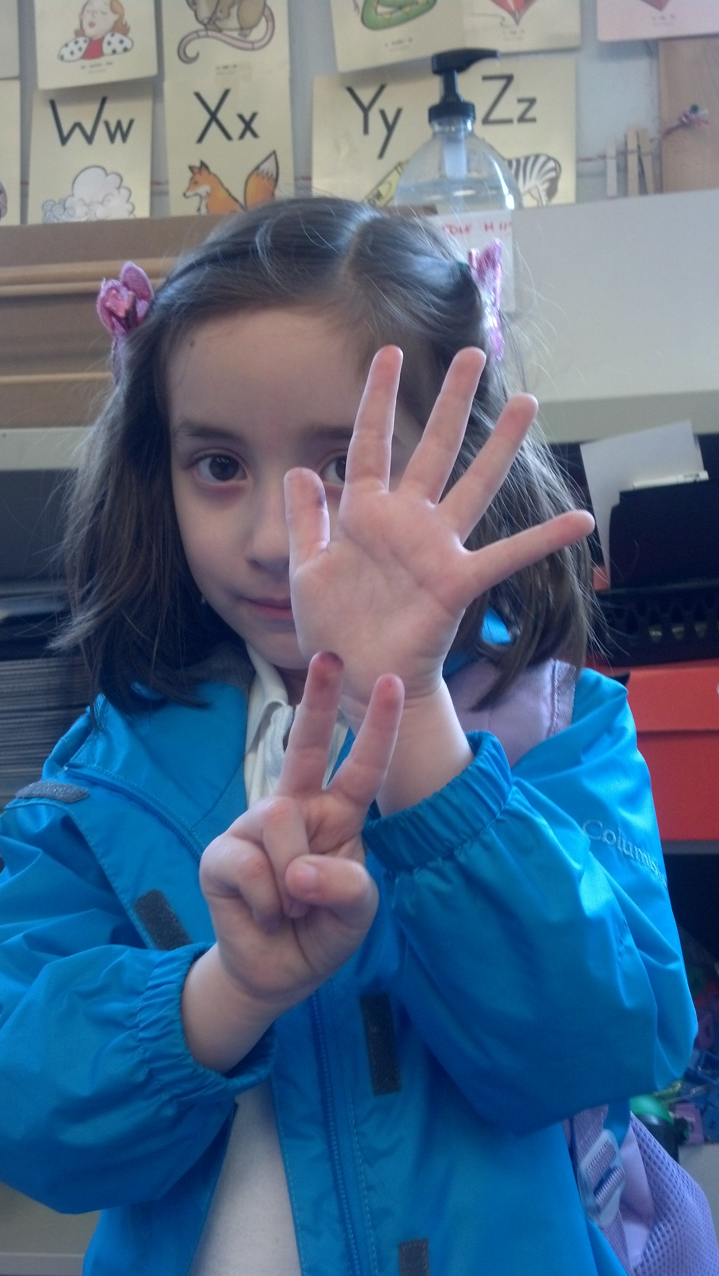
A student demonstrates 7
as 5 on top and 2 on the bottom.
Materials: (T) Large 5-group cards (5−7) (Lesson 5 Fluency Template 1)
Note: This maintenance activity develops flexibility in seeing the 5-groups vertically or horizontally and adds a kinesthetic component.
T: (Show the 6 dot card.) Raise your hand when you know how many dots are on top. (Wait until all hands are raised, then signal.) Ready?
S: 5.
T: Bottom?
S: 1.
T: We can show this 5-group on our hands. 5 on top: 1 on the bottom, like this (Demonstrate on hands: one above the other).
S: (Show 5 and 1 on hands: one above the other.)
T: Push your hands out as you count on from 5, like this: 5 (extend the top hand forward), 6 (extend the bottom hand forward). Try it with me.
S: 5 (extend the top hand forward), 6 (extend the bottom hand forward).
Continue with 5, 6, 7, steadily decreasing guidance from the teacher, until students can show the 5-groups on their hands with ease.
Roll and Draw 5-Groups (5 minutes)
Materials: (S) Die (with the 6 dot side covered), personal white board
Note: Observe to see which students erase completely each time and begin with one rather than draw more or erase some to adjust to the new number. By drawing 5-groups, students see numbers as having length in relationship to the five.
Conduct activity as outlined in Lesson 7.
Application Problem (5 minutes)
Put the following sentence frame on the board, then read it to the students.
NOTES ON
MULTIPLE MEANS
OF REPRESENTATION:
Scaffold the directions for English language learners by using gestures as you read the sentence one section at a time: “I am lighter” with a slow lift from the hand, and “I am heavier” with a quick drop of the hand. As you gesture, hold something light for the “I am lighter” sentence and something heavy for the “I am heavier” sentence.
I am lighter than __________, but I am heavier than _____________.
Draw two things on your paper that would make this sentence true for you. Show your pictures to your partner. Does he or she agree with you? How much do you think you weigh?
Note: This problem bridges the relative weight comparisons in yesterday’s exercise to today’s more precise focus using a balance. The balance scale will help students recall times when they themselves have been weighed, for example, at the doctor’s office. It will also allow the teacher to see what general perceptions the students have about the measurement of weight.
Concept Development (25 minutes)
Materials: (T) Lighter or heavier recording sheet (Template) affixed to the white board (S) Simple balance scale and assortment of objects such that each small group of students will have at least three things to compare (include some objects that will be the same weight); lighter or heavier recording sheet (Template)
T: Sometimes when we are comparing the weights of things that are almost the same, it is hard to tell which is lighter and which is heavier. Can you give me an example from yesterday? Was it sometimes hard to tell which thing was heavier?
S: When we compared the marker and the eraser. It was hard to tell with the balloon and the cotton ball.
T: We have a special tool that can help us find out which object is lighter and which is heavier or if they are the same weight. It is called a balance scale or a balance. (Display the balance scale. Ask students what they know about the balance.)
NOTES ON
MULTIPLE MEANS
OF ACTION AND REPRESENTATION:
Extend the understanding of heavier than, lighter than, and equal to by introducing students working above grade level to interactive balance scale activities such as the one found at http://www.bgfl.org/bgfl/custom
/resources_ftp/client_ftp/ks2/maths
/weigh/free.htm.
MP.2
T: If I were to put the cotton balls on this side (point to one side of the balance) and the eraser on the other side (point), what would happen?
S: The eraser side would go down. The side that is heavier will be lower.
T: Let’s test your guess. (Demonstrate.) You were right! The balance scale shows us that the eraser is heavier than the cotton balls. It shows us that the cotton balls are lighter than the eraser. I will draw the cotton balls and the eraser in the right places on the lighter or heavier recording sheet. (Demonstrate.)
T: Repeat with other pairs of objects until the students are comfortable with the technique of predicting and then experimenting. Draw each pair of items on the lighter or heavier recording sheet.
T: In your small groups, you will be comparing the weights of several pairs of things. You will take turns.
- Student A chooses two things to compare.
- Test them first by just holding them and silently guessing which will be heavier.
- Pass them around so your friends get a chance to guess, too!
- Student A puts one object on one side of the balance and the other object on the other side of the balance to test the guesses.
- All of you will record the results on your own lighter or heavier recording sheet.
- Then it will be the next student’s turn to choose. (Allow ample time for experimentation and recording. Circulate to ensure accurate use of the materials and recording of the results.)
T: Put your balances away. What did your group discover? Were there any surprises? Did anyone find some objects that were the same weight? How did you know? (Allow time for discussion.)
Problem Set (10 minutes)
In this lesson, the Problem Set will be replaced with the lighter or heavier recording sheet to be used during the Concept Development.
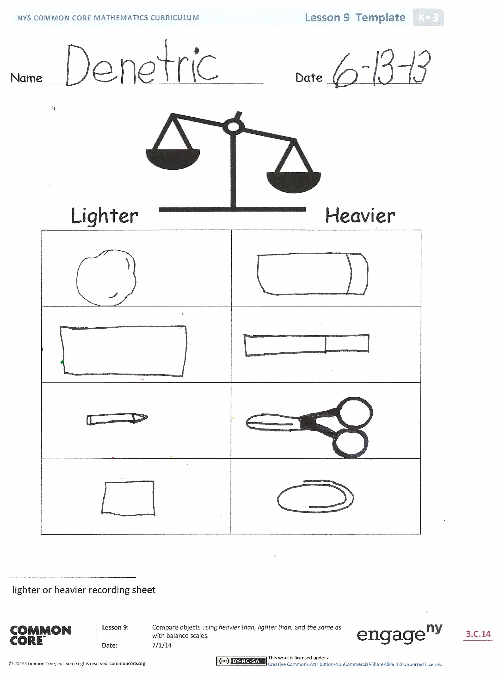
Student Debrief (6 minutes)
Lesson Objective: Compare objects using heavier than, lighter than, and the same as with balance scales.
The Student Debrief is intended to invite reflection and active processing of the total lesson experience.
Invite students to review their lighter or heavier recording sheet. They should check work by comparing answers with a partner before going over answers as a class. Look for misconceptions or misunderstandings that can be addressed in the Debrief. Guide students in a conversation to debrief the lighter or heavier recording sheet and process the lesson.
You may choose to use any combination of the questions below to lead the discussion.
- Why is a balance scale helpful?
- Which objects did you record as heavier than? Which ones were lighter than?
- Did you find any objects that were about the same weight?
- Were you surprised by anything you discovered in the activity?
- Explain to your friend which objects you recorded as being lighter or heavier. Did you have the same answer as your friend?
Name Date
Draw something inside the box that is heavier than the object on the balance.

Draw something lighter than the object on the balance.

Name Date
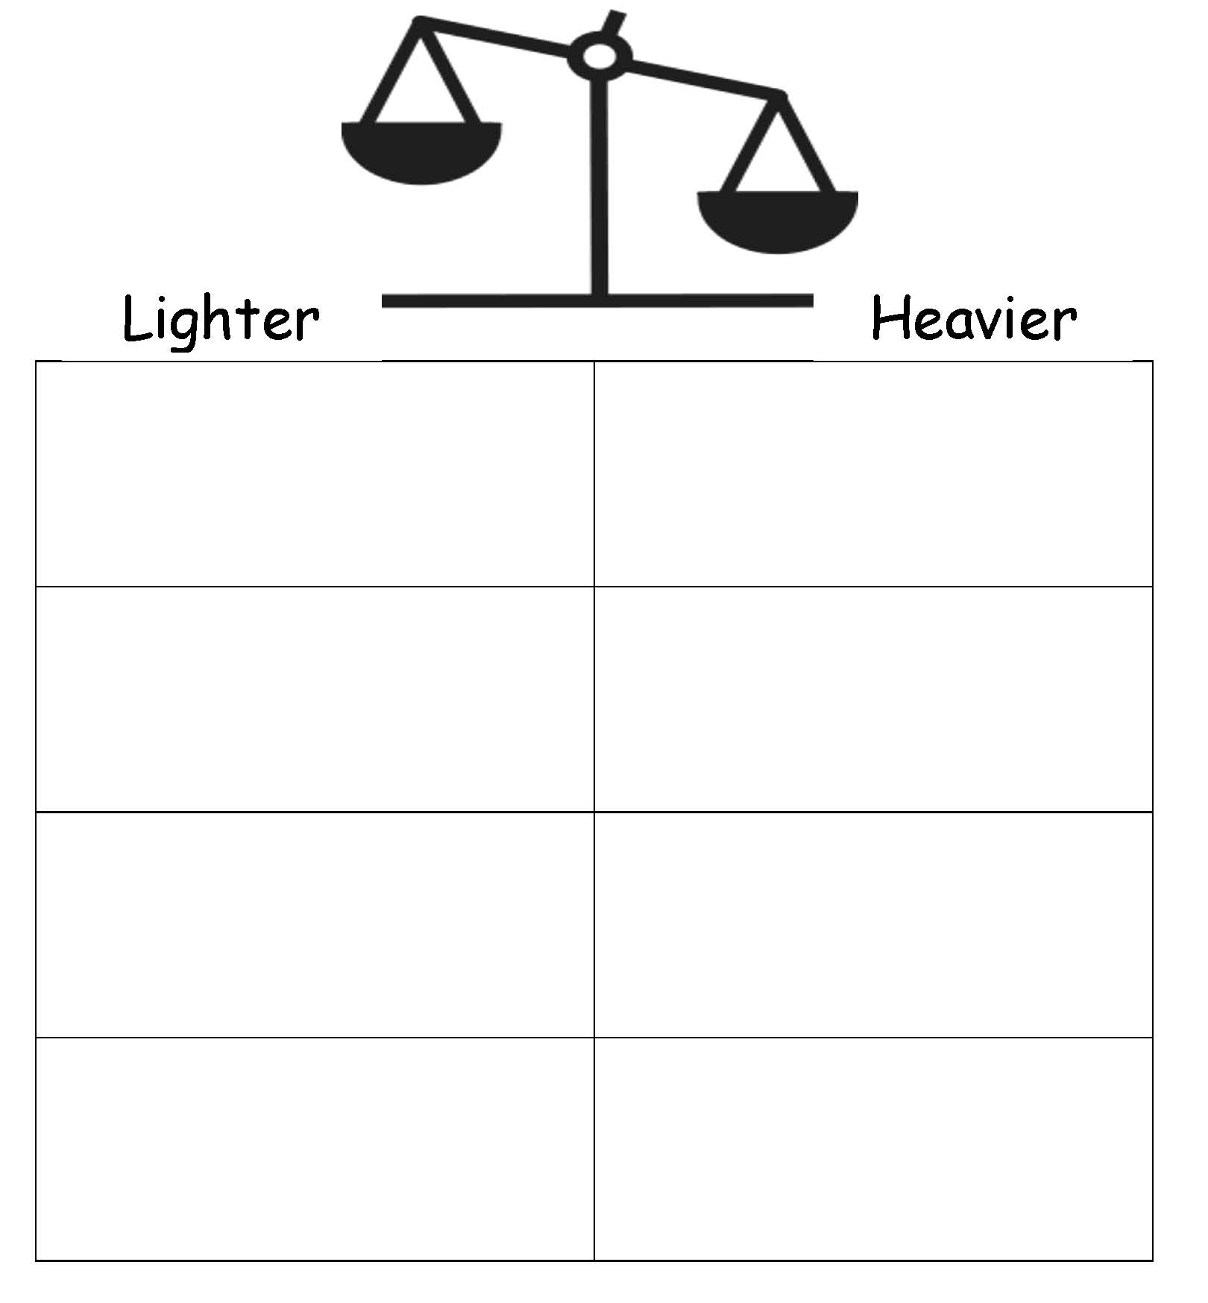

lighter or heavier recording sheet

