Lesson 8
Objective: Compare using heavier than and lighter than with classroom objects.

Suggested Lesson Structure
 Fluency Practice (19 minutes)
 Application Problem (5 minutes)
 Concept Development (20 minutes)
 Student Debrief (6 minutes)
Total Time (50 minutes)
Fluency Practice (19 minutes)
- Make It Equal K.CC.6 (6 minutes)
- Counting the Say Ten Way with the Rekenrek K.NBT.1 (4 minutes)
- Beep Number K.CC.4a (4 minutes)
- Draw More or Cross Out to Make 5 K.OA.3 (5 minutes)
Make It Equal (6 minutes)
Materials: (S) Bag of beans, laminated paper or foam work mat, 2 dice
Note: In this activity, students experience comparison visually, a skill crucial to the work of this module.
1. Teacher introduces the term equal as meaning the same number.
2. Both partners roll dice and then put that many beans on their mat.
3. Partner A has to make her beans equal to her partner’s by taking off or putting on more beans.
4. Partner B counts to verify.
5. Switch roles and play again.
Variation: Have students line up their beans (up to 10 beans) in horizontal or vertical rows.
Counting the Say Ten Way with the Rekenrek (4 minutes)
Conduct activity as outlined in Lesson 6, but now continue to 20 (ten 2) if students are ready.
Note: This activity is an extension of students’ previous work with the Rekenrek and anticipates working with teen numbers.
Beep Number (4 minutes)
Materials (optional): (T) Personal white board (S) Number path (Lesson 1 Fluency Template)
Note: This activity extends students’ proficiency with number order and anticipates working with teen numbers.
Conduct activity as outlined in GK–M1–Lesson 15, but with teen number sequences, counting the Say Ten way. Numbers after will be easier to determine than numbers before. Crossing ten will prove difficult.
A possible sequence, moving from simple to complex, is the following:
Ten 1, ten 2, beep
Ten 6, beep, ten 8
Beep, ten 4, ten 5
9, beep, ten 1
Variation: Extend the sequences to four numbers, for example, ten 1, ten 2, beep, ten 4.
Draw More or Cross Out to Make 5 (5 minutes)
Materials: (S) Make 5 (Fluency Template)
After giving clear instructions and completing the first few problems together, allow students time to work independently. Encourage them to do as many problems as they can within a given time frame.
Optionally, review the answers as a class. Direct students to energetically shout “Yes!” for each correct answer.
Application Problem (5 minutes)
NOTES ON
MULTIPLE MEANS
OF ACTION AND EXPRESSION:
Connect the directions for the Application Problem with gestures that illustrate their meaning. For instance, as you tell students to draw one thing that you would not want to carry around in your backpack because it might make you very tired, you can move slowly and breathe heavily as if you are out of breath.
Draw three things you would not mind carrying around in your backpack, even if you had to walk a long way.
Now, draw one thing that you would not want to carry around in your backpack because it might make you very tired. Why wouldn’t you want to carry it? How is it different from the first things you drew? Talk to your partner about your pictures.
Note: Thinking about things that are too heavy to carry provides the anticipatory set for today’s lesson about relative weights.

Concept Development (20 minutes)
Collect objects from the classroom of varying weights, enough that each pair of students will have at least three objects to test. Include something tall but light (such as a bag of rice cakes) and something short but heavy (such as a can). Other suggestions include: a stack of books, a pencil, an eraser, a marker, a balloon, a tower of linking cubes, a block, a sphere, some cotton balls, some rocks, and a bag of coins. Be sure to include some surprises that are large but relatively light and some that are small but relatively heavy! Place the objects on a table in the front of the room prior to the beginning of the lesson.
T: Look at the rice cakes and the can. Which is taller?
MP.2
S: The bag of rice cakes.
T: Which would you rather carry home from the store?
S: The bag of rice cakes!
T: Why?
S: It is lighter.
T: We’ve been talking about how tall, short, or long things are. There are other ways we can compare things, aren’t there? Can you think of some more?
S: (Various responses.) We could compare two shoes, which is longer and which is heavier.
We could compare a dog and a cat, which is lighter but which is bigger.
T: Good thinking. Let’s do some comparing right now. Student A, would you come to the front and be my helper? Please pick up this book.
S: (Pick up book.)
T: Thank you. Now, pick up these cotton balls. (Student A picks them up.) Which would you rather carry in your backpack all day?
S: The cotton balls!
T: Why?
S: They are lighter.
T: The cotton balls are lighter than the book. The book is heavier than the cotton balls. We can say that they have different weights. Weight is the math word for how heavy or light something is. Thank you, Student A.
NOTES ON
MULTIPLE MEANS
OF ENGAGEMENT:
Scaffold the lesson for students working below grade level by having them practice the concept using interactive technology such as the one found at http://www.ixl.com/math
/kindergarten/light-and-heavy

T: Student B, would you please come up? Hold the book in one hand and the rocks in the other. What do you notice?
S: The rocks are heavier. They pull this hand to the floor more. The book is lighter.
T: The rocks are heavier than the book. The book is lighter than the rocks. Compare using the word than.
S: The rocks are heavier than the book.

T: They have different weights. Put down the book and find something else that is lighter than the rocks. (Allow the student to choose another object. Discuss the student’s choice, and ask how he or she determined that the object was lighter.)
T: Thank you! Student C, do you think the book will be heavier than the eraser or lighter than the eraser? (Allow various students to predict and test the relative weights of various objects against the weight of the book. Discuss how the students determined their answers.)
T: I am going to give you and your partner each some objects. First, make some guesses, and then hold each of them to feel its weight. Work together to see which of your things is the lightest and which is the heaviest. (Allow time for experimentation and discussion. Circulate to encourage use of correct heavier than and lighter than vocabulary.)
T: Which object did you find to be the heaviest in your group? Hold it up! Which was the lightest? Hold it up. Are the biggest things always the heaviest? (Allow time for discussion.)
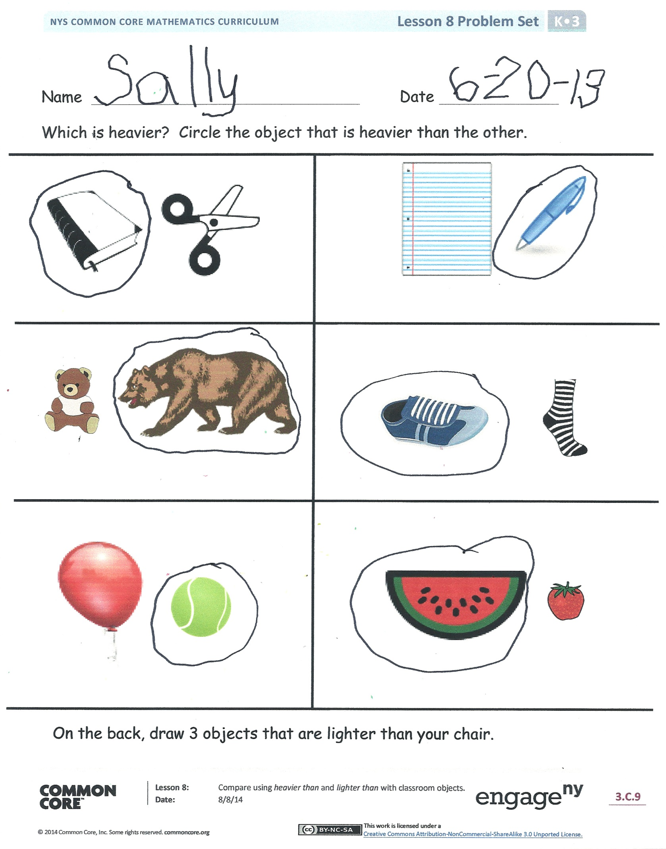
Problem Set (10 minutes)
Students should do their personal best to complete the Problem Set within the allotted time.
Student Debrief (6 minutes)
Lesson Objective: Compare using heavier than and lighter than with classroom objects.
The Student Debrief is intended to invite reflection and active processing of the total lesson experience.
Invite students to review their solutions for the Problem Set. They should check work by comparing answers with a partner before going over answers as a class. Look for misconceptions or misunderstandings that can be addressed in the Debrief. Guide students in a conversation to debrief the Problem Set and process the lesson. You may choose to use any combination of the questions below to lead the discussion.
- What did you notice about heavier than and lighter than when you were working with your partner on our class activity?
- How could you tell that one thing was lighter than or heavier than another?
- Are larger objects always heavier than smaller objects?
- Are smaller objects always lighter than larger objects?
- How did you decide which objects on the Problem Set would be heavier? Could you make a prediction even though you couldn’t feel their weight?
- Which objects did you circle? Why?
- What new (or significant) math vocabulary did we use today to talk about our object?
Name Date
Which is heavier? Circle the object that is heavier than the other.

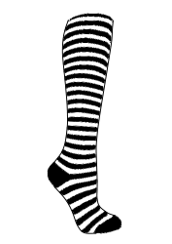
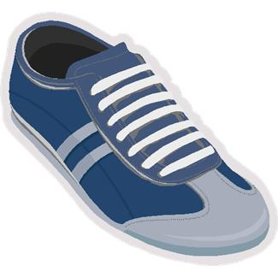
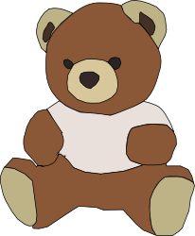

On the back, draw 3 objects that are lighter than your chair.

Name Date
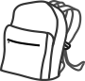
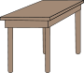
Draw an object that would be lighter than the one in the picture.

Draw more objects or cross out objects to make 5. Circle the group of 5.

make 5

