Lesson 11
Objective: Explain fraction equivalence using a tape diagram and the number line, and relate that to the use of multiplication and division.

Suggested Lesson Structure
 Fluency Practice (12 minutes)
 Application Problem (5 minutes)
 Concept Development (33 minutes)
 Student Debrief (10 minutes)
Total Time (60 minutes)
Fluency Practice (12 minutes)
- Find the Quotient and Remainder 4.NBT.6 (4 minutes)
- Find Equivalent Fractions 4.NF.1 (4 minutes)
- Draw Equivalent Fractions 4.NF.1 (4 minutes)
Find the Quotient and Remainder (4 minutes)
Materials: (S) Personal white board
Note: This fluency activity reviews G4–M3–Lesson 28.
T: (Write 6,765 ÷ 2.) On your personal white board, find the quotient and remainder.
S: (Solve for and write 3,382 R1.)
Continue with the following possible sequence: 6,811 ÷ 5, 1,265 ÷ 4, and 1,736 ÷ 4.
Find Equivalent Fractions (4 minutes)
Materials: (S) Personal white board
Note: This fluency activity reviews Lesson 9.
T: ($\frac{\text{2}}{\text{10}}$ = $\frac{\text{ ÷ }}{\text{÷ }}$ = $\frac{}{\text{5}}$. Point to $\frac{\text{2}}{\text{10}}$.) Say the fraction.
S: 2 tenths.
T: On your personal white board, fill in the unknown numbers to find the equivalent fraction.
S: (Write $\frac{\text{2}}{\text{10}}$ = $\frac{\text{2} \text{÷} \text{2}}{\text{10} \text{÷} \text{2 }}$= $\frac{\text{1}}{\text{5}}.$)
Continue with the following possible sequence: $\frac{\text{2}}{\text{4}}$ , $\frac{\text{5}}{\text{10}}$ , $\frac{\text{3}}{\text{6}}$ , and $\frac{\text{4}}{\text{12}}$.
Draw Equivalent Fractions (4 minutes)
Materials: (S) Personal white board
Note: This fluency activity reviews Lesson 10.
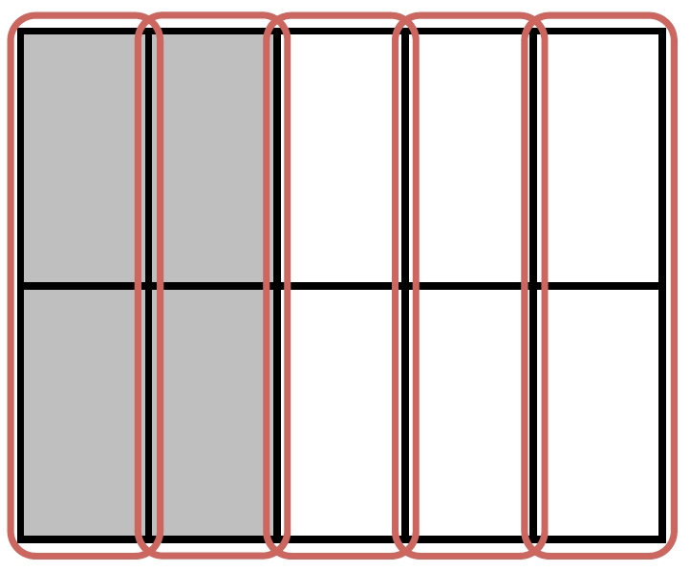
T: (Project a model with 4 out of 10 equal units shaded.) Draw the model, and write the fraction that is shaded.
S: (Draw a model with 4 out of 10 equal units shaded. Write $\frac{\text{4}}{\text{10}}$.)
T: (Write $\frac{\text{4}}{\text{10}}$ = $\frac{\text{ ÷ }}{\text{÷ }}$ = $\frac{}{}.$) Compose the shaded units into larger units by circling. Then, complete the number sentence.
S: (Circle the shaded units into 1 larger unit. Write $\frac{\text{4}}{\text{10}}$= $\frac{\text{4 ÷ 2}}{\text{10 ÷ 2}}$= $\frac{\text{2}}{\text{5}}.$)
Continue with the following possible sequence: $\frac{\text{4}}{\text{6}}$ , $\frac{\text{6}}{\text{9}}$ , $\frac{\text{8}}{\text{10}}$ , and $\frac{9}{12}$.
Application Problem (5 minutes)
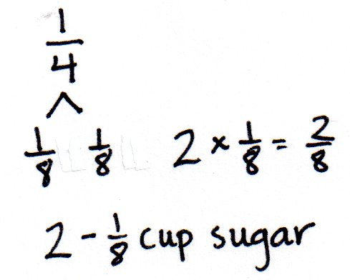
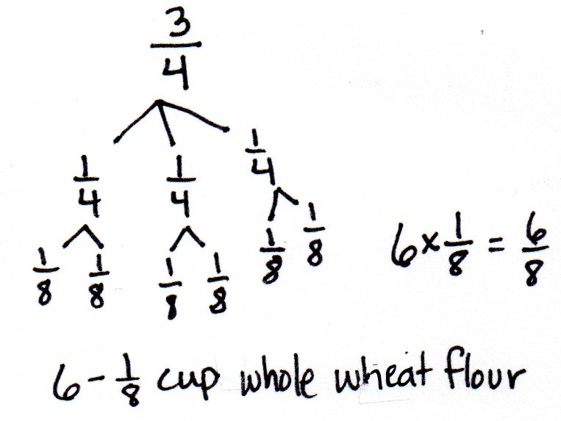
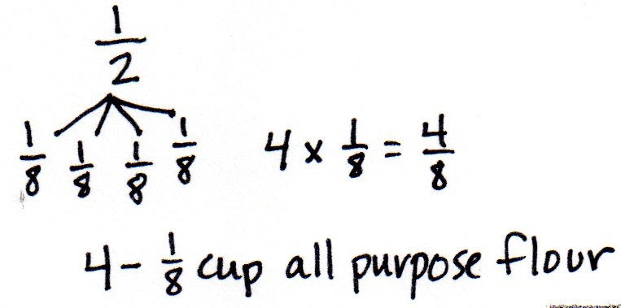
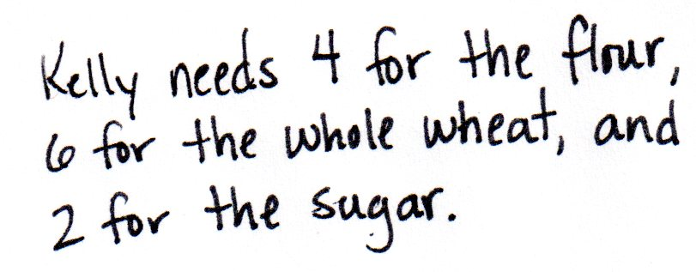
Kelly was baking bread but could only find her $\frac{\text{1}}{\text{8}}$cup measuring cup. She needs $\frac{\text{1}}{\text{4}}$ cup sugar, $\frac{\text{3}}{\text{4}}$ cup whole wheat flour, and $\frac{\text{1}}{\text{2}}$ cup all-purpose flour. How many $\frac{\text{1}}{\text{8}}$ cups will she need for each ingredient?
Solution 2
Solution 1

Note: This Application Problem places equivalent fractions into a context that may be familiar to students. Multiple solution strategies are possible. The first solution models the equivalency learned in Lessons 7 and 8. The second solution uses number bonds to find unit fractions, reviewing Topic A content.

Concept Development (33 minutes)
Materials: (S) Personal white board, ruler
Problem 1: Use a tape diagram and number line to find equivalent fractions for halves, fourths, and eighths.
T: Draw a tape diagram to show 1 partitioned into halves.
S: (Draw a tape diagram.)
T: Shade $\frac{\text{1}}{\text{2}}.$ Now, decompose halves to make fourths. How many fourths are shaded?
S: 2 fourths.
T: On your personal white board, write what we did as a multiplication number sentence.
S: (Write $\frac{\text{1}}{\text{2}}\text{=}\frac{\text{1 × 2}}{\text{ 2 × 2 }}\text{=}\frac{\text{2}}{\text{4}}.$)

NOTES ON
MULTIPLE MEANS
OF REPRESENTATION:
To preserve the pace of the lesson, provide a tape diagram and number line Template for some learners. Students may also choose to transform the tape diagram into a number line by erasing the top line, labeling points, and extending the endpoints.

T: Decompose fourths to make eighths. How many eighths are shaded?
S: 4 eighths.
T: Write a multiplication number sentence to show that
2 fourths and 4 eighths are equal.
S: (Write $\frac{\text{2}}{\text{4}}\text{=}\frac{\text{2 × 2}}{\text{ 4 × 2 }}\text{=}\frac{\text{4}}{\text{8}}.$)
T: Now, use a ruler to draw a number line slightly longer than the tape diagram. Label points 0 and 1 so that they align with the ends of the tape diagram.
S: (Draw a number line.)
T: Label $\frac{\text{1}}{\text{2}}$ on the number line. Decompose the number line into fourths. What is equivalent to $\frac{\text{2}}{\text{4}}$on the number line?
S: $\frac{\text{1}}{\text{2}}\text{=}\frac{\text{2}}{\text{4}}$. We showed that on the tape diagram.
T: Decompose the number line into eighths.
S: (Label the eighths.)
T: What is $\frac{\text{4}}{\text{8}}$ equal to on the number line?
S: $\frac{\text{1}}{\text{2}}\text{=}\frac{\text{4}}{\text{8}}$. $\frac{\text{2}}{\text{4}}\text{=}\frac{\text{4}}{\text{8}}$. That also means $\frac{\text{1}}{\text{2}}\text{=}\frac{\text{2}}{\text{4}}\text{=}\frac{\text{4}}{\text{8}}$.
T: Explain what happened on the number line as you decomposed the half.
S: When we decomposed the half into fourths, it was like sharing a licorice strip with four people instead of two. We got 4 smaller parts instead of 2 larger parts. There are 4 smaller segments in the whole instead of 2 larger segments. We doubled the number of parts but made smaller parts, just like with the area model. It made 2 lengths that were the same length as 1 half.
Problem 2: Use a number line, multiplication, and division to decompose and compose fractions.
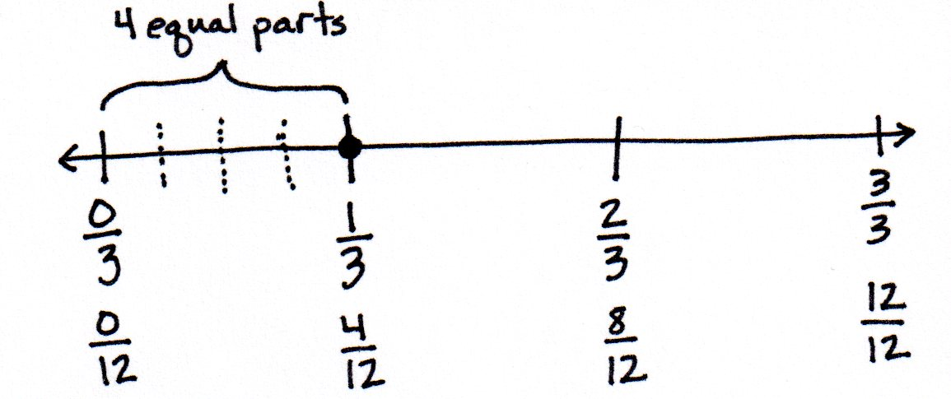
T: Partition a number line into thirds. Decompose
1 third into 4 equal parts.
T: Write a number sentence using multiplication to show what fraction is equivalent to 1 third on this number line.
S: (Write $\frac{\text{1}}{\text{3}}\text{=}\frac{\text{1} \text{×} \text{4}}{\text{3} \text{×} \text{4}}\text{=}\frac{\text{4}}{\text{12}}$.)
T: Explain to your partner why that is true.
S: It’s just like the area model. We made more smaller units, but the lengths stayed the same instead of the area staying the same. If we multiply a numerator and a denominator by the same number, we find an equivalent fraction. 1 third was decomposed into fourths, so we multiplied the number of units in the whole and number of selected units by 4.
T: Write the equivalence as a number sentence using division.
S: (Write $\frac{\text{4}}{\text{12}}\text{=}\frac{\text{4} \text{÷} \text{4}}{\text{12} \text{÷} \text{4}}\text{=}\frac{\text{1}}{\text{3}}$.)
T: Explain to your partner why that is true.
S: We can join four smaller segments to make one longer one that is the same as 1 third. We can group the twelfths together to make thirds. Four copies of $\frac{\text{1}}{\text{12}}$ equals $\frac{\text{1}}{\text{3}}$. Just like the area model, we are composing units to make a larger unit.
Problem 3: Decompose a non-unit fraction using a number line and division.
T: Draw a number line. Partition it into fifths, label it, and locate $\frac{\text{2}}{\text{5}}$.
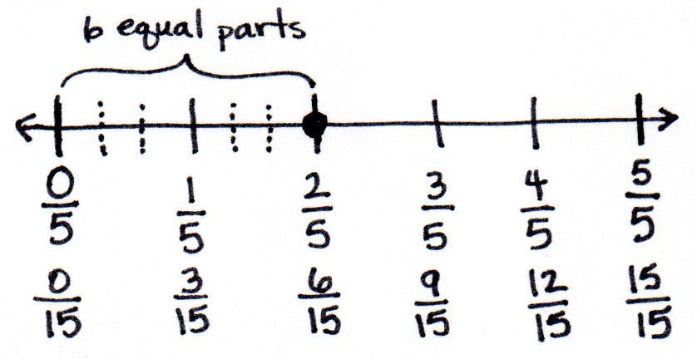
S: (Draw.)
T: Decompose $\frac{\text{2}}{\text{5}}$ into 6 equal parts. First, discuss your strategy with your partner.
S: I will make each fifth into 6 parts. No, we have to decompose 2 units, not 1 unit. Each unit will be decomposed into 3 equal parts. Two units are becoming 6 units. We are multiplying the numerator and denominator by 3.
T: Write a number sentence to express the equivalent fractions.
S: (Write $\frac{\text{2}}{\text{5}}\text{=}\frac{\text{2} \text{×} \text{3}}{\text{5} \text{×} \text{3}}\text{=}\frac{\text{6}}{\text{15}}$.)

Problem Set (10 minutes)
Students should do their personal best to complete the Problem Set within the allotted 10 minutes. For some classes, it may be appropriate to modify the assignment by specifying which problems they work on first. Some problems do not specify a method for solving. Students should solve these problems using the RDW approach used for Application Problems.
Student Debrief (10 minutes)

NOTES ON
MULTIPLE MEANS
OF ENGAGEMENT:
Challenge students working above grade level and others to discuss or journal about the three models used for finding equivalent fractions. Ask, “How do the tape diagram and number line relate to one another? When might you choose to use a number line rather than an area model? Why?”

Lesson Objective: Explain fraction equivalence using a tape diagram and the number line, and relate that to the use of multiplication and division.
The Student Debrief is intended to invite reflection and active processing of the total lesson experience.
Invite students to review their solutions for the Problem Set. They should check work by comparing answers with a partner before going over answers as a class. Look for misconceptions or misunderstandings that can be addressed in the Debrief. Guide students in a conversation to debrief the Problem Set and process the lesson.
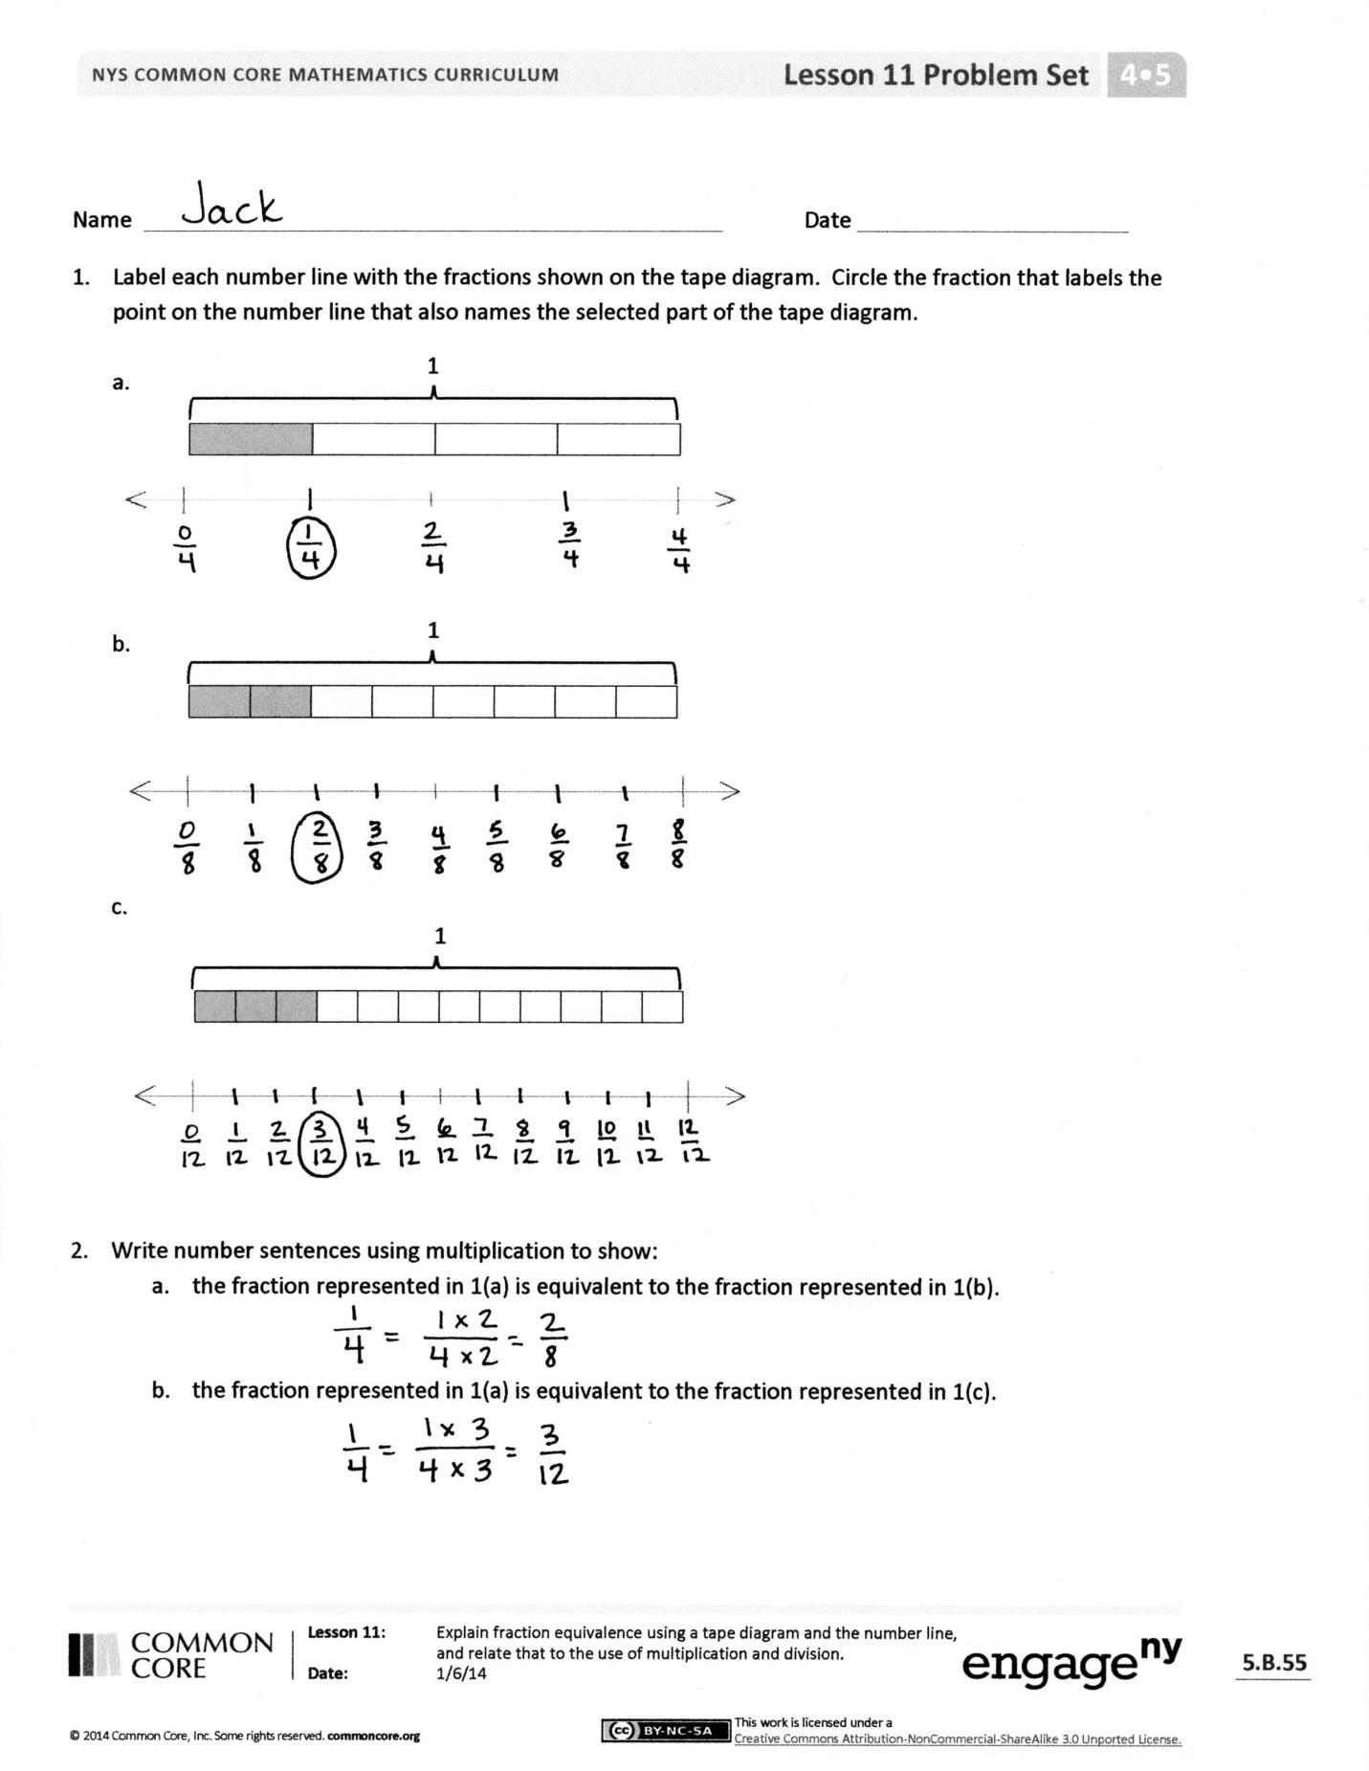
Any combination of the questions below may be used to lead the discussion.
- In Problem 1, compare the distance from 0 to each point on the number line you circled. What do you notice?
- In Problem 1, does the unshaded portion of the tape diagram represent the same length from the point to 1 on every number line? How do you know?
- Compare your number sentences in Problem 2. Could they be rewritten using division?
- In Problem 5, what new units were created when 2 fifths was decomposed into 4 equal parts?
- How is modeling with a number line similar to modeling with an area model? How is it different?
- In Grade 3, you found equivalent fractions by locating them on a number line. Do you now require a number line to find equivalent fractions? What other ways can you determine equivalent fractions?
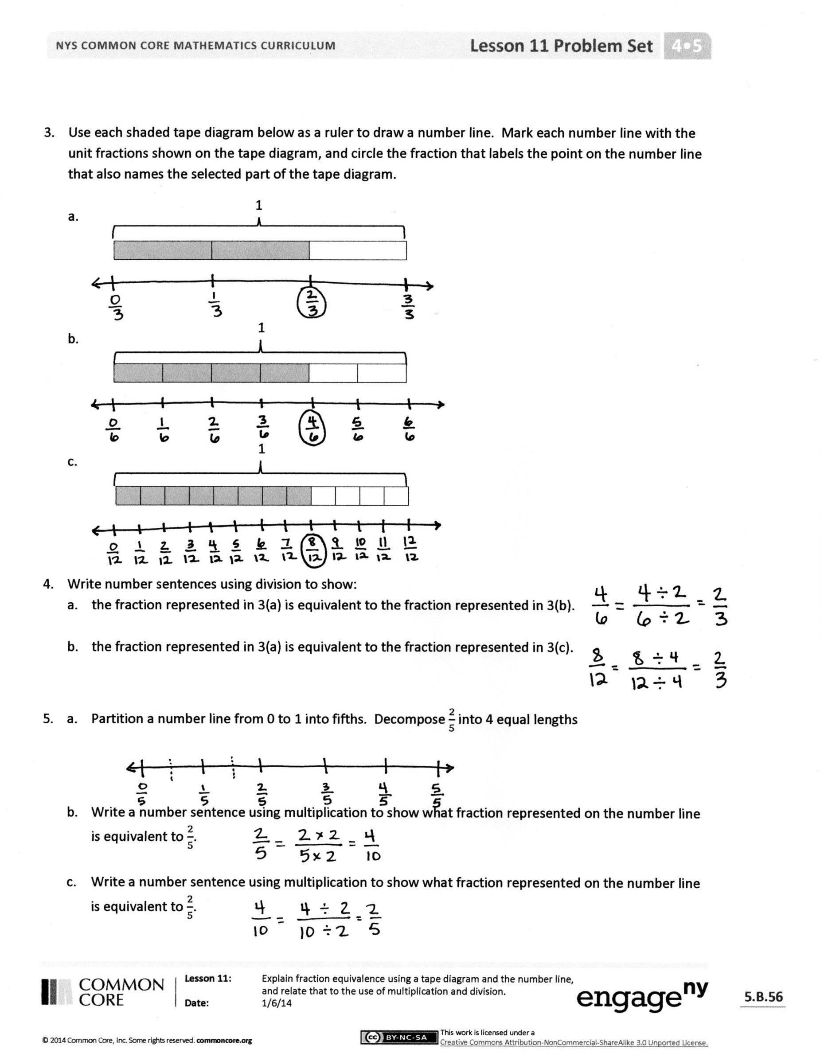
Exit Ticket (3 minutes)

After the Student Debrief, instruct students to complete the Exit Ticket. A review of their work will help with assessing students’ understanding of the concepts that were presented in today’s lesson and planning more effectively for future lessons. The questions may be read aloud to the students.

Name Date
- Label each number line with the fractions shown on the tape diagram. Circle the fraction that labels the point on the number line that also names the selected part of the tape diagram.
1

1

1

- Write number sentences using multiplication to show:
- The fraction represented in 1(a) is equivalent to the fraction represented in 1(b).

- The fraction represented in 1(a) is equivalent to the fraction represented in 1(c).

- Use each shaded tape diagram below as a ruler to draw a number line. Mark each number line with the fractional units shown on the tape diagram, and circle the fraction that labels the point on the number line that also names the selected part of the tape diagram.
1

1

1

- Write number sentences using division to show:
  - The fraction represented in 3(a) is equivalent to the fraction represented in 3(b).

  - The fraction represented in 3(a) is equivalent to the fraction represented in 3(c).

- a. Partition a number line from 0 to 1 into fifths. Decompose $\frac{2}{5}$ into 4 equal lengths.

- Write a number sentence using multiplication to show what fraction represented on the number line is equivalent to $\frac{2}{5}$.

- Write a number sentence using division to show what fraction represented on the number line is equivalent to $\frac{2}{5}$.

Name Date

- Partition a number line from 0 to 1 into sixths. Decompose $\frac{2}{6}$into 4 equal lengths.

- Write a number sentence using multiplication to show what fraction represented on the number line is equivalent to $\frac{2}{6}$.

- Write a number sentence using division to show what fraction represented on the number line is equivalent to $\frac{2}{6}$.

Name Date
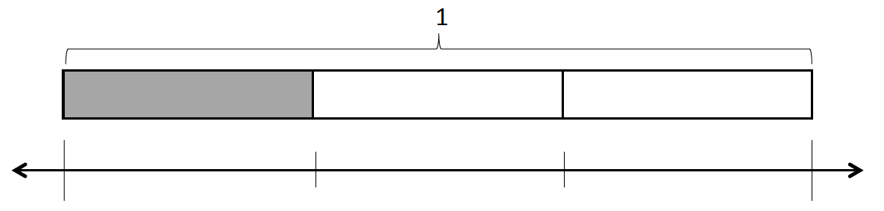
- Label each number line with the fractions shown on the tape diagram. Circle the fraction that labels the point on the number line that also names the selected part of the tape diagram.

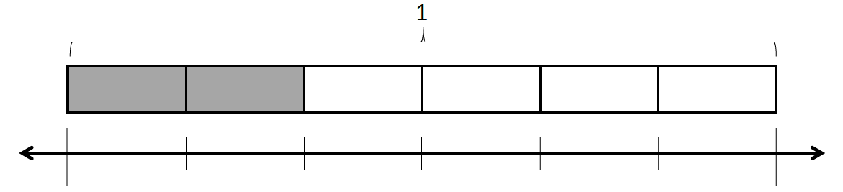

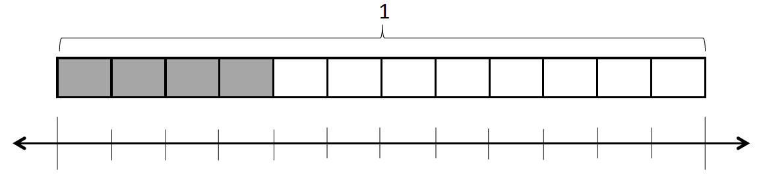

- Write number sentences using multiplication to show:
- The fraction represented in 1(a) is equivalent to the fraction represented in 1(b).

- The fraction represented in 1(a) is equivalent to the fraction represented in 1(c).

- Use each shaded tape diagram below as a ruler to draw a number line. Mark each number line with the fractional units shown on the tape diagram, and circle the fraction that labels the point on the number line that also names the selected part of the tape diagram.
1

1

1

- Write a number sentence using division to show the fraction represented in 3(a) is equivalent to the fraction represented in 3(b).

- a. Partition a number line from 0 to 1 into fourths. Decompose $\frac{3}{4}$ into 6 equal lengths.

- Write a number sentence using multiplication to show what fraction represented on the number line is equivalent to $\frac{3}{4}$.

- Write a number sentence using division to show what fraction represented on the number line is equivalent to $\frac{3}{4}$.

