Lesson 7
Objective: Compare objects using the same as.

Suggested Lesson Structure
 Fluency Practice (10 minutes)
 Application Problem (5 minutes)
 Concept Development (29 minutes)
 Student Debrief (6 minutes)
Total Time (50 minutes)
Fluency Practice (10 minutes)
- Counting the Say Ten Way with the Rekenrek K.NBT.1 (3 minutes)
- Roll and Draw 5-Groups K.OA.3 (4 minutes)
- Green Light, Red Light K.CC.2 (3 minutes)
Counting the Say Ten Way with the Rekenrek (3 minutes)
Conduct activity as described in Lesson 6, but this time, continue to ten 5.
Note: This activity is an extension of students’ previous work with the Rekenrek and anticipates working with teen numbers.
Roll and Draw 5-Groups (4 minutes)
Materials: (S) Die (with the 6 dot side covered), personal white board
Note: Observe to see which students erase completely and begin each time from 1 rather than draw more or erase some to adjust to the new number. By drawing 5-groups, students see numbers in relationship to the five.
Roll the die, count the dots, and then draw the number as a 5-group.
Green Light, Red Light (3 minutes)
Materials: (T) Green and red dry-erase markers
On the board, draw a green dot with a 1 underneath and a red dot with a 3 underneath. Explain to students that they will start counting and stop counting on the number as indicated by the color code.

T: Look at the numbers. (Point to the number 1 written below the green dot and the number 3 below the red dot.) Think. Ready? Green light!
S: 1, 2, 3.
T: Very good! (Erase numbers 1 and 3, and write the new numbers.) New numbers (green is 3, red is 1). Look, think, ready… green light!
S: 3, 2, 1.
At this point in the year, it may not be necessary to start at 1. Work within a range that is comfortable for the students and build incrementally. Challenge them by frequently changing directions between counting up and counting down.
Application Problem (5 minutes)

NOTES ON
MULTIPLE MEANS
OF REPRESENTATION:
Challenge students working above grade level to write down what strategies they used to compare the length of their snakes to their fingers and how they know which snake is longer or shorter than their fingers. Encourage them to draw pictures, but also to write the math words they know.
Materials: (S) Small ball of clay
Make a little clay snake that is as long as your pointer finger. Now, make a friend for him that is as long as your pinky finger. Which one is longer? Show your creations to your partner.
Note: Circulate to notice students’ strategies in terms of comparing the length of their snakes to their fingers. Tactile creation of objects of equal length to fingers provides the anticipatory set for the more abstract length equality exercise in today’s Concept Development.
Concept Development (29 minutes)
Materials: (T/S) Bag of linking cube number stairs, riddle work mat (Template) copied on two sides of the paper or inserted into personal white board
T: Mix up your number stairs on your desk. Find your 5-stick. Look at it carefully. Now, listen to my riddle. We are two different sticks. We are each shorter than the 5-stick, but when you put us together, we are the same length as the 5-stick!
MP.7
T: Which sticks could the riddle be talking about? Look at your sticks and find two that would work. (Allow time for experimenting.)
T: Student A, what did you find?
S: My 3-stick and my 2-stick. (Hold up sticks.)
T: Right! We would say it like this, “Together, my 3-stick and my 2-stick are the same length as my
5-stick.” Repeat after me.
S: Together, my 3-stick and my 2-stick are the same length as my 5-stick.
T: Did anyone do it differently?
S: I found 1 and 4. (Hold up sticks.)
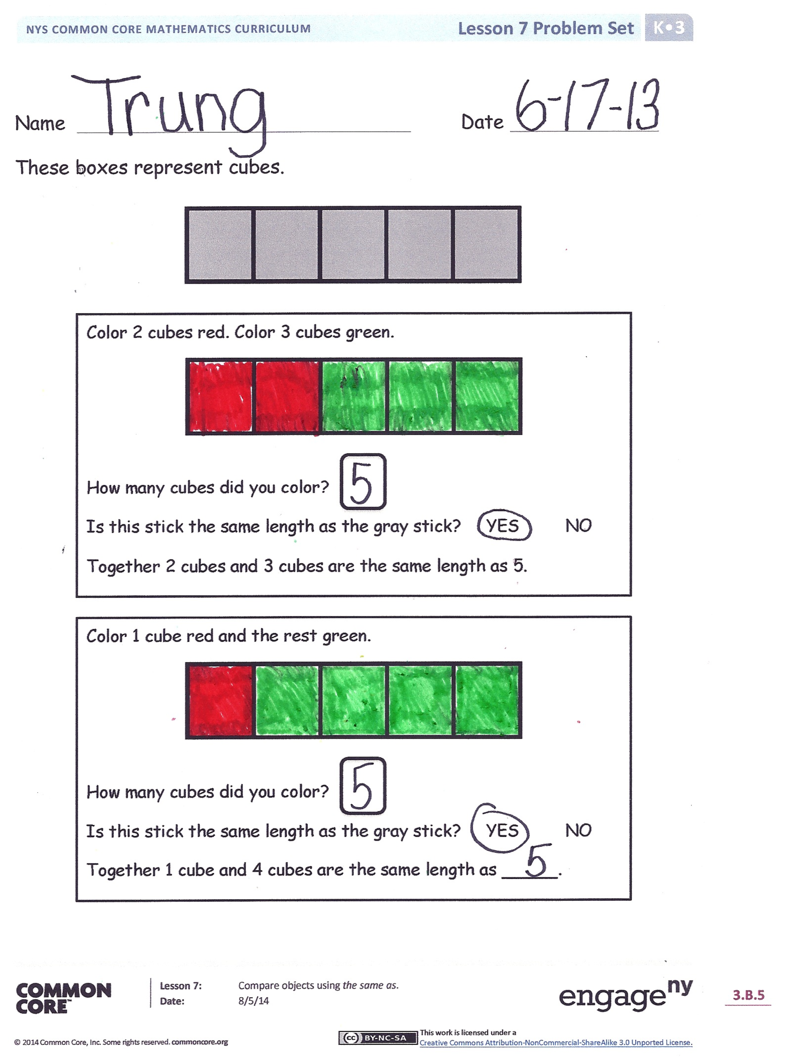
T: Say with me, “Together, my 1-stick and my 4-stick are the same length as my 5-stick.”
MP.7
T: Let’s record what we just found. On your work mat, trace your 5-stick like this. (Demonstrate.) Now, trace the 1-stick and the 4-stick underneath the 5-stick you drew. (Demonstrate.) Finish the sentence frame: “Together, my 1-stick and my
4-stick are the same length as my 5-stick.”
T: We are going to see how many sets of sticks we can find that will make our riddle true. (Allow time for experimenting and recording.)
T: How many different ways did you find to make a stick the same length as your 5-stick? Would anyone like to share their work? (Allow time for discussion and sharing.)
S: I found 4 and 1. I found 3 and 2. 2 and 3 works too!
Problem Set (10 minutes)
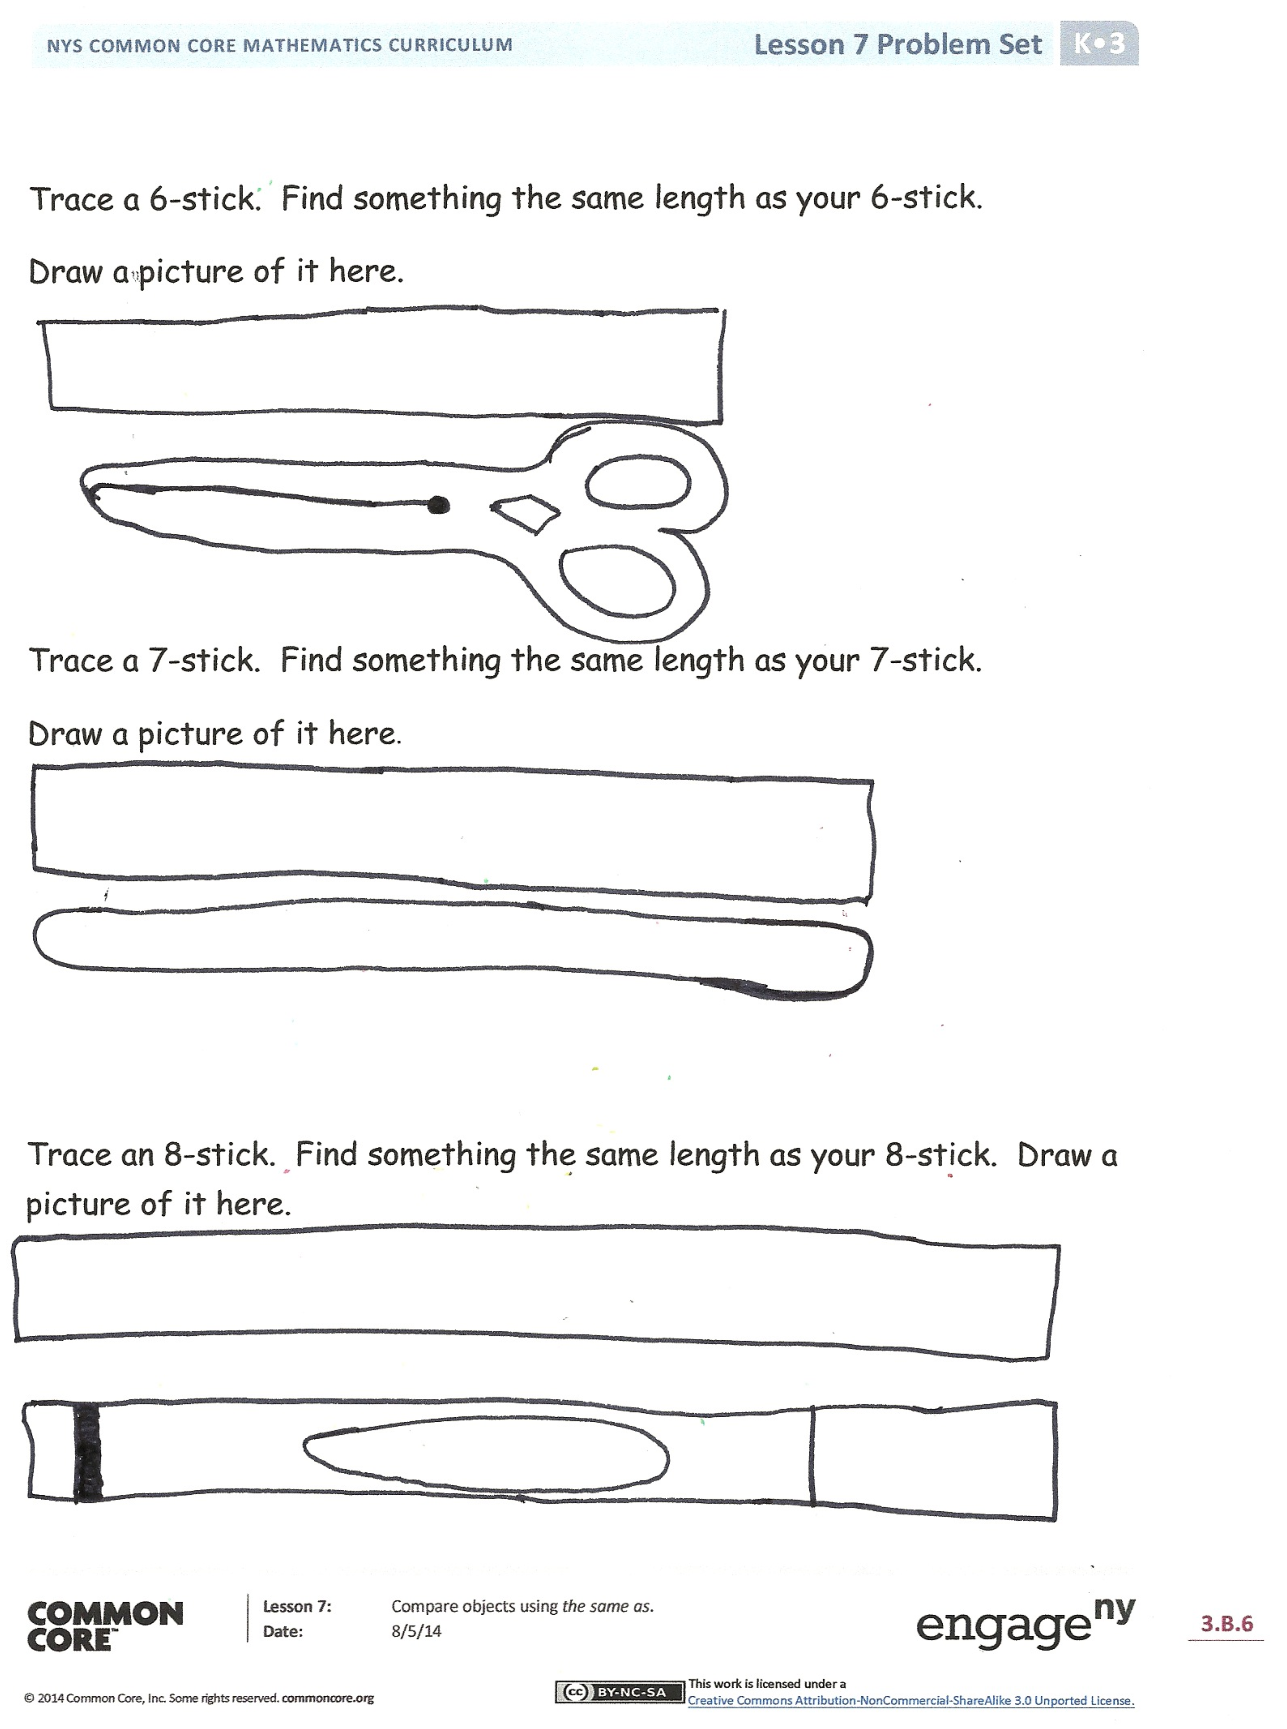
Note: Before beginning the Problem Set, take a few minutes to build a stick with students, emphasizing the language in the Problem Set that is continued from the lesson.
Students should do their personal best to complete the Problem Set within the allotted time.
Student Debrief (6 minutes)
Lesson Objective: Compare objects using the same as.
The Student Debrief is intended to invite reflection and active processing of the total lesson experience.
Invite students to review their solutions for the Problem Set. They should check work by comparing answers with a partner before going over answers as a class. Look for misconceptions or misunderstandings that can be addressed in the Debrief. Guide students in a conversation to debrief the Problem Set and process the lesson.

You may choose to use any combination of the questions below to lead the discussion.
- When you made the clay snake today, how could you tell it was the same length as your finger?
- How did you solve the riddle in the lesson today?
- How did you use the cube sticks to help you solve the riddle?
- Are there other riddles that you can think of about cube sticks that together make the same length as another? Turn to your partner and see if you can think of some other riddles.
Name Date
These boxes represent cubes.
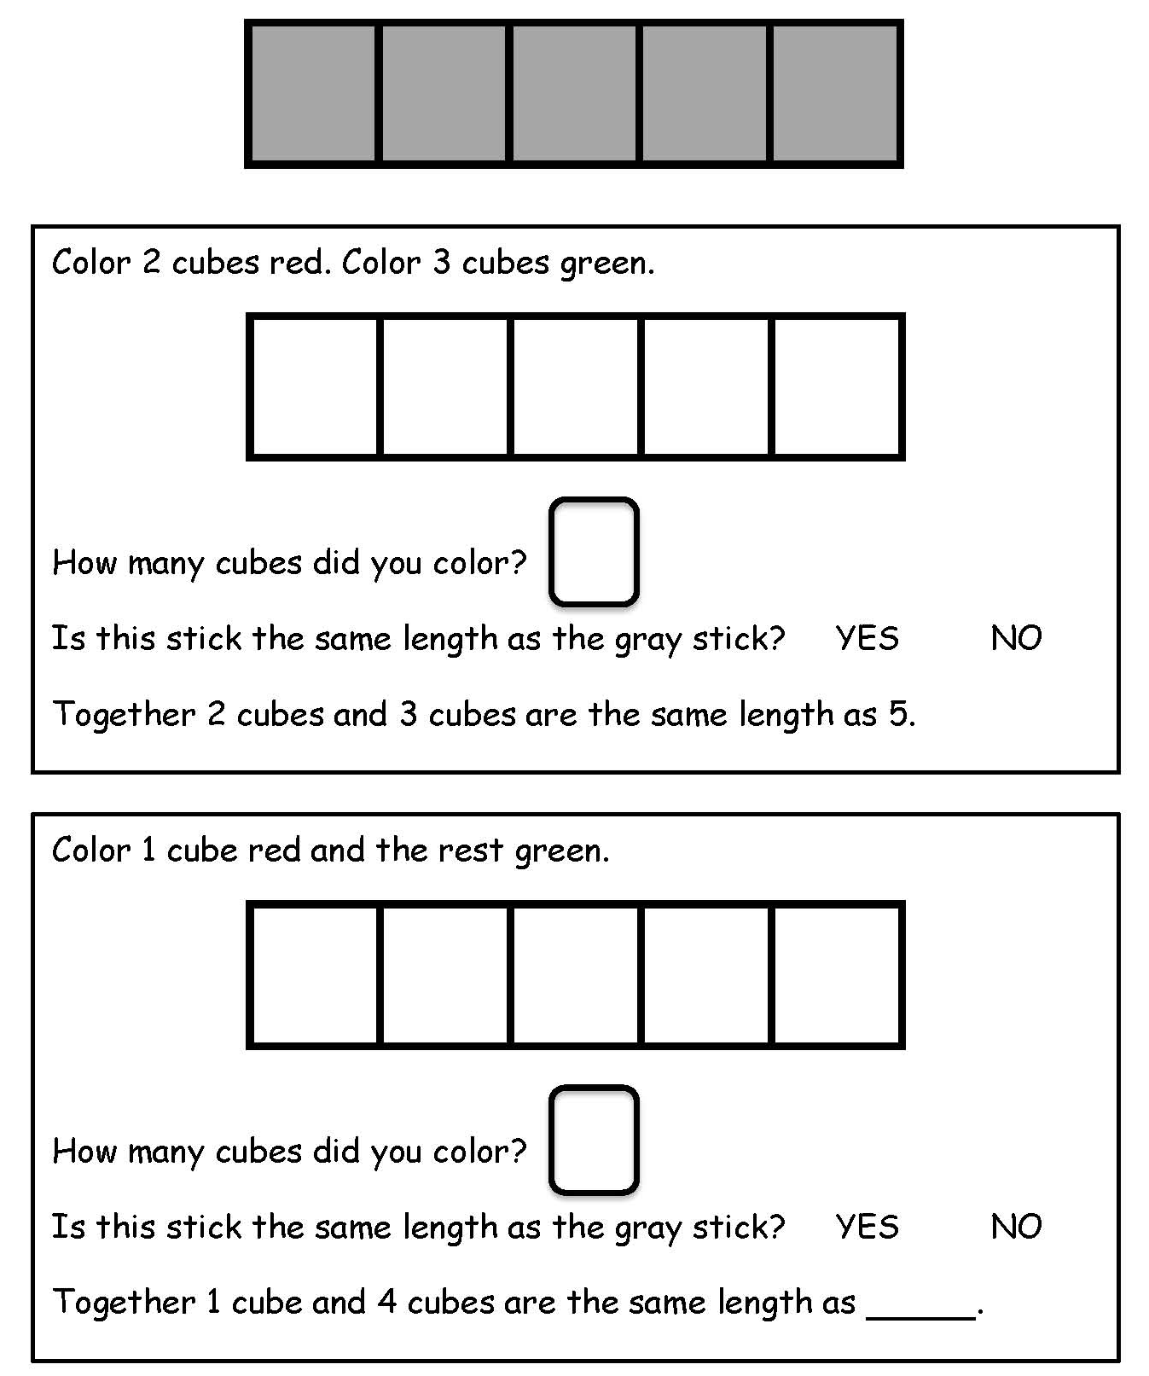
Trace a 6-stick. Find something the same length as your 6-stick.
Draw a picture of it here.

Trace a 7-stick. Find something the same length as your 7-stick.
Draw a picture of it here.

Trace an 8-stick. Find something the same length as your 8-stick. Draw a picture of it here.

Name Date
These boxes represent cubes.

Color 2 cubes green. Color 3 cubes blue.
Together, my 2 green stick and 3 blue stick are the same length as 5 cubes.

Color 3 cubes blue. Color 2 cubes green.
Together, my 3 blue stick and 2 green stick are the same length as ___ cubes.

Color 2 cubes yellow. Color 2 cubes blue.
Together, my 2 yellow and 2 blue are the same as _____.

Color 1 cube green. Color 4 cubes blue.
How many did you color? ________

Color 4 cubes green. Color 1 cube blue.
How many did you color? ________

My 5:

My _____:

My _____:

Together, my _____ and my ______ are the same as my 5.

riddle work mat

