Lesson 6
Objective: Compare the length of linking cube sticks to various objects.

Suggested Lesson Structure
 Fluency Practice (10 minutes)
 Application Problem (5 minutes)
 Concept Development (29 minutes)
 Student Debrief (6 minutes)
Total Time (50 minutes)
Fluency Practice (10 minutes)
- Show Me Taller and Shorter K.MD.1 (3 minutes)
- Counting the Say Ten Way with the Rekenrek K.NBT.1 (4 minutes)
- Hidden Numbers K.OA.3 (3 minutes)
Show Me Taller and Shorter (3 minutes)
Note: This kinesthetic fluency activity reviews vocabulary.
Conduct activity as described in Lesson 2, but with longer and shorter. Now, students extend their hands from side to side to indicate length.
Counting the Say Ten Way with the Rekenrek (4 minutes)
Materials: (T) 20-bead Rekenrek
Note: This activity is an extension of students’ previous work with the Rekenrek and anticipates working with teen numbers.
T: We can count with the Rekenrek the same way we do our Say ten push-ups (fluency activity in Lesson 3). (Keep the screen on the right side of the Rekenrek to cover beads which are not being counted. Slide over all of the beads on the top row.) How many do you see?
S: 10.
T: Here’s 1 more. (Slide over 1 bead on the bottom row). That’s what ten 1 looks like on the Rekenrek. How many do you see?
S: Ten 1.
T: (Slide 1 more bead over on the bottom row.) How many do you see?
S: Ten 2.
T: (Slide 1 more bead over on the bottom row.) How many do you see?
S: Ten 3.
Continue counting forward and backward with the following suggested sequence: ten 1, ten 2, ten 1, ten 2, ten 3, ten 2, ten 3, ten 2, ten 1, etc.
Hidden Numbers (3 minutes)
Materials: (S) Hidden numbers mat (Lesson 3 Fluency Template) inserted into personal white board
Note: Finding embedded numbers anticipates the work of GK–M4 by developing part–whole thinking.
Conduct activity as described in Lesson 3, but this time, guide students to find hidden numbers within a group of 7.
Application Problem (5 minutes)

NOTES ON
MULTIPLE MEANS
OF REPRESENTATION:
Scaffold the Application Problem for struggling students by first modeling and then helping them trace their hands. Watch as they follow the first direction until it is ensured that they are clear about what to do.

Materials: (S) Crayon, paper, bag of linking cube stairs
Spread your hand out on the piece of paper and trace around it to make your handprint. Now, take your hand off of the paper and look carefully at the fingers in your handprint drawing.
Think about which linking cube stick might be as long as your thumb. Take out that stick and check your guess. Were you right? Which one would be about as long as your little finger? Your middle finger?
Test your guesses to see if you were close. Share your discoveries with your friend. Are your friend’s fingers and your fingers the same lengths?
Note: This problem gives students experience using linking cubes as a simple comparison tool in anticipation of today’s lesson.
Concept Development (29 minutes)
Materials: (S) Bag of linking cube number stairs and paper bag filled with various items to measure (e.g., pencil, eraser, glue stick, toy car, small block, 8-inch piece of string, marker, child’s scissors, crayon) per pair
Note: Save a set of student materials for the culminating task in Lesson 32.
T: With your partner, take the items out of your mystery bag and place them on your desk. Now, use the linking cube sticks to make a set of number stairs on your desk. Put them in order from the 1-cube to the 10-stick. Let’s count to make sure we have them all.
MP.3
S: 1. 1 more is 2. 2. 1 more is 3. …10.
T: Find the crayon. Hold it up. Now, guess which cube stick might be the same length as your crayon. Test your guess with your partner. (Allow time for discussion and comparison of the lengths.)
T: Find your 10-stick. Look at the items from your mystery bag. Point to something that you think might be shorter than your 10-stick. Now, compare the length of your 10-stick with the length of your object. Test your guess. Were you correct? (Allow time for discussion and comparison of the lengths.)
MP.3
S: Yes!
T: This time, point to something that you think will be longer than your 4-stick. Test your guess. Were you correct?

NOTES ON
MULTIPLE MEANS
FOR ACTION AND EXPRESSION:
English language learners will be better able to follow the fast pace of the Simon Says game if practiced a few times with familiar commands. Simon says, raise your hand. Simon says, sit down, etc.
S: Yes!
T: We will play Simon Says. Simon says, point to something that you think is shorter than your 8-stick. Simon says, test your guess. Simon says, hold up your object if you were correct. Put it down. I didn’t say Simon says!
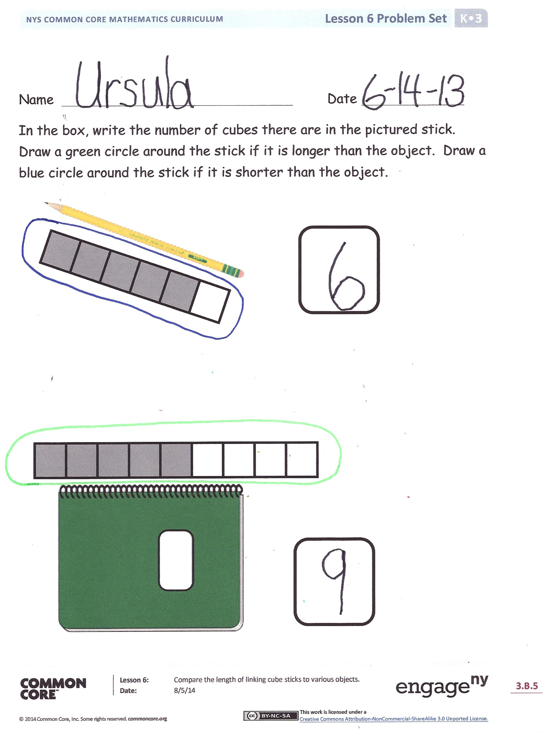
T: Simon says, point to something that you think is taller than your 2-stick. Simon says, test your guess. Hold up your object if you were correct…. I didn’t say Simon says!
T: (Continue playing the game several times, varying the shorter than, longer than, and taller than language and incorporating all of the number sticks at least once. Observe accuracy of student responses with respect to object length.)
T: Great listening! Put your objects back in your mystery bag, and carefully put away the linking cube sticks. We will be talking more about linking cube sticks during our Problem Set.
Problem Set (10 minutes)
Note: The problems in today’s Problem Set may take more time than usual since reading and writing are required. The problems are meant to be done with the teacher reading the sheet and guiding the students through the Problem Set. Students should do their personal best to complete the Problem Set within the allotted time.

Student Debrief (6 minutes)
Lesson Objective: Compare the length of linking cube sticks to various objects.
The Student Debrief is intended to invite reflection and active processing of the total lesson experience.
Invite students to review their solutions for the Problem Set. They should check work by comparing answers with a partner before going over answers as a class. Look for misconceptions or misunderstandings that can be addressed in the Debrief. Guide students in a conversation to debrief the Problem Set and process the lesson.
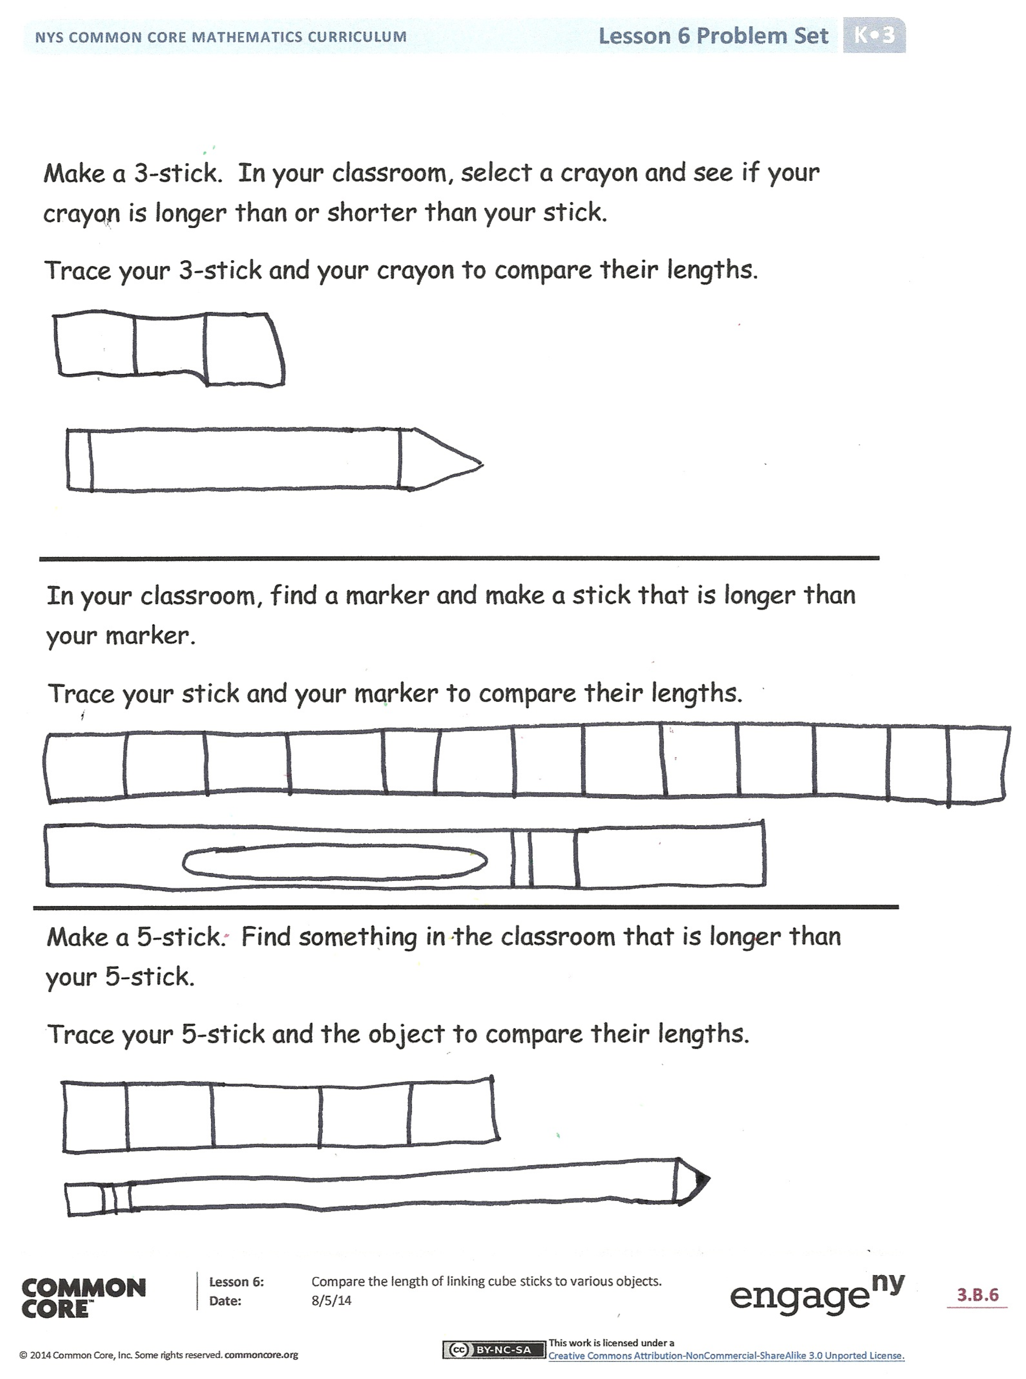
You may choose to use any combination of the questions below to lead the discussion.
- What did we do when we were playing Simon Says?
- How did you make your guesses?
- What did you draw on your Problem Set that was longer than your 3-stick? Shorter than your
3-stick?
- Can you think of something at home that would be shorter than your 5-stick? Bring it tomorrow so that you may test your guess!

Name Date
In the box, write the number of cubes there are in the pictured stick. Draw a green circle around the stick if it is longer than the object.
Draw a blue circle around the stick if it is shorter than the object.

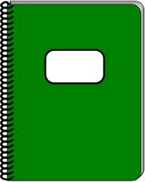

Make a 5-stick. Find something in the classroom that is longer than your 5-stick.
Trace your 5-stick and the object to compare their lengths.
In your classroom, find a marker, and make a stick that is longer than your marker.
Trace your stick and your marker to compare their lengths.

Make a 3-stick. In your classroom, select a crayon, and see if your crayon is longer than or shorter than your stick.
Trace your 3-stick and your crayon to compare their lengths.
Name Date
Color the cubes to show the length of the object.

