Lesson 5
Objective: Determine which linking cube stick is longer than or shorter than the other.

Suggested Lesson Structure
 Fluency Practice (10 minutes)
 Application Problem (5 minutes)
 Concept Development (29 minutes)
 Student Debrief (6 minutes)
Total Time (50 minutes)
Fluency Practice (10 minutes)
- Show Me Longer and Shorter K.MD.1 (2 minutes)
- 5-Group Hands K.CC.2 (4 minutes)
- 5-Groups on the Dot Path K.CC.2 (4 minutes)
Show Me Longer and Shorter (2 minutes)
Note: This kinesthetic activity reviews vocabulary.
Conduct activity as described in Lesson 2, but with longer and shorter. Now, students extend their hands from side to side to indicate length.
5-Group Hands (4 minutes)
Materials: (S) 5-group cards in vertical orientation (Fluency Template 1)
Note: This maintenance activity develops flexibility in seeing the 5-groups vertically or horizontally, and adds a kinesthetic component.
Conduct activity as described in GK–M2–Lesson 1, but this time showing the 5-group cards in the vertical orientation. Accordingly, students should put their hands side by side to represent the number.
5-Groups on the Dot Path (4 minutes)
Materials: (S) Dot path (Fluency Template 2) placed inside of a personal white board
Note: This activity helps students gain flexibility in grouping 5 and starting to count on from 5 pictorially.
T: Touch and count the dots on your dot path.
S: 1, 2, 3, …10.
T: What do you notice about the dot path?
S: There are 10 dots. There are two different color dots. A color change at 5.
T: Yes. I’m going to ask you to circle a group of dots. Use the color change at 5 to count and circle
them as fast as you can. Ready? Circle 5.
S: (Circle a group of 5 dots.)
T: How did you do that so fast?
S: I just circled all the light ones, and I knew it was 5.
T: Erase. Get ready for your next number. Circle 6.
S: (Circle a group of 6 dots.)
T: How did you count 6?
S: I counted all of the dots until I got to 6. I counted one more than 5.
If students are starting to count on, let them share their thinking with the class. Continue the process with numbers to 10. Deviate from a predictable pattern as students show mastery.
Application Problem (5 minutes)
NOTES ON
MULTIPLE MEANS
OF ENGAGEMENT:
Scaffold the Application Problem for English language learners and students with disabilities by walking them through the directions one step at a time. Begin with the box above the star and point to it. Observe students as they follow directions to ensure their complete understanding.
Write your name so that one letter is in each box. Begin with the box above the star. Don’t skip any boxes!

You made a name train. Compare your train to that of your partner. What do you notice? Which train has more letter passengers?
Note: By replacing the vertical emphasis in yesterday’s linking cube exercise with a horizontal representation, the problem serves as an anticipatory set for today’s lesson. Circulate during the discussion to notice use of longer than and shorter than terminology; observe endpoint alignment skills.
Concept Development (29 minutes)
Materials: (S) 1 bag of linking cube stairs from Lesson 4 per pair
T: With your partner, arrange your linking cube stairs from yesterday on your desk. This time, put them in order from the tallest to shortest. Let’s count to make sure they are all here. How many are in the longest stick?
S: 10. 1 less is 9. 9. 1 less is 8. …1.
T: Find your 5-stick and hold it up. How many?
S: 5.
T: Now, find your 2-stick and compare it to your 5-stick. What do you notice?
S: It is shorter.
T: Repeat after me, “My 2 is shorter than my 5. My 5 is longer than my 2.” (Hold up sticks, and demonstrate.)
S: My 2 is shorter than my 5. My 5 is longer than my 2.
T: Put your sticks down. Find your 5 and your 4. Compare the sticks. What do you notice?
S: My 4 is shorter than my 5. My 5 is longer than my 4.
T: Great! Now, use your 5 and choose another stick of your own. What did you choose?
S: The 7! It is longer than the 5. (Answers may vary.)
T: Say it with me. “The 7 is longer than the 5. The 5 is shorter than the 7.” Did anyone choose a different stick? (Allow other students to tell about their choices.)
Repeat this exercise and sentence modeling through several iterations, using a variety of different sticks for the initial comparison.
T: Do you see a stick that is shorter than the 1? Why not? (Allow time for discussion.)
T: Do you see a stick that is longer than the 10? Why not? (Allow time for discussion.)
T: Mix up all of your sticks on your desk. Now, you will play a game with your partner. One of you will close your eyes and choose two sticks. When you open your eyes, quickly tell your partner which stick is longer than the other one and which stick is shorter than the other one. Make sure you tell your partner in the way that we just practiced! Then, it will be your partner’s turn. (Allow students to play until you observe that they are comfortable with the correct language of comparison.)

NOTES ON
MULTIPLE MEANS
FOR ACTION AND EXPRESSION:
As you give directions about how to play the game, illustrate your meaning for English language learners. Hold up two sticks and demonstrate by saying, “My 2-stick is shorter than my 7-stick. My 7-stick is longer than my 2-stick.”
MP.2
T: What did you notice while you were playing your game? (Allow time for responses.)
T: Did it matter if your sticks were up, down, or sideways?
S: No! They were still the same length!
T: Put your stairs away carefully for next time.
Problem Set (10 minutes)
Students should do their personal best to complete the Problem Set within the allotted time.
For this Problem Set, it is recommended that all students begin with circling the sticks and possibly leave filling in the blanks to the end if time allows.

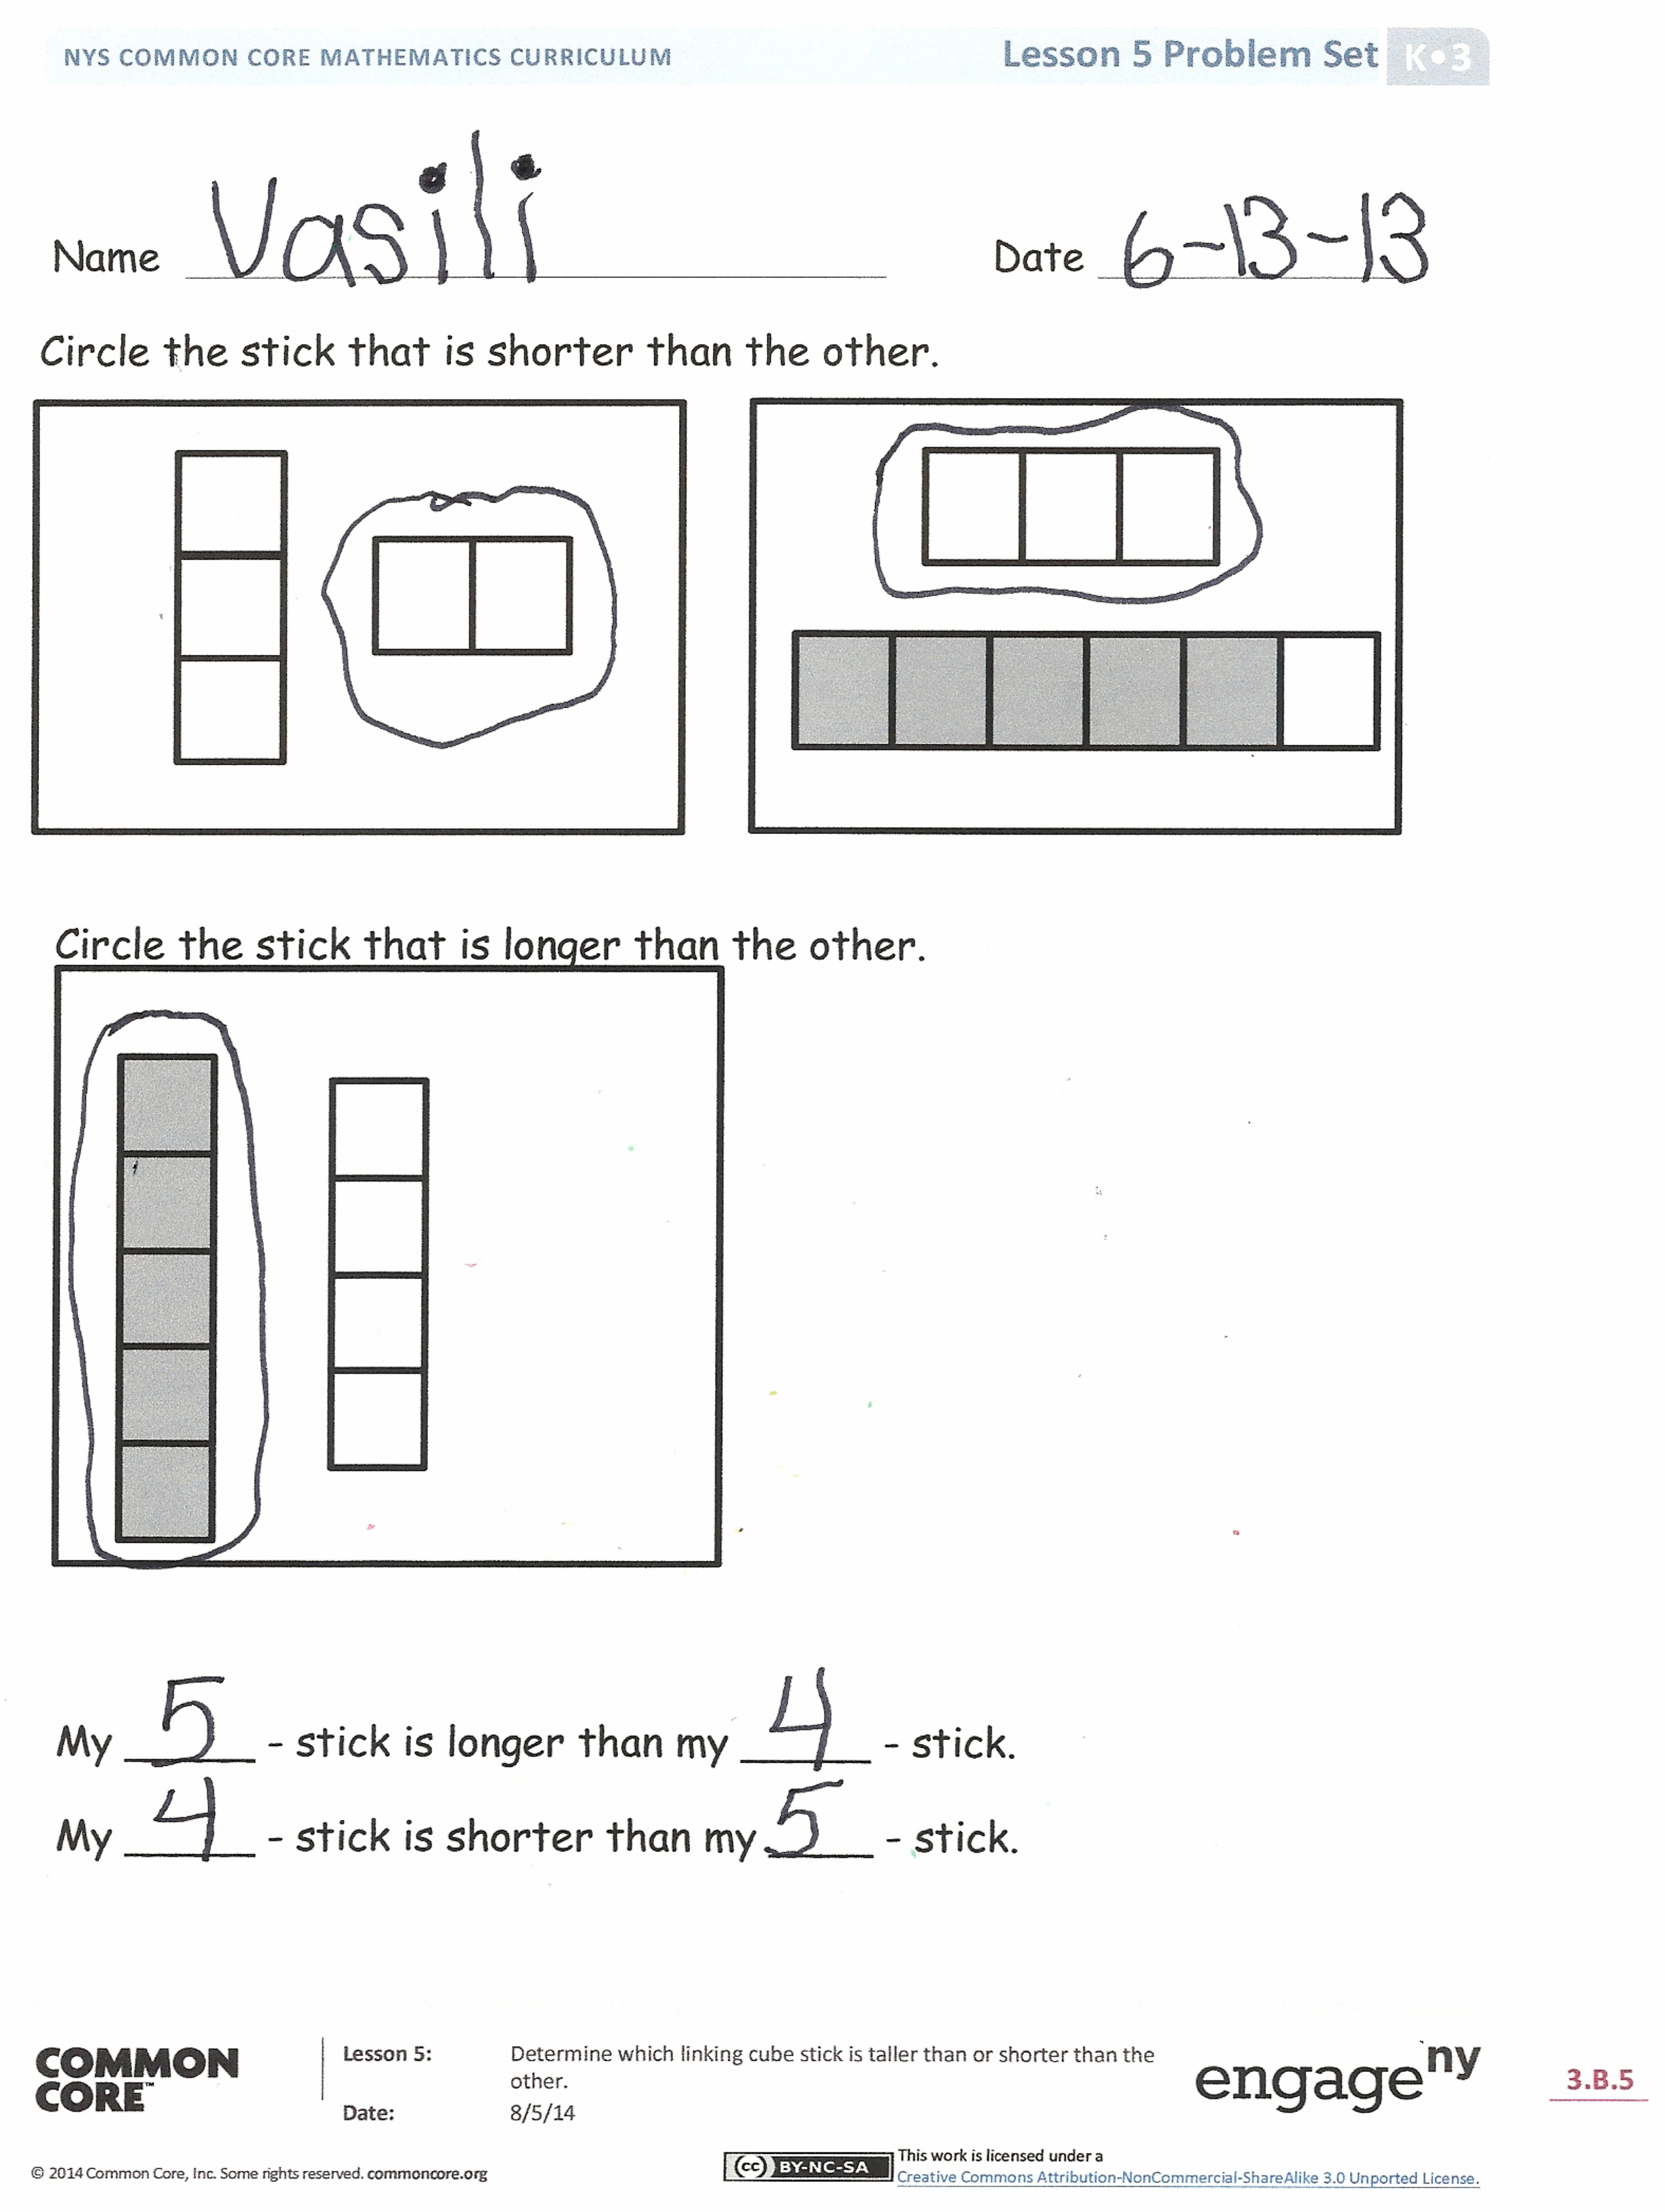
Student Debrief (6 minutes)
Lesson Objective: Determine which linking cube stick is longer than or shorter than the other.
The Student Debrief is intended to invite reflection and active processing of the total lesson experience.
Invite students to review their solutions for the Problem Set. They should check work by comparing answers with a partner before going over answers as a class. Look for misconceptions or misunderstandings that can be addressed in the Debrief. Guide students in a conversation to debrief the Problem Set and process the lesson.
You may choose to use any combination of the questions below to lead the discussion.
- When you were asked to draw a stick taller or shorter than 6 or 9 cubes, what did you draw?
- Did you all choose to draw the same stick? What else could you have chosen?
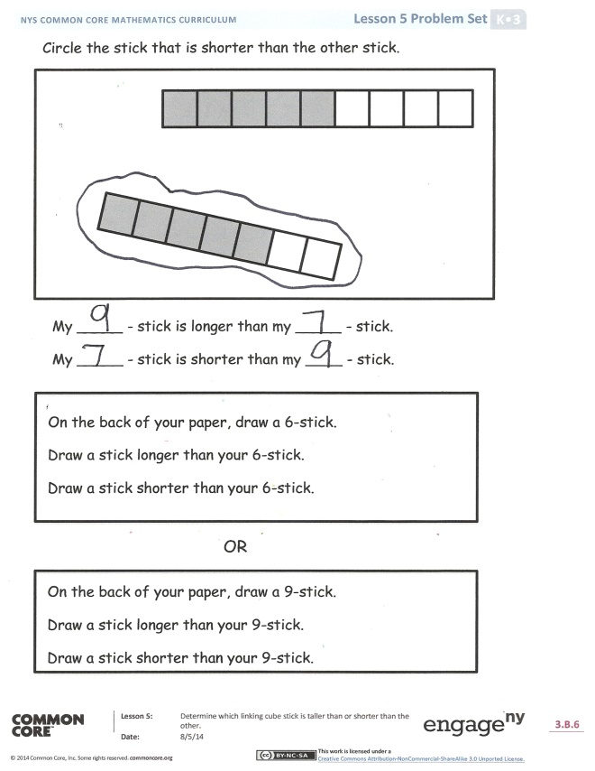
- How did you compare the lengths of your sticks?
- Tell your partner about the number of cubes in the stick you drew using the sentence, “My_____stick is longer than/shorter than my _____stick.”
- Turn to your partner and tell them something you could teach or share with your family tonight about length. Be sure to use the words longer than and shorter than!

Name Date

Circle the stick that is shorter than the other.

Circle the stick that is longer than the other.
My _____ -stick is longer than my _____ -stick.
My _____ -stick is shorter than my ____ -stick.

Circle the stick that is shorter than the other stick.

My _____ -stick is longer than my _____ -stick.
My _____ -stick is shorter than my ____ -stick.

On the back of your paper, draw a 6-stick.
Draw a stick longer than your 6-stick.
Draw a stick shorter than your 6-stick.

On the back of your paper, draw a 9-stick.
Draw a stick longer than your 9-stick.
Draw a stick shorter than your 9-stick.
OR

Name Date
Circle the stick that is shorter than the other.

My _____ -stick is shorter than my _____ -stick.
My _____ -stick is longer than my _____ -stick.

On the back of your paper, draw a 7-stick.
Draw a stick that is longer than the 7-stick.
Draw a stick that is shorter than the 7-stick.
Circle the stick that is longer than the other.

On the back of your paper, draw a stick that is between a 4- and a
6-stick.
Draw a stick that is longer than your new stick.
Draw a stick this is shorter than your new stick.
our paper draw a stick that would be between a 4- and a 6-stick.
Draw a stick that is longer than that.
Draw a stick this is shorter than that.

My _____ -stick is shorter than my _____ -stick.
My _____ -stick is longer than my _____ -stick.

5-group cards
dot path

