Lesson 4
Objective: Compare the length of linking cube sticks to a 5-stick.

Suggested Lesson Structure
 Fluency Practice (10 minutes)
 Application Problem (5 minutes)
 Concept Development (29 minutes)
 Student Debrief (6 minutes)
Total Time (50 minutes)
Fluency Practice (10 minutes)
- Show Me Longer and Shorter K.MD.1 (3 minutes)
- Show Me Fingers the Say Ten Way K.NBT.1 (4 minutes)
- 5-Group Finger Counting K.CC.2 (3 minutes)
Show Me Longer and Shorter (3 minutes)
Note: This kinesthetic fluency activity reviews vocabulary.
Conduct activity as described in Lesson 2, but with longer and shorter. Now, students extend their hands from side to side to indicate length.
Show Me Fingers the Say Ten Way (4 minutes)
T: You’re getting very good at counting on your fingers the Say Ten Way! Show me ten 1.
S: Ten (push out both hands as if doing a push-up exercise in the air) and (closed fists, close to body), 1 (push out the left hand pinky finger).
T: Show me ten 2.
S: Ten (push out both hands as if doing a push-up exercise in the air) and (closed fists, close to body), 2 (push out the left hand pinky and ring fingers).
Continue in a predictable pattern, then randomly.
5-Group Finger Counting (3 minutes)
Note: This activity helps solidify students’ understanding of numbers to 10 in relationship to the five, which will be useful in upcoming lessons.
Conduct activity as described in Lesson 1.
Application Problem (5 minutes)
NOTES ON
MULTIPLE MEANS
OF REPRESENTATION:
Scaffold the Application Problem for English language learners, as well as students with disabilities, if needed, by asking questions such as “Which is longer, the crayon or the ruler?” and “Which is shorter, the paper clip or the pencil?” Continue to ask questions, gradually leading students to independence.
Write the following sentence frame on the board, and then read it to the students.
I am taller than ______________. I am shorter than __________________.
Draw two things on your paper that would make your sentence true. Tell your sentence to your partner. Does he agree that it is true?
Note: Mentally comparing the height or length of two different objects to a third object provides a good cumulative review of the topic to date. This helps students be fully prepared for a more abstract development of measurement in upcoming lessons. Circulate during the activity to ensure that students are completing the sentence.
Concept Development (29 minutes)
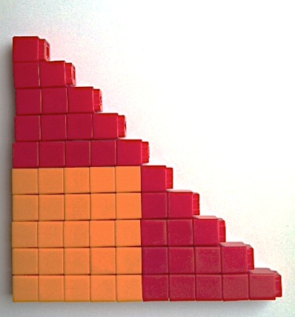
Materials: (S) Bag of loose linking cubes per pair: 40 red and 15 of another color or 30 of one color and 25 of another depending on how you build the stairs (the latter is pictured below), longer or shorter mat (Template)
T: Do you remember the number stairs we made earlier this year? With your partner, make a set of red number stairs from 1 to 5.
S: (Create stairs.)
T: What did we do to make the rest of the stairs?
S: We made a bunch of 5-sticks, and then we put other cubes on top.
T: You have great memories! Let's do that again. Use the rest of your red cubes (or orange cubes) to make as many 5-sticks as you can. Then, add your other cubes to make the rest of your number stairs. Put them in order so you make sure you have them all.
S: (Complete and arrange number stairs.)
T: What do you notice about the number stairs?
S: Some are all red. Some have two colors. Some are longer. Some are shorter.
T: Let’s count to make sure we aren’t missing any!
S: 1. 1 more is 2. 2. 1 more is 3. 3. …10.
T: Now, mix them all up. Can you find your 5-stick? Hold it up for me to see. How many cubes?
NOTES ON
MULTIPLE MEANS
OF ENGAGEMENT:
Push the comprehension of students working above grade level by asking them to explain and defend their placement of shorter than/longer than linking cube sticks to a friend who is is visually impaired.
S: 5.
T: Let’s compare with your 5-stick! We will use this new work mat to help us organize the rest of the stairs. (Pass out work mat.) Choose another cube stick from your desk. Is that stick longer than or shorter than your 5-stick? (Encourage students to use the sentence, “My _____ stick is shorter than/longer than my ____stick.”)
MP.2
S: (Answers will vary.)
T: If your stick is longer than your 5-stick, put it on this side of the mat. (Demonstrate.) If it is shorter, put it on this side. (Demonstrate.) Choose another one. Compare it to your 5-stick. Which side should it go on? (Continue activity until all sticks have been compared.)
T: Take all of the sticks off your mat and mix them up again on your desk. Find your 5-stick. This time, I am going to see how long it takes you to measure and sort your sticks onto your work mat. Ready? Set. Go! (Count while students quickly sort sticks. If necessary, repeat activity until students demonstrate fluency and confidence with comparing and sorting.)
T: Great! Now, take a minute to look at your work mat with your partner. Talk about what you notice about the sticks that you sorted. (Circulate to observe discussions. Observe to determine whether students are making the connection between sticks longer than/shorter than the 5-stick and numbers that are greater than/less than 5. Also observe to determine whether students detect the connection between length and color.)
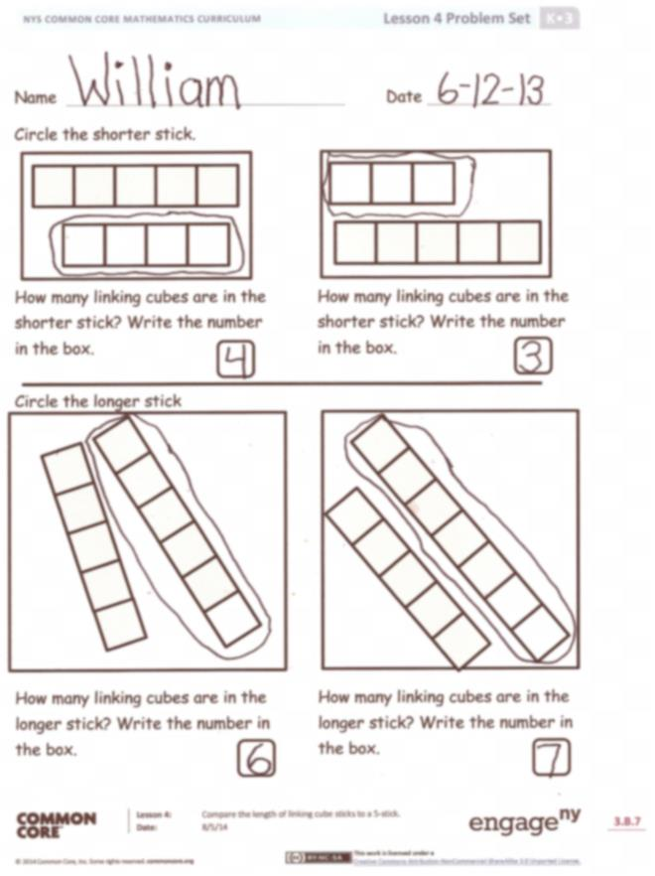
This would be a good time to call on students to make a comparison using the sentence, “My ____stick is shorter/longer than my _____ stick.”
T: Put your sticks away carefully because we will be using them again tomorrow.
Problem Set (10 minutes)
Students should do their personal best to complete the Problem Set within the allotted time.
Student Debrief (6 minutes)
Lesson Objective: Compare the length of linking cube sticks to a 5-stick.
The Student Debrief is intended to invite reflection and active processing of the total lesson experience.

Invite students to review their solutions for the Problem Set. They should check work by comparing answers with a partner before going over answers as a class. Look for misconceptions or misunderstandings that can be addressed in the Debrief. Guide students in a conversation to debrief the Problem Set and process the lesson.
You may choose to use any combination of the questions below to lead the discussion.
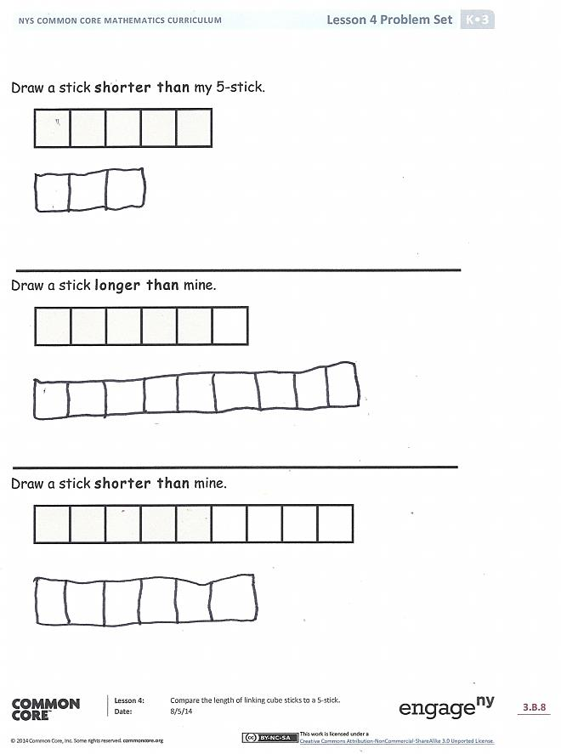
- How did you compare the sticks in the sorting activity? (Review the importance of endpoint alignment.)
- Was it easier to sort the sticks the second time? Why?
- When you were sorting the sticks, did you notice any patterns?
- Did you notice any clues from the colors of the sticks that helped you with your sort?
Name Date
Circle the shorter stick.

How many linking cubes are in the shorter stick? Write the number in the box.
How many linking cubes are in the shorter stick? Write the number in the box.

Circle the longer stick

How many linking cubes are in the longer stick? Write the number in the box.
How many linking cubes are in the longer stick? Write the number in the box.

Draw a stick shorter than my 5-stick.

Draw a stick longer than mine.

Draw a stick shorter than mine.

Name Date
Use a red crayon to circle the sticks that are shorter than the 5-stick.

Use a blue crayon to circle the sticks that are longer than the 5-stick.

On the back, draw a 7-stick. Draw a stick longer than it. Draw a stick shorter than it.

Shorter than my 5-stick:
Longer than my 5-stick:

longer or shorter mat

