Lesson 3
Objective: Make a series of longer than and shorter than comparisons.

Suggested Lesson Structure
 Fluency Practice (10 minutes)
 Application Problem (5 minutes)
 Concept Development (29 minutes)
 Student Debrief (6 minutes)
Total Time (50 minutes)
Fluency Practice (10 minutes)
- Say Ten Push-Ups K.NBT.1 (3 minutes)
- Hidden Numbers (5 as the Whole) K.OA.3 (4 minutes)
- Make It Equal K.CC.6 (3 minutes)
Say Ten Push-Ups (3 minutes)
Conduct activity as outlined in Lesson 1, but now continue to ten 5, encouraging students to predict what comes next in the pattern.
Note: This activity extends students’ understanding of numbers to 10 in anticipation of working with teen numbers.
Hidden Numbers (5 as the Whole) (4 minutes)
Materials: (S) Hidden numbers mat (Fluency Template) inserted into personal white board
Note: Finding embedded numbers anticipates the work of GK–M4 by developing part–whole thinking.
T: Touch and count the fish on your mat. Raise your hand when you know how many. (Wait for all hands to go up, and then give the signal.) Ready?
S: 10.
T: Put an X on 5 of the fish. We’re not going to count those fish right now. Pretend they swam away!
S: (Cross out 5 fish.)
T: Circle a group of 4 from the fish who didn’t swim away.
T: How many fish are left?
S: 1.
T: Let’s circle that 1. How many did you circle all together?
S: 5.
T: Erase your board. Put an X on 5 of the fish again to show they swam away. How many fish did not swim away?
S: 5.
T: Now, this time, circle a group of 2. Circle another 2.
S: (Circle two groups of 2.)
T: How many fish have you circled so far?
S: 4.
T: Circle 1 more. Now, how many are circled?
S: 5.
T: Erase your boards. Put an X on 5 of the fish again to show they swam away. How many fish did not swim away?
S: 5.
T: This time, circle a group of 3.
T: Circle a group of 2.
T: How many are in the larger group?
S: 3.
T: How many are in the smaller group?
NOTES ON
MULTIPLE MEANS
OF REPRESENTATION:
Students working below grade levels will benefit from extra practice in determining what objects are longer than or shorter than. This will help prepare them for comparing two different lengths with a third object in this lesson. Use interactive technology, such as the following website: http://www.kidport.com/Gradek/math/MeasureGeo/MathK_Tall.htm.

S: 2.
T: How many did you circle all together?
S: 5.
Continue this procedure, looking for hidden numbers within a group of 6. Pause occasionally to allow students to explain efficient ways of locating the groups.
Make It Equal (3 minutes)
Conduct activity as outlined in Lesson 2, but now have students line up their beans (up to 10 beans) in horizontal rows or vertical columns.
Note: In this activity, students experience comparison visually, a skill crucial to the work of this module.
Application Problem (5 minutes)
Draw a monkey with a very long tail. Draw a monkey with a very short tail. Now, draw a yummy banana for the monkeys to share. Is the banana longer than or shorter than the tail of the first monkey? Is it longer than or shorter than the tail of the second monkey? Tell your partner what you notice.
Note: The comparison of two different lengths with a neutral object introduces today’s lesson objective.
Concept Development (29 minutes)
Materials: (S) Longer than and shorter than work mat (Template), popsicle stick and prepared paper bag filled with various items to measure (e.g., pencil, eraser, glue stick, toy car, small block, 12-inch piece of string, marker, child’s scissors, crayon, tower of 5 linking cubes) per pair
T: Today, you and your partner have a mystery bag! Each of you close your eyes and take something out of the bag. Put the objects on your desk.
NOTES ON
MULTIPLE MEANS
OF ACTION AND REPRESENTATION:
Challenge students working above grade level by extending the task. Ask them, individually or in teams, to order the objects in their mystery bags from shortest to longest. Also, ask them to find objects in the classroom that can be added to everyone’s mystery bag.
T: Here is a popsicle stick. Take one of your objects and compare its length to the popsicle stick. (Select a pair of students to demonstrate. Model and have students repeat. Correct longer than and shorter than language, if necessary.) Student A, what do you notice?
MP.6
S: This car is shorter than the popsicle stick.
T: Student B?
S: This pencil is longer than the popsicle stick.
T: Take out another object and compare it to the popsicle stick. Tell your partner what you observe. (Allow time for students to compare the rest of the objects in the bag with the stick.)
T: How could we use the popsicle stick to help us sort these objects?
S: By size! We could find all of the things that are longer than the length of the stick and the ones that are shorter than the length of the stick.
T: Good idea. Here is a work mat to help you with your sort. (Distribute work mats to students and allow them to begin. During the activity, students may line up objects by size within the sort category. Acknowledge correct examples of this, but do not require it.)
T: What if you put away your popsicle stick and used your toy car instead to help you sort?
S: The sort would come out differently. This would have to go on the other side!
T: Which objects would you need to move? Let’s find out. This time, use your toy car to measure the other things. (Continue the exercise through several iterations, each time sorting with respect to the length of a different object from the bag.)
NOTES ON
MULTIPLE MEANS
OF REPRESENTATION:
Modify the directions on the Problem Set as necessary depending on the overall ability level of the class. If students seem to tire, curtail the exercise after drawing a few of the objects. If they are adept at the exercise, give some extra time for the extension activity at the end of the story.
T: Did you notice anything during your sorting?
S: It changes every time! When we used the little eraser to sort, everything was on one side. When we used the string, everything else was on one side. The string was the longest thing.
T: Put your objects back in the bag. Let’s use our imaginations to think about length in a different way as we complete our Problem Set activity.
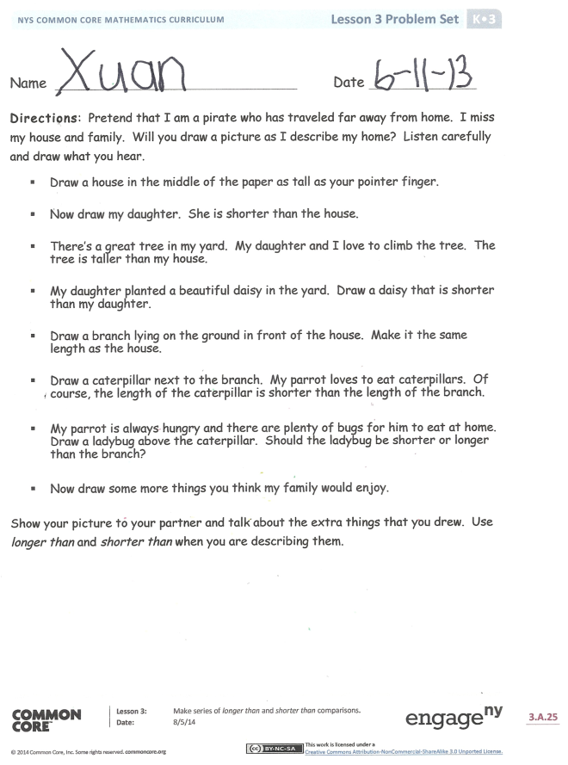
Problem Set (10 minutes)
Students should do their personal best to complete the Problem Set within the allotted time.
Read the directions carefully to the students. You may wish to use a timer to limit the sketching of each object, leaving a couple of minutes toward the end during which the students may fill in details of their drawing. Circulate during the activity to assess understanding.
Student Debrief (6 minutes)
Lesson Objective: Make a series of longer than and shorter than comparisons.
The Student Debrief is intended to invite reflection and active processing of the total lesson experience.
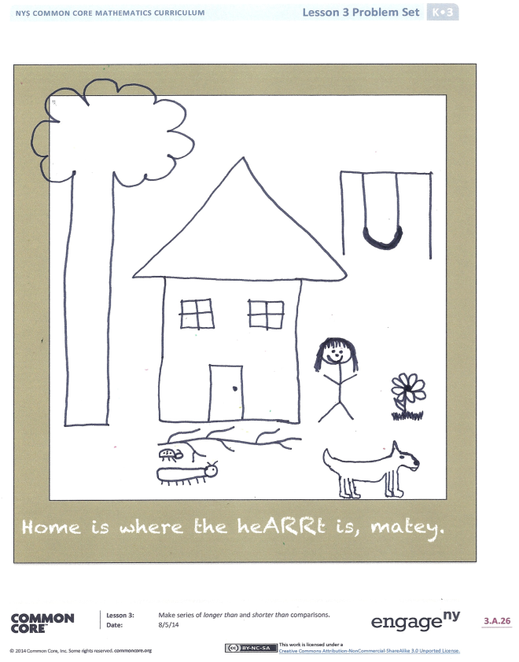
Invite students to review their solutions for the Problem Set. They should check work by comparing answers with a partner before going over answers as a class. Look for misconceptions or misunderstandings that can be addressed in the Debrief. Guide students in a conversation to debrief the Problem Set and process the lesson.
You may choose to use any combination of the questions below to lead the discussion.
- What did you notice when you changed the object you were comparing within our mystery bag activity?
- What did you think about when you were deciding how to draw the pirate’s daughter?
- What did you think about when you were deciding how to draw your caterpillar? How were the words longer than and shorter than useful when you were telling your partner about your picture?
Name Date
Directions: Pretend that I am a pirate who has traveled far away from home. I miss my house and family. Will you draw a picture as I describe my home? Listen carefully and draw what you hear.
- Draw a house in the middle of the paper as tall as your pointer finger.

- Now, draw my daughter. She is shorter than the house.

- There’s a great tree in my yard. My daughter and I love to climb the tree. The tree is taller than my house.

- My daughter planted a beautiful daisy in the yard. Draw a daisy that is shorter than my daughter.

- Draw a branch lying on the ground in front of the house. Make it the same length as the house.

- Draw a caterpillar next to the branch. My parrot loves to eat caterpillars. Of course, the length of the caterpillar is shorter than the length of the branch.

- My parrot is always hungry and there are plenty of bugs for him to eat at home. Draw a ladybug above the caterpillar. Should the ladybug be shorter or longer than the branch?

- Now, draw some more things you think my family would enjoy.

Show your picture to your partner and talk about the extra things that you drew. Use longer than and shorter than when you are describing them.
Home is where the heARRt is, matey.
Name Date
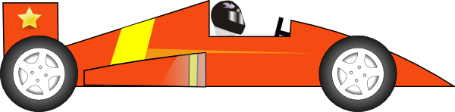
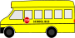
Take out a new crayon. Circle objects with lengths shorter than the crayon blue. Circle objects with lengths longer than the crayon red.

On the back of your paper, draw some things shorter than the crayon and longer than the crayon. Draw something that is the same length as the crayon.

Longer than…

Shorter than…

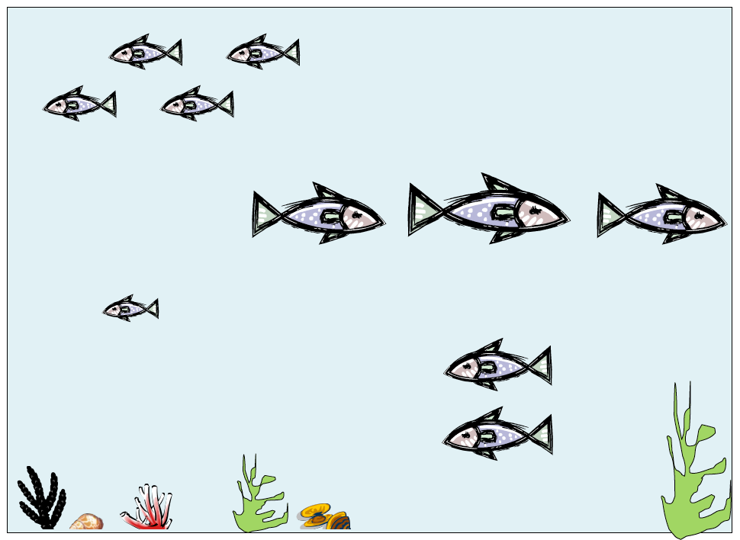

longer than and shorter than work mat
hidden numbers mat

