Lesson 2
Objective: Compare length measurements with string.

Suggested Lesson Structure
 Fluency Practice (10 minutes)
 Application Problem (5 minutes)
 Concept Development (29 minutes)
 Student Debrief (6 minutes)
Total Time (50 minutes)
Fluency Practice (10 minutes)
- Show Me Taller and Shorter K.MD.1 (3 minutes)
- Say Ten Push-Ups K.NBT.1 (3 minutes)
- Make It Equal K.CC.6 (4 minutes)
Show Me Taller and Shorter (3 minutes)
Materials: (T) Marker, crayon
Note: This activity recalls the previous lesson’s work with height, connecting to today’s work with length.
T: Let’s use our hands to show taller and shorter. For taller, we’ll do this (hold one hand above head and the other at waist level, indicating height). Show me taller.
S: (Show the hand gesture for taller.)
T: To show shorter, we’ll do this (hold hands closer than before, indicating a shorter height).
S: (Show the gesture for shorter.)
T: Let’s practice. Show me taller.
S: (Show the hand gesture for taller.)
T: Show me shorter.
S: (Show the gesture for shorter.)
Mix it up and quicken the pace to see that students understand the meaning of the vocabulary.
T: Look at my marker (hold a marker upright) and look at my crayon. Is the crayon shorter or taller?
T: Show me the gesture for taller if you think the crayon is taller. Show me the gesture for shorter if you think the crayon is shorter.
S: (Demonstrate either shorter or taller gesture.)
Use a couple more items for demonstration (book, pencil) of shorter, taller.
Say Ten Push-Ups (3 minutes)
Note: This activity extends students’ understanding of numbers to 10 in anticipation of working with teen numbers.
Conduct activity as described in Lesson 1, but now continue to ten 5.
Make It Equal (4 minutes)
Materials: (S) Bags of beans, laminated paper or foam work mat, dice
Note: Students develop a visual sense of comparison in this activity, preparing them to compare lengths of objects in this lesson.
- Teacher introduces the term equal as meaning the same number.
- Both partners roll dice, and put the same number of beans on their work mat as dots shown on the dice.
- Partner A has to make his or her beans equal to his or her partner’s by taking off or putting on more beans.
- Partner B counts to verify.
- Switch roles and play again.

NOTES ON
MULTIPLE MEANS
OF REPRESENTATION:
Highlight the critical vocabulary of taller than and shorter than for English language learners by showing a visual of the words as they are taught. This will help them follow the lesson and engage with the key concepts of the lesson. Include the words taller than and shorter than with the visual on your word wall after the lesson.
Application Problem (5 minutes)
Draw a picture of something you have seen that is very tall. Compare your picture to your friend’s. Is the item in his drawing taller than or shorter than yours? Are you sure? How can you find out?
Note: This application problem serves as a review of the vocabulary of yesterday’s lesson and allows the students to practice proper endpoint alignment in comparison. They will use this skill in today’s lesson. Circulate to ensure they are comparing accurately.
Concept Development (29 minutes)
Materials: (T) String, scissors, masking tape (S) String, scissors, clipboard, pencil, longer or shorter recording sheet (Template)
Note: Have students save their string as they will need it for their homework.
T: Today, your job will be to compare the length or height of things in our classroom to the length of a piece of string. You will each have a string of your own to use. First, I will make one for myself.
MP.5
(Cut a piece of string approximately one foot long and show it to the students. Label the string with a piece of masking tape and your initials.)
T: I want my string to be this long. Now, I want to compare it to some things in the room. Let’s make a chart. (On the board, create a quick chart as follows.)
MP.5
These things are shorter than my string.

These things are longer than my string.

T: I’m going to test a few things to show how this works. Look at my desk. (Review and model correct endpoint alignment, lining the string up on the edge of the desk.) Is my desk longer than or shorter than my string?
S: Longer.
T: Can you say, “Longer than your string”?
S: Longer than your string.
T: Let’s draw that on the chart. (Repeat with a few other examples. Model correct technique until students understand how to make precise comparisons.)
T: Now, you and your partner will help each other make your special measuring strings. Show your partner how long you would like your string to be, and then he can help you cut it. Be sure to label your strings with a piece of masking tape and your initials, because otherwise, they will look a lot alike! (Assist as necessary while students prepare their measuring tools. While it is not necessary that all of the strings be the same, encourage students to use reasonable lengths.)
T: Here are clipboards and your own charts just like the one on the board. Use your strings to compare lengths. Find at least five things that are longer than your string and at least five things that are shorter than your string. Draw them on your charts. Maybe you will discover something that is the same length as your string! If you do, draw it on the back of your sheet. (Allow time for exploration, measurement, and recording.)
T: Who would like to show and share some things that he or she discovered? Did you find any things that are almost the same length as your string? (Allow a few minutes for discussion.)
T: Put your string in your pocket or backpack. You can measure more things after school and at home tonight.
Problem Set (10 minutes)
Students should do their personal best to complete the Problem Set within the allotted time.
On this Problem Set, have students compare as many pictures as they can. For the sake of time, students could circle or just put a line of color on the object for longer or shorter to stay within the timeframe.
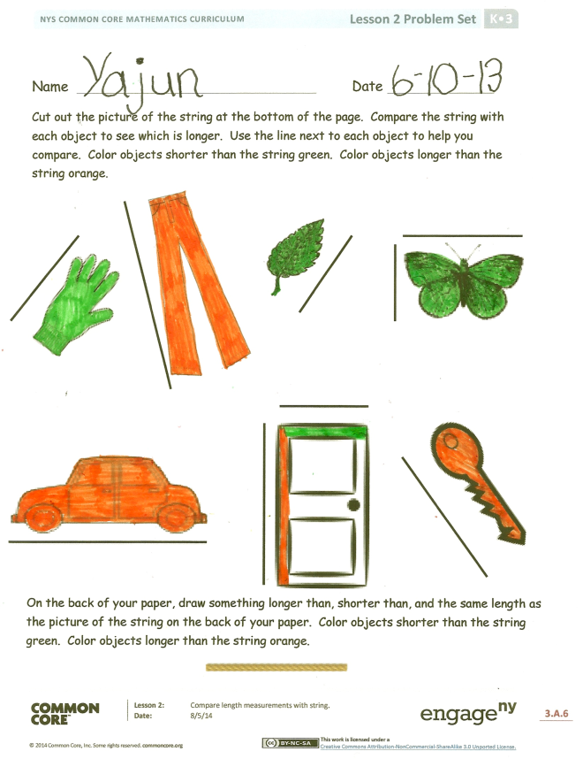
Student Debrief (6 minutes)
Lesson Objective: Compare length measurements with string.
The Student Debrief is intended to invite reflection and active processing of the total lesson experience.
Invite students to review their solutions for the Problem Set. They should check work by comparing answers with a partner before going over answers as a class. Look for misconceptions or misunderstandings that can be addressed in the Debrief. Guide students in a conversation to debrief the Problem Set and process the lesson.
You may choose to use any combination of the questions below to lead the discussion.
- What did you notice as you compared each object to the string?
- Did you do anything different as you compared the lengths? What did you need to be sure to do? Why?
- Did you predict if the string would be shorter than or longer than before you measured?
- Explain to your partner how you compared the heights. Did your partner do anything different?
- Does it matter which way you compare two objects? Why? How did you compare the string and the door?
- Did your partner find something that was longer for his string that was shorter for yours? Did she find something that was shorter for her string that was longer for yours? Why did that happen?
- What new math vocabulary did we use today to communicate precisely?
- How did the Application Problem connect to today’s lesson?

Name Date
Cut out the picture of the string at the bottom of the page. Compare the string with each object to see which is longer. Use the line next to each object to help you compare. Color objects shorter than the string green. Color objects longer than the string orange.

On the back of your paper, draw something longer than, shorter than, and the same length as the picture of the string on the back of your paper. Color objects shorter than the string green. Color objects longer than the string orange.
Name Date
Shorter than the string
Longer than the string

Using the piece of string from class, find three items at home that are shorter than your piece of string and three items that are longer than your piece of string. Draw a picture of those objects on the chart. Try to find at least one thing that is about the same length as your string, and draw a picture of it on the back.

Longer or Shorter Recording Sheet
These objects are shorter than my string.
These objects are longer than my string.

longer or shorter

