Lesson 9

Objective: Identify and sort shapes as two-dimensional or three-dimensional, and recognize two-dimensional and three-dimensional shapes in different orientations and sizes.

Suggested Lesson Structure

 Fluency Practice (10 minutes)

 Application Problem (5 minutes)

 Concept Development (25 minutes)

 Student Debrief (10 minutes)

**Total Time (50 minutes)**

Fluency Practice (10 minutes)

* Groups of Shapes (Solid Shapes) **K.G.2** (3 minutes)
* Groups of 9 K.CC.4b (3 minutes)
* Hide and See 5  **K.OA.2** (4 minutes)

Groups of Shapes (Solid Shapes) (3 minutes)

|  |  |
| --- | --- |
|  | NOTES ON  MULTIPLE MEANS  OF ACTION AND EXPRESSION: |
| Challenge above grade level students by asking them to draw two or more shapes and to construct solids that match faces of their shapes. Pair them up and ask them to challenge each other with shapes they have not drawn. | |

Note: Kinesthetic learners benefit greatly from getting up and moving in this fluency activity. As they move, they are analyzing and are encouraged to talk about how they know where to go.

Materials: (T) Signs with pictures of shapes to indicate where to form each group (S) Assortment of real world objects and wooden or plastic solid shapes

Conduct the activity as described in Lesson 5, but with solid shapes.

Groups of 9 (3 minutes)

Note: This fluency activity helps students gain efficiency in counting objects in varied configurations.

Conduct the activity as outlined in Lesson 2, but with 9. Allow students to share their strategies for making groups quickly.

Hide and See 5 (4 minutes)

Materials: (S) 5 linking cubes, personal white board

Note: In this fluency activity, students’ understanding of the conservation of a number develops into part to whole thinking at the concrete level, anticipating the work of Module 4 (number bonds, addition, and subtraction).

Conduct the activity as described in Lesson 6. Challenge students to list all possible combinations.

Application Problem (5 minutes)

Materials: (S) Small piece of paper, pencil, ball of clay

Draw one of the shapes that we have talked about this week. Can you make a solid with your clay that has the shape you drew as one of its faces? Share your work with your partner when you are done.

Note: In addition to serving as a review, this Application Problem requires students to think about the connections among flat shapes and solids in preparation for today’s Concept Development.

Concept Development (25 minutes)

Materials: (S) Cutouts from earlier in the week, including triangles, circles, rectangles, squares, and hexagons; bag of solids including a sphere, a cylinder, a cone, and a cube (Lesson 5 Template)

|  |  |
| --- | --- |
|  | NOTES ON  MULTIPLE MEANS  OF ACTION AND EXPRESSION: |
| For below grade level students who are experiencing difficulty with the sorting activity, use interactive technology to sort triangles such as the one found at <http://www.coppschool.lancsngfl.ac.uk/Classwork/Classwork/flashaids/venn_diagram.swf> and the more complex task of sorting shapes such as the one found at <http://www.coppschool.lancsngfl.ac.uk/Classwork/Classwork/flashaids/carroll_diagram.swf>. This kind of practice will help students improve their ability to recognize similarities and differences. | |

T: Take out all of your flat shapes and all of your solids and arrange them in front of you.

T: I see a lot of things on your desk! Stand up and look at your things as though you were a bird. What do you see?

S: I see flat things and solids that look like circles! 🡪 I see squares.

T: Now, bend down and look across your desk as though you were an ant. What do you notice?

S: We can only see the solid shapes. 🡪 We can’t see the flat shapes now.

T: Do you think we could sort all of the things on your desk? Take a few minutes to look at all of your objects and what things they might have in common. (Allow time for thought and experimenting.)

T: Does anyone have a sorting rule for us to try?

S: We could put all of the things with curves over here and the things that are all straight over here.

T: Good! Let’s try. (Allow time for sorting; circulate to ensure accuracy.) Show your groups to your partner. Do your groups look alike? (Allow time for discussion.)

T: Did anyone think of a different rule for sorting?

S: Shapes that roll and shapes that don’t. 🡪 Shapes that are flat and shapes that are solid.   
🡪 Shapes with edges and shapes without edges. 🡪 Shapes with faces and shapes with no faces.

T: (Continue sorting exercises and discussion for several minutes. Circulate to observe correct use of vocabulary and accuracy in grouping.)

T: Listen to my directions. I will say the name of a shape or a solid. When I do, echo me, find the object, and put it back in its bag. Then, I will pass out your Problem Sets.

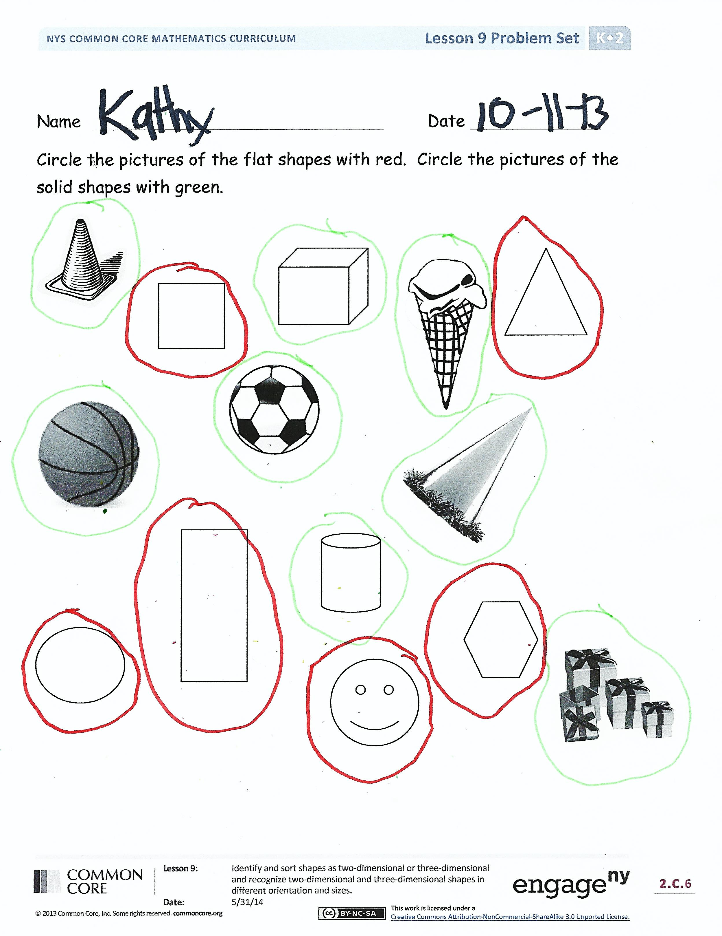Problem Set (10 minutes)

Students should do their personal best to complete the Problem Set within the allotted time.

Student Debrief (10 minutes)

**Lesson Objective:** Identify and sort shapes as two-dimensional or three-dimensional, and recognize two-dimensional and three-dimensional shapes in different orientations and sizes.

The Student Debrief is intended to invite reflection and active processing of the total lesson experience.

Invite students to review their solutions for the Problem Set. They should check work by comparing answers with a partner before going over answers as a class. Look for misconceptions or misunderstandings that can be addressed in the Debrief. Guide students in a conversation to debrief the Problem Set and process the lesson.

You may choose to use any combination of the questions below to lead the discussion.

* What new (or significant) math vocabulary did we use today to communicate precisely?
* How did you determine whether to use a red or green circle? Did someone do it another way?
* Looking at your paper, who can name a flat shape? Solid shape?
* Can you name some other flat shapes that are not on your paper? Solid shapes?
* How did the Application Problem connect to today’s lesson?

Name Date

Circle the pictures of the flat shapes with red. Circle the pictures of the solid shapes with green.



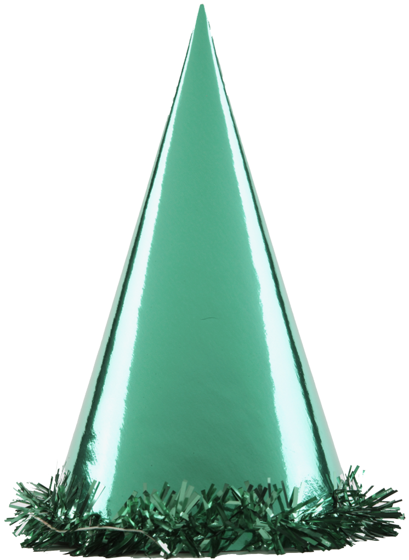



Name Date

In each row, circle the one that doesn’t belong. Explain your choice to a grown-up.