Lesson 8

Objective: Describe and communicate positions of all solid shapes using the words *above, below, beside, in front of, next to,* and *behind*.

Suggested Lesson Structure

 Fluency Practice (12 minutes)

 Application Problem (5 minutes)

 Concept Development (26 minutes)

 Student Debrief (7 minutes)

**Total Time (50 minutes)**

Fluency Practice (12 minutes)

* Position Words Game **K.G.1** (4 minutes)
* Show Me Shapes **K.G.2** (4 minutes)
* Rekenrek Roller Coaster **K.CC.4a** (4 minutes)

Position Words Game (4 minutes)

Note: As students work with position words, they are analyzing their world and their relationship to that world in space. This leads to insights about measurement and distance.

Call students to the rug with their partners. Use position words such as *above, below, beside, in front of, next to,* and *behind* to give directions for activities to do with a partner. For example, “Partner A, put your hand above Partner B’s head. Stand beside your partner. Partner B, stand in front of Partner A.”

The benefit of partner work is that they will check and correct each other, and, in the process, explain their thinking.

Show Me Shapes (4 minutes)

Note: Now that students have had the chance to really study the attributes of shapes, they should visualize each shape as they say the name of it.

Conduct the activity as outlined in Lesson 7, but now use the names of solid shapes.

Rekenrek Roller Coaster (4 minutes)

Materials: (T) 20 Rekenrek

Note: As students gain deeper understanding of the numbers in relationship to 5, the Rekenrek allows them to start building a relationship to 10 ones, as outlined in GK–M1–Lesson 23.

T: Let’s practice counting with the Rekenrek. (Show students the 20 Rekenrek with the side panel attached.) Say how many you see. (Slide the balls you want the students to count completely to one side.)

Direct the students to gradually raise their hands as the numbers increase, and to lower their hands as the numbers decrease, mimicking the motion of a roller coaster. A suggested sequence is counting up, counting down, then in short sequences, 1, 2, 3, 2, 3, 4, 3, 4, 5, 4, 3, etc. Gradually build up to 10.

Be careful not to mouth the number words or count along with the students. Listen carefully for hesitations or errors, and return to a simpler sequence if necessary. If students demonstrate mastery, consider introducing the 5-group orientation (e.g., 6 as 5 red beads on top and 1 red bead on the bottom).

Application Problem (5 minutes)

Materials: (S) Small ball of clay

Make a sphere with your ball of clay. Make your ball into a cylinder. Make your cylinder into a cube. Make your cube into a cone. Put your cone next to your partner’s. Partner A put your cone above Partner B’s.

Note: This Application Problem reviews vocabulary from yesterday’s lesson and bridges to the work of positioning solids in today’s lesson.

Concept Development (26 minutes)

Materials: (T) Set of geometric solids in a paper bag; set of flashcards in a paper bag showing the words *above, beside, below, in front of, next to,* and *behind* (S) Set of geometric solids per pair

T: We are going to play a math game today called Guess What I Am. I’m going to call on a lot of volunteers, so be ready to be mathematicians! I have two bags in front of me. Who can guess what is in my bags? (Shake bags and elicit guesses from students.)

|  |  |
| --- | --- |
|  | NOTES ON  MULTIPLE MEANS  OF REPRESENTATION: |
| English language learners will be able to participate better if the flashcards have a visual illustrating what *beside, above, in front of, next to,* and *behind* mean. This type of multiple representation will help them learn these terms more quickly. | |

T: Student A, please come up to help me. I want you to put your hand in this bag and find one of the objects, but don’t look at it! See if you can guess what it is just by feeling it. Here is a hint: It is something that we looked at yesterday. (Allow student to locate one of the solids in the bag.) Tell us about it.

**MP.3**

S: It feels smooth and round. It is a sphere!

T: Take it out of the bag. Is he right? (Yes.) Find your spheres and put them on your desks. (Allow time for pairs of students to put their spheres on their desks.)

T: Student B, would you help me next? Find something in the bag, and see if you can tell us what it is without looking. What do you feel?

S: I feel something with lots of corners. It has lots of flat sides. It is a cube!

|  |  |
| --- | --- |
|  | NOTES ON  MULTIPLE MEANS  OF ENGAGEMENT: |
| Challenge above grade level students by handing them interesting images and getting them to analyze them from shape and position with a partner. Have them present their insights in the Debrief. | |

T: Is he right? (Yes!) Now, Student B, take a card out of the other bag. (Student selects a card.) This card says *beside*. Find a cube in your bag and put it beside your sphere. Student C, it’s your turn!

**MP.3**

S: I feel something that is flat on one side and pointy on the other. It has one face. It is a cone. (Takes it out of the bag.) I’m right!

T: Now, choose a card. (Student selects a card.) The card says *above*. Find your cones and put them above the cube. Look! You made a building!

Play the game at a fast pace for several minutes or until all students have had a turn to identify a solid by touch. Put solids or cards back in the bags as often as necessary to continue the exercise. If the combinations create impossible situations, such as *put the sphere above the cone,* ask students what positional word could be used instead.

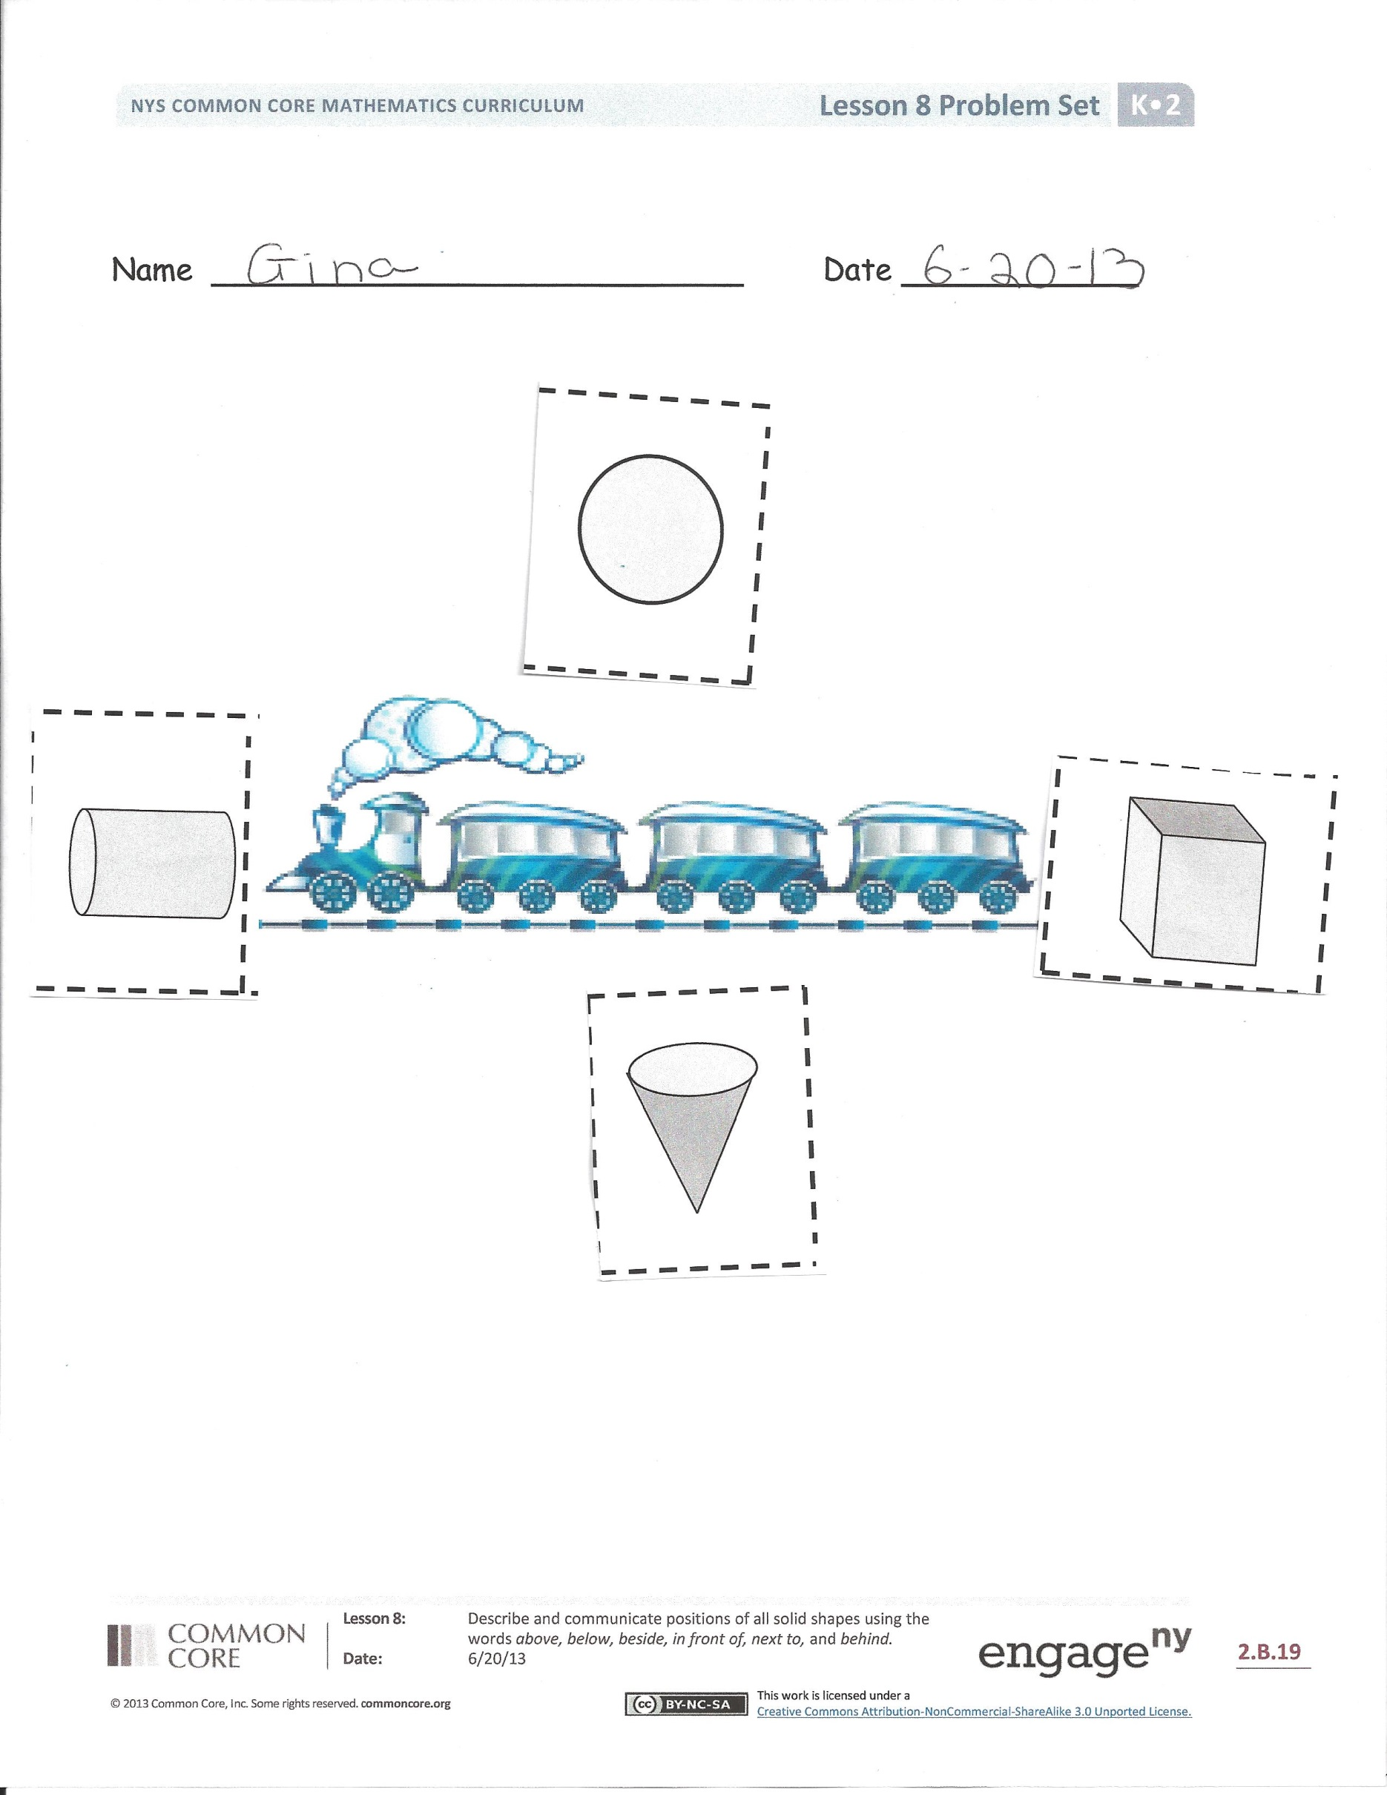T: Now, arrange the solids on your desk. You will play a similar game with your partner, but in a different way. Tell your partner, “I am the solid that is next to the cube. What am I?” When your partner guesses the solid correctly, it will be his turn to give you a riddle. (Allow students time to practice using the words of position and identifying the solids.)

T: Put your solids away in your bag. Put your bag in front of you. I will put your Problems Sets beside them.

Problem Set (10 minutes)

Students should do their personal best to complete the Problem Set within the allotted time.

Note: To extend this activity, the teacher could copy a second set of shapes and use these clues.

* Paste the shape with no faces above the train.
* Paste the shape with many faces behind the train.
* Paste the shape with two faces in front of the train.
* Paste the shape with one point below the train.

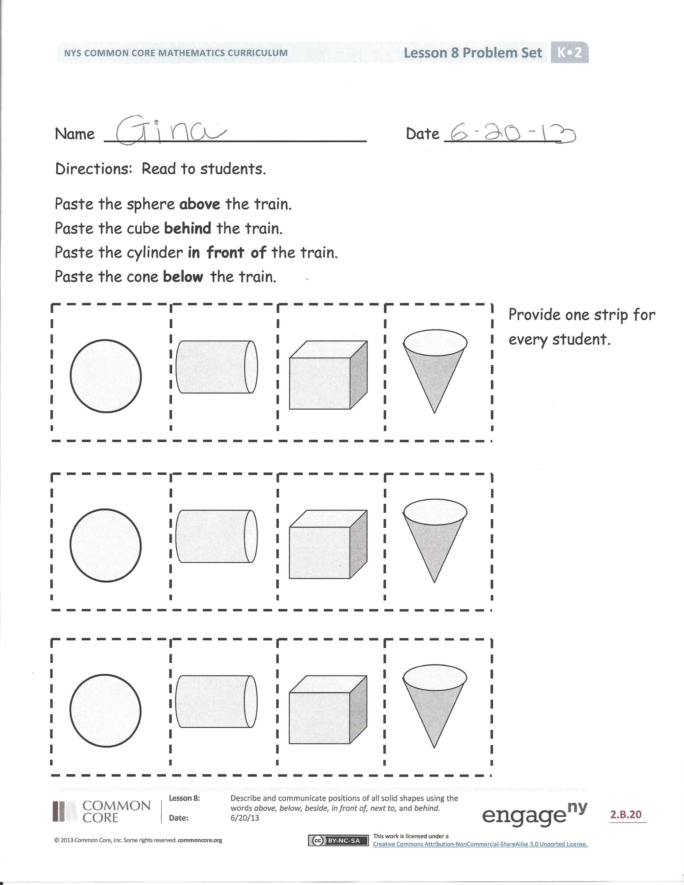Student Debrief (7 minutes)

**Lesson Objective:** Describe and communicate positions of all solid shapes using the words *above, below, beside, in front of, next to,* and *behind*.

The Student Debrief is intended to invite reflection and active processing of the total lesson experience.

Invite students to review their solutions for the Problem Set. They should check work by comparing answers with a partner before going over answers as a class.   
Look for misconceptions or misunderstandings that can be addressed in the Debrief. Guide students in a conversation to debrief the Problem Set and process the lesson.

You may choose to use any combination of the questions below to lead the discussion.

* What new (or significant) math vocabulary did we use today to communicate precisely?
* Where did you place each solid on your paper? (Go through each direction, and compare where students put their shapes on their paper.)
* Were there important words you needed to know to complete this Problem Set?
* Compare with your partner. Did you put your shapes in the same place as your partner?
* What shapes do you see on your paper?
* How did the Application Problem connect to today’s lesson?

Name Date



Name Date

Directions: Read to students.

Paste the sphere **above** the train.

Paste the cube **behind** the train.

Paste the cylinder **in front of** the train.

Provide one strip

for every student.

Paste the cone **below** the train.

Name Date

Tell someone at home the names of each solid shape.

Sphere Cylinder Cone Cube

C:\Users\store64\AppData\Local\Microsoft\Windows\Temporary Internet Files\Content.IE5\Q11W2AUA\MC900048285[1].wmf

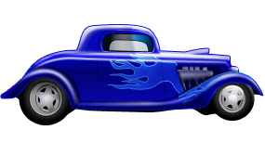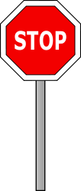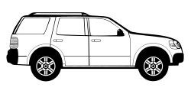

Color the car **beside** the stop sign green.

Circle the **next** car with blue.

Color the car **behind** the circled car red.

Draw a road **below** the cars.

Draw a policeman **in front of** the cars.

Draw a sun **above** the cars.