Lesson 7

Objective: Explain decisions about classification of solid shapes into categories. Name the solid shapes.

Suggested Lesson Structure

 Fluency Practice (12 minutes)

 Application Problem (5 minutes)

■ Concept Development (25 minutes)

 Student Debrief (8 minutes)

**Total Time (50 minutes)**

Fluency Practice (12 minutes)

* Show Me Shapes **K.G.2** (4 minutes)
* Making 5 with 5-Group Mats **K.OA.1** (5 minutes)
* 5-Group Hands **K.CC.2** (3 minutes)

Show Me Shapes (4 minutes)

Materials: (S) Assortment of solid shapes, possibly a mixture of everyday objects and wooden or plastic solid shapes

Note: In this activity, students continue to analyze solid shapes to gain fluency with recognizing attributes and using geometric vocabulary.

Scatter the solid shapes and objects onto the students’ tables or in the center of the rug.

T: Look at the shapes that are on the rug. I will ask you to find a certain kind of shape. When you find it, hold it up. Ready? Show me shapes that have points.

S: (Hold up cubes and cones.)

T: Yes. Put them back on the rug, and listen to what I want you to find next. Show me shapes that have no points.

S: (Hold up spheres.)

T: Yes. Now, show me shapes that have a curve.

S: (Hold up spheres, cones, and cylinders.)

Continue having students test each other so they practice the vocabulary.

Making 5 with 5-Group Mats (5 minutes)

Materials: (S) 5-group mats (Lesson 1 Fluency Template 1), 5 linking cubes

Note: In this activity, students work towards fluency with numbers within 5.

Conduct the activity as outlined in Lesson 1, but now have students rotate their mats so that they work with 5-groups in the vertical orientation.

5-Group Hands (3 minutes)

Materials: (T) Large 5-group cards (Lesson 1 Fluency Template 3)

Note: Students’ facility with their hands lays the foundation for the use of the number line.

Conduct the activity as outlined in Lesson 1, but now continue to 10. Consider showing the cards in the vertical orientation so that students can gain flexibility in locating the 5-group.

Application Problem (5 minutes)

Materials: (S) Small piece of modeling clay

|  |  |
| --- | --- |
|  | NOTES ON  MULTIPLE MEANS  OF ACTION AND EXPRESSION: |
| As the vocabulary terms *cone, face, cube, corners,* and *edges* come up in the lesson, use gestures like touching your face then the *face* of the solid as you say the word *face* in order to enrich English language learners’ experience and make it easier for them to access the content of the lesson. | |

Think about the solids you investigated yesterday. Now, listen to the riddle and make this mystery solid with your clay: I am a solid that can roll. I don’t have any corners. I have zero edges. Make me!

When you are done, show the solid to your friend. Do your solids look alike?

Note: The purpose of this problem is to remind students of the vocabulary used in yesterday’s lesson. They will need to focus on descriptions of this type in today’s lesson. It also gives kinesthetic learners a chance to manipulate the clay.

Concept Development (25 minutes)

Materials: (S) Set of geometric solids including a cube, sphere, cone, and cylinder per student pair; paper and colored pencils; small smiley face stickers

Note: In the context of polyhedra, faces must be polygonal. However, in more general contexts, a face may be circular (such as the base of a right circular cylinder), or even irregular. It is this more inclusive interpretation of face that is used in this Kindergarten module.

T: Take your solids out of your bag. We are going to look at them carefully to see if any of them have things in common. If they do, we can sort them. Does anyone have any ideas?

S: This one rolls, but these two don’t. 🡪 These both have flat sides. 🡪 These have pointy parts.

T: I hear some good ideas! We will try some of them. (Hold up a **cone**.) This solid is called a cone. What do you notice about this solid?

S: It is flat on the bottom. 🡪 There is a circle on the bottom.

T: The circle, the flat part of the cone, is called a **face**. Take a smiley sticker and put it on the face of the cone. Do you have other solids that have faces?

S: This one! (Holds up a **cube**.)

T: Yes, that solid has many faces! It is called a cube. Put a smiley sticker on each face of the cube. How many faces does it have? (Continue to hold up the solids and mark faces, counting the faces of each. Introduce the students to the names of each of the solids.)

**MP.7**

T: Can we sort our solids into groups of those with a face and those without?

S: Yes! (Sort the solids. Name the **sphere** and **cylinder**.)

Guide children to sort solids several times by other criteria, for example, those that roll and those that only slide, those that can stack and those that cannot, those that have corners, those that have edges, those that look like circles from above, and so on. As you monitor students sorting, use and encourage correct vocabulary to reinforce learning.

T: Which of your solids has the most faces?

|  |  |
| --- | --- |
|  | NOTES ON  MULTIPLE MEANS  OF ACTION AND EXPRESSION: |
| Facilitate struggling students’ talk by providing them with various sentence frames such as, “These two solids are the same because they have…” and, “This one rolls, but this one just….” Encourage them to use the names of the solids. | |

S: The cube.

T: Put your cube on one of its faces onto your piece of paper. Use your favorite colored pencil to trace around the solid. Now, lift your solid. What do you see underneath?

S: A square.

T: The face of the cube is a flat square. I wonder what would happen if you traced the face of your cone? (Allow students to try.)

S: It makes a circle.

T: Should we trace a face of the cylinder?

S: Yes! It makes a circle too.

T: Trace the faces of any of your objects to make shape designs on your paper. (Allow time for tracing and discussion.)

T: Put your solids away. Would anyone like to share their Trace the Face picture, and tell us how the shapes are the same and how they are different?

Problem Set (10 minutes)

Students should do their personal best to complete the Problem Set within the allotted time.

Student Debrief (8 minutes)

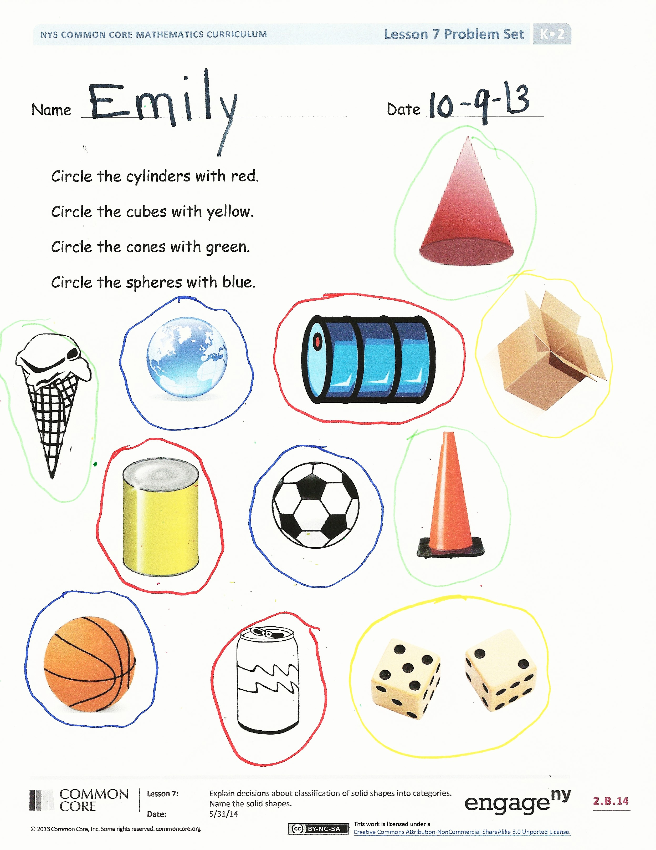**Lesson Objective:** Explain decisions about classification of solid shapes into categories. Name the solid shapes.

Invite students to review their solutions for the Problem Set. They should check work by comparing answers with a partner before going over answers as a class. Look for misconceptions or misunderstandings that can be addressed in the Debrief. Guide students in a conversation to debrief the Problem Set and process the lesson.

You may choose to use any combination of the questions below to lead the discussion.

* Which objects did you circle that were **cylinders**? (**Cubes**, **cones**, and **spheres**.)
* What did you need to remember when you were finding the cylinders to circle? (Cubes, cones, and spheres.) Did anyone think of something else?
* What new (or significant) math vocabulary did we use today to communicate precisely? (Emphasize **faces**, corners, and edges.)
* How can you tell about each shape without using the shape’s name?
* How did the Application Problem connect to today’s lesson?
* What were some different ways we sorted our shapes?

Name Date

Circle the cylinders with red.

Circle the cubes with yellow.

Circle the cones with green.

Circle the spheres with blue.

[](http://openclipart.org/detail/82747/brown-cone-by-mireille)

C:\Users\store64\AppData\Local\Microsoft\Windows\Temporary Internet Files\Content.IE5\Q11W2AUA\MC900197504[1].wmf







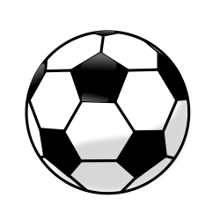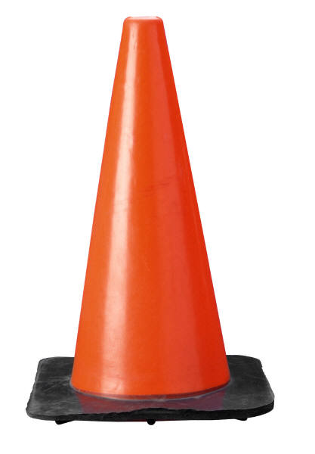

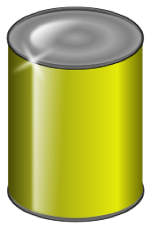

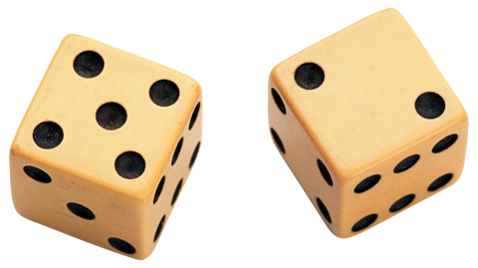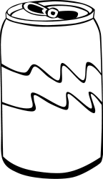

Name Date

Cut one set of solid shapes. Sort the 4 solid shapes. Paste onto the chart.

These have corners.

These do not have corners.

Cut the other set of solid shapes and make a rule for your sort. Paste onto the chart.

[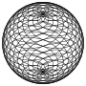](http://openclipart.org/detail/177257/spiral-sphere-1-by-jarda-177257)