Lesson 6
Objective: Find and describe solid shapes using informal language without naming.

Suggested Lesson Structure
 Fluency Practice (12 minutes)
■ Application Problem (5 minutes)
■ Concept Development (25 minutes)
 Student Debrief (8 minutes)
Total Time (50 minutes)
Fluency Practice (12 minutes)
- Beep Number K.CC.4a (4 minutes)
- Hide and See 5 K.OA.2 (4 minutes)
- Take Apart Groups of Circles K.OA.1 (4 minutes)
Beep Number (4 minutes)
Note: This fluency activity ensures that students gain flexibility with number order in both directions on the number line.
Materials: (T) Personal white board (optional) (S) Number path (Fluency Template) (optional)
T: Let’s play Beep Number! Listen carefully while I count. Instead of saying a number, I’ll say beep. You can touch each number on your number path as I say it. When you know what the beep number is, raise your hand. 5, beep, 7! (Wait until all hands are raised, then give the signal.)
S: 6!
T: (Turn over the personal board to reveal the number 6 so that students can verify that their answer was correct.)
T: 7, beep, 5! (Wait until all hands are raised, then give the signal.)
S: 6!
T: (Turn over the personal board to reveal the number 6.)
Continue in a thoughtful sequence, intermingling counting up and counting down. Return to a simpler sequence if students have difficulty.
The teacher’s use of the personal white board is optional, but it can increase engagement, as students perceive the number as secret. Initially, students may rely heavily on the number path in order to determine the missing number. Challenge students to solve mentally when they are ready.
Hide and See 5 (4 minutes)
Materials: (S) 5 linking cubes, personal white board
Note: In this activity, students’ understanding of conservation of a number develops into part to whole thinking at the concrete level, anticipating the work of Module 4 (number bonds, addition, and subtraction).
Materials: (S) 5 linking cubes
T: Touch and count your cubes.
S: 1, 2, 3, 4, 5.
T: Hide 2 behind your back. How many can you see?
S: 3.
T: Put them back together. How many cubes do you have?
S: 5.
T: Hide 1 behind your back. How many can you see?
S: 4.
T: Put them back together. How many cubes do you have?
S: 5.
Variation: As students put the cubes together, they can write the expressions on their personal white boards. Challenge students to list all possible combinations.
Take Apart Groups of Circles (4 minutes)
Materials: (S) Personal white board
Note: In order to meet the goal of adding and subtracting fluently within 5, students need to begin practicing early and regularly.
T: Draw three circles on your board. (Wait for students to do this.) Put an X on two of them. How many circles have an X?
S: 2.
T: How many circles do not have an X?
S: 1.
T: How many circles are on your board?
S: 3.
T: Raise your hand when you can say the number sentence starting with 2. (Wait for all students to raise hands, and then signal.) Ready?
S: 2 and 1 make 3.
T: Very good. Let’s go a little faster now. Erase. Draw four circles on your board. (Wait for students to do this.) Put an X on three of them. (Wait.) How many do not have an X?
S: 1.
T: Raise your hand when you can say the number sentence starting with 3. (Wait for all students to raise hands, and then signal.) Ready?
S: 3 and 1 make 4.
Continue working through problems within 5. Alternatively, students can write the equation when 3 is the total, and the expressions when 4 or 5 is the total.
Application Problem (5 minutes)
Have students work with a partner. Give each set of students a small ball and a cube.
We are going to do a test. Take turns with your partner. Roll the ball back and forth between you a few times. Watch the ball carefully as it rolls. Now, try to roll the block between you. Talk to your partner about what happens. Why do you think the objects behave so differently? What would be the best way to get the block to your partner? Why do most cups have a circle on the bottom but don’t roll off the table?
Note: This Application Problem requires students to start thinking about the differences between balls and cubes in preparation for today’s lesson.
Concept Development (25 minutes)
Preparation: As with the hexagons, prior to the lesson, strategically place some extra examples of the geometric solids around the classroom if they are not already present. Suggestions include party hats, cans, snow cone cups, drums, and boxes.
Materials: (S) 1 bag containing a set of geometric solids per student pair (solids should include a cone, a cylinder, a cube, and a sphere), clipboard, paper, pencil, real or toy magnifying glass (if available)
T: I have something new for you to explore today! You will be working with your partner. Please take everything out of your bag. I will give you a few minutes to look and talk with your partner about what you notice.

NOTES ON
MULTIPLE MEANS
OF REPRESENTATION:
To help English language learners, introduce key vocabulary like flat, solid, edges, corners, sides, points, curves, and solids days before you teach the lesson. Post these terms on the word wall with visuals or a concrete example of each.

S: (Allow three minutes for free exploration and discussion time.)
T: Place your things on your desk. Stand up and look down at them as though you were a bird. What do you notice?
S: From up here, this one looks like a square! This one looks like a circle. From here, these two look alike.
T: Now pretend that you are an ant. Bend down and look from eye level across the top of your desk. When we did this with your flat shapes, you said you couldn’t see them anymore. What happens this time?
S: They stick up! Now, I see a triangle. They are not flat.
T: You’re right. They are not flat. We call these solids. Find the solid that looks like this. (Hold up the sphere). Tell me about this solid.
S: It looks like a ball. It is round.

NOTES ON
MULTIPLE MEANS
OF REPRESENTATION:
Students working below grade level might benefit from using interactive technology such as the one found at http://www.brainpopjr.com/math/geometry/solidshapes/search/, where they are challenged to sort solids and two-dimensional shapes.

T: (Hold up the cube.) Look at this solid. Find the one that looks like it on your desk. How is it different? (Continue examining the solids until students have had a chance to describe them all. Encourage the students to use language such as edges, corners, sides, points, and curves in their discussion.)
MP.6
T: Put your shapes back in the bag. Take out your detective materials. You and your partner are going to hunt for these shapes around our classroom. When you find one, draw it on your paper. (Allow students five minutes to identify some of the solids in the environment.)
T: Please return to your seats. Would anyone like to show and share about what they found? (Allow time for discussion and sharing.) We will find some more solids on our Problem Set.
Problem Set (10 minutes)
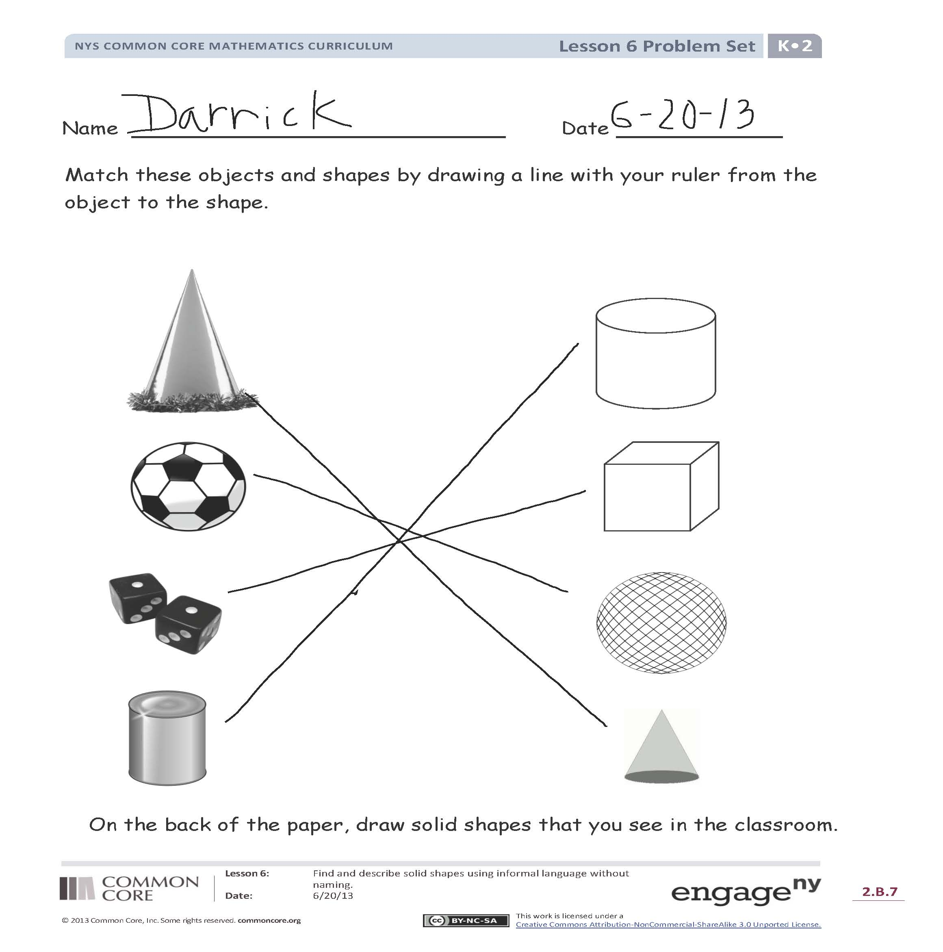
Students should do their personal best to complete the Problem Set within the allotted time.
Note: If students finish early, have them draw solid shapes that they see around them.
Student Debrief (8 minutes)
Lesson Objective: Find and describe solid shapes using informal language without naming.
The Student Debrief is intended to invite reflection and active processing of the total lesson experience.
Invite students to review their solutions for the Problem Set. They should check work by comparing answers with a partner before going over answers as a class. Look for misconceptions or misunderstandings that can be addressed in the Debrief. Guide students in a conversation to debrief the Problem Set and process the lesson.

You may choose to use any combination of the questions below to lead the discussion.
- What solids did you match that were curved? What solids did you match that were not curved?
- Which shapes were the hardest to match? Why?
- Explain to your partner what you drew on the back of your paper. Can you think of other objects around you that are these solid shapes? Have a volunteer (or two) share their drawings.
- What new (or significant) math vocabulary did we use today to communicate precisely? How can you tell about each solid without using the solid’s name?
- How did the Application Problem connect to today’s lesson?

Name Date
Match these objects and solids by drawing a line with your ruler from the object to the solid.

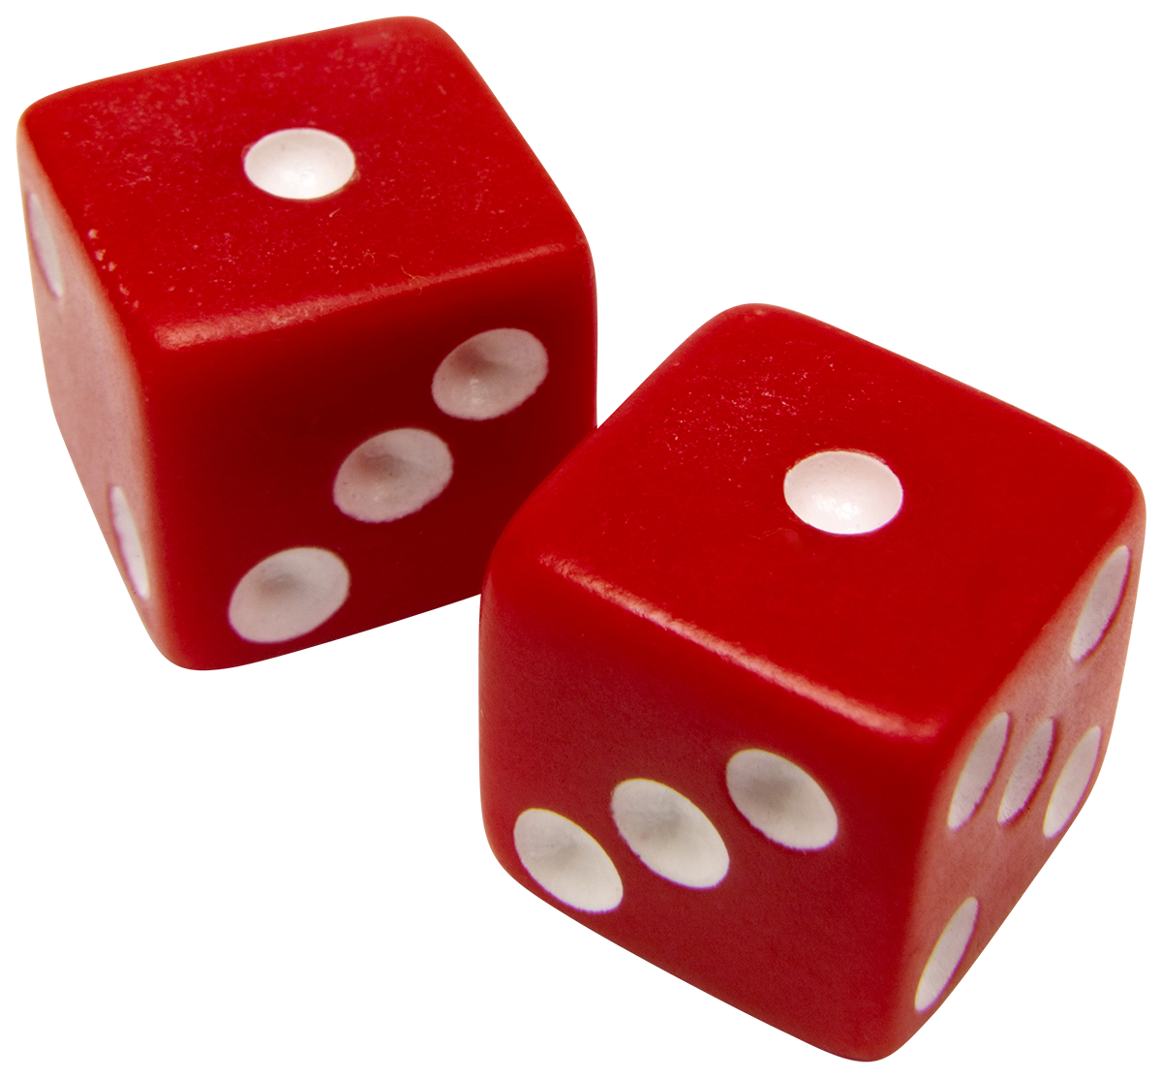
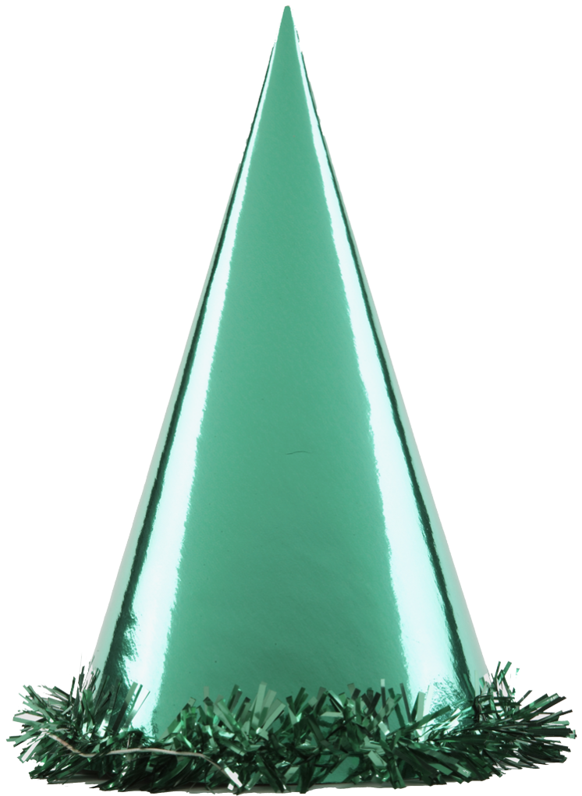

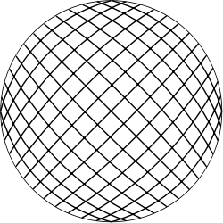

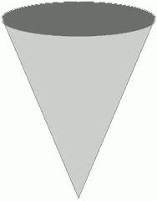
On the back of the paper, draw solid shapes that you see in the classroom.
Name Date
Find things in your house or in a magazine that look like these solids. Draw the solids or cut out and paste pictures from a magazine.

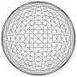

1 | 2 | 3 | 4 | 5 | 6 | 7 | 8 | 9 | 10
1 | 2 | 3 | 4 | 5 | 6 | 7 | 8 | 9 | 10
1 | 2 | 3 | 4 | 5 | 6 | 7 | 8 | 9 | 10
1 | 2 | 3 | 4 | 5 | 6 | 7 | 8 | 9 | 10

number path

