Lesson 5
Objective: Describe and communicate positions of all flat shapes using the words above, below, beside, in front of, next to, and behind.

Suggested Lesson Structure
 Fluency Practice (12 minutes)
 Application Problem (5 minutes)
 Concept Development (25 minutes)
 Student Debrief (8 minutes)
Total Time (50 minutes)
Fluency Practice (12 minutes)
- Groups of Shapes K.G.2 (5 minutes)
- Peek-a-Boo Shapes K.G.2 (3 minutes)
- Groups of 8 K.CC.4b (4 minutes)
Groups of Shapes (5 minutes)
Materials: (T) Signs with pictures of shapes to indicate where to form each group (Fluency Template 1)
(S) Paper cutouts of triangles, rectangles, squares, hexagons, and circles (variety of sizes, include exemplars, non-examples, and variants) (Fluency Template 2)
Note: In this fluency activity, students bring together their insights from Lessons 1–4 to form groups, each defined by a shape. This will allow teachers to also use shapes as part of their classroom management techniques, which will further embed geometry into the classroom culture.
T: Choose a shape from your pile, and then meet me at the rug.
T: Look at your shape. Raise your hand if you know the name of your shape. When I give the signal, whisper the name of your shape to yourself. Ready?
T: Look around the room. Do you see signs with pictures of shapes?
S: Yes.
T: Do you see your shape?
S: Yes.
T: When I start the music, I want you to calmly walk to the sign that has the same shape as yours.
T: When I point to your group, say the name of your shape. (Point to the group of triangles.)
S: Triangles.
Continue identifying the remaining groups, and then call students back to the rug to trade for a new shape. Circulate to see which students struggle with this task. Support them by having them identify the attributes of their shape and compare it to the shapes pictured on the signs.
Peek-a-Boo Shapes (3 minutes)
Materials: (T) Paper cutouts of triangles, rectangles, squares, hexagons, and circles (variety of sizes, include exemplars, non-examples, and variants), pictures of real world objects that are flat shapes (Fluency Template 3)
Note: With the teacher hiding the shapes, students get accustomed to visualizing, a skill they will be applying to numbers, for example, with dot cards. This is an imperative step in number sense. It is a significant moment when students realize they can make a mental picture of something.
One shape at a time, show students each shape briefly. Then, take the shape out of view. Remind students beforehand that they are to use the listen, think, raise your hand, wait for the snap procedure to name the shape in choral response. Start with easy shapes to build confidence, and then steadily increase the level of difficulty.
Groups of 8 (4 minutes)
Note: This fluency activity helps students gain efficiency in counting objects in varied configurations.
Conduct the activity as outlined in Lesson 2, but with 8. Allow students to share their strategies for making groups quickly.
Application Problem (5 minutes)
Work with your partner. Stand somewhere in the classroom so that you are facing a wall, but your partner is facing the other way. Tell your partner several things that you think are behind you in the room. Have him look to see if you are right. When you are done, switch places with your partner.
Note: Behind is a preposition with which most children are very familiar. Introducing newer directional concepts with this familiar word will set the stage for learning in the lesson today.
Concept Development (25 minutes)
Materials: (S) Scissors, glue, paper bag containing cutouts of various shapes (two non-identical shapes of each type including triangles, rectangles, circles, hexagons, and squares) (Template)
The following are suggestions:

T: You have new mystery bags! Carefully shake your shapes onto your desk. Work with your partner and say the name of each shape.

NOTES ON
MULTIPLE MEANS
OF ACTION AND EXPRESSION:
English language learners will be more successful in following Simon Says directions if shown concrete visual examples with the directions. For example, say, “Hold up a shape that has four corners,” while pointing to a picture of a corner.

S: (Sort out and arrange shapes.)
T: (Allow time for sharing and discussion.) Let’s play Simon Says! I will describe a shape to you. If I say “Simon says!” find the shape, hold it up, and freeze. Then, listen carefully while I describe a new shape. Find the new shape only if I say, “Simon says!” If I don’t, stay frozen.
T: Simon says, hold up a shape that has four corners. Simon says, hold up a shape that has no straight sides. Simon says, hold up a shape that has one more than five sides. Hold up the shape that has four sides which are exactly the same.
MP.6

NOTES ON
MULTIPLE MEANS
OF REPRESENTATION:
Support students who struggle by partnering key words such as next to, below, above, and below with modeling the actions for them.

S: You didn’t say “Simon says!”
T: (Continue several times until students show fluency in identifying the correct shapes.)
T: Now, put all of your shapes in a row on the top of your desk. We are going to play our game a different way.
I am going to ask you to arrange your shapes in certain ways. Listen carefully, and don’t forget to listen for “Simon says!”
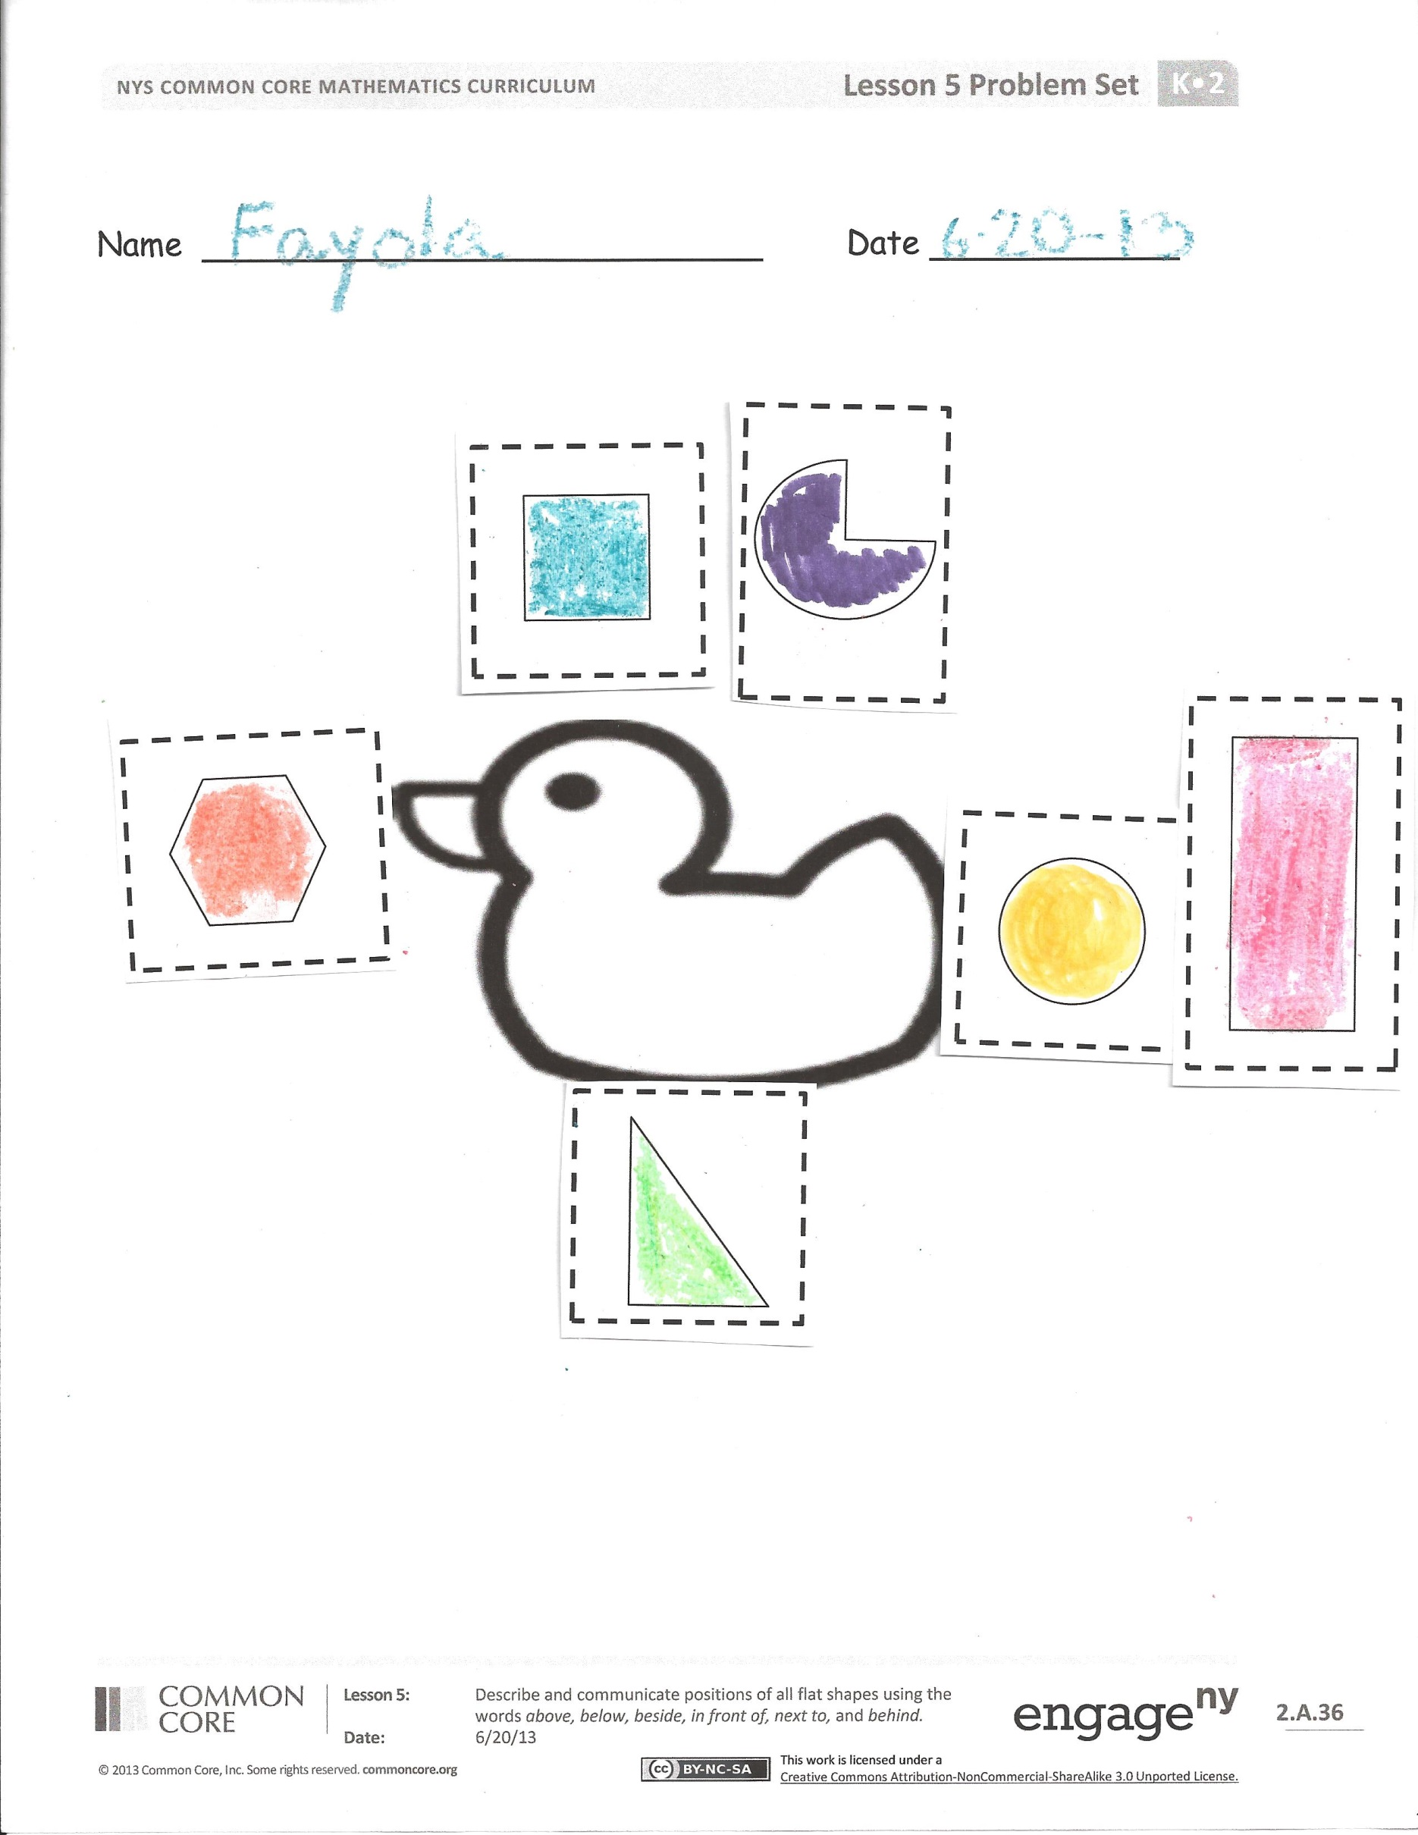
T: Simon says, put a shape with one less than four sides in the middle of your desk. Simon says, put a shape made with a curved line beside that shape. Simon says, put a shape with only one
L-corner next to the shape with a curved line. Put a shape with six corners next to that shape.
I didn’t say “Simon says!” (Play several more times.)
T: Simon says, put a curved shape below your chair. Simon says, hold your square above your head. Simon says, hold it behind your friend. Put a square in front of you!
S: You didn’t say “Simon says!”
T: Put your shapes in the bag. We are going to practice more words like below, above, and beside in our Problem Set.

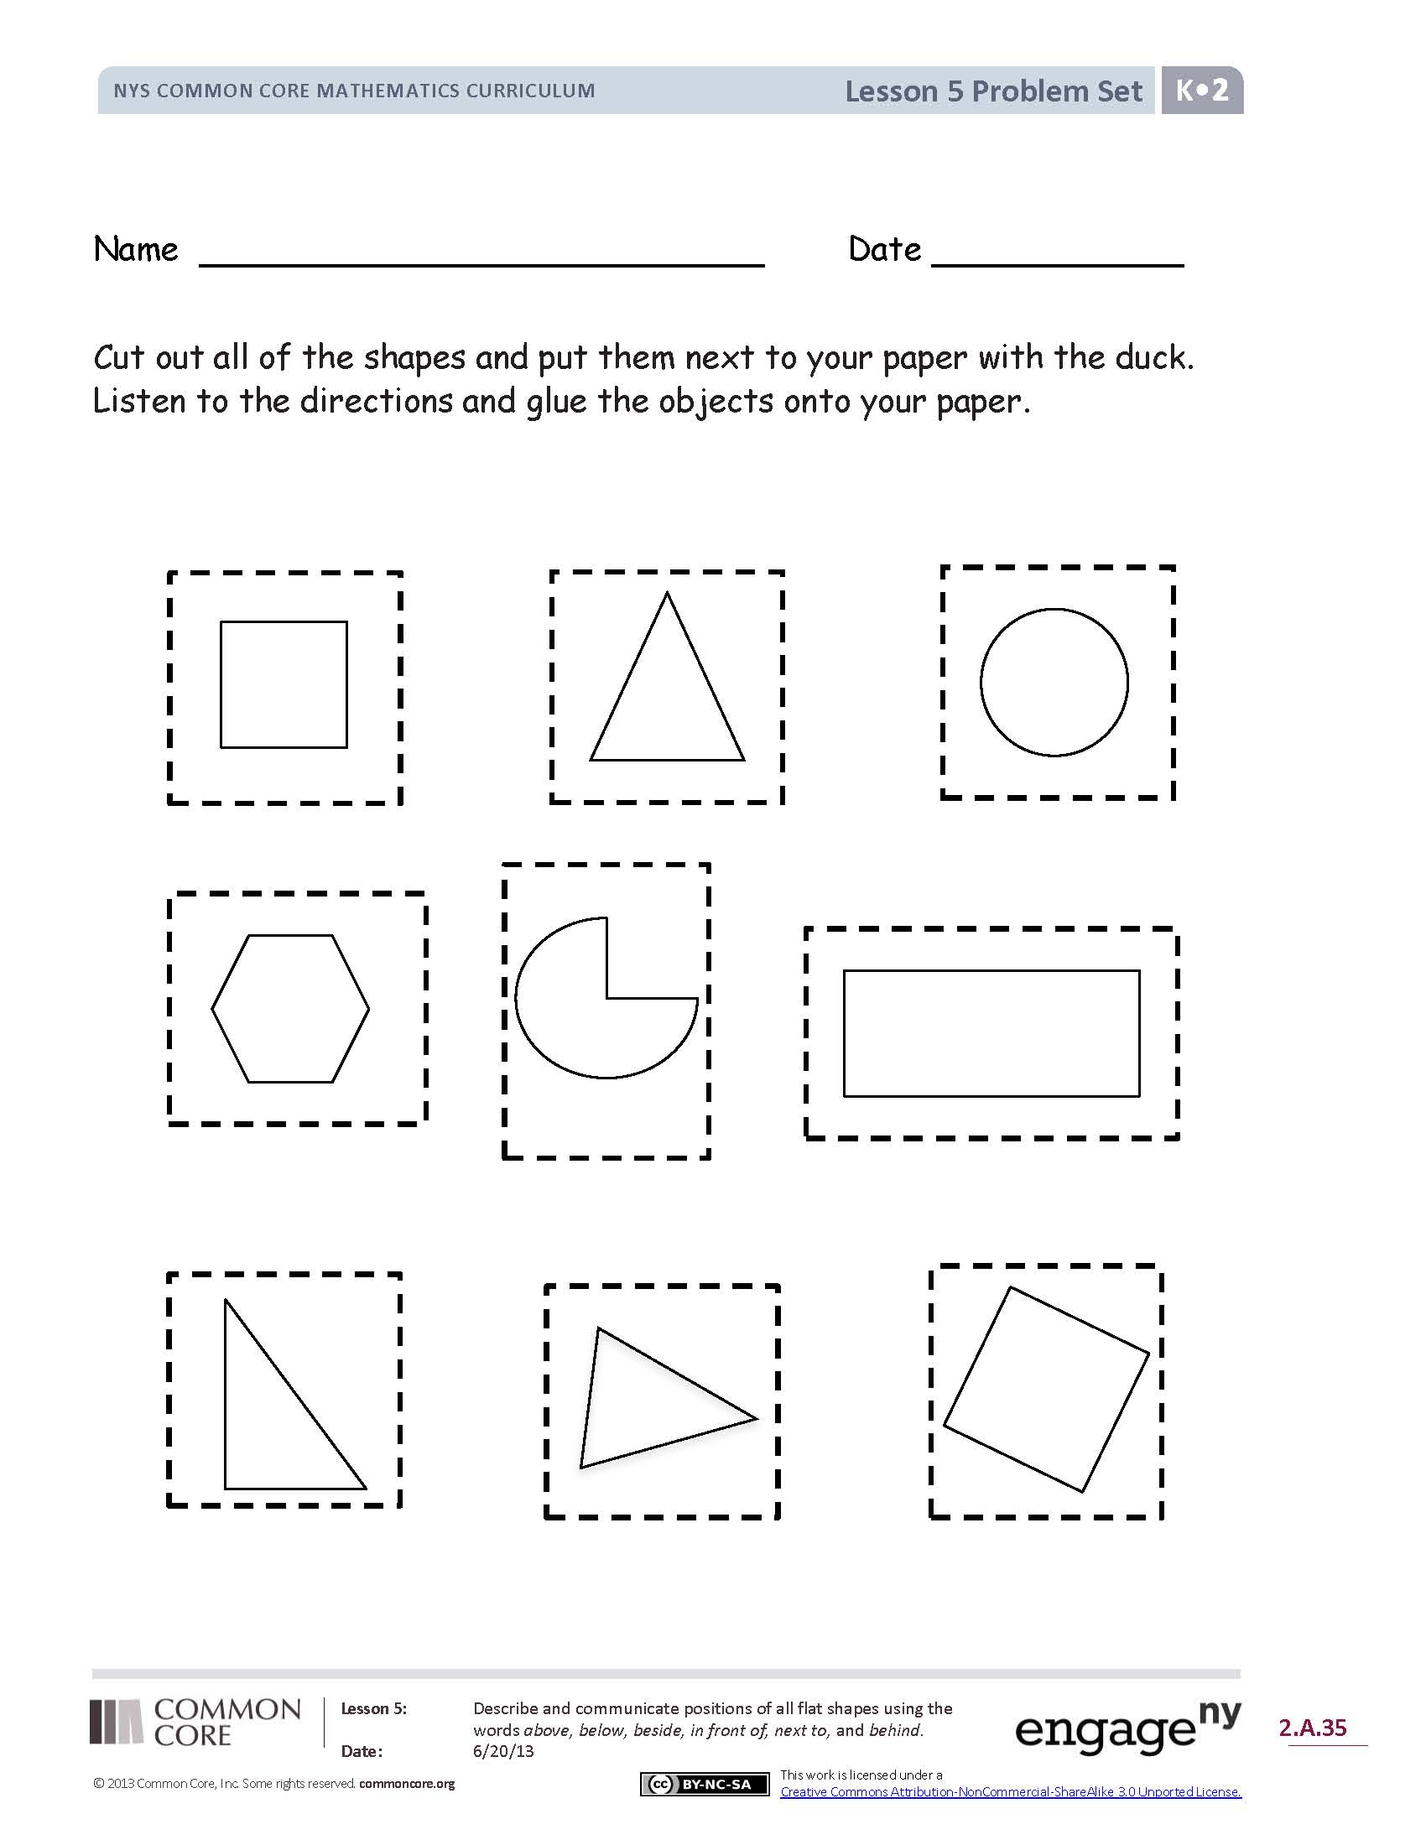
Problem Set (10 minutes)
Students should do their personal best to complete the Problem Set within the allotted time.
In this Problem Set, students should begin by cutting out the shapes and lining them next to the duck sheet.
Note: Students will not use all cutout shapes in the Problem Set.
Read the directions for the Problem Set, and then circulate as students work to see if they have mastered the names of the shapes.
- Find the shape with four straight sides that are exactly the same. Color it blue. Glue the shape above the duck.
- Find the shape with no corners. Color it yellow. Glue the shape behind the duck.
- Find the shape with three straight sides. Color it green. Glue the shape below the duck.
- Find the shape with four sides. Two sides are long and the same length, and two sides are short and the same length. Color it red. Glue the shape beside the circle.
- Find the shape with six corners. Color it orange. Glue the shape in front of the duck.
- Find the shape with curves and corners. Color it purple. Glue the shape next to the square.
Student Debrief (8 minutes)
Lesson Objective: Describe and communicate positions of all flat shapes using the words above, below, beside, in front of, next to, and behind.
The Student Debrief is intended to invite reflection and active processing of the total lesson experience.
Invite students to review their solutions for the Problem Set. They should check work by comparing answers with a partner before going over answers as a class. Look for misconceptions or misunderstandings that can be addressed in the Debrief. Guide students in a conversation to debrief the Problem Set and process the lesson. You may choose to use any combination of the questions below to lead the discussion.
- What new (or significant) math vocabulary did we use today to communicate precisely?
- How did you place each object on your paper? Go through each direction (above, below, in front of, next to, and behind), and compare where students put their objects on their paper.
- Compare with your partner. Did you put your shapes in the same place as your partner?
- What shapes do you see on your paper? How did you know they were those shapes?
- How did the Application Problem connect to today’s lesson?

Name Date
Cut out all of the shapes, and put them next to your paper with the duck.
Listen to the directions, and glue the objects onto your paper.

Name Date

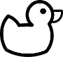

Name Date
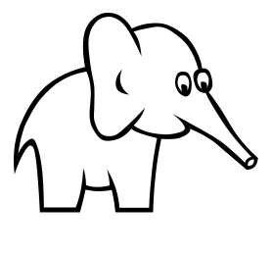

- Behind the elephant, draw a shape with 4 straight sides that are exactly the same length. Color it blue.
- Above the elephant, draw a shape with no corners. Color it yellow.
- In front of the elephant, draw a shape with 3 straight sides. Color it green.
- Below the elephant, draw a shape with 4 sides, 2 long and 2 short. Color it red.
- Below the elephant, draw a shape with 6 corners. Color it orange.

On the back of your paper draw 1 hexagon and 4 triangles.
How many shapes did you draw? Put your answer in the circle.

triangle

rectangle
square

hexagon

circle

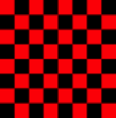
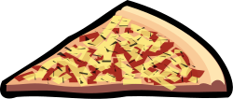

signs
signs
signs
shapes
shapes
shapes

