Lesson 4
Objective: Explain decisions about classifications of hexagons and circles, and identify them by name. Make observations using variants and non-examples.

Suggested Lesson Structure
 Fluency Practice (12 minutes)
 Application Problem (5 minutes)
 Concept Development (25 minutes)
 Student Debrief (8 minutes)
Total Time (50 minutes)
Fluency Practice (12 minutes)
- Rectangle or Not K.G.2 (3 minutes)
- Make a Shape K.G.4 (4 minutes)
- Groups of 7 K.CC.4b (5 minutes)
Rectangle or Not (3 minutes)
Materials: (T) Paper shapes of the same color in varying sizes, a wide range of exemplars, non-examples, and variants (Fluency Template)
Note: This is a preparatory fluency activity intended to review the previous lesson’s work with rectangles and prepare students to name and identify hexagons and circles in a similar manner.
This is similar to Lesson 3, but with rectangles.
Identify shapes as rectangles or not rectangles, from simple to complex, by starting with the exemplar of each shape, then the non-examples, and then the variants.
Make a Shape (4 minutes)
Note: This activity is repeated with a new shape, allowing students to focus on the new component, the hexagon, rather than the logistics of the activity itself.
Conduct the activity as outlined in Lesson 2, but this time include hexagons without naming.

Groups of 7 (5 minutes)
Note: This maintenance activity supports efficiency in counting objects in varied configurations.
Conduct the activity as outlined in Lesson 2, but with 7. Allow students to share their strategies for making groups quickly.
Application Problem (5 minutes)
Using only triangles and rectangles, design a rocket ship on your paper. Trade rocket ships with your partner. Count how many triangles and rectangles you see in his picture. Did you use the same number of each shape?
Note: This problem is designed as a review exercise prior to the introduction and definition of two new shapes in today’s lesson.
Concept Development (25 minutes)
Preparation: While many objects in classrooms have a circular shape, hexagons in the classroom environment usually must be engineered. Strategically place several cutout or outlined shapes of regular and irregular hexagons around the room prior to the lesson. You may wish to include a few different hexagons constructed on geoboards or on dot paper.
Create outlines of geometric figures on paper to be affixed to the board during the lesson. Shapes should include, but not be limited to, those illustrated below:

Materials: (T) Paper shapes (Template) (S) Clipboard with paper and pencil, real or toy magnifying glass (if available)
T: We have talked about triangles, rectangles, and squares, and you have made many of these yourselves. Here are some new shapes for you to look at today.
Sort shape outlines to make a group of hexagons and then circles in the same manner as in Lessons 2 and 3. As in previous lessons, begin the discussion with exemplar shapes to guide the students as they discover each shape’s defining characteristics. As sorting continues, guide them to realize that a hexagon is a closed flat shape with six straight sides and that a circle is a flat, closed, curved shape with no straight sides.
Note: Students can become frustrated as they attempt to articulate the difference between a circle and an oval. Though they may not be able to describe the concept of equidistance from a center, they can tell you that if they had a race car, they would rather have wheels in the shape of a circle than in the shape of an oval. “Circles can roll better!” “They are not squished!”
T: We are going to have another detective hunt today. You and your partner will search for these shapes in the classroom. Use your clipboards and detective equipment, and draw any circles and hexagons that are hiding! (Allow students to investigate for five minutes before they return to their seats.)

A NOTE ON
MULTIPLE MEANS
OF REPRESENTATION:
Once the vocabulary words hexagon and circle have been introduced, post these on the word wall with a visual of a circle and many different examples of hexagons.
MP.1
T: Would anyone like to show and share one of the circles or hexagons they found in the classroom today? How is your circle or hexagon different from the other shapes we’ve learned? (Allow time for sharing and discussion.)
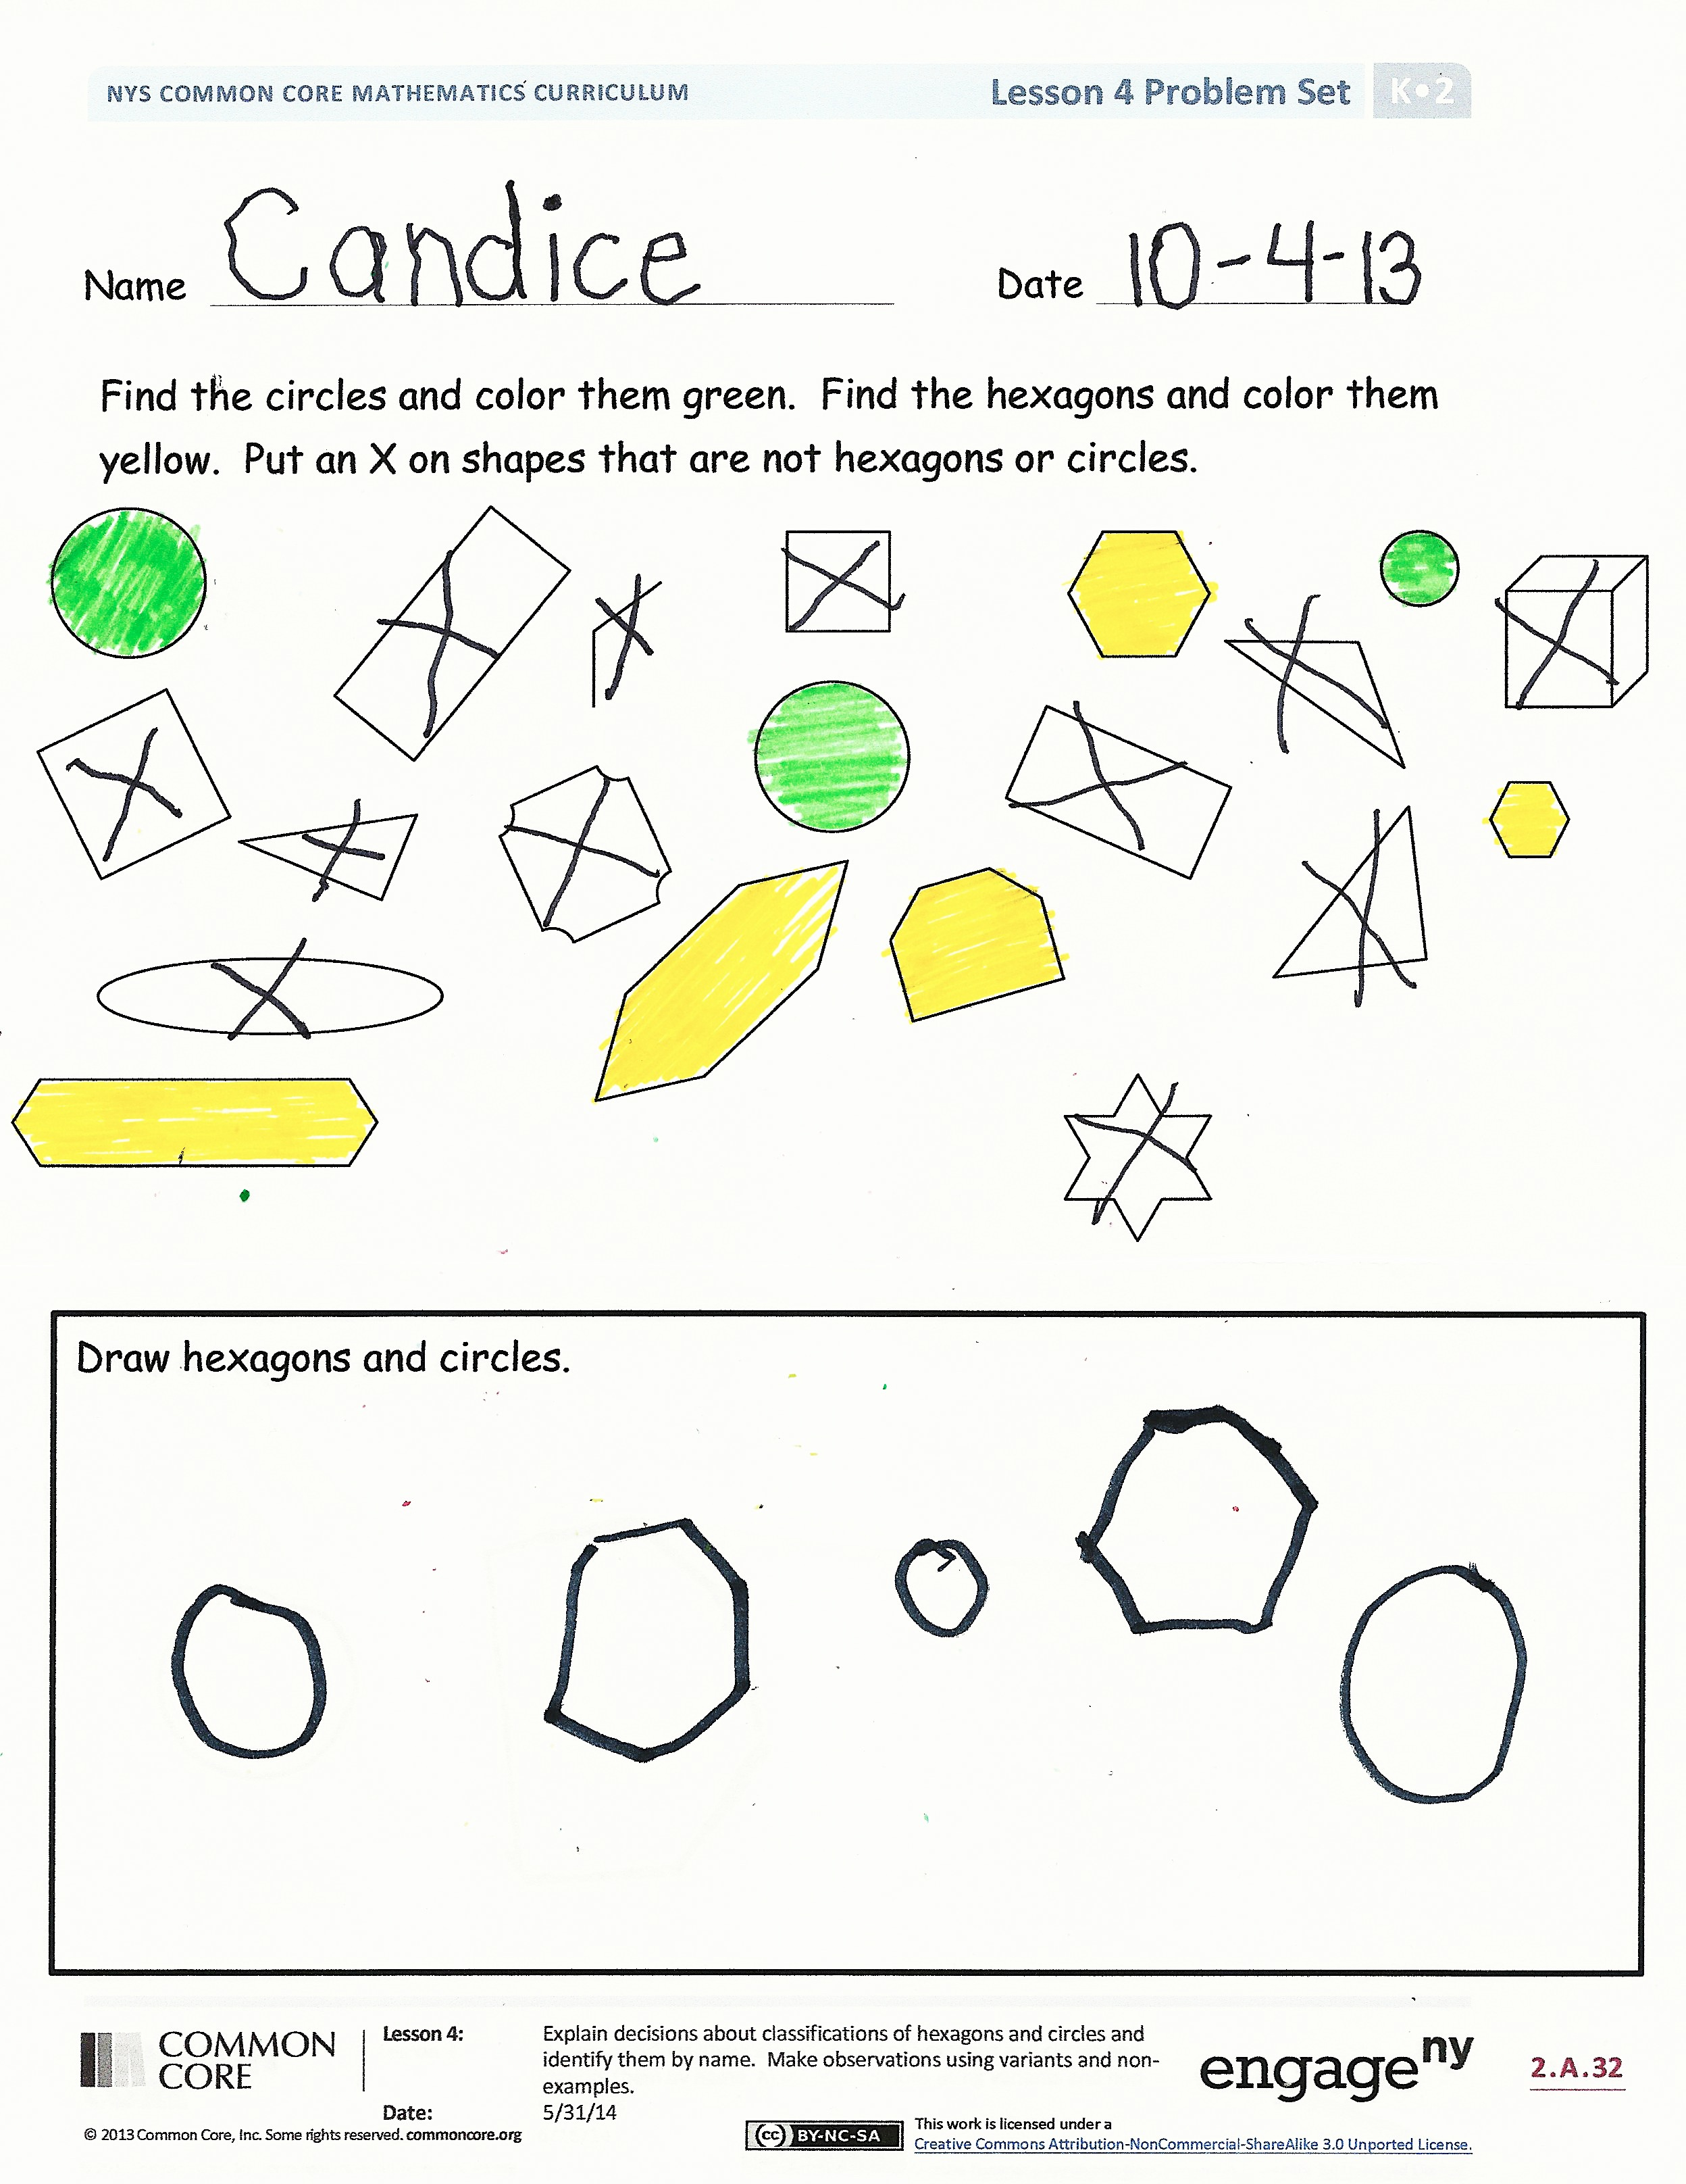
Problem Set (10 minutes)
Students should do their personal best to complete the Problem Set within the allotted time.
Since hexagons and circles are the focus of this lesson, have students first identify one of the two shapes and then the other.
Student Debrief (8 minutes)
Lesson Objective: Explain decisions about classifications of hexagons and circles, and identify them by name. Make observations using variants and non-examples.
The Student Debrief is intended to invite reflection and active processing of the total lesson experience.
Invite students to review their solutions for the Problem Set. They should check work by comparing answers with a partner before going over answers as a class. Look for misconceptions or misunderstandings that can be addressed in the Debrief. Guide students in a conversation to debrief the Problem Set and process the lesson.
You may choose to use any combination of the questions below to lead the discussion.
- How did the Application Problem connect to today’s lesson?
- What new (or significant) math vocabulary did we use today to communicate precisely?
- Did you color the same hexagons and circles as your partner?
- Explain to your partner how you knew the objects you colored were hexagons or circles.
- Count how many circles and hexagons you colored. Did your partner color that same number?
- Which shape is more like a circle, a square or a hexagon with equal sides? What if there were more and more equal sides to our shape, could it look more and more like a circle?

Name Date
Find the circles and color them green. Find the hexagons and color them yellow. Put an X on shapes that are not hexagons or circles.

Draw hexagons and circles.

Name________________________ Date____________________

Color the triangles blue.
Color the rectangles red.
Color the circles green.
Color the hexagons yellow.

On the back of your paper draw 2 triangles and 1 hexagon.
How many shapes did you draw? ______

shapes
shapes

