Lesson 3

Objective: Explain decisions about classifications of rectangles into categories using variants and non-examples. Identify shapes as rectangles.

Suggested Lesson Structure

 Fluency Practice (12 minutes)

  Application Problem (5 minutes)

  Concept Development (25 minutes)

 Student Debrief (8 minutes)

**Total Time (50 minutes)**

Fluency Practice (12 minutes)

* 5-Group Hands **K.CC.2** (5 minutes)
* Making 4 with Squares and Beans **K.CC.4a** (4 minutes)
* Triangle or Not  **K.G.2** (3 minutes)

5-Group Hands (5 minutes)

Materials: (T) Large 5-group cards (Lesson 1 Fluency Template 3)

Note: We repeat work with the hands often because students need frequent practice to achieve fluency. The same exercises must be repeated again and again. As they gain depth of understanding, they visualize. As they visualize, they no longer need their fingers.

Conduct the activity as outlined in Lesson 1, but now continue to 10.

Making 4 with Squares and Beans (4 minutes)

Materials: (S) 4 beans, paper or foam squares, personal white board

Note: Students work early in the year towards fluency with sums and differences within 5. This takes time and a great deal of practice.

T: Touch and count the corners of the square.

S: 1, 2, 3, 4.

T: Touch and count your beans.

S: 1, 2, 3, 4.

T: Our job is to make 4. Put 3 beans on the corners of your square. Keep the other bean in your hand. How many beans on your square?

S: 3.

T: How many beans in your hand?

S: 1.

T: We can tell how to make 4 like this: 3 and 1 make 4. Echo me, please.

S: 3 and 1 make 4.

T: Show me 2 beans on your square. Keep the rest in your hand. How many beans on your square?

S: 2.

T: How many beans in your hand?

S: 2.

T: Raise your hand when you can say the sentence. (Wait until all hands are raised, and then give the signal.)

S: 2 and 2 make 4.

Continue with placing 1 bean on the square, then 4, and finally 0 to work through all of the number combinations. Have students write the equations on their personal white boards. Challenge students to list and verify that they have found all possible combinations.

Triangle or Not (3 minutes)

Materials: (T) Paper shapes of the same color in varying sizes, a wide range of exemplars, non-examples, and variants (Fluency Template)

Note: This is a preparatory fluency activity intended to review the previous lesson’s work with triangles and prepare students to name and identify rectangles in a similar manner.

T: I’ll show you a shape. We’ll try to decide if it’s a triangle or not. If you think it’s a triangle, give me a thumbs up. If it’s not a triangle, thumbs down. Either way, be ready to explain your choice! Here we go. (Show an exemplar triangle.)

S: (Show thumbs up sign.)

T: You’re right! It is a triangle. Who can tell us why?

S: (Give varied responses. Justify with informal language and attributes of the shape.)

Continue identifying shapes as triangles or not triangles. Proceed from simple to complex by starting with the exemplar of each shape, then the non-examples, and then the variants.

Application Problem (5 minutes)

Design your own dollar bill! Draw your dollar bill on a piece of paper. Whose picture will you put in the center? Compare your dollar with your partner’s. Tell him about the shape of your bill. How are your dollars alike?

Note: In this problem, the students should, from their own general knowledge, draw some sort of a rectangle. Describing their dollars to their friends will lead them to articulate what they already know about the shape in anticipation of today’s lesson.

Concept Development (25 minutes)

Preparation: Create outlines of geometric figures on paper to be affixed to the board during the lesson (Template 1). Shapes should include, but not be limited to, those illustrated below:

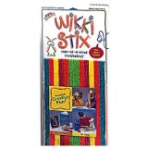Materials: (S) Copy of dot paper (Template 2) on cardstock, Wikki Stix (crayons or markers may also be used)

T: We are going to talk about another type of shape today. Look at the shape on the board. Use your math words to tell about it. (Place exemplar **rectangle** on the board.)

S: It has four corners. 🡪 It has four sides. 🡪 The sides are all straight.

**MP.7**

T: This shape is called a **rectangle**. (Write *Rectangle* on board, and affix the shape beneath it.)

|  |  |
| --- | --- |
|  | NOTES ON  MULTIPLE MEANS  OF REPRESENTATION: |
| For English language learners, connect the key vocabulary of the lesson (*straight, sides, corners*) with pictures that represent the meaning of these terms. | |

T: (Place another rectangle on the board.) Tell about this shape.

S: It has four straight sides and four corners. It is a rectangle, too.

T: Hmmm. I wonder if we will have another pattern today. Let’s put this over by the other rectangle. How about this shape? (Place a square on the board.)

S: It has four corners and four sides. All the sides look the same.

T: So, this is a rectangle, too? (Yes.) This special rectangle, in which all the sides are the same length, is called a…

S: **Square**!

T: How about this one? (Affix to board.) Is this a rectangle? It has straight sides and four corners.

S: No! It’s not a rectangle! 🡪 The corners don’t look right.

T: What do the corners look like in a rectangle?

S: They need to be L-shaped.

T: Let’s put this over here, then. It is not a rectangle. (Write *Not a Rectangle* on the board and affix the shape beneath it.)

As you did with the triangles yesterday, continue to sort the rest of the shapes with the students. Be sure to place the shapes in a variety of orientations. Guide them to point out pertinent attributes of variants, distractors, and non-examples. Encourage them to insist that any rectangles have four straight sides and four right angles and are closed shapes.

|  |  |
| --- | --- |
|  | NOTES ON  MULTIPLE MEANS  OF ENGAGEMENT: |
| Challenge your students working above grade level by asking them to squeeze their Wikki Stix rectangles (making a parallelogram) and have them decide whether the new shape is a rectangle or not. | |

T: You have learned many rules about rectangles today! Now, make some rectangles of your own. Use these Wikki Stix for the sides, and use the special dots on this paper to keep your sides straight. Use the rectangles you sorted on the board for your models.

Pass out materials and allow time for construction and discussion. Circulate to ensure accuracy. If Wikki Stix are not available, students can use crayons or markers to connect the dots in their shape construction.

T: Great work! When you take these home after school, see if you notice any rectangles like these on the way!

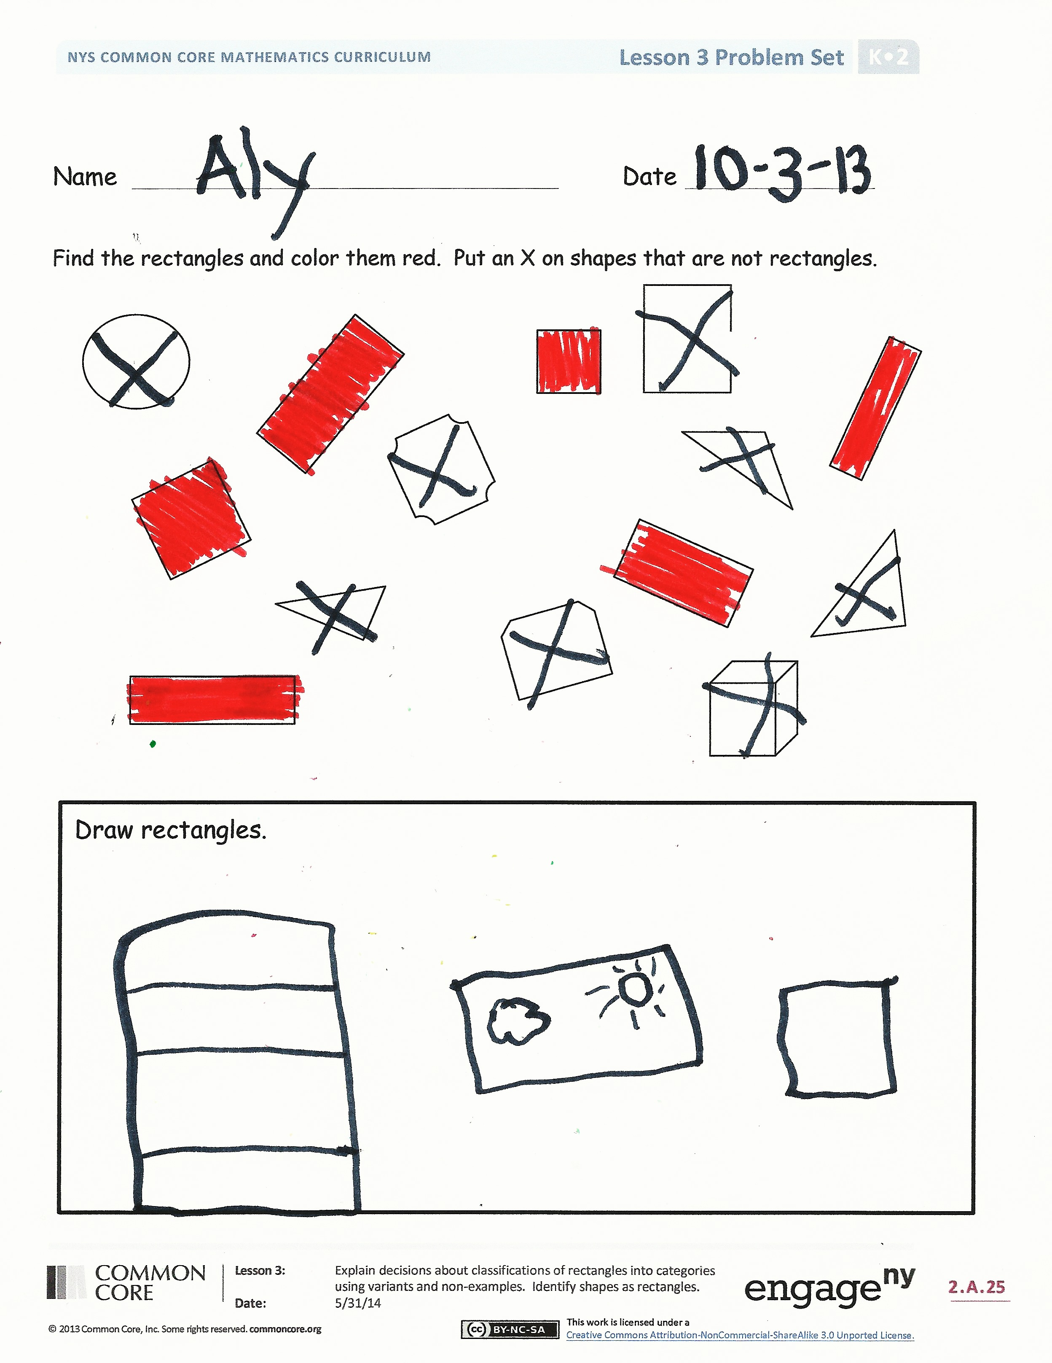Problem Set (8 minutes)

Students should do their personal best to complete the Problem Set within the allotted time.

In this Problem Set, we suggest all students begin by putting an X on all the shapes that are not rectangles and possibly leave the coloring to the end if they still have time.

Student Debrief (8 minutes)

**Lesson Objective:** Explain decisions about classifications of rectangles into categories using variants and non-examples. Identify shapes as rectangles.

The Student Debrief is intended to invite reflection and active processing of the total lesson experience.

Invite students to review their solutions for the Problem Set. They should check work by comparing answers with a partner before going over answers as a class. Look for misconceptions or misunderstandings that can be addressed in the Debrief. Guide students in a conversation to debrief the Problem Set and process the lesson.

You may choose to use any combination of the questions below to lead the discussion.

* How did the Application Problem connect to today’s lesson?
* What new (or significant) math vocabulary did we use today to communicate precisely?
* Count how many **rectangles** you colored. Did your partner color that same number?
* Did you color the same rectangles as your partner?
* Explain to your partner how you knew the objects you colored were rectangles.
* What do you look for in a rectangle?
* What shape did you draw with four sides? Can you draw more than one shape with four sides?
* How are rectangles and triangles the same and different?
* Why is a **square** a special kind of rectangle?

Name Date

Find the rectangles and color them red. Put an X on shapes that are not rectangles.

Draw some rectangles.

Name Date

Color all the rectangles red. Color all the triangles green.

On the back of your paper, draw 2 rectangles and 3 triangles.

How many shapes did you draw? Put your answer in the circle.

[1]



[2]

[3]



1. shapes
2. shapes
3. dot paper