Lesson 2
Objective: Explain decisions about classifications of triangles into categories using variants and non-examples. Identify shapes as triangles.

Suggested Lesson Structure
 Fluency Practice (12 minutes)
 Application Problem (5 minutes)
 Concept Development (25 minutes)
 Student Debrief (8 minutes)
Total Time (50 minutes)
Fluency Practice (12 minutes)
- Making 3 with Triangles K.OA.3 (3 minutes)
- Make a Shape K.G.4 (5 minutes)
- Groups of 6 K.CC.4b (4 minutes)
Making 3 with Triangles (3 minutes)
Materials: (S) 3 beans, 1 paper or foam triangle, personal white board
Note: This activity was chosen to set the stage for the analysis of triangles coming in today’s lesson.
T: Touch and count the corners of the shape.
S: 1, 2, 3.
T: Touch and count your beans.
S: 1, 2, 3.
T: Our job is to make 3. Put 2 beans on the corners of your shape. Keep the other bean in your hand. How many beans are on your shape?
S: 2.
T: How many beans are in your hand?
S: 1.
T: We can tell how to make 3 like this: 2 and 1 make 3. Echo me, please.
S: 2 and 1 make 3.
T: Show me 1 bean on your shape. Keep the rest in your hand. How many beans on your shape?
S: 1.
T: How many beans in your hand?
S: 2.
T: Raise your hand when you can say the sentence, and start with 1. (Wait until all hands are raised, and then give the signal.)
S: 1 and 2 make 3.
Guide students as they write the equations on their personal white boards. Challenge students to list and verify that they have found all possible combinations.
Make a Shape (5 minutes)
Materials: (S) Craft sticks or straws of two different lengths, foam or construction paper work mat
Note: Refrain from naming the shapes at this point. Ask students, if they know them, to keep the names of the shapes secret for now. If students name the shapes, have them explain their thinking by describing the shape’s attributes using informal language: “I knew I made a triangle because it has three corners.”
T: Let’s play Make a Shape. Put three craft sticks this size (hold up the longer of the two lengths) on your mat.
T: Move the sticks so they make a shape with three points.
S: (Move the sticks to form a triangle shape.)
T: Touch and count the points.
S: 1, 2, 3.
T: Touch and count the sides.
S: 1, 2, 3.
T: Are there any curved sides?
S: No.
T: Trade in your three long sticks for three short ones, like this (show students an example of the shorter length), and put them on your mat.
T: Move the sticks so they make a new shape with three points.
S: (Move the sticks to form a different triangle shape.)
T: Does your shape still have three points? Three sides? No curved sides? (Pause after each question to allow students time to verify.)
S: (Respond to questions.)
T: Now, put one of your sticks back. Get a stick this size (hold up the longer of the two lengths), and put it on your mat.
S: (Place the longer stick on the mat so there are now two short and one long.)
T: Move the sticks so they make a new shape with three points.
S: (Move the sticks to form a different triangle shape.)
Have students count the points and sides again and verify that there are no curved sides so that they realize that the attributes of the shape are the same, even as the shape takes on a different appearance. Have them carefully rotate their work mats to view the shape from different angles.

Here is a suggested sequence with names of shapes listed for the teacher’s reference:
1. A triangle composed of two long sticks and one short
2. A square composed of four long sticks
3. A smaller square composed of four short sticks
4. A rectangle composed of two short sticks and two long sticks
Groups of 6 (4 minutes)
Note: This maintenance fluency activity helps students gain efficiency in counting objects in varied configurations.
T: When the music starts, calmly walk around the room, visiting corners of the room until you and your classmates can make a group of 6. Don’t forget to count yourself! How many can be in a group?
S: 6!
T: So, if you go to a corner that already has 5 people there, can you stay?
S: Yes!
T: What if there are already 6?
S: No.
T: Remember to check all the corners of the room. See if we can all get into groups of 6 before the music stops!
If there are not enough students to make equal groups of the designated number, supplement with puppets or stuffed animals. Allow students to share strategies for making groups quickly.
Application Problem (5 minutes)

NOTES ON
MULTIPLE MEANS
OF ACTION AND EXPRESSION:
Scaffold the Application Problem for students who struggle by giving directions one at a time and waiting until students complete the task they were given before giving them the next direction. For example, say, “Draw a large pizza pie.” After students comply, continue with, “Use your crayon to cut the pizza into slices for two friends.”

It’s pizza time! On a piece of paper, draw a large, round pizza pie. Don’t forget your favorite toppings! With your crayons, show how you would cut the pizza into enough slices for your family. Compare your slices to those of a partner. Are they alike? Carefully describe the shape of a slice to your partner.
Note: The purpose of this problem is two-fold; first, to have the students create three-sided figures, but second, to set up a potential non-example for use later in the lesson. The curved edge of the crust in their drawing will mean that the slices are not actually triangles.

Concept Development (25 minutes)
Preparation: Create outlines of geometric figures on paper to be affixed to the board during the lesson (Template). Shapes should include, but not be limited to, those illustrated below:

Materials: (S) Geoboard, rubber band
Note: If this is the first time the students have used a geoboard, allow a few extra minutes during the lesson to instruct them in proper use of the materials. Using a rubber band, the students stretch the rubber band around pegs to create various shapes. Emphasize that the rubber band must remain on the geoboard at all times.
T: Yesterday, when you were telling me about your shapes, you used a lot of math words to describe them. What were some of the things you noticed?
S: Corners. Curved lines. Straight. Number of sides. Pieces missing.
T: We are going to look at some more shapes today to see what else you notice. (Put a triangle on the classroom board.)
T: Tell me about this shape.
S: It has three sides. It has three corners. It doesn’t have any curves.
T: We call a shape like this a triangle. (Write the word Triangle on board and affix the shape beneath it. Choose another triangle outline.)
T: Tell me about this shape.
S: It has three corners and three sides. It has straight sides. It is a triangle!
T: (Affix to board under the first triangle.) I am beginning to see a pattern! How many corners does each shape have? (Three.) How many sides? (Three.) What do the sides look like?
S: They are all straight!
T: So, a triangle has three straight sides and three corners?
S: Yes.

T: (Choose .) Here is another shape. It has three corners, and all of the sides are straight. It must be a triangle.
S: No! It’s open!
T: If you were a pet inside this fence, you could escape! So, triangles have to be closed?

NOTES ON
MULTIPLE MEANS
OF ENGAGEMENT:
Support English language learners’ capacity to discuss how the shapes they made on their geoboards are examples of triangles by providing them with sentence frames such as, “My shape is a triangle because it has…” to use as discussion starters with their partners.

S: Yes!
T: (Write Not a Triangle on the board, and place the shape beneath it. Continue discussion and sorting with the rest of the shapes, guiding students to point out specific attributes of the variants, non-examples, and distractors.)
T: We have several triangles on the board. I’m going to ask you to copy these triangles onto your geoboard. Remember, you can only use one rubber band. Stretch it around three corners! (Demonstrate, and then pass out geoboards and rubber bands. Assist students as they try to copy the shapes. Make sure that they have shapes with exactly three sides.)
MP.3
T: Now, create your own triangle on your geoboard and show your partner. Be sure to tell how you know it is a triangle! (Allow time for sharing and discussion.)
T: Put your geoboards away, and get ready for some triangle hunting on your Problem Set.

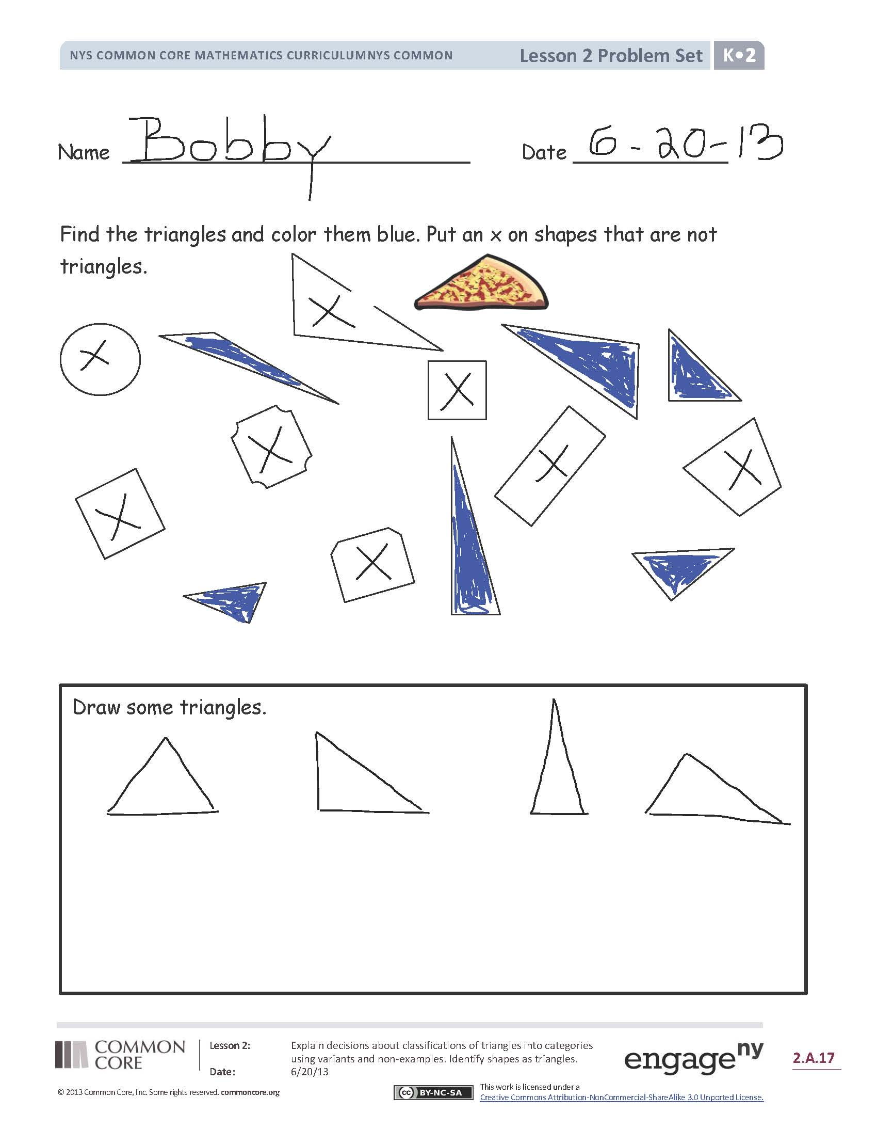
Problem Set (10 minutes)
Students should do their personal best to complete the Problem Set within the allotted time.
Student Debrief (8 minutes)
Lesson Objective: Explain decisions about classifications of triangles into categories using variants and non-examples. Identify shapes as triangles.
The Student Debrief is intended to invite reflection and active processing of the total lesson experience.
Invite students to review their solutions for the Problem Set. They should check work by comparing answers with a partner before going over answers as a class. Look for misconceptions or misunderstandings that can be addressed in the Debrief. Guide students in a conversation to debrief the Problem Set and process the lesson.
You may choose to use any combination of the questions below to lead the discussion.
- What new (or significant) math vocabulary did we use today to communicate precisely?
- Count how many triangles you colored. Did your partner color that same number?
- Did you color the same triangles as your partner?
- Explain to your partner how you knew the objects you colored were triangles.
- What do you look for in a triangle?
- Were the slices of the pizza in the Application Problem triangles? Why or why not?

Name Date
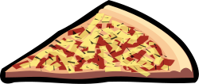
Find the triangles and color them blue. Put an X on shapes that are not triangles.

Draw some triangles.
Name Date
Color the triangles red and the other shapes blue.

Draw 2 different triangles of your own.

shapes

