Lesson 1
Objective: Find and describe flat triangles, squares, rectangles, hexagons, and circles using informal language without naming.

Suggested Lesson Structure
 Fluency Practice (17 minutes)
 Concept Development (25 minutes)
 Student Debrief (8 minutes)
Total Time (50 minutes)
Fluency Practice (17 minutes)
- Making 5 with 5-Group Mats K.OA.1 (6 minutes)
- Draw More to Make 5 K.OA.3 (8 minutes)
- 5-Group Hands K.CC.2 (3 minutes)
Making 5 with 5-Group Mats (6 minutes)
Materials: (S) 5-group mats (Fluency Template 1), 5 linking cubes
Note: While students are working with geometry, the fluency goal throughout Module 2 will be to maintain and further develop number concepts to 10 (see Fluency Practice note in GK–M1–Lesson 1).
T: Touch and count your cubes.
S: 1, 2, 3, 4, 5.
T: Touch and count the dots on your mat.
S: 1, 2, 3, 4, 5.
T: Our job is to make 5. Put 4 cubes on the dots of your mat. (Check to see that students place the cubes from left to right without skipping any dots.) Raise your hand when you know how many more cubes to make 5. (Wait until all hands are raised, then signal.) Ready?
S: 1.
T: We can tell how to make 5 like this: 4 and 1 make 5. Echo me, please.
S: 4 and 1 make 5.
Continue working through the decompositions of 5 in a systematic way. As students begin to demonstrate mastery, scale back the amount of guidance: “Show me x cubes; say the number sentence.”

Draw More to Make 5 (8 minutes)
Materials: (S) Draw more (Fluency Template 2)
Note: Go over the answers, and direct students to energetically shout “Yes!” for each correct answer.
After giving clear instructions and completing the first few problems together, allow students time to work independently. Encourage them to do as many problems as they can within a given time frame.
5-Group Hands (3 minutes)
Materials: (T) Large 5-group cards (5–7) (Fluency Template 3)
T: (Show the 6 dot card.) Raise your hand when you know how many dots are on top. (Wait until all hands are raised, then signal.) Ready?
S: 5.
T: Bottom?
S: 1.
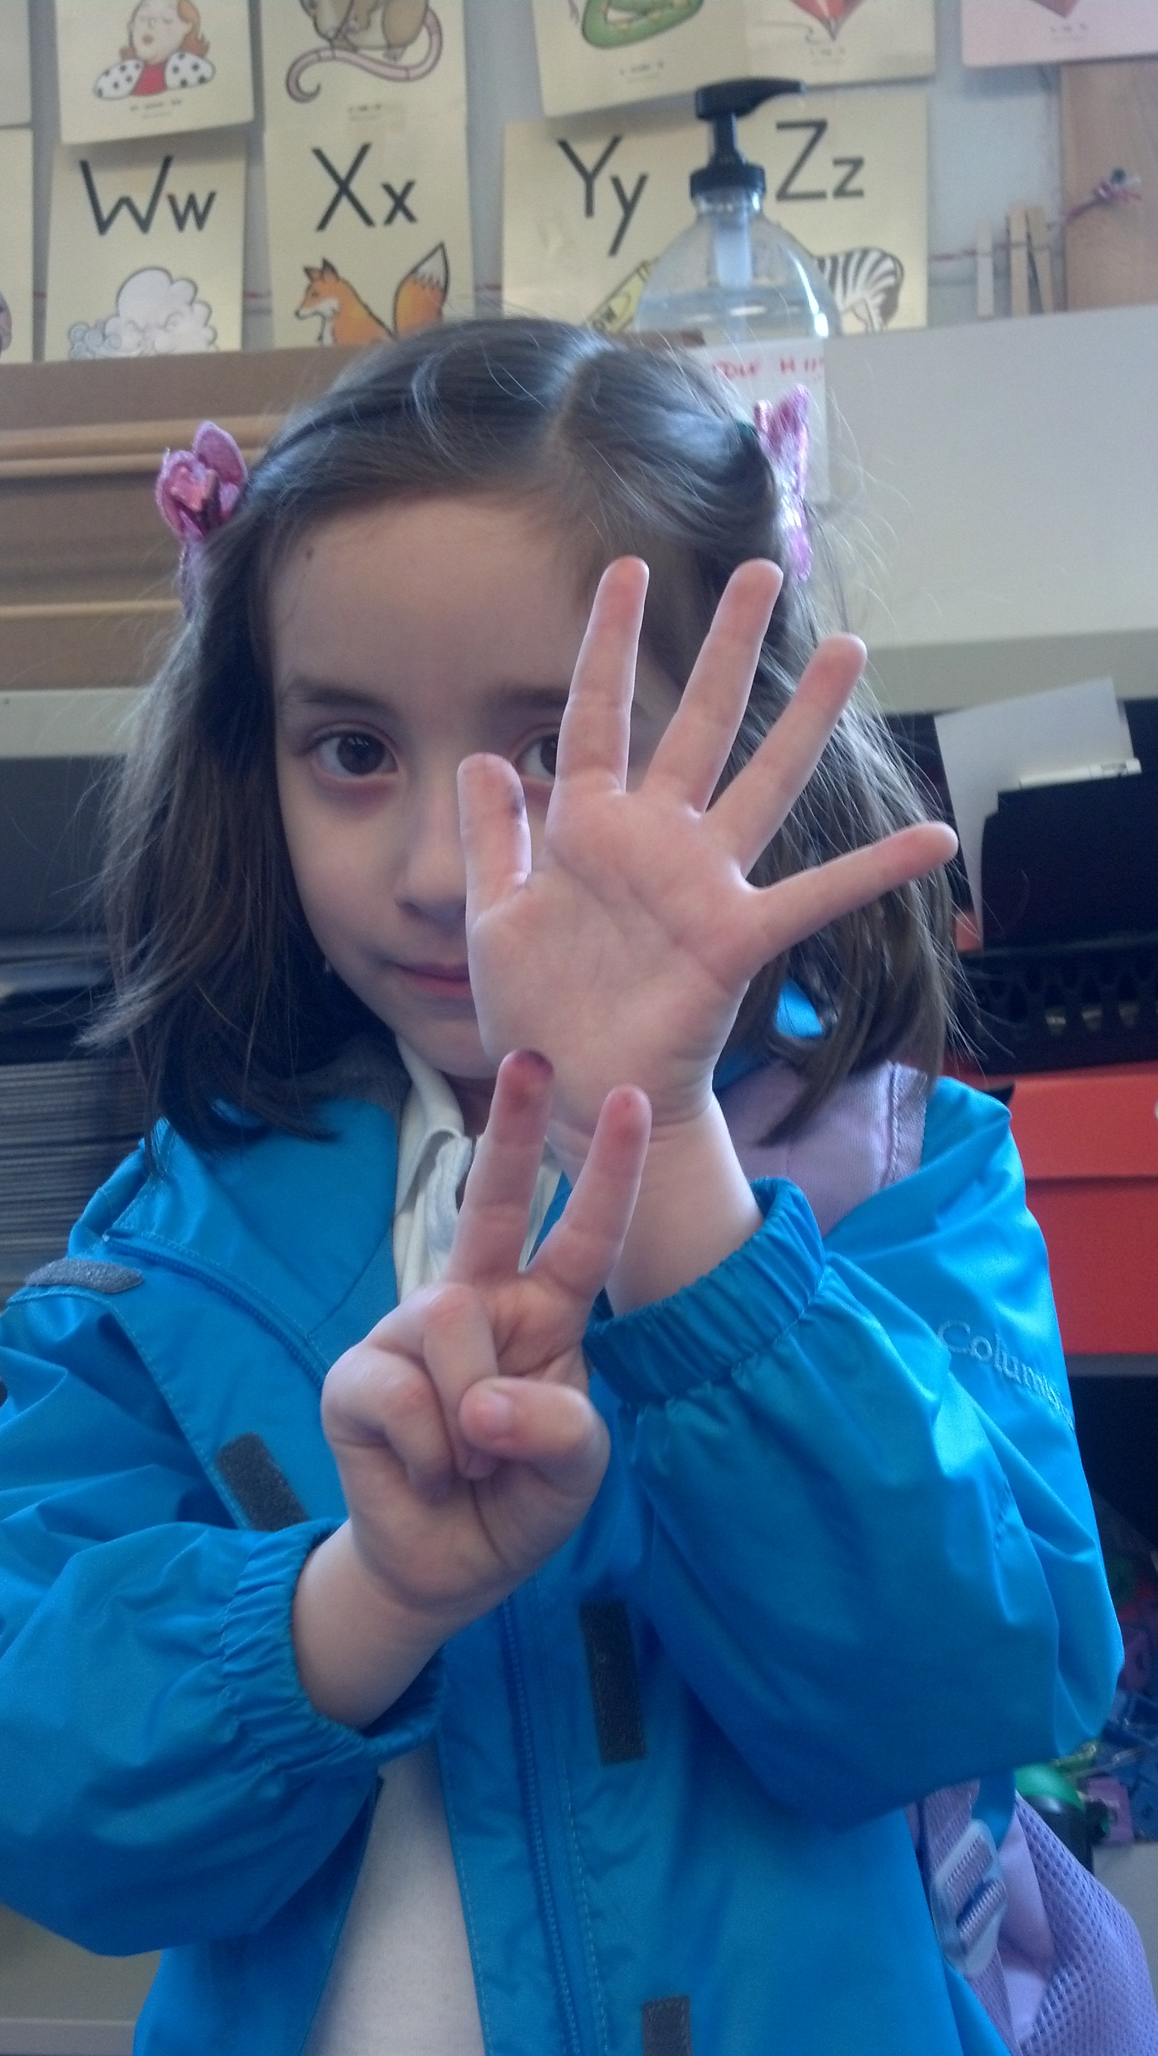
A student demonstrates
7 as 5 on top, and 2
on the bottom.
T: We can show this 5-group on our hands. Five on top, 1 on the bottom, like this. (Demonstrate on hands, one above the other.)
S: (Show 5 and 1 on hands, one above the other.)
T: Push your hands out as you count on from 5, like this. 5 (extend the top hand forward), 6 (extend the bottom hand forward). Try it with me.
S: 5 (extend the top hand forward), 6 (extend the bottom hand forward).
Continue with 5, 6, and 7, steadily decreasing guidance from the teacher, until students can show the 5-groups on their hands with ease.
Concept Development (25 minutes)
Materials: (T) Large cutouts of each shape (to be affixed to the board with tape) (Template)
(S) Clear bag containing smaller cutouts of various shapes (all of one hue to limit distractions from variation in color), blank side of Problem Set affixed to clipboard, pencil, real or toy magnifying glass (if available)
Suggestions for shape cutouts are pictured as follows, but need not be limited to these. Be sure to include, at minimum, a triangle, a circle, a square, a rectangle, and a hexagon for discussion purposes.
Note: Today’s lesson focuses on the attributes of the shapes but not their specific names. Assure students that tomorrow’s work will include naming the shapes since many may be very eager to share their knowledge.

T: You have a mystery bag! Open your bag, and carefully shake out the surprises inside. What do you see? (Give students a moment to explore the contents of the bag and discuss with their friends.)
S: Different shapes!
T: (Select a shape from the bag.) Look at my shape. Can you find the one that looks like mine? (Affix to board.) Tell me about the shape. (In order to encourage a discussion purely about geometric attributes, select one of the more unusual cutouts to begin.)

NOTES ON
MULTIPLE MEANS
OF REPRESENTATION:
English language learners will benefit from having the words curved, straight, pointy, round, sides, and other attributes introduced before the lesson so that they can participate in the discussion with the class. After introducing them, post the vocabulary on the word wall with visuals so that students can refer to them.

S: It is round. But, it is pointy! It has a piece missing. It has three sides.
T: I like your observations! (Write student responses on chart paper and continue exercise with the rest of the shapes, encouraging students to verbalize attributes such as corners, curves, straight lines, number and length of sides, “missing pieces,” etc.)
MP.6
T: Arrange your shapes on your desktop. Do they have anything in common? (Responses will vary.) Now, bend down so that you are looking across the edge of your desktop. Can you see your shapes now? Are any of them sticking up?
S: We can’t see them. They are all flat!
T: Yes, they do have that in common! These are all flat shapes. Put your shapes back in the bag.
T: It’s time to play shape detectives! Detectives need to have special equipment, so I am going to give you and a partner a magnifying glass to use if you need it. You are going to go on a shape hunt around the room. Whenever you see an interesting shape, tell your partner about it and draw it on your paper. Take your bag of shapes with you to use as clues. Maybe you will see some shapes in the room that match shapes in your bag!
S: (With partners, search for shapes and re-create them on their clipboards.)

NOTES ON
MULTIPLE MEANS
OF ENGAGEMENT:
Push above grade level students by asking them questions and assigning activities that engage thinking at higher levels. “What would that shape look like if it was not flat?” “Can you make a picture of that shape but make it so that it is sticking up?”

T: (After five minutes, call students back to their seats.) Does anyone want to share one of the shapes they found? Tell us about it! (Allow time for sharing and discussion.)
T: Maybe you will find more shapes to add tonight. Turn your Problem Sets over so that we can do some shape coloring and matching. When you are done, if there is time, you can use the same color code to color some of the similar shapes you found in the room.
Problem Set (10 minutes)
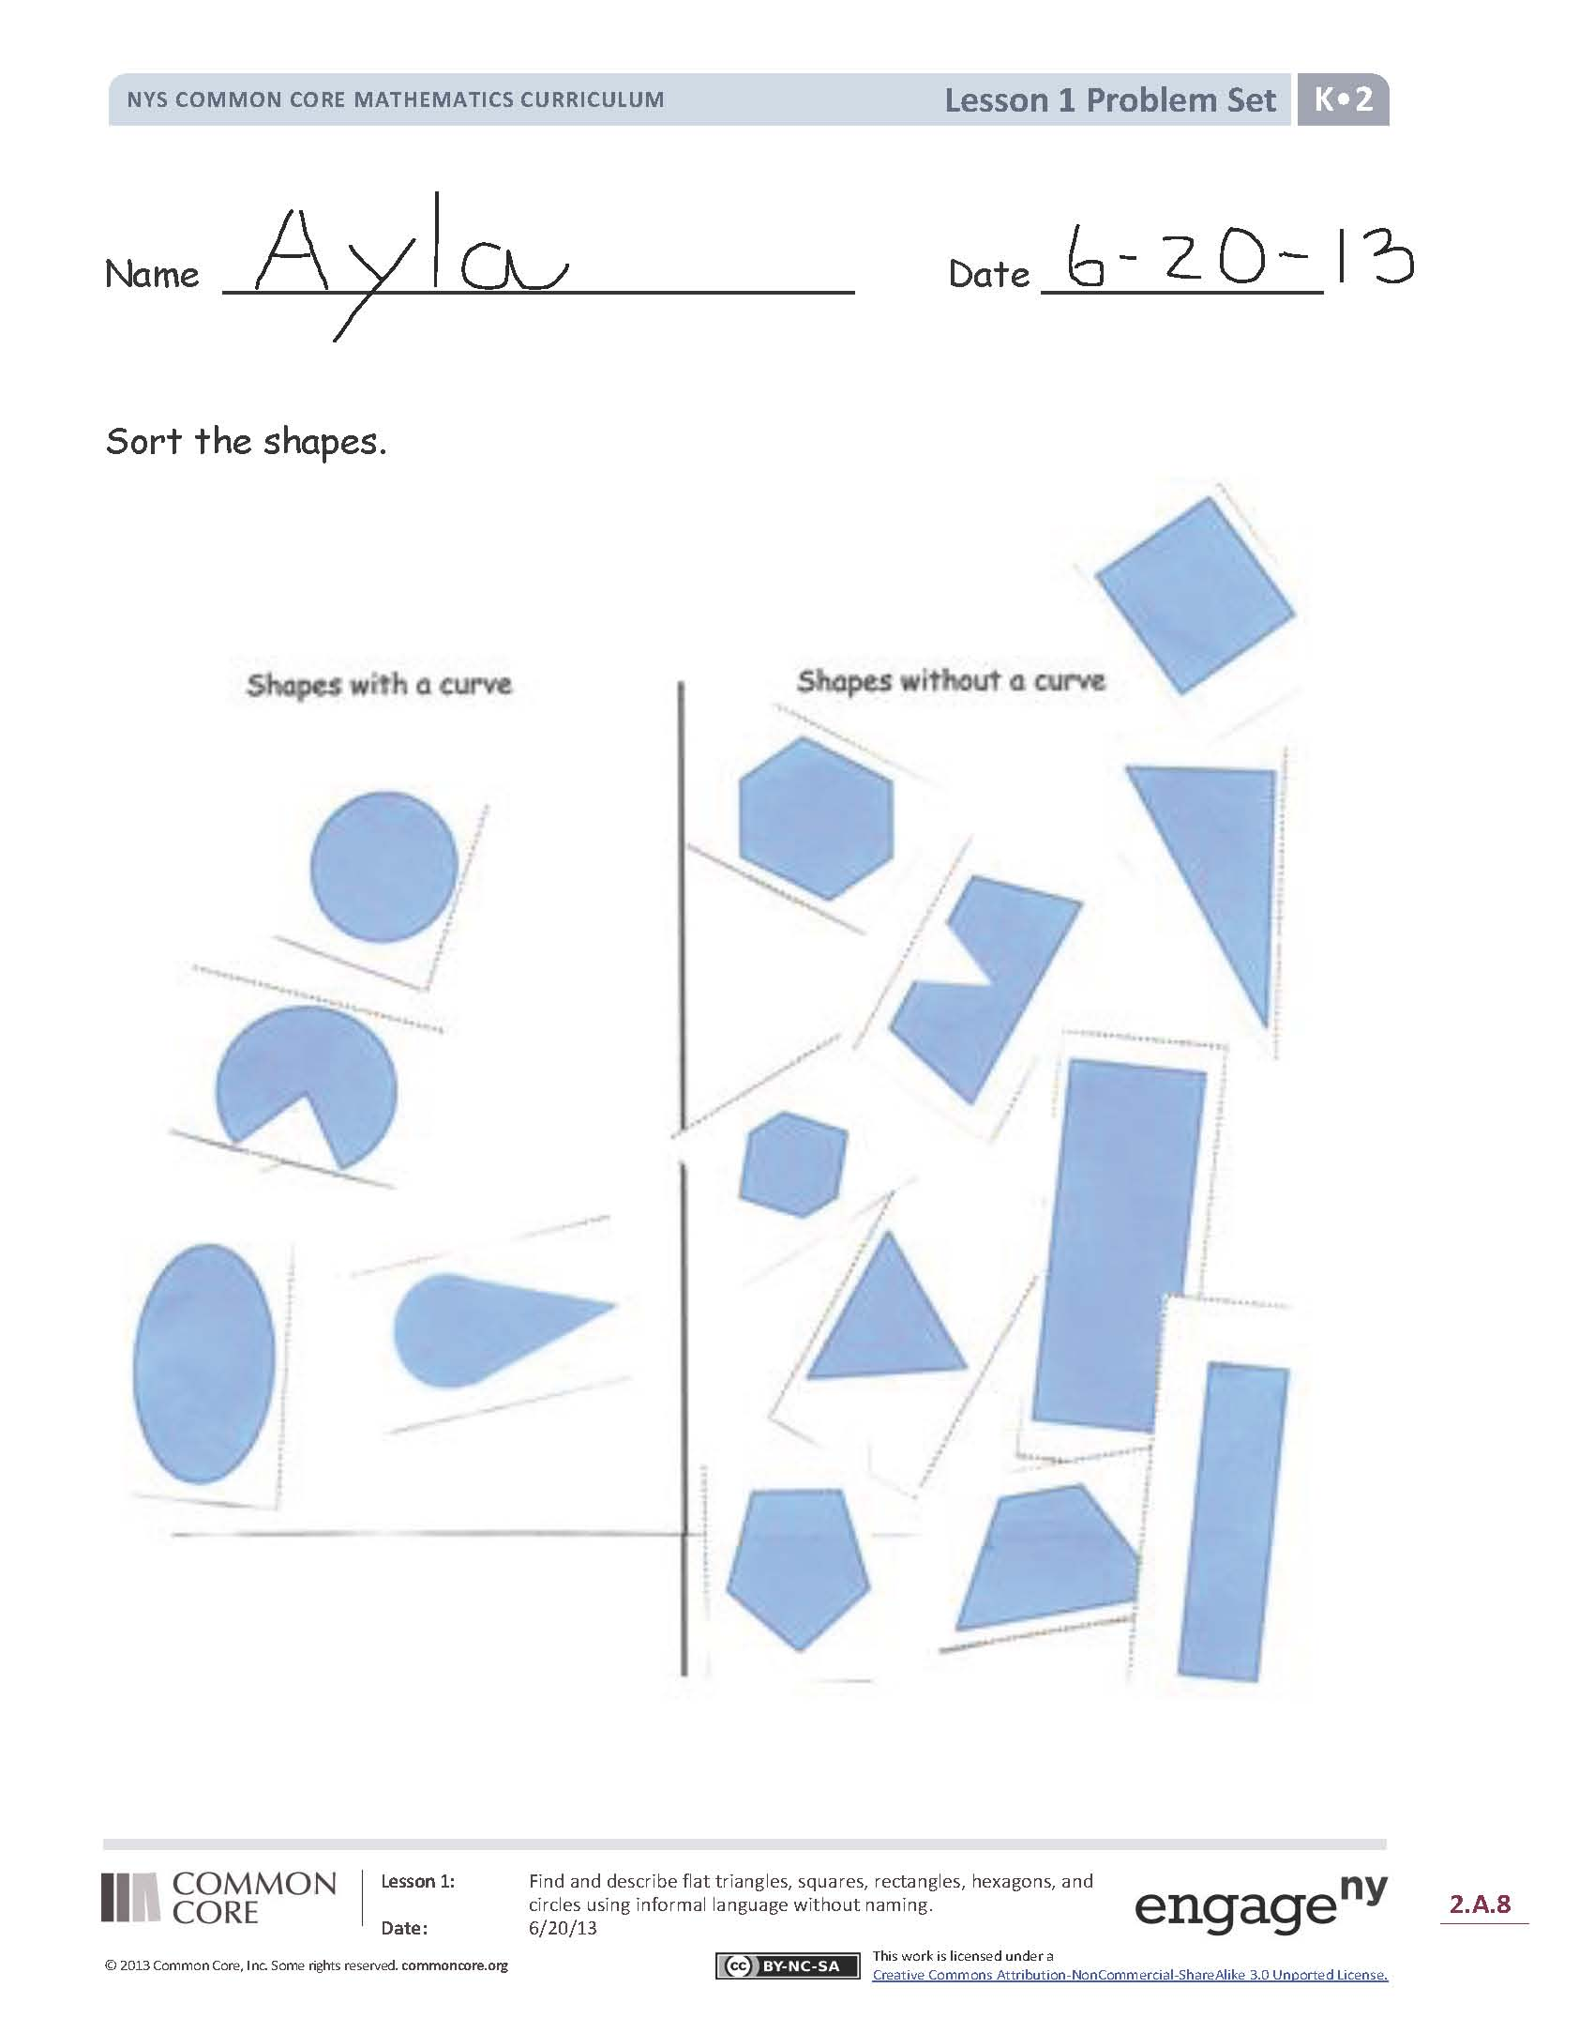
Students should do their personal best to complete the Problem Set within the allotted time.
For some classes, it may be appropriate to modify the assignment by specifying which problems students should work on first. With this option, let the purposeful sequencing of the Problem Set guide your selections so that problems continue to be scaffolded. Balance word problems with other problem types to ensure a range of practice. Assign incomplete problems for homework or at another time during the day.
In this Problem Set, we suggest all students begin with sorting the shapes that clearly have or do not have curves and possibly leave any questionable shapes to the end if time permits.
Suggestions for other ways you may ask students to sort are listed below:
- Shapes that have curves and sharp points.
- Shapes that have only curves.
- Shapes that have four or fewer corners.
- Shapes that have four or more sides.

Student Debrief (8 minutes)
Lesson Objective: Find and describe flat triangles, squares, rectangles, hexagons, and circles using informal language without naming.
The Student Debrief is intended to invite reflection and active processing of the total lesson experience.
Invite students to review their solutions for the Problem Set. They should check work by comparing answers with a partner before going over answers as a class. Look for misconceptions or misunderstandings that can be addressed in the Debrief. Guide students in a conversation to debrief the Problem Set and process the lesson.
You may choose to use any combination of the questions below to lead the discussion:
- Which objects did you sort that were curved? Which objects did you sort that were not curved?
- Which flat shapes were the hardest to sort? Why?
- Explain to your partner which shapes you drew on the back of your paper. Can you think of other objects around you that have these same shapes?
- What new (or significant) math vocabulary did we use today to communicate precisely?
- How can you tell about each shape without using the shape’s name?

Name Date
Sort the shapes.
Shapes with a Curve
Shapes without a Curve

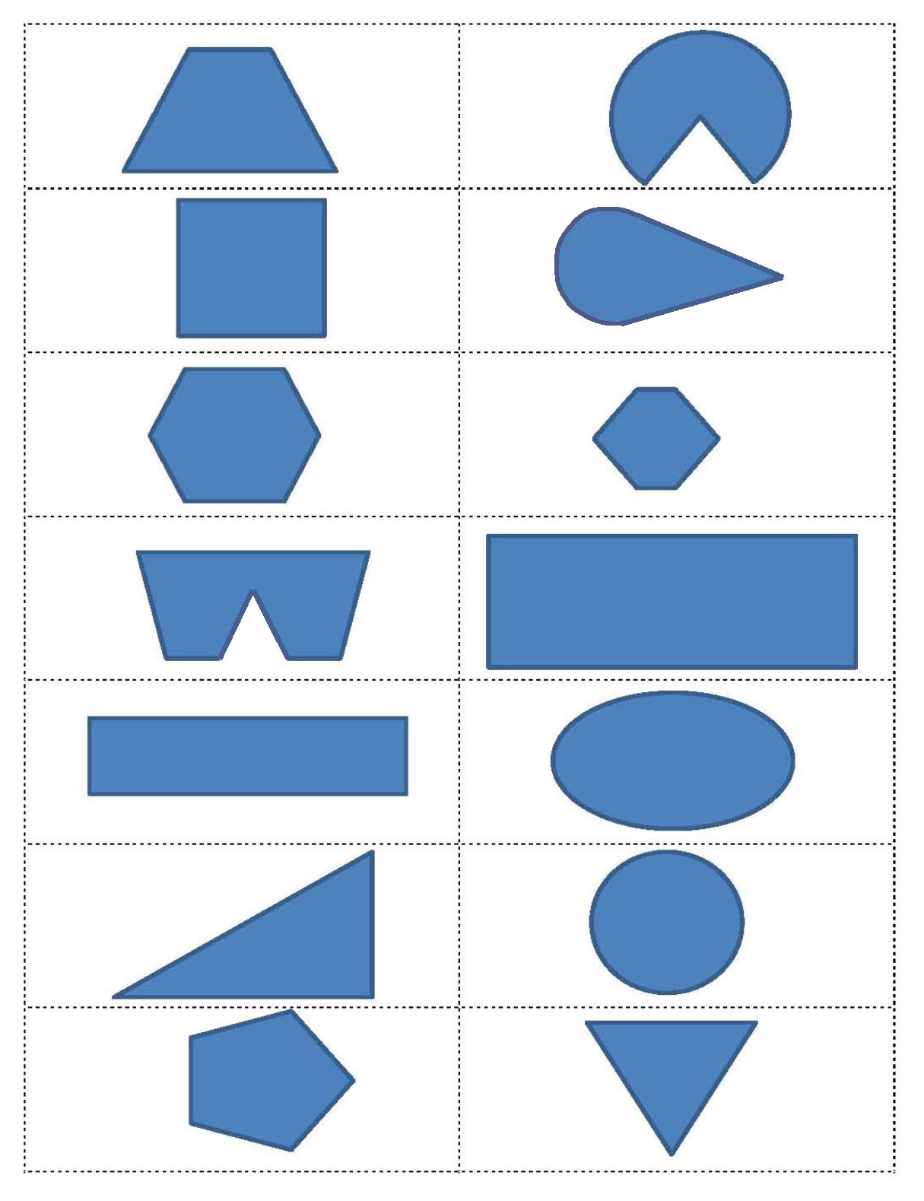
Name Date
Draw a line from the shape to its matching object.
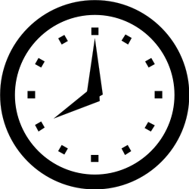
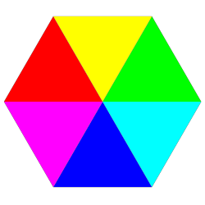
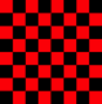
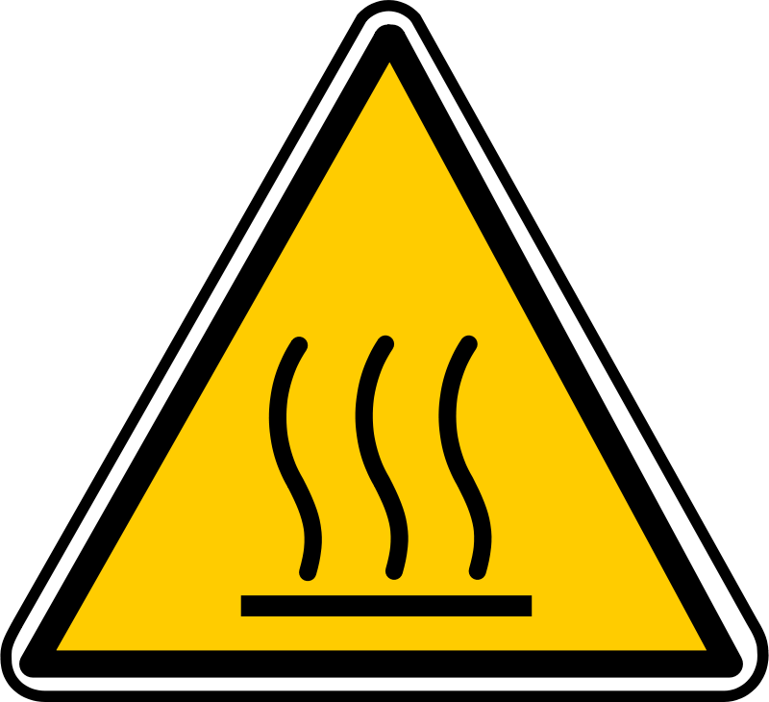

Draw more to make 5.

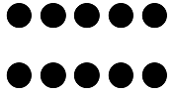 |  | 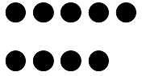 | 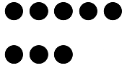

5-group mat
draw more
5-group cards
shapes

