Grade 8: Module 2B: Unit 2: Lesson 9
Mid-Unit 2 Assessment: Analyzing Narrative Structure and Author’s Craft: Part 1

Long-Term Targets Addressed (Based on NYSP12 ELA CCLS)
I can determine a theme or the central ideas of a literary text. (RL.8.2)
I can analyze the development of a theme or central idea throughout the text (including its relationship to the characters, setting, and plot). (RL.8.2)
I can objectively summarize literary text. (RL.8.2)
I can analyze how specific dialogue or incidents in a plot propel the action, reveal aspects of a character, or provoke a decision. (RL.8.3)
I can determine the meaning of words and phrases in a literary text (figurative, connotative, and technical meanings). (RL.8.4)
I can analyze the impact of word choice on meaning and tone (analogies or allusions). (RL.8.4)
I can compare and contrast the structure of multiple texts. (RL.8.5)
I can analyze how different structures affect meaning and style of a text. (RL.8.5)
I can analyze the connections between modern fiction and myths, traditional stories, or religious works (themes, patterns of events, character types). (RL.8.9)
I can analyze figurative language, word relationships and nuances in word meanings. (L.8.5a)
Supporting Learning Targets | Ongoing Assessment
- I can identify the narrative structure of the myth “The Harvest That Never Came.”  - I can use the plot structure to summarize the myth “The Harvest That Never Came.” | - A Midsummer Night’s Dream structured notes, 5.1.380–455 (from homework)  - Mid-Unit 2 Assessment: Analyzing Narrative Structure and Author’s Craft: Part 1

Agenda | Teaching Notes
- Opening  - Reviewing Learning Targets (2 minutes)  - Work Time  - Mid-Unit 2 Assessment: Analyzing Narrative Structure and Author’s Craft: Part 1 (40 minutes)  - Closing and Assessment  - Debrief (3 minutes)  - Homework  - None. | - The Mid-Unit 2 Assessment has two parts, taking two lessons to complete. In Part 1, students read a new myth and plot the narrative structure on the same Narrative Structure note-catcher used in Lesson 6 of this unit. Students show what they know using a fresh text which lets attend to the skills being assessed, rather than exert effort to comprehend a passage from the play and then apply the skills being assessed. Since students practiced this skill with a text that is in the form of a narrative with a narrator (rather than the play, which is mostly dialogue), they will use this new myth on the assessment Just as they did in Lesson 6, students use their completed note-catcher to write a summary of the myth.  - Assess student responses on the mid-unit assessment using the Mid-Unit 2 Assessment: Analyzing Narrative Structure and Author’s Craft: Part 1 (answers, for teacher reference) and the Grade 8 Two-Point Rubric—Short Response.  - Post: Learning targets.

Lesson Vocabulary | Materials
None | - Mid-Unit 2 Assessment: Analyzing Narrative Structure and Author’s Craft: Part 1 (one per student)  - Mid-Unit 2 Assessment: Analyzing Narrative Structure and Author’s Craft: Part 1 (answers, for teacher reference)  - Grade 8 Two-Point Rubric—Short Response (for teacher reference)

Opening | Meeting Students’ Needs
A. Reviewing Learning Targets (2 minutes)  - Read the learning targets aloud as students follow along silently:  - “I can identify the narrative structure of the myth ‘The Harvest That Never Came.’”  - “I can use the plot structure to summarize the myth ‘The Harvest That Never Came.’”  - Tell students that they had similar learning targets in Lesson 6 when they analyzed the narrative structure of “Pyramus and Thisbe” and then wrote a summary of the story. Explain that students will be doing the same thing independently in this lesson for a new myth that they haven’t seen before for the first part of their mid-unit assessment. | - Learning targets are a research-based strategy that helps all students, especially challenged learners.  - Posting learning targets allows students to reference them throughout the lesson to check their understanding. The learning targets also provide a reminder to students and teachers about the intended learning behind a given lesson or activity.

Work Time | Meeting Students’ Needs
A. Mid-Unit 2 Assessment: Analyzing Narrative Structure and Author’s Craft: Part 1 (40 minutes)  - Distribute the Mid-Unit 2 Assessment: Analyzing Narrative Structure and Author’s Craft: Part 1 to each student.  - Point out that they need to read the myth at the beginning of the assessment, then analyze the narrative structure using the note-catcher and then use their analysis of the narrative structure to write a summary. Share with them that the myth they are reading is related to the “Pyramus and Thisbe” myth they have been reading. They will be reading this new myth instead of a passage from the play since this new myth is structured in a similar narrative format as “Pyramus and Thisbe” as opposed to the structure of the play, which contains mostly dialogue.  - Remind them that the note-catcher on the assessment handout is the same one they filled out in Lesson 6 for “Pyramus and Thisbe,” so they are to fill it in the same way.  - Remind the class that because this is an assessment, it is to be completed independently. However, if students need assistance, they should raise their hand to speak with you.  - Circulate and support students as they work. During an assessment, your prompting should be minimal.  - Collect the Mid-Unit 2 Assessment: Part 1. | - For some students, this assessment may require more than the 40 minutes allotted. Consider providing students time over multiple days if necessary.  - If students receive accommodations for assessments, communicate with the cooperating service providers regarding the practices of instruction in use during this study as well as the goals of the assessment.

Closing and Assessment | Meeting Students’ Needs
A. Debrief (3 minutes)
- Invite students to show a Fist to Five for each of the learning targets in how well they think they have achieved them in this part of the mid-unit assessment.
Homework | Meeting Students’ Needs
- None.

Note: This module launches Independent Reading using the stand alone document Launching Independent Reading in Grades 6–8: Sample Plan on EngageNY,org. Be prepared to launch this in the next lesson.

Grade 8: Module 2B: Unit 2: Lesson 9
Supporting Materials

Mid-Unit 2 Assessment:
Analyzing Narrative Structure and Author’s Craft: Part 1

Name:
Date:

Long-Term Learning Targets Assessed:
I can determine a theme or the central ideas of a literary text. (RL.8.2)
I can analyze the development of a theme or central idea throughout the text (including its relationship to the characters, setting, and plot). (RL.8.2)
I can objectively summarize literary text. (RL.8.2)
I can analyze how specific dialogue or incidents in a plot propel the action, reveal aspects of a character, or provoke a decision. (RL.8.3)
I can determine the meaning of words and phrases in a literary text (figurative, connotative, and technical meanings). (RL.8.4)
I can analyze the impact of word choice on meaning and tone (analogies or allusions). (RL.8.4)
I can compare and contrast the structure of multiple texts. (RL.8.5)
I can analyze how different structures affect meaning and style of a text. (RL.8.5)
I can analyze the connections between modern fiction and myths, traditional stories, or religious works (themes, patterns of events, character types). (RL.8.9)
I can analyze figurative language, word relationships and nuances in word meanings. (L.8.5a)

Part 1. Summarize a narrative text.
Directions: Read the Swedish myth below, complete the Narrative Structure note-catcher, and write a summary (be sure to keep in mind what you have written on the Narrative Structure note-catcher for your summary).

Mid-Unit 2 Assessment:
Analyzing Narrative Structure and Author’s Craft: Part 1

“The Harvest That Never Came” by Aaron Shepard

My dearest Arild,
I promised to wait for you forever, but I fear I will not be allowed to. My father says you will never return, and he has chosen another man to be my husband. Though I pleaded with him, he has already set the marriage date.
I will love you always.
Your faithful,
Thale

Arild Ugerup, son of a noble Danish family, sat on his cot, reading the letter by the dim light of his prison cell. How cruel the tricks played by war, he thought, his eyes filling with tears.

Though Arild and his family were nobles of Denmark, they had long lived peaceably in Sweden. When King Erik of Sweden was crowned, Arild had been one of his honored guests. But then Denmark and Sweden declared war on each other, and Arild was drafted into the Danish navy. He was captured in battle and imprisoned by King Erik.

Arild’s childhood sweetheart, Thale Thott, had promised to marry him when he came back from the war. Now it seemed he would lose Thale as well as his freedom.

Arild sat thinking for many hours, the letter lying loose in his hand. At last he crossed to a small table. Dipping his pen in an inkwell, he began to write.

Your Royal Majesty,
Though I am now your prisoner, you once counted me as a friend. Grant me one favor. Let me go home to marry the woman I love. Then allow me to stay only long enough to plant a crop and harvest it.
On my word of honor, I will return to your prison as soon as the harvest is gathered.

Arild signed and sealed the letter, then called the jailer.

The reply came the next day. King Erik had agreed! Arild was free—at least until the harvest.
Arild returned home, where Thale met him joyfully. Her father was not happy to have his plans changed, but in the end the two were married.

Mid-Unit 2 Assessment:
Analyzing Narrative Structure and Author’s Craft: Part 1

Now it was spring, the time for planting. And, in only a few months, Arild would have to harvest his crop and return to King Erik’s prison.

Arild thought long and hard about what he would plant. At last he went to the fields and planted his seeds, placing each of them six paces from the rest.

Late that fall, a messenger arrived from King Erik. “The harvest season is past,” he said. “The King awaits your return.”

“But my crop is not harvested,” said Arild. “In fact, it has not yet sprouted!”

“Not sprouted?” said the messenger. “What did you plant?”

“Pine trees,” replied Arild.

When King Erik heard what Arild had done, he laughed and said, “A man like that does not deserve to be a prisoner.”

Arild was allowed to remain home with his beloved Thale. And a magnificent forest stands today as a testament to his love.

Copyright © 1993 by Aaron Shepard. For more stories, visit www.aaronshep.com

Mid-Unit 2 Assessment:
Analyzing Narrative Structure and Author’s Craft: Part 1

- Complete the Narrative Structure note-catcher based on “The Harvest That Never Came.”

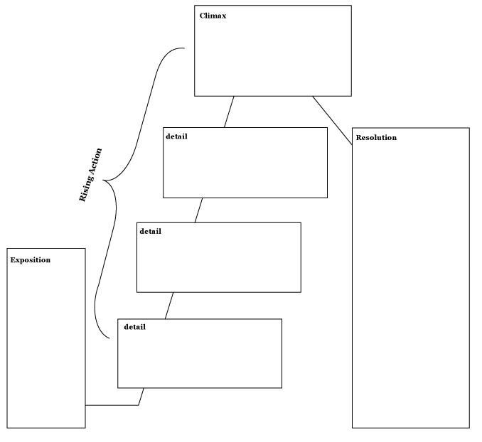

Mid-Unit 2 Assessment:
Analyzing Narrative Structure and Author’s Craft: Part 1

- Write a summary paragraph of the story of “The Harvest That Never Came.” You may use the Narrative Structure note-catcher from the previous question to help you write your summary.

- List two similarities and two differences between the Swedish myth “The Harvest That Never Came” by Aaron Shepard and the Greek myth “Pyramus and Thisbe” by Thomas Bulfinch.

Two Similarities | Two Differences
Mid-Unit 2 Assessment: Analyzing Narrative Structure and Author’s Craft:
Part 1 (Answers, for Teacher Reference)

Long-Term Learning Targets Assessed:
I can determine a theme or the central ideas of a literary text. (RL.8.2)
I can analyze the development of a theme or central idea throughout the text (including its relationship to the characters, setting, and plot). (RL.8.2)
I can objectively summarize literary text. (RL.8.2)
I can analyze how specific dialogue or incidents in a plot propel the action, reveal aspects of a character, or provoke a decision. (RL.8.3)
I can determine the meaning of words and phrases in a literary text (figurative, connotative, and technical meanings). (RL.8.4)
I can analyze the impact of word choice on meaning and tone (analogies or allusions). (RL.8.4)
I can compare and contrast the structure of multiple texts. (RL.8.5)
I can analyze how different structures affect meaning and style of a text. (RL.8.5)
I can analyze the connections between modern fiction and myths, traditional stories, or religious works (themes, patterns of events, character types). (RL.8.9)
I can analyze figurative language, word relationships and nuances in word meanings. (L.8.5a)

Part 1. Summarize a narrative text.

- Complete the Narrative Structure note-catcher based on “The Harvest That Never Came.”

Mid-Unit 2 Assessment: Analyzing Narrative Structure and Author’s Craft:
Part 1 (Answers, for Teacher Reference)

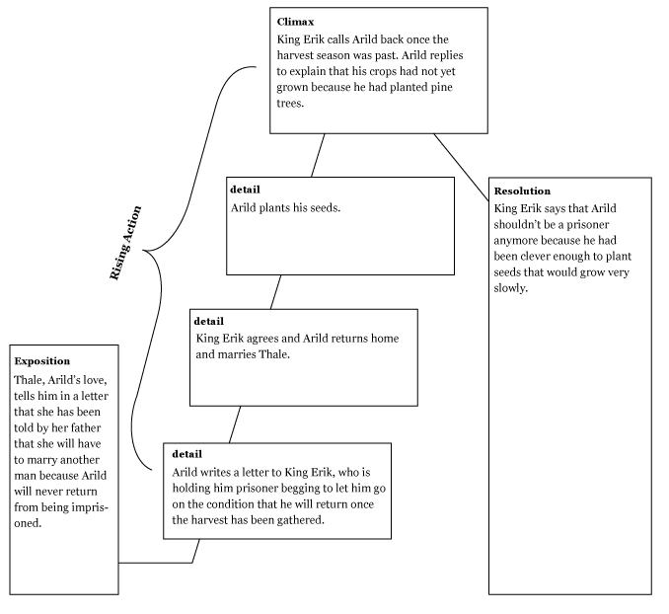

Mid-Unit 2 Assessment: Analyzing Narrative Structure and Author’s Craft:
Part 1 (Answers, for Teacher Reference)

- Write a summary paragraph of the story of “The Harvest That Never Came.” You may use the Narrative Structure note-catcher from the previous question to help you write your summary.

Thale, Arild’s love, tells him in a letter that her father has lined her up to marry another man because Arild will never return from being imprisoned. Arild writes a letter to his captor, King Erik, begging to let him return to his love on the condition that he will return after the harvest season. King Erik agrees and Arild returns home to marry Thale. He plants his seeds and when King Erik sends for him after the season, Arild explains that his crops have not yet grown because he planted pine trees. King Erik thinks this is very clever and releases Arild from being a prisoner.

- List two similarities and two differences between the Swedish myth “The Harvest That Never Came” by Aaron Shepard and the Greek myth “Pyramus and Thisbe” by Thomas Bulfinch.

Two Similarities | Two Differences
Both stories are about two young lovers who are separated by unfortunate circumstances.  Both lovers make a plan to be together. | Pyramus and Thisbe are kept separated by their parents, but Arild and Thale are separated because Arild is imprisoned because of war.  Pyramus and Thisbe both die as a result of their plan gone terribly wrong, while Arild and Thale live happily ever after as a result of Arild’s plan going better than expected.

Grade 8 Two-Point Rubric—Short Response

2-point Response | The features of a 2-point response are:
- Valid inferences and/or claims from the text where required by the prompt
- Evidence of analysis of the text where required by the prompt
- Relevant facts, definitions, concrete details, and/or other information from the text to develop response according to the requirements of the prompt
- Sufficient number of facts, definitions, concrete details, and/or other information from the text as required by the prompt
- Complete sentences where errors do not impact readability

1-point Response | The features of a 1-point response are:
- A mostly literal recounting of events or details from the text as required by the prompt
- Some relevant facts, definitions, concrete details, and/or other information from the text to develop response according to the requirements of the prompt
- Incomplete sentences or bullets

0-point Response | The features of a 0-point response are:
- A response that does not address any of the requirements of the prompt or is totally inaccurate
- No response (blank answer)
- A response that is not written in English
- A response that is unintelligible or indecipherable

¹From New York State Department of Education, October 6, 2012.

