Grade 8: Module 2B: Unit 2: Lesson 6
Analyzing How Shakespeare’s Play Draws upon Greek Mythology: Part 2

Long-Term Targets Addressed (Based on NYSP12 ELA CCLS)
I can objectively summarize literary text. (RL.8.2)
I can analyze how specific dialogue or incidents in a plot propel the action, reveal aspects of a character, or provoke a decision. (RL.8.3)
Supporting Learning Targets | Ongoing Assessment
- I can identify the narrative structure of the myth “Pyramus and Thisbe.”  - I can use the plot structure to summarize the myth “Pyramus and Thisbe.” | - A Midsummer Night’s Dream structured notes, 5.1.114–379 (from homework)  - “Pyramus and Thisbe” Narrative Structure  - “Pyramus and Thisbe” Summary  - Homework QuickWrite: The Thirst of the Lioness

Agenda | Teaching Notes
- Opening  - Engaging the Reader: Homework Focus Question (5 minutes)  - Reviewing Learning Targets (4 minutes)  - Work Time  - Narrative Structure of “Pyramus and Thisbe” (20 minutes)  - Summarizing the Plot (10 minutes)  - Closing and Assessment  - Partner Share (6 minutes)  - Homework  - QuickWrite: Write a paragraph to answer the question: How did the thirst of the lioness propel the action in the story “Pyramus and Thisbe”? | - In this lesson, students map out the narrative structure of the story “Pyramus and Thisbe” using a new narrative structure organizer. Since students have not seen this organizer before, it is completed with the students as a whole class, inviting them to suggest what should go in each box.  - Students use their completed narrative structure organizers to write a summary of the story “Pyramus and Thisbe.”  - In order to address standard RL.8.3, students will do a QuickWrite for homework in which they answer the question: How did the thirst of the lioness propel the action in the story “Pyramus and Thisbe”?  - Post: Learning targets.

Lesson Vocabulary | Materials
narrative structure, summary | - “Pyramus and Thisbe” Narrative Structure note-catcher (one per student and one for display)  - “Pyramus and Thisbe” by Thomas Bulfinch (from Lesson 4)  - “Pyramus and Thisbe” Narrative Structure note-catcher Teacher’s Guide (for teacher reference)  - Lined paper (one piece per student)  - Homework QuickWrite: The Thirst of the Lioness (one per student)  - Homework QuickWrite: The Thirst of the Lioness Teacher’s Guide (for teacher reference)

Opening | Meeting Students’ Needs
A. Engaging the Reader: Homework Focus Question (5 minutes)  - Invite students to sit with their Albany discussion partners.  - Have students discuss their answers to the homework focus question:  - “What does the audience of ‘Pyramus and Thisbe’ think of the play? How do you know?”  - After a minute, cold call a pair to share their responses to the focus question. Listen for students to explain that the audience thinks the play “Pyramus and Thisbe” is terrible and makes fun of it. Ask:  - “How is this version of the story similar to the play in A Midsummer Nights Dream? How is it different?”  - After a minute, cold call a pair to share their responses to the focus question. Listen for students to explain that the similarities are that the key characters are exactly the same and the plot is exactly the same. The differences are that there is more detail at the beginning of the story about how they live in adjoining houses and how their parents forbade them from getting married. There is also more detail in the story about what happens after their deaths. Also in the story Pyramus opens his eyes when he sees Thisbe before he dies. | - Opening the lesson by asking students to share their homework makes them accountable for completing it. It also gives you the opportunity to monitor which students are not doing their homework.
B. Reviewing Learning Targets (4 minutes)  - Read the learning targets aloud as students follow along silently:  - “I can identify the narrative structure of the myth ‘Pyramus and Thisbe.’”  - “I can use the plot structure to summarize the myth ‘Pyramus and Thisbe.’”  - Ask students:  - “What is the narrative structure of piece of literary text?”  - Select volunteers to share their responses. Listen for students to explain that the narrative structure is the way the plot is built and organized—so for example, most narratives have a setup, a conflict, and a resolution; therefore, the narrative structure is how the story is set up, what the conflict is, and what the resolution is.  - Ask students:  - “What is a summary of a text?”  - Cold call students to share their responses. Listen for them to explain that a summary is an account that outlines the main points of the text, and remind them that they wrote a summary of an informational text in Module 1. Explain that writing a summary of a narrative is just a bit different. | - Reviewing the key academic vocabulary in learning targets can prepare students for vocabulary they may encounter in the lesson.  - Posting learning targets allows students to reference them throughout the lesson to check their understanding. The learning targets also provide a reminder to students and teachers about the intended learning behind a given lesson or activity.

Work Time | Meeting Students’ Needs
A. Narrative Structure of “Pyramus and Thisbe” (20 minutes)  - Invite students to sit with their discussion partners. Display and distribute the “Pyramus and Thisbe” Narrative Structure note-catcher. Ask students to read it over and make an inference about what it is used for.  - Cold call one or two students to hear their inferences. Listen for them to say something like: “It is a map of the story,” or “It has parts of a story on it.”  - After students make their inferences, explain that this is a way to look at the plot of a story. It is also called a story arc. “Narrative” can be a synonym for “story.” Point to the elements on the note-catcher and explain that most stories have these elements. The exposition is where the reader gets to know the characters and the setting. It gives the reader context for the narrative. After that, narratives have a conflict that is developed in the rising action. A conflict is the problem in the story. For example, in the story “The Three Little Pigs,” the conflict is between the pigs and the wolf. The wolf wants to eat the pigs and the pigs want to live! The conflict leads to the climax, the turning point in the story that is often the most exciting or important event in the narrative. After that, the plot usually has a resolution that wraps up any loose ends.  - Invite students to read along silently as you reread aloud the first paragraph of “Pyramus and Thisbe” by Thomas Bulfinch to the class. Ask students to turn and talk to their partner about the information in that selection. Cold call pairs to share their ideas. Listen for students to say: “Pyramus and Thisbe live in Babylonia in adjoining houses,” “They love each other, but have been forbidden from marrying by their parents,” and “Pyramus and Thisbe communicate through a hole in the wall.” Write these responses in the Exposition box on the displayed graphic organizer and ask students to write them on their own graphic organizers. (If needed, refer to the “Pyramus and Thisbe” Narrative Structure note-catcher Teacher’s Guide for the rest of Work Time A.) Point out that this meets the criteria of exposition: The setting and a new character are introduced.  - Read the second paragraph aloud and invite students to read along silently.  - Again ask students to turn and talk about what happened in the plot in that excerpt. Cold call pairs to share. Listen for students to say: “Pyramus and Thisbe met at the hole in the wall and decided to meet at the Tomb of Ninus the next night,” and “Thisbe arrives first and gets frightened away by a lioness who chews the veil she loses as she flees.” Write these details on the displayed graphic organizer in the first two Details boxes under Rising Action and ask students to write them on their own graphic organizers.  - Read the third paragraph aloud and invite students to read along silently. | - Activating students’ prior knowledge helps them master new skills.  - Graphic organizers and recording forms engage students more actively and provide the necessary scaffolding that is especially critical for learners with lower levels of language proficiency and/or learning.  - Teaching the structure of a text supports all students, especially ELLs or students who struggle with reading, by making this important element of text explicit.

Work Time | Meeting Students’ Needs
- Again ask students to turn and talk about what happened in the plot in that excerpt. Listen for students to say: “Pyramus arrives at the tomb, finds the bloodied veil, and thinks Thisbe has been killed by the lioness.” Write this detail in the third Details box under Rising Action and ask students to write it on their own graphic organizers.
- Listen for students also to say: “Pyramus stabs himself in the heart with his sword in despair.” Record this in the top of the Climax box and ask students to write it on their own graphic organizers.
- Read the fourth paragraph aloud and invite students to read along silently.
- Once again ask students to turn and talk about what happened in the plot in that excerpt. Listen for students to say: “On finding Pyramus dead, Thisbe stabs herself in the heart.” Record this in the rest of the Climax box and ask students to write it on their own graphic organizers.
- Listen for students also to say: “Thisbe and Pyramus were buried together,” and “The berries of the mulberry bush were turned red to serve as a reminder of their blood.” Record these details in the Resolution box and ask students to write them on their own graphic organizers.
B. Summarizing the Plot (10 minutes)  - Distribute lined paper. Explain to students that they can use the “Pyramus and Thisbe” Narrative Structure note-catcher to help them write a summary of the story “Pyramus and Thisbe” because a summary is an account of the main points, and this note-catcher contains the main points.  - Model how to begin the summary using the “Pyramus and Thisbe” Narrative Structure note-catcher. Write on the board the contents of the Exposition box: “At the beginning of the story, Pyramus and Thisbe live next door to each other in Babylonia. They love each other but have been forbidden from marrying by their parents, so they communicate through a hole in the wall.”  - Invite students to work in pairs to use their “Pyramus and Thisbe” Narrative Structure note-catcher to write a summary of the story. | - Modeling how to use an organizer to write a summary provides a guide for students and outlines the expectations you have of their work.  - Consider working with students who may require assistance recording their ideas.  - Invite those students who may need support recording ideas to say their ideas aloud before writing anything.

Closing and Assessment | Meeting Students’ Needs
A. Partner Share (6 minutes)  - Invite students to pair up to share their summaries. Invite them to make revisions if they think it’s necessary based on what they see in their new partner’s work.  - Distribute Homework QuickWrite: The Thirst of the Lioness. | - Sharing work with peers enables students to self-assess and make improvements to their work by learning from others.
Homework | Meeting Students’ Needs
- QuickWrite: Write a paragraph to answer the question: How did the thirst of the lioness propel the action in the story “Pyramus and Thisbe”?

Grade 8: Module 2B: Unit 2: Lesson 6
Supporting Materials

“Pyramus and Thisbe” Narrative Structure Note-catcher

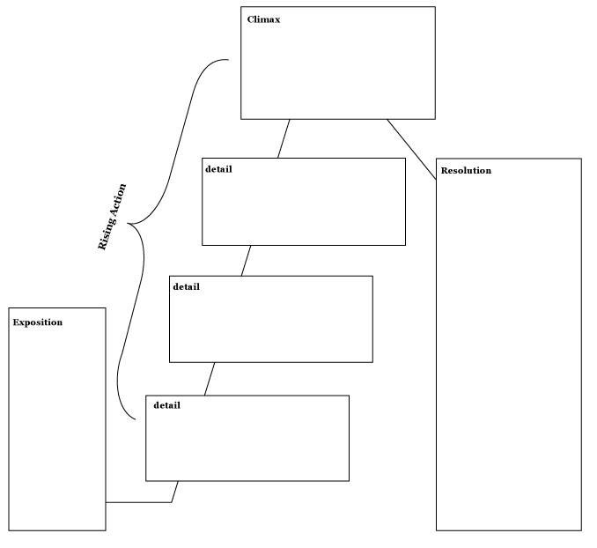
“Pyramus and Thisbe” Narrative Structure Note-catcher
(For Teacher Reference)

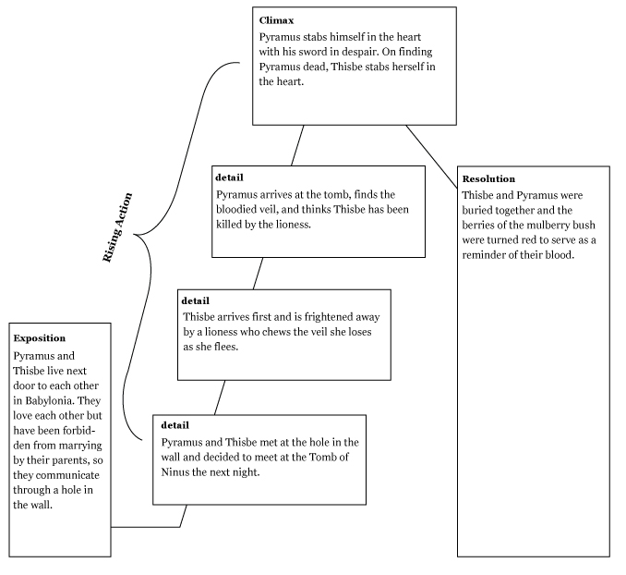
Homework QuickWrite: The Thirst of the Lioness

Name:
Date:

Focus question: How did the thirst of the lioness propel the action in the story “Pyramus and Thisbe”? What events did the thirst of the lioness cause? If she hadn’t been thirsty and wanted to drink at the fountain, how might things be different?

Homework QuickWrite: The Thirst of the Lioness Teacher’s Guide
(For Teacher Reference)

Name:
Date:

Focus question: How did the thirst of the lioness propel the action in the story “Pyramus and Thisbe”? What events did the thirst of the lioness cause? If she hadn’t been thirsty and wanted to drink at the fountain, how might things be different?

The thirst of the lioness caused the rest of the events in the story because it caused her to be in the same place as Thisbe. The presence of the lioness caused Thisbe to run away, dropping her veil, which the lion chewed and then Pyramus found; thinking Thisbe dead, Pyramus killed himself. Had the lioness not been thirsty, Thisbe would have been at the meeting place waiting for Pyramus as planned.

