Lesson 36
Objective: Arrange, analyze, and draw sequences of quantities that are 1 less in configurations other than towers.

Suggested Lesson Structure
 Fluency Practice (12 minutes)
 Application Problem (5 minutes)
 Concept Development (25 minutes)
 Student Debrief (8 minutes)
Total Time (50 minutes)
Fluency Practice (12 minutes)
- Cross 1 Out and Write How Many K.CC.4c (4 minutes)
- Show 1 Less K.CC.4c (4 minutes)
- Roll and Show 1 Less K.CC.4c (4 minutes)
Cross 1 Out and Write How Many (4 minutes)
Materials: (S) Draw 1 More Template (Lesson 32 Fluency Template)
This activity uses the same template as Lesson 32, but with a different task. After giving clear instructions and completing the first few problems together, allow students time to work independently. Encourage them to do as many problems as they can within a given timeframe.
Optional: Go over the answers, and direct students to energetically shout “Yes!” for each correct answer.
Show 1 Less (4 minutes)
Show me 1 less with fingers the Math Way.
T: Show me 3 fingers the Math Way.
S: (Hold up the left pinky, left ring finger, and the left middle finger to show 3 fingers the Math Way.)
T: Now, show me 1 less.
S: (Put down the left middle finger, so that only the left pinky and left ring finger remain, showing 2 the Math Way.)
T: How many fingers are you showing me now?
S: 2.
Avoid showing the finger combinations yourself. The Math Way will soon become an immediately recognizable configuration that will decrease the need for students to recount each time. Allow time to recount for students who still need to.
Roll and Show 1 Less (4 minutes)
Materials: (S) 1 die
1. Partner A rolls the die.
2. Both partners count the dots.
3. Partner B determines the number that is 1 less and shows that many fingers the Math Way.
4. Partner A verifies that the number is 1 less.
5. Switch roles and play again.
Remind students that if they should roll a 1, they can show 1 less by indicating 0 as a closed fist.
Application Problem (5 minutes)
Draw these number towers on the board.

NOTES ON
MULTIPLE MEANS
OF ENGAGEMENT:
Challenge students performing above grade level by extending the task. Suggestions include drawing and ordering the towers so that the picture shows 1 more, or drawing and ordering four more towers showing 1 less, using the numbers 5, 6, 7, and 8.

MP.2

Someone mixed up these towers! Draw the towers in order so that each tower in your picture shows 1 less. Write the numbers underneath the towers.
Note: Recalling the 1 less concept in linear formations helps children as they learn to count 1 less in other formations today.

Concept Development (25 minutes)
Materials: (S) Large construction paper work mat
(24" × 21") per pair inscribed as pictured to the right (circles should have a diameter of at least 4"), set of linking cube stairs from yesterday, red and blue crayons
T: Put your number towers on your desk in front of you. Make sure they are in order! Let’s check. Point to the correct tower and echo me: “10. One less is 9. 9. One less is 8….”
S: 10. One less is 9. 9. One less is 8…. (Continue through all the towers.)
T: We are going to make more bracelets today. Take your 10 tower apart, and put the cubes in the last circle on your work mat. (Demonstrate.) How many are in your last circle?
S: 10.

NOTES ON
MULTIPLE MEANS
OF ENGAGEMENT:
Help English language learners participate and explain why they do not have to count every cube in the circles by providing sentence starters such as, “I know that we don’t have to count every one of the cubes in the circles because….”

T: We have 10 cubes. One less is ______. (Wait for answer.)
S: 9!
T: Please show me your tower for 9. Take the cubes apart, and put them in the circle next to the 10. (Demonstrate.) How many?
S: 9.
T: We have 9 cubes. One less is _____. (Wait for answer.)
S: 8!
T: (Continue with this sequence until the cubes of each stair are scattered in their circle on the work mat. Circulate to ensure accuracy.)
T: Let’s count the cubes in our circles. Do we have to count every one of the cubes to know how many there are in each circle? Did the numbers change just because we broke apart our towers? (Discuss briefly.) Let’s count just to be sure….
S: 10. 1 less is 9. 9. 1 less is 8…
T: We will pretend we are making bracelets now. Move the cubes to the edges of their circles so that they are like beads on a bracelet. What do you notice? (Guide students to have a comparative discussion about size, shapes, and colors similar to that in Lesson 31.)
T: Do you remember what we did with our last set of bracelets? Take the cubes off the last circle, and draw red and blue beads there instead. (Demonstrate.) What would we do on the next circle?
S: Take off each cube, and draw a bead instead. When we get to the smaller numbers, we will only need our blue crayons!
T: Great ideas. Go ahead and carefully replace each of the cubes with a crayon bead. (Circulate to ensure accuracy.)
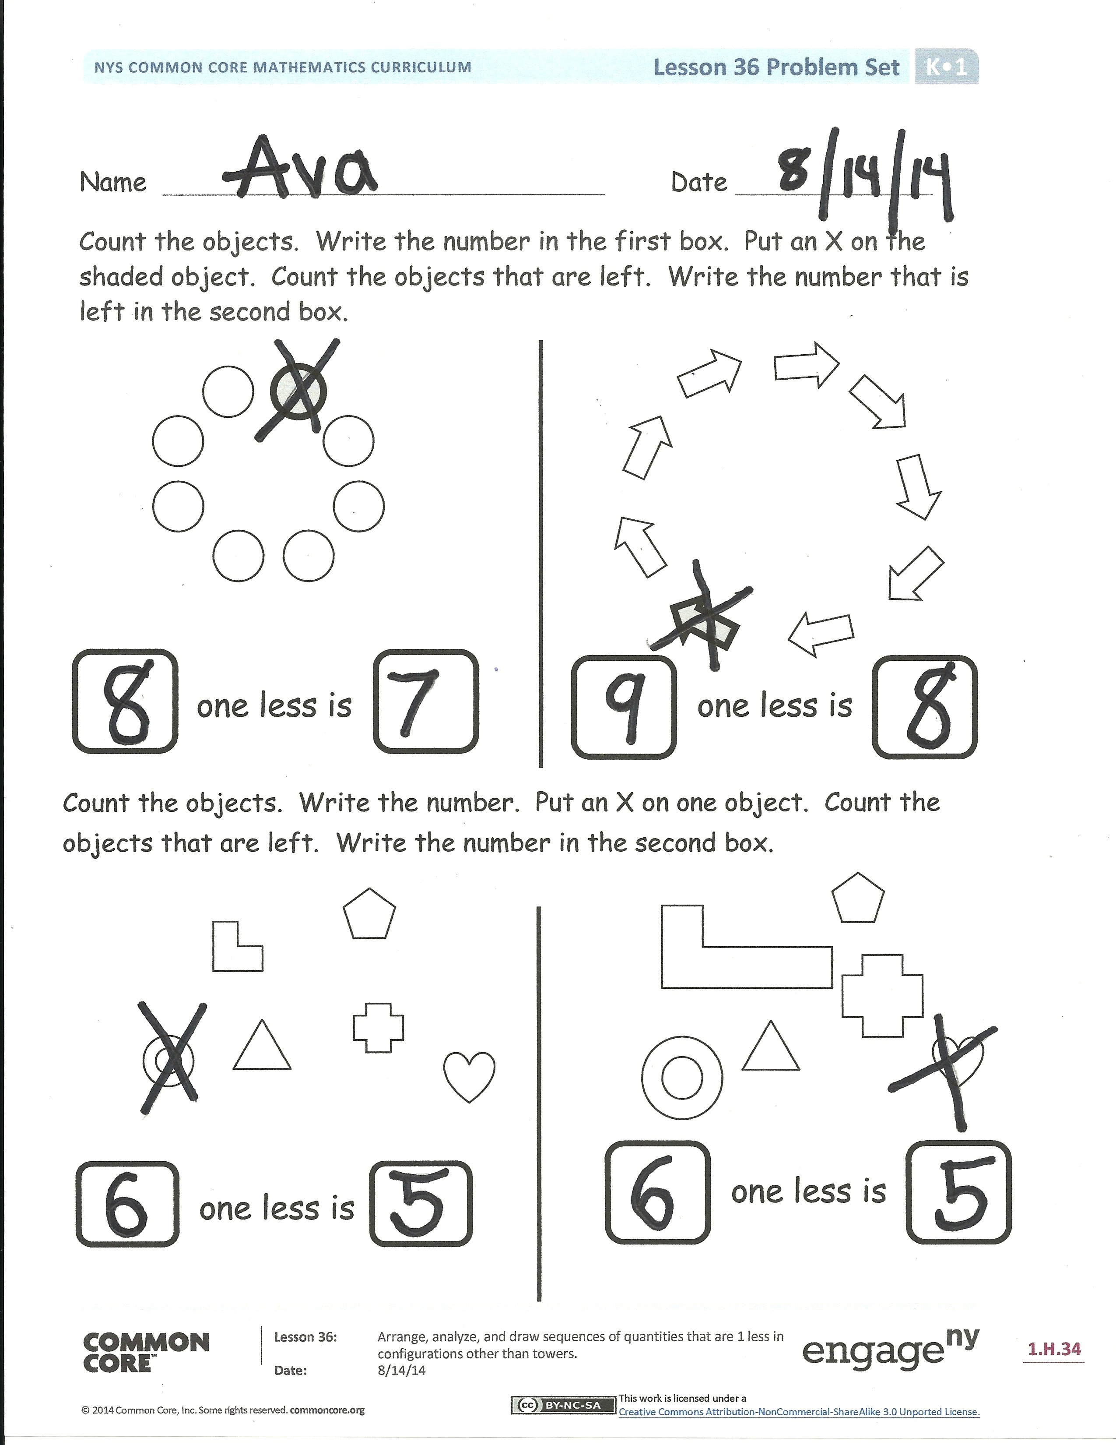
T: Now, we need to name our bracelets. Let’s call our last bracelet 10. What should we call the bracelet with 1 less?
S: 9.
T: Yes, we can name each one after its number of beads. Choose a crayon and label all of your bracelets. Now, you can take them home.
Problem Set (5 minutes)
Students should do their personal best to complete the Problem Set within the allotted time.
Distribute both pages to the students. Follow the directions. Review the phrase “9. One less is 8,” as students count and write the total and count what is left after crossing out 1 object.
Student Debrief (8 minutes)
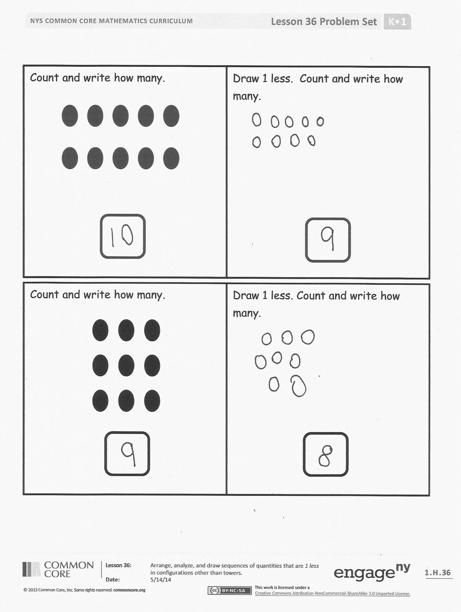
Lesson Objective: Arrange, analyze, and draw sequences of quantities that are 1 less in configurations other than towers.
The Student Debrief is intended to invite reflection and active processing of the total lesson experience.
Invite students to review their solutions for the Problem Set. They should check work by comparing answers with a partner before going over answers as a class. Look for misconceptions or misunderstandings that can be addressed in the Debrief. Guide students in a conversation to debrief the Problem Set and process the lesson.
You may choose to use any combination of the questions below to lead the discussion.
- What happens when you cross out 1 object from a group of objects?
- Look at the scattered set of objects. Show your neighbor the objects you put an X on. Tell them why you chose that object to cross out.
- Did you and your neighbor choose different objects or the same object to cross out? Did it make a difference when you counted how many were left?
Exit Ticket (3 minutes)
After the Student Debrief, instruct students to complete the Exit Ticket. A review of their work will help you assess the students’ understanding of the concepts that were presented in the lesson today and plan more effectively for future lessons. You may read the questions aloud to the students.

Name Date
Count the objects. Write the number in the first box. Put an X on the shaded object. Count the objects that are left. Write the number that is left in the second box.
one less is
one less is
one less is
Count the objects. Write the number. Put an X on one object. Count the objects that are left. Write the number in the second box.
one less is

Draw 1 less. Count and write how many.
Count and write how many.
Draw 1 less. Count and write how many.
Count and write how many.

Name Date
Fill in the missing numbers.

10, 9, ____, ____, ____, 5, 4, ____, _____, _____
Count and write the number of happy faces in the box. Draw another set below it that has one less, and write the number in your set.

My set:

Name _________________________ Date_______________
Draw bracelets to show 1 less than the number in the box.
If the number is missing, write it in the box.

4

5
9

100

Fill in the missing numbers.
_____, _____, 8, 7, _____, _____, _____, 3, 2, 1, _____

