Lesson 35

Objective: Arrange number towers in order from 10 to 1, and describe the pattern.

Suggested Lesson Structure

 Fluency Practice (12 minutes)

 Application Problem (5 minutes)

 Concept Development (25 minutes)

 Student Debrief (8 minutes)

**Total Time (50 minutes)**

Fluency Practice (12 minutes)

* Show Me 1 Less **K.CC.4c**  (4 minutes)
* Finish My Sentence (1 Less) **K.CC.4c** (4 minutes)
* Happy Counting Within 10 **K.CC.2** (4 minutes)

Show Me 1 Less (4 minutes)

Materials: (S) Bag of red and white beans, left hand mat (Lesson 1 Fluency Template)

T: Show me 3 beans.

S: (Place a red bean on the left pinky, left ring finger, and the left middle finger to show 3 beans.)

T: Now, show me 1 less.

S: (Remove a red bean from the left middle finger, leaving 2 beans.)

T: How many beans are on your mat now?

S: 2.

Stay within a predictable pattern until students are comfortable with this exercise, then skip around. Carefully observe to see which students must recount all of the beans to tell the number that is 1 less.

Finish My Sentence (1 Less) (4 minutes)

T: Raise your hand when you can finish this sentence. 3. One less is… (wait for all hands to go up, and then signal).

S: 2!

T: 2. One less is… (wait for all hands to go up, and then signal).

S: 1!

If students exhibit mastery, skip around after establishing a predictable pattern.

Happy Counting Within 10 (4 minutes)

Conduct the activity as outlined in Lesson 6. At this point, students will likely be ready for a challenge and will want to show how quickly they can do this exercise. Try alternating between a rapid pace and a very slow pace to keep students focused. Never allow them to rush the choral response. Ensure that they are always responding to the teacher’s signals.

Application Problem (5 minutes)

|  |  |
| --- | --- |
|  | NOTES ON  MULTIPLE MEANS  OF ENGAGEMENT: |
| Challenge students performing above grade level by asking them to repeat the problem with different numbers. Have them say how their two pictures are similar and how they are different. | |

Draw a snow girl that is 3 snowballs high. Next to her, draw a snow boy with 1 less. How many snowballs are in your snow boy? Compare your pictures with your friend’s.

Note: In this problem, the students begin thinking about linear comparisons of 1 less.

Concept Development (25 minutes)

Materials: (S) 1 set of linking cube stairs prepared per the instructions in Lesson 30, 1 set of 5-group cards (Lesson 7 Template, numeral side)

On the board, draw a pictorial chart similar to the one below. Cut out the images of the bear and the honey, and affix them to the board with tape to use in the lesson discussion.

C:\Users\store64\AppData\Local\Microsoft\Windows\Temporary Internet Files\Content.IE5\KBZFFY2J\MC900305467[1].wmf

C:\Users\store64\AppData\Local\Microsoft\Windows\Temporary Internet Files\Content.IE5\ZA32B5B8\MC900264344[1].wmf

T: Our friend baby bear is back! He is awake today and is very hungry for some honey. Do you think you can help show him the way?

S: Yes! He should go down the stairs.

|  |  |
| --- | --- |
|  | NOTES ON  MULTIPLE MEANS  OF REPRESENTATION: |
| Ask English language learners to practice telling a partner “1 less than 10 is 9,” etc., as they take apart a tower. Practicing the language will help English language learners to participate and to internalize the concepts being taught. | |

T: Which stair is he on now?

S: 10.

T: (Label the 10 stair.) Now, where should he go?

S: He should go down to the next stair. He should go to 9.

T: Say it with me while I move the bear: “10. One less is 9.” (Move bear to 9.)

S: 10. One less is 9.

T: Tell the bear where to go next. (As in Lesson 30, continue to repeat the pattern and label the stairs until the bear has reached the honey.)

T: He made it! Let’s count our stairs one more time the *1 less* way. Repeat after me: “10. One less is 9. 9. One less is 8….” (Point to the board stairs as you count.)

S: (Repeat counting sequence.)

T: Take the stair for 10 out of your bag. Check with your partner to make sure you both took out stairs that are exactly the same. What do you notice?

S: There are 5 red and 5 blue cubes. There are 10 cubes.

T: Take off 1 red cube. What do you see now?

S: We have 5 blue and 4 red. We have 9 cubes in our stair.

T: Yes. You had 10. One less is 9. Take off another red cube. One less is…

S: 8!

T: (Continue through sequence until students are holding only 1 cube.) Put your tower back together so it is exactly the same as when you took it out of the bag. Check with your partner to make sure.

S: (Discuss with partners.)

T: Remove all of the other stairs from your bag. Put them in order so the baby bear can get to the honey. If you need help, you may look at the board.

**MP.7**

S: (Arrange the stairs in decreasing order.)

T: Let’s count our stairs to be sure.

S: (Count on their stairs while the teacher demonstrates on the board.) 10. One less is 9. 9. One less is 8….

T: It’s time to name our stairs. Take out the 5-group cards. Look at each stair and put the card with the correct number next to the stair. When you are done, share your work with a partner. Show him how you would count your stairs the *1 less* way. (Circulate to ensure understanding and accuracy.)

T: We will be using your stairs again tomorrow, so put them back in the bag carefully.

Problem Set (5 minutes)

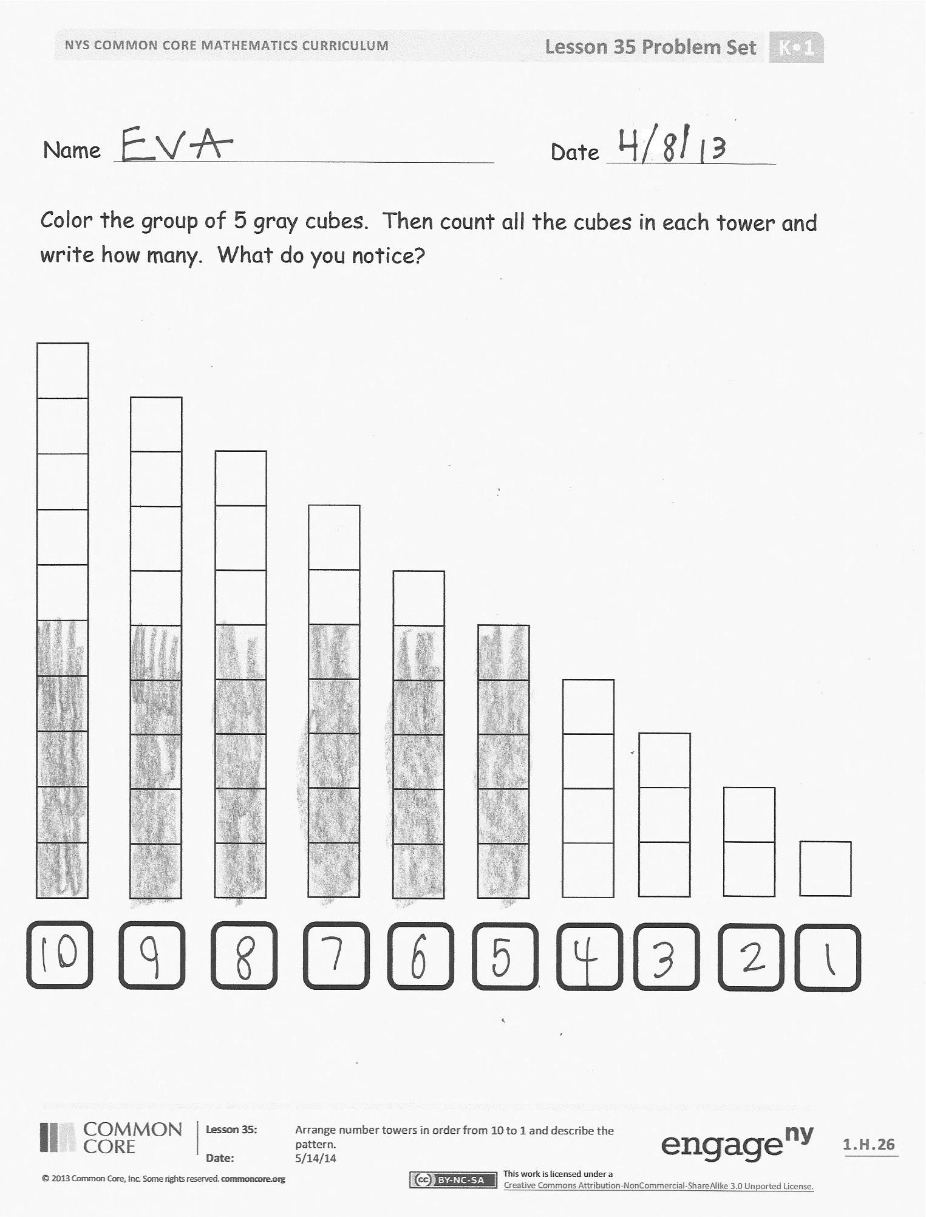Students should do their personal best to complete the Problem Set within the allotted time.

Distribute the Problem Set to students. Guide students to color the bottom group of 5 cubes. Then, count the cubes and write how many. Ask students to think about what they notice as they are coloring and counting.

On the second page, count the number of cubes in a stair. Then, cross off the top square. As you cross off each square, you should say, “10. One less is 9. 9. One less is 8.” Keep this going until you reach the bottom of the stairs.

Student Debrief (8 minutes)

**Lesson Objective**: Arrange number towers in order from 10 to 1 and describe the pattern.

The Student Debrief is intended to invite reflection and active processing of the total lesson experience.

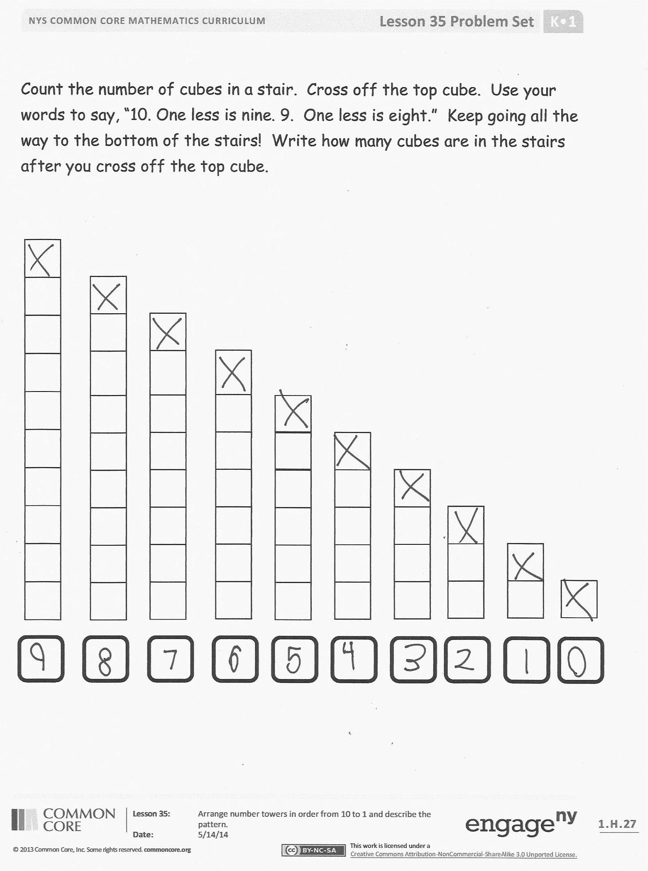Invite students to review their solutions for the Problem Set. They should check work by comparing answers with a partner before going over answers as a class. Look for misconceptions or misunderstandings that can be addressed in the Debrief. Guide students in a conversation to debrief the Problem Set and process the lesson.

You may choose to use any combination of the questions below to lead the discussion.

* How did you count the cubes? Is there an easier way to count them? Did it help to color the 5 cubes? How did that help?
* Did you notice a pattern when you counted the cubes? How was it different from counting cubes in Lesson 30?
* What did you notice about the stairs on the second page of the Problem Set? Let’s start with the first tower and repeat the words you said. “10. One less is 9.” Keep going as a whole group. Have students repeat this with their partners.

Exit Ticket (3 minutes)

After the Student Debrief, instruct students to complete the Exit Ticket. A review of their work will help you assess the students’ understanding of the concepts that were presented in the lesson today and plan more effectively for future lessons. You may read the questions aloud to the students.

Name Date

Color the group of 5 gray cubes. Then, count all the cubes in each tower and write how many. What do you notice?

Count the number of cubes in a stair. Cross off the top cube. Use your words to say, “10. One less is nine. 9. One less is eight.” Keep going all the way to the bottom of the stairs! Write how many cubes are in the stairs after you cross off the top cube.

Name Date

Count and say the number of cubes in the towers. Count the cubes that are crossed out. Say “1 less” and write the number.



Name Date

Count and color the cubes in the tower. Cross the top cube off, and write the number. Draw the next tower with 1 less cube until there are no towers left.