Lesson 34

Objective: Count down from 10 to 1, and state 1 less than a given number.

Suggested Lesson Structure

 Fluency Practice (12 minutes)

 Application Problem (5 minutes)

 Concept Development (25 minutes)

 Student Debrief (8 minutes)

**Total Time (50 minutes)**

Fluency Practice (12 minutes)

* Green Light, Red Light **K.CC.2** (4 minutes)
* Wet Dog Counting **K.CC.4a** (4 minutes)
* Rekenrek **K.CC.2** (4 minutes)

Green Light, Red Light (4 minutes)

Conduct the activity as outlined in Lesson 5, but now focus more on counting down.

Wet Dog Counting (4 minutes)

T: Pick a number between 1 and 10. (Call on a student.)

S: 4.

T: Wet dog, counting down from 4. Ready?

S: 4, 3, 2, 1 (while shaking the right arm), 4, 3, 2, 1 (while shaking the left arm), 4, 3, 2, 1 (while shaking the right leg), 4, 3, 2, 1 (while shaking the left leg).

Select another student to choose another number, and repeat.

Rekenrek (4 minutes)

Repeat the whisper/talk and think/talk Rekenrek counting activity as outlined in Lesson 28.

Application Problem (5 minutes)

|  |  |
| --- | --- |
|  | NOTES ON  MULTIPLE MEANS  OF REPRESENTATION: |
| Help English language learners solve the problem by first reading to them and then modeling the different steps. Explain the concept *1 less* by showing an example of 1 less than any number within 10 looks like. | |

Draw 2 plates. On your first plate, draw 8 grapes. On the next, draw 1 less. Write the numbers below the plates. Now, draw 2 cups. In the first cup, draw 6 straws. In the next, draw 1 less. Write the numbers below the cups.

**MP.1**

Note: Reviewing the concept of *1 less* prepares students for counting down in today’s lesson.

Concept Development (25 minutes)

Materials: (T) Large tree drawn on the board, 10 cardboard apples affixed with tape to the tree in a circular formation, simple puppet made from a paper bag to represent a farmer   
(S) 5-group cards (Lesson 7 Template, numeral side)

T: We are going to have a math play. What do you notice on the board?

S: I see an apple tree. There are 10 apples on the tree.

T: Listen to my story. Once upon a time, there was a farmer who had an apple orchard. (Introduce the farmer puppet). It was harvest time, and the farmer picked his first apple of the season. (Remove an apple from the tree with the puppet. Be sure to remove the apples in an order that mimics the sequence of the robot activity in the Problem Set below). How many apples does he have left?

S: There are 9 apples.

T: There were 10 apples. **One** **less** is 9. We have 9 apples.

|  |  |
| --- | --- |
|  | NOTES ON  MULTIPLE MEANS  OF ACTION AND EXPRESSION: |
| Repeat the game in a small group for students who are performing below grade level so that they have an opportunity to practice counting 1 less. Ask them to say how they know what *1 less* is by asking them to restate what they did. | |

T: The next day, he picked another apple. (Demonstrate.) How many are on the tree now?

S: 8!

T: Yes, 1 less is 8. (Continue with the story until all but 1 have been picked.) Let’s do our play one more time, and this time we’ll tell the story just with numbers. (Count and replace apples in preparation to repeat activity.) Say it with me.

S: 10! One less is 9. 9. One less is 8. 8.... (Continue until there is only 1 apple left.)

T: What would happen if he picked the last apple? (Allow time for discussion to recall the concept of 0.)

T: Let’s play a game. I’ll put some apples on the tree. Count them silently, and think about the number that would be 1 less. Raise your hand when you know. When you hear the magic snap, tell me the number that would be 1 less.

S: (Answer chorally.)

T: (Repeat several times with different numbers of apples until the students are confident in their answers and demonstrate clear understanding of *1 less*.)

T: Now, we will tell the story in a different way with our Problem Set.

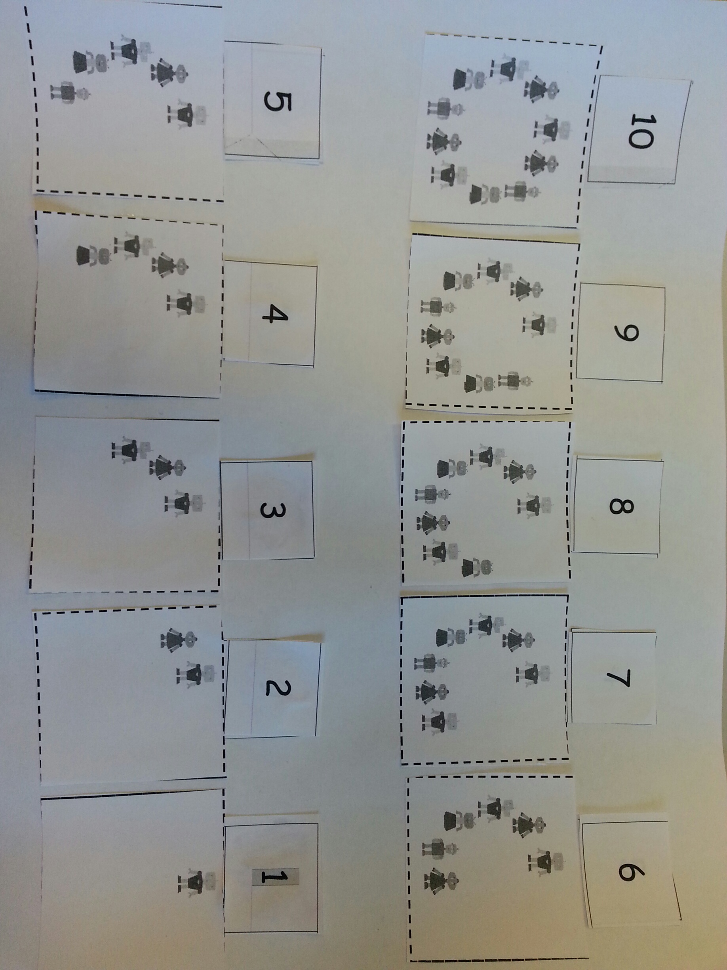Problem Set (5 minutes)

Students should do their personal best to complete the Problem Set within the allotted time.

Distribute double 5-group mat and robot cutouts. Read the story all the way through before the students do any cutting. Then, have them cut out all the robot circles. Each student should place their cutouts so that they can see them all. Read the story again as students glue their cutouts in the right place.

Student Debrief (8 minutes)

**Lesson Objective**: Count down from 10 to 1, and state 1 less than a given number.

The Student Debrief is intended to invite reflection and active processing of the total lesson experience.

Invite students to review their solutions for the Problem Set. They should check work by comparing answers with a partner before going over answers as a class. Look for misconceptions or misunderstandings that can be addressed in the Debrief. Guide students in a conversation to debrief the Problem Set and process the lesson.

You may choose to use any combination of the questions below to lead the discussion.

* With a partner, take turns telling the story again. Partner 1 says, “Ten robots were playing in a circle. One robot’s mom called and he had to go home. 10. **One less** is 9.” Then, Partner 2 says, “Nine robots were playing in a circle. One robot’s mom called and he had to go home. 9. One less is 8.” See how far you can get with the story.
* How many robots had to go home each time? What happened to the circle when he left?
* Did you see a pattern after each robot left?

Exit Ticket (3 minutes)

After the Student Debrief, instruct students to complete the Exit Ticket. A review of their work will help you assess the students’ understanding of the concepts that were presented in the lesson today and plan more effectively for future lessons. You may read the questions aloud to the students.

Name Date

Read the story to the students. Have students cut out the robots. Read the story again as the students glue the robots on the 5-group mat.

10 robots were playing in a circle. 1 robot’s mom called, and he had to go home. 10. One less is nine. 9 robots were playing in a circle. 1 robot’s mom called, and he had to go home. 9. One less is eight. 8 robots were playing in a circle. 1 robot’s mom called, and he had to go home. 8. One less is seven. 7 robots were playing in a circle. 1 robot’s mom called, and he had to go home. 7. One less is six. 6 robots were playing in a circle. 1 robot’s mom called, and he had to go home. 6. One less is five. 5 robots were playing in a circle. 1 robot’s mom called, and he had to go home. 5. One less is four. 4 robots were playing in a circle. 1 robot’s mom called, and he had to go home. 4. One less is three. 3 robots were playing in a circle. 1 robot’s mom called, and he had to go home. 3. One less is two. 2 robots were playing in a circle. 1 robot’s mom called, and he had to go home. 2. One less is one. And, he played happily ever after!

|  |  |  |  |  |
| --- | --- | --- | --- | --- |
| 1 | 2 | 3 | 4 | 5 |
| 6 | 7 | 8 | 9 | 10 |









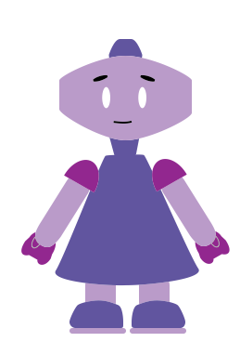





































































































Name Date

Count and write the number of apples. Color only the group of apples that is 1 less.





Count and write the number of hearts. Color only the group of hearts that is 1 less.

Name Date

Count and color the triangles. Draw a group of triangles that is 1 less. Write how many you drew.





Count and color the pears. Draw a group of pears that is 1 less. Write how many you drew.

[####](http://openclipart.org/detail/8543/simple-fruit-pear-by-gerald_g-8543)

[#](http://openclipart.org/detail/8543/simple-fruit-pear-by-gerald_g-8543) [##](http://openclipart.org/detail/8543/simple-fruit-pear-by-gerald_g-8543)