Lesson 33

Objective: Order quantities from 10 to 1 and match numerals.

Suggested Lesson Structure

 Fluency Practice (12 minutes)

 Application Problem (5 minutes)

 Concept Development (25 minutes)

 Student Debrief (8 minutes)

**Total Time (50 minutes)**

Fluency Practice (12 minutes)

* Sunrise/Sunset Counting to 10 **K.CC.2** (4 minutes)
* 1, 2, 3, Stand on 10 K.CC.2 (4 minutes)
* Make It Equal K.CC.6 (4 minutes)

Sunrise/Sunset Counting to 10 (4 minutes)

Conduct the activity as outlined in Lesson 7, but remind students to plan to reach 5 as the midpoint and 10 at the highest position.

1, 2, 3, Stand on 10 (4 minutes)

Conduct the activity as outlined in Lesson 22.

Make It Equal (4 minutes)

Materials: (S) Bag of beans, laminated paper or foam work mat, die

1. The teacher introduces the term *equal* as meaning *the same number*.

2. Both partners roll dice, and put that many beans on their mat.

3. Partner A has to make their beans equal to their partner’s by taking off or putting on more beans.

4. Partner B counts to verify.

5. Switch roles and play again.

Application Problem (5 minutes)

Preparation: Draw a baking tray on the board like the one below:

|  |  |
| --- | --- |
|  | NOTES ON  MULTIPLE MEANS  OF ENGAGEMENT: |
| Challenge students who are performing above grade level by extending the Application Problem:   * Draw another baking tray to show how many biscuits are left if the kitten steals 2 biscuits. * Write both the number of the remaining biscuits and the number of biscuits the kitten stole. | |

Margaret baked some biscuits for dinner. While they were cooling, her kitten jumped on the table and took one away. Draw the tray to show how many biscuits Margaret can serve for dinner. Don’t forget to cross off the one that the kitten took! Write the number.

Note: This problem presents a practical application of *1 less*.

Concept Development (25 minutes)

Materials: (T) Large numeral cards 1–10 (Lesson 8 template) or a number path written on the board   
(S) Bag of loose linking cubes (5 blue, 5 red), 5-group dot mat (Lesson 17 Template), 1 set of   
5-group cards (Lesson 7 template)

T: Put a 5-group mat in front of you. Place 1 blue linking cube in each place on the mat. How many blue cubes do you have?

S: 5.

T: Now, put each red linking cube on the mat. What do you notice?

S: We have a row of blue and a row of red. 🡪 We have 10 cubes. (Guide students to see that this configuration looks just like the dot representation of 10 on their cards.)

T: Find the card that shows how many linking cubes are on your mat. We will begin a row of cards, starting with this 10 card. Put it on your desk so that the dot side is facing up. Now, take the last red cube from your card, and put it back in the bag. What do you see?

S: We still have a row of 5 blue cubes, but now we have 4 red cubes. We have 9 cubes. It looks like our 5-group mat for 9!

T: Find the card that shows how many linking cubes are on your mat. Does it look exactly the same as your 5-group mat?

**MP.2**

S: Yes! It’s the same.

T: Put it next to the 10 in your card row. (Repeat until there is only 1 cube left on the first 5-group mat.)

T: How many cubes are on your mat?

S: 1.

T: How many cards do you have left?

S: 1.

|  |  |
| --- | --- |
|  | NOTES ON  MULTIPLE MEANS  OF REPRESENTATION: |
| Help English language learners understand what to do by modeling. Model for students how to be number detectives so that they understand what is being asked of them. | |

T: Let’s put the last card in our row. Does anyone notice anything about the row of cards?

S: There are more dots on the first ones. 🡪 There is only 1 on the last one. 🡪 They get smaller!

T: Put the last cube away, and let’s look at our cards. Touch each card, and tell how many dots are on it. We will go down the row. (Demonstrate.)

S: 10, 9, 8, 7, 6, 5, 4, 3, 2, 1.

T: Put your cards in a stack. We will play Mix and Fix. Mix up your cards, and then see how quickly you can put them back in a row. Make sure the card with 10 dots is on the left!

S: (Arrange cards. Circulate to ensure accuracy.)

T: I want you to be number detectives. When I point to a number on our number path, I want you to find the dot card that matches. Ready? Hold it up high! (Repeat several times until students are confident matching the numerals to the dot configurations.)

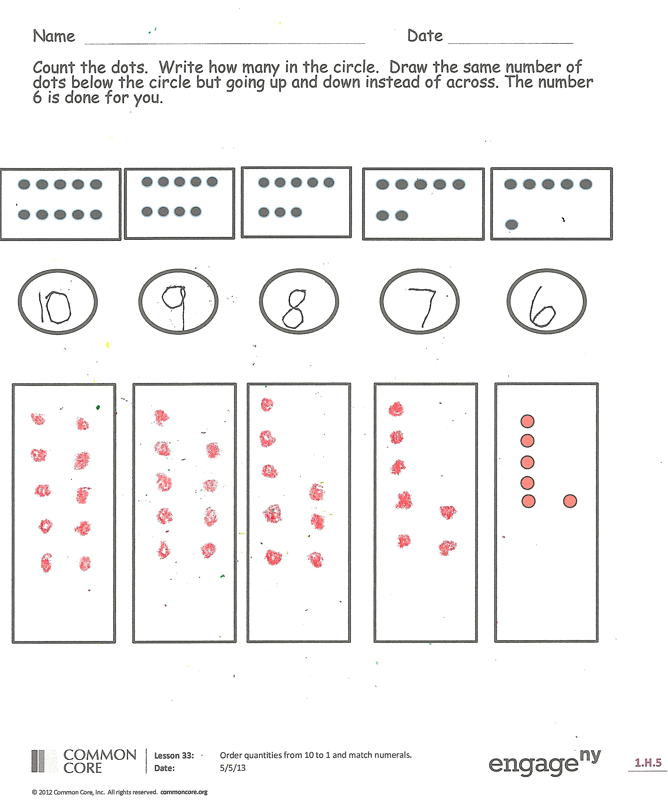Problem Set (5 minutes)

Students should do their personal best to complete the Problem Set within the allotted time.

Distribute the Problem Set to students. Students count the dots and write how many. Guide students in drawing the same number of dots below the box going up and down. Model the 10 dots for students, or let students model for the class.

Remind students to count the objects, then cross out 1 and count again, writing how many.

Student Debrief (8 minutes)

**Lesson Objective**: Order quantities from 10 to 1 and match numerals.

The Student Debrief is intended to invite reflection and active processing of the total lesson experience.

Invite students to review their solutions for the Problem Set. They should check work by comparing answers with a partner before going over answers as a class. Look for misconceptions or misunderstandings that can be addressed in the Debrief. Guide students in a conversation to debrief the Problem Set and process the lesson.

You may choose to use any combination of the questions below to lead the discussion.

* 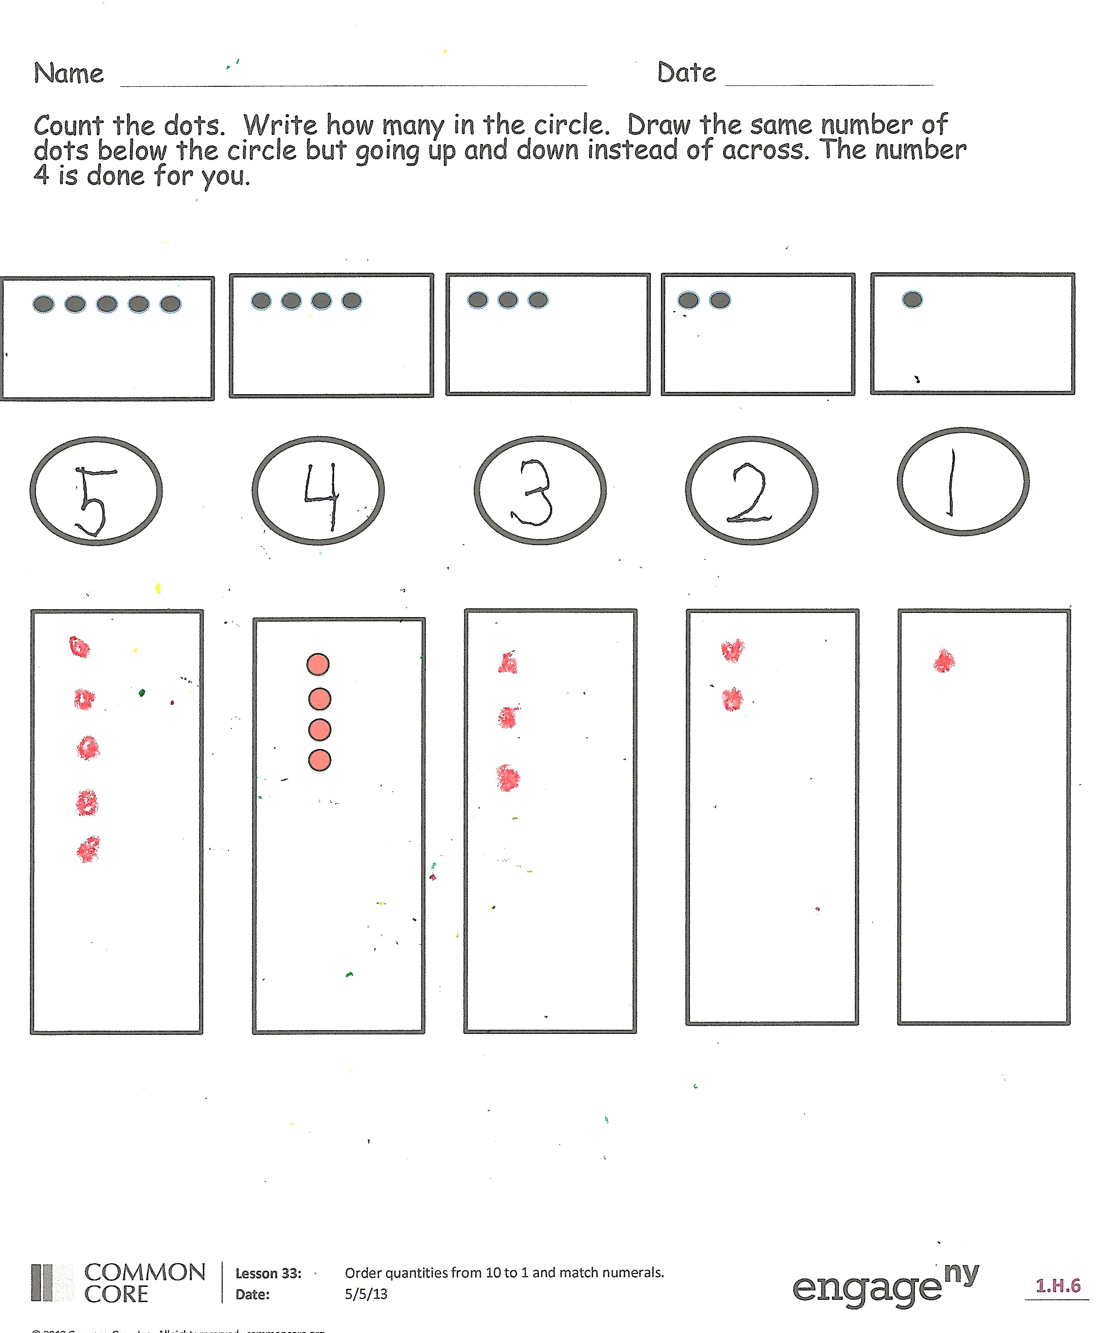How did you count the dots? Did you count the same way as your partner? Did it help to color the 5-dot groups first?
* Did you notice a pattern as you counted? (Focus on the pattern of *1 less*.)

Exit Ticket (3 minutes)

After the Student Debrief, instruct students to complete the Exit Ticket. A review of their work will help you assess the students’ understanding of the concepts that were presented in the lesson today and plan more effectively for future lessons. You may read the questions aloud to the students.

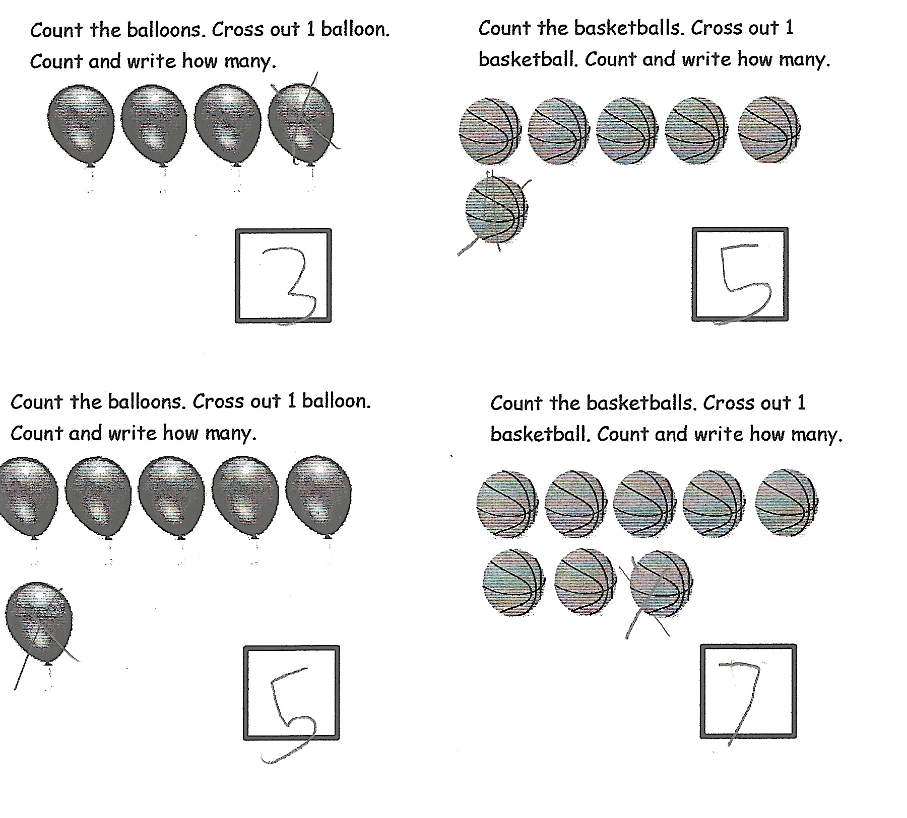

Name Date

Count the dots. Write how many in the circle. Draw the same number of dots below the circle, but going up and down instead of across. The number 6 is done for you.

Count the dots. Write how many in the circle. Draw the same number of dots below the circle, but go up and down instead of across. The number 4 is done for you.



Count the balloons. Cross out 1 balloon. Count and write how many balloons are left in the box.

Count the basketballs. Cross out 1 basketball. Count and write how many basketballs are left in the box.



Count the basketballs. Cross out 1 basketball. Count and write how many basketballs are left in the box.



Count the balloons. Cross out 1 balloon. Count and write how many balloons are left in the box.



Draw a line to match the picture to its number.

Name Date

**8**

**8**

**8**

**8**

**8**

**8**

**8**

**8**

**8**

C:\Users\store64\AppData\Local\Microsoft\Windows\Temporary Internet Files\Content.IE5\KBZFFY2J\MC900238187[1].wmfC:\Users\store64\AppData\Local\Microsoft\Windows\Temporary Internet Files\Content.IE5\KBZFFY2J\MC900238187[1].wmfC:\Users\store64\AppData\Local\Microsoft\Windows\Temporary Internet Files\Content.IE5\KBZFFY2J\MC900238187[1].wmfC:\Users\store64\AppData\Local\Microsoft\Windows\Temporary Internet Files\Content.IE5\KBZFFY2J\MC900238187[1].wmfC:\Users\store64\AppData\Local\Microsoft\Windows\Temporary Internet Files\Content.IE5\KBZFFY2J\MC900238187[1].wmfC:\Users\store64\AppData\Local\Microsoft\Windows\Temporary Internet Files\Content.IE5\KBZFFY2J\MC900238187[1].wmfC:\Users\store64\AppData\Local\Microsoft\Windows\Temporary Internet Files\Content.IE5\KBZFFY2J\MC900238187[1].wmfC:\Users\store64\AppData\Local\Microsoft\Windows\Temporary Internet Files\Content.IE5\KBZFFY2J\MC900238187[1].wmfC:\Users\store64\AppData\Local\Microsoft\Windows\Temporary Internet Files\Content.IE5\KBZFFY2J\MC900238187[1].wmfC:\Users\store64\AppData\Local\Microsoft\Windows\Temporary Internet Files\Content.IE5\KBZFFY2J\MC900238187[1].wmf

**6**

**8**

**8**

**8**

**8**

**8**

**8**

**8**

**8**

C:\Users\store64\AppData\Local\Microsoft\Windows\Temporary Internet Files\Content.IE5\4HNJXDX3\MC900326480[1].wmfC:\Users\store64\AppData\Local\Microsoft\Windows\Temporary Internet Files\Content.IE5\4HNJXDX3\MC900326480[1].wmfC:\Users\store64\AppData\Local\Microsoft\Windows\Temporary Internet Files\Content.IE5\4HNJXDX3\MC900326480[1].wmfC:\Users\store64\AppData\Local\Microsoft\Windows\Temporary Internet Files\Content.IE5\4HNJXDX3\MC900326480[1].wmf

C:\Users\store64\AppData\Local\Microsoft\Windows\Temporary Internet Files\Content.IE5\4HNJXDX3\MC900326480[1].wmfC:\Users\store64\AppData\Local\Microsoft\Windows\Temporary Internet Files\Content.IE5\4HNJXDX3\MC900326480[1].wmfC:\Users\store64\AppData\Local\Microsoft\Windows\Temporary Internet Files\Content.IE5\4HNJXDX3\MC900326480[1].wmfC:\Users\store64\AppData\Local\Microsoft\Windows\Temporary Internet Files\Content.IE5\4HNJXDX3\MC900326480[1].wmf

**5005**

**8**

**8**

**8**

**8**

**8**

**8**

**8**

**8**

**100**

**8**

**8**

**8**

**8**

**8**

**8**

**8**

**8**

**3**

**8**

**8**

**8**

**8**

**8**

**8**

**8**

**8**

**9**

**8**

**8**

**8**

**8**

**8**

**8**

**8**

**8**

**2**

**8**

**8**

**8**

**8**

**8**

**8**

**8**

**8**

**4**

**8**

**8**

**8**

**8**

**8**

**8**

**8**

**8**

**1**

**8**

**8**

**8**

**8**

**8**

**8**

**8**

**8**

**7**

**8**

**8**

**8**

**8**

**8**

**8**

**8**

**8**

C:\Users\store64\AppData\Local\Microsoft\Windows\Temporary Internet Files\Content.IE5\4HNJXDX3\MC900417528[1].wmf

C:\Users\store64\AppData\Local\Microsoft\Windows\Temporary Internet Files\Content.IE5\Q11W2AUA\MC900358179[1].wmfC:\Users\store64\AppData\Local\Microsoft\Windows\Temporary Internet Files\Content.IE5\Q11W2AUA\MC900358179[1].wmf

C:\Users\store64\AppData\Local\Microsoft\Windows\Temporary Internet Files\Content.IE5\KBZFFY2J\MC900192309[1].wmfC:\Users\store64\AppData\Local\Microsoft\Windows\Temporary Internet Files\Content.IE5\KBZFFY2J\MC900192309[1].wmfC:\Users\store64\AppData\Local\Microsoft\Windows\Temporary Internet Files\Content.IE5\KBZFFY2J\MC900192309[1].wmfC:\Users\store64\AppData\Local\Microsoft\Windows\Temporary Internet Files\Content.IE5\KBZFFY2J\MC900192309[1].wmf

C:\Users\store64\AppData\Local\Microsoft\Windows\Temporary Internet Files\Content.IE5\ZA32B5B8\MC900233594[1].wmfC:\Users\store64\AppData\Local\Microsoft\Windows\Temporary Internet Files\Content.IE5\ZA32B5B8\MC900233594[1].wmfC:\Users\store64\AppData\Local\Microsoft\Windows\Temporary Internet Files\Content.IE5\ZA32B5B8\MC900233594[1].wmfC:\Users\store64\AppData\Local\Microsoft\Windows\Temporary Internet Files\Content.IE5\ZA32B5B8\MC900233594[1].wmfC:\Users\store64\AppData\Local\Microsoft\Windows\Temporary Internet Files\Content.IE5\ZA32B5B8\MC900233594[1].wmf

C:\Users\store64\AppData\Local\Microsoft\Windows\Temporary Internet Files\Content.IE5\Q11W2AUA\MC900111472[1].wmfC:\Users\store64\AppData\Local\Microsoft\Windows\Temporary Internet Files\Content.IE5\Q11W2AUA\MC900111472[1].wmfC:\Users\store64\AppData\Local\Microsoft\Windows\Temporary Internet Files\Content.IE5\Q11W2AUA\MC900111472[1].wmfC:\Users\store64\AppData\Local\Microsoft\Windows\Temporary Internet Files\Content.IE5\Q11W2AUA\MC900111472[1].wmfC:\Users\store64\AppData\Local\Microsoft\Windows\Temporary Internet Files\Content.IE5\Q11W2AUA\MC900111472[1].wmfC:\Users\store64\AppData\Local\Microsoft\Windows\Temporary Internet Files\Content.IE5\Q11W2AUA\MC900111472[1].wmf

      

Make 5-group Cards.

Cut the cards out on the dotted lines. On one side, write the numbers from 1-10. On the other side, show the 5-group dot picture that goes with the number. Mix up your cards, and practice putting them in order in the “1 less” way.