Grade 6: Module 1: Unit 2: Lesson 7
Analyzing the Model Analytical Mini-Essay:
“Elements of Mythology and Theme of Cronus”

Long-Term Targets Addressed (Based on NYSP12 ELA CCLS)
I can analyze how a particular sentence, paragraph, chapter, or section fits into the overall structure of a text and contributes to the
development of the ideas. (RI.6.5)
I can write informative/explanatory texts that convey ideas and concepts using relevant information that is carefully selected and organized. (W.6.2)
With support from peers and adults, I can use a writing process to produce clear and coherent writing. (W.6.5)
I can use evidence from a variety of grade-appropriate texts to support analysis, reflection, and research. (W.6.9)
Supporting Learning Targets | Ongoing Assessment
- I can describe the structure of an analytical mini-essay.  - I can describe the details the author used to make a claim about the elements of a myth.  - I can describe the details the author used to make a claim about the theme of a myth.  - I can explain why an author chose particular details to support a claim. | - Elements of Myth graphic organizer (for the model mini-essay)  - Theme graphic organizer (for the model mini-essay)

Agenda | Teaching Notes
- Opening  - Engaging the Reader: Text-Dependent Vocabulary Questions from Chapter 15 of The Lightning Thief (5 minutes)  - Work Time  - Analyzing a Model Mini-Essay (15 minutes)  - Partner Work: How This Author Might Have Planned the Analytical Mini-Essay (20 minutes)  - Closing and Assessment  - Feedback: Comparing Our Graphic Organizers to the Author’s (5 minutes)  - Homework  - Read Chapter 16 of The Lightning Thief. With your evidence flags, mark three allusions (references) to myths, stories, or characters you find. Also record any new or challenging vocabulary for a discussion at the beginning of the next lesson. | - In previous lessons, students learned how to identify a myth and the themes in a myth by closely reading for details of mythological elements.  - This lesson introduces students to a model mini-essay with two body paragraphs: one in which the author describes elements of mythology in the myth of Cronus, and a second in which the author describes a significant theme in that same myth. It is called a mini-essay because it has a very short introduction and conclusion (just one sentence each). This model essay provides an example of what students will be expected to write for their mid-unit assessment.  - This lesson addresses W.6.5 because by analyzing a model essay, students are preparing to write an analytical mini-essay for the mid-unit assessment.  - In this lesson, students work with the Elements of Myth graphic organizer and the Theme graphic organizer. They practice using these two graphic organizers to become familiar with how to use them to organize their thinking; they will use these organizers more independently later for the mid-unit assessment.  - Students begin by analyzing the structure of the Analytical Mini-Essay: “Elements of Mythology and Theme of Cronus.” They then take the two body paragraphs in the model mini-essay (one at a time) and use “reverse engineering” to think about the planning the author of the model mini-essay would have done before writing. To do this, they fill out the Elements of Myth graphic organizer and Themes graphic organizer.They then compare their graphic organizers to the sample graphic organizers to identify where they have made errors and why.  - In advance: Review Analytical Mini-Essay: “Elements of Mythology and Theme of Cronus”; the Elements of Myth graphic organizer and Theme graphic organizer, and the completed samples of the two graphic organizers (all in supporting materials). The Themes graphic organizer is adapted in collaboration with Odell Education based on their Evidence-Based Claims worksheet (also see stand-alone document on EngageNY.org and odelleducation.com/resources).  - Note that these organizers support students in arriving at a claim through an inductive thinking process. Students begin by identifying details in the text that highlight elements of mythology or theme, and they record those details in the first row of boxes. In the second row of boxes they describe what they think about that detail, particularly in terms of how it relates to elements of mythology or theme. In the next row they connect all the details together and describe how the details are all linked, and in the final row they then use that to help them make a claim about elements of myth or theme.  - Note, too, that the second graphic organizer (Theme) builds directly off the first (Elements of Myth), because some of the elements of mythology contribute to the themes.

Lesson Vocabulary | Materials
supporting details, claim, element of mythology, theme; decreased, skeptically, proposition, temperamental, marooned | - The Lightning Thief (book; one per student and one to display)  - Model Analytical Mini-Essay: “Elements of Mythology and Theme of Cronus” (one per student and one to display)  - Structure of Model Analytical Mini-Essay about Myth anchor chart (new; teacher created; see Work Time A for suggestions)  - Elements of Myth graphic organizer (for Body Paragraph 1) (one per student and one to display)  - Document camera  - Elements of Myth graphic organizer (for Body Paragraph 1) (sample response; For Teacher Reference)  - Theme graphic organizer (for Body Paragraph 2) (one per student and one to display)  - Theme graphic organizer sample response (for Body Paragraph 2) (for Teacher Reference)  - Homework: Purpose for Reading—Chapter 16 (one per student)  - Homework: Purpose for Reading—Chapter 16 (for Teacher Reference)

Opening | Meeting Students’ Needs
A. The Lightning Thief Routine: Sharing Evidence Flags (3 minutes)  - Tell students that they are going to take a few minutes to think about some key vocabulary in the chapter they read for homework. Cold call students and ask:  - “Why are we revisiting the vocabulary in a chapter you have already read?”  - Listen for responses like: “It improves our understanding and builds our vocabulary.”  - Invite students to refer to their text The Lightning Thief to answer the vocabulary questions below:  - “On page 222, Percy describes how ‘the music’s volume decreased drastically.’ What does decreased mean? How has it been used in this context?”  - “On page 224, Percy described how the waitress ‘raised her eyebrow skeptically.’ What does skeptically mean? How do you raise an eyebrow skeptically?”  - “At the top of page 227, Ares has a proposition for Percy. What is a proposition?” | - Many students will benefit from seeing the vocabulary posted on a Smartboard or via a document camera, but introduce one new vocabulary word or sentence at a time, as it is discussed.

Opening | Meeting Students’ Needs
  - “On page 230, Ares’ girlfriend is described as ‘very temperamental.’ If someone is temperamental, what is he or she like? What does temperamental mean?”
  - “On page 233, the boat is described as ‘Marooned at the bottom of the pool.’ What does marooned mean?”
- Point out to students that Percy, as a narrator, has a very strong vocabulary. His use of rich words is part of what makes the story so engaging to read.

Work Time | Meeting Students’ Needs
A. Analyzing a Model Mini-Essay (15 minutes)  - Direct students’ attention to the learning targets for today’s lesson. Read aloud as students read along:  - “I can describe the structure of an analytical mini-essay.”  - “I can describe the details the author used to make a claim about the elements of a myth.”  - “I can describe the details the author used to make a claim about the theme of a myth.”  - “I can explain why an author chose particular details to support a claim.”  - Explain to students that for their mid-unit assessment they will be writing a “mini” essay with a very short introduction and conclusion and two body paragraphs. Through that process, they will begin to learn about writing essays in general.  - Refer to the first learning target. Ask students to Think-Pair-Share:  - “Why do you need to be able to describe the structure of an analytical essay? When might you need to do that?”  - Listen for answers like: “You need to know what one looks like so you can plan and write your own.”  - Ask students to Think-Pair-Share:  - “In the context of these learning targets, what does the word claim mean?”  - Listen for: “A claim is a statement the author is making about the text.” Elaborate for students, telling them that when writing a literary response, it is useful to describe the structure of a good model in order to recreate that model using your own content. | - Discussing and clarifying the language of learning targets helps build academic vocabulary.  - Adding visuals or graphics to anchor charts can help students remember or understand key ideas or directions.  - Before asking students to analyze the structure of the Model Analytical Mini-Essay: “Elements of Mythology and Theme of Cronus,” always question them about the content. Students need to understand the message the author is trying to convey to be able to understand how the structure has helped communicate this message.

Work Time (continued) | Meeting Students’ Needs
- Distribute the Model Analytical Mini-Essay: “Elements of Mythology and Theme of Cronus” to each student. Tell them that this is an example that is about the myth of Cronus, with which they are familiar. Explain that for the mid-unit assessment, students will write their own analytical mini-essay. Emphasize, however, that they will not be writing about Cronus for their own essays.
- Tell students that they first are going to read the essay just to think about the content: what the writer is telling the reader. Invite students to read along silently as you read the Model Analytical Mini-Essay: “Elements of Mythology and Theme of Cronus” aloud.
- After reading, invite students to Think-Pair-Share:
  - “What is this text about? What is the author trying to tell us?”
- Listen for responses like: “The author has described the significant elements of mythology in the Cronus myth and also the theme.”
- Focus on the first sentence, the introduction. Ask students to Think-Pair-Share:
  - “What is the main idea the author is trying to tell you in this very first sentence?”
- Listen for students to notice that this sentence tells readers the main idea of the entire essay.
- Ask members of the class to label the four paragraphs:
  - Introduction
  - Body Paragraph 1
  - Body Paragraph 2
  - Conclusion
- Tell students that now they will reread the essay to think about how it is structured: How did the author put his/her ideas together to make it clear for the reader? Focus students on Body Paragraph 1. Ask them to notice:
  - “What does the first body paragraph include? How is it structured?”
- Cold call and use student responses to break down the structure. Chart students’ thinking on the new Structure of Model Analytical Mini-Essay anchor chart. For example:
  - Introduction sentence: gives the significant theme
  - Body Paragraph 1 summary: describes elements of mythology evident in Cronus
  - Opening sentence of Body Paragraph 1: explains why Cronus is a myth

Work Time (continued) | Meeting Students’ Needs
  - Next section: describes a key mythological element and provides evidence of that mythological element from Cronus
  - Next section: describes another mythological element and provides evidence of that mythological element from Cronus
- Repeat with the second body paragraph. Ask students to Think-Pair-Share:
  - “What is the main idea the author is telling you in the second paragraph? How are the two paragraphs linked? What does the opening sentence tell you? What does the next part of the paragraph tell you?”
- Cold call and use student responses to break down the structure on the Structure of Model Text anchor chart. For example:
  - Body Paragraph 2 summary: describes the theme of Cronus
  - Opening sentence of Body Paragraph 2: describes the important theme in Cronus
  - Next section: provides evidence of the theme in Cronus
  - Closing sentence of Body Paragraph 2: summarizes how the evidence supports the theme
  - Closing sentence of writing: links the theme with an element of mythology
- Invite students to look back at the learning targets and provide a Fist to Five response (five being confident about doing it, fist being totally unsure):
  - “Can you describe the structure of an extended literary response?”
  - “Can you identify the qualities of a strong extended literary response?”
  - “How will being able to do this help you write your own mini-essay?”
B. Partner Work: How This Author Might Have Planned the Analytical Mini-Essay (20 minutes)  - Display and distribute the Elements of Myth graphic organizer (for Body Paragraph 1) on either a large copy or a copy projected using a document camera. Explain to the class that the author used this model to help structure his/her writing of the first body paragraph.  - Ask students to Think-Pair-Share:  - “What do you think the completed model graphic organizer looked like before the author wrote the first body paragraph?”  - “What kind of information do you think should go in each box?”  - Do not give students the sample responses, but use the Elements of Myth graphic organizer sample response (for Body Paragraph 1) (for Teacher Reference) to guide students thinking on what should go in each box. For example: | - Paraphrasing helps all students understand what they read. It is useful for all learners, but particularly for ELLs or other students who struggle.

Work Time (continued) | Meeting Students’ Needs
  - Detail from Cronus: evidence of elements of mythology present in Cronus (quotes from the text)
  - My thinking about this detail: how this links to an element of mythology
  - How I connect these details: how all the evidence and elements of mythology are connected
  - Claim: Is it a myth or not? Why/why not?
- Ask students to pair up. Invite them to reread the first body paragraph, and work backward to fill in the graphic organizer about elements of mythology. Emphasize that this graphic organizer is a tool the author would have used when planning his/her essay; students can simply jot notes and do not need to write full sentences.
- Circulate to observe how pairs are using the first paragraph of the model text to fill out the graphic organizer. Use the questions below to question students on what they have recorded to ensure that they understand how to use the graphic organizer to deconstruct the ideas in the text.
- If students are having problems figuring out what to write on their graphic organizers and/or have recorded responses that don’t reflect the information, ask them guiding questions:
  - “What evidence from the myth of Cronus did the author present as key elements of mythology in the model paragraphs?”
  - “So what do you think should go in this box? Why?”
  - “What does the title of the box suggest?”
  - “Why did he/she present those examples? What do you think the thinking was?”
  - “How are all the details connected?”
  - “What claim did the author make in the first paragraph? Look at your graphic organizer—how/why did he/she make that claim?”
- Invite pairs to find another pair to compare their organizers with for peer feedback. Invite pairs to look for similarities and differences between the two and to determine which seems most accurate against the first paragraph of the model text. “Remember that you are filling out this organizer as the author would have to organize his/her thinking of the elements of mythology in Cronus. Is there evidence of the information on your organizer in the first paragraph of the model text?” Invite pairs to revise their charts accordingly.

Work Time (continued) | Meeting Students’ Needs
- Reconvene the class. Display and distribute the Theme graphic organizer (for Body Paragraph 2). Point out that it looks much like the other organizer they used, but has a different title. This is because it goes with the second body paragraph of the model essay. But the basic pattern of thinking to figure out how to write both body paragraphs is fairly similar:
- Look across details in a text.
- Notice how the details connect.
- Make a claim supported by evidence.
- Use the questions below to question students on what they have recorded to ensure that they understand how to use the graphic organizer to deconstruct the ideas in the text. If students are having problems figuring out what to write on their charts and/or have recorded responses that don’t reflect clear thinking, ask them guiding questions:
  - “What evidence from the myth of Cronus did the author present as themes in the model paragraphs?”
  - “So what do you think should go in this box? Why?”
  - “What does the title of the box suggest?”
  - “Why did he/she present those examples? What do you think the thinking was?”
  - “How are all the details connected?”
  - “What claim did the author make in the second paragraph? Look at your graphic organizer—how/why did he/she make that claim?”
- Invite pairs to find another pair, a different one from last time, to compare their organizers with for peer feedback. Invite pairs to look for similarities and differences between the two and to determine which seems most accurate against the second paragraph of the model text. “Remember that you are filling out this organizer as the author would have to organize his/her thinking of the theme in Cronus. Is there evidence of the information on your organizer in the second paragraph?” Invite pairs to revise their charts accordingly.

Closing and Assessment | Meeting Students’ Needs
A. Feedback: Comparing Our Graphic Organizers to the Author’s (5 minutes)
- Tell students that you have a copy of the author’s graphic organizers for the students to compare with the graphic organizers they just filled out. Display the Elements of Myth graphic organizer sample response.
- Think-Pair-Share:
  - “Are there any obvious differences between your organizer and the organizer filled out by the author? Why do you think that might be?
  - “How could you revise your organizer to improve it?”
- Display the Theme graphic organizer sample response (for Body Paragraph 2). Repeat the process above: Again, explain that you have a copy of what the author did to plan his/her essay so students can compare their own thinking with the author’s.
- Think-Pair-Share:
  - “Are there any obvious differences between your organizer and the organizer filled out by the author? Why do you think that might be? How could you revise your organizer to improve it?”
- Invite students to look back at the learning targets and provide a Fist to Five response (five being confident about doing it, fist being totally unsure):
  - “Can you explain why an author chose particular details to support a claim? When might you need to be able to do that?”
- Encourage students to file the model essay and the two graphic organizers for reference.
- Distribute Homework: Chapter 16 Allusions and Vocabulary.

Homework | Meeting Students’ Needs
- Read Chapter 16 of The Lightning Thief. With your evidence flags, mark three allusions (references) to myths, stories, or characters you find. Also record any new or challenging vocabulary for a discussion at the beginning of the next lesson.

Grade 6: Module 1: Unit 2: Lesson 7
Supporting Materials

The story of Cronus is a classic myth that shows the theme of a mother’s love.

All myths contain significant elements of mythology. In the myth of Cronus, the text says, “This filled his wife Rhea with sorrow and anger. When it came to Zeus, her sixth and last child, Rhea was determined to save this one child at least, to love and cherish.” One significant element of mythology is that the characters are often non-human, but they have human emotions and qualities. Rhea is a non-human Titan, but she has human emotions such as sadness and loneliness. In the Cronus text it also says, “She asked her parents, Uranus and Gaea, for advice and assistance. They told her to wrap a stone in baby-clothes and give it to Cronus. She did, and he swallowed the stone without noticing the deception.” Many myths contain a struggle for power. This struggle can be between members of the same family. This shows a wife tricking her husband in order to save her child. These elements of mythology help define this story as a classic myth.

An important theme in the myth of Cronus is a mother’s love for her children. Mother Earth’s love for her other children is so powerful that it makes her want to destroy her son Cronus. The text says, “Cronus did overthrow his father, but he did not save his monstrous brothers. Gaea, who loved all of her children, was so angered that Cronus did not help his brothers that she began to plan Cronus’ ruin.” Also, Rhea’s love for her children is what makes her trick her husband. In the myth, it says, “Anxious to keep the secret of his existence from Cronus, Rhea sent the infant Zeus secretly to Crete, where he was fed, protected, and educated.” Both these examples show the power of mother’s love for her children.

This classic myth shows how a mother’s struggle to save her children became the origin of the gods and Greek culture.

Name:
Date:

In our study of mythology, we have learned key elements present in most myths.
What key elements of mythology are present in the myth of Cronus?

Detail from the Cronus myth | Detail from the Cronus myth
My thinking about this detail… | My thinking about this detail…

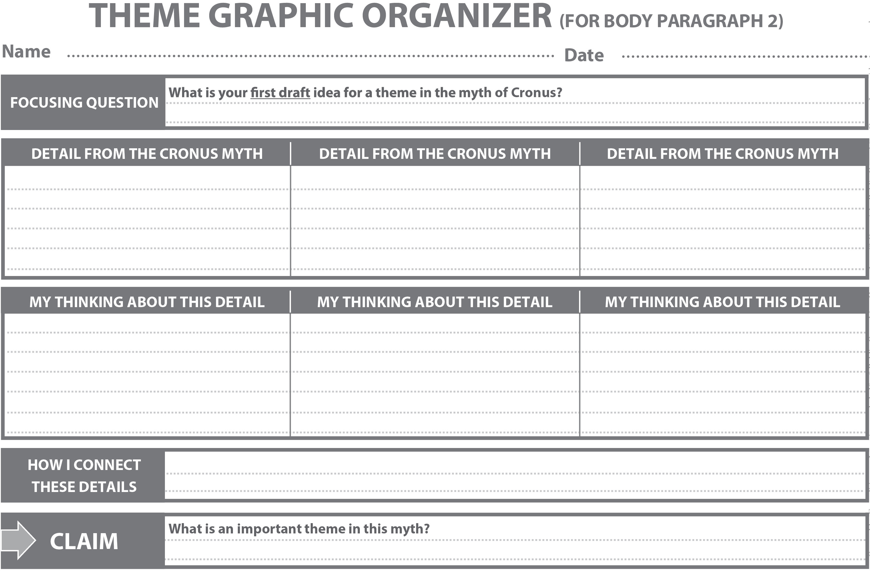
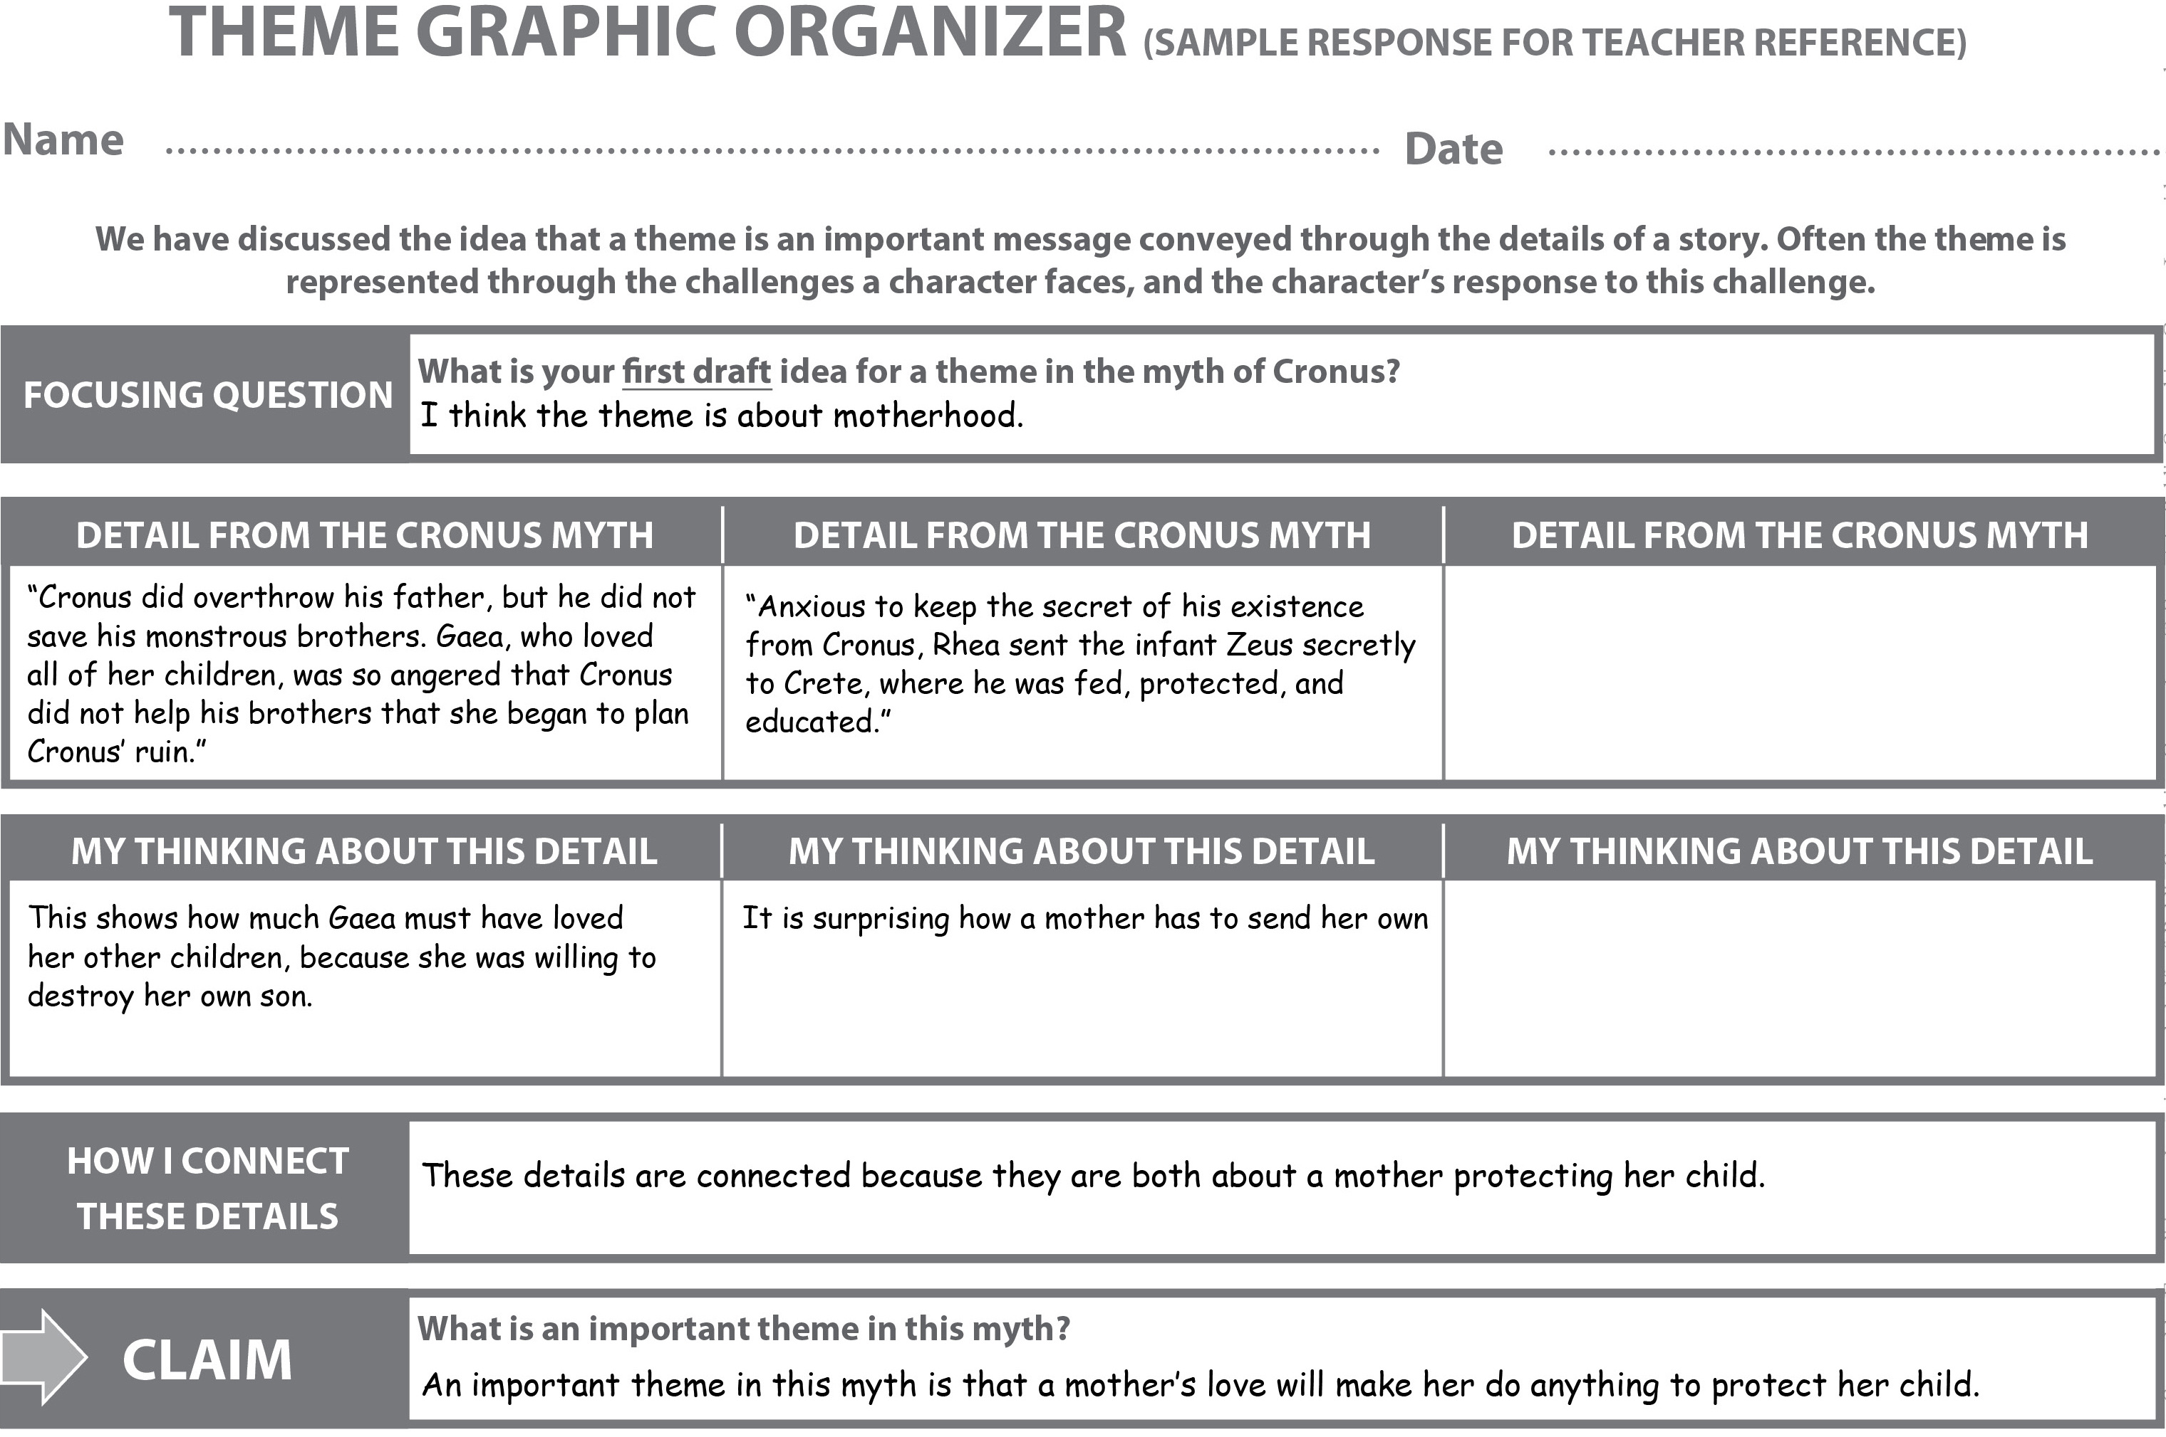
Name:
Date:

With your evidence flags, mark three allusions (references) to myths, stories, or characters you find.
Then below, record any new or challenging vocabulary for a discussion at the beginning of the next lesson.

Word | Location (page number, paragraph member)
Example: Humane | Page 242, paragraph 4

Allusions to Greek Myths/Stories/Characters:

Page Number | What is the myth, story, or character alluded to?

Allusions to Greek Myths/Stories/Characters:

Page Number | What is the myth, story, or character alluded to?
244 | The god Ares and his relationship with Aphrodite.
247 | The story of Athena, Arachne, and the weaving contest.
258 | The story of the Lotus Eaters (from the Odyssey).

