Lesson 32

Objective: Arrange, analyze, and draw sequences of quantities of 1 more, beginning with numbers other than 1.

Suggested Lesson Structure

 Fluency Practice (12 minutes)

 Application Problem (5 minutes)

 Concept Development (25 minutes)

 Student Debrief (8 minutes)

**Total Time (50 minutes)**

Fluency Practice (12 minutes)

* Green Light, Red Light **K.CC.2** (2 minutes)
* Guess the Hidden Number **K.CC.2** (5 minutes)
* Draw 1 More and Write How Many **K.CC.4c** (5 minutes)

Green Light, Red Light (2 minutes)

Conduct the activity as outlined in Lesson 5, but now include sequences within 10.

Guess the Hidden Number (5 minutes)

Conduct the activity as outlined in Lesson 29, but now have the students fold the number path to reveal a short sequence of numbers (e.g., 4, 5, 6, 7).

Draw 1 More and Write How Many (5 minutes)

Materials: (S) Draw 1 More (Fluency Template)

After giving clear instructions and completing the first few problems together, allow students time to work independently. Encourage them to do as many problems as they can within a given timeframe.

Optional: Go over the answers, and direct students to energetically shout “Yes!” for each correct answer.

Application Problem (5 minutes)

Draw 6 shirts on the board as pictured below:

**9**

**5**

**44**

C:\Users\store64\AppData\Local\Microsoft\Windows\Temporary Internet Files\Content.IE5\Q11W2AUA\MC900013595[1].wmfC:\Users\store64\AppData\Local\Microsoft\Windows\Temporary Internet Files\Content.IE5\Q11W2AUA\MC900013595[1].wmf C:\Users\store64\AppData\Local\Microsoft\Windows\Temporary Internet Files\Content.IE5\Q11W2AUA\MC900013595[1].wmf C:\Users\store64\AppData\Local\Microsoft\Windows\Temporary Internet Files\Content.IE5\Q11W2AUA\MC900013595[1].wmf C:\Users\store64\AppData\Local\Microsoft\Windows\Temporary Internet Files\Content.IE5\Q11W2AUA\MC900013595[1].wmfC:\Users\store64\AppData\Local\Microsoft\Windows\Temporary Internet Files\Content.IE5\Q11W2AUA\MC900013595[1].wmf

There were 6 friends on Katharine’s team. Their uniforms got mixed up in the laundry, and some of the numbers washed off. Quickly draw the shirts and the numbers on the shirts to help the team!

Note: This problem is a pictorial anticipation of today’s lesson of sequencing consecutive subsets of 10.

Concept Development (25 minutes)

Materials: (T) Set of linking cube number stairs 1–10 (S) 10 index cards, crayons

T: Look at my number stairs. Help me count the way we did yesterday to make sure I have them in the right order. Count with me.

S: This is 1. One more is 2. One more is 3. One more is 4…. (Continue through to the end.)

T: We are going to play a game! I am going to hide one of my towers. Ready? Close your eyes. (Hide the 5 tower.) You may open them. Look, think, and raise your hand. (When most hands are raised, snap your fingers to signal students to answer chorally.) Which tower is missing?

S: 5!

T: (Replace tower and repeat several times with other towers.) You are good detectives! This time I will hide two of my towers. Close your eyes! (Hide 4 and 5. Repeat game several times with subsets of two consecutive towers.)

T: This time I will hide three towers. (Repeat game several more times, each time hiding three consecutive towers.)

T: We are going to make some tower cards so that you and your partner can play this game yourselves. I will give you 10 index cards. On each card, I want you to draw one of these number towers. Write the number on the back like this. (Demonstrate.) Be sure that you make exactly one card for each of the number stairs.

S: (Make flashcards for the 1–10 towers.)

T: Put your cards in a pile. Now, arrange them in a row on your desk with the tower side up. Start with your 1 tower. Each card should be 1 more. What should they show?

S: 1, 2, 3, 4, 5, 6, 7, 8, 9, 10. (Arrange cards.)

T: (Check for completion and accuracy.)

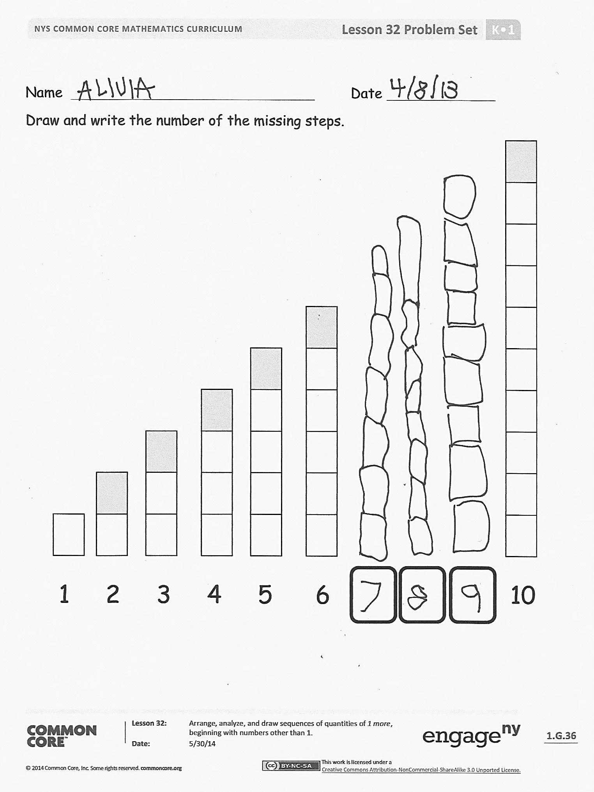T: Work with a partner. While your partner closes his eyes, hide two cards from your row. You will choose a card and then hide it behind your back with the card that is 1 more. Ask your partner to open his eyes and look at the cards left in your row. When he is ready to tell which cards you must be hiding, he has to find those cards in his row to show you. You can then compare your cards to see if he was right. Then, it will be your turn!

S: (Play several rounds of the game.)

T: Turn your cards over so the number side is showing and play again.

S: (Play several rounds of the game.)

T: This time, choose three cards from your row and hide them behind your back. Remember, you must choose three cards next to each other! (Play several more rounds of the game, and then turn the cards all over to play with the other side again.) Put your cards away now and get ready for your Problem Set.

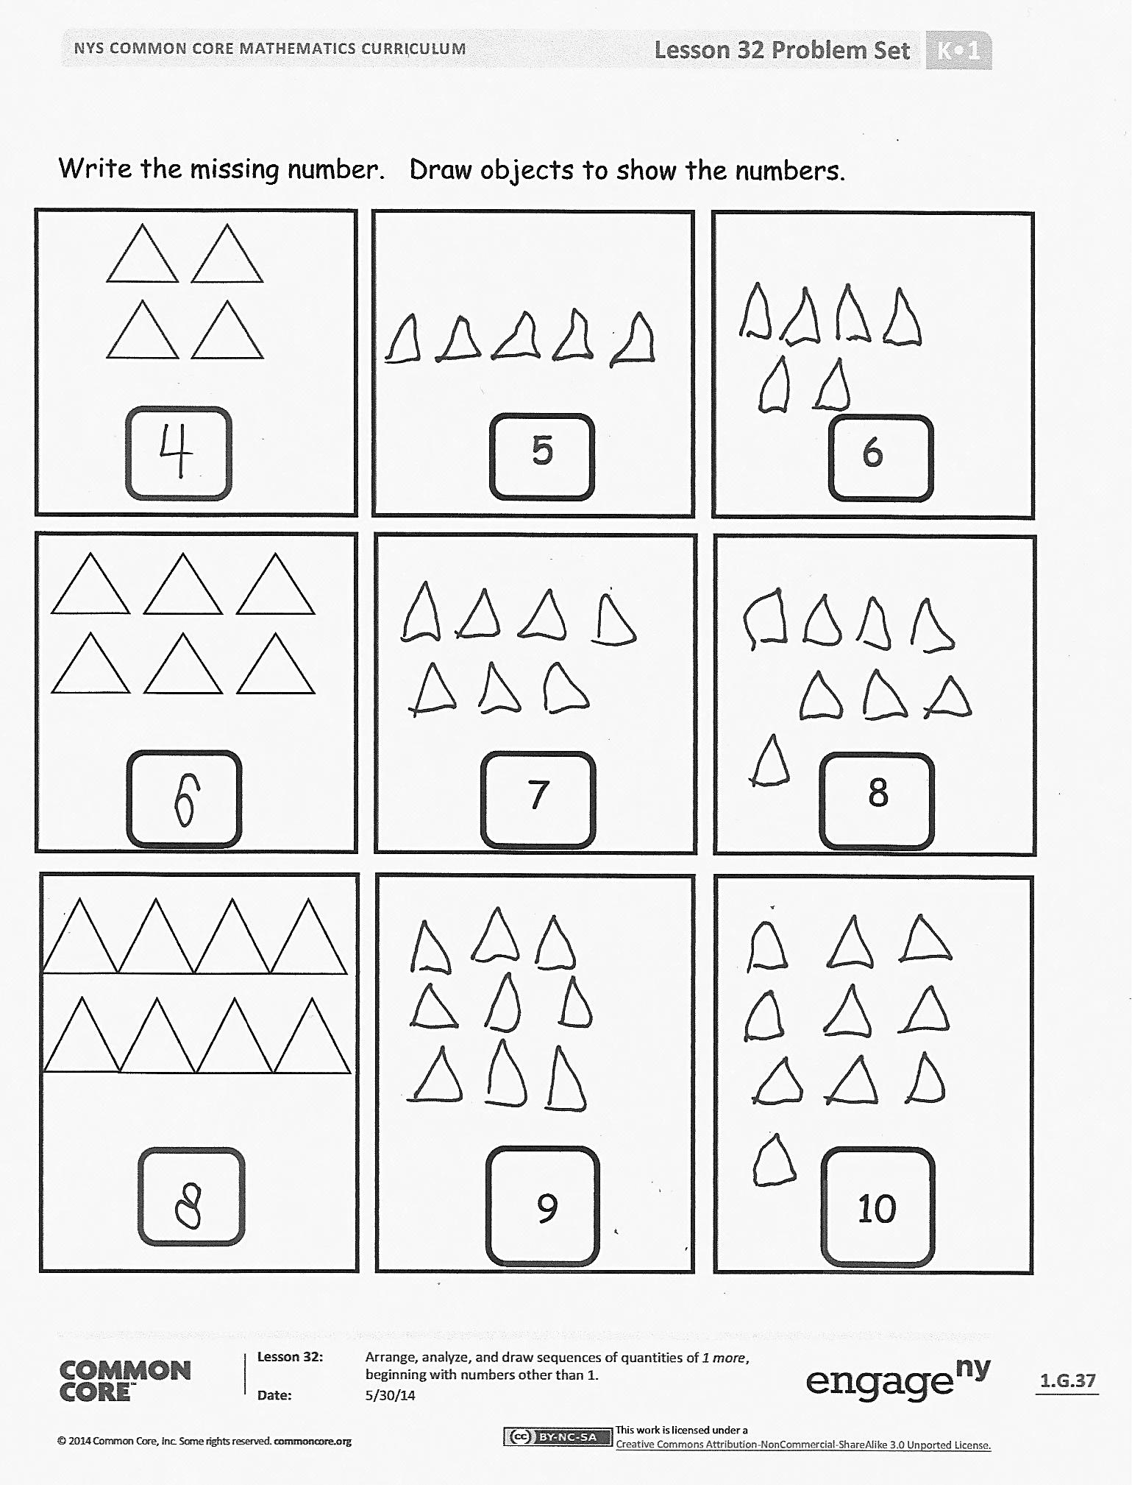Problem Set (8 minutes)

Students should do their personal best to complete the Problem Set within the allotted time.

Distribute the Problem Set to students. Support students who struggle with drawing the consecutive steps by drawing the first step of each stair. This will give them a starting point and help them with spacing and position.

When drawing the objects at the end of the Problem Set, guide students to draw any objects they choose. Remind them that they can draw their objects in linear, array, 5-group, circular, or scattered formation.

Student Debrief (8 minutes)

**Lesson Objective:** Arrange, analyze, and draw sequences of quantities of 1 more, beginning with numbers other than 1.

The Student Debrief is intended to invite reflection and active processing of the total lesson experience.

Invite students to review their solutions for the Problem Set. They should check work by comparing answers with a partner before going over answers as a class. Look for misconceptions or misunderstandings that can be addressed in the Debrief. Guide students in a conversation to debrief the Problem Set and process the lesson.

You may choose to use any combination of the questions below to lead the discussion.

* When you drew the missing steps, did you count all the numbers before the first missing step? Is there a way to know how many steps are in the missing stair without counting from 1? How?
* Show your neighbor the dots and numbers you drew. Tell your friend if you wrote the numbers first or drew the dots first. Tell them why you did so.
* Could you have drawn your objects a different way? If you drew the objects a different way, would you have to change the number?
* What strategy did you use to put your stairs in order?

Exit Ticket (3 minutes)

After the Student Debrief, instruct students to complete the Exit Ticket. A review of their work will help you assess the students’ understanding of the concepts that were presented in the lesson today and plan more effectively for future lessons. You may read the questions aloud to the students.

Name Date

Draw 1 more, and write how many in the box.

[1]

How many?

How many?

|  |  |  |  |
| --- | --- | --- | --- |
|  |  |  |  |
|  |  |  |  |
|  |  |  |  |
|  |  |  |  |
|  |  |  |  |
|  |  |  |  |
|  |  |  |  |
|  |  |  |  |

Name Date

Draw and write the number of the missing steps.

1 2 3 4 5 6 10

Write the missing number. Draw objects to show the numbers.

8

7

10

9

6

5

Name Date

Write the missing numbers.

**3, ______, ______, 6, 7, ______, ______, ______**

Draw 1 more apple each time.

C:\Users\store64\AppData\Local\Microsoft\Windows\Temporary Internet Files\Content.IE5\KBZFFY2J\MC900300097[1].wmfC:\Users\store64\AppData\Local\Microsoft\Windows\Temporary Internet Files\Content.IE5\KBZFFY2J\MC900300097[1].wmf

Name Date

Write the missing numbers.

**____, 2, ____, ____, ____, 6, 7, ____, ____, 10**

**xxxxx**

Draw X’s or O’s to show 1 more.

**X**

**xx**

ooooooo

**OOO**

ooooo

Tell someone a story about “1 more…and then 1 more.” Draw a picture about your story.

**O O O O**

1. draw 1 more