Lesson 31

Objective: Arrange, analyze, and draw 1 more up to 10 in configurations other than towers.

Suggested Lesson Structure

 Fluency Practice (10 minutes)

 Application Problem (5 minutes)

 Concept Development (27 minutes)

 Student Debrief (8 minutes)

**Total Time (50 minutes)**

Fluency Practice (10 minutes)

* Beep Number **K.CC.4a** (2 minutes)
* Show Me 1 More **K.CC.4c** (3 minutes)
* Roll and Write 1 More **K.CC.4c**  (5 minutes)

Beep Number (2 minutes)

This activity is repeated from Lesson 29 to continue the focus on sequences beyond 5. Remember that the sample sequence that goes from simple to complex.

7, 8, beep!

7, beep, 9.

Beep, 8, 9.

Variation: Extend the sequences to four numbers, for example 7, 8, beep, 10.

Show Me 1 More (3 minutes)

Show me 1 more with your fingers the Math Way:

T: Show me 3 fingers, the Math Way.

S: (Hold up the left pinky, left ring finger, and the left middle finger to show 3 fingers the Math Way.)

T: Now, show me 1 more.

S: (Hold up the left pinky, left ring finger, the left middle finger, and the left index finger to show 4 fingers the Math Way.)

T: How many fingers are you showing me now?

S: 4.

Avoid showing the finger combinations. The Math Way will soon become an immediately recognizable configuration that will decrease the need for students to recount each time. Allow time to recount for students who still need to do so.

Roll and Write 1 More (5 minutes)

Materials: (S) Die, paper and pencil or personal white board

Partner A rolls the die. Both partners count the dots. Partner B determines the number that is 1 more, and writes the numeral. Partner A verifies that the number is 1 more. Switch roles and play again.

Application Problem (5 minutes)

|  |  |
| --- | --- |
|  | NOTES ON  MULTIPLE MEANS  OF ENGAGEMENT: |
| Challenge advanced students by asking them to draw more problem situations. For example, ”Draw 8 oranges and 2 more, or draw 9 oranges and 1 more to share.” | |

Caleb had a plate of 7 oranges to share with his friends. Draw the oranges. Draw 1 more orange in case someone is extra hungry. How many oranges are on the plate? Write the number. Tell your friend: There were 7 oranges. One more is (     ).

Note: In this and other problems in this topic, remember to emphasize with students the language pattern of ( ). *One more* is ( ). They will be using that pattern again in this lesson. A further reminder to practice restraint: In Module 3, we introduce the complexity of 4 is *1 less than* 5.

Concept Development (27 minutes)

Materials: (S) Large construction paper work mat (21" x 24") per 2 students inscribed as shown below (circles should have a diameter of at least 4"), set of linking cube stairs from yesterday, red and blue crayon

T: Put your number stairs on your desk in front of you. Make sure they are in order! Let’s check. Point to the correct stair and echo me: 1. 1 more is 2. 2. 1 more is 3. 3. 1 more is 4.

    

   

My Bracelets to 10

S: 1. 1 more is 2. 2. 1 more is 3. 3. 1 more is 4. (Continue through all the stairs.)

T: We are going to make some bracelets today. Take your first stair and put it inside the first circle on your work mat. (Demonstrate.) How many cubes are inside your first circle?

S: 1.

T: We have 1 cube. *One more* is ( ). (Wait for answer.) 2. Please show me your stair for 2. Take the cubes apart and put them in the second circle. (Demonstrate.) How many?

S: 2.

T: We have 2 cubes. *One more* is (_). (Wait for answer.) 3. (Continue with this sequence until the cubes of each stair are inside the students’ circle on the work mat. Circulate to ensure accuracy.)

T: Let’s count the cubes in our circles. Do we have to count every one of the cubes to know how many there are in each circle?

S: No. We put them in order, so we can just count circles. 1, 2, 3, 4, 5, 6, 7, 8, 9, 10.

T: Did the number change just because we broke apart our tower? (Discuss briefly.)

T: Pretend we are making bracelets now. Move the cubes to the edge of the circle so that they are like beads on a bracelet. What do you notice?

S: The beads from bigger towers can make circles. 🡪 Just like our bracelets.🡪 Some of the beads are red and some are blue.

**MP.7**

T: On the bracelets we made before, were the colors all mixed up, or were our beads in groups of colors?

S: We had red beads and then white beads. 🡪 They were not mixed up. 🡪 We should make sure that the blue cubes are on one side of the circle and the red ones are on the other side.

T: Good idea! Let’s do that. (Circulate to check for understanding.) What do you notice?

S: All of them have red cubes. 🡪 The bottom bracelets all have 5 blue cubes. (Guide students to see that the colors of the cubes can help them to identify the numbers.)

|  |  |
| --- | --- |
|  | NOTES ON  MULTIPLE MEANS  OF ENGAGEMENT: |
| Encourage English language learners to respond to the question: “What would we do on the next circle?” This allows students to show their thinking rather than verbalize it. | |

T: These are great; I wish you could put them on the bulletin board. Maybe you could. If we drew beads instead of using the cubes, we could put them on our bulletin board. Take the cube off the first circle and draw a blue bead there instead. (Demonstrate.) What would we do on the next circle?

S: Take off each cube and draw a blue bead instead 🡪 When we get to the bigger numbers, we can use our red crayons too.

T: Great ideas! Go ahead and carefully replace each of the cubes with a crayon bead. (Circulate to ensure accuracy.)

T: Now we need to name our bracelets. Let’s call our first bracelet 1. What should we call the next one?

S: 2.

T: Yes, we can name each one after its number of beads. Choose a crayon and label all of your bracelets. Now you can take them home and show them to your family!

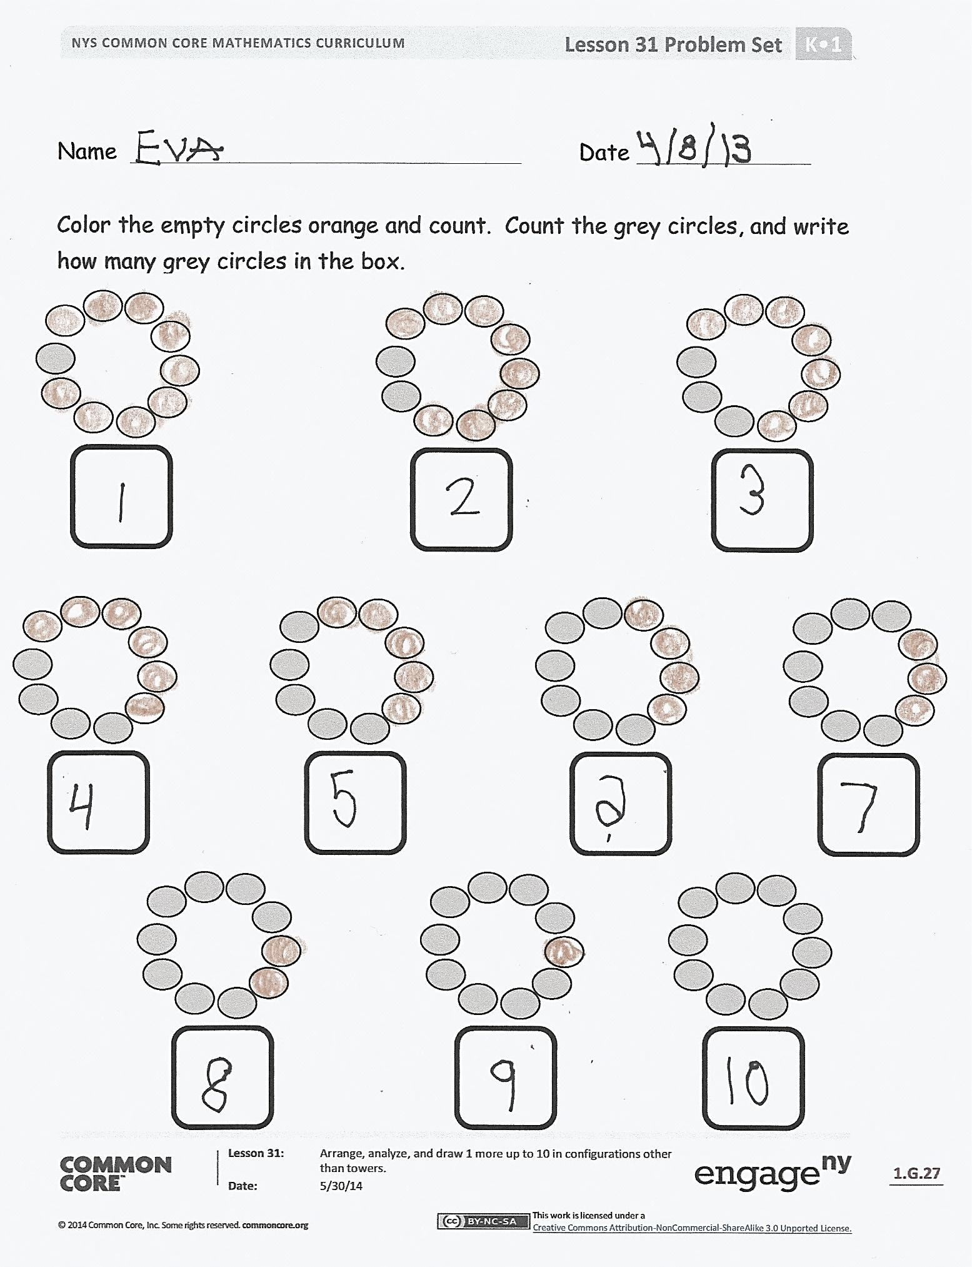**Problem Set (10 minutes)**

Students should do their personal best to complete the Problem Set within the allotted time.

Distribute Problem Set to students. Guide students to first color the empty circles orange and count. Then, count the grey circles and write how many in the box. On the second page, count and color the white circles blue. Draw 1 more and count all the circles. Write how many.

Student Debrief (8 minutes)

**Lesson Objective**: Arrange, analyze, and draw *1 more* up to 10 in configurations other than towers.

The Student Debrief is intended to invite reflection and active processing of the total lesson experience.

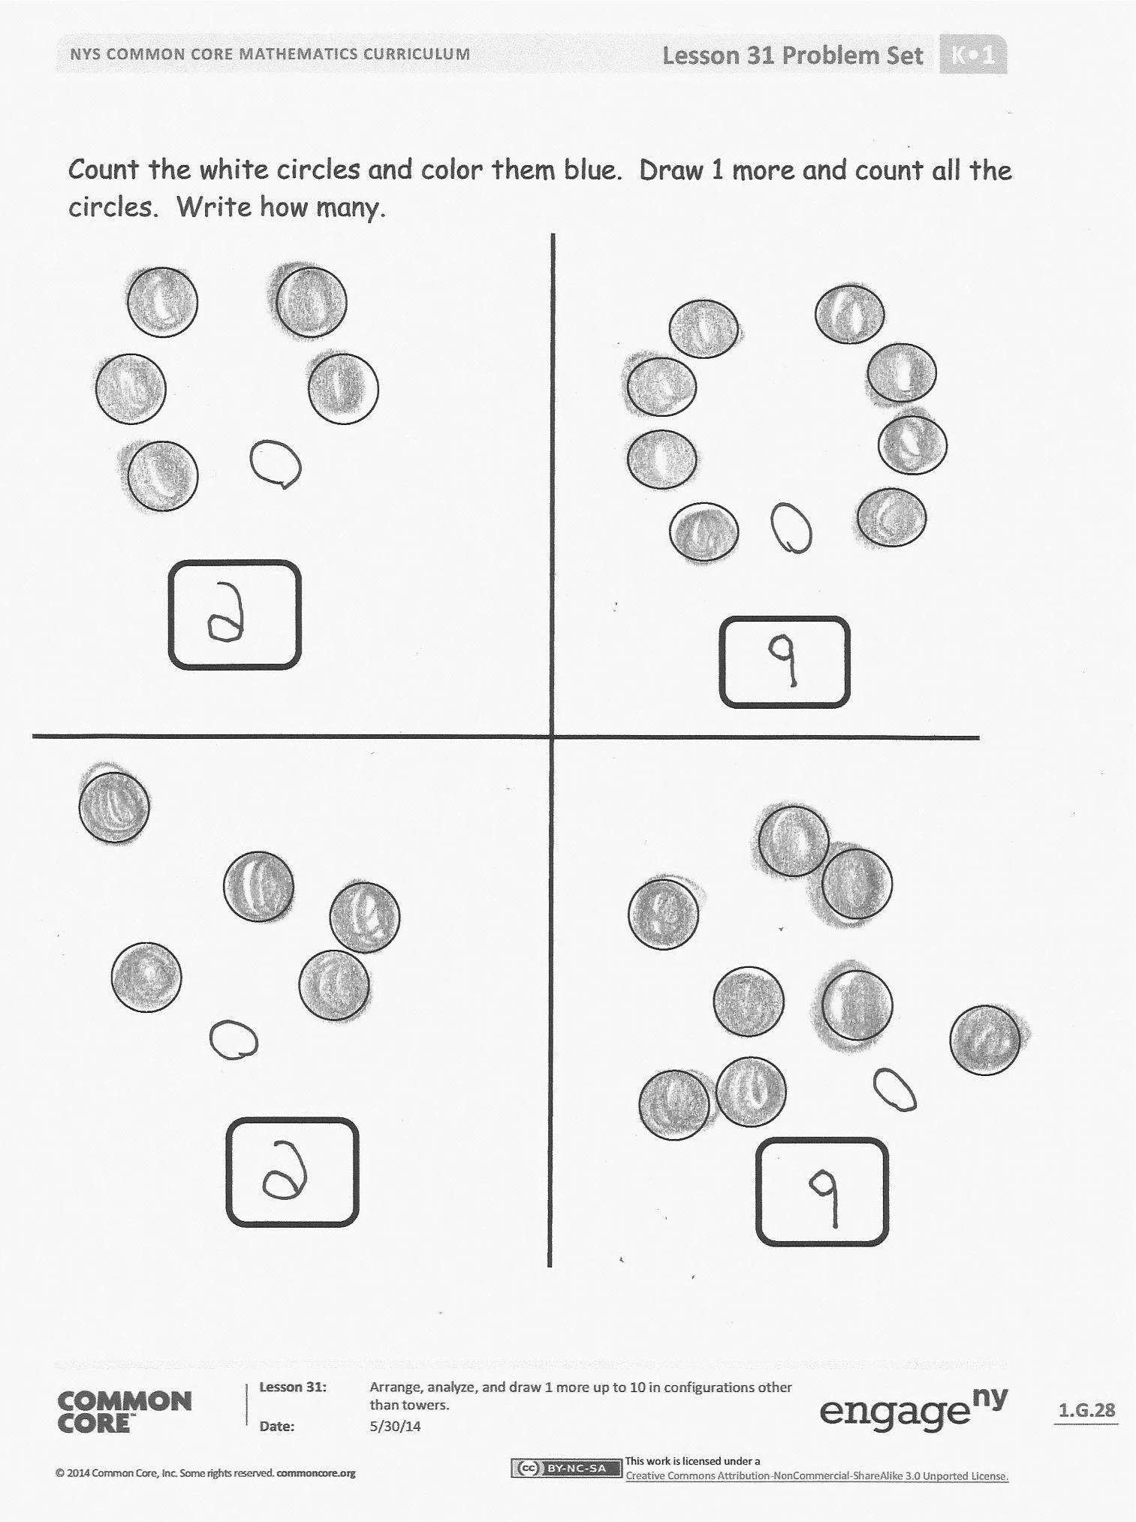Invite students to review their solutions for the Problem Set. They should check work by comparing answers with a partner before going over answers as a class. Look for misconceptions or misunderstandings that can be addressed in the Debrief. Guide students in a conversation to debrief the Problem Set and process the lesson.

You may choose to use any combination of the questions below to lead the discussion.

* What do you notice about the first three bracelets? (Lead discussion so students see that all of the orange circles are 5.) How can this help with counting?
* How did you count the scattered configurations?
* What do you notice about the circles you colored orange? How did this help you count?
* What did you notice on the second page of the Problem Set when you added 1 more?
* Tell your partner how many you counted in each problem. What happened when you added 1 more?
* Why was it so easy to count the cubes on our bracelets? How did the colors of the cubes help us? (Lead them to mention number conservation from linear to other configurations. Help them to notice that identifying the groups of 5 within the sets was very helpful in counting.)

Exit Ticket (3 minutes)

After the Student Debrief, instruct students to complete the Exit Ticket. A review of their work will help you assess the students’ understanding of the concepts that were presented in the lesson today and plan more effectively for future lessons. You may read the questions aloud to the students.

Name Date

Color the empty circles orange and count. Count the gray circles, and write how many gray circles in the box.

Count the white circles and color them blue. Draw 1 more and count all the circles. Write how many.

Name Date

Color the stars blue. Draw 1 more star. Color the happy faces red.

Color it blue, and write how many. Draw 1 more happy face.   
 Color it red, and write how

many.

Name Date

Draw one more square. Color all the squares and write how many.

Draw one more cloud. Color all the clouds and write how many.