Lesson 30

Objective: Make math stairs from 1 to 10 in cooperative groups.

Suggested Lesson Structure

 Fluency Practice (12 minutes)

 Application Problem (5 minutes)

 Concept Development (25 minutes)

 Student Debrief (8 minutes)

**Total Time (50 minutes)**

Fluency Practice (12 minutes)

* Sunrise/Sunset Counting to 10 **K.CC.2** (4 minutes)
* Tell the Missing Number **K.CC.2** (5 minutes)
* Show Me 1 More **K.CC.4c** (3 minutes)

Sunrise/Sunset Counting to 10 (4 minutes)

Conduct the activity as outlined in Lesson 7, but instruct students to reach 5 as the midpoint and 10 at the highest position. Some modeling may be required initially.

Tell the Missing Number (5 minutes)

Materials: (S) 5-group cards (Lesson 7 Template, numeral side)

Partners work together to put the numeral cards in order. Partner A closes her eyes. Partner B removes one of the cards, and then tells Partner A to open her eyes. Partner A tells which numeral card is missing. Switch roles and play again.

Variation: Remove two or three cards; determine the missing number in a short counting sequence. Continue with the following suggested sequence: 4, 5, 6, and 7.

Show Me 1 More (3 minutes)

Materials: (S) Bag of red and white beans, left hand mat (Lesson 1 Fluency Template)

T: Show me 3 beans.

S: (Place a red bean on the left pinky, left ring finger, and left middle finger to show 3 beans.)

T: Now, show me 1 more.

S: (Place a red bean on the left index finger, for a total of 4.)

T: How many beans are on your mat now?

S: 4.

Note: Stay within a predictable pattern until students are comfortable with this exercise, and then skip around. Carefully observe to see which students must recount all of the beans in order to tell the number that is 1 more.

**Application Problem (5 minutes)**

There are 4 flowers in your vase. Your friend brings you 1 more flower to put in your vase. Draw your vase with all the flowers. Write the number.

Note: This problem anticipates the *1 more* pattern of today’s lesson.

**Concept Development (25 minutes)**

Materials: (T/S) Bears (Template) (S) Bag of 30 loose red linking cubes, bag of 25 loose blue linking cubes per pair

C:\Users\store64\AppData\Local\Microsoft\Windows\Temporary Internet Files\Content.IE5\ZA32B5B8\MC900053402[1].wmfDraw a pictorial growth chart similar to the following. Print the template to use in the activity on the board. Affix them to the board with tape.

C:\Users\store64\AppData\Local\Microsoft\Windows\Temporary Internet Files\Content.IE5\Q11W2AUA\MC900232136[1].wmf

T: Baby bear is tired, and he wants to go home to his mother in his den! We need to show him the way. How should he go home?

S: He should go up the stairs.

T: Let’s help him. Where should he go first?

S: To the first stair.

T: (Move the baby bear to the top of the first step.) What should we call this step?

S: 1.

T: (Label the first step.) Where should he go next?

S: To the next step. 🡪 To the higher stair. 🡪 To the 2. 🡪 To the stair with two squares.

T: 1. One more is 2. (Move bear and label the next step.) Now, where should he go?

S: 3.

T: Move him with me. 2. One more is 3. Repeat.

S: 2. One more is 3.

T: (Move bear and label the step 3. Continue until the bear has been reunited with his mother on step 10.)

T: Great job! Let’s count our steps again the *1 more* way.

S: 1. One more is 2. 2. One more is 3. 3. (Continue through 10.)

T: Now, let’s make some stairs like this with our cubes. You can work with your partner to help each other. Find your bag of red linking cubes, please.

T: Take a red cube, and put it at the top of your desk. What is the name of this stair?

S: 1.

T: Make the next stair. Take out another red linking cube. Add 1 more. Repeat after me: 1. One more is 2. 2.

S: 1. One more is 2. 2.

T: Put the stair for 2 next to the one on your desk. Let’s make the next one. (Continue making the stairs 1–5. Circulate to ensure understanding.)

T: Great job! Can you make another set of red stairs just like that? Let’s see how fast you can do it! I will time you.

S: (Create another set of stairs 1–5, and align on desk.)

T: Compare your stairs to the ones on the board. Will your stairs work to get the baby bear home?

S: They are not tall enough. 🡪 We don’t have any more red cubes. 🡪 We need some of our stairs to be higher. 🡪 We need to use some of the blue cubes.

T: What should we do? (Guide students to make towers of 5 from the blue cubes. They can put one set of the red stairs on the 5 towers to complete the sequence to 10. Demonstrate and assist as necessary.)

T: Put all of your stairs in order on your desk. Now, could the baby bear get home? Count with me. 1. One more is 2. 2. One more is 3. 3. (Count and demonstrate on the board while students count on their stairways.)

S: (Repeat counting language.) Yes, he is home now!

T: You will need your stairs for tomorrow, so put them away carefully in your bags.

Problem Set (5 minutes)

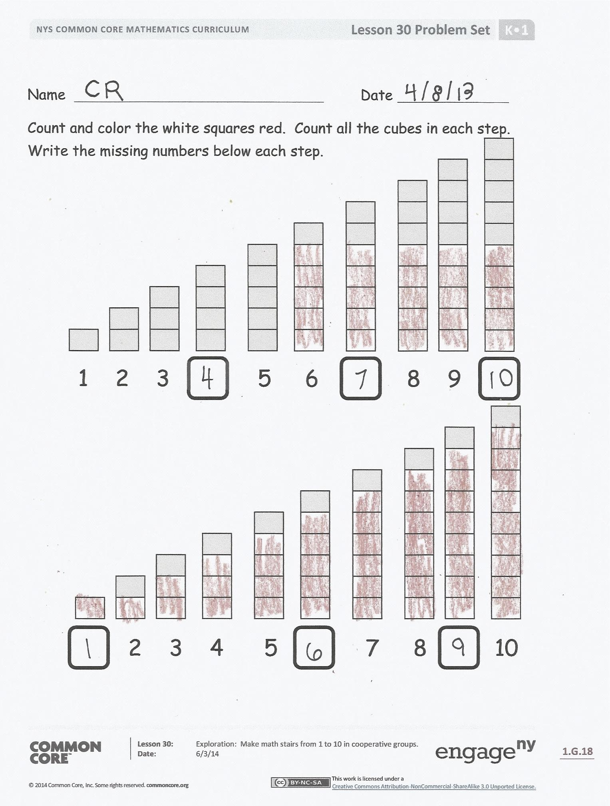Students should do their personal best to complete the Problem Set within the allotted time.

Distribute the Problem Set to students. Have students use a red crayon to color the white cubes of each step. When the students draw the cubes on the second sheet of the Problem Set, remind them that stairs have to rise. Therefore, a preceding step cannot be taller than the next one. Some children will still struggle to draw a step one higher than the preceding step.

Student Debrief (8 minutes)

**Lesson Objective:** Make math stairs from 1 to 10 in cooperative groups.

The Student Debrief is intended to invite reflection and active processing of the total lesson experience.

Invite students to review their solutions for the Problem Set. They should check work by comparing answers with a partner before going over answers as a class. Look for misconceptions or misunderstandings that can be addressed in the Debrief. Guide students in a conversation to debrief the Problem Set and process the lesson.

You may choose to use any combination of the questions below to lead the discussion.

* Look at the first staircase. What do you notice about the red steps? How many numbers have a group of 5 red steps? Which numbers are they?
* Do the numbers 1, 2, 3, and 4 have a 5-group of red steps? Why or why not?
* Look at the next staircase. What is similar or different about the red steps? What do you notice about the gray step at the top of the steps?
* Look at the steps you drew. With your words, say to your friend what happened each time you drew another step.

Exit Ticket (3 minutes)

After the Student Debrief, instruct students to complete the Exit Ticket. A review of their work will help you assess the students’ understanding of the concepts that were presented in the lesson today and plan more effectively for future lessons. You may read the questions aloud to the students.

Name Date

Count and color the white squares red. Count all the cubes in each step. Write the missing numbers below each step.

2 3 4 5 7 8 10

1 2 3 5 6 8 9

Name Date

Draw a stair that shows 1 more, and write the new number in the box.

Name Date

Draw the missing stairs. Write the numbers below each step.

C:\Users\store64\AppData\Local\Microsoft\Windows\Temporary Internet Files\Content.IE5\KBZFFY2J\MC900053402[1].wmf

C:\Users\store64\AppData\Local\Microsoft\Windows\Temporary Internet Files\Content.IE5\Q11W2AUA\MC900232136[1].wmf

Ask someone to help you write about what you think baby bear will do now that you have helped him to get home. Use the back of this paper.

Draw 1 more cube on each stair so the cubes match the number. Say as you draw, “1. One more is two. 2. One more is three.”

1 2 3 4 5 6 7 8 9 10

C:\Users\store64\AppData\Local\Microsoft\Windows\Temporary Internet Files\Content.IE5\KBZFFY2J\MC900053402[1].wmf

C:\Users\store64\AppData\Local\Microsoft\Windows\Temporary Internet Files\Content.IE5\Q11W2AUA\MC900232136[1].wmf[1]

1. bears template