Lesson 29
Objective: Order and match numeral and dot cards from 1 to 10. State 1 more than a given number.

Suggested Lesson Structure
 Fluency Practice (11 minutes)
 Application Problem (5 minutes)
 Concept Development (26 minutes)
 Student Debrief (8 minutes)
Total Time (50 minutes)
Fluency Practice (11 minutes)
- Guess the Hidden Number K.CC.2 (4 minutes)
- Piggy Bank Pennies K.CC.2 (5 minutes)
- Beep Number K.CC.4a (2 minutes)
Guess the Hidden Number (4 minutes)
Materials: (S) Pennies, number path (Lesson 15 Fluency Template)
Note: Partner A closes her eyes. Partner B hides one of the numbers on the number path with a penny, and then tells Partner A to open her eyes. Partner A tells the hidden number. Partners switch roles and play again. Circulate and provide support to students who must count from 1 to determine the hidden number each time.
Variation: Cover two or three numbers with pennies.
Piggy Bank Pennies (5 minutes)
Materials: (T) Magnets or brown circles of paper to represent pennies (S) Baggie of pennies, piggy bank mat (Fluency Template)
T: Here is a wallet (baggie) with some money in it. When I put money in my bank (model), you put the same amount in your bank. (Put 5 pennies in the bank.) Show me exactly the same number of pennies in your bank.
S: (Place 5 pennies on their piggy bank mat.)
T: How many pennies are in your bank?
S: 5 pennies.
T: (Take 1 off.) Now, show this many. Raise your hand when you know how many pennies are in your bank now. (Wait for students to raise hands, and then signal.) Ready?
S: 4 pennies.
T: (Put 1 penny on the mat.) Now, show this many. Raise your hand when you know how many pennies are in your bank now. (Wait for students to raise hands, and then signal.) Ready?
S: 5 pennies.
Continue in this way, putting on and taking off small amounts, not to exceed 10. Insist that students state the unit (pennies) each time. Watch carefully to see which students must recount each time. Support them by making connections to the counting exercise sequences. Continue with the following possible sequence: 1, 2, 3 and 2, 3, 4.
Beep Number (2 minutes)
Optional Materials: (T) Personal white board (S) Number path (Lesson 15 Fluency Template)
Conduct the activity as outlined in Lesson 15, but this time, focus on sequences beyond 5. Here is a sample sequence that goes from simple to complex:

7, 8, beep!
7, beep, 9.
Beep, 8, 9.
Variation: Extend the sequences to four numbers, for example 7, 8, beep, 10.
Application Problem (5 minutes)

NOTES ON
MULTIPLE MEANS
OF ACTION AND EXPRESSION:
English language learners might not be familiar with a scoop of ice cream. Show a picture of a scoop of ice cream, or, depending on the number of English language learners in the class and their backgrounds, suggest that they draw a comparable but culturally familiar object to allow the lesson to proceed.

Draw 10 little dishes on your paper. Write the numbers 1–10 on your dishes. On some of your dishes, draw 1 scoop of strawberry ice cream. In the rest, draw 1 scoop of chocolate ice cream. Show your treats to a friend. Do your treats look alike?
Note: The review of writing numerals 1–10 prepare the students for today’s Problem Set.
Concept Development (26 minutes)
Materials: (S) 1 set of 5-group cards (Lesson 7 Template)
Note: Remember to practice restraint. In Module 3, we introduce the complexity of 4 is 1 less than 5.
T: We are going to play the game Mix and Fix Numbers 1–10. Do you remember how to play? (Review directions found below if necessary.)
T: Good! Mix up your cards, and scatter them on your desk in front of you. Make sure that each card has the numeral facing up. When I say go, put your cards in increasing order in a straight row on your desk. What should your row of cards say?
S: 1, 2, 3, 4, 5, 6, 7, 8, 9, and 10.
T: Ready? Set. Go! (Circulate to ensure accuracy.)
S: (Arrange cards, numeral side up, in a row in front.)
T: Turn over the card that says 1. What do you see?
S: 1 dot.
T: What do you think you might see when you turn over the next card?
S: 2 dots.
T: Let’s check your prediction. Turn over your 2. Were you correct?
S: Yes. There is another dot.
T: Now, turn over your 3, 4, and 5. What do you notice?
MP.8
S: We see the right number of dots in a row on each card.
T: It’s just like our Math Way of counting on our fingers, isn’t it? Let’s do that. (Quickly complete finger count with students.) What would six look like on our fingers?
S: 5 fingers and then 1 more.
T: I wonder what will be on the back of the 6 card?
S: We will have a row of 5 dots and then 1 more, just like with our fingers.
T: Let’s check! Turn over your 6 card. Were you right? (Discuss.) What do you think you will see on the back of the 7? (Continue to lead discussion in this way until all cards have been turned over.)
T: Let’s play another game with our cards. Make sure that your cards are still in order in a row with all the 5-group dot sides facing up. I will show you how to play: Hold up your dot for 1. Echo me: I have 1. One more is 2.
S: I have 1. One more is 2.

NOTES ON
MULTIPLE MEANS
OF ACTION AND EXPRESSION:
In order to encourage all to participate in echoing the teacher and in order to assess who is able to follow, have students take turns by asking the boys to echo it alone and then the girls, or by asking only a small group of students to echo the teacher. This will allow weaker students to be heard, because they are not being drowned out by the sound of the whole group.

T: Now, put down the 1 and hold up your dots for 2. Echo me: I have 2. One more is 3. (Echo.) Then, you will put down your 2. We will continue with the rest of our cards. Do you understand? Are you ready?
T: (Work through the sequence to 10 rapidly and rhythmically with students. Repeat several times.)
T: We have time for one last game. Choose a partner. One of you will put your cards in front of you with the numerals facing up; the other will put his cards by yours with the dots facing up. Take turns choosing a numeral card and then quickly finding the dot card that has 1 more than your numeral card. You may play until I say game time is over, and then you may put your cards away. (Demonstrate if necessary. Circulate to check for understanding.)

Problem Set (7 minutes)
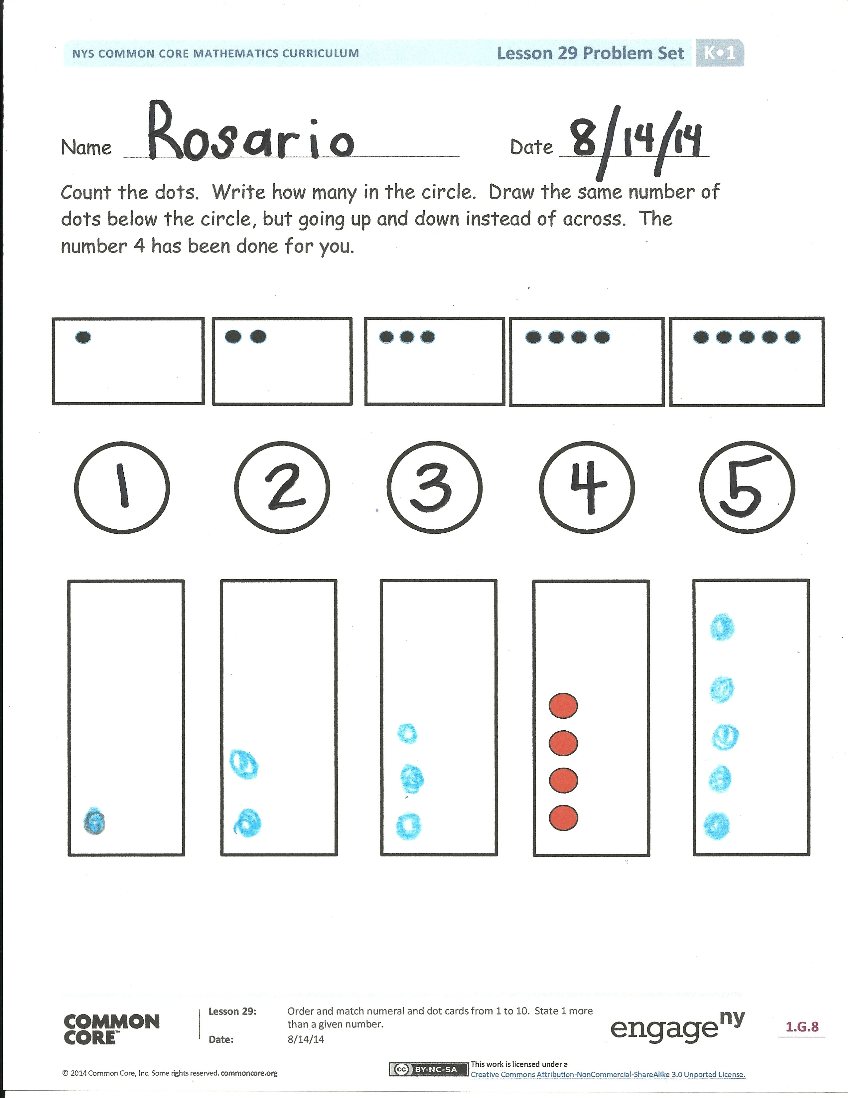
Students should do their personal best to complete the Problem Set within the allotted time.
Distribute the Problem Set to the class. Students color and count the dots, and write how many. Then, they draw the same number of dots below the box. Show students the 4 dots that are modeled.
Students count the balloons and basketballs. They draw 1 more, count the balloons and basketballs, and write how many.
Note: In the student work to the right, the student has built his second 5-group from the top down. It is preferred that the second 5 grow from the bottom up, but there is nothing wrong with this, just as there is nothing wrong with showing fingers in ways other than the Math Way. Explain to students the reasoning: Usually, things grow up. The number of dots is growing, so when drawing the number going up, starting from the bottom is more common.
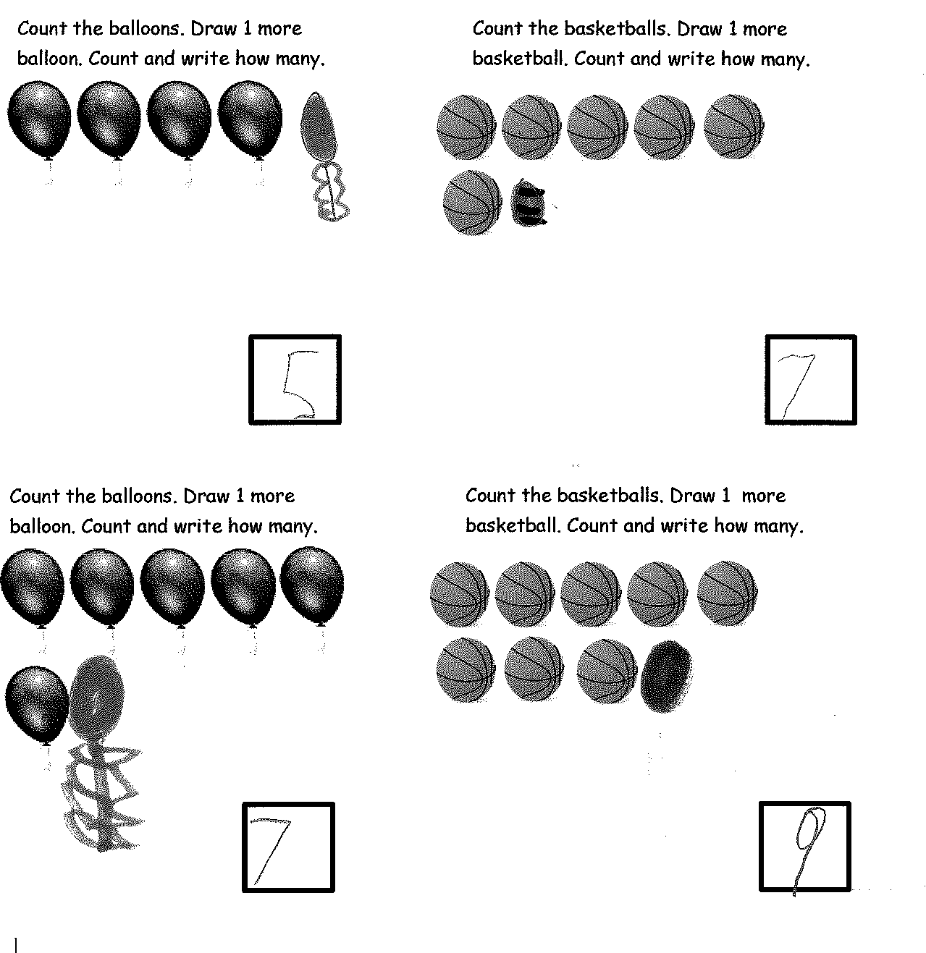
Student Debrief (8 minutes)
Lesson Objective: Order and match numeral and dot cards from 1 to 10. State 1 more than a given number.
The Student Debrief is intended to invite reflection and active processing of the total lesson experience.
Invite students to review their solutions for the Problem Set. They should check work by comparing answers with a partner before going over answers as a class. Look for misconceptions or misunderstandings that can be addressed in the Debrief. Guide students in a conversation to debrief the Problem Set and process the lesson.
You may choose to use any combination of the questions below to lead the discussion.
- How many balloons did you count before drawing 1 more? What did you notice when you drew 1 more?

- How many basketballs did you count before drawing 1 more? What did you notice when you drew 1 more?
- Have students discuss how they counted their dots: Did you count each one? Observe strategies students are using to count.
- Did you notice anything about the dot cards that helped you to count?
- Would you rather show a number by using the numeral or by showing the dots? Why?
- Which would you rather use if your number were really, really big?
- Do you think there is always a number that is 1 more than the number you are saying?
Exit Ticket (3 minutes)
After the Student Debrief, instruct students to complete the Exit Ticket. A review of their work will help you assess the students’ understanding of the concepts that were presented in the lesson today and plan more effectively for future lessons. You may read the questions aloud to the students.

Name Date
Count the dots. Write how many in the circle. Draw the same number of dots below the circle, but going up and down instead of across. The number 4 has been done for you.

4

Count the balloons. Draw 1 more balloon. Count and write how many balloons.

Count the basketballs. Draw 1 more basketball. Count and write how many basketballs.

Count the basketballs. Draw 1 more basketball. Count and write how many basketballs.

Count the balloons. Draw 1 more balloon. Count and write how many balloons.
Count the balloons. Draw 1 more balloon. Count and write how many balloons.

Name Date
Fill in the missing numbers.
1
22
5
9
8
6

Name Date

Count the dots. Write how many in the circle. Draw the same number of dots below the circle, but going up and down instead of across. The number 6 has been done for you.

6

Make your own 5-group cards! Cut the cards out on the dotted lines. On one side, write the numbers from 1 to 10. On the other side, show the
5-group dot picture that goes with the number.

piggy bank mat

