Grade 8: Module 2B: Unit 1: Lesson 2
The Authorship of Shakespeare: “The Shakespeare Shakedown”

Long-Term Targets Addressed (Based on NYSP12 ELA CCLS)
I can cite text-based evidence that provides the strongest support for an analysis of literary text. (RI.8.1)
Supporting Learning Target | Ongoing Assessment
- I can cite the evidence that Simon Schama uses to support his claims in “The Shakespeare Shakedown.” | - Advantages/Disadvantages T-Chart (from homework)  - “The Shakespeare Shakedown”: Lesson 2 text-dependent questions

Agenda | Teaching Notes
Opening  - Engaging the Reader: Reviewing Homework (3 minutes)  - Reviewing the Learning Target (1 minute)  Work Time  - Reading for Gist: Reading “The Shakespeare Shakedown” (15 minutes)  - Text-Dependent Questions (25 minutes)  Closing and Assessment  - Debriefing the Learning Target and Previewing Homework (1 minute)  Homework  - QuickWrite 1: What are three pieces of evidence Schama gives to support his central claim in the article “The Shakespeare Shakedown”? | - In the Opening of this lesson, students share the advantages/disadvantages T-chart from homework. It is important to note that they are not assessed on this standard until Module 3. This activity serves as practice.  - This is the first in a series of four lessons in which students build background knowledge about Shakespeare and the questions about his authorship. In this lesson, students study an article that addresses one viewpoint on the question of whether Shakespeare penned all of the works attributed to him. Students begin their close reading and analysis of this article by reading the article for the gist.  - “The Shakespeare Shakedown” is the focus of Lessons 2–5. Be sure students hold on to their copy of the article throughout these lessons.  - Lessons 2–5 are based heavily on the Making Evidence-Based Claims units developed by Odell Education. Students will refer to the Reading Closely: Guiding Questions handout (first introduced in Module 1, Unit 2, Lesson 1). For the original Odell Education units, go to www.odelleducation.com/resources.

Agenda | Teaching Notes (continued)
- The writing in Module 2B, Unit 1 builds on the skills students developed in Module 1, including QuickWrites (see in particular Module 1, Unit 1, Lesson 3) and summary writing (see in particular Module 1, Unit 2, Lesson 5).
- Beginning with Module 2, lessons that involve close reading include a new type of supporting material, a Close Reading Guide (for teacher reference). Use this guide to support you in facilitating Work Time in this lesson.
- In advance: Read and prepare Simon Schama’s “The Shakespeare Shakedown.” The text needs to be broken into sections by paragraph. Before giving the students their text, mark the sections as follows:
  - Section A: Paragraph 1
  - Section B: Paragraph 2
  - Section C: Paragraph 3
  - Section D: Paragraph 4
  - Section E: Paragraph 5
  - Section F: Paragraph 6
- Post: Learning target.

Lesson Vocabulary | Materials
cite, claim, central claim, supporting claims; attributed, authorship, bard, anonymous, patron, courtier, middling, rudimentary | - “The Shakespeare Shakedown” by Simon Schama (one per student)  - Reading Closely: Guiding Questions handout (from Module 1; one to display)  - Document camera  - “The Shakespeare Shakedown”: Lesson 2 Text-Dependent Questions (one per student and one to display)  - “The Shakespeare Shakedown”: Lesson 2 Close Reading Guide (for teacher reference)  - QuickWrite 1 (one per student)

Opening | Meeting Students’ Needs
A. Engaging the Reader: Reviewing Homework (3 minutes)
- Ask students to locate their Advantages/Disadvantages T-chart (from homework). Invite them to turn and talk with a partner about the advantages and disadvantages of learning from images and text.
- Cold call several students to share their advantages and disadvantages.
B. Reviewing the Learning Target (1 minute)  - Invite a student to read the learning target aloud:  - “I can cite the evidence that Simon Schama uses to support his claims in ‘The Shakespeare Shakedown.’”  - Ask:  - “What does it mean to cite evidence?”  - Cold call a student to answer. Ideally, students will understand that to cite means “to name or mention,” and evidence refers to the details the author uses from the text.  - Explain that an author uses claims to identify and support his position. The author’s overall position is called the central claim, and the reasons the author uses to support this central claim are called the supporting claims. | - Careful attention to learning targets throughout a lesson engages, supports, and holds students accountable for their learning. Consider revisiting learning targets throughout the lesson so that students can connect their learning with the activity they are working on.

Work Time | Meeting Students’ Needs
A. Reading for Gist: Reading “The Shakespeare Shakedown” (15 minutes)  - Ask:  - “What if I told you that Shakespeare didn’t actually write all the things that are attributed or credited to him? What if I told you some people doubt his authorship or that he authored or wrote the things he did?”  - Invite students to turn and talk about this question. Tell them that they are going to read an article that defends the authorship of Shakespeare. Later on, they will read another article that denies the authorship of Shakespeare.  - Distribute “The Shakespeare Shakedown” by Simon Schama. Share with students that they will spend some time with this new text over the next four lessons.  - Ask students to notice the title, author’s name, and date. Invite them to turn and talk to a partner to restate the author’s position or perspective.  - Display the Reading Closely: Guiding Questions handout using the document camera. Ask students to think to themselves about which questions they should ask when getting a text for the first time. Ask them to turn and talk to their partner:  - “What questions do you think are important to ask? Why?”  - Cold call a pair to share. Listen for students to point out the questions in the Approaching Texts row of the document, including:  - “Who is the author?”  - “What is the title?”  - “What type of text is it?”  - “Who published the text?”  - “When was the text published?”  - Tell students that they will read closely to understand the author’s position or view and how the author crafts the structure of the text to prove the central claim.  - Ask them to read along silently and circle words they are unfamiliar with as you read the article aloud.  - Invite them to turn to a partner and talk about the gist of the article. | - Hearing a complex text read slowly, fluently, and without interruption or explanation promotes fluency for students: They are hearing a strong reader read the text aloud with accuracy and expression and are simultaneously looking at and thinking about the words on the printed page. Be sure to set clear expectations that students read along silently in their heads as you read the text aloud.  - Asking students to identify challenging vocabulary helps them monitor their understanding of a complex text. When students annotate the text by circling these words, it can also provide a formative assessment for the teacher.  - Text-dependent questions can be answered only by referring explicitly to the text being read. This encourages students to reread the text for further analysis and allows for a deeper understanding.

Work Time (continued) | Meeting Students’ Needs
B. Text-Dependent Questions (25 minutes)  - Display and distribute “The Shakespeare Shakedown”: Lesson 2 Text-Dependent Questions.  - Use “The Shakespeare Shakedown”: Lesson 2 Close Reading Guide (for teacher reference) to help students work through the series of text-dependent questions. | - When reviewing the graphic organizers or recording forms, consider using a document camera to display the document for students who struggle with auditory processing.  - Providing models of expected work supports all learners, but especially challenged learners.

Closing and Assessment | Meeting Students’ Needs
A. Debriefing the Learning Target and Previewing Homework (1 minute)
- Invite students to reflect on the learning target.
- Cold call one or two to cite an important piece of evidence they uncovered from the article about the authorship of Shakespeare.
- Distribute the QuickWrite 1 and preview as necessary, emphasizing the criteria for a strong response.
Homework | Meeting Students’ Needs
- QuickWrite 1: What are three pieces of evidence Simon Schama gives to support his central claim in the article “The Shakespeare Shakedown”?

Note: In the next lesson, students will use the Close Reading document again, which was first introduced in Module 1, Unit 2, and was reviewed during this lesson. Be sure students have their own old copies of this document or prepare new ones.

Grade 8: Module 2B: Unit 1: Lesson 2
Supporting Materials

The Shakespeare Shakedown
Newsweek, October 24, 2011
Byline: Simon Schama
The new film 'Anonymous' says the Bard was a fraud. Don't buy it.

Roland Emmerich's inadvertently comic new movie, Anonymous, purports to announce to the world thatthe works we deluded souls imagine to have been written by one William Shakespeare were actuallypenned by Edward de Vere, the 17th Earl of Oxford. James Shapiro's fine book Contested Will chroniclesthe long obsession with depriving Shakespeare of authentic authorship of his works, mostly on the groundsthat no manuscripts survive but also that his cultural provenance was too lowly, and his education toorudimentary, to have allowed him to penetrate the minds of kings and courtiers. Only someone from theupper crust, widely traveled and educated at the highest level, this argument runs, could have had theintellectual wherewithal to have created, say, Julius Caesar.

Alternative candidates for the "real" Shakespeare have numbered the Cambridge-schooled ChristopherMarlowe (who also happens to have been killed before the greatest of Shakespeare's plays appeared) andthe philosopher-statesman Francis Bacon. But the hottest candidate for some time has been the Earl ofOxford, himself a patron of dramatists, a courtier-poet of middling talent, and an adventurer who was atvarious times banished from the court and captured by pirates. The Oxford theory has been doing therounds since 1920, when an English scholar, Thomas Looney (pronounced Loaney), first brought it beforethe world.

None of which would matter very much were there not something repellent at the heart of the theory, andthat something is the toad, snobbery—the engine that drives the Oxfordian case against the son of theStratford glover John Shakespeare. John was indeed illiterate. But his son was not, as we know
incontrovertibly from no fewer than six surviving signatures in Shakespeare's own flowing hand, the firstfrom 1612, when he was giving evidence in a domestic lawsuit.

The Earl of Oxford was learned and, by reports, witty. But publicity materials for Anonymous say that Shakespeare by comparison went to a mere "village school" and so could hardly have compared with the cultural richness imbibed by Oxford. The hell he couldn't! Stratford was no "village," and the "grammar school," which means elementary education in America, was in fact a cradle of serious classical learning in Elizabethan England. By the time he was 13 or so, Shakespeare would have read (in Latin) works by Terence, Plautus, Virgil, Erasmus, Cicero, and probably Plutarch and Livy too. One of the great stories of the age was what such schooling did for boys of humble birth.
The Shakespeare Shakedown

How could Shakespeare have known all about kings and queens and courtiers? By writing for them and playing before them over and over again—nearly a hundred performances before Elizabeth and James, almost 20 times a year in the latter case. His plays were published in quarto from 1598 with his name on the page. The notion that the monarchs would have been gulled into thinking he was the true author, when in fact he wasn't, beggars belief.

The real problem is not all this idiotic misunderstanding of history and the world of the theater but a fatal lack of imagination on the subject of the imagination. The greatness of Shakespeare is precisely that he did not conform to social type—that he was, in the words of the critic William Hazlitt, "no one and everyone." He didn't need to go to Italy because Rome had come to him at school and came again in the travels of his roaming mind. His capacity for imaginative extension was socially limitless too: reaching into the speech of tavern tarts as well as archbishops and kings. It is precisely this quicksilver, protean quality that of course stirs the craving in our flat-footed celeb culture for some more fully fleshed-out Author.

That's what, thank heavens, the shape-shifting Shakespeare denies us. But he gives us everything and everyone else. As Hazlitt beautifully and perfectly put it, "He was just like any other man, but that he was like all other men. He was the least of an egotist that it was possible to be. He was nothing in himself, but he was all that others were, or that they could become."

By Simon Schama

Full Text: COPYRIGHT 2011 Newsweek Daily Beast Company LLC. All rights reserved. Any reuse,
distribution or alteration without express written permission of the publisher is prohibited. For permission:
www.newsweek.com.
http://www.thedailybeast.com/newsweek.html
Source Citation

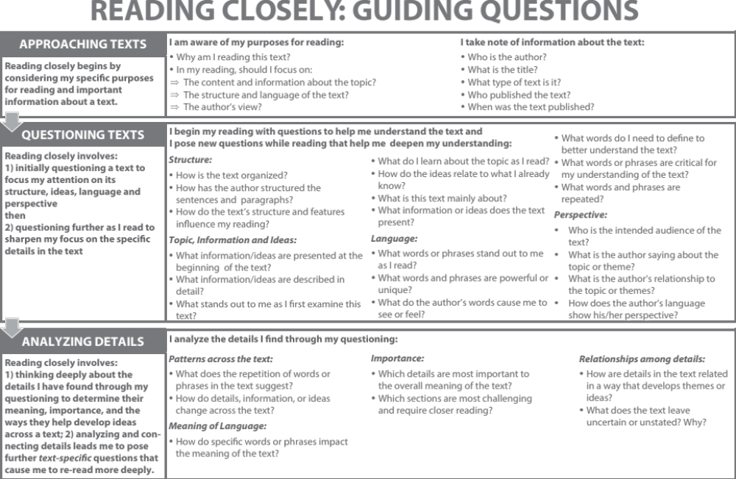

Reading Closely: Guiding Questions Handout

From Odell Education’s “Reading Closely for Details: Guiding Questions” handout. Used by permission
“The Shakespeare Shakedown”: Lesson 2 Text-Dependent Questions

Name:
Date:

Approaching the Text | Notes
Who is the author?

What is the title?

What type of text is it?
Who is the audience?

Read the text silently in your head as you hear it read aloud.

Text-Dependent Questions | Notes
1. What does the word anonymous mean?

2. In James Shapiro’s book Contested Will, what evidence or reasons does he attribute to those who want to deprive “Shakespeare of authentic authorship of his works”?

“The Shakespeare Shakedown”: Lesson 2 Text-Dependent Questions

Text-Dependent Questions | Notes
3. Look at Paragraph B.

What credentials does the Earl of Oxford have for being the “real Shakespeare”?

What does the term “patron of dramatists” mean?

What does the term “courtier-poet of middling talent” mean?
4. Look at Paragraph C.
What is the first supporting claim or reason Schama gives to support the central claim about the authenticity of Shakespeare’s authorship?
5. Look at Paragraph D.
What is the second supporting claim or reason Schama gives to support the authenticity of Shakespeare’s authorship?
6. Look at Paragraph E.
What is the last supporting detail or reason Schama gives to support the authenticity of Shakespeare’s authorship?
7. Look at Paragraph F.
According to Schama, why do some question the authenticity of Shakespeare’s authorship?

“The Shakespeare Shakedown”: Lesson 2 Close Reading Guide
(For Teacher Reference)

Approaching the Text | Teacher Guide
Who is the author? | Prompt students to find the name of the author, Simon Schama.
What is the title? | Invite students to point to the title and then write it on their note-catcher.
What type of text is it?  Who is the audience? | Ask students to think about what type of text this is. If they are struggling, help them narrow it down by asking: * “Is it a letter? A novel? A speech? An article?”  Once students know it is an article, ask them to identify where the article was published. Be sure they note that the article was published in Newsweek magazine. Explain that this is a magazine geared toward adult readers looking to keep up on current events and popular culture, including sports, entertainment, and literature.
Read for Gist | Teacher Guide
Read the article aloud while students follow along.

Ask students to turn to a partner and talk about the gist of the article.

The Shakespeare Shakedown”: Lesson 2 Close Reading Guide
(For Teacher Reference)

Approaching the Text | Teacher Guide
Text-Dependent Questions | Teacher Guide
1. What does the word anonymous mean? | Reread the first line above Paragraph A and explain that the term bard refers to someone who recites poetry, and Shakespeare is often given the honor of being called “the Bard” with a capital B.  Invite students to read the question with you.  Direct their attention to the line above Paragraph 1 so they can see the word anonymous in context.  Ask pairs to discuss what they think the word means.  Invite pairs to record their ideas on their text-dependent questions handout.  Cold call a pair to share their answer with the whole group. Clarify what the word means if necessary.  Ask students to revise their notes where they are incorrect.  Answer: The word anonymous means something that is not named.

The Shakespeare Shakedown”: Lesson 2 Close Reading Guide
(For Teacher Reference)

Approaching the Text | Teacher Guide
Text-Dependent Questions | Teacher Guide
2. In James Shapiro’s book Contested Will, what evidence or reasons does he attribute to those who want to deprive “Shakespeare of authentic authorship of his works”? | 1. Invite students to read the question with you.  2. Ask pairs to discuss what they think the answer is.  3. Invite pairs to record their ideas on their text-dependent questions handout.  4. Cold call a pair to share their answer with the whole group. Clarify the answer, if necessary.  5. Ask students to revise their notes where they are incorrect.  Answer: Skeptics cite that there are no existing original manuscripts from Shakespeare’s time and that Shakespeare lacked the family, education, and connections to write such “intellectual” pieces.  Be sure students understand that Schama specifically references the importance of family, education, and connections. These three points will directly relate to Schama’s argument.

The Shakespeare Shakedown”: Lesson 2 Close Reading Guide
(For Teacher Reference)

Approaching the Text | Teacher Guide
3. Look at Paragraph B.  What credentials does the Earl of Oxford have for being the “real Shakespeare”?  What does the term “patron of dramatists” mean?  What does the term “courtier-poet of middling talent” mean? | - Repeat the numbered steps from the previous question.  - The Earl of Oxford was “a patron of dramatists,” “a courtier-poet of middling talent,” and “an adventurer,” having been “banished from the courts and captured by pirates.”  - “Patron of dramatists”: The Earl of Oxford provided financial support to playwrights.  - “Courtier-poet of middling talent”: Ask students:  *“Do you recognize a word within the word courtier?” Ideally, students will notice the word court and explain that the Earl of Oxford may have been invited to the royal court as a poet of average or moderate talent.  If students are struggling, point them to the bottom of the page, where several of the words are defined for them. Share with students that this is complex, mature language. They are studying this slowly and carefully to help them better understand the author’s argument.
4. Look at Paragraph C.  What is the first supporting claim or reason Schama gives to support the central claim about the authenticity of Shakespeare’s authorship? | - Repeat the numbered steps from the second question.  - Schama addresses the issue of Shakespeare’s family. Though his father, John Shakespeare, could not read or write, William Shakespeare could certainly read and write. According to Schama, the proof of this is that there are at least six signatures written by Shakespeare.

The Shakespeare Shakedown”: Lesson 2 Close Reading Guide
(For Teacher Reference)

Approaching the Text | Teacher Guide
5. Look at Paragraph D.  What is the second supporting claim or reason Schama gives to support the authenticity of Shakespeare’s authorship? | - Repeat the numbered steps from the second question.  - Schama addresses the next issue, Shakespeare’s education, by arguing that the rudimentary or basic education of a village school was actually quite intense. Shakespeare would have read Roman and Greek philosophers and authors in Latin.
6. Look at Paragraph E.  What is the last supporting claim or reason Schama gives to support the authenticity of Shakespeare’s authorship? | - Repeat the numbered steps from the second question.  - Schama addresses the third issue, Shakespeare’s connections, by arguing that he would have known about how royalty functions, since he performed before them almost 100 times.
7. Look at Paragraph F.  According to Schama, why do some question the authenticity of Shakespeare’s authorship? | - Repeat the numbered steps from the second question.  - Schama believes that the reason some might argue that Shakespeare was a fraud is because they lack the imagination to believe that someone could have written such pieces that reach both the common person and the royal court.

QuickWrite 1

Name:
Date:

What are the three pieces of evidence Simon Schama gives to support his central claim in the article “The Shakespeare Shakedown”? Use specific evidence from the text to write a paragraph that answers this prompt.

- Answer the prompt completely.
- Provide relevant and complete evidence.
- Your paragraph should include:
  - A focus statement explaining the author’s central claim
  - At least three pieces of evidence from the text
  - For each piece of evidence, an analysis or explanation: What does this evidence mean?
  - A concluding sentence

Inadvertently: accidentally
Provenance: background
rudimentary: basic or simple
incontrovertibly: certainly or undoubtedly
quicksilver: changeable
protean: adjustable

