Lesson 27   
Objective: Count 10 objects and move between all configurations.

Suggested Lesson Structure

 Fluency Practice (12 minutes)

 Application Problem (5 minutes)

 Concept Development (25 minutes)

 Student Debrief (8 minutes)

**Total Time (50 minutes)**

Fluency Practice (12 minutes)

* Four Corners (Pairs of 5-Groups) K.CC.4b (4 minutes)
* Rekenrek Roller Coaster to 10 **K.CC.4a** (4 minutes)
* Line Up, Sprinkle, Circle **K.CC.5** (4 minutes)

Four Corners (Pairs of 5-Groups) (4 minutes)

Conduct the activity as outlined in Lesson 18, but form groups of 10 instead. Have students first form groups of 5, and then pair each 5-group with another 5-group to make 10. If the number of students present does not allow for forming equal groups, use puppets or stuffed animals as stand-ins. Just be sure to explain that they are to be counted as additional *students*. The activity can be done with counters instead.

Rekenrek Roller Coaster to 10 (4 minutes)

Conduct the activity as outlined in Lesson 7. Consider alternating between the 5-group orientation (e.g., 6 as 5 red beads on top and 1 red bead on the bottom) and the color change orientation (e.g., 6 as 5 red beads and 1 white bead on the top row). Just be sure to alert students to the different types of orientation so that they will know what to expect. (“Now I’ll show you the 5-group way.”)

Line Up, Sprinkle, Circle (4 minutes)

Conduct the activity as outlined in Lesson 10. This can also be played as a partner game, with two partners showing the same number of beans but in different configurations.

Application Problem (5 minutes)

Create a snowman that is 5 snowballs high. Make a friend next to him that is also 5 snowballs high. How many snowballs did you use? Write the number.

Note: In this problem, students draw 10 in an array configuration to prepare for drawing 10 in different ways in today’s lesson.

Concept Development (25 minutes)

Materials: (S) Bag of 10 small counters (objects should vary from student to student), 5-group mat (Lesson 17 Template), work mat inscribed with a large circle, plastic cup

T: Take out 5 of your counters, and put them on the 5-group mat. Now, count out 5 more, and put them on the mat. How many?

S: 10.

T: Show your friend how you counted. Did you both count the same way? How did you make sure you didn’t count one twice?

S: (Responses will vary. Allow time for sharing and discussion.)

T: Let’s pretend these are beads like the ones we used on our bracelet yesterday. Arrange your counters on the big circle to look like a bracelet. Do you think you need to count them all again to know how many counters are on your bracelet? (Allow time for discussion. Guide students to realize that because of number conservation, they don’t really need to recount.)

T: Let’s count to test your idea. With your pencil, make a mark by the beadyou will use to start your counting, and then count. How many?

S: 10.

T: Show your friend how you counted. Did you both count the same way? How did you make sure you didn’t count one twice?

**MP.7**

S: (Responses will vary. Allow time for sharing and discussion.)

T: This time, start with a bead on the other side of the bracelet and count again. Do you have the same number? How do you know?

S: (Responses will vary. Guide students to again discuss the conservation of number.)

T: This time let’s put our counters in a long row across the paper. How many counters do you have now? This is a long row! Let’s make some smaller ones. Take all your counters off.

T: Now, put five of your counters in a row on your work mat. Make another row of counters underneath the first one. (Demonstrate.) What do you notice?

S: We have 2 fives. 🡪 We have two 5-groups. 🡪 The rows are exactly the same. 🡪 We have 10.

T: Turn your mat so your rows look like towers. (Demonstrate.) What do you see now?

S: We have little rows. 🡪 The rows have 2 counters. 🡪 There are 5 little rows. 🡪 We still have 10.

T: Put your counters in the plastic cup. Shake them up ten times, and pour them onto your work mat. (Demonstrate.) Count your objects. How many?

|  |  |
| --- | --- |
|  | NOTES ON  MULTIPLE MEANS  OF REPRESENTATION: |
| For the students who are still counting their beads after every change, repeat the process by asking them to organize their beads into two rows and count them, and then move them into a circle and recount. Let students try as many times as they need in order to be convinced that they no longer need to recount and are able to say that they have 10 beads no matter how they display them. This may take many weeks. Be patient! | |

S: 10!

T: Look at your friend’s work mat, and compare his set to yours. How are they the same? How are they different? (Allow time for observation.) Show each other how you counted. Did you count them the same way?

S: (Responses will vary. Allow time for sharing and discussion.)

T: Put 5 of your counters back in the bag. Now, put 5 more counters back in the bag. How many counters did you put away? How many do you have left?

**MP.7**

S: 10! There are 0 left.

Problem Set (6 minutes)

Students should do their personal best to complete the Problem Set within the allotted time.

|  |  |
| --- | --- |
|  | NOTES ON  MULTIPLE MEANS  OF ENGAGEMENT: |
| Challenge students by asking them to find different hidden partnersinside 10. | |

Distribute the Problem Set to students. Guide students to color the first shape counted in the circular configuration. Read the directions step by step for drawing the cookies and the flowers.

Remind students to connect the apples as they are counting. Make a different counting path for each set of apples.

Student Debrief (8 minutes)

**Lesson Objective:** Count 10 objects and move between all configurations.

The Student Debrief is intended to invite reflection and active processing of the total lesson experience.

Invite students to review their solutions for the Problem Set. They should check work by comparing answers with a partner before going over answers as a class. Look for misconceptions or misunderstandings that can be addressed in the Debrief. Guide students in a conversation to debrief the Problem Set and process the lesson.

You may choose to use any combination of the questions below to lead the discussion**.**

Have students come to the carpet and discuss the Problem Set.

* With which circle did you begin counting? Was it different from your partner’s?
* How did you draw your 10 circles? Compare your drawings with your partner’s.
* (Discuss the pattern of counting in the scattered array.) How was this counting path different from the first path? How was your partner’s counting path different?
* 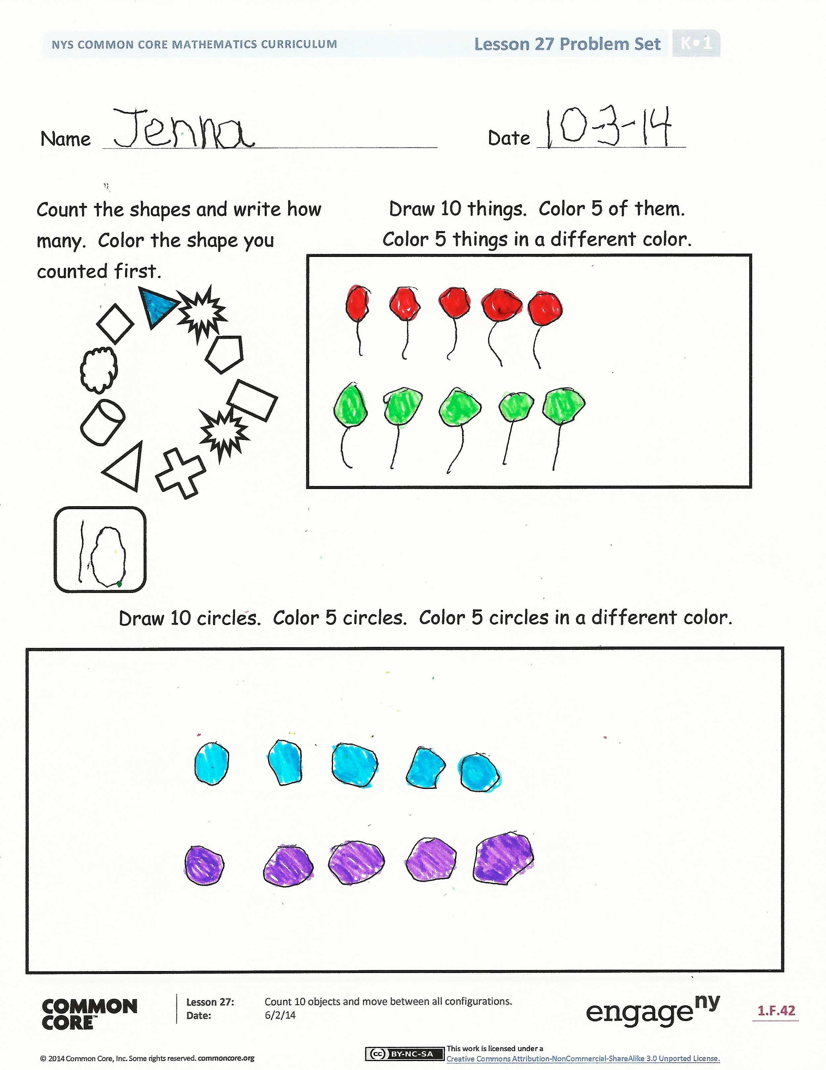Lead discussion for the best path students used to count the scattered configuration.
* The number 10 is very special for our bodies. Why do I say that?

Exit Ticket (3 minutes)

After the Student Debrief, instruct students to complete the Exit Ticket. A review of their work will help you assess the students’ understanding of the concepts that were presented in the lesson today and plan more effectively for future lessons. You may read the questions aloud to the students.

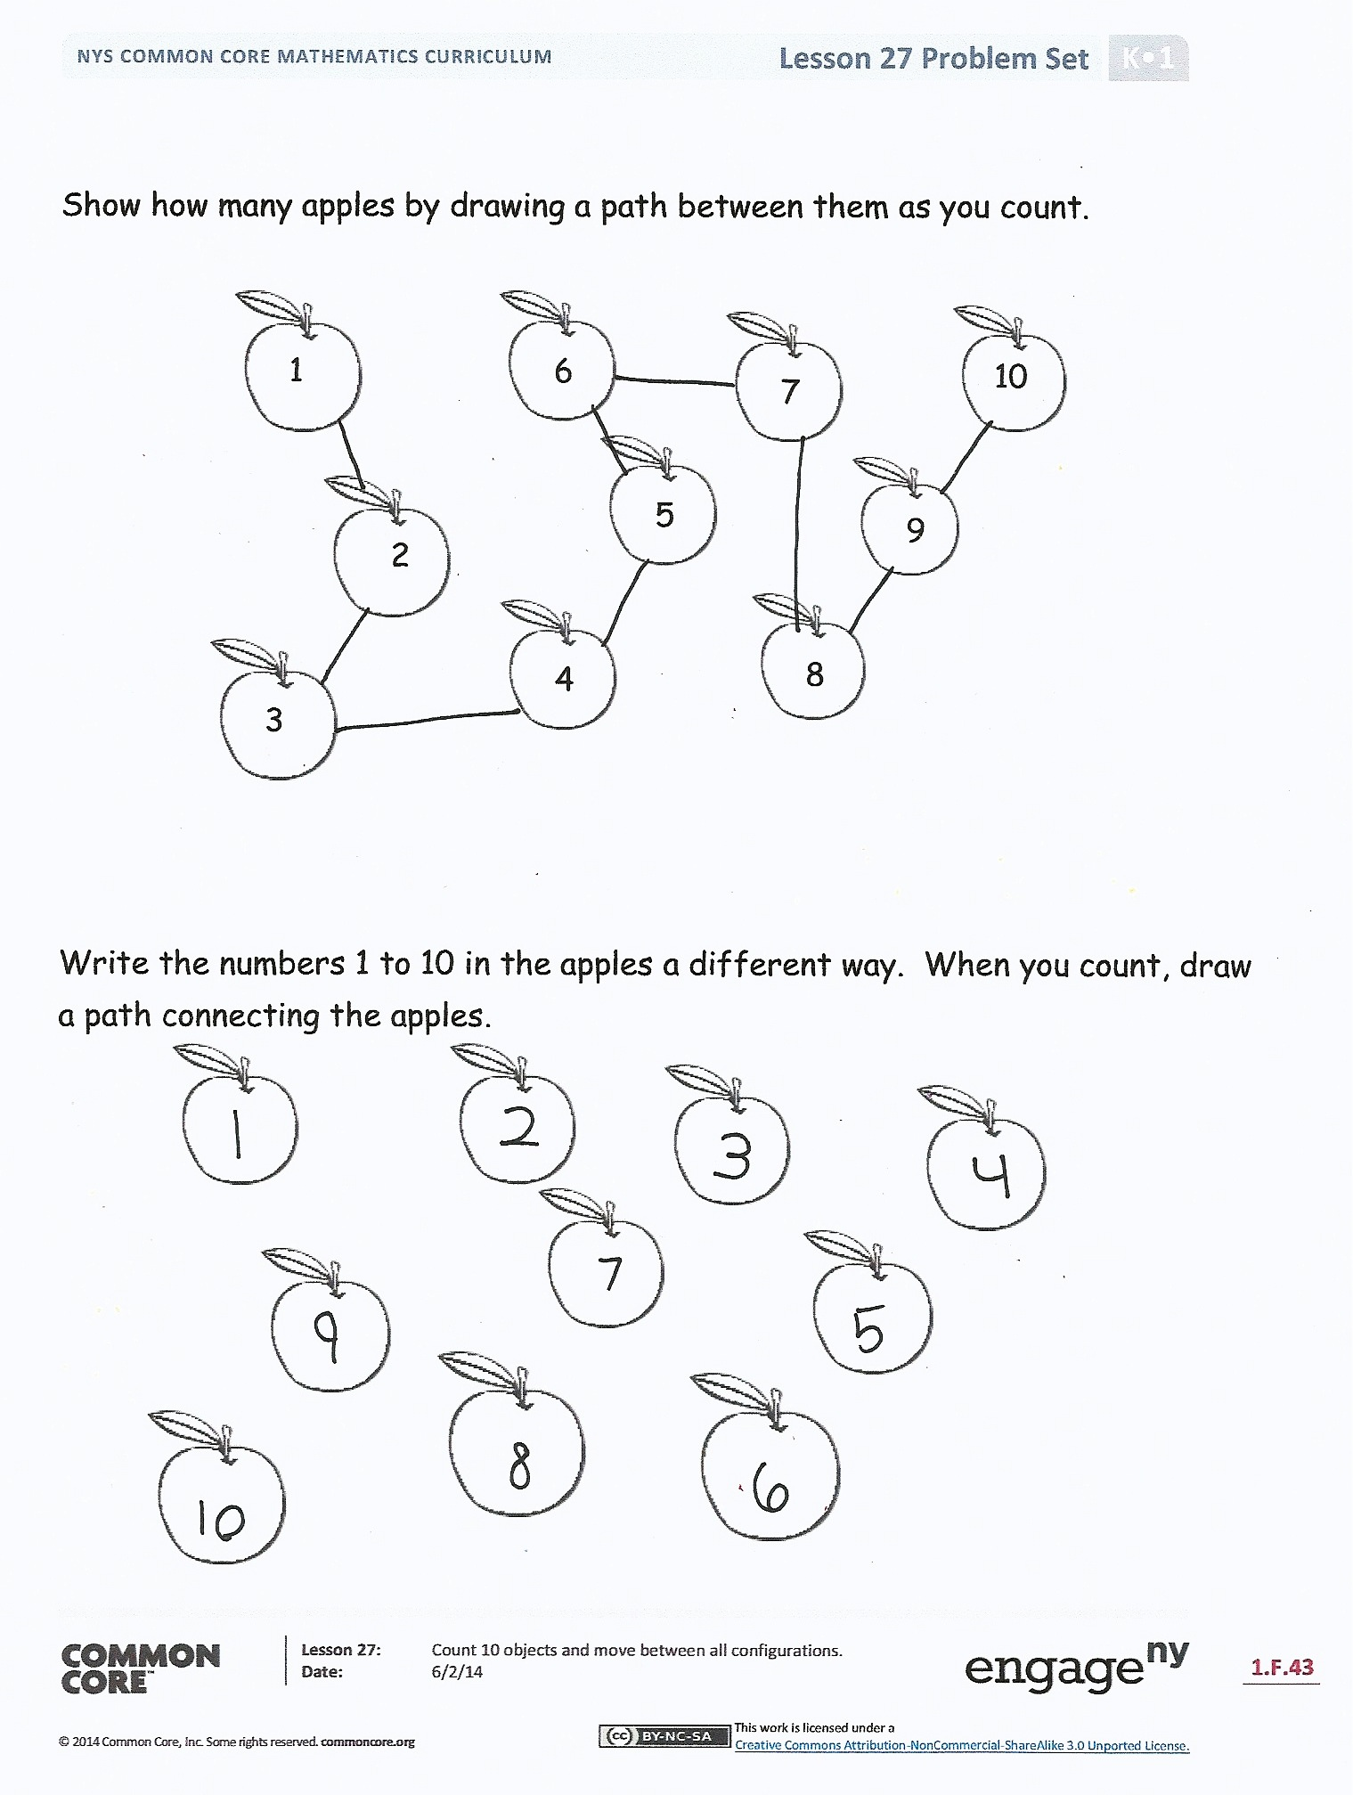

Name Date

Draw 10 things. Color 5 of them.   
Color 5 things a different color.

Count the shapes, and write how many. Color the shape you counted first.

Draw 10 circles. Color 5 circles. Color 5 circles a different color.



1

2

3

5

4

6

7

8

9

Show how many apples by drawing a path between them as you count.

10



Write the numbers 1 to 10 in the apples a different way. When you count, draw a path connecting the apples.

Name Date

Draw 10 beads on the bracelet.

Count and write the numbers 1 to 10 in the . Write how many in the box.



Name Date

Draw enough to make 10.

Draw enough to make 10.