Lesson 26
Objective: Count 10 objects in linear and array configurations (5 and 5). Match with numeral 10. Place on the 5-group mat. Dialogue about 9 and 10. Write numeral 10.

Suggested Lesson Structure
 Fluency Practice (12 minutes)
 Application Problem (5 minutes)
 Concept Development (25 minutes)
 Student Debrief (8 minutes)
Total Time (50 minutes)
Fluency Practice (12 minutes)
- Roll, Count, Show the Number K.CC.4a (4 minutes)
- Match Movements to Counts K.CC.4b (4 minutes)
- See, Count, Write Numbers to 10 K.CC.5 (4 minutes)
Roll, Count, Show the Number (4 minutes)
Conduct the activity as outlined in Lesson 9. Be sure to cover the 6-dot side to represent 0, ensuring that the total number of dots does not exceed 10.
Match Movements to Counts (4 minutes)
Select two students. One student chooses a number from 1 to 10; the other student selects a movement or exercise to do that number of times. For each movement, maintain an even pace. Do not allow students to count too quickly. Do the movement with the class, but do not count with them.
Student A: The number is 4.
Student B: Clap hands.
T: So, what do we do, everyone?
S: Clap our hands 4 times.
T: Ready? Go!
S: 1 (clap), 2 (clap), 3 (clap), 4 (clap).
Choose two more students and repeat with different numbers and movements.
See, Count, Write Numbers to 10 (4 minutes)
Materials: (S) Personal white board
Conduct the activity as outlined in Lesson 15, but extend to 10. Using the personal white boards allows students to provide immediate feedback—a thumbs up, or try again. Reinforce proper numeral formation as well. Challenge early finishers by asking what if questions. For example, “What if there were 2 more dots? What if 1 disappeared?”
Variation: Show objects in different configurations such as those on 5-group cards; name objects in the room for students to count.
Application Problem (5 minutes)
Let’s build a wall! Draw a row of 5 bricks. Build your wall by drawing another row of 5 bricks on top. How many bricks did you draw?
Note: The exercise reinforces the count of 10 in an array formation, anticipating today’s Problem Set.
Concept Development (25 minutes)
Materials: (T) Cardboard writing frame on board (S) Bag of pony beads (5 red and 5 white), pipe cleaner or lanyard for bracelet, 5-group mat (Lesson 17 Template), personal white board
T: Take 5 red beads from your bag, and put them onto the mat. Take 5 white beads from your bag, and put them onto the mat. What do you see? How many beads do you have?

NOTES ON
MULTIPLE MEANS
OF ACTION AND EXPRESSION:
Help English language learners understand the instructions by gesturing with arms extended fully above the head while instructing students to make their beads into a column. Or, point to a visual of column while giving directions. Alternatively, ask students to show a column with their arms to be sure that the instructions are clearly understood.

S: We have two groups of 5 We have 10 beads.
T: Yes! Ten is the same as 5 and 5. Turn your mats so the rows become columns. How many beads?
S: Still 10.
MP.7
T: Now, take your red beads and make a row on your desk. How many red beads?
S: 5.
T: Make another row with your white beads underneath your first row. Do you still have 10 beads? How do you know? (Allow time for discussion. Help students to line up the rows carefully so they will be prepared to draw fairly accurate rows on the Problem Set.)
T: Can you move your red beads so they make a column? (Demonstrate if necessary.) Now, make a column with your white beads next to it. What do you notice? (Encourage students to notice that there are now 5 rows of 2. They may need to separate the rows a bit to make this more intuitive.)
T: How many beads?

NOTES ON
MULTIPLE MEANS
OF REPRESENTATION:
Because understanding the number 10 deserves special attention, help special needs students by using different representations of 10 (fingers, pennies, ten frames of different objects, pictures, and other visuals of 10 objects scattered and on 5-group mats) to assist students in mastering this important milestone. Use interactive technology such as the activity found at: http://illuminations.nctm.org/ActivityDetail.aspx?ID=75
Note that the website uses the 10-frame (rather than the 5-group configuration), which keeps the two fives very close together. This will be used more in Module 5 as students work with 10 ones within teen numbers.

S: 10.
T: We are going to make bracelets to celebrate the number 10! Take your 5 red beads, and put them onto the pipe cleaner. (Demonstrate.) How many are left on your desk?
S: 5.
T: Now, put 5 white beads on your bracelet. Close it like this. (Demonstrate and assist if necessary.) Push your beads all together on your bracelet. How many beads are in the row?
S: 10!
T: I wonder what happens if we move one bead to the other side of your bracelet. (Demonstrate.)
S: We have 9 beads on 1 side and 1 bead on the other.
T: What if we separate the red and white beads into groups on our bracelet?
S: The bracelet looks different. The groups are exactly the same size. We have a red and a white part. We have two groups of 5. We still have 10 beads.
T: You can put your bracelets on and take them home to show your family about your bead groups. Show your bracelet to a friend, and tell her about your beads!
S: (Allow time for comparison and discussion.)
T: Let’s write the number that shows how many beads are on your bracelet. We write the number 10 like this. (Demonstrate in the cardboard writing frame. Use the rhymes for numeral formation, if desired.)
T: Try it with your skywriting while I show you again on the board. (Repeat. Follow by having children practice with their fingers on the rug or table for tactile reinforcement.) You may practice writing tens on your personal board. When you are ready, take out your practice page, and write tens with your pencil. (Distribute penmanship practice sheet to students.)
Problem Set (5 minutes)
Students should do their personal best to complete the Problem Set within the allotted time.
Have students color, count, and draw the groups of 10. Have them draw a picture of their bracelet on the back.

Student Debrief (8 minutes)
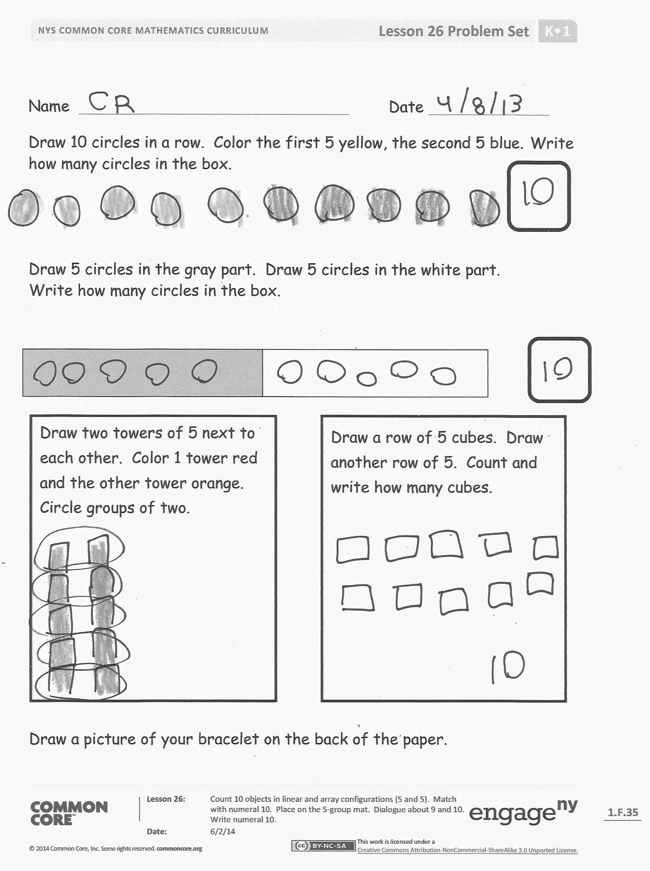
Lesson Objective: Count 10 objects in linear and array configurations (5 and 5). Match with numeral 10. Place on the 5-group mat. Dialogue about 9 and 10. Write number 10.
The Student Debrief is intended to invite reflection and active processing of the total lesson experience.
Invite students to review their solutions for the Problem Set. They should check work by comparing answers with a partner before going over answers as a class. Look for misconceptions or misunderstandings that can be addressed in the Debrief. Guide students in a conversation to debrief the Problem Set and process the lesson.
You may choose to use any combination of the questions below to lead the discussion.
- Show your partner how you made your yellow and blue circles.
- With your partner, count the gray cubes. Then, count the white cubes. What was the last number you said when you counted each group?
- Look at one of your hands. Is there anything the same about your fingers and the things we just counted?
- Think about when we matched our fingers on one hand to our other hand. Is there something on your Problem Set that is like what we did with our fingers? How?
- Tell your friend about the beads on your bracelet. Count them together. Can you count them another way?
- What do you like about the number 10?
Exit Ticket (3 minutes)
After the Student Debrief, instruct students to complete the Exit Ticket. A review of their work will help you assess the students’ understanding of the concepts that were presented in the lesson today and plan more effectively for future lessons. You may read the questions aloud to the students.

Name Date
Put this page into your personal white boards. Practice. When you are ready, write your numbers in pencil on the paper.

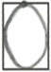

Name Date
Draw 10 circles in a row. Color the first 5 yellow, the second 5 blue. Write how many circles in the box.

Draw 5 circles in the gray part. Draw 5 circles in the white part.
Write how many circles in the box.

Draw two towers of 5 next to each other. Color 1 tower red and the other tower orange. Circle groups of two.

Draw a row of 5 cubes. Draw another row of 5. Count. Write how many cubes.

Draw a picture of your bracelet on the back of the paper.
Name Date
Color 5 blocks red and 5 blocks green. How many blocks? Write how many in the box.

Color 5 blocks brown and
5 blocks yellow. How many blocks?
Write how many in the box.

Name Date
Draw 5 triangles in a row. Draw another 5 triangles in a row under them.
How many triangles did you draw?
Write the number in the box.

Write how many Write how many
in the box. in the box.

