Lesson 25
Objective: Count 10 objects in linear and array configurations (2 fives). Match with numeral 10. Place on the 5-group mat. Dialogue about
9 and 10. Write numeral 10.

Suggested Lesson Structure
 Fluency Practice (12 minutes)
 Application Problem (5 minutes)
 Concept Development (25 minutes)
 Student Debrief (8 minutes)
Total Time (50 minutes)
Fluency Practice (12 minutes)
- Five Shortcut K.CC.2 (4 minutes)
- Happy Counting Within 10 K.CC.2 (4 minutes)
- 1, 2, 3, Stand on 10 K.CC.2 (4 minutes)
Five Shortcut (4 minutes)
Materials: (S) Personal white board, blank 5-group (Fluency Template)
T: I’m going to say a number, and I want you to draw that many dots. Remember to start at the top, filling in the rows from left to right, the same way we see on our 5-group cards!
T: Ready? Draw 5 dots.
S: (Draw 5 dots to fill in the top row.)
T: How many dots?
S: 5.
T: Are they on the top row or bottom row?
S: Top.
T: So, if the top row is full, we know there are…
S: 5!
T: Now, show me 6 dots. (Observe carefully, noting which students simply make an additional dot and which must count from 1.)
S: (Draw an additional dot on the bottom row for a total of 6.)
T: How many dots are on the top row?
S: 5.
T: Since we already know there are 5 on top, we can take the five shortcut, like this:
Fiiiiiive (slide finger across the row of 5), 6 (point to the individual dot). Try it with me.
S: Fiiiiiive (slide finger across the row of 5), 6 (point to the individual dot).
Proceed similarly with drawing and counting 7–10 dots, starting from 5. As students develop familiarity with the exercise, reduce teacher language to increase efficiency in completing the problems.
Variation: For students who require a more concrete experience, allow them to place cubes on the blank
5-group, in lieu of drawing dots.
Happy Counting Within 10 (4 minutes)
Conduct the activity as outlined in Lesson 6, gradually building to sequences within 10. If students hesitate or have difficulty, return to work within 7. If they are ready to be challenged, quicken the pace.
1, 2, 3, Stand on 10 (4 minutes)
Conduct the activity as outlined in Lesson 22. Challenge students to complete a round of play faster than the last time. If a student struggles to recall what numbers to say, prompt them by showing the numbers with fingers the Math Way, which by now they will be able to recognize quickly.
Application Problem (5 minutes)
Make a group of 9 smiley faces. Write the number 9. Count the smiley faces by connecting them with lines. Make sure you don’t count any of them twice! Compare your picture with that of a friend. Discuss what would happen if you had another smiley face in your picture.
MP.7
Note: This review problem helps students to anticipate the number 10. We call out MP.7 because students are using the structure of 9 to think about what would happen if they added another smiley face.
Concept Development (25 minutes)
Materials: (T) Cardboard writing frame on board (S) Bag of 10 beans, bag of 10 linking cubes (5 red, 5 blue), construction paper work mat, 5-group mat (Lesson 17 Template), 5-group cards (Lesson 8 Template, numeral side)
T: Count 5 beans from your bag, and put them on the 5-group mat. Count out 4 more beans, and put them on the mat. How many beans do you have?
S: 9.
T: Should we fill up our mats?
S: Yes!
T: How many more beans will we need?
S: 1.

NOTES ON
MULTIPLE MEANS
OF ACTION AND EXPRESSION:
Help English language learners understand the directions by gesturing with arms extended fully to the sides while instructing them to place their linking cubes in a row. Or, point to a visual of row while giving directions. Alternatively, ask students to show you a row with their arms to be sure that the instructions are clear.

T: Go ahead and fill your 5-group mat! Now, you have 1 more than 9 beans. Let’s count our beans.
S: 1, 2, 3, 4, 5, 6, 7, 8, 9 …10.
T: Yes, 9 and 1 more make 10! You have 10 beans now. What do you notice about your mats?
S: We have 5 in one row and 5 in the other.
T: Ten is the same as 5 and 5. Trade each bean in your first row for a red linking cube.
S: (Trade.)
T: Now, trade each bean in your second row for a blue linking cube. What do you see?
S: The rows are exactly the same size. We have 5 red and 5 blue. Our mats are full. We have 10 cubes.
T: Let’s make towers! Put your red cubes together in a tower and your blue cubes in another tower. How many cubes are in each tower?
S: 5.
T: Put your towers together to make a taller one! Count your cubes. How many?
S: 10.
T: Let me show you how to write the numeral for 10. (Demonstrate on the classroom board.) Find the number card that shows how many cubes are in your tower. Hold it up. How many?
S: 10!

NOTES ON
MULTIPLE MEANS
OF ACTION AND EXPRESSION:
Increase the pace of learning for students performing above grade level by asking them to show how they would represent an array of the 9 remaining cubes. Pair them up to discuss the differences between an array of 10 linking cubes and an array of 9 linking cubes. Have them find shortcuts to move between the two arrays.

T: We are going to take our towers apart in a special way. Listen carefully! Make your tall tower into red and blue towers. Take off one red and one blue cube and put them in a little row on your work mat. How many cubes are in your row?
S: 2.
T: Make a row underneath that is exactly the same as your first row. (Repeat.) Do we have enough left to make more rows like this? Keep going until your cubes are gone. What do you notice?
S: We have 5 rows of 2! We have 10 cubes.
T: What happens if you turn your work mat like this? (Demonstrate turning mat from horizontal to vertical.) What do you see?
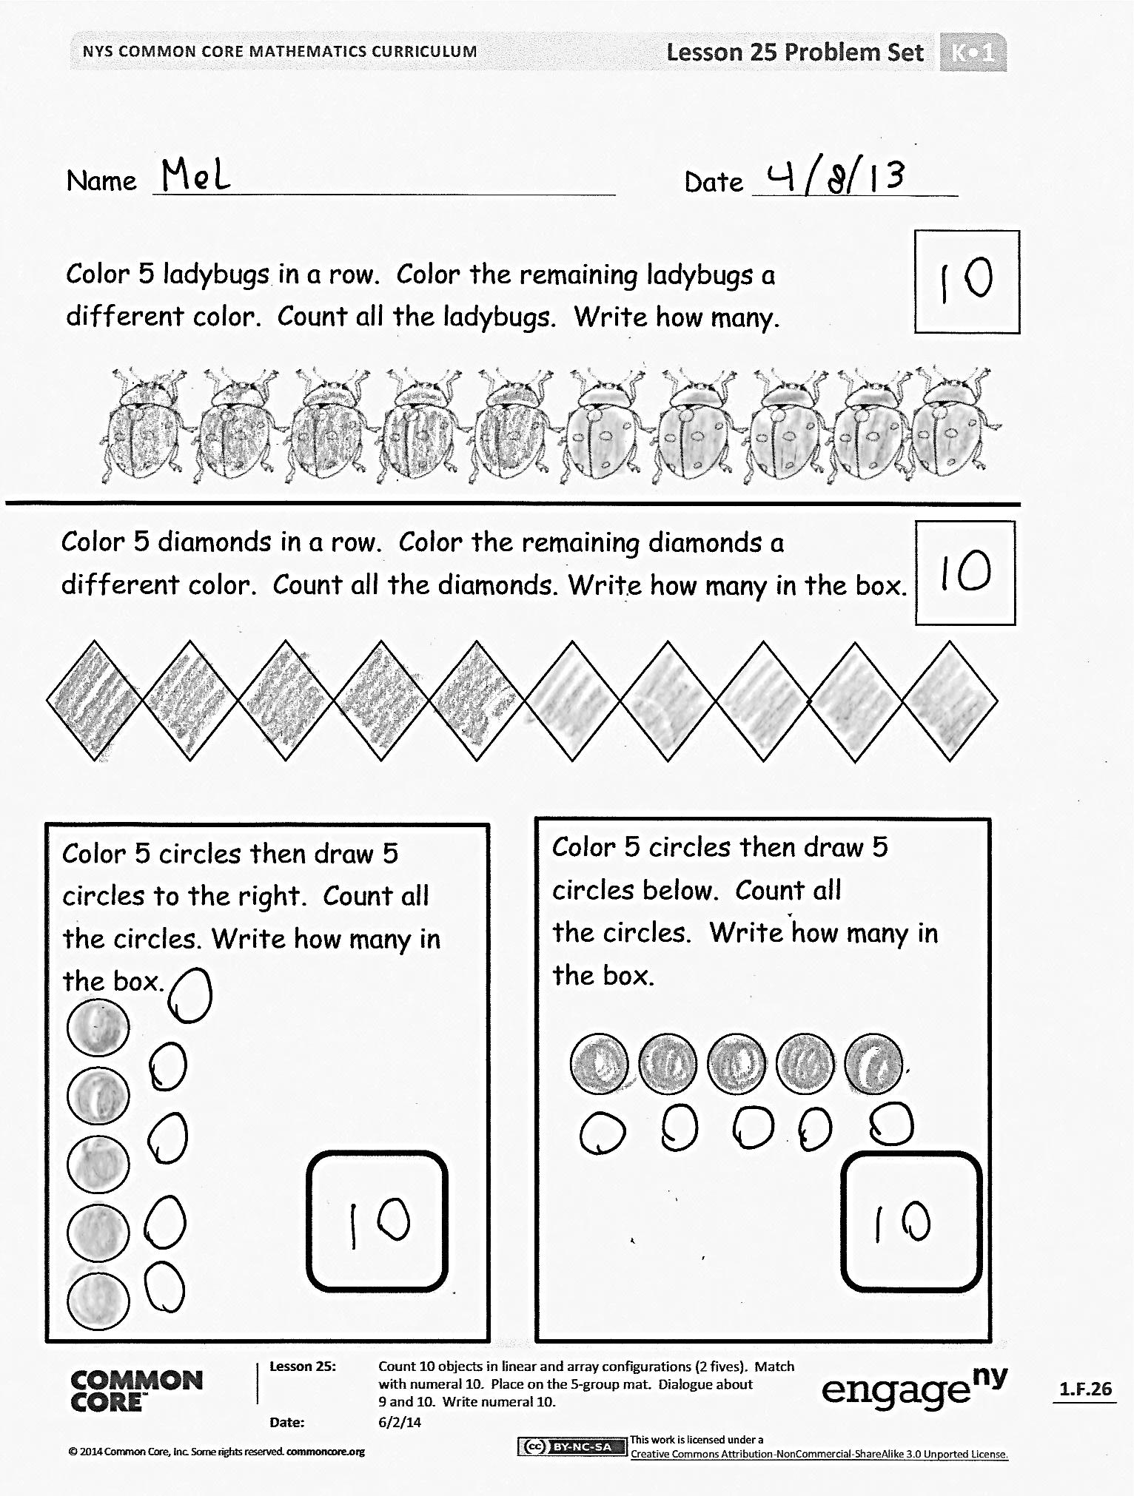
S: Now, we have 2 rows of 5, but we still have 10 cubes. (Repeat this exercise a few times to show the different arrays and to reinforce understanding of number conservation.)
T: Hold up the card that shows how many cubes are on your mat. How many?
S: (Hold up card.) 10!
T: Put 1 cube away. I wonder how many you still have left on your mat? (Allow time for discussion.) Now, put 9 cubes away, and get ready for your Problem Set.
Problem Set (8 minutes)
Students should do their personal best to complete the Problem Set within the allotted time.
Student Debrief (8 minutes)
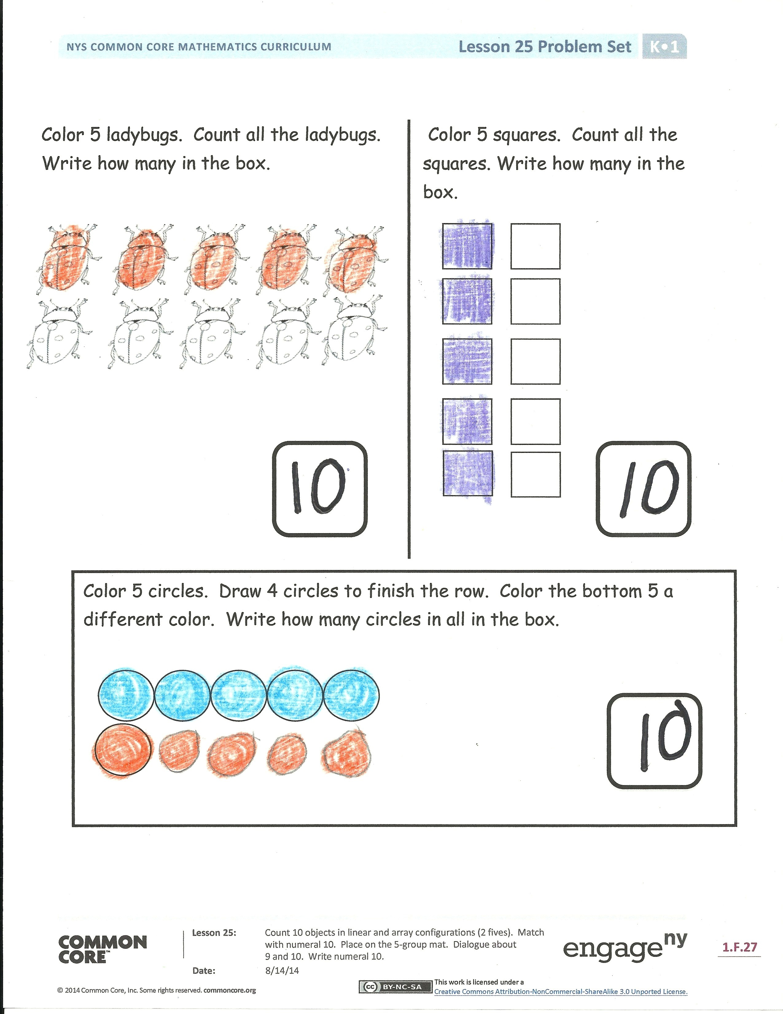
Lesson Objective: Count 10 objects in linear and array configurations (2 fives). Match with numeral 10. Place on the 5-group mat. Dialogue about 9 and 10. Write number 10.
The Student Debrief is intended to invite reflection and active processing of the total lesson experience.
Invite students to review their solutions for the Problem Set. They should check work by comparing answers with a partner before going over answers as a class. Look for misconceptions or misunderstandings that can be addressed in the Debrief. Guide students in a conversation to debrief the Problem Set and process the lesson.
You may choose to use any combination of the questions below to lead the discussion.
- Discuss the groups within 9. Nine is 5 and 4. How does 10 change the 5-groups?
- How did you color 5 squares? Did your partner color in the same way?
- How are the ladybugs and squares different in how they are placed on the paper?
- Focus on 10 as being 2 rows of 5 or 5 rows of 2. Also, find hidden partners inside 9 and 10.
- What did you learn today about the number 10?
Exit Ticket (3 minutes)
After the Student Debrief, instruct students to complete the Exit Ticket. A review of their work will help you assess the students’ understanding of the concepts that were presented in the lesson today and plan more effectively for future lessons. You may read the questions aloud to the students.

Name Date
Color 5 ladybugs in a row. Color the remaining ladybugs a
different color. Count all the ladybugs. Write how many in the box.
Color 5 diamonds in a row. Color the remaining diamonds a
different color. Count all the diamonds. Write how many in the box.

Color 5 circles. Then, draw 5 circles below. Count all
the circles. Write how many in the box.

Color 5 circles. Then, draw 5 circles to the right. Count all the circles. Write how many in the box.

Color 5 ladybugs. Count all the ladybugs. Write how many in the box.

Color 5 squares. Count all the squares. Write how many in the box.

Color 5 circles. Draw 4 circles to finish the row. Color the bottom 5 a different color. Write how many circles in all in the box.

Name Date
Draw 5 more circles. How many are there now? Write how many in the box.

Color 5 blocks blue. Color 5 blocks green. Write how many in the box.

Name Date
Color 9 squares. Color 1 square a different color.
Color 5 squares. Color 5 squares a different color.

Color 9 squares. Color 1 square a different color.

Draw 5 circles under the row of circles. Color 5 circles red. Color 5 circles blue.

Draw 10 circles in a line. Color 5 circles red. Color 5 circles blue.

blank 5-group

