Lesson 23
Objective: Organize and count 9 varied geometric objects in linear and array (3 threes) configurations. Place counts on 5-group mat. Match with numeral 9.

Suggested Lesson Structure
 Fluency Practice (10 minutes)
 Application Problem (5 minutes)
 Concept Development (27 minutes)
 Student Debrief (8 minutes)
Total Time (50 minutes)
Fluency Practice (10 minutes)
- 5-Groups (Count On from 5) K.CC.2 (3 minutes)
- Show Me Beans (Color Change at 5) K.CC.2 (3 minutes)
- Rekenrek Wave to 10 K.CC.4a (4 minutes)
5-Groups (Count On from 5) (3 minutes)
Conduct the activity as described in Lesson 19. Continue to 10 if students are ready.
Show Me Beans (Color Change at 5) (3 minutes)
Conduct the activity as outlined in Lesson 19, but reduce teacher language as students develop familiarity with the exercise. For example, ask, “How many red? White? Count on from 5.”
Continue to 10 if students are ready.
Rekenrek Wave to 10 (4 minutes)
Conduct the activity as outlined in Lesson 7, but gradually build up to 10. Be careful not to mouth the words or count along with the students. Listen carefully for hesitations or errors, and return to a simpler sequence if necessary. If students demonstrate mastery, consider introducing the 5-group orientation (e.g., 6 as 5 red beads on top and 1 red bead on the bottom).
Application Problem (5 minutes)
Draw a shape that you might see as a fence at a playground. (Demonstrate, if you choose.) Draw 8 balls inside the fence. Count the balls. Share your counting with a friend.
Note: Reinforcing a scatter-count of 8 prepares students to count 9 in today’s lesson.
Concept Development (27 minutes)
Materials: (T) Cardboard writing frame on board (S) 1 bucket of assorted pattern blocks, 5-group mat (Lesson 17 Template), 5-group cards (1–9) (Lesson 7 Template, numeral side)
T: Put your 5-group mat in front of you. Count out 5 different pattern blocks from your bucket, and put each one on the mat. (Circulate to ensure proper placement.) Now, count out 4 pattern blocks, and put each one on the mat. What do you notice?

NOTES ON
MULTIPLE MEANS
OF REPRESENTATION:
Support English language learners and students with special needs by modeling directions for them: Take blocks from the bucket, and trade shapes so that what remains in the arrays are the same shape.

S: One row is full. There are 4 on the other one.
T: Look at your mat and compare it to your friend’s mat.
If you wanted to fill your mat, how many more blocks would you need?
S: 1!
T: Count the pattern blocks on your mat.
S: 1, 2, 3, 4, 5, 6, 7, 8, 9.
T: You have 9 pattern blocks. The numeral 9 looks like this: “A loop and a line. That’s the way we make a 9!” (Demonstrate in cardboard writing frame.) Find the digit card that shows how many blocks are on your mat. Hold it up and say the number.
S: (Hold up card.) 9.
T: Right! You have 5 shapes in one row and 4 in the other. Nine is 5 and 4.
T: Take 3 of your blocks and put them in a row on your desk. Now, take more blocks and make another row underneath that is exactly the same size. Look at what is left on your mat. Do you have enough shapes left to make another row?
S: Yes. We can make one more row. We can make 3 rows. When I put 3 rows, it kind of makes a square. We can make 3 rows of 3!
S: (Complete the additional rows.)
T: Look at the first shape in your top row. Take blocks from the bucket and trade the other shapes in the row so that they are all the same as the first one. Don’t take any extra shapes or lose one! Trade the shapes in the other rows the same way. (Circulate to ensure understanding.) Count the shapes again. Do you notice anything?
S: I still have 9 shapes. I have 3 green shapes, 3 pointy shapes, and 3 yellow shapes. (Answers may vary.)
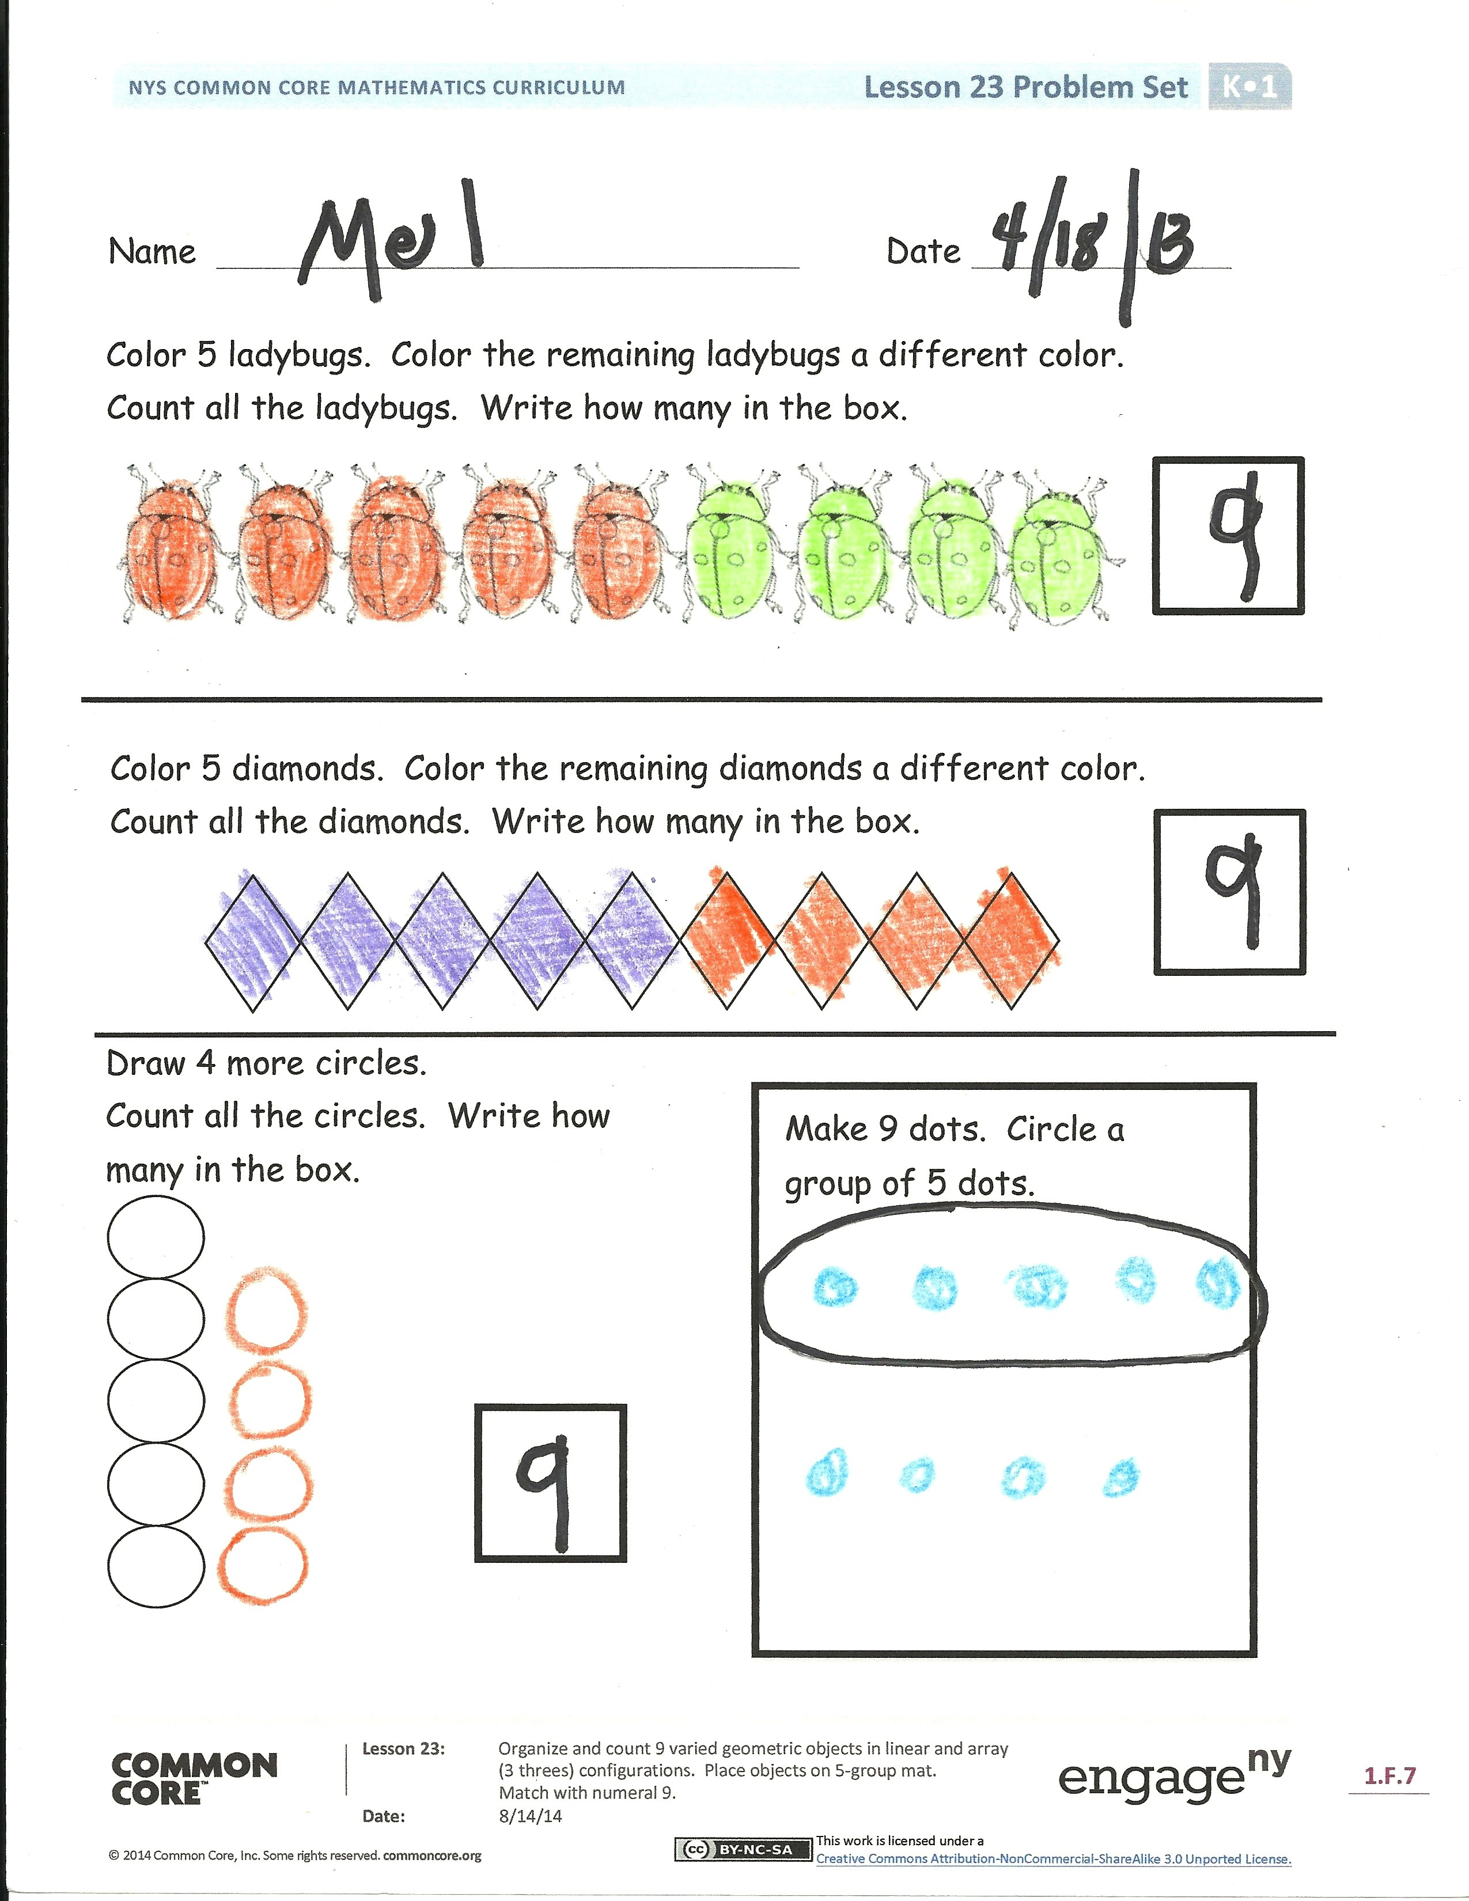
T: Look at your friend’s shapes. Do they look the same? (Allow time for sharing and discussion.)
Hold up the number card and say the number that tells how many shapes you have.
S: (Hold up card.) 9!
T: Count your blocks as you put them back into the bucket. We are going to look for more nines on your Problem Set.
Problem Set (10 minutes)
Students should do their personal best to complete the Problem Set within the allotted time.
Student Debrief (8 minutes)
Lesson Objective: Organize and count 9 varied geometric objects in linear and array (3 threes) configurations. Place objects on 5-group mat. Match with numeral 9.
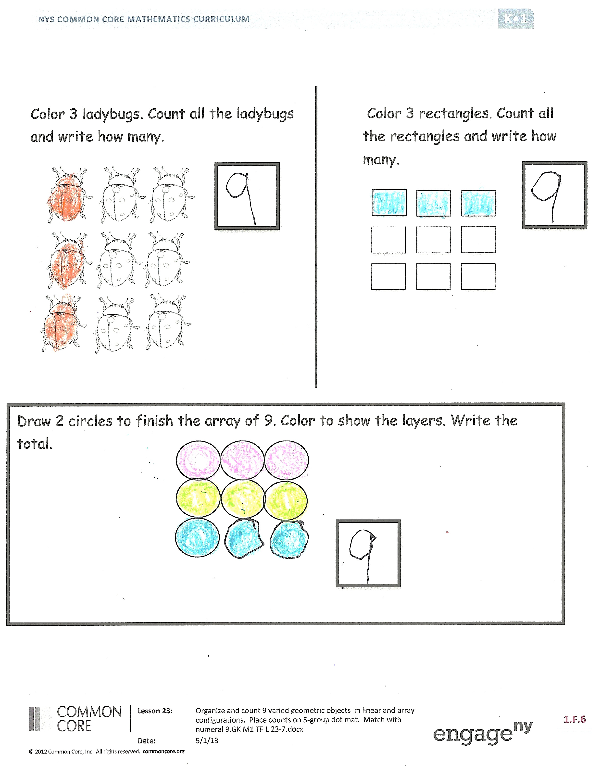
The Student Debrief is intended to invite reflection and active processing of the total lesson experience.
Invite students to review their solutions for the Problem Set. They should check work by comparing answers with a partner before going over answers as a class. Look for misconceptions or misunderstandings that can be addressed in the Debrief. Guide students in a conversation to debrief the Problem Set and process the lesson.
You may choose to use any combination of the questions below to lead the discussion.
- How did your groups of 9 differ? Lead students to discuss 9 as 5 and 4, as missing 1 to be 2 fives, and as being 3 rows of 3.
- What is different about the first two configurations?
MP.3
- Discuss with a partner how you drew your dots in 5-groups and in rows. Did your partner draw them the same way?

Exit Ticket (3 minutes)

NOTES ON
MULTIPLE MEANS
OF ACTION AND EXPRESSION:
Challenge students who are performing above grade level by asking them to draw or demonstrate the different configurations of 9 (e.g., let them draw or show you how 5 and 4 is different from 6 and 3). Analyze 9 as an array of 3 threes and share with the class. Let them see if they can find shortcuts for changing from the 5-group configuration to the array.

After the Student Debrief, instruct students to complete the Exit Ticket. A review of their work will help you assess the students’ understanding of the concepts that were presented in the lesson today and plan more effectively for future lessons. You may read the questions aloud to the students.

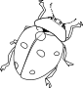
Name Date
Color 5 ladybugs. Color the remaining ladybugs a different color.
Count all the ladybugs. Write how many in the box.

Draw 4 more circles.
Count all the circles. Write how many in the box.
Make 9 dots. Circle a group of 5 dots.
Color 5 diamonds. Color the remaining diamonds a different color.
Count all the diamonds. Write how many in the box.

Color 3 ladybugs. Count all the ladybugs. Write how many in the box.
Color 3 rectangles. Count all the rectangles. Write how many in the box.

Draw 2 circles to finish the last row to make 9. Color to show the rows.
Write how many in the box.

Name Date
Color 5 shapes. Count how many shapes in all. Write the number in the box.

Count how many dots. Write the number in the box.

Name Date
Color 9 shapes.
Color 9 shapes.

Draw 9 shapes.
Draw 9 shapes a different way.

