Grade 7: Module 2B: Unit 2: Lesson 1
Building Background Knowledge: Introducing Pygmalion

Long-Term Targets Addressed (Based on NYSP12 ELA CCLS)
I can cite several pieces of text-based evidence to support an analysis of literary text. (RL.7.1)
I can select high-quality texts to read independently. (RL.7.11a and b)
Supporting Learning Targets | Ongoing Assessment
- I can build my background knowledge about the setting of the play we will read in this unit.  - I can make predictions and inferences based on a text. | - 3-2-1 Exit ticket

Agenda | Teaching Notes
1. Opening  - Entry Task: Mystery Quote (8 minutes)  - Introducing Learning Targets (2 minutes)  - Work Time  - Gallery Walk: Victorian England (15 minutes)  - Spirit Read (5 minutes)  - Mystery Excerpt from Pygmalion (10 minutes)  - Closing and Assessment  - 3-2-1 Exit Ticket (5 minutes)  - Homework  - Read independently for at least 30 minutes. | - In this lesson, students learn background information about Victorian England and the setting and time period of the play Pygmalion. They then begin to familiarize themselves with the language and the structure of the play, which is the central text of Unit 2.  - Review the Unit 2 overview. As explained in more detail in that document, Pygmalion is a more complex text than A Long Walk to Water (from Module 1) and also is a play, which has its own specific genre conventions and format. All students, even readers at grade level, will need your support in developing their stamina and independence with complex text during this unit. Consider how your existing routines and class culture around celebrating homework completion and effort might be used to support and encourage students as they read Pygmalion. Be sure to read the text in advance and consider what supports your students will need to understand it. See the Unit 2 Overview for a list of ways to support struggling readers and determine what will be most effective for your students.  - If students already know the play they will be reading or what it is about due to previous work, this is fine. While the Gallery Walk protocol works as a “mystery,” it will also work as simply an engaging introduction to the setting and background culture of the play. In particular, the Entry Task and Work Time C can still stand as “mysterious” quotes and excerpts; the mystery will relate then to the content of the play, not the name or basic information of the play. As in Unit 1, the sequence of homework, lessons, and assessments in this unit has been carefully designed to provide appropriate support during class and to make sure that students who are struggling with reading complex text at home will not be unduly disadvantaged on assessments. The sections of the play that students focus on during class are the sections most relevant to assessment tasks.  - The Reader’s Notes that students complete as they read for homework and the daily Checking for Understanding entry task that begins class the next day provide students with structures that help them make meaning of the text and then check to make sure their understanding is accurate.  - Homework in this lesson is independent reading, which takes place periodically in Unit 2. It is assumed at this point that an independent reading program has been launched before, during, or shortly after Unit 1—see the Unit 1 Overview for details and references.

Agenda | Teaching Notes (continued)
- In advance:
  - Print and post the Gallery Walk images and texts.
  - Find 10–12 additional images of Victorian England culture—the streets, people, clothing, food, transportation, etc.); print these and post them around the room.
  - Cut out individual quotation strips from the Quotations from Pygmalion handout (see supporting materials) for the Spirit Read.
  - Review: Gallery Walk and Spirit Read protocols (see Appendix).
- Post: Learning targets.

Lesson Vocabulary | Materials
crooning; bilious (from entry task) | - Entry Task: Lesson 1 (one per student)  - Gallery Walk images and texts (to print and post around room)  - Predictions note-catcher (one per student)  - Quotation strips from Pygmalion (one strips per student; see Teaching Notes  - Mystery excerpt (one per student)  - 3-2-1 Exit ticket

Opening | Meeting Students’ Needs
A. Entry Task: Mystery Quote (8 minutes)  - As students enter the room, distribute the Entry Task: Lesson 1. Ask students to do the following:  - “Read the quotation below, which is from the next text we will read, and answer the following: What would you guess this text is about?”  - Direct students to complete the entry task individually and silently, just as they did during Module 1.  - When students are done, invite them to read the excerpt aloud with an elbow partner and then share what they wrote. Cold call on several to share their answers. Listen for students to say: “This text is about a woman who talks strangely” or “The text is about language and how people should be treated.”  - Prompt students further:  - “What did the text say that helped you make that prediction?”  - Ask students to find specific words that stood out to them and serve as clues.  - Explain that they will continue to build background knowledge as they explore the topics and the language in the text today. | - Discussing and clarifying the language of learning targets helps build academic vocabulary.
B. Introducing Learning Targets (2 minutes)
- Direct students’ attention to the learning targets for today. Read them aloud:
  - I can build my background knowledge about the setting of the play Pygmalion.
  - I can make predictions and inferences based on a text.

Work Time | Meeting Students’ Needs
A. Gallery Walk: Victorian England (15 minutes)  - Point out to students that Gallery Walk images and texts are posted around the room. Explain that you will now conduct a silent Gallery Walk and have students make more predictions about the text, including its characters and setting and general topics.  - Distribute a Predictions Walk note-catcher to each student.  - Review directions with students:  - Please stand up with your note-catcher, a surface to write on, and a writing utensil.  - Push in your chair and quietly circulate the room, looking at each posted image or quotation.  - Fill in your note-catcher after every two or three stops along the Gallery Walk.  - Conduct the Gallery Walk for approximately 10 minutes, prompting students to write in their note-catchers every so often.  - Ask students to return to their seats and share their responses on their note-catchers with an elbow partner. After 1 or 2 minutes, cold call on different pairs to share out what they predicted and what clues they saw in the Gallery Walk. | - When reviewing graphic organizers or recording forms, consider using a document camera or chart paper to display the document for students who struggle with auditory processing.  - Consider having a “viewing” station during the Gallery Walk where you show a video of the Cockney accent (such as one featuring Michael Cain) or a scene from My Fair Lady.
B. Spirit Read (5 minutes)  - Give each student a single strip cut from the quotation strips from Pygmalion.  - Ask students to bring their quotations with them as they stand in a large circle around the room. Tell them that you will now conduct a Spirit Read in which every student reads his or her quotation out loud, one at a time, in no particular order. Students should try to bring the words to life as much as possible and even read their quotation after a different one that theirs might connect with. A little silence is OK, and students should be careful not to talk over one another. Review the Spirit Read protocol in Appendix A for more suggestions.  - Begin the Spirit Read and allow time for each student to read his or her quote. When every student has read, tell students that the Spirit Read is over, and ask them to return to their seats.  - Invite students to discuss further with their seat partner about possible topics and themes that this new book may be about. Ask them to record their thoughts on their Predictions note-catchers. Cold call on some pairs to share out. | - Remind students that there may be some words within their quotations that they have never seen before. Emphasize that perfect pronunciation is not expected, and that it’s OK—even good—if they struggle with pronouncing these difficult, unfamiliar, and somewhat nonsensical words.

Work Time (continued) | Meeting Students’ Needs
C. Mystery Excerpt from Pygmalion  - Distribute the mystery excerpt to students.  - Invite students to follow along and listen as you read the excerpt aloud. Try to dramatize the characters by using different voices as much as you are comfortable. The key is to give students an introduction to the characters and topic of the play.  - After you have read the text aloud, ask students to reread the excerpt in their heads.  - Ask students to turn to their partner one more time, and again answer the question:  - “What do you think this text will be about?”  - Allow students to talk for 2 minutes.  - Cold call on students for their answers. Write down their suggestions on the board or chart paper, which can be left up for the next class when students officially start the book. | - Give students who may benefit from additional reading support different colored pens or highlighters so they can mark up the text as they read it in order to help them make predictions.

Closing and Assessment | Meeting Students’ Needs
A. 3-2-1 Exit Ticket (5 minutes)  - Distribute a 3-2-1 Exit ticket to each student. Ask students to follow the directions on the ticket, writing down three things they noticed about Victorian England from the Gallery Walk, two ideas they have about what Pygmalion might be about, and one question they have.  - Collect the tickets as students leave the room. | - You might allow students to take a peek at the images still on the walls from the Gallery Walk to refresh their memories.
Homework | Meeting Students’ Needs
- Read your independent reading book for at least 30 minutes.

Note: In the next class, students will start reading Pygmalion. Be sure to remind them to bring their copies or have your class set ready.

Grade 7: Module 2B: Unit 2: Lesson 1
Supporting Materials

Entry Task: Lesson 1

Read the quoted lines below, which are from the text we will read next, and answer the questions that follow.

THE FLOWER GIRL [with feeble defiance] I’ve a right to be here if I like, same as you.
THE NOTE TAKER. A woman who utters such depressing and disgusting sounds has no right to be anywhere—no right to live. Remember that you are a human being with a soul and the divine gift of articulate speech: that your native language is the language of Shakespeare and Milton and The Bible; and don’t sit there crooning* like a bilious** pigeon.
THE FLOWER GIRL [quite overwhelmed, and looking up at him in mingled wonder and deprecation without daring to raise her head] Ah-ah-ah-ow-ow-ow-oo!

*crooning—singing
**bilious—sickening

- What would you guess this text is about?

Gallery Walk Images and Texts

The Victorian era of British history was the period of Queen Victoria's reign from June 20, 1837, until her death on January 22, 1901.

Gallery Walk Images and Texts

Cockney
Cockney is probably the second most famous British accent. It originated in the East End of London, but shares many features with and influences other dialects in that region.
Features:
- Raised vowel in words like trap and cat so these sound like “trep” and “cet.”
- London vowel shift: The vowel sounds are shifted around so that Cockney “day” sounds are pronounced IPA dæɪ (close to American “die”) and Cockney buy verges near IPA bɒɪ (close to American “boy”).
- Glottal stopping: the letter t is pronounced with the back of the throat (glottis) in between vowels; hence better becomes IPA be?ə (sounds to outsiders like “be’uh”).
- L-vocalization: The l at the end of words often becomes a vowel sound; hence pal can seem to sound like “pow.” (I’ve seen this rendered in IPA as /w/, /o,/ and /ɰ/.)
- Th-fronting: The th in words like think or this is pronounced with a more forward consonant depending on the word: thing becomes “fing,” this becomes “dis,” and mother becomes “muhvah.”

Wikipedia contributors. "Cockney." Wikipedia, The Free Encyclopedia. Wikipedia, The Free Encyclopedia, 19 Feb. 2014. Web. 27 Feb. 2014.

 | ----------------------------------------------------------------------------------

No, but I was in repertory, which meant that I would do like 40 plays a year, one a week, so I was playing all different sorts of people. But I am what’s called a Cockney, which is very, very working-class London.

And a symbol of the class system in the ’60s was, for me, my first big role in a movie which got me recognition was in a movie called Zulu, right? The director of the movie was an American, and I was up for the part of the Cockney corporal. But it had been cast by the time I got to the audition. And he said to me, “Can you do any other accent except the one you’ve got?” And I said, “I can do any accent you like.” And he cast me as a very upper-crust toffee-nosed English officer.

I assure you, even if I said I could have done the accent, no British director would have cast me as an upper-crust officer. And I was a big success—it started me on the road to stardom.

~Michael Caine

©2013 National Public Radio, Inc. NPR news report excerpt titled “Michael Caine: I Spent My Whole Life Doing Something That I Love” by NPR Staff was originally published on NPR.org on May 30, 2013, and is used with the permission of NPR. Any unauthorized duplication is strictly prohibited.
Gallery Walk Images and Texts, Continued

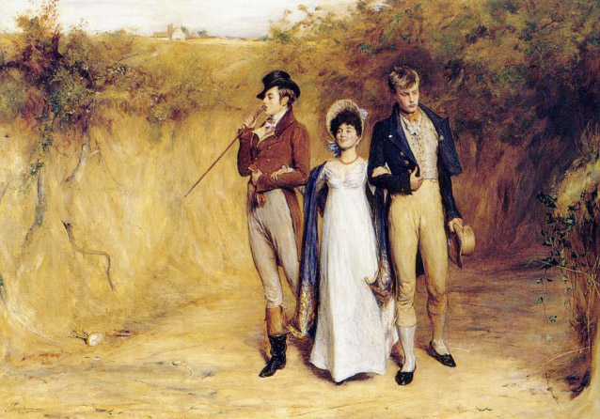

public domain
Gallery Walk Images and Texts, Continued

The origins of London slums date back to the mid-18th century, when the population of London, or the “Great Wen,” as William Cobbett called it, began to grow at an unprecedented rate. In the last decade of the 19th century, London’s population expanded to four million, which spurred a high demand for cheap housing. London slums arose initially as a result of rapid population growth and industrialization. They became notorious for overcrowding, unsanitary, and squalid living conditions. Most well-off Victorians were ignorant or pretended to be ignorant of the subhuman slum life, and many who heard about it believed that the slums were the outcome of laziness, sin, and vice of the lower classes. However, a number of socially conscious writers, social investigators, moral reformers, preachers, and journalists, who sought solution to this urban malady in the second half of the 19th century, argued convincingly that the growth of slums was caused by poverty, unemployment, social exclusion, and homelessness.

The Slums of East London
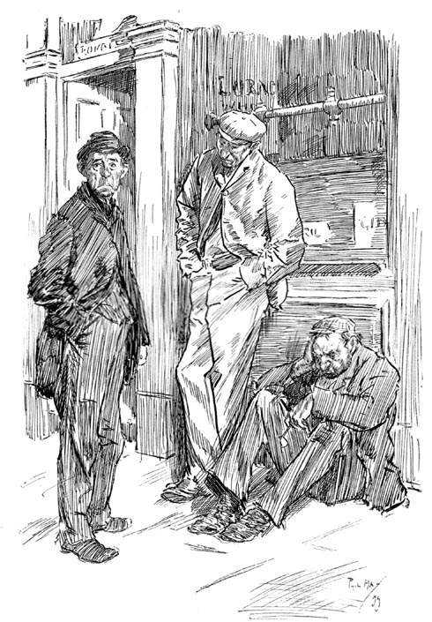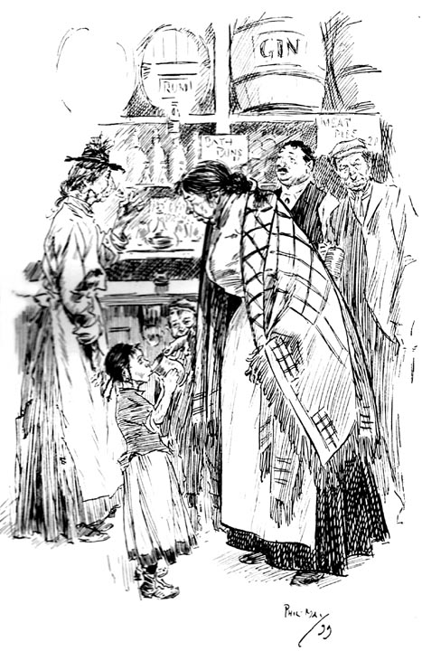
Two of Phil May's depictions of life in the East End: East End Loafers and A Street-Row in the East End.

Image by Phil May
This image may be used without prior permission for any scholarly or educational purpose. victorianweb.org http://www.victorianweb.org/history/slums.html
Gallery Walk Images and Texts, Continued

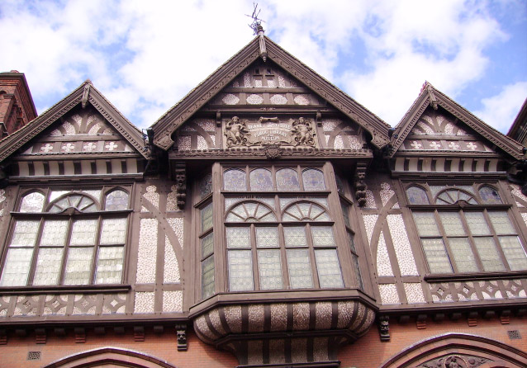

public domain
Gallery Walk Images and Texts, Continued
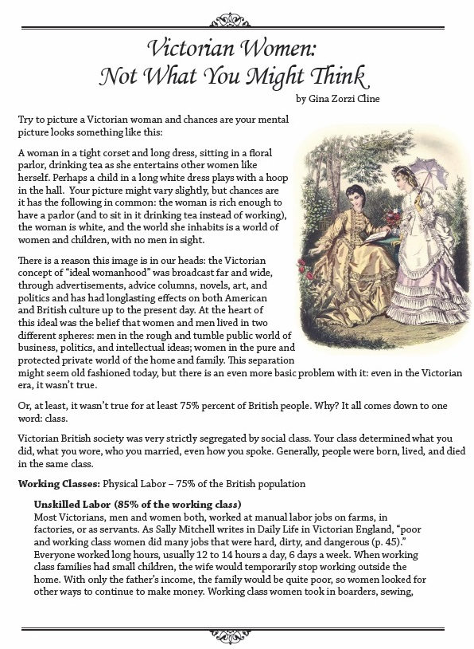
Gallery Walk Images and Texts, Continued
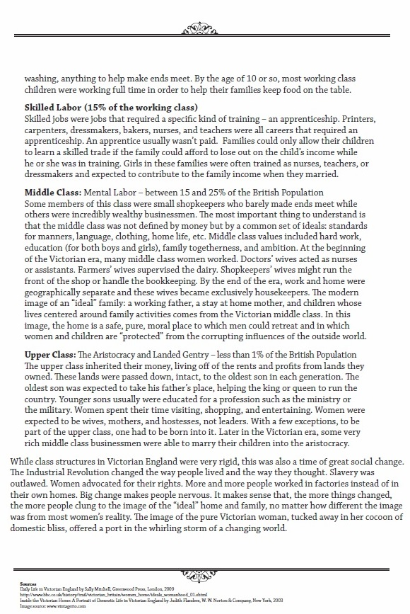
Cline, Gina Zorzi. "Victorian Women: Not What You Might Think." American Reading Company. 2014: Print.
Gallery Walk Images and Texts, Continued

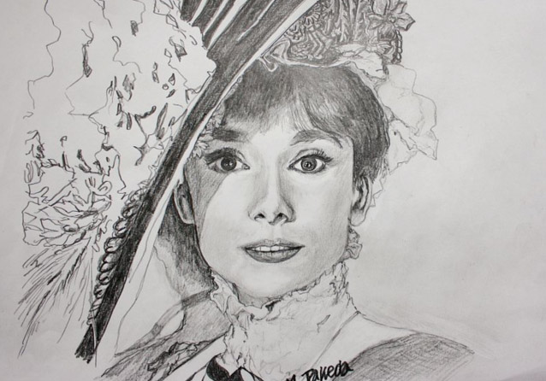

"My Fair Lady" http://creativecommons.org/licenses/by-sa/3.0/deed.en
Gallery Walk Images and Texts, Continued

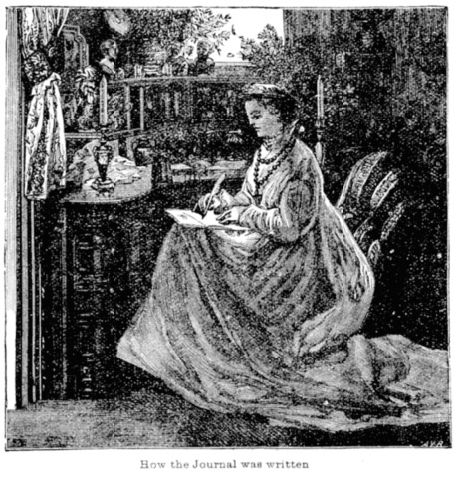

public domain
Gallery Walk Images and Texts, Continued

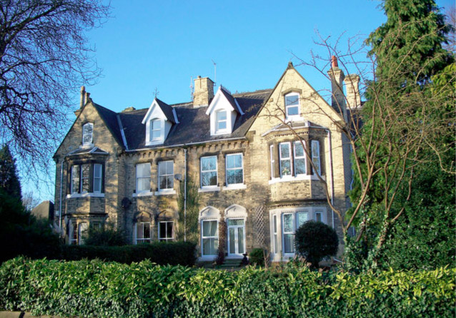

David Wright
http://creativecommons.org/licenses/by-sa/2.0/deed.en
Predictions Note-catcher

During the Gallery Walk:

What I think this text is about … | Clues from Gallery Walk

After the Sprit Read:

I think this text could be about …

Quotation Strips from Pygmalion

Teacher Directions: Copy this page and cut up so each quotation is on its own strip. Give one quote strip to each student.

THE FLOWER GIRL [springing up terrified] I ain’t done nothing wrong by speaking to the gentleman. I’ve a right to sell flowers if I keep off the kerb.

THE FLOWER GIRL [with feeble defiance] I’ve a right to be here if I like, same as you.

HIGGINS. Oh, that’s all right, Mrs. Pearce. Has she an interesting accent?
MRS. PEARCE. Oh, something dreadful, sir, really. I don’t know how you can take an interest in it.

LIZA. Oh, I know what’s right. A lady friend of mine gets French lessons for eighteenpence an hour from a real French gentleman. Well, you wouldn’t have the face to ask me the same for teaching me my own language as you would for French; so I won’t give more than a shilling. Take it or leave it.

MRS. PEARCE. Well, the matter is, sir, that you can’t take a girl up like that as if you were picking up a pebble on the beach.

LIZA. I ain’t got no parents. They told me I was big enough to earn my own living and turned me out.

HIGGINS. Very well, then, what on earth is all this fuss about? The girl doesn’t belong to anybody—is no use to anybody but me.

LIZA. Oh, you’ve no feeling heart in you: you don’t care for nothing but yourself [she rises and takes the floor resolutely]. Here! I’ve had enough of this. I’m going [making for the door]. You ought to be ashamed of yourself, you ought.

HIGGINS. What! That thing! Sacred, I assure you. [Rising to explain] You see, she’ll be a pupil; and teaching would be impossible unless pupils were sacred.

HIGGINS. Mrs. Pearce: this is Eliza’s father. He has come to take her away. Give her to him.

Quotation Strips from Pygmalion

DOOLITTLE [with fatherly pride] Well, I never thought she'd clean up as good looking as that, Governor. She’s a credit to me, ain’t she?

HIGGINS. Have you any further advice to give her before you go, Doolittle? Your blessing, for instance.

HIGGINS. Nonsense! I know I have no small talk; but people don’t mind.

HIGGINS. Oh, she’ll be all right: don’t you fuss. Pickering is in it with me. I’ve a sort of bet on that I'll pass her off as a duchess in six months. I started on her some months ago; and she’s getting on like a house on fire. I shall win my bet.

HIGGINS. You see, I’ve got her pronunciation all right; but you have to consider not only how a girl pronounces, but what she pronounces; and that’s where—

MISS EYNSFORD HILL. I sympathize. I haven’t any small talk. If people would only be frank and say what they really think!

PICKERING. Don’t ask me. I’ve been away in India for several years; and manners have changed so much that I sometimes don’t know whether I’m at a respectable dinner-table or in a ship’s forecastle.

MRS. HIGGINS. You silly boy, of course she’s not presentable. She’s a triumph of your art and of her dressmaker’s; but if you suppose for a moment that she doesn’t give herself away in every sentence she utters, you must be perfectly cracked about her.

HIGGINS. Well, dash me if I do! I’ve had to work at the girl every day for months to get her to her present pitch.

MRS. HIGGINS. You certainly are a pretty pair of babies, playing with your live doll.

PICKERING. Oh, I see. The problem of how to pass her off as a lady.

MRS. HIGGINS. The manners and habits that disqualify a fine lady from earning her own living without giving her a fine lady’s income! Is that what you mean?

HIGGINS. She’ll mimic all the people for us when we get home.
Quotation Strips from Pygmalion

PICKERING. Were you nervous at the garden party? I was. Eliza didn’t seem a bit nervous.

HIGGINS. If I hadn’t backed myself to do it I should have chucked the whole thing up two months ago. It was a silly notion: the whole thing has been a bore.

PICKERING. You’ve never been broken in properly to the social routine.

LIZA. What am I fit for? Where am I to go? What am I to do?

LIZA. I can’t. I could have done it once; but now I can’t go back to it.

DOOLITTLE [sad but magnanimous] They played you off very cunning, Eliza, them two sportsmen.

HIGGINS. About you, not about me. If you come back I shall treat you just as I have always treated you.

HIGGINS [irritated] The question is not whether I treat you rudely, but whether you ever heard me treat anyone else better.

LIZA. I won’t care for anybody that doesn’t care for me.
Mystery Excerpt

LIZA. I should look all right with my hat on. [She takes up her hat; puts it on; and walks across the room to the fireplace with a fashionable air.]

HIGGINS. A new fashion, by George! And it ought to look horrible!

DOOLITTLE [with fatherly pride] Well, I never thought she’d clean up as good looking as that, Governor. She’s a credit to me, ain’t she?

LIZA. I tell you, it’s easy to clean up here. Hot and cold water on tap, just as much as you like, there is. Woolly towels, there is; and a towel horse so hot, it burns your fingers. Soft brushes to scrub yourself, and a wooden bowl of soap smelling like primroses. Now I know why ladies is so clean. Washing’s a treat for them. Wish they saw what it is for the like of me!

HIGGINS. I’m glad the bath-room met with your approval.

3-2-1 Exit Ticket

3: Write down three things you noticed about Victorian England from the Gallery Walk:

2: Write down two ideas you have about what you think Pygmalion is about:

1: Write down one question you have as we begin to read this play:

