Lesson 19
Objective: Count 5─7 linking cubes in linear configurations. Match with numeral 7. Count on fingers from 1 to 7 and connect to 5-group images.

Suggested Lesson Structure
 Fluency Practice (12 minutes)
 Application Problem (5 minutes)
 Concept Development (25 minutes)
 Student Debrief (8 minutes)
Total Time (50 minutes)
Fluency Practice (12 minutes)
- 5-Groups (Count On from 5) K.CC.2 (4 minutes)
- Show Me Beans (Color Change at 5) K.CC.2 (4 minutes)
- Rekenrek Roller Coaster to 7 K.CC.4a (4 minutes)
5-Groups (Count On from 5) (4 minutes)
Materials: (T) Large 5-group cards (Lesson 8 Template)
T: (Show the 6 dot card.) Raise your hand when you know how many dots. (Wait for all hands to be raised, then signal.) Ready?
S: 6 dots!
T: This time, count only the dots on the top row. Raise your hand when you know how many dots are on top. (Wait for all hands to be raised, then signal.) Ready?
S: 5 dots.
T: This time, count only the dots on the bottom row. Raise your hand when you know how many dots are on the bottom. (Wait for all hands to be raised, then signal). Ready?
S: 1 dot.
T: We can count it like this. 5 (slide finger across the row of 5), 6 (point to the 1 dot on the bottom row). Try it with me. Ready?
S: 5, 6. (Mimic the sliding and pointing motions, if desired.)
T: (Show the 7 dot card.) Raise your hand when you know how many dots. (Wait for all hands to be raised, then signal.) Ready?
S: 7!
T: Top? (Wait for all hands to be raised, then signal.) Ready?
S: 5.
T: Bottom? (Wait for all hands to be raised, then signal.) Ready?
S: 2.
T: Count from 5. Ready?
S: 5, 6, 7.
Reducing the questions to as few words as possible (top, bottom) once students understand the essential task will allow them to complete a greater volume of problems in a short time and maintain an energetic pace.
Show Me Beans (Color Change at 5) (4 minutes)
Materials: (S) Two hands mat (Template), bag with 5 red beans and 5 white beans
T: Take 5 red beans out of your bag, and put them on the left hand on your mat. Count how many beans are on your mat.
S: 1, 2, 3, 4, 5.
T: Take a white bean out of your bag and put it on the thumb of the right hand on your mat. Count how many beans are on your mat now.
S: 1, 2, 3, 4, 5, 6.
T: How many red beans are on your mat? (Allow time to recount if necessary.)
S: 5 beans.
T: How many white beans?
S: 1 bean.
T: How many beans are on the whole mat?
S: 6 beans.
T: If we already know there are 5 red beans, do we really need to go back and count them every time?
S: No.
T: So, we can count from 5 like this: 5 (shadow the full hand of 5), 6 (point to the single white bean). Try it with me.
Continue this process as far as students are comfortable with the task, again with the goal of reducing teacher language.
Rekenrek Roller Coaster to 7 (4 minutes)
Conduct the activity as outlined in Lesson 7, but now introduce 6 and 7 into the sequence and generate a discussion about the color change at 5. If students demonstrate mastery, consider introducing the 10-frame orientation (e.g., 6 as 5 red beads on top and 1 red bead on the bottom).

Application Problem (5 minutes)
Draw 5 ice-cream cones. Draw 1 more ice-cream cone. Count how many ice-cream cones you drew on your paper. Write the number.
Note: This reinforces the concept of 6 as 5 and 1, preparing students for understanding 7 in the same way.
Concept Development (25 minutes)
Materials: (T) Writing frame on board, classroom size 5-group mat (Lesson 17 Template) (S) 1 bag of 10 loose linking cubes (5 each of red and blue), 5-group mat (Lesson 17 Template), 5-group cards (Lesson 8 Template, numeral side)
T: Count out 5 linking cubes of the same color from your bag. Put them in a tower. How many?

NOTES ON
MULTIPLE MEANS
OF REPRESENTATION:
- Give children with dexterity challenges a 5-group card, and have them put colored sticky dots on it.
- Have a selection of 5-group cards with various dot combinations for students who might have difficulty placing cubes on the cards. The student selects the appropriate card.

S: 5.
T: Excellent! Take your tower apart and put one cube in each square of your first 5-group. Can you find the number card that shows how many cubes are on your mat? Hold it up high!
S: (Hold up card.) 5!
T: Take a cube of a different color from your bag and put it in the first square on your other 5-group. What do you notice?
S: This 5-group has only one cube. This cube is a different color.
T: How many cubes are there in all? Count your cubes. Hold up the number card and say the number.
S: (Hold up card.) 6!
T: Yes! Six is 5 and 1 more. Take another cube of that color from your bag, and add it to your mat. What do you see now?
S: There is one with 5 and one with 2; there are 5 (blue) and 2 (red) cubes.
T: Does anyone know the number that is 5 and 2? Let’s count the cubes to find out.
S: 1, 2, 3, 4, 5, 6, …7!
T: Yes, the number is 7. Five and 2 are hiding in 7! Put your cubes all together to make a tower of 7 like this. (Demonstrate.) Do you see two little towers of 5 and 2 hiding inside? Show me. (Circulate and observe to ensure understanding.)
T: Let me show you how we write the numeral 7. “Across the sky and down from heaven; that is how we make a 7!” (Write 7 in the frame on the board.) Find the number card that shows me how many cubes are in your tower.
S: (Hold up card.) 7!
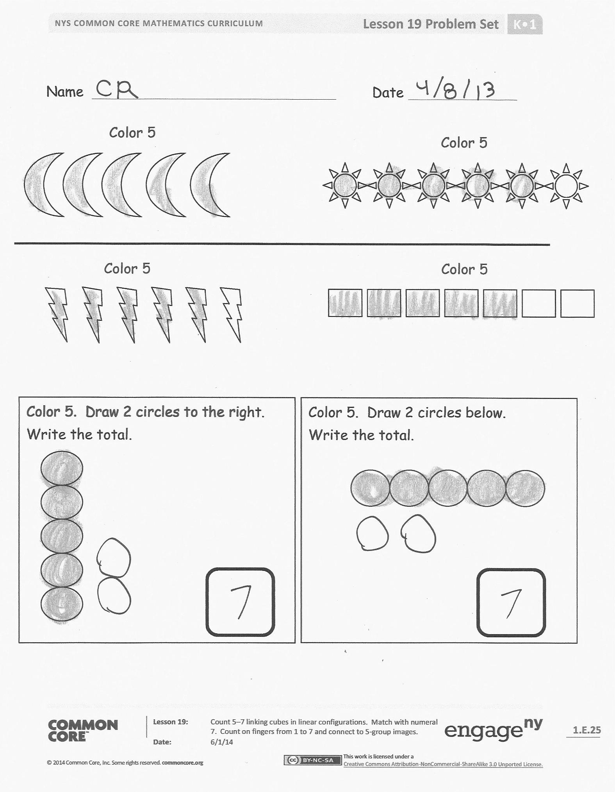
T: Good. Put your cubes away now. We are going to play Show Me the Number. When I hold up my 5-group cards, show me the same number with your cubes, then on your fingers the Math Way, and then tell how many. (Repeat quickly many times, showing all numbers but focusing especially on 5, 6, and 7.)
Problem Set (5–8 minutes)
Students should do their personal best to complete the Problem Set within the allotted time.
Student Debrief (8 minutes)
Lesson Objective: Count 5–7 linking cubes in linear configurations. Match with numeral 7. Count on fingers from 1 to 7 and connect to 5-group images.
The Student Debrief is intended to invite reflection and active processing of the total lesson experience.
Invite students to review their solutions for the Problem Set. They should check work by comparing answers with a partner before going over answers as a class. Look for misconceptions or misunderstandings that can be addressed in the Debrief. Guide students in a conversation to debrief the Problem Set and process the lesson.

NOTES ON
MULTIPLE MEANS
OF ENGAGEMENT:
Pair English language learners with native English speakers. Model for them how to take turns asking each other probing questions about their thinking and have them practice using sentence starters.

You may choose to use any combination of the questions below to lead the discussion.
- When we had a tower of 5, how many more did we add to make 7?
- What are hidden partners in 7?
MP.3
- Who can show me 5 the Math Way? Who can show me 7 the Math Way?
- Create a story using the Problem Set.
Exit Ticket (3 minutes)
After the Student Debrief, instruct students to complete the Exit Ticket. A quick review of their work will help you assess the students’ understanding of the concepts that were presented in the lesson today. Students have two minutes to complete the Exit Ticket. You may read the questions aloud to the students.

Name Date
Color 5
Color 5

Color 5
Color 5
Color 5. Draw 2 circles to the right. Write the total.

Color 5. Draw 2 circles below.
Write the total.

Name Date
Color 5 squares on the 5-group card. Then, color 2 squares on the other
5-group card.

Count how many squares you colored.
Write the numeral in the box.

Answer my riddle. 7 is 5 and ______ more.

Name Date
4

3

5

6

7

Draw a line from the numeral to the 5-group cards it matches.

Fill in the missing numbers.
____, 5, ____, 7
7, 6, ____, 4, ____, 2
1, ___, 3, ___, 5, ___, ___
7, ___, 5, ____, ___, 2, 1

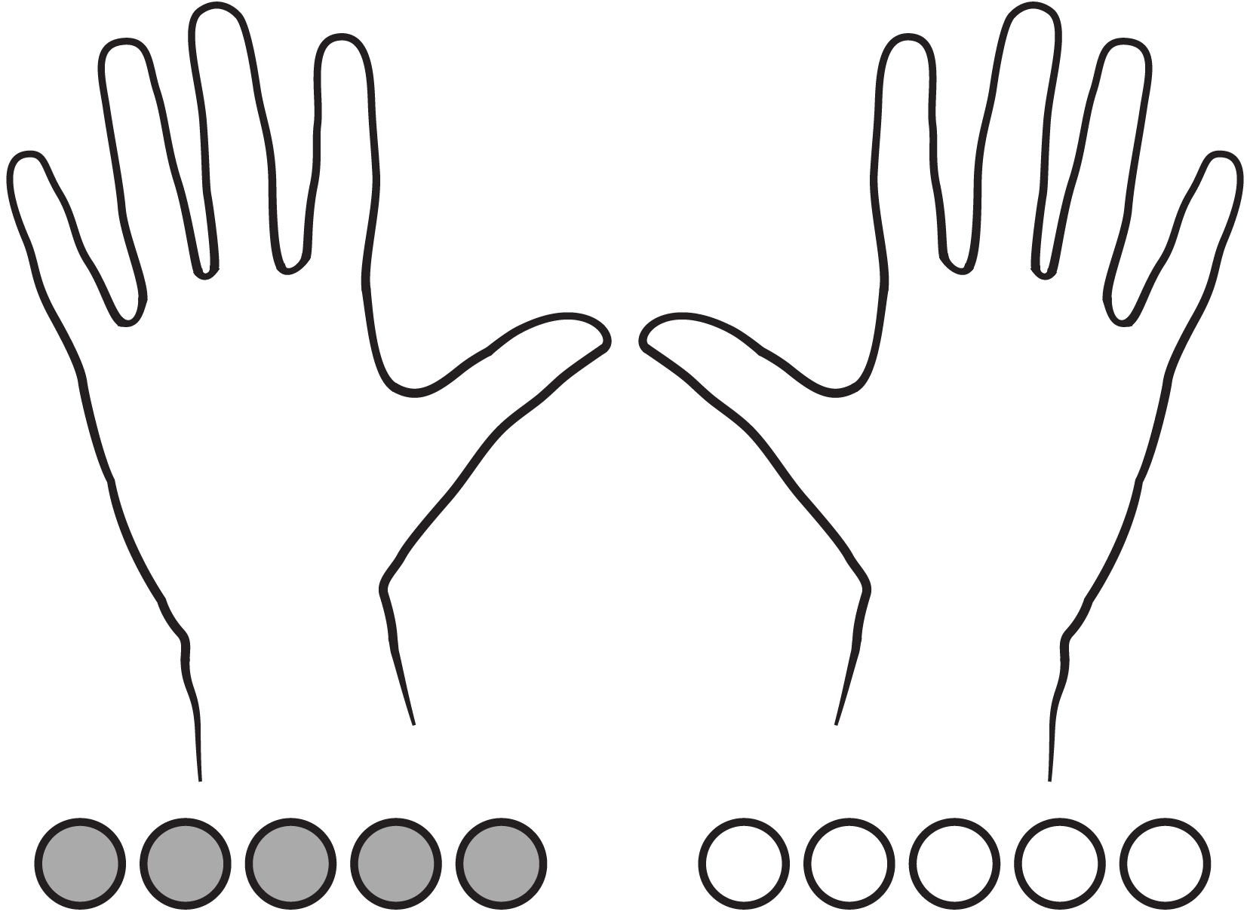

two hands mat

